Guidelines for Professional Development Providers
  - Guidance for all Professional Development Providers, including Institutions of Higher Education, School Districts, and Educational Collaboratives
Updated: June 2015

Massachusetts Department of Elementary and Secondary Education
75 Pleasant Street, Malden, MA 02148-4906
Phone 781-338-3000 TTY: N.E.T. Relay 800-439-2370
www.doe.mass.edu

© 2015 Massachusetts Department of Elementary and Secondary Education
Permission is hereby granted to copy any or all parts of this document for non-commercial educational purposes. Please credit the “Massachusetts Department of Elementary and Secondary Education.”

This document is printed on recycled paper.

Massachusetts Department of Elementary and Secondary Education
75 Pleasant Street, Malden, MA 02148-4906
Phone 781-338-3000 TTY: N.E.T. Relay 800-439-2370
www.doe.mass.edu
The Massachusetts Department of Elementary and Secondary Education, an affirmative action employer, is committed to ensuring that all of its programs and facilities are accessible to all members of the public.
We do not discriminate on the basis of age, color, disability, national origin, race, religion, sex or sexual orientation.
Inquiries regarding the Department’s compliance with Title IX and other civil rights laws may be directed to the
Human Resources Director, 75 Pleasant St., Malden, MA 02148-4906.
Phone: 781-338-6105.

This document was prepared by the
Massachusetts Department of Elementary and Secondary Education
Mitchell D. Chester, Ed.D.
Commissioner

Table of Contents

A Letter from the Commissioner 1
Purpose of Guidelines 2
Key Updates and Background Information 3
Requirements of Professional Development Providers by Provider Type 6
Important Definitions 8
Professional Development and Professional License Renewal 9
Professional Development and Educator Evaluation 11
Massachusetts Standards for Professional Development 13
Resources and Important Websites 15
Appendix A 16

August 2015
Dear Professional Development Providers and other Interested Parties:

I am pleased to present you with this update to the Guidelines for Professional Development Providers. Since they were issued in 2000, these guidelines have been a valuable resource for professional development providers in planning and delivering professional development in accordance with Massachusetts law, regulations, and the Licensure Renewal Guidelines. Several new initiatives now influence the work of professional development providers; these new initiatives require an update to the Guidelines:

- In 2012, the Educator License Renewal Regulations, 603 CMR 44.00, were amended to include new professional development requirements related to providing instruction to English Language Learners; and
- The Evaluation of Educator Regulations, 603 CMR 35.00, was amended in 2013.
- The Department adopted the Massachusetts Standards for Professional Development (2013).
- The Department adopted an addendum to the License Renewal Guidelines (2015).

You will find that updates go beyond expectations related to license renewal to also include those related to the planning and implementation of high quality professional development.

Whether you are an independent professional development provider, school administrator, teacher leader, collaborative director, or university professor, we know that you work hard to provide high quality professional development to our educators. To that end, we ask that you use the guidelines and the companion resources found at http://www.doe.mass.edu/pd to guide you in the planning, delivery, and assessment of your professional development. We trust that your content is aligned with the applicable Massachusetts Curriculum Frameworks and that your planning is grounded in best practices of adult learning theory.

We thank you for providing our educators with numerous and varied opportunities for high quality professional learning. Your assistance will increase educators’ ability to improve student learning.

Sincerely,

Mitchell D. Chester, Ed.D.
Commissioner of Elementary and Secondary Education

2

Purpose of Guidelines
Like the Guidelines for Professional Development Providers first issued in 2000, these guidelines are intended to support professional development providers in the planning and delivery of professional development to ensure that:
- Professional Development Points (PDPs) and academic credits are awarded to PreK-12 educators in accordance with the License Renewal Guidelines for Massachusetts Educators and the 2015 addendum.
- Professional development providers (PD providers) plan and deliver professional development that increases the ability of Massachusetts educators to improve student learning.

As illustrated in the graphic below, professional development is one of several Department initiatives designed to support educator effectiveness.
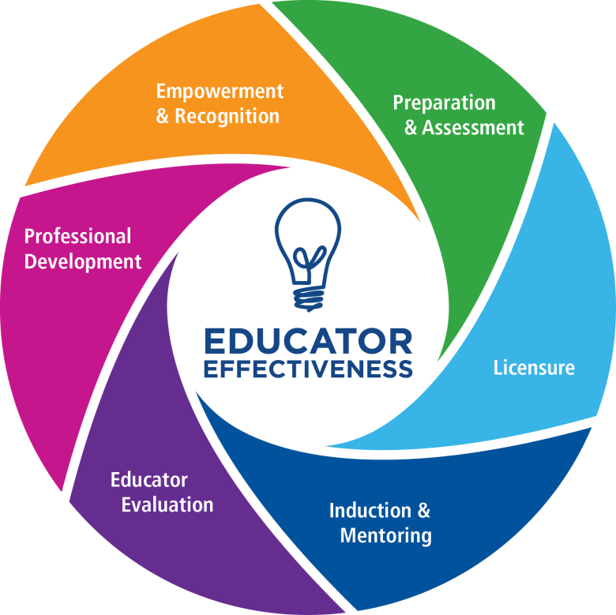

These guidelines reflect the current requirements and expectations of all PD providers outlined in the:

- Professional License Renewal/ 2015 Addendum: Guidelines For Massachusetts Educator
- Massachusetts Educator Evaluation Framework
- Massachusetts Standards for Professional Development
3

Key Updates and Background Information

Key Updates
The following updates to the Guidelines for Professional Development Providers furnish new information relevant to: (1) the Professional Development Provider Registry, (2) changes to license renewal requirements, and (3) supporting educator effectiveness through high quality professional development. The updates below are listed in order of the most recent updates.
- Establishment of an Online PD Provider Registry: The Department has maintained a list of registered providers for years. In 2015, a list of registered providers was published as a searchable online database at http://www.doe.mass.edu/pd/search.
- Changes to the PD Provider Application Process: Over the past four years, supported by federal funding through Race to the Top (RTTT), the Department has been working to improve the quality of professional development for Massachusetts educators. One of the Department’s goals was to improve the application review and approval process used to develop the Professional Development Provider Registry. To date, the process has resulted in the registration of nearly 100 professional development providers on the Department’s online registry.
- Registration Requirements of Institutions of Higher Education (IHEs): IHEs that grant university/college credits or CEUs are not required to register with the Department. However, if a university or college wishes to provide professional development points only, the organization or university program must register with the Department.

- An Addendum to the License Renewal Guidelines: The Professional License Renewal 2015 Addendum: Guidelines for Massachusetts Educators outlines the requirements of the Sheltered English Immersion (SEI) Endorsement, Professional Development Point (PDP) distribution for renewal of a Professional license after 7/1/16, requiring PD for all educators in ESL/SEI and special education/different learning styles. It also provides alignment opportunities for the Educator Plan for Educator Evaluation for license renewal (see below) and more.

- Establishment of Standards and Companion Resources that Support High Quality Professional Development: The Massachusetts Standards for Professional Development describe, identify, and characterize what high quality learning experiences should look like for educators. The Professional Development Standards and companion resources can be found here.

- Changes to the Recertification Regulations: In June of 2012, the Board of Elementary and Secondary Education adopted new regulations that focused on instruction for English Language Learners (ELLs).

4
- Educator Plans & Individual Professional Development Plan (IPDP) Alignment: The Educator License Renewal Regulations (see 603 CMR 44.04 (1) (c)) were revised in 2012 to allow educators to use one plan to satisfy both license renewal and educator evaluation requirements. For more information on aligning Educator Plans and IPDPs, see the Educator Evaluation FAQs and/or Professional License Renewal 2015 Addendum: Guidelines for Massachusetts Educators.

- Establishment of the Educator Evaluation Framework: On June 28, 2011, the Board of Elementary and Secondary Education (Board) adopted new regulations for evaluating all Massachusetts educators. The regulations apply to both administrators and teachers throughout the state and have a direct impact on their professional development planning and decision-making.

- Elimination of Department approval of an Advanced Academic Course of Study: Only two applications have been sent to ESE since 2011. Districts/schools are likely to partner or contract with a college or university to provide college-level courses for educators. In such cases, course participants may be awarded academic credit and/or the equivalent number of PDPs.

Background Information
In October 1999, the Educator License Renewal Regulations were amended to strengthen the ongoing professional development of Massachusetts educators and to align individual professional development plans more effectively with school and district goals. In February 2000, the Guidelines for Professional Development Providers were issued to provide guidance to professional development providers in implementing these new regulations. Primarily, the guidelines outlined the requirements and expectations of PD providers regarding the professional development activities they offered and the assignment of PDPs. In light of the developments between 2000-2015 (summarized in earlier sections), a number of requirements and expectations have been revised in these guidelines.

Access to high quality professional development is essential to the license renewal process, the Model System for Educator Evaluation, and the ultimate goal of improving educator effectiveness and student outcomes. As defined in the Massachusetts Standards for Professional Development:

High quality professional development is a set of coherent learning experiences that is systematic, purposeful, and structured over a sustained period of time with the goal of improving educator practice and student outcomes. It enables educators to facilitate the learning of students by acquiring and applying knowledge, skills, and abilities that address student needs and improvement goals of the district, school, and individual.

5
Many institutions, organizations, and individuals provide Massachusetts educators with high quality professional development; but, as shown below, with the exception of automatic providers, most must register with the Department in order to issue PDPs or credits to Massachusetts educators for license renewal.

Automatic PDP Providers | Providers Required to Register  with ESE
- Public school districts, including charter schools  - Educational collaboratives  - Massachusetts Department of Elementary and Secondary Education  - Automatic providers of credits and CEUs  - Accredited colleges and universities that grant credits, and professional organizations approved by IACET to award CEUs. | - Educational organizations and associations  - Governmental agencies  - Museums and cultural institutions  - Non-public schools including Chapter 766 Schools  - Not-for-profit organizations  - Private, for-profit organizations and individuals  - College and university programs that issue professional development points only.

6

Requirements of Professional Development Providers by
Provider Type

The following table outlines the requirements of professional development providers.

Requirements |  | Non-public/ Nonprofit Organizations | Colleges and Univers-ities | School districts/  Collabor-atives | Chapter 766  Schools | ESE
Register with ESE | X |  | Only if issuing PDPs | N/A | X | N/A
Comply with all PDP requirements |  | X | X | X | X | X
Provide educators with documentation/evidence of PD |  | X | X | X | X | X
Adopt and implement a professional development plan for all principals, teachers, and other professional staff |  | N/A | N/A | X | N/A | N/A
Approval of educators’ professional development plans |  | N/A | N/A | For their staff only | For their staff only | N/A
Alignment with PD Standard |  | X | X | X | X
7
In addition to the requirements above, there are several general expectations of professional development providers.

General Expectations of Professional Development Providers
Massachusetts Curriculum Frameworks
Focus professional development on the content and skills outlined in the learning standards of the Massachusetts Curriculum Frameworks.
Professional Development Website
Visit the Professional Development webpage regularly for important updates, resources, and information. Providers should also be well acquainted with the information found in the Frequently Answered Questions/FAQs.
Professional Conferences
Providers should not issue PDPs for attendance at a professional conference alone. See question 2 in the FAQs for more.
Registration with ESE
Approval to award PDPs is granted for three years. Registered providers must renew their application every three years if they wish to continue issuing PDPs.

Develop a System of Accountability and Record Keeping
Professional Development Providers must develop a system of accountability that addresses policies regarding attendance, end-of-course assessment, issuance of Certificates of Completion, and other related matters. Providers have the authority to employ other educators, consultants, trainers, or others to provide professional development activities for educators. These “subcontractors” do not need to be approved by the Department of Education, nor do they need to become registered Professional Development Providers. The Department of Education expects Providers to uphold and maintain standards of quality in their selection of “subcontractors.”
Providers should keep records of PD content descriptions, attendance, assessments, participant evaluations, and certificates of completion for five years from the date of the professional development. (Note: School districts and collaboratives may use electronic PD management software that provides an educator with a summary of their PDPs for the entire year.)

Important Definitions 8
Addendum to License Renewal Guidelines: an addendum to the 2000 Guidelines. See Professional License Renewal 2015 Addendum: Guidelines For Massachusetts Educator.
End-of-course Assessment: A summative assessment that is aligned with both the content and learning objectives of the professional development. The end of course assessment is used to determine if a participant met the PD goals and objectives. For professional development intended to strengthen content knowledge, the assessment will most likely be a written exam. For professional development related to professional practice, the assessment will likely be an observable demonstration of learning and/or a product.
Automatic Providers: Professional development providers who do not have to register with ESE in order to award professional development points (i.e., school districts, educational collaborative only) or to use college/university credits or CEUs (i.e., accredited colleges and universities or organizations registered with the International Association for Continuing Education and Training).
Bundle: An educator may combine or group (i.e., bundle) workshops, activities and/or conference hours for a minimum of 10 hours of professional development on a related/similar topic.
CEUs (or continuing education credits): Units of measurement of professional development activities that meet the requirements of the International Association for Continuing Education and Training (IACET).
Educator: Any person employed by a school or school district in a position requiring a license.
Educator Evaluation Framework: A framework designed to: promote growth and development of leaders and teachers; place student learning at the center, using multiple measures of student learning, growth and achievement; recognize excellence in teaching and leading; and set a high bar for professional teaching status; and shorten timelines for improvement.
Educator Plan: The growth or improvement actions identified as part of each educator's evaluation. For a copy of the ESE form that educators can use to track professional development points (PDPs) instead of an IPDP.,(See the Educator Plan Form.
Educator Plan Addendum: A resource intended to guide conversations between educators and evaluators when completing Educator Plans and during regular discussions about educator performance and engagement in professional development. The addendum supports alignment between educator plans and individual professional development plans (IPDPs). These links take you to the addendum for license renewal before July 2016 and the addendum for license renewal after 2016.
High Quality Professional Development (HQPD): A set of coherent learning experiences that is systematic, purposeful, and structured over a sustained period of time with the goal of improving teacher practice and student outcomes. HQPD includes both job-embedded learning opportunities (e.g., an educator reflecting on a unit plan with his or her grade level team or observing a colleague) and formal learning opportunities (e.g., participating in a district training on the MA Curriculum Frameworks or graduate-level coursework in his or her content area).
Individual Professional Development Plan (IPDP): ESE has designed a recertification process that requires all educators to prepare an IPDP for each five‐year renewal cycle. The plan must be consistent with the educational needs of the school and/or district and enhance the ability of the educator to improve student learning. Educators are required to obtain initial approval and final endorsement of their plans from their supervisor.
License Renewal Guidelines: Guidelines for Massachusetts educators that are aligned with the Educator License Renewal Regulations for professional development. See the License Renewal Guidelines, in particular, Section III: Guidelines for School Districts and Educational Collaboratives and Section IV: Guidelines for Registered Providers.
Professional Development Point (PDP): A unit of measurement of professional development activities. One clock hour is equivalent to one professional development point. One semester hour is equivalent to 15 PDPs. One continuing education unit is equivalent to 10 PDPs. Department guidelines detail the PDPs earned by professional development activities not readily measured in clock hours.

9

Professional Development and Professional License Renewal

The process of license renewal (also known as recertification) is defined in the License Renewal Guidelines. It outlines a process of ongoing professional development that is carried out through the completion of an Individual Professional Development Plan (IPDP), which is aligned with school and district improvement plans.

Renewing a primary Professional license requires 150 PDPs and each additional Professional license that is renewed requires 30 PDPs in the content area of the respective license. The IPDP describes the activities that will apply toward license renewal within a given five-year cycle. At least 80% of the proposed PDPS in the educator’s IPDP must be consistent with the educational needs of the school and district improvement plans. PD providers should be mindful of the license renewal requirements in planning, delivering, and documenting educators’ participation in professional development.

Due to regulatory changes to the Educator License Renewal Regulations in June of 2012, an educator with a core academic license who has been assigned to a cohort within his/her school district is required to obtain the Sheltered English Immersion (SEI) Endorsement. In addition to these requirements, educators who hold a license that is due to expire on or after 7/1/16 are required to meet the renewal requirements as set forth in 603 CMR 44.06. For more information on the license renewal requirements in accordance with the new regulations, please see the 2015 Addendum to the Licensure Renewal Guidelines.

10
Expectations Related to PDPs, Academic Credits, and
Certificates of Completion for License Renewal
Awarding PDPs
Per 603CMR 44.03 (2), “PDPs may be awarded by registered providers to license holders who complete a professional development activity and demonstrate proficiency in the relevant subject area or skill through an appropriate end-of-course assessment that satisfies Department guidelines.” For a list of allowable professional development activities, please see page 5 of the Recertification/Renewal Guidelines.

PD Providers may only award PDPs when all of the following conditions are met:
- The professional development is offered by the MA Department of Elementary and Secondary Education Department (ESE), school district, educational collaborative, or a provider that is registered with ESE.
- The professional development must be at least 10 hours per topic.*
- The professional development must include an assessment of learning. (This may be an end-of-course assessment or an observable demonstration of learning.)
- The professional development participant has met the provider’s criteria for mastery.
*With one exception found on page 4 of the 2015 addendum: Educators with a professional license who participate in a district-sponsored, approved provider-sponsored evaluation training program or a training program on the Massachusetts Framework for Educator Evaluation through their own district will be able to count those activities towards their license renewal, even if the training program was less than 10 hours.

A template of a PDP certificate may be found in Appendix C. Providers may use other styles of PDP certificates or create a letter that includes all the required information.
Many educators meet their professional development requirements by taking credit bearing courses, as well as workshops that are less than 10 hours. If credits are awarded, they are converted to PDPs; if a certificate of completion is awarded the hours may be bundled.)
Awarding Academic Credits
For the purpose of license renewal, the Office of Educator Licensure accepts documentation of university and college credits from an accredited institution. Reviewers use a formula to convert those credits into PDPs: one undergraduate credit = 15 PDPs; one graduate credit = 22.5 PDPs; one CEU = 10 PDPs
If another provider wishes to partner with a college or university to develop a credit bearing course, course participants may be awarded either university credit or the equivalent number of PDPs (assuming participants have done the equivalent amount of work).
The Department will accept CEUs from organizations with approval from The International Association for Continuing Education and Training (IACET). CEUs attained from unaccredited providers will not be accepted.
Awarding Certificates of Completion
Registered providers may award certificates of completion for professional development that is less than 10 hours. Certificates of Completion should follow a similar format as the PDP certificate template found in the Appendix.

11

Professional Development and Educator Evaluation
The Massachusetts Educator Evaluation Regulations (603 CMR 35.00), as amended in 2011, established a common, statewide system to support the continuous growth and improvement of all educators licensed by ESE.
As illustrated in the graphic below, educator evaluation and professional development are mutually reinforcing and aim to support educators’ continuous growth and development, improvements in educator practice, and student outcomes. The evaluation process highlights an individual educator’s needs for professional development while providing schools and districts with data that they can use in planning professional development. Educators will consider district and school priorities and planned PD opportunities in writing their goals and individual educator plans. (NOTE: The IPDP and educator plan may be combined. See page 4 of the 2015 Addendum.)

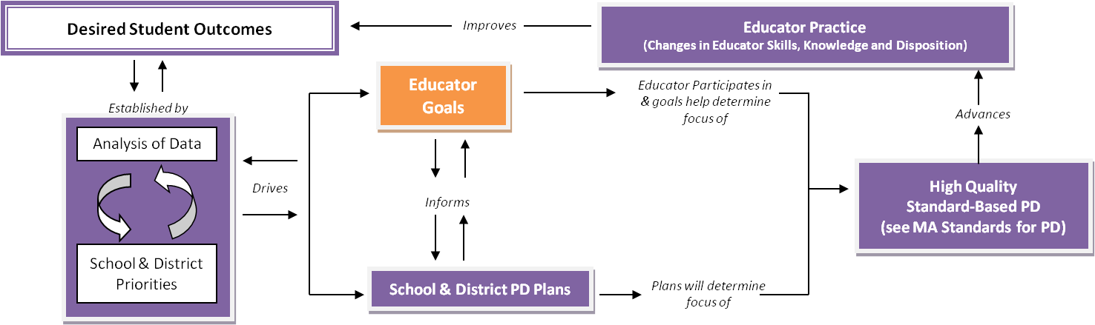

There are several opportunities for professional development providers to support educators throughout the 5-Step Cycle of the Educator Evaluation Framework. The questions below are meant to serve as examples of considerations that a provider might make in planning and delivering professional development to support educators throughout the cycle.

12

Professional Development within the 5-Step Cycle

Continuous Learning

13

Massachusetts Standards for Professional Development
Professional development planning, delivery, and assessment should be driven by the needs of educators as well as students and be guided by the Massachusetts Standards for Professional Development. In addition to these standards, PD providers should be acquainted with of the four guiding principles shown below. These principles describe the necessary conditions for implementing the standards.

MA’s Guiding Principles for High Quality Professional Development (HQPD)
HQPD is intentional
HQPD is a process
HQPD is evaluated for effectiveness
HQPD requires strong leadership

Professional Development and School and District Improvement Planning
As described in this overview of the improvement planning process, schools and districts use this process to create a multi-year School Improvement Plan that is grounded in the analysis of a wide array of data. It should establish specific, measurable school outcomes that are aligned with the District Plan and identify the objectives and initiatives to accomplish them. As articulated in the Massachusetts Guide for Planning High Quality Professional Development, schools and districts determine their professional development needs during the improvement planning process. This practice is aligned with the indicators for Standard 2 of the Massachusetts Standards for Professional Development:
- Professional development goals align with educator performance standards, individual professional growth goals, and/or state, district, or school improvement priorities.
- Professional development prepares educators to address state, district, school, and individual goals or priorities.

14

Expectations Related to the Massachusetts Standards for

Professional Development

Per the PD Provider Registry Application, registered PD providers are expected to plan, implement, and assess their professional development offerings guided by the Massachusetts Standards for Professional Development. Providers may demonstrate alignment with the standards in many ways, including but not limited to:
- Syllabi and program descriptions that include the PD goals and objectives with clear ties to student outcomes (standard 1).
- Evidence of analysis and clear connections between the PD and the goals and priorities of ESE, districts, schools, and/or educators (standard 2).
- The use of multiple data sources in prioritizing, planning, improving, and differentiating the PD. Such data use goes beyond analyses of evaluations completed by the participant at the end of the PD (standard 3).
- Learning is assessed through an end-of-course assessment. PDPs are only awarded when a participant has met the provider’s criteria for mastery (standard 4).
- Syllabi and agendas include a description of planned collaboration methods (standard 5) and strategies to support an application to practice (standard 6).
- Surveys, questionnaires and/or initial lessons are used to determine the need to differentiate content, methods, and/or expectations by audience (e.g., novice vs. veteran, elementary vs. high school; urban vs. suburban) (standard 7).
- The use of varied PD learning experiences with adequate time for learning, collaboration, and application to practice (standard 8), planned in a coherent and sequential manner (standard 10).
- Instructors’ credentials demonstrate content expertise and best practice in adult learning theory (standard 9).

15

Resources and Important Websites

- District Analysis and Review Tools (DARTs)
- Educator Evaluation Website
- Educator Licensure Website
- Educator Plan Form Updated to Track Professional Development Activities
- Educator Plan Addendums for Educators Renewing License Before 7/1/16, for Educators Renewing License On or After 7/1/16
- Frequently Asked Questions
- Guidelines for Reviewing, Approving and Endorsement IPDPs
- Individual Professional Development Plan (IPDP) Template
- Licensure Renewal Guidelines
- MA Curriculum Frameworks
- Massachusetts Standards for Professional Development
- The Massachusetts Guide for Planning High Quality Professional Development
- PD Provider Registry
- Professional Development Case Studies
- Professional Development Website
- Quick Reference Guide: Educator Evaluation & Professional Development
- Resources and Tools for Providers
- School and District Profiles
- The School Improvement Planning Process
- High Quality Professional Development Planning and Assessing Cycle

16

Appendix A
PDP Certificate Template
PDP CERTIFICATE
(Provider name)
(Provider number)
This PDP Certificate is being awarded to:

for participation in
(Title of Professional Development)

Main Content Area(s) of PD
Date(s) of PD
Objective(s) of PD
Description of Assessments
Total hours of PD
No. of PDPs
(Print name of person signing)
Signature of Provider
_____________________________________________

Including school districts, institutes of higher education, and educational collaboratives.
ESE converts these credits to PDPs.
International Association for Continuing Education and Training (IACET) http://www.iacet.org/
Approved private special education schools submit a modified application in order to issue PDPs to their staff only. If a school wishes to offer PDPs to other educators, the school must complete a full PD Provider Registry application.
Including charter schools
10 hours, includes an assessment of learning, and the participant has met the provider's criteria for mastery.
May be modified for use as a certificate of attendance or completion.

