Calibrating Feedback
A Model for Establishing Consistent Expectations of Educator Practice

Adapted from the Massachusetts Candidate Assessment of Performance

Facilitator’s Guide
Massachusetts Department of Elementary and Secondary Education
75 Pleasant Street, Malden, MA 02148-4906
Phone 781-338-3000 TTY: N.E.T. Relay 800-439-2370
www.doe.mass.edu
Contents
Preparing for the Workshop 1
Overview 1
Context 1
Intended Outcomes 1
Equipment and Materials 1
Facilitator’s Guide 2
I. Warming Up (10 minutes) 2
II. Learning (30 minutes) 3
III. Practicing (45 minutes) 7
IV. Calibrating (45 minutes) 9
V. Recapping (5 minutes) 11

Preparing for the Workshop

Overview
This workshop provides an overview of the ESE Model CAP Observation Protocol used in the Candidate Assessment of Performance (CAP), as well as opportunities to practice conducting observations and constructing feedback and calibrating evidence and feedback with colleagues. Districts and schools may find the Model CAP Observation Protocol and the calibration activities included in this workshop helpful to developing common expectations for educator practice, as well as practicing conducting observations and providing feedback. The goal of this workshop is to build capacity for delivering high-quality, targeted, and actionable feedback to educators grounded in evidence collected during observations.

Context
This facilitator’s guide is designed to assist districts in delivering a rich and engaging training experience for evaluators and educators. The content of this workshop is based on the CAP Model Observation Protocol. Districts may substitute the model protocol and instead facilitate the workshop using one of their own . In all cases, districts should review this guide and the other workshop materials carefully to determine where they will need to be customized to reflect the district’s expectations and process for conducting observations and providing feedback.

Intended Outcomes
At the end of this session:
- Participants will have a clear understanding of the Model CAP Observation Protocol (or whatever protocol is used in its place), including the process for collecting and organizing evidence and providing high-quality, targeted, and actionable feedback to educators.
- Participants will have practiced conducting an observation and constructing feedback.
- Participants will have a clear understanding of calibration and have engaged in a calibration activity to begin to develop a common set of expectations for educator practice.

Equipment and Materials
- Equipment: Laptop computer with an internet connection and a copy of the workshop PowerPoint slides and a projector.
- Handouts packet, which includes:
  - ESE Model CAP Observation Protocol
  - CAP Observation Forms
- Teacher Performance Rubric (not included)

Facilitator’s Guide
This workshop is divided into five sections and has a total time of 2 hours and 10 minutes:

Warming Up (10 minutes)

Learning (30 minutes)

Practicing (45 minutes)

Calibrating (45 minutes)

Recapping (5 minutes)
Slides are provided to facilitate each section and this corresponding guide includes facilitator notes, as well as italicized talking points for each slide.
Note: Facilitators may opt to omit the Learning section to reduce total workshop time to roughly 1 hour and 45 minutes, if participants will be using a familiar observation protocol to complete the activities.

I. Warming Up (10 minutes)
Title slide  - This workshop is designed to be delivered to a group of evaluators and/or educators. Portions of the workshop are based on the Model CAP Observation Protocol. Districts are free to customize the content as needed to reflect their expectations and processes for conducting observations and providing feedback. | 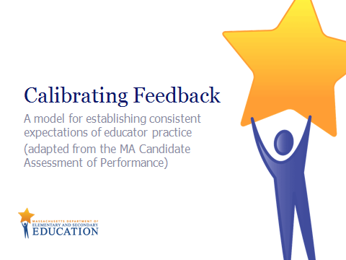  Slide 1  Quick transition
Warming Up:  - This workshop is broken up into the following sections Warming Up, Learning, Practicing, Calibrating, and Recapping. | Slide 2  Quick transition
Warming Up:  - The video clip featured on this slide is from the Transforming Educator Evaluation in Massachusetts (TEEM) series. The TEEM videos feature educators from four MA districts describing strategies for creating meaningful, high quality educator evaluation experiences This video on Observations and Feedback is a good primer to help participants reflect on their observation practices.  - Click on the screenshot in presentation mode to launch the 5-minute video clip. | 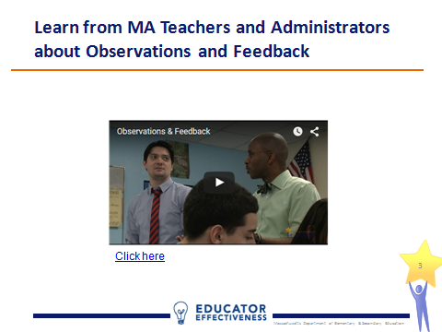  Slide 3  5 minutes
Warming Up:  - Push participants to be specific about their current processes for determining what feedback to offer those they observe.  - Participants will likely have a range of experiences and preferences conducting observations and providing feedback. Facilitators may find it helpful to surface these differences by adding a whole-group share to the warm up activity. | 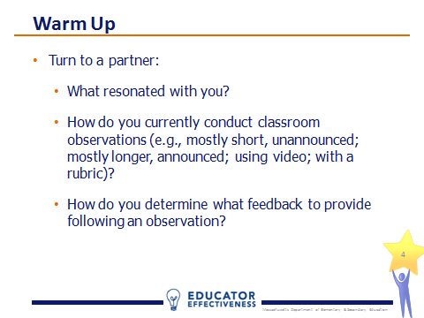  Slide 4  5 minutes

II. Learning (30 minutes)
Learning:  - In this section, participants will learn how observations are used in CAP, the CAP Model Observation Protocol, and the CAP Observation Forms. | Slide 5  Quick Transition
Learning:  - The protocol used in this workshop was created to support the Candidate Assessment of Performance, or CAP. CAP is a performance assessment designed to asses a teacher candidate’s readiness to teach. Starting in 2016-17, successful completion of CAP will be a requirement for educator preparation program completers.  - CAP is aligned to the MA Educator Evaluation Framework. Now, pre-service teachers participate in the very same 5-step cycle as in-service educators to support their growth and development.  - Like the educator evaluation framework, CAP relies on observations as a main source of evidence. | 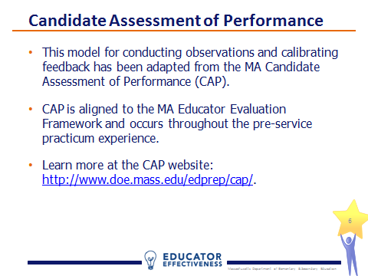  Slide 6  1 minute
Learning:  - During the observation, evaluators should be focused on documenting what is happening by recording teacher and student behaviors and actions. This is called active evidence collection.  - After the observation, the evaluator will analyze the evidence collected, extract trends and draw conclusions.  - The educator should also reflect on his/her performance during the lesson and share the reflection with the evaluator. This is an important step in cultivating reflective practice.  - Finally, the observation should result in targeted feedback for the educator in the form of specific areas of reinforcement and refinement, which will be covered in depth later. | 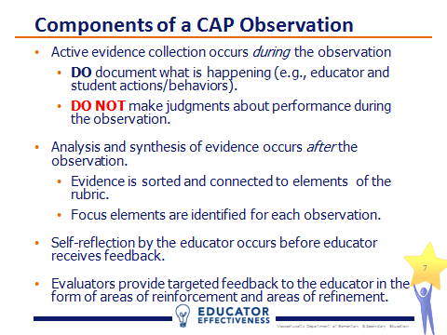  Slide 7  3 minutes
Learning:  - Slides 8-13 unpack the Model CAP Observation Protocol. Districts using a different protocol should adapt this content as needed.  - Here are the main components of the Model CAP Observation Protocol. The next several slides unpack the protocol.  - Note that part 1, Before the Observation, is omitted for unannounced observations.  - Refer participants to the ESE Model Observation Protocol included in the handouts packet (pages 4-9). | 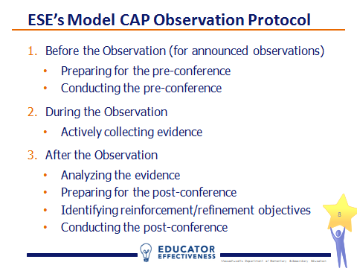  Slide 8  Quick Transition
Learning:  - The pre-conference can be an important opportunity to build rapport with the educator, establish a coaching relationship, and begin to collect evidence for the upcoming observation.  - It should occur 1-2 days prior to an announced observation. Plan for 15-20 minutes.  - Prior to the pre-conference program observers should gather and review evidence including: the lesson plan and lesson materials and prior feedback provided to candidate.  - Observers should keep the pre-conference conversation focused by preparing 2-3 questions for the educator. The model protocol includes additional example questions. See page 5 of the handouts packet.  - Review pages 5-6 of the handouts packet with participants, which cover a three-step outline for the pre-conference: introduction, lesson discussion, closure from the CAP Model Observation Protocol. | 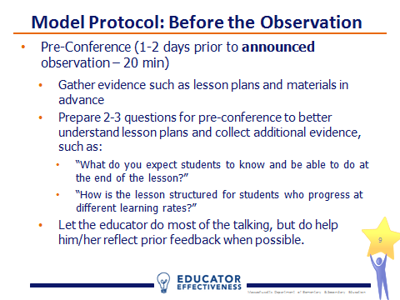  Slide 9  4 minutes
Learning:  - During the observation, the observer engages in active evidence collection, documenting what is happening by recording teacher and student actions and behaviors.  - At this point, judgment should be withheld.  - Scripting portions of the lesson may be a helpful way to collect evidence.  - Observers will have an opportunity to polish and sort evidence after the observation. | Slide 10  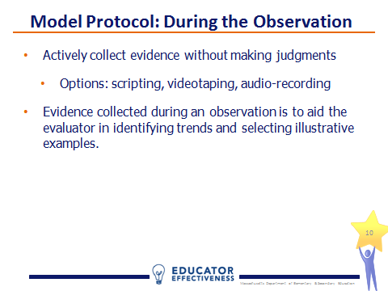  2 minutes
Learning:  - Refer participants to the CAP Observation Form included in the handouts packet (page 10).  - Note that not all evidence collected must be sorted.  - Evidence statements should say what happened in the observation that shows or does not show that a skill has been demonstrated. For example, an evidence statement in the II.A.3 Meeting Diverse Needs category might read, “Met diverse needs by circulating to each group during group work, asking probing questions and checking for understanding. However, neither groupings nor questioning was differentiated based on individual student need (not noted in lesson plans or during pre/post conferences).” | 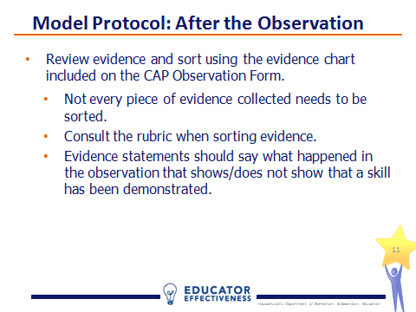  Slide 11  4 minutes
Learning:  - Refer participants to the Post-Conference Planning Form from the model observation protocol included in the handouts packet (page 13) and let them know that they will be working with this form later in the workshop.  - Once the evidence has been analyzed and synthesized using the observation form, it is time to plan for the post-conference. The Post-Conference Planning Form may be helpful here.  - As a first step, if the observation was conducted jointly, it’s important for the observers to calibrate feedback prior to the post-conference.  - Next, the observers should collect a self-reflection from the educator (again, a good source of evidence for the reflective practice element).  - Finally, the observers identify at least 1-2 areas of reinforcement and 1-2 areas of refinement to share as feedback to the candidate during the post-conference. | 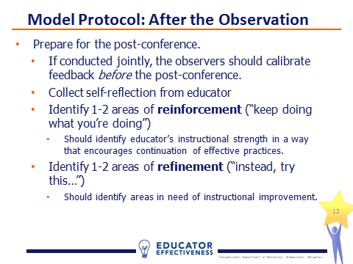  Slide 12  5 minutes
Learning:  - During the post-conference, the observer will provide the educator with the completed observation form and talk through the feedback and available supports, asking reflection questions throughout.  - Review pages 8 and 9 of the handouts packet with participants, which cover a three-step outline for the post-conference: introduction, discussion of reinforcement/refinement areas, closure. | 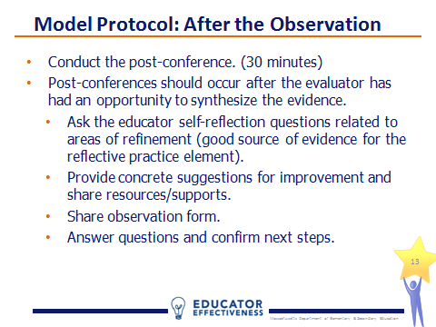  Slide 13  3 minutes

III. Practicing (45 minutes)
Practicing:  - In this section, participants will watch a video of instructional practice and practice conducting an observation and developing feedback using the Model CAP Observation Protocol (notably the Post-Conference Planning Form).  - Again, districts may choose to modify this activity to the reflect their chosen observation process. | Slide 14  Quick Transition
Practicing:  - Prepare participants to conduct a simulated unannounced observation. Participants should use a strategy such as scripting on notepaper to thoroughly capture teacher and student actions and behaviors without judgment.  - Provide participants with a few minutes to review the performance descriptors for the focus elements for the observation. Using focus elements for this workshop will result in a more meaningful conversation because all participants are looking for the same practices. Facilitators may choose to substitute the focus elements for elements that better align to district/school priorities or can leave them in place for the purposes of this exercise.  - Note the focus elements for this lesson are well-structured lessons and safe-learning environment, the same as Unannounced Observation #1 in CAP. | 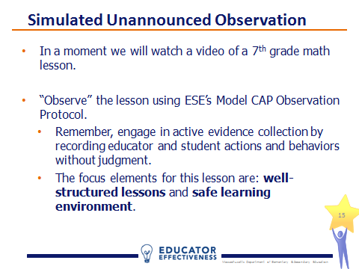  Slide 15  3 minute
Practicing:  - The video clip featured on this slide is from the ESE’s Calibration Video Library. The teacher practice depicted in the series is intentionally variable in quality to promote robust conversations.  - Click on the screenshot in presentation mode to launch the video clip.  - Stop the video at the 9:52 mark. | 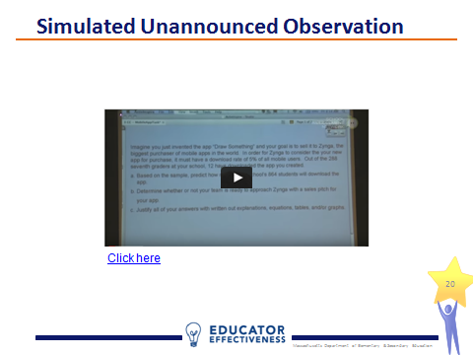  Slide 16  10 minutes
Practicing:  - Refer participants to the rubric (not provided in the handouts packet) and CAP Observation Form for Unannounced Observation #1 on page 12 of the handouts packet.  - Note that the observation form reflects the six elements from the rubric measured by CAP. Facilitators may decide to substitute these for different elements to better align to district/school priorities or can leave them in place for the purposes of this exercise, or limit the scope of the observation to just the two focus elements.  - Each participant should work independently for 10 minutes using the rubric and observation form to sort the evidence collected by the rubric element, and identify 1-2 reinforcement and 1-2 refinement areas. Cap the activity at 10 minutes and inform participants that it’s ok if they do not complete the process in the time allotted. | 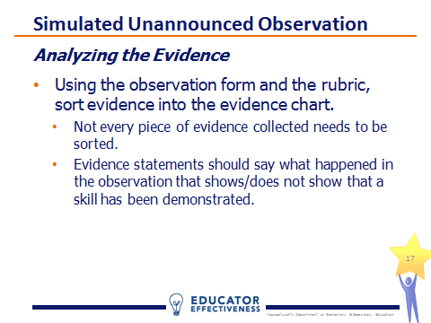  Slide 17  12 minutes
Practicing:  - Refer participants to the Post-Conference Planning Form from the Model Observation Protocol included in the handouts packet (page 13).  - Facilitators will need to modify the form if they make changes to the rubric elements for which participants have collected evidence.  - Simulating the calibration that should occur between multiple observers, participants should pair-up and complete the post-conference planning form. Again, cap the activity at 10 minutes.  - The guiding questions from the model protocol on pages 7-8 of the handouts packet may be helpful in indentifying reinforcement and refinement areas. | 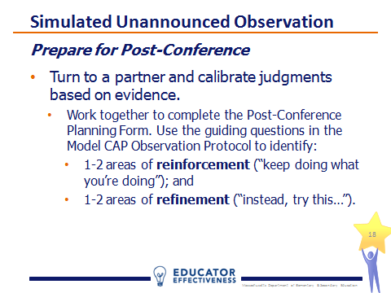  Slide 18  12 minutes
Practicing:  - Provide each pair an opportunity to share their 1-2 reinforcement and 1-2 refinement areas.  - Conduct a whole group discussion to uncover whether the judgments made based on the evidence collected and the feedback provided to the teacher (i.e., the reinforcement and refinement areas) were consistent within each pair and across the full group. If not, ask participants to reflect on why there were differences. | 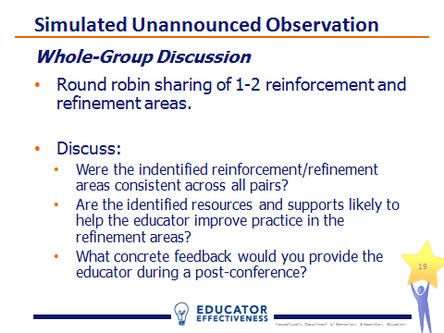  Slide 19  10 minutes

IV. Calibrating (45 minutes)
Calibrating:  - In this section, participants will watch a second video of instructional practice and engage in a calibration activity to promote a common, shared understanding of practice.  - Districts are encouraged to provide opportunities for evaluators to calibrate often. ESE’s Calibration Video Library includes over 40 videos of classroom instruction, as well as other calibration protocols and activities that can be used with the videos to develop a shared understanding of quality practice. | Slide 20  Quick Transition
Calibrating:  - This definition of calibration is used by ESE’s educator evaluation team and reflects the importance of consistency in any evaluation process. | 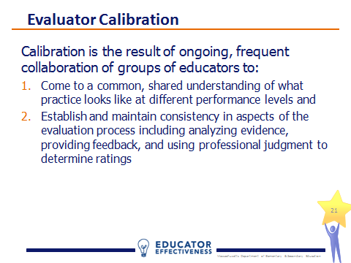  Slide 21  1 minute
Calibrating:  - Prepare participants to conduct a second simulated unannounced observation. Participants should again use a strategy such as scripting on notepaper to thoroughly capture teacher and student actions and behaviors without judgment.  - Again, facilitators may choose to change the focus element for this observation.  - Note the focus element for this lesson is adjustments to practice. | 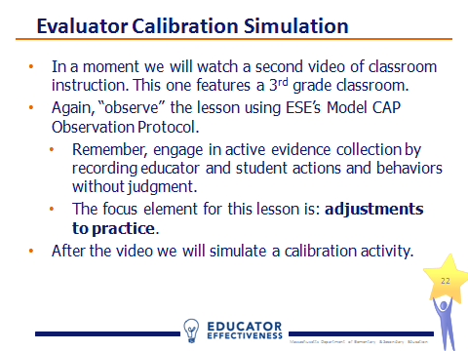  Slide 22  1 minute
Calibrating:  - The video clip featured on this slide is from the ESE’s Calibration Video Library. The videos in this series are not exemplars. The teacher practice depicted in the series is intentionally variable in quality to promote robust conversations.  - Click on the screenshot in presentation mode to launch the video clip.  - Stop the video at the 10:04 mark. | 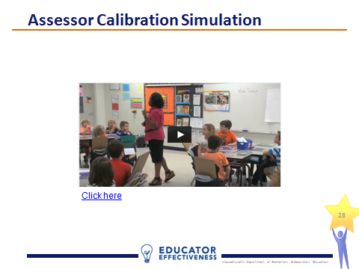  Slide 23  10 minutes
Calibrating:  - Refer participants to the CAP Observation Form for Unannounced Observation #2 (page 15), the rubric (not included), and the second Post-Conference Planning Form (page 16) included in the handouts packet.  - As before, each participant should work independently for 10 minutes using the observation form and rubric to sort the evidence collected by the rubric elements and identify 1-2 reinforcement and 1-2 refinement areas. Cap the activity at 10 minutes and inform participants that it’s ok if they do not complete the process in the time allotted. | 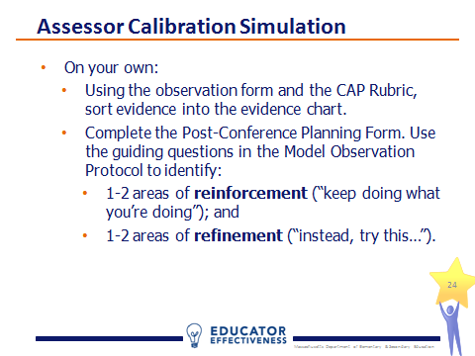  Slide 24  12 minutes
Calibrating:  - Participants should break into teams of 3-4 and conduct a peer review of a group member’s feedback to the teacher. This process is based on a model developed and used by the administrative team of the Revere Public Schools.  - Each team identifies a subject who is willing to read aloud his/her feedback (i.e., the areas of reinforcement and refinement and) to the group. (2 minutes)  - Next, the remaining group members critique the subject’s feedback and make suggestions for improvement while the subject listens quietly. (4 minutes)  - Then the subject has a chance to respond to the team. (1 minute)  - Finally, the team works together to brainstorm ways to make the subject’s feedback stronger. (3 minutes)  - Depending on the time allotted for the workshop, facilitators may wish to let teams choose a second subject and repeat the process. | 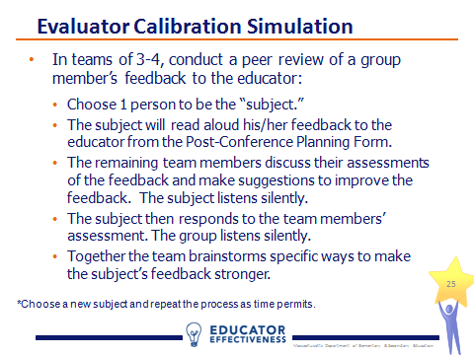  Slide 25  12 minutes
Calibrating:  - Provide each team an opportunity to share 1-2 exemplars of feedback and a common understanding of practice that emerged in their discussion. | 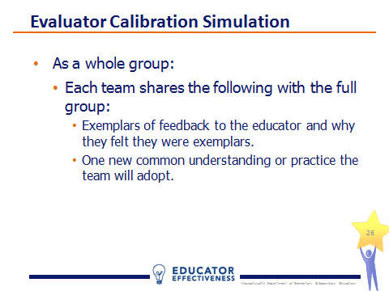  Slide 26  10 minutes

V. Recapping (5 minutes)
Recapping  - In this final section, the facilitator will recap key takeaways and take questions. | Slide 32  Quick Transition
Recapping  - Provide participants an opportunity to chart key takeaways and ask questions. | 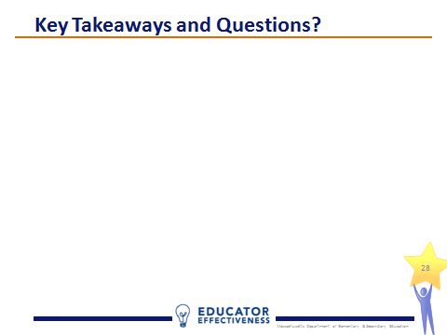  Slide 33  5 minutes

