OPTIC: Online Platform for Teaching and Informed Calibration
A virtual professional learning platform supporting the ongoing, collaborative study of instructional practice and high-quality feedback.

OPTIC supports synchronous and asynchronous professional learning experiences, including:
- Shared observations and calibration discussions across groups of educators using 100+ videos of K-12 instruction.
- The study of student work in relation to grade-level standards.
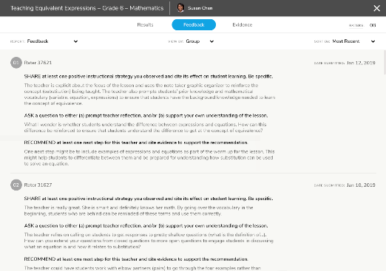
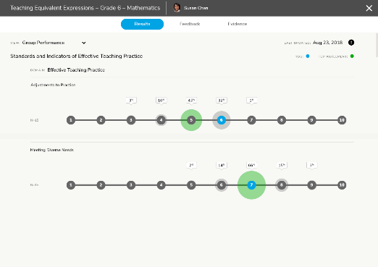
- Virtual instructional coaching by teacher mentors, administrators, or ed prep supervisors.
Tag and time-stamp evidence.
Unpack differences in perceptions of practice.
Draft and analyze feedback.

If you want to use OPTIC to… | Here’s how…
Calibrate as a team around perceptions of effective teaching practice aligned to MA’s Model Classroom Teacher Rubric. | - Use the Video Library Search Tool to scan and select calibration tasks by rubric elements, grade levels, or subject areas, then use Module 1 in the Facilitator’s Guide to plan your workshop (or see this guide for a quick overview of how to get started).  - Use this guide to upload your own teaching videos and create customized calibration activities for your department, school or district.
Study and refine expectations for standards-aligned instruction based on the MA Curriculum Frameworks.
Finetune your group’s skills in drafting actionable, content-specific written feedback to teachers | - Use Module 2 in the Facilitator’s Guide to plan a workshop focused on feedback.
Study student writing in relation to grade-specific learning standards | - Use OPTIC’s student writing collection and associated workshop guide.  - Upload local student writing samples (new guide coming soon to the OPTIC Resources page).
Receive feedback on a video of your teaching (in an in-person, mixed reality, or remote setting) | - Use this guide to upload and share your teaching video with an assigned observer(s) or mentor.
FREE through June 2021 -- visit the OPTIC website.
Contact educatordevelopment@doe.mass.edu for support or to learn more.

