Quick Reference Guide: Summative Performance Rating
The Massachusetts Educator Evaluation Framework is designed to promote educators’ professional growth and development while placing improved student learning at the center. All educators receive a summative performance rating that focuses on the critical intersection of professional practice and student learning to create a complete picture of educator performance.
The Summative Evaluation is the final step of the 5-Step Cycle. Upon consideration of an educator’s evidence of practice and progress towards goals, evaluators apply professional judgment and determine the Summative Performance Rating for each Standard and overall.
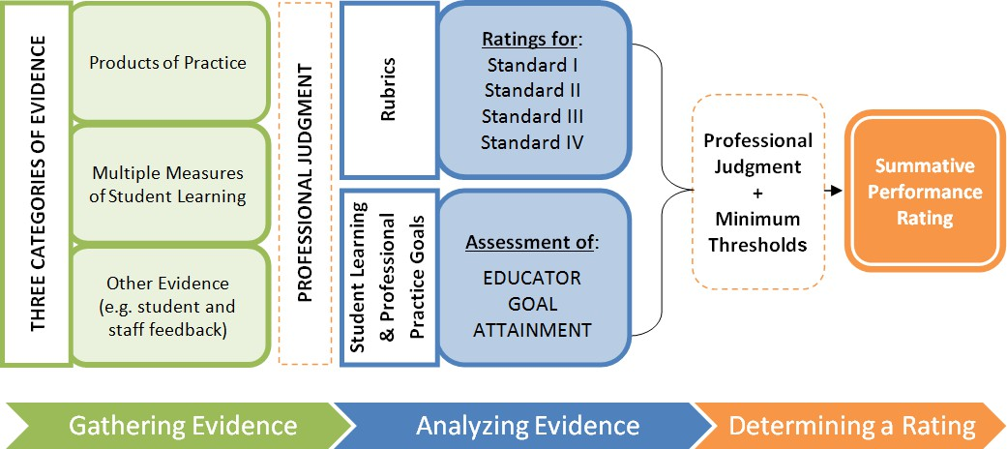

Three Categories of Evidence

Products of Practice
The first category of evidence includes judgments based on products of practice, such as (1) artifacts related to educator practice, and (2) observations of practice. Both sources of evidence should yield information about the educator’s practice related to the four Standards and/or the educator’s goals.

Multiple Measures of Student Learning, Growth & Achievement
Educators use multiple measures of student learning, growth and achievement to demonstrate the effectiveness of their practice related to one or more of the four Standards, as well as to show progress toward their student learning goals. Measures that contribute to the Summative Performance Rating include classroom assessments, district common assessments, and statewide assessments that provide evidence related to the Standards or goal attainment.

Other Evidence related to Standards of Practice (including Student or Staff Feedback)
The third category of evidence must include feedback from students or staff. Other sources of information, such as evidence of fulfillment of professional responsibilities and evidence of family engagement, may also be considered.

Educator Goal Attainment
Every educator is required to have a minimum of two goals: a student learning goal and a professional practice goal. Overall goal attainment reflects progress across all goals. For example, if an educator exceeds their projected target on their student learning goal and makes significant progress on his professional practice goal, the evaluator may determine overall goal attainment as having met goal. See DESE’s Model System Guidance for more information about setting and evaluating educator goals.

Minimum Thresholds
To be rated Proficient overall, a teacher shall, at a minimum, have been rated Proficient on Standard I: Curriculum, Planning, and Assessment and Standard II: Teaching all Students Standards. An administrator shall, at a minimum, have been rated Proficient on the Instructional Leadership Standard for administrators. (603 CMR 35.08)
Additional Resources
- Summative Evaluation Forms
- Guidance on the Summative Evaluation process
- Deep-Dive: Minimum Threshold Requirements
- Quick Reference Guide: Educator Evaluation Data Collection

