Candidate Assessment of Performance
Conducting Observations and Providing Meaningful Feedback

Workshop for Program Supervisors and Supervising Practitioners

Facilitator’s Guide
Massachusetts Department of Elementary and Secondary Education
75 Pleasant Street, Malden, MA 02148-4906
Phone 781-338-3000 TTY: N.E.T. Relay 800-439-2370
www.doe.mass.edu
Contents
Preparing for the Workshop 1
Overview 1
Context 1
Intended Outcomes 1
Equipment and Materials 1
Facilitator’s Guide 2
I. Warming Up (10 minutes) 2
II. Learning (30 minutes) 3
III. Practicing (45 minutes) 9
IV. Calibrating (45 minutes) 11
V. Recapping (5 minutes) 13

Preparing for the Workshop

Overview
This workshop is designed to provide program supervisors and supervising practitioners with an overview of the role of observations and feedback in the Candidate Assessment of Performance (CAP), as well as opportunities to practice conducting observations and constructing feedback using the CAP Model Observation Protocol and calibrating evidence and feedback with colleagues. The goal of this workshop is to build capacity for delivering high-quality, targeted, and actionable feedback to teacher candidates grounded in evidence collected during observations.

Context
This facilitator’s guide is designed to assist educator preparation program staff in delivering a rich and engaging training experience for program supervisors and/or supervising practitioners. The content of this workshop is based on the CAP Model Observation Protocol. Programs using an alternative observation protocol should review this guide and the other workshop materials to determine where they will need to be customized to reflect the program’s expectations for conducting observations and providing feedback. Given that participants will have varying levels of knowledge about the CAP and a range of experience conducting observations and providing feedback, ESE recommends that participants be familiar with the following resources prior to engaging in the workshop:
- CAP Flyover
- CAP Model Observation Protocol

Intended Outcomes
At the end of this session:
- Participants will have a clear understanding of the role of observations in CAP.
- Participants will know how to effectively use the CAP Observation Forms and ESE Model Observation Protocol to collect and organize evidence and provide high-quality, targeted, and actionable feedback to teacher candidates.
- Participants will have practiced conducting a CAP observation and constructing feedback.
- Participants will have a clear understanding of calibration and have engaged in a calibration activity to begin to develop a common set of expectations for practice.

Equipment and Materials
- Equipment: Laptop computer with an internet connection and a copy of the workshop PowerPoint slides and a projector.
- Handouts packet, which includes:
  - ESE Model Observation Protocol
  - CAP Observation Forms

Facilitator Guide
This workshop is divided into five sections and has a total time of 2 hours and 15 minutes:

Warming Up (10 minutes)

Learning (30 minutes)

Practicing (45 minutes)

Calibrating (45 minutes)

Recapping (5 minutes)
Slides are provided to facilitate each section and this corresponding guide includes facilitator notes, as well as italicized talking points for each slide.
Note: If participants have experience with the CAP Observation Forms and ESE Model Observation Protocol, facilitators may opt to omit the Learning section to reduce total workshop time to 1 hour and 45 minutes.

I. Warming Up (10 minutes)
Title slide  - This workshop is designed to be delivered to a group of program supervisors and/or supervising practitioners. Portions of the workshop are based on the CAP Model Observation Protocol included in the CAP Guidelines. Programs that have made changes to the model protocol or are using a different protocol should examine this content carefully and make any necessary adjustments. | Slide 1  Quick transition
Warming Up:  - This workshop is broken up into the following sections Warming Up, Learning, Practicing, Calibrating, and Recapping. | Slide 2  Quick transition
Warming Up:  - The video clip featured on this slide is from the Transforming Educator Evaluation in Massachusetts (TEEM) series. The TEEM videos feature educators from four MA districts describing strategies for creating meaningful, high quality educator evaluation experiences This video on Observations and Feedback is a good primer to help participants reflect on their observation practices.  - Click on the screenshot in presentation mode to launch the 5-minute video clip. | 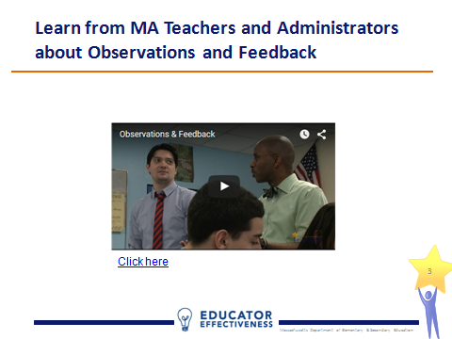  Slide 3  5 minutes
Warming Up:  - Push participants to be specific about their current processes for determining what feedback to offer those they observe.  - Participants will likely have a range of experiences and preferences conducting observations and providing feedback. Facilitators may find it helpful to surface these differences by adding a whole-group share to the warm up activity. | 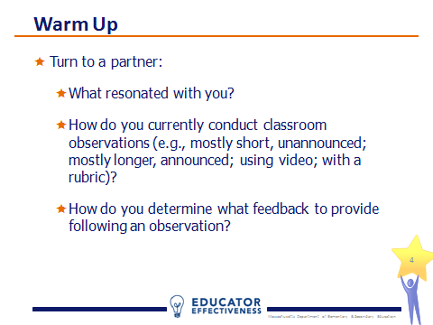  Slide 4  5 minutes

II. Learning (30 minutes)
Learning:  - In this section, participants will learn how observations are used in CAP, the CAP Model Observation Protocol, and the CAP Observation Forms. | Slide 5  Quick Transition
Learning:  - Review the goals of CAP to ground the workshop.  - Note the responsibility of program supervisors and supervising practitioners to support candidates’ growth and development through feedback. | 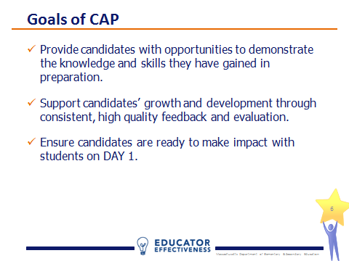  Slide 6  1 minute
Learning:  - Remind participants about the multiple categories of evidence that are used in CAP and note the prominent role of observations. | 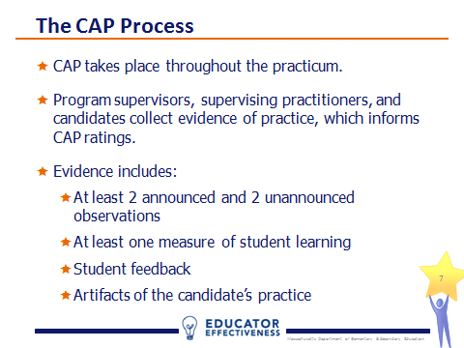  Slide 7  2 minutes
Learning:  - Observations help program supervisors and supervising practitioners both collect evidence of performance and provide focused feedback to teacher candidates to drive improvement in their practice. | 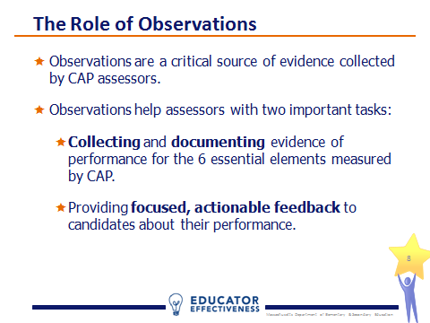  Slide 8  1 minute
Learning:  - In CAP, the four required observations are aligned to “focus elements,” which are a subset of the six essential elements measured by CAP.  - Announced Observation #1 is focused on well-structured lessons and high expectations.  - Unannounced Observation #1 is focused on well-structured lessons and safe-learning environment.  - Announced Observation #2 is focused on adjustments to practice and meeting diverse needs.  - Unannounced Observation #2 is focused on adjustments to practice.  - Focus elements help program supervisors and supervising practitioners provide targeted feedback and prevent candidates from feeling overwhelmed.  - Evidence related to any of the six essential elements can be documented during any observation. The focus elements set the minimum expectations and give assessors license to be specific. | 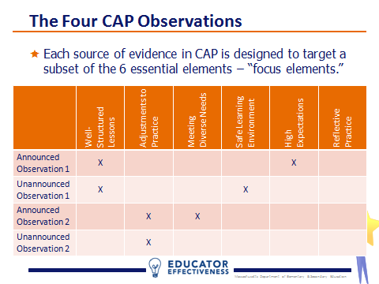  Slide 9  3 minutes
Learning:  - During the observation, program supervisors and supervising practitioners should be focused on documenting what is happening by recording teacher and student behaviors and actions. This is called active evidence collection.  - After the observation, the program supervisor and/or supervising practitioner will analyze the evidence collected, extract trends and draw conclusions.  - The candidate should also reflect on his/her performance during the lesson and share the reflection with the program supervisor and/or supervising practitioner. This is an important step in developing candidates capable of improving practice based on their reflections about what did and did not go as planned, as well as documenting the candidate’s performance on the reflective practice element.  - Finally, the observation should result in targeted feedback for the candidate in the form of specific areas of reinforcement and refinement, which will be covered in depth later. | 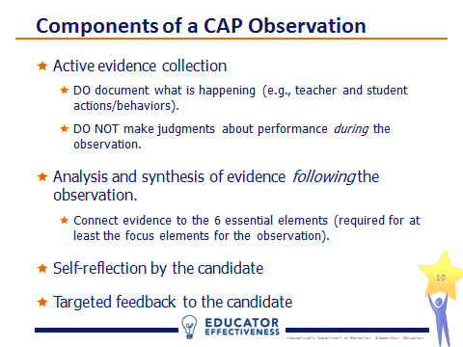  Slide 10  3 minutes
Learning:  - Slides 11-16 unpack the CAP Model Observation Protocol. Programs that are not using the model protocol should adapt this content as needed.  - Here are the main components of the CAP Model Observation Protocol. The next several slides unpack the protocol.  - Note that part 1, Before the Observation, is omitted for unannounced observations.  - Refer participants to the ESE Model Observation Protocol included in the handouts packet (pages 4-10). | 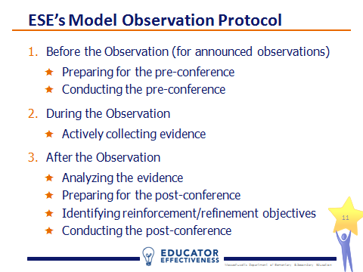  Slide 11  Quick Transition
Learning:  - The pre-conference can be an important opportunity to build rapport with the teacher candidate, establish a coaching relationship, and begin to collect evidence for the upcoming observation.  - It should occur 1-2 days prior to an announced observation. Plan for 15-20 minutes.  - Prior to the pre-conference program supervisors and/or supervising practitioners should gather and review evidence including: the lesson plan and lesson materials and prior feedback provided to candidate.  - CAP is an assessment, so it is important not to provide substantial feedback on lesson plans and materials that will dramatically influence the candidate’s plan during the pre-conference.  - The program supervisor and/or supervising practitioner should keep the pre-conference conversation focused by preparing 2-3 questions for the candidate. Page 2 of the model protocol includes additional example questions.  - Review page 6 of the handouts packet with participants, which covers a three-step outline for the pre-conference: introduction, lesson discussion, closure from the CAP Model Observation Protocol. | 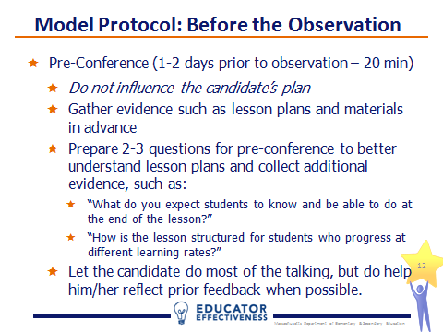  Slide 12  4 minutes
Learning:  - During the observation, the program supervisor and/or supervising practitioner engage in active evidence collection, documenting what is happening by recording teacher and student actions and behaviors.  - At this point, judgment should be withheld.  - Scripting portions of the lesson may be a helpful way to collect evidence.  - ESE does not collect evidence from observations. In fact, program supervisors and supervising practitioners need not worry about the format or style of notes collected during an observation. Use whatever process will most accurately capture what happened during the lesson. Assessors will have an opportunity to polish and sort evidence after the observation. | 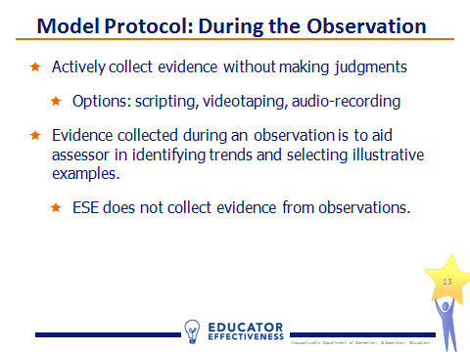  Slide 13  2 minutes
Learning:  - Refer participants to the CAP Observation Form included in the handouts packet (page 11).  - Note that the CAP Guidelines include separate forms for each of the four required observations that indicate the focus elements for each observation.  - Indicate the section of the form where evidence collected during the observation is sorted by the six essential elements. Note that not all evidence collected must be sorted.  - Evidence statements should say what happened in the observation that shows or does not show that a skill has been demonstrated. For example, an evidence statement in the II.A.3 Meeting Diverse Needs category might read, “Met diverse needs by circulating to each group during group work, asking probing questions and checking for understanding. However, neither groupings nor questioning was differentiated based on individual student need (not noted in lesson plans or during pre/post conferences).” | 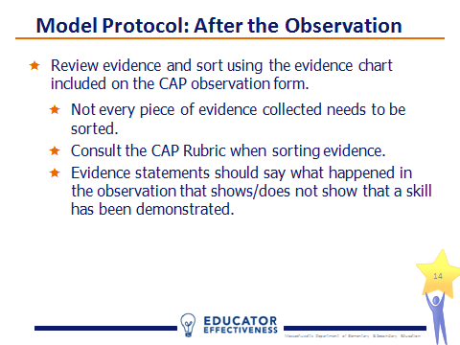  Slide 14  4 minutes
Learning:  - Refer participants to the Post-Conference Planning Form from the model observation protocol included in the handouts packet (page 20) and let them know that they will be working with this form later in the workshop.  - Once the evidence has been analyzed and synthesized using the observation form, it is time to plan for the post-conference. The Post-Conference Planning Form may be helpful here.  - As a first step, if the observation was conducted jointly, it’s important for the program supervisor and supervising practitioner to calibrate feedback prior to the post-conference.  - Next, the program supervisor or supervising practitioner should collect a self-reflection from the candidate (again a good source of evidence for the reflective practice element). A model self-reflection form is included with the model observation protocol.  - Finally, the program supervisor and/or supervising practitioner identify at least 1-2 areas of reinforcement and 1-2 areas of refinement to share as feedback to the candidate during the post-conference. | 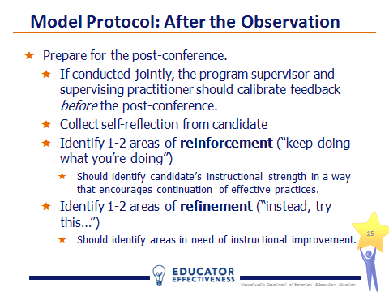  Slide 15  5 minutes
Learning:  - During the post-conference, the program supervisor and/or supervising practitioner will provide the candidate with the completed observation form and talk through the feedback and available supports, asking reflection questions throughout.  - Review pages 9 and 10 of the handouts packet with participants, which cover a three-step outline for the post-conference: introduction, discussion of reinforcement/refinement areas, closure. | 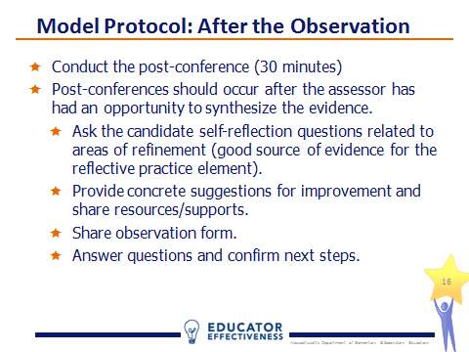  Slide 16  3 minutes
Learning:  - A final quick reminder that the CAP Observation Forms are required for the four observations.  - The forms are not to be used during the observations, but rather after as a place for categorizing the evidence gathered during observation by the six essential elements. | 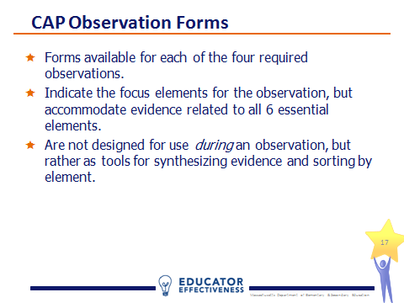  Slide 17  2 minutes

III. Practicing (45 minutes)
Practicing:  - In this section, participants will watch a video of instructional practice and practice conducting an observation and developing feedback using the CAP Model Observation Protocol (notably the Post-Conference Planning Form).  - Again, programs that are not using the model protocol should modify this activity to reflect observation process program supervisors and supervising practitioners will use in the administration of CAP | Slide 18  Quick Transition
Practicing:  - Prepare participants to conduct a simulated unannounced observation. Participants should use a strategy such as scripting to thoroughly capture teacher and student actions and behaviors without judgment.  - Note the focus elements for this lesson are well-structured lessons and safe-learning environment, the same as Unannounced Observation #1 in CAP. | 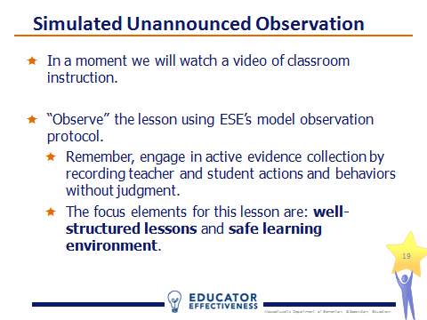  Slide 19  1 minute
Practicing:  - The video clip featured on this slide is from the ESE’s Calibration Video Library. The teacher practice depicted in the series is intentionally variable in quality to promote robust conversations.  - Click on the screenshot in presentation mode to launch the video clip.  - Stop the video at the 9:52 mark. | 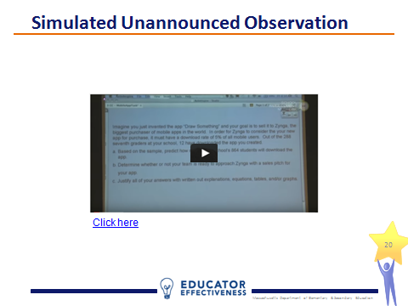  Slide 20  10 minutes
Practicing:  - Refer participants to the CAP Rubric (pages 13-18) and CAP Observation Form for Unannounced Observation #1 (page 19) included in the handouts packet.  - Each participant should work independently for 10 minutes using the rubric and observation form to sort the evidence collected by the six essential elements and identify 1-2 reinforcement and 1-2 refinement areas. Cap the activity at 10 minutes and inform participants that it’s ok if they do not complete the process in the time allotted. | 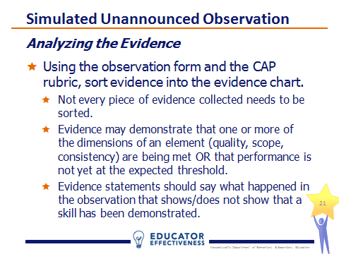  Slide 21  12 minutes
Practicing:  - Refer participants to the Post-Conference Planning Form from the Model Observation Protocol included in the handouts packet (page 20).  - Simulating the calibration that occurs between program supervisors and supervising practitioners, participants should pair-up and complete the post-conference planning form. Again, cap the activity at 10 minutes.  - The guiding questions on page 5 of the model protocol may be helpful in indentifying reinforcement and refinement areas. | 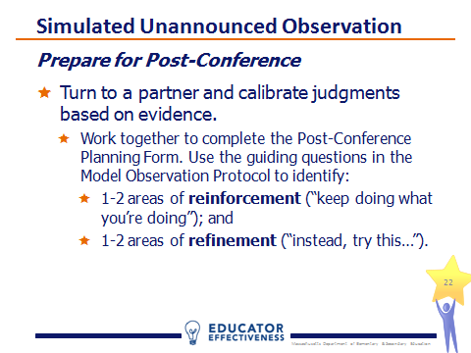Slide 22  12 minutes
Practicing:  - Provide each pair an opportunity to share their 1-2 reinforcement and 1-2 refinement areas.  - Conduct a whole group discussion to uncover whether the judgments made based on the evidence collected and the feedback provided to the teacher (i.e., the reinforcement and refinement areas) were consistent within each pair and across the full group. If not, ask participants to reflect on why there were differences. | 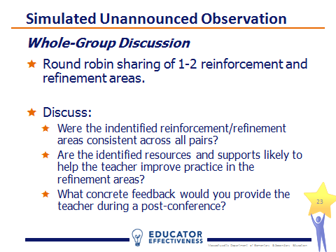  Slide 23  10 minutes

IV. Calibrating (45 minutes)
Calibrating:  - In this section, participants will watch a second video of instructional practice and engage in a calibration activity to promote a common, shared understanding of practice.  - Programs are encouraged to provide opportunities for CAP assessors to calibrate often. ESE’s Calibration Video Library includes over 40 videos of classroom instruction, as well as calibration protocols and activities that can be used with the videos to develop a shared understanding of quality practice. | Slide 24  Quick Transition
Calibrating:  - This definition of calibration is used by ESE’s educator evaluation team and reflects the importance of consistency in any evaluation process. | 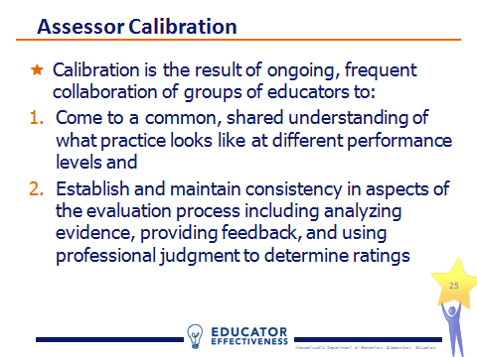  Slide 25  1 minute
Calibrating:  - In CAP, calibration is important in two ways. First, program supervisors and supervising practitioners must be calibrated to ensure that candidates receive consistent feedback. Second, calibration across all program supervisors will ensure that a program’s rigorous expectations for candidate performance are reinforced with each observation. | 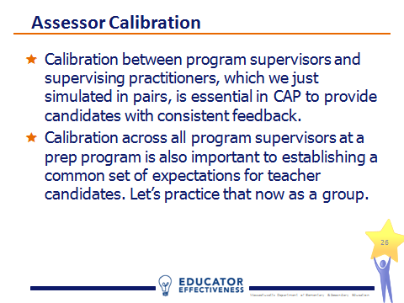  Slide 26  1 minute
Calibrating:  - Prepare participants to conduct a second simulated unannounced observation. Participants should again use a strategy such as scripting to thoroughly capture teacher and student actions and behaviors without judgment.  - Note the focus element for this lesson is adjustments to practice, the same as Unannounced Observation #2 in CAP. | 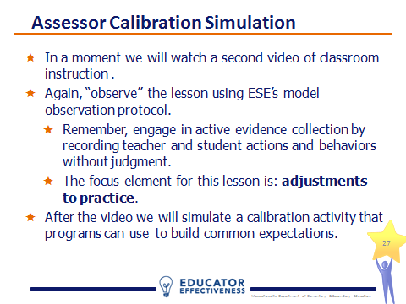  Slide 27  1 minute
Calibrating:  - The video clip featured on this slide is from the ESE’s Calibration Video Library. The videos in this series are not exemplars. The teacher practice depicted in the series is intentionally variable in quality to promote robust conversations.  - Click on the screenshot in presentation mode to launch the video clip.  - Stop the video at the 10:04 mark. | 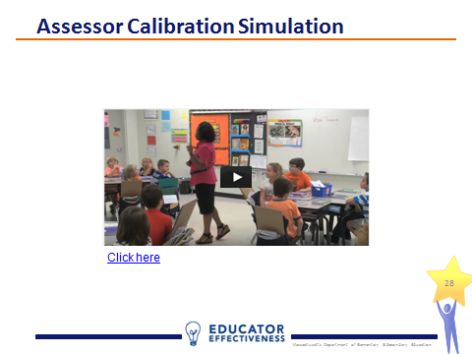  Slide 28  10 minutes
Calibrating:  - Refer participants to the CAP Observation Form for Unannounced Observation #2 (page 22), the CAP Rubric (pages 13-18), and the Post-Conference Planning Form (page 23) included in the handouts packet.  - As before, each participant should work independently for 10 minutes using the observation form and rubric to sort the evidence collected by the six essential elements and identify 1-2 reinforcement and 1-2 refinement areas. Cap the activity at 10 minutes and inform participants that it’s ok if they do not complete the process in the time allotted. | 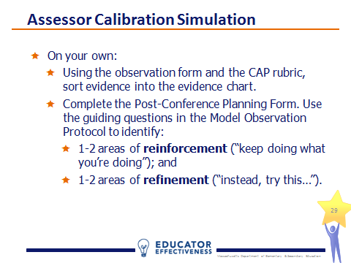  Slide 29  12 minutes
Calibrating:  - Participants should break into teams of 3-4 and conduct a peer review of a group member’s feedback to the teacher. This process is based on a model developed and used by the administrative team of the Revere Public Schools.  - Each team identifies a subject who is willing to read aloud his/her feedback (i.e., the areas of reinforcement and refinement and) to the group. (2 minutes)  - Next, the remaining group members critique the subject’s feedback and make suggestions for improvement while the subject listens quietly. (4 minutes)  - Then the subject has a chance to respond to the team. (1 minute)  - Finally, the team works together to brainstorm ways to make the subject’s feedback stronger. (3 minutes)  - Depending on the time allotted for the workshop, facilitators may wish to let teams choose a second subject and repeat the process. | 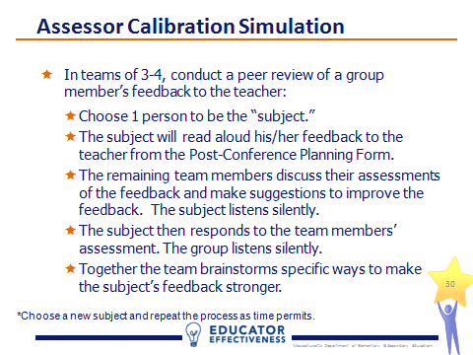  Slide 30  12 minutes
Calibrating:  - Provide each team an opportunity to share 1-2 exemplars of feedback and a common understanding of practice that emerged in their discussion. | 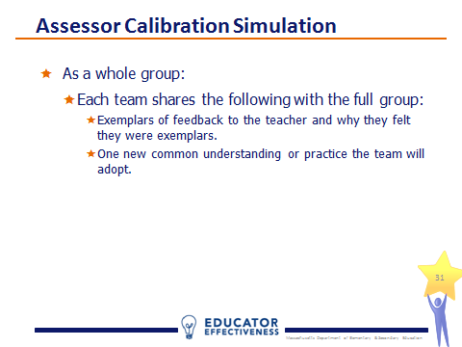  Slide 31  10 minutes

V. Recapping (5 minutes)
Recapping  - In this final section, the facilitator will recap key takeaways and take questions. | Slide 32  Quick Transition
Recapping  - Review the goal of observations in CAP and remind participants of the model observation protocol. | 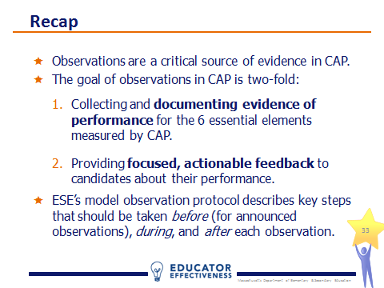  Slide 33  2 minutes
Recapping  - Review the process for collecting evidence through observations and the importance of calibration. | 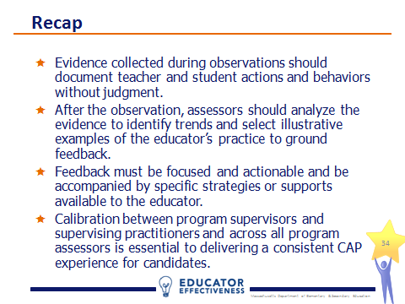  Slide 34  2 minutes
Recapping  - Provide participants an opportunity to ask questions. | 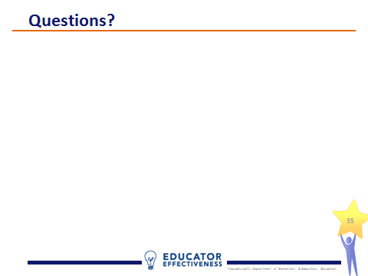  Slide 39  1 minute

