Guidelines for the Candidate Assessment of Performance
Assessment of Teacher Candidates
August 2019

Massachusetts Department of Elementary and Secondary Education
75 Pleasant Street, Malden, MA 02148-4906
Phone 781-338-3000 TTY: N.E.T. Relay 800-439-2370

Table of Contents
Purpose 2
Overview of CAP 3
Candidate Assessment of Performance (CAP) 6
CAP Content 6
CAP Process 15
Context 20
Conclusion 22
Appendix A: Candidate Assessment of Performance (CAP) Rubric 23
Appendix B: Crosswalk of CAP’s Seven Essential Elements to PST Indicators 28
Appendix C: CAP & The Educator Evaluation Framework 32
CAP & the Educator Evaluation Framework 33
Appendix D: 603 CMR 7.00 Regulations for Educator Licensure and Program Approval (Excerpts) 35
Appendix E: Required Forms for CAP 36
Required Forms 36
CAP Form 37
Observation Form 39

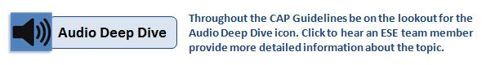

Purpose

The Massachusetts Candidate Assessment of Performance (CAP) is designed to assess the overall readiness of teacher candidates at the conclusion of their preparation experience. By requiring teacher candidates to demonstrate their readiness, Massachusetts will ensure that new teachers enter classrooms prepared to make an impact with their students on day one.
CAP creates an intentional bridge from preparation to practice by aligning preparation expectations with the Massachusetts Educator Evaluation Framework for in-service educators. This allows Sponsoring Organizations to ensure that teacher candidates have the most relevant skills and knowledge necessary to be effective teachers in Massachusetts.
The goals of CAP are:
- To measure teacher candidates’ practice on key Indicators as outlined in the Guidelines for the Professional Standards for Teachers (PSTs);
- To support teacher candidates in improving their practice through targeted feedback and performance evaluations; and
- To ensure teacher candidates are ready to make impact with students on day one.
In support of these goals, these Guidelines outline expectations for the implementation and completion of CAP by Sponsoring Organizations, Program Supervisors, Supervising Practitioners, and candidates as they work together to ensure successful demonstration of the Professional Standards for Teachers (PSTs).
Please Note: These Guidelines are intended to explain what CAP is and why it is important. DESE has created a separate CAP Implementation Handbook designed to support implementation. The Handbook is a how-to guide to each step of CAP’s 5-Step Cycle, including all required and recommended forms, and suggested resources for use in CAP by teacher candidates, Supervising Practitioners, and Program Supervisors.

Overview of CAP
CAP’s content and process mirror the experience of educators engaged in the Massachusetts Educator Evaluation Framework with key modifications to ensure that the assessment is appropriate for the context of preparation and is focused on essential elements of practice for novice teachers. Aspects of the Massachusetts Educator Evaluation Framework that are evident in CAP include:
- A 5-step cycle that includes self-assessment, goal setting, plan implementation, formative assessment and a summative assessment;
- The use of elements and performance descriptors from the Model Teacher Rubric; and
- Performance assessment based on multiple measures, including:
  - Evidence of growth in student learning
  - Artifacts of practice
  - Feedback from students
  - Announced and unannounced observations
  - Progress toward a professional practice goal
This intentional alignment between preparation and in-service performance evaluations exemplifies the cohesion Massachusetts is building across the educator career continuum. For a detailed explanation of the parallels between CAP and the Massachusetts Educator Evaluation Framework see Appendix C.

Preparation Context Considered in CAP
CAP is designed to take place within the context in which the evaluation of the candidate occurs, in this case a practicum or practicum equivalent. DESE took into account the following considerations when modifying the Educator Evaluation Framework for use in preparation:
- Time: In most cases, teachers engage in the 5-step evaluation cycle over one or two school years; in preparation, teacher candidates complete CAP during the practicum/practicum equivalent, which can range in length from as little as eight weeks to as long as a school year. As is the case with the practicum experience itself, CAP is intended to be intensive and is therefore designed to be effectively completed during any length of practicum. (Sample implementation timelines are available in the CAP Implementation Handbook.)
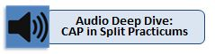

- Ownership/Responsibility: Unless already employed as a teacher-of-record, candidates will be assessed on their skills while working in classrooms that are not their own. It can be challenging in these situations to determine the readiness of a candidate independent from the context in which they are completing the practicum. That being said, it is the expectation that candidates be provided opportunities to demonstrate their own skills and abilities within this context. This will require concerted effort from the Supervising Practitioner and the Program Supervisor to coordinate authentic experiences for the candidate during engagement in CAP.
- Role of Evaluator: In the in-service context, single evaluators are often responsible for an educator’s evaluation. In preparation, CAP ratings are the results of calibrated, summative judgments by both a Supervising Practitioner and a Program Supervisor.
- Developmental Progression of Practice: DESE acknowledges that teaching is a profession in which individuals will grow in their expertise and skill; DESE’s educator effectiveness policies are dedicated to supporting continuous improvement through the career continuum. That said, DESE believes that novice teachers must meet specific standards deemed essential to being immediately impactful with students on the first day in the classroom. While districts or individual schools may choose to emphasize different elements within their evaluation processes, DESE has prescribed the key skills through CAP to determine teacher readiness (aligned to the PST Guidelines and with advice from advisory groups and stakeholders).

Shifts in Assessment: From PPA to CAP
With the 2003 Pre-Service Performance Assessment (PPA), Massachusetts was one of the first states in the nation to implement a standard assessment of candidate performance and require it for program completion across all Sponsoring Organizations. This history is important as Massachusetts embarks on the implementation of CAP, which is similarly a first of its kind endeavor for a state. While the practice of assessment in preparation is not new for Massachusetts Sponsoring Organizations, there are significant differences in the approach to assessing performance in CAP than what occurred under the PPA. Namely, CAP:

- Includes a rubric with descriptors for various levels of performance
- Focuses assessment on seven essential elements
- Uses multiple measures to determine performance
- Distributes the responsibility of evidence collection between Program Supervisors, Supervising Practitioners, and teacher candidates
- Emphasizes targeted feedback and creates structures to document improvement in practice (e.g., observation protocol forms)
- Aligns expectations for program completion to expectations for performance once employed (as measured by the Educator Evaluation ratings)
- Generates data to be collected by DESE and considered, along with other outcome measures, in program review decisions

Implications for Sponsoring Organizations
These changes underscore DESE’s commitment to supporting Sponsoring Organizations in strengthening not only the field-based experiences of teacher preparation candidates, but the coursework and pre-practicum experiences as well. By the time a candidate begins his/her practicum experience, they should be poised to demonstrate and refine—not acquire—core skills and competencies associated with CAP’s Seven Essential Elements.
The refinement of both coursework and pre-practicum experiences to strengthen their alignment to key PST indicators as well as to the core competencies assessed in CAP will not only ensure candidate readiness for success in CAP, it will drive the meaningful placement of teacher candidates into field-based experiences that benefit students, teachers, and schools.

Candidate Assessment of Performance (CAP)
The Candidate Assessment of Performance assesses a candidate’s readiness to positively impact students’ learning from their first day in a Massachusetts classroom. There are two facets of the assessment system: the content and the process. By engaging in specific activities throughout the 5-Step Cycle (process), the candidate demonstrates required skills at a certain level (content). The following sections describe how the content and the process individually and collectively contribute to measuring candidate readiness.
CAP Content:  - CAP’s Seven Essential Elements  - The CAP Rubric  - Quality, Scope, Consistency  - Readiness Thresholds  - Categories of Evidence | CAP Process:  - 5-Step Cycle Overview  - 5-Step Cycle – Step by Step

CAP Content
In developing CAP, DESE first decided exactly what skills the assessment needed to measure and then determined how to measure them. The sections that follow detail how the content of CAP maintains adherence to the core language and expectations of practice articulated in the PSTs and the Educator Evaluation Framework, as well as the types of evidence that best communicate those skills.

CAP’s Seven Essential Elements
CAP assesses candidate performance on seven elements. In order to understand the decision to narrow the focus of the assessment to these seven elements, it is helpful to understand the structure of the Massachusetts Model Teacher Rubric in relation to the PSTs:
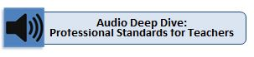
- Standards: Standards are the broad categories of knowledge, skills, and performance of effective practice detailed in regulations for both educator evaluation (Standards for Effective Teaching) and educator licensure (Professional Standards for Teachers). These four standards are identical:
1) Curriculum, Planning, and Assessment
2) Teaching All Students
3) Family and Community Engagement
4) Professional Culture
  - Indicators: Indicators are detailed in PST Guidelines and describe specific knowledge, skills, and performance for each Standard. For each Indicator, there is a corresponding level of practice expected for preparation candidates (introduction, practice, demonstrate).
      - Elements: Elements further break down the Indicators into more specific descriptions of educator practice.
Overall, there are 23 PST Indicators, thirteen of which were designated at the “demonstrate” level of expected practice by a teacher candidate. The graphic below shows the distribution of CAP’s Seven Essential Elements within these thirteen Indicators.

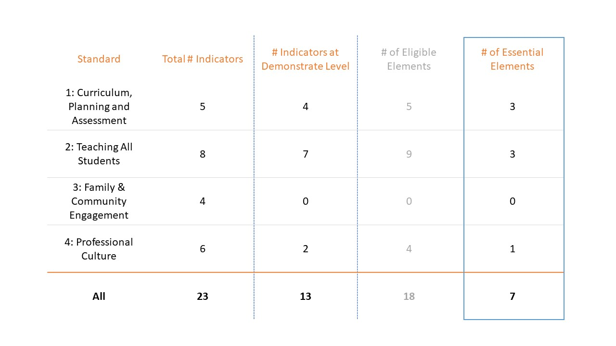

An element was deemed essential to CAP if:
- The absence of a teacher’s competency in the skill would likely put students at risk
- The element could serve as an umbrella for skills outlined in other elements, in most cases other elements were pre-requisite skills to those outlined in the essential element. See Appendix B for the crosswalk of coverage.

The Seven Essential Elements of CAP:
Standard | Element | Proficient Descriptor*
1: Curriculum, Planning & Assessment | 1.A.1: Subject Matter Knowledge | Demonstrates sound knowledge and understanding of the subject matter and the pedagogy it requires by consistently engaging students in learning experiences that enable them to acquire complex knowledge and subject-specific skills and vocabulary, such that they are able to make and assess evidence-based claims and arguments.
 | 1.A.3: Well-Structured Units and Lessons | Adapts as needed and implements standards-based units comprised of well-structured lessons with challenging tasks and measurable outcomes; appropriate student engagement strategies, pacing, sequence, , resources, and grouping; purposeful questioning; and strategic use of technology and digital media; such that students are able to learn the knowledge and skills defined in state standards/local curricula.
 | 1.B.2: Adjustments to Practice | Analyzes results from a variety of assessments to determine progress toward intended outcomes and uses these findings to adjust practice and identify and/or implement differentiated interventions and enhancements for students.
2: Teaching All Students | 2.A.3: Meeting Diverse Needs | Uses appropriate inclusive practices, such as tiered supports and scaffolded instruction, to accommodate differences in students’ learning needs, abilities, interests, and levels of readiness, including those of academically advanced students, students with disabilities, and English learners.
 | 2.B.1: Safe Learning Environment | Uses rituals, routines, and appropriate responses that create and maintain a safe physical and intellectual environment where students take academic risks and most behaviors that interfere with learning are prevented.
 | 2.E.1: High Expectations | Clearly communicates high standards for student work, effort, and behavior, and consistently reinforces the expectation that all students can meet these standards through effective effort, rather than innate ability.
4: Professional Culture | 4.A.1: Reflective Practice | Regularly reflects on the effectiveness of lessons, units, and interactions with students, both individually and with colleagues, and uses insights gained to improve practice and student learning.
*Proficient Descriptor is included here to provide a sense of the expectation outlined in the element. Expectations of demonstrated competency for preparation candidates are outlined further in the Rubric Overview section below.

Combined performance on these elements is considered representative of candidates’ readiness to be impactful on day one. DESE will collect data to assess the extent to which these elements are predictive of performance once employed and will revise/update CAP as appropriate in the coming years.
While DESE has identified essential elements for the purposes of CAP, Sponsoring Organizations and candidates should keep the following in mind:
- CAP is a program completion requirement, not a licensure requirement. It is embedded as a program requirement because there are other indicators and expectations of readiness, both outlined by DESE and at an individual Sponsoring Organizations’ discretion.
- Sponsoring Organizations may choose to include additional elements in assessing a candidate’s practice and have the authority to consider other factors in determinations about readiness and ultimately endorsement for licensure.

The CAP Rubric
CAP is designed to provide teacher candidates with targeted feedback to inform their growth and to ensure that candidates meet specific readiness thresholds for performance expectations. The CAP Rubric supports both objectives by helping candidates, Program Supervisors and Supervising Practitioners:
- develop a consistent, shared understanding of what performance looks like in practice,
- develop a common terminology and structure to organize evidence,
- engage in meaningful discussions about educator practice, and
- make informed professional judgments about performance ratings.
Used in each step of the CAP 5-Step Cycle, the CAP Rubric supports the provision of targeted, detailed feedback based on fine-grained descriptions of educator practice. The result is a more transparent and manageable process.
The CAP Rubric uses the same four performance levels of the Massachusetts Model Teacher Rubric (Exemplary, Proficient, Needs Improvement, Unsatisfactory) and includes the same descriptors of practice for elements at each performance level. This maintains consistency and alignment between the two rubrics. The two major differences between the two rubrics are:
- the CAP Rubric only includes the Seven Essential Elements, and
- the CAP Rubric unpacks the performance descriptors for each element across three dimensions (Quality, Scope, and Consistency) and assigns specific readiness thresholds for performance to each dimension.

Quality, Scope & Consistency
In the MA Model Teacher Rubric, descriptions of practice for a given element are differentiated across four performance levels by Quality, Scope and Consistency.
- Quality: the ability to perform the skill, action or behavior
- Scope: the scale of impact (e.g., one student, subset of children, all students) to which the skill, action or behavior is demonstrated with quality
- Consistency: the frequency (e.g., all the time, sometimes, once) that the skill, action or behavior is demonstrated with quality
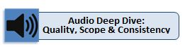
The CAP Rubric recognizes that while quality is an indicator of skill, proficiency in Scope and Consistency will come with time. By deconstructing each of the Seven Essential Elements into these three components of practice, the CAP Rubric makes it possible for Program Supervisors and Supervising Practitioners to appropriately differentiate expectations for novice teachers without changing the fundamental components of effective practice.

Readiness Thresholds
In order for a novice teacher to make a positive impact with students from day one, it is not necessary that they demonstrate full proficiency in each of the Seven Essential Elements. The CAP Rubric therefore associates a readiness threshold to the three dimensions of Quality, Scope and Consistency for each of the Seven Essential Elements. While candidates are expected to demonstrate Proficiency in Quality for all seven elements at the conclusion of CAP, candidates may be considered Needs Improvement for Consistency and Scope.
Quality Proficient
Scope Needs Improvement
Consistency Needs Improvement

In this way, the Quality rating serves as a gatekeeper for each element, ensuring that a candidate can demonstrate the fundamental skill at a proficient level, even if he/she still needs to improve the consistency of delivery, or the scope of impact. Needing improvement in those two dimensions is understandable for many novice teachers and does not indicate lack of readiness, but rather signals areas for further growth and development upon employment.
Candidates must meet these readiness thresholds for all Seven Essential Elements to pass CAP. Sponsoring Organizations may establish higher thresholds if they choose.
Below is a graphic illustrating the main features of the CAP Rubric (the complete rubric is available in Appendix A). The Program Supervisor and Supervising Practitioner use this rubric to determine a candidate’s readiness in each of the Seven Essential Elements for both the Formative and Summative Assessments. 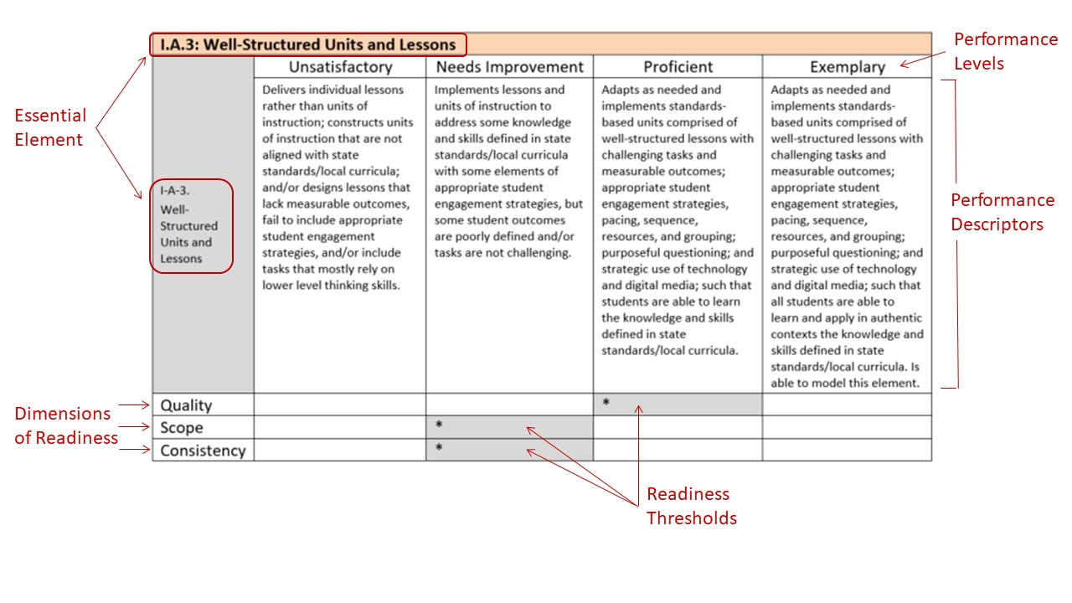

Categories of Evidence
Just as the Educator Evaluation Framework in Massachusetts relies on the use of multiple measures to assess performance, CAP assesses candidate readiness using comparable multiple measures. There are five major categories of evidence required in CAP: observations, measure(s) of student learning, student feedback, progress toward a candidate’s professional practice goal, and candidate artifacts. In addition to these required categories of evidence, Sponsoring Organizations may identify other sources of evidence or more narrowly specify the evidence required in each category.

Observations (Elements 1.A.1, 1.A.3, 1.B.2, 2.A.3, 2.B.1, 2.E.1)
Observations provide the Supervising Practitioner and Program Supervisor with the opportunity to collect evidence of a teacher candidate’s practice in six of the Seven Essential Elements and to provide targeted, timely feedback that both reinforces promising practice and recommends additional actions or skill development. A teacher candidate is observed at least four times throughout the practicum: a minimum of two announced and two unannounced observations. Program Supervisors and Supervising Practitioners actively collect evidence during the observation and then synthesize the key evidence to provide focused feedback to candidates.
Recommendations and supports for collecting evidence through observations can be found in the CAP Implementation Handbook, including a Model Observation Protocol and the required Observation Form.

Measure of Student Learning (Elements 1.A.1, 1.A.3, 1.B.2, 2.A.3, 4.1.A)
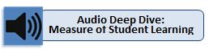
A measure of student learning aligned to a meaningful sample of content for which the teacher candidate will have responsibility allows the candidate, Supervising Practitioner and Program Supervisor to identify (1) the extent to which the candidate’s practice is having an impact on student learning, and (2) the candidate’s ability to reflect on and adjust practice accordingly. Because the measure of student learning serves as a primary source of evidence for the element 1.B.2: Adjustments to Practice, the measure should yield enough information about student learning for a candidate to draw reasonable conclusions about the impact of his/her practice on learning outcomes. This reflection by the candidate and subsequent adjustments to practice are as if not more important evidence than the learning outcomes themselves.
It is the responsibility of the Supervising Practitioner, in collaboration with the candidate, to identify at least one concrete and purposeful measure of student learning, growth, or achievement for use by the teacher candidate, and to set clear expectations for how and when the measure will be administered and scored. Using his/her professional experience with the identified measure(s) and understanding of the specific learning context, the Supervising Practitioner also sets parameters for a range of expected learning, growth, and/or achievement outcomes. See DESE’s Implementation Brief on Scoring and Parameter Setting for more information about this process.
Recommendations and supports for collecting and using evidence related to the measure of student learning, including Guidance for Measuring Candidate Impact on Student Learning, can be found in the CAP Implementation Handbook.

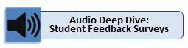
Student Feedback (Elements 2.B.1, 2.E.1, 4.A.1)
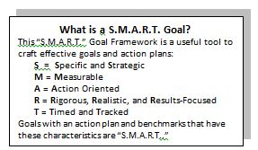
Feedback from students plays a key role in teaching and learning in the Commonwealth and is therefore a critical source of evidence in understanding candidate performance. Candidates collect student feedback using the CAP Model Student Feedback Surveys (Grades 3-12) or DESE’s K-2 Discussion Prompts (Grades K-2). These instruments are aligned to the Standards for Effective Teaching practice (which mirror the Professional Standards for Teachers) and items have been validated for use in the Educator Evaluation Framework. The CAP Model Student Feedback Surveys include standard and mini forms, all of which target practice related to the Seven Essential Elements.
The CAP Implementation Handbook includes all CAP surveys and discussion protocols, information on administering student feedback instruments, paper-based and online templates, and suggestions for using feedback data.

Professional Practice Goal (4.A.1, one additional element)
A candidate’s professional practice goal should reflect the needs of the individual educator that surface through the self-assessment and evidence related to the goal should communicate relevant activities and progress toward its attainment. This makes it easy to track, support, and assess progress throughout the practicum.
The candidate identifies evidence related to goal progress and attainment during Step 2 of the 5-Step Cycle (Goal Setting & Plan Development). This ensures that relevant evidence is a product of naturally occurring activities in support of their professional practice goal and not “one more thing.” The Preliminary Goal-Setting & Plan Development Form supports the development of a goal that is S.M.A.R.T. (consistent with practices expected of educators under the Educator Evaluation Framework), with concrete action steps, timelines, benchmarks, and evidence of progress. For more supports and resources in goal development related evidence collection, see the CAP Implementation Handbook.
Recognizing that progress toward a professional practice goal is a required source of evidence for CAP, DESE advises programs to build the writing of S.M.A.R.T. goals into a candidate’s pre-practicum experience so they may gain exposure prior to this assessment.

Candidate Artifacts (4.A.1)
Teacher candidates are encouraged to share artifacts of practice throughout the CAP 5-Step Cycle as additional sources of evidence to support their assessment. These artifacts may include, but are not limited to:
- unit and/or lesson plans  - examples of students’ work  - behavior plans/ behavior data | - audio/video recordings  - reflection logs

Candidate artifacts may further demonstrate practice related to a specific element, provide additional information related other evidence (such as student feedback, or an unannounced observation), or simply demonstrate new or innovative work with students. Since candidate artifacts directly inform practice associated with Essential Element 4.A.1 (Reflective Practice), the objective should always be to demonstrate meaningful reflection and adjustments to practice.

Evidence Requirements for Each Essential Element
CAP has been designed to make evidence collection a natural and meaningful component of the entire assessment, while ensuring that specific and sufficient types of evidence inform each of the Seven Essential Elements. The table below outlines the types of evidence that are, at a minimum, required to be used in assessing practice related to each element. Evidence collection is not limited to the minimum requirements.

Evidence Required for each Essential Element
Essential Element | Observations |  |  |  | Measure of Student Learning | Student Feedback | Candidate Artifacts | Professional Practice Goal
 | #1 Announced | #1 Unannounced | #2 Announced | #2 Unannounced
1.A.1: Subject Matter Knowledge
1.A.3: Well-Structured Units and Lessons
1.B.2: Adjustments to Practice
2.A.3: Meeting Diverse needs
2.B.1: Safe Learning Environment
2.E.1: High Expectations
4.A.1: Reflective Practice

When done well, the collection and analysis of evidence is a valuable process for candidates to reflect on and monitor their own performance and progress and for Supervising Practitioners and Program Supervisors to establish a comprehensive and informed assessment of candidate readiness.

CAP Process
Like the alignment in content between the Educator Evaluation Framework and CAP, the CAP process follows a 5-Step Cycle similar to that of the Framework. There are, however, key differences. The Educator Evaluation Framework focuses on driving the professional growth and continuous improvement of an educator, whereas the primary purpose of CAP is to assess baseline readiness for entry into the profession. This difference in purpose necessitated key adjustments to the Framework’s process for use in CAP.

CAP 5-Step Cycle Overview
In the MA Educator Evaluation Framework, the 5-Step Evaluation Cycle provides educators with a continuous opportunity for professional growth and development through self-directed analysis and reflection, planning, action steps, and collaboration. While these goals remain present in CAP, they are secondary to the primary goal of assessing candidate readiness.
To this end, CAP’s 5-Step Cycle retains the same core architecture of the Educator Evaluation Framework cycle with key modifications designed to support the unique context of preparation, as well as the specific needs of candidates, Program Supervisors, and Supervising Practitioners:
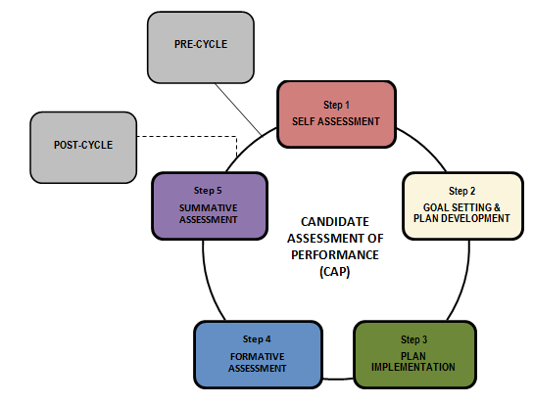

CAP 5-Step Cycle: Step-by-Step
Pre-Cycle
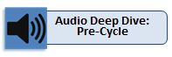
WHAT—The Pre-Cycle activities set the stage for a robust and meaningful 5-Step Cycle. The teacher candidate and Supervising Practitioner meet in pre-conference for the first observation. The Program Supervisor and Supervising Practitioner conduct Announced Observation #1. The Supervising Practitioner identifies which assessment will be used as a measure of student learning for the candidate.
WHEN—Pre-Cycle activities take place within the first three weeks of a practicum.

Step 1: Self-Assessment
WHAT—The first step of the CAP 5-Step Cycle is self-assessment. Drawing from prior experiences in pre-practicum and coursework, the teacher candidate completes a self-assessment of practice in the Seven Essential Elements and shares a preliminary professional practice goal with the Program Supervisor and Supervising Practitioner. The Program Supervisor and Supervising Practitioner complete a baseline assessment of the candidate’s skills based on Observation #1 and other sources of evidence.
WHEN—Step 1 activities take place within the first three weeks of the practicum.

Step 2: Goal Setting & Plan Development
WHAT— Step 2 of the cycle is goal setting and plan development. The Program Supervisor, Supervising Practitioner, and teacher candidate hold their first Three-Way Meeting in which they discuss the candidate’s self-assessment in relation to the Program Supervisors and Supervising Practitioners’ baseline assessment, and finalize the candidate’s professional practice goal and plan.
WHEN—Step 2 activities take place following Announced Observation #1.

Step 3: Plan Implementation
WHAT— The third step of the cycle is plan implementation. While the teacher candidate works toward his/her goal and collects relevant evidence of practice, the Supervising Practitioner and Program Supervisor conduct Unannounced Observation #1 and Announced Observation #2 (including relevant pre- and post-conferences), and any additional observations as needed. Assessors provide the candidate with feedback for improvement and ensure timely access to planned supports.
WHEN—Plan implementation begins after Step 2 and continues until the end of the cycle. Unannounced Observation #1 takes place about one-third of the way through the practicum, and Announced Observation #2 occurs just prior to the Formative Assessment.

More Observations as Needed

Step 4: Formative Assessment
WHAT—Step 4 is the formative assessment during which the Program Supervisor and Supervising Practitioner discuss evidence collected to date, determine formative assessment ratings on each element, and share these ratings with the teacher candidate during the second Three-Way Meeting. The triad revisits and adjusts the plan or professional practice goal as necessary.
WHEN—The formative assessment/evaluation occurs halfway through the practicum.

More Observations as Needed
Step 5: Summative Assessment
WHAT— The Supervising Practitioner conducts Unannounced Observation #2 and post-conference, after which the Supervising Practitioner and Program Supervisor meet to discuss all five categories of evidence collected throughout the CAP 5-Step Cycle. The Program Supervisor and Supervising Practitioner calibrate and determine summative ratings for each element before holding the final Three-Way Meeting with the candidate to share and discuss the summative assessment.
WHEN—Unannounced Observation #2 takes place about two-thirds of the way through the practicum, and the final Three-Way Meeting occurs during the final two weeks of the practicum.

Post-Cycle
WHAT— As part of the post-cycle, the teacher candidate establishes a professional practice goal based on the results of the summative assessment. This activity is designed to solidify the relationship between the candidate’s preparation experience and employment.
WHEN—Post-Cycle activities take place after the Summative Assessment.

The figure below illustrates the entire process by which Supervising Practitioners and Program Supervisors determine summative assessment ratings. Incorporating evidence from five categories of evidence, they apply their professional judgment to an evaluation of the candidate’s practice within each of the seven essential elements, assess whether the candidate has met the readiness thresholds under each element, and determine final summative assessment ratings.

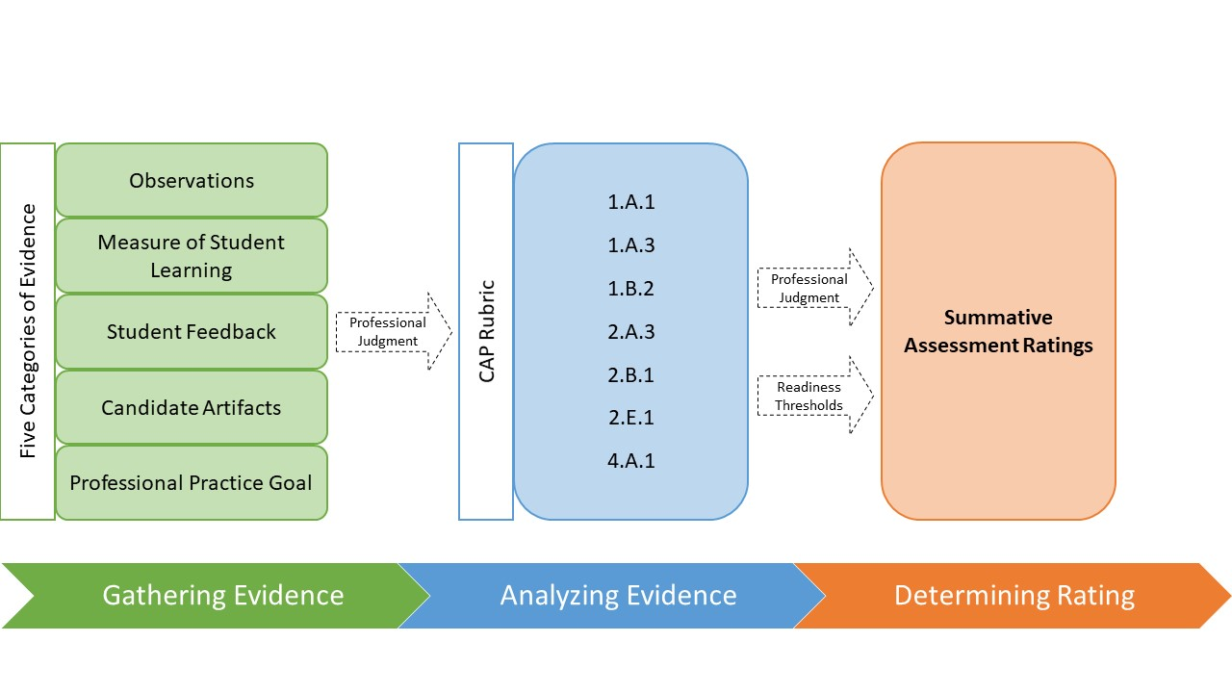

The Role of Professional Judgment
How do Supervising Practitioners and Program Supervisors know how to rate practice on a specific element? How does this translate into an overall determination of readiness?
Professional judgment of the Supervising Practitioner and the Program Supervisor, informed by multiple types of evidence, drives the final determination of candidate readiness. There are no numbers or percentages that dictate summative ratings on elements. This approach to assessment is modeled on the underlying tenets of the Educator Evaluation Framework, in which:
- Evaluators look for trends and patterns in practice across multiple types of evidence and apply their professional judgment based on this evidence when evaluating an educator
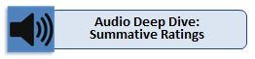
- Formulaic or numerical processes that calculate ratings and preclude the application of professional judgment are inconsistent with the letter and the spirit of evaluation
- Professional judgment based on multiple types of evidence promotes a more holistic and comprehensive analysis of practice
With its emphasis on professional judgment, the Massachusetts approach to educator evaluation and preparation assessment allows evaluators to be responsive to local context or individual needs, emphasize trends and patterns of practice rather than rely on individual data points, and better target feedback and resources to individual educators. All of these factors contribute to a more holistic and comprehensive assessment of educator practice that is designed to develop, support, and continually strengthen the skills of our educators from preparation through employment.

Context

Background
In 2010, Massachusetts launched a major effort to increase the rigor and quality of educator preparation in the Commonwealth. In June 2012, the Massachusetts Board of Elementary and Secondary Education (BESE) approved changes to the Regulations for Educator Licensure and Preparation Program Approval (603 CMR 7.03) which raised expectations for preparation through a variety of strategies, including:
- Increasing practicum hour requirements
- Requiring Supervising Practitioners to be rated Proficient or Exemplary on their most recent Summative Evaluation in order to serve in the role
- Updating the Program Approval Standards to emphasize a provider’s ability to meet the needs of schools/districts and engage in data-driven continuous improvement
- Collecting and publicly reporting additional outcome measures associated with the quality of preparation
As an extension of these regulatory changes, BESE passed updated Professional Standards for Teachers (PSTs) in January of 2014. Not only do these PSTs define the pedagogical and professional knowledge and skills required of all teachers, they align expectations for teacher preparation candidates with those for in-service teachers as outlined in the Massachusetts Educator Evaluation Framework. Sponsoring Organizations are expected to use the PSTs and Indicators in designing their teacher preparation programs to best prepare their teacher candidates.

Developing CAP
Following the adoption of the 2014 PSTs, DESE convened a Teacher Preparation Performance Assessment Task Force made up of stakeholders working in PK-12 schools and preparation programs across the state to provide a recommendation on the adoption or development of a new assessment instrument. Both DESE and the Task Force recognized that the Pre-Service Performance Assessment (PPA) that had been in use since 2003 needed to be replaced with a more robust instrument to assess candidates’ performance in a way that was consistent with the revised PSTs and current evaluation practices in the state. The Task Force investigated commercially available products (e.g., edTPA), reviewed all available research, discussed best practice, and ultimately crafted a set of considerations that led DESE to build a state-specific instrument to meet the Commonwealth’s objectives for a meaningful performance assessment. Task Force members continued to consult about the development of CAP during the 2014-2015 academic year through an advisory committee.

Below is a timeline of activities associated with the development of CAP.

February 2014 The Teacher Preparation Assessment Task Force convened six times.
June 2014 The Teacher Preparation Assessment Task Force presented their recommendations to the Commissioner.
September 2014 DESE issued a contract to a vendor to support the development of the new assessment instrument.
December 2014 Development work began.
December 2014 DESE and the vendor conducted interviews and focus groups with external stakeholders.
January 2015 The Advisory Committee, including members of the Task Force and several additional stakeholders, met three times.

June 2015 DESE released CAP Guidelines for the 2015-2016 CAP Pilot.
September 2015 – Sponsoring Organizations
May 2016 piloted CAP with a minimum of ten teacher candidates.

December 2015 – DESE solicited feedback through surveys and focus groups to
May 2016 revise CAP Guidelines.

June 2016 DESE released revised draft of CAP Guidelines.

August 2019 DESE released revised draft of CAP Guidelines, incorporating updates mirroring those made to the Massachusetts Educator Evaluation Framework and adding a Seventh Essential Element
Aligning the PSTs with the Standards of Effective Teaching Practice used in the Massachusetts Educator Evaluation Framework was the first step in building the bridge between preparation and in-service performance expectations. Developing a rigorous assessment for program completion that ensures teacher readiness in employment strengthens that bridge and solidifies a career continuum that systematically supports educators in continuously improving their practice.

Conclusion
In order to ensure meaningful, consistent implementation of CAP across programs, Sponsoring Organizations will have to devote time and resources to supporting Program Supervisors, Supervising Practitioners, and teacher candidates in their understanding of the Seven Essential Elements, readiness thresholds, and use of the CAP Rubric. With special attention to the collaborative roles of the Program Supervisors and Supervising Practitioners, Sponsoring Organizations can elevate not only the standards to which they hold teacher candidates, but the influence and responsibilities of experienced educators in shaping the next generation of effective teachers in Massachusetts.
This work will take time to perfect. DESE anticipates that when CAP is led by talented, experienced educators working together across the preparation and K-12 sectors, the benefits of a robust preparation experience aligned to the Standards of Effective Practice and assessed by CAP will be visible in results for students and educators alike. The end result is a coherent system of educator preparation, development, and growth that supports the ongoing learning and achievement of all students.

Appendix A: Candidate Assessment of Performance (CAP) Rubric
Appendix A is the CAP Rubric on which the candidate is evaluated in both the formative and summative assessments for Quality, Scope, and Consistency of practice for each of the Seven Essential Elements.

This section is included for reference only. Program Supervisors and Supervising Practitioners should complete the Formative and Summative Assessment Forms to evaluate candidates on the Seven Essential Elements.
CAP Rubric

I.A.1: Subject Matter Knowledge
I-A-1.  Subject Matter Knowledge | Unsatisfactory | Needs Improvement | Proficient | Exemplary
 | Demonstrates limited knowledge of the subject matter and/or its pedagogy; relies heavily on textbooks or resources for development of the factual content. Rarely engages students in learning experiences focused on complex knowledge or subject-specific skills and vocabulary. | Demonstrates factual knowledge of subject matter and the pedagogy it requires by sometimes engaging students in learning experiences that enable them to acquire complex knowledge and subject-specific skills and vocabulary. | Demonstrates sound knowledge and understanding of the subject matter and the pedagogy it requires by consistently engaging students in learning experiences that enable them to acquire complex knowledge and subject-specific skills and vocabulary, such that they are able to make and assess evidence-based claims and arguments. | Demonstrates expertise in subject matter and the pedagogy it requires by consistently engaging all students in learning experiences that enable them to acquire, synthesize, and apply complex knowledge and subject-specific skills and vocabulary, such that they are able to make and assess evidence-based claims and arguments. Models this practice for others.
Quality |  |  | *
Scope |  | *
Consistency |  | *

I.A.3: Well-Structured Units and Lessons
I-A-3.  Well-Structured Units and Lessons | Unsatisfactory | Needs Improvement | Proficient | Exemplary
 | Delivers individual lessons rather than units of instruction; constructs units of instruction that are not aligned with state standards/local curricula and/or designs lessons that lack measureable outcomes, fail to includeappropriate student engagement strategies, and/or include tasks that mostly rely on lower level thinking skills. | Implements lessons and units of instruction to address some knowledge and skills defined in state standards/local curricula with some elements of appropriate student engagement strategies, but some student outcomes are poorly defined and/or tasks are not challenging. | Adapts as needed and implements standards-bsaed units comprised of well-structured lessons with challenging tasks and measurable ooutcomes; appropriate student engagement strategies, pacing, sequence, resources, and grouping; purposeful questioning; and strategic use of technology and digital media; such that students are able to learn the knowledge and skills defined in state standards/local curricula. | Adapts as needed and implements standards-based units comprised of well-structured lessons with challenging tasks and measurable outcomes; appropriate student engagement strategies, pacing, sequence, resources, and grouping; purposeful questioning; and strategic use of technology and digital media; such that all students are able to learn and apply in authentic contexts the knowledge and skills defined in state standards/local curricula.Models this practice for others.
Quality |  |  | *
Scope |  | *
Consistency |  | *

I.B.2: Adjustments to Practice
I-B-2.  Adjustments to Practice | Unsatisfactory | Needs Improvement | Proficient | Exemplary
 | Makes few adjustments to practice based on formal and informal assessments. | May analyze some assessment results but only occasionally adjusts practice or modifies future instruction based on the findings. | Analyzes results from a variety of assessments to determine progress toward intended outcomes and uses these findings to adjust practice and identify and/or implement differentiated interventions and enhancements for students. | Regularly organizes and analyzes results from a variety of assessments to determine progress toward intended outcomes and uses these findings to adjust practice in real-time and in upcoming lessons or units by (a) identifying and/or implementing appropriate differentiated interventions and enhancements for all students, and (b) making appropriate modifications to lessons and units. Models this practice for others.
Quality |  |  | *
Scope |  | *
Consistency |  | *

II.A.3: Meeting Diverse Needs
II-A-3.  Meeting Diverse Needs | Unsatisfactory | Needs Improvement | Proficient | Exemplary
 | Uses limited and/or inappropriate practices to accommodate differences. | May use some appropriate practices to accommodate differences, but fails to address an adequate range of differences. | Uses appropriate inclusive practices, such as tiered supports and scaffolded instruction, to accommodate differences in students’ learning needs, abilities, interests, and levels of readiness, including those of academically advanced students, students with disabilities, and English learners. | Uses a variety of appropriate inclusive practices, such as tiered supports and scaffolded instruction, to address specific differences in individual students’ learning needs, abilities, interests, and levels of readiness, creating structured opportunities for each student to meet or exceed state standards/local curriculum and behavioral expectations. Models this practice for others.
Quality |  |  | *
Scope |  | *
Consistency |  | *

II.B.1: Safe Learning Environment
II-B-1.  Safe Learning Environment | Unsatisfactory | Needs Improvement | Proficient | Exemplary
 | Maintains a physical environment that is unsafe or does not support student learning. Uses inappropriate or ineffective rituals, routines, and/or responses to reinforce positive behavior or respond to behaviors that interfere with students’ learning. | May create and maintain a safe physical environment but inconsistently maintains rituals, routines, and responses needed to prevent and/or stop behaviors that interfere with all students’ learning. | Uses rituals, routines, and appropriate responses that create and maintain a safe physical and intellectual environment where students take academic risks and most behaviors that interfere with learning are prevented. | Uses rituals, routines, and proactive responses that create and maintain a safe physical and intellectual environment where students take academic risks and play an active role—individually and collectively—in preventing behaviors that interfere with learning. Models this practice for others.
Quality |  |  | *
Scope |  | *
Consistency |  | *

II.E.1: High Expectations
II-E-1.  High Expectations | Unsatisfactory | Needs Improvement | Proficient | Exemplary
 | Does not communicate specific academic and behavior expectations to students, and gives up on some students or communicates that some cannot master challenging material. | Occassionally communicates expectations for student work, effort, and behavior in the classroom, but inconsistently enforces these expectations and/or does little to counteract student misconceptions about innate ability. | Clearly communicates high standards for student work, effort, and behavior, and consistently reinforces the expectation that all students can meet these standards through effective effort, rather than innate ability. | Effectively communicates high standards for student work, effort, and behavior such that students take ownership of meeting them; models and reinforces ways that students can master challenging material through effective effort, and successfully challenges misconceptions about innate ability. Models this practice for others.
Quality |  |  | *
Scope |  | *
Consistency |  | *

IV.A.1: Reflective Practice
IV-A-1.  Reflective Practice | Unsatisfactory | Needs Improvement | Proficient | Exemplary
 | Demonstrates limited reflection on practice and/or use of insights gained to improve practice. | May reflect on the effectiveness of lessons/ units and interactions with students by oneself, but not with colleagues and/or rarely uses insights to improve practice. | Regularly reflects on the effectiveness of lessons, units, and interactions with students, both individually and with colleagues, and uses insights gained to improve practice and student learning. | Regularly reflects on the effectiveness of lessons, units, and interactions with students, both individually and with colleagues; uses and shares back with colleagues insights gained to improve practice and student learning.
Quality |  |  | *
Scope |  | *
Consistency |  | *

Appendix B: Crosswalk of CAP’s Seven Essential Elements to PST Indicators
The following table crosswalks the Indicators identified at the “demonstrate” level of practice in the PST Guidelines to the Seven Essential Elements assessed in CAP.

This resource is for reference only.

(1) Curriculum, Planning, and Assessment Standard: Promotes the learning and growth of all students by providing high quality and coherent instruction, designing and administering authentic and meaningful student assessments, analyzing student performance and growth data, using this data to improve instruction, providing students with constructive feedback on an on-going basis, and continuously refining learning objectives.
Indicator | Essential Element in CAP
(a) Curriculum and Planning indicator: Knows the subject matter well, has a good grasp of child development and how students learn, and selects, adapts as necessary, and implements effective and rigorous standards-aligned curricular materials consisting of well-structured units and lessons with measurable outcomes. [Note: This language reflects propsed updates to the PST Guidelines to ensure alignment with the MA Model Teacher Rubric.] | 1.A.1 Subject Matter Knowledge  1.A.3 Well-Structured Units and Lessons
(b) Assessment indicator: Uses a variety of informal and formal methods of assessment to measure student learning, growth, and understanding, develop differentiated and enhanced learning experiences, and improve future instruction. | 1.B.2 Adjustments to Practice
SEI (a) Uses instructional planning, materials, and student engagement approaches that support students of diverse cultural and linguistic backgrounds, strengths, and challenges. | 1.A.3 Well-Structured Units and Lessons
SEI (c) Demonstrates knowledge of the difference between social and academic language and the importance of this difference in planning, differentiating and delivering effective instruction for English language learners at various levels of English language proficiency and literacy. | 2.B.1 Safe Learning Environment  2.A.3 Meeting Diverse Needs  2.E.1 High Expectations
(2) Teaching All Students Standard: Promotes the learning and growth of all students through instructional practices that establish high expectations, create a safe and effective classroom environment, and demonstrate cultural proficiency.
Indicator | Essential Element in CAP
(a) Instruction indicator: Uses instructional practices that reflect high expectations regarding content and quality of effort and work, engage all students, and are personalized to accommodate diverse learning styles, needs, interests, and levels of readiness. | 1.A.1 Subject Matter Knowledge  2.A.3 Meeting Diverse Needs  2.E.1 High Expectations
(b) Learning Environment indicator: Creates and maintains a safe and collaborative learning environment that values diversity and motivates students to take academic risks, challenge themselves, and claim ownership of their learning. | 1.A.3: Well-Structured Units and Lessons  2.B.1 Safe Learning Environment
c) Cultural Proficiency indicator: Actively creates and maintains an environment in which students' diverse backgrounds, identities, strengths, and challenges are respected. | 2.A.3 Meeting Diverse Needs  2.B.1 Safe Learning Environment
(d) Expectations indicator: Plans and implements lessons that set clear and high expectations and make knowledge accessible for all students. | 1.A.1 Subject Matter Knowledge  2.A.3 Meeting Diverse Needs  2.E.1 High Expectations
(f) Classroom Management Indicator: Employs a variety of classroom management strategies to monitor, modify, and motivate positive student behavior and to establish and maintain consistent routines and procedures. | 1.A.3: Well-Structured Units and Lessons  2.A.3 Meeting Diverse Needs  2.B.1 Safe Learning Environment
SEI (b) Uses effective strategies and techniques for making content accessible to English language learners. | 2.A.3 Meeting Diverse Needs
SEI (d) Creates and maintains a safe collaborative learning environment that values diversity and motivates students to meet high standards of conduct, effort, and performance. | 2.A.3 Meeting Diverse Needs
(4) Professional Culture Standard: Promotes the learning and growth of all students through ethical, culturally proficient, skilled, and collaborative practice.
Indicator | Essential Element in CAP
(a) Reflection indicator: Demonstrates the capacity to reflect on and improve the educator's own practice, using informal means as well as meetings with teams and work groups to gather information, analyze data, examine issues, set meaningful goals, and develop new approaches in order to improve teaching and learning. | 4.A.1 Reflective Practice
(f) Professional Responsibilities indicator: Is ethical and reliable, and meets routine responsibilities consistently. | 1.A.1 Subject Matter Knowledge  1.A.43 Well-Structured Units and Lessons:  1.B.2 Adjustments to Practice  2.A.3 Meeting Diverse Needs  2.B.1 Safe Learning Environment  2.E.1 High Expectations  4.A.1 Reflective Practice

Appendix C: CAP & The Educator Evaluation Framework
This section highlights the important parallels between the CAP 5-Step Cycle and the 5-Step Cycle used as part of the Educator Evaluation Framework.

This resource is for reference only.

CAP & the Educator Evaluation Framework
CAP measures a candidate’s readiness to be effective on day one of his/her teaching career. It is aligned to the Massachusetts Educator Evaluation Framework, which outlines a comprehensive process for continuous educator growth and development used by all school districts statewide. This intentional alignment exemplifies the cohesion Massachusetts is building across the educator career continuum through complementary educator effectiveness policies.
CAP is designed to keep student learning at the center of a candidate’s practicum experience and to promote honest reflection about candidate performance. Like the Educator Evaluation Framework, inquiry into practice and impact is grounded in a 5-Step Cycle. The 5-Step Cycle used in CAP has been modified to meet the needs of candidates, Program Supervisors, and Supervising Practitioners, but retains the same core architecture of the cycle included in the evaluation framework:

Step 1: Self-Assessment
Step 2: Goal-Setting and Plan Development
Step 3: Plan Implementation
Step 4: Formative Assessment
Step 5: Summative Evaluation

One of the most important characteristics of the Educator Evaluation Framework is the intention to give educators significant agency over their evaluation experience. That starts with the Self-Assessment, during which educators reflect on their practice, review data, and identify areas of focus for individual goals. Likewise, CAP positions teacher candidates to play a lead role in maximizing their practicum experiences through the inclusion of self-assessment and goal setting activities. With support from the Program Supervisor and Supervising Practitioner, the candidate evaluates his/her practice and develops a professional practice goal that will form the backbone of his/her plan throughout CAP.
Another point of alignment is visible in Step 3: Plan Implementation. CAP, like the Educator Evaluation Framework, requires the collection of multiple types of evidence to evaluate educator practice and progress toward goals. Announced and unannounced observations, artifacts of practice, student feedback, and measures of student learning are all part of the evidentiary bases of both CAP and the Evaluation Framework. This deliberate congruity will help candidates successfully transition to the educator workforce.
CAP’s inclusion of a formative assessment prior to the summative assessment is also borrowed from the Educator Evaluation Framework. The Evaluation Framework is founded on educator growth and development, so it is fitting that “no surprises” has emerged as a mantra in many districts. It is vitally important that educators receive consistent, timely, and actionable feedback throughout the duration of their plans. However, the formative assessment provides an opportunity for a more thorough mid-point check. Evaluators and educators sit down to review evidence of the educator’s practice as it relates to their performance rubric and the educator’s goals. If there are concerns, the evaluator may adjust the educator’s plan to provide more targeted support. The formative assessment plays a similar role in the CAP. Here, Program Supervisors and Supervising Practitioners meet with candidates to review the evidence collected so far and decide what supports or interventions, such as additional observations, might be needed. Candidates in jeopardy of not meeting CAP expectations should be put on notice during the formative assessment and be provided with strategies for improvement prior to the summative assessment.

Finally, following the CAP’s summative assessment, passing candidates use the feedback received to develop a draft of a professional practice goal for their first year of teaching. Since this assessment is firmly aligned to the Educator Evaluation Framework, candidates placed in Massachusetts districts will enter with a high degree of familiarity and comfort with the 5-Step Cycle and be prepared with a draft professional practice goal informed by the authentic evaluation experience provided by the CAP.
In support of the alignment between these two systems, Sponsoring Organizations should make use of the significant resources materials available through the educator evaluation website. In particular:
- Training Modules and Workshops for Evaluators and Teachers. Including a few spotlighted below:
  - For Evaluators (to be adapted for use with Supervising Practitioners and Program Supervisors)
    - Module 5: Gathering Evidence
    - Module 6: Observations & Feedback
  - For Teachers (to be adapted for use with candidates)
    - Workshop 2: Self-Assessment
    - Workshop 4: Gathering Evidence
- Evidence Collection Toolkit: Designed to support districts to establish clear and consistent expectations for evidence collection and promote a meaningful process for the collection, analysis, and sharing of high quality artifacts. Includes: brief guidance, examples of district strategies, a worksheet for district decision-making, and a handout of Evidence Collection Tips for Educators.
- Student Feedback Surveys, including:
  - Resources to highlight the value and importance of this measure in understanding and improve teaching practice.
  - Technical Report outlining the process of developing and validating the surveys.
  - CAP’s Model Feedback Surveys and Administration Protocols
- Guidance on measuring student impact, including example assessments and Implementation briefs issued to support the work around developing common assessments.
- Quick Reference Guides that provide helpful overviews. Including a few spotlighted below:
  - Connection between Educator Evaluation & Professional Development
  - Connection between Educator Evaluation & the MA Curriculum Frameworks

Appendix D: 603 CMR 7.00 Regulations for Educator Licensure and Program Approval (Excerpts)
This section excerpts regulations from 603 CMR 7.00 outlining the requirements relevant to the execution of these guidelines.

This resource is for reference only.

------------------------------------
The Massachusetts Regulations for Educator Licensure and Preparation Program Approval (603 CMR 7.03) require an assessment of a candidate’s performance in a practicum or practicum equivalent using guidelines developed by the Massachusetts Department of Elementary and Secondary Education (DESE) for all programs that are approved to endorse candidates for an Initial teacher license as well as the Performance Review Program for Initial Licensure (603 CMR 7.05(2)(c) and 7.08(1)).

603 CMR 7.08(1) Professional Standards for Teachers
(1) Application. The Professional Standards for Teachers define the pedagogical and other professional knowledge and skills required of all teachers. These standards and indicators referred to in 603 CMR 7.08 (2) and (3) are used by Sponsoring Organizations in designing their teacher preparation programs and in preparing their candidates. The standards and indicators are also used by the Department in reviewing programs seeking state approval, and as the basis of performance assessments of candidates. Candidates shall demonstrate that they meet the Professional Standards and Indicators referred to in 603 CMR 7.08 (2) and (3) by passing a Performance Assessment for Initial License using Department guidelines.

Appendix E: Required Forms for CAP

Required Forms
The following forms are required for CAP Implementation:
- CAP Form (included)
- CAP Observation Form (included)
- Student Feedback Instruments (available online)
- Formative Assessment Form (see Appendix A: CAP Rubric for an outline of this form)
- Summative Assessment Form (see Appendix A: CAP Rubric for an outline of this form)
All required forms should be retained on file at the Sponsoring Organization.

Recommended Forms
Recommended forms and suggested resources are available in the CAP Implementation Handbook. Recommended forms may also be useful in demonstrating certain criteria are met during an upcoming DESE review. Refer to the Candidate Record Retention advisory for more information.

CAP Form
Candidate Assessment of Performance Form
Section 1: General Information (to be completed by the Candidate and the Program Supervisor)
C andidate Information
First Name: |  |  |  |  |  |  |  | Last Name:
Street Address:
City/Town: |  |  |  |  |  |  |  |  |  |  |  |  | State: |  |  |  |  |  |  | Zip:
MEPID #:
Massachusetts license number(if applicable):
Program Information
Sponsoring Organization:
Program Area & Grade Level:
Have any components of the approved program been waived? 603 CMR 7.03(1)(b)
 |  |  |  |  |  |  |  |  |  |  |  |  |  |  |  |  | Yes |  |  |  |  |  | No
Practicum Information |  |  |  |  |  |  |  |  |  |  | Practicum |  |  |  |  |  |  |  | Practicum Equivalent
Practicum/Equivalent Course Number: |  |  |  |  |  |  |  |  |  |  |  |  |  |  |  |  | Credit hours:
Practicum/Equivalent Seminar Course Title:
Practicum/Equivalent Site: |  |  |  |  |  |  |  |  |  |  |  | Grade Level(s) of Students:
Supervising Practitioner Information (to be completed by the Program Supervisor)
Name:
School District: |  |  |  |  |  |  |  |  |  |  |  | Position:
License Field(s): |  |  |  |  |  |  |  |  |  |  |  |  |  |  |  | MEPID or License #
# of years experience under license: |  |  |  |  |  |  |  |  |  |  |  |  |  |  |  |  | Initial |  |  |  |  |  |  | Professional
To the best of my knowledge (per the Supervising Practitioner’s Principal/Evaluator), the Supervising Practitioner has received a summative evaluation rating of proficient or higher in his most recent evaluation. |  |  |  |  |  |  |  |  |  |  |  |  |  |  |  |  | Yes |  |  |  |  |  |  | No

Name: |  | Date:
Candidate Assessment of Performance Form
Section 2: Total Hours and Signatures

Three-Way Meetings
1st Three-Way Meeting  Date: | Candidate
 | Supervising Practitioner
 | Program Supervisor
2nd Three-Way Meeting  Date: | Candidate
 | Supervising Practitioner
 | Program Supervisor
Final Three-Way Meeting  Date: | Candidate
 | Supervising Practitioner
 | Program Supervisor

Total Number of Practicum Hours: |  |  |  | Number of hours assumed full responsibility in the role:
Based on the candidate’s performance as measured on the CAP Rubric, we have determined this candidate to be: |  |  | Ready to Teach |  |  | Not Yet Ready
Supervising Practitioner | Date:
Program Supervisor | Date:
Mediator  (if necessary see: 603 CMR 7.04(4)) | Date:

Observation Form
Name: Date:
Observation #: ___ |  |  | Type (Announced/Unannounced):
Observed By:
Focus Elements: |  | 1.A.1: Subject Matter Knowledge (#1 Announced, #2 Unannounced) 2.B.1 Safe Learning Environment ( #1 Unannounced)  1.A.3: Well Structured Units and Lessons (#1 Announced, #1 Unannounced) 2.E.1 High Expectations (#1 Announced)  1.B.2: Adjustments to Practice (#2 Announced, #2 Unannounced) 4.A.1 Reflective Practice  2.A.3: Meeting Diverse Needs  (#2 Announced)
Date of Lesson: |  |  |  | Time (start/end):
Content Topic/Lesson Objective:
 | Whole Group |  | Small Group |  | One-on-One |  | Other

Active Evidence Collection occurred during the observation and is synthesized and categorized below.
Element | Evidence
1.A.1
1.A.3
1.B.2
2.A.3
2.B.1
2.E.1
4.A.1

Focused Feedback
Reinforcement Area/Action:
(strengths)
Refinement Area/Action:
(areas for improvement)

These guidelines apply to all initial licensure teacher candidates except those pursuing the following specialist licenses: Reading; Speech, Language, and Hearing Disorders; and Instructional Technology. It is the expectation of DESE that programs endorsing in license areas not covered by CAP develop and implement a performance assessment appropriate for the license.
Candidates that are employed as teachers-of-record are still required to undergo CAP for program completion. Candidates and Sponsoring Organizations may leverage activities associated with in-service evaluations to support CAP and reduce duplication of efforts, but evaluation ratings provided by a school/district evaluator may not replace or substitute for CAP ratings. Proficiency on one does not necessitate proficiency on the other. In these cases, ESE encourages Sponsoring Organizations and schools/districts to communicate around expectations for performance.
“…[T]he evaluator determines an overall rating of educator performance based on the evaluator's professional judgment and an examination of evidence that demonstrates the educator's performance against Performance Standards and evidence of the attainment of the Educator Plan goals” (603 CMR 35.06(6); see also ESE Model Teacher & Caseload Educator Contract, Section 14(b); “The professional judgment of the primary evaluator shall determine the overall summative rating that the Educator receives” (ESE Model Teacher & Caseload Educator Contract, Section 14(c)).
For more information on the MA Educator Evaluation Framework and how the system compares to other evaluation systems throughout the country, as well as lessons ESE learned throughout the implementation of the framework, please refer to the Center for American Progress article, Educator Evaluation: A Case Study of Massachusetts’ Approach.
These guidelines apply to all initial licensure teacher candidates except the following specialist licenses: Academically Advanced, Reading, and Speech, Language, and Hearing Disorders teachers. It is the expectation of ESE that programs endorsing in license areas not covered by CAP develop and implement a performance assessment appropriate for the license.

