Quick Reference Guide: CAP Data Retention and Submission

Introduction

The Candidate Assessment of Performance (CAP) assesses teacher candidate readiness using multiple categories of evidence, including observations, measures of student learning, student feedback, progress towards a professional practice goal, and candidate artifacts. This document outlines the Department of Elementary and Secondary Education’s (DESE) expectations for retention and submission of data collected through CAP.

CAP is a statewide assessment and, as such, DESE monitors the implementation of this assessment to determine its efficacy. The data collected informs DESE research about the validity of CAP. Additionally, the data is used for accountability purposes during the program approval process. Finally, collecting this data allows us to provide more meaningful data to sponsoring organizations for continuous improvement.

Record Retention
All required forms, as identified in the CAP Implementation Handbook and listed below, should be retained on file by the sponsoring organization for all teacher candidates enrolled during the three most recent academic years. Records may be maintained electronically or in the CAP Online Platform.
- CAP Form
- Observation Forms
- CAP Early Literacy Observation Form (for Early Literacy programs)
- Student Feedback Form
- Formative Assessment Form
- Summative Assessment Form

In addition to the required documents above, other forms and artifacts, such as those listed as Optional in the CAP Handbook, may also be kept on file if they are useful in demonstrating that criteria are met during a DESE Formal Review. For more information, please refer to the Candidate Record Retention Advisory.

Data Reporting
The following table lists the CAP data points reported to DESE on an annual basis.
SOs using the CAP Online Platform do not need to enter additional information.
- This data will be submitted into the system by completing the candidate cycles.
SOs not using the CAP Online Platform must submit this information using the downloadable template provided on the platform.
- All candidates with a practicum experience in the previous academic year should be included in the submitted data, even if they did not meet the readiness thresholds.
- Use the Enrollment Import feature in ELAR to download accurate name data for your candidates. Instructions for how to do this can be found under Enrollment Import Steps in the ELAR Sponsoring Organization User Guide.
- All data must be reported in the exact form in which it appears in our systems, including uppercase/lowercase letters. It will be rejected until all errors are corrected.
- Cells cannot be left blank, (with the exception of the SP MEPID when SPs are at private schools, out of state, or approved special education schools) in order for the data to be consumed.
- We highly encourage sponsoring organizations to begin reviewing data for accuracy as far in advance as possible.

Required Data | Definition
Organization Name | Name of sponsoring organization. This can be seen in the upper right-hand corner when you log into the CAP Online Platform to download the template.
TC-MEPID | Teacher candidate’s 8-digit MEPID¹ identification number.
TC-FirstName | Teacher candidate’s first name. This must be formatted exactly as it is in ELAR. Do not include middle names or initials or use nicknames.
TC-LastName | Teacher candidate’s last name. This must be formatted exactly as it is in ELAR.
TC-Email Address | Teacher candidate’s email address.
SP-FullName | Supervising practitioner’s full name. Do not include middle names or initials or use nicknames.
SP-MEPID | Supervising practitioner’s 8-digit MEPID. You may not use their license number. Do NOT use the SP MEPID for out-of-state, approved special education, or private school SPs, even if they have one; instead, please leave the cell blank.
SP-Email | Supervising practitioner’s email address.
PracticumDistrict | District location of the practicum. This must be formatted exactly as it is in profiles without the LEA code.  (e.g., In profiles, the district name appears as Amherst-Pelham (06050000). The number 06050000 is the LEA code. Only “Amherst-Pelham" should be used for reporting purposes)
PracticumSchool | School site location of the practicum. This must be formatted as it is in profiles without the district name and school code. (e.g., In profiles, the school name appears as Abington: Abington High (00010505). Abington: is the district, and 00010505 is the school code. Only “Abington High" should be used for reporting purposes)
PS-FullName | Program supervisor’s full name.
PS-Email Address | Program supervisor’s email address.
SchoolYear | Academic year of the practicum in the YY-YY format. (e.g. 25-26)
Program | Program type and grade-level. (e.g., Academic: Teacher, Elementary, 1-6, Initial, Baccalaureate.) This must be formatted as shown in this example, with commas. You can copy program names through the “Verify Cycle Information Tool” within the CAP Online Platform. Because the CAP reporting system must connect to multiple platforms, it must be formatted with commas. It cannot be formatted as it appears in the ELAR Enrollment Import.
Formative Ratings | Formative assessment ratings for Quality, Scope, and Consistency of each of the seven Essential Elements, using single letters for ratings (e.g., e for Exemplary, p for Proficient, n for Needs Improvement, u for Unsatisfactory). The formatting for each field is not case sensitive.
Summative Ratings | Summative assessment ratings for Quality, Scope, and Consistency of each of the seven Essential Elements, using single letters for ratings (e.g., e for Exemplary, p for Proficient, n for Needs Improvement, u for Unsatisfactory). The formatting for each field is not case sensitive.
Ready to Teach | A determination of whether the readiness thresholds have been met (Y/N) for all seven Essential Elements. Data submissions should include all candidates who completed CAP this school year, even if they did not meet the readiness thresholds.
Announced 1 Modality and Announced 2 Modality | Description of the modality of Announced Observations 1 and 2:  In-person (IP); virtual, synchronous (VS); or virtual, asynchronous (VA)

CAP Data Submission
All required CAP data must be submitted to DESE by July 15th of each year.
- After this date, DESE extracts the data to be used in Edwin. Incomplete data may limit SOs’ ability to access accurate data.
- If your organization’s CAP Manager will be out of the office during the submission period, please share an alternate contact with our office by June 15th.
SOs using the CAP Online Platform should complete the following to ensure all required data is entered:
- CAP managers or program supervisors mark each CAP cycle as “Complete”.
- CAP manager ensures all cycles are complete by checking Annual Reports within the platform.
- If any cycle is incomplete, the information (blank or marked “i”) must be corrected by the program supervisor, supervising practitioner, or teacher candidate.

SOs not using the CAP Online Platform for the full Process must do the following:
- Identify a CAP Manager to submit data to DESE by the July 15th deadline.
- Ensure this individual has CAP Manager permissions within the DESE Security Portal. You can email EducatorPreparation@mass.gov to verify that someone from your sponsoring organization has these permissions.
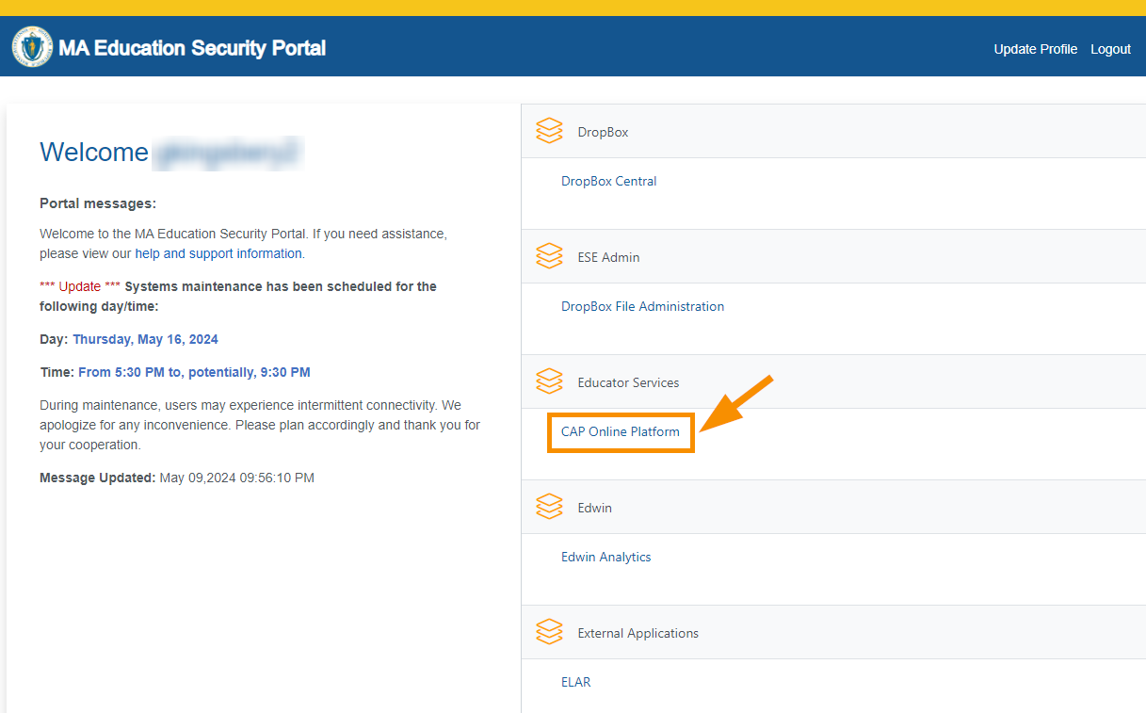

- Log in to the CAP Online Platform and select “Reports”.
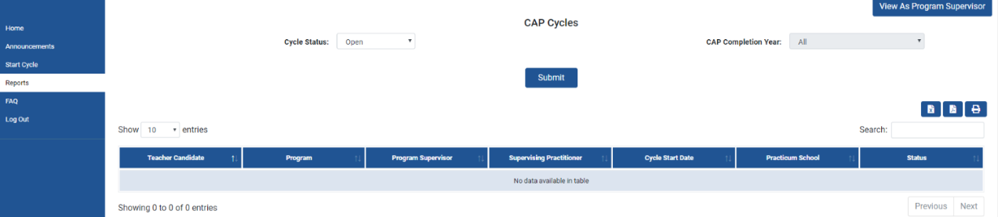
- Under “Reports,” select “Upload Cycles” and then select “Download Template.”
It is important to download the current template from the platform.
Ensure the template remains in .csv format, or it will not be able to upload.
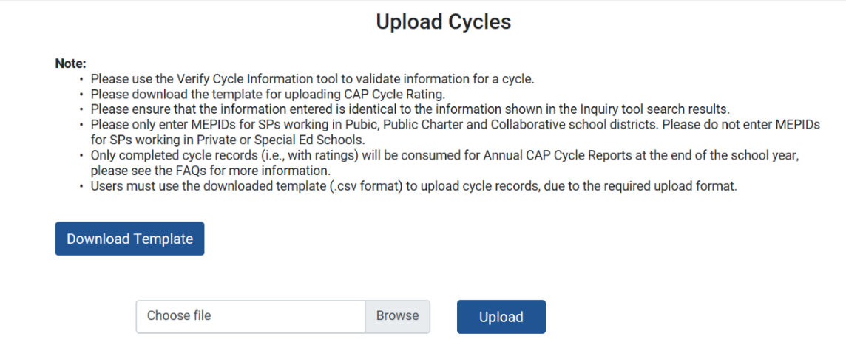
- Within the template, complete all fields for each cycle
    - Use single letters for ratings (e.g. e for Exemplary, p for Proficient).
    - The formatting for each field is not case sensitive.
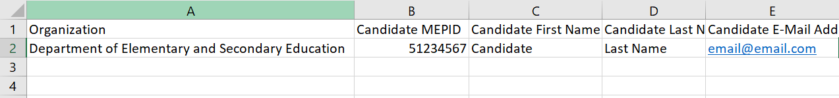
- For Private, Special Education School, or Out-of-State placements, do not include the SP MEPID as it will prevent you from uploading the form. In these cases, leave the cell blank.
- Once finished, make sure the document is saved as a .CSV file.
- Go back to the CAP Online Platform and select “Upload” to add the file.

- If there are no errors in your file, it will upload and you will be able to see your imported cycles under “Imported Cycles”.
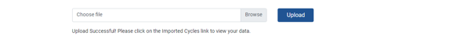
- If there are errors in your file, you will receive an error message and a link to download an Error Log.
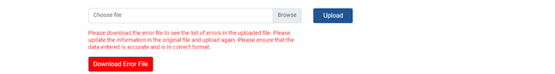

The Error Log will have two tabs.
- The first tab provides Error Codes for your upload. You must scroll all the way to the right to see the cycle information for each error.
- The second tab is the Error Index which will help you determine how to correct the issue.

You will need to correct all errors in the template and re-upload the document until your file uploads.
- You do not have to upload all of the cycles in one batch. You may elect to separate the errors from the cycles without errors into two separate documents so that you can continue to work on the errors.
- See Troubleshooting Tips and Tricks below for more information regarding the errors you might see.

For example, if the error is in the PROGRAM_NAME

PROGRAM_NAME  The Program information does not exist in the database. Please ensure that the information is correct. | An incorrect Program name leads to no match in the DB. | - Use the 'Verify Cycle Information" page.  - Ensure spelling and format are correct.  - Check Early ID for correct program name.  - Contact Ed Prep for more information.

- Some errors require you to identify the correct information about the teacher candidate, program, supervising practitioner, or practicum site. You can use the Verify Cycle page to find the information needed to correct identified errors.
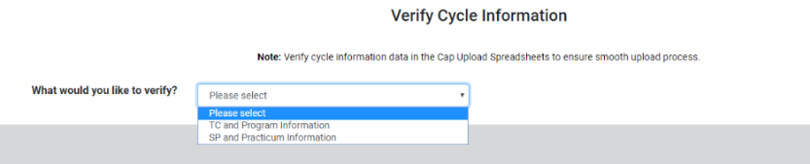
- If you need to look up information about the candidate or their program,
select “TC and Program Information.”
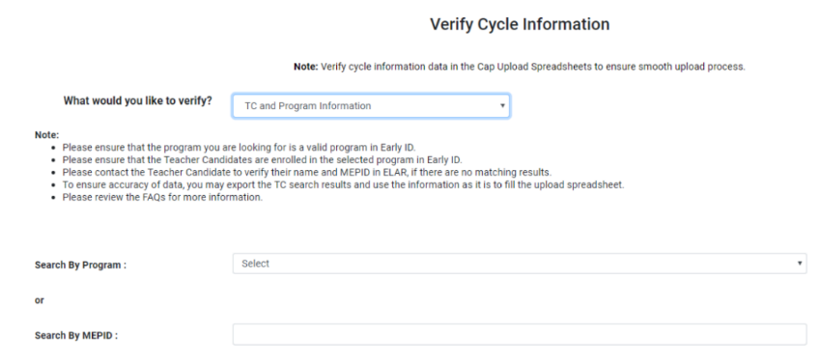
- If you need to look up information about the supervising practitioner or practicum site, select “SP and Practicum Information.”
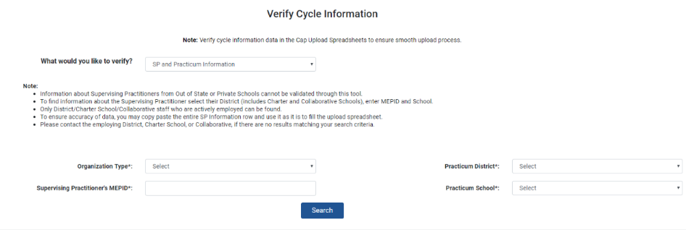
- Use this information to correct the errors in the .csv template. Do not make the changes in the error file.
- If you are unable to find a supervising practitioner within the system, ask them if they were reported in their district’s most recent reporting. The CAP data is tied to the most recent district EPIMs or SIF data collections, meaning that if the district has not recently reported their data, the teacher may be miscoded or absent from the district roster. If you still cannot find the teacher, remove their MEPID number and a match will no longer be required to consume the cycle.
- Once you have corrected all errors, re-upload the .csv file as outline in step 8.

Troubleshooting Tips and Tricks

Formatting Program Names
Program names must be formatted with commas and worded exactly as in profiles.
- Incorrect - Teacher English 5-12 Initial Post-Bacc
- Correct - Academic: Teacher, English, 5-12, Initial, Post-Baccalaureate
The incorrect example is missing “Academic:” from the start of the program name, missing commas, post-baccalaureate is abbreviated, and there are extra spaces.

Formatting District Name
District names must appear as they do in profiles without the LEA codes.
- Incorrect - Berlin Boylston (06200000)
- Correct - Berlin-Boylston
The incorrect example includes the LEA code and is missing the hyphen.

Formatting School Name
School names must appear as in profiles without district names or school codes.
- Incorrect - Boston: Charles Sumner
- Correct - Charles Sumner
The incorrect example includes the district name.
- Incorrect - Olmsted
- Correct - Richardson Olmsted School
The incorrect example was an abbreviation of the full school name.

SP MEPID Numbers
SPs must have MEPIDs and not License numbers. MEPIDs begin with “5”.
For SPs who are from private schools, special education schools, or who are out of state, do NOT include their MEPIDs, even if they have them, as this will prompt the system to look for a recognized public school or district name. Leave the cell blank.

SP Not Included in Most Recent District Reporting
If this is the case, please remove the MEPID, which will then remove the requirement for a match to the educator’s name.

Entering Split or Dual Practicum Information
For split or dual practicum, the system is only set up to consume one cycle for each candidate for each program. You will need to enter the SP information for the SP who provided the Summative Assessment ratings. Do not submit multiple cycles for the same candidate for the same program.

Formatting School Year
Cycles can only be uploaded for the current school year in the YY-YY format.
- Incorrect – 2025-2026
- Correct – 25-26

Ratings
Ratings must be in the format of single letters (e for Exemplary, p for Proficient, n for Needs Improvement, u for Unsatisfactory). Case does not matter. These cells must be completed for the data to be consumed.
Rating | Code
Proficient | P or p
Exemplary | E or e
Needs Improvement | N or n
Unsatisfactory | U or u

Ready to Teach
Must be in the format of a single letter. Case does not matter. These cells must be completed for the data to be consumed.
Rating | Code
Yes | Y or y
No | N or n

Additional Spaces
Sometimes it can be difficult to tell what the error is. Common errors include double spaces, or spaces at the end of names where there should not be none. A search for spaces may help to identify the issue.

Overall
If you only have a few cycles with errors in your spreadsheet that you are having issues with, we recommend saving them to a separate template and re-uploading your correct cycles before continuing to work on the isolated cycles.
The Error Log will only return the first error that the system encounters. For example, if there is a mismatch between the MEPID and candidate first name because a nickname was used, then that is the error that would be provided. However, that does not mean that there are no further errors in the cycle for that candidate. We recommend checking all of the information for the cycle if an error is found.

