This Quick Guide is intended to facilitate easy access to the CAP online platform. The Quick Guide does not cover all requirements of a CAP cycle, but it highlights some critical details. For more information, please see our CAP Online Platform 2.0 User Guide.

Getting Started
The CAP Online Platform is embedded within the Education Security Portal. The log-in page appears below:
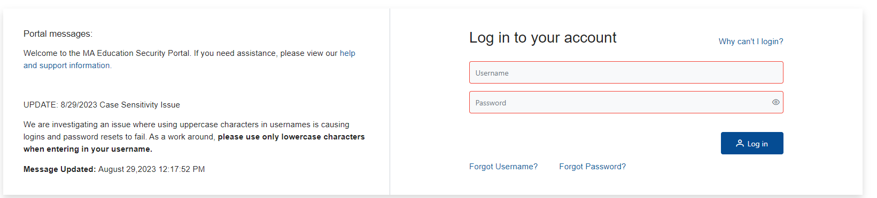
Your CAP username will be new. Your personal ELAR username and password will not enable you to see the cycle assigned to you in the system. When logging in for the first time, please use the “Forgot Password” feature with your username and the email associated with your account to set up a password. Additional resources can be found here.
To begin using the system:
- If you are able to see CAP, but not the candidate cycle assigned to you, you have likely logged in through your personal ELAR account and not your CAP account that was generated when the cycle was started. Please check your email or reach out to the Program Supervisor (PS) or CAP Manager (CM) for information about your username. If you log in with the correct username and are still having issues, please log out and try clearing your web browser’s cache, opening an incognito browser, or use another browser.
- Select the CAP Online Platform from the list of applications.

Role of the SP
The SP has the ability to:
- View candidate progress
- View and complete forms
- Upload evidence
- Communicate with the triad
Private school and out-of-state SPs will not be able to fill out the forms on their own; the CM and the PS will need to complete the forms on their behalf due to access and security concerns.
Navigating the System
Once you have logged in, the SP home page will appear.
On the SP home page, you will be able to:
- View the progress of your candidate throughout their CAP cycle, and
- View the PS assigned to the candidate.
Each row in the table is one candidate’s CAP cycle. The table above provides a snapshot of each candidate’s progress through the components of CAP.
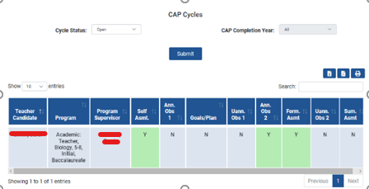

Completing the Observation Forms
Please complete these forms per the CAP Guidelines. First, collaborate with your PS to determine whether you are completing the joint version or the individual version of each form. You will be able to enter information in the “Supervising Practitioner Feedback” box and the “Calibrated Feedback” box. For the joint version of the form, three fields will be shown per element, and only the “Calibrated Evidence” box needs to be complete to finalize the form. If only the SP is filling out the form, only one field per element will be shown.
Joint form (showing the Supervising Practitioner Evidence, the Program Supervisor Evidence, and the Calibrated Evidence):
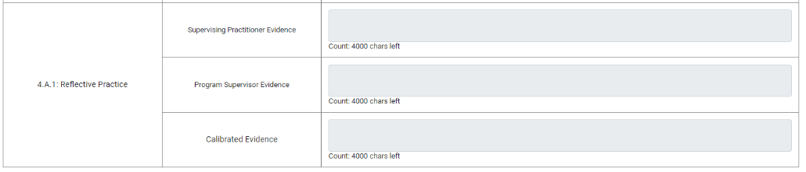
Individual form (showing the singular cell to input evidence:
If the SP is completing the form individually, only the SP needs to select “Complete.” For the joint version of the form, both the PS and SP need to select “Complete” to finalize the form and make it available to the TC. Note: Once you have selected “Complete” the CM must unlock the form for you to be able to make edits.
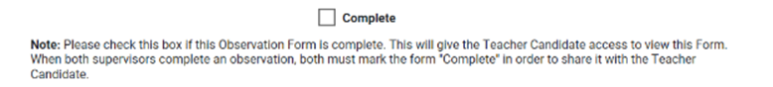
Important Note: Toggling back and forth between who completes the form may result in the deletion of work. If the PS attempts to fill out a form that has been completed by an SP, it will override the original observation. In addition, if both the PS and SP are completing an observation, the calibrated evidence will reflect whoever saved last. To avoid the deletion of work, please communicate well with the PS about who will enter the calibrated evidence.
For information about completing other forms, please see the CAP Online Platform 2.0 User Guide.

