This Quick Guide is intended to facilitate easy access to the CAP online platform. The Quick Guide does not cover all requirements of a CAP cycle, but it highlights some critical details. For more information, please see our CAP Online Platform 2.0 User Guide.

Getting Started
The CAP Online Platform for Teacher Candidates is embedded within the Education Security Portal. The log-in page appears below:
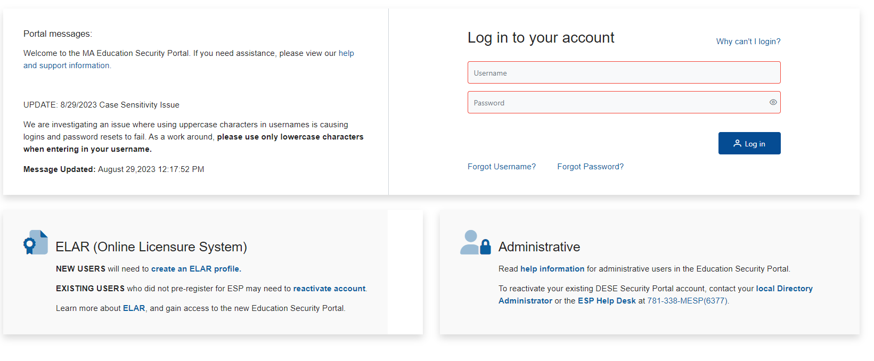
- If you do not already have access to the CAP Online Platform, contact the CAP Manager to request that they start a CAP cycle to provide you with access.
- Log on to Education Security Portal.
- Select the CAP Online Platform from the list of applications. You may need to click into ELAR to see the CAP Online Platform.

Role of the Teacher Candidate (TC)
The TC has the ability to:
- Complete the Rubric Summary and Self-Assessment
- View completed Observation Forms and Formative and Summative Assessments
- Contribute to the Finalized Goal and Implementation Form
- Upload evidence
- Communicate with the triad (teacher candidate, supervising practitioner, and program supervisor)

Completing the Rubric Summary and Self-Assessment
Before the first three-way meeting, you will be responsible for completing the Rubric Summary and Self-Assessment and preliminary Goal-Setting Form. For each of the Seven Essential Elements, select ratings for yourself for Quality, Scope, and Consistency and complete a series of reflective questions. See the CAP Guidelines and the Quick Reference Guide: CAP Rubric for more information.

To complete the Self-Assessment Rubric (Rubric Summary):
- Select Rubric Summary from the navigation bar.
- Select a rating of your performance for each element and click “Next.”
- Once you complete all of the elements, select “Save.”
- Once all Seven Essential Elements ratings are completed, the option to select “Complete Rubric” will appear at the bottom of the final screen. You will not be able to work on your Self-Assessment and preliminary Goal-Setting Form until you have checked the “Complete Rubric” box that will appear once you have completed the rubric.
Once you complete the Rubric Summary, you will move on to the Self-Assessment Form (Self-Assessment).
To complete the Self-Assessment Form:
- Choose “Self-Assessment” from the left-hand navigation bar on your home page. Please save on each page as you go.
- Complete the rest of the form, responding to each prompt and creating a preliminary professional practice SMART goal.
- Once you have completed all portions of the form and are ready to share, click “Complete” at the bottom of the screen as well as “Save.” NOTE: all entries must be completed in order for the “Complete” box to appear. This will make the form available to the PS and SP.
- Your PS and SP will then have the opportunity to review this document. They will accept it or return it to you with feedback to continue working. If the document is returned to you, your Rubric Summary will be unlocked and you can make any applicable edits, after which you must once again select “Complete Rubric” in order to access the Self-Assessment Form. Once you are finished applying any edits, you will need to once again click “Complete” to submit the form.

Completing the Finalized Goal and Implementation Plan
After the PS and the SP approve the Self-Assessment and Goal-Setting Form, you will work as a triad to complete the Finalized Goal and Implementation Plan Form. This form is unique because it is the only form in the system in which all three users share responsibility for completion.
To complete this form:
- The SP, in coordination with the PS, will complete the “Measure of Student Learning” section.
- The PS and the SP will complete the “Implementation Plan” section.
- The TC will complete the “Professional Practice Goal” section, based on the Self-Assessment and Goal-Setting Form.
You will have the opportunity to revise your preliminary goal based on any input provided by your PS and SP during the first Three-Way Meeting.
Once all members of the triad have completed and saved their sections, the PS must select the “Complete” button that will appear on the PS form. Once the form is complete, it cannot be edited.

