Mixed Reality Gateway Task: Leading a Collaborative Parent-Teacher Conference
Candidates will meet with a parent avatar to review their child’s math assessment results and collaboratively develop an academic plan.
This mixed-reality scenario has been adapted to serve as a pre-practicum gateway task to assess candidates’ ability to successfully conduct a collaborative parent-teacher conference. The supplemental materials below include detailed task manager, sim-specialist, and candidate instructions as well as a rubric and must-sees to assess candidate performance. Please read through the full document as implementation of this scenario as a gateway task differs from practice sessions. In particular, while practice sessions are often structured as a fish-bowl activity, gateway tasks should be scheduled such that each candidate only engages with the scenario once and does not observe others’ performance prior to their own.

Relevant Licensure Fields and Grade Levels
- Elementary, 1-6
- Mathematics, 1-6, 5-8
- Middle School: Mathematics/Science, 5-8
- Moderate Disabilities, PreK-8 and 5-12

Alignment to Subject Matter Knowledge

This lesson is aligned to the Massachusetts Mathematics Curriculum Framework. Teacher candidates must demonstrate the necessary depth and breadth of content knowledge needed to support all students in mastering the following content standard:
- Mathematics.6.SP.B.05.c - Summarize numerical data sets in relation to their context, such as by: Giving quantitative measures of center (median, and/or mean) and variability (range and/or interquartile range), as well as describing any overall pattern and any striking deviations from the overall pattern with reference to the context in which the data were gathered.
Alignment to Professional Standards for Teachers

In order to facilitate a culturally responsive conference which engages the parent avatar in collaboratively developing an academic plan, teacher candidates must demonstrate proficiency in the following pedagogical skills:
- III-B Collaboration: Collaborates with families and communities to create and implement strategies for supporting student learning and development both at home and at school.
- III-C Communication: Engages in regular, two-way, and culturally proficient communication with families about student learning and performance.
- I-C: Analysis indicator: Analyzes data from assessments, draws conclusions, and shares them appropriately.

Educator Preparation Task Manager Instructions

This task is designed to be completed during Pre-Practicum Stage 1 because it does not require a candidate to directly engage with students in a PK-12 classroom.
- Book the DESE_FC_Gateway Family Engagement (EdP Custom 1:1) scenario on Mursion’s Platform and add the candidate’s full name in the notes section if you are scheduling on their behalf.
- Calibrate expectations for candidates’ performance by reviewing the “Must Sees” on pages 12-13. Be clear about what a scorer must see in the candidates’ performance in order to select “Meets Expectations.”
- Provide each candidate with the instructions and assessment materials on pages 5-9. Note: These materials are not comprehensive. They are designed to be an easy-to-digest snapshot of the student avatar’s academic performance.
- Use the rubric on pages 10-11 to score the candidate’s performance and written responses. Recommended extension: Have the candidate watch and reflect on a video recording of their session prior to completing the written responses reflecting on their scenario engagement.
- Review all candidates’ performance and submissions, identify trends, and discuss implications or adjustments necessary to continue to support candidate readiness and programmatic continuous improvement.

As a reminder, this gateway task is not intended to be a high stakes assessment for candidates. It is designed to be used as a data point within a constellation of evidence about a candidate’s performance, and the results are intended to be used to identify strengths and areas for growth in specific skills in critical areas of teaching.

Simulation Specialist Instructions

The Simulation Specialist facing instructions are outlined below for Task Manager reference only. This is the full extent of information available for Simulation Specialists prior to engaging in the scenario. Task Managers are not responsible for sharing the instructions in advance as they are embedded within Mursion’s platform.

Scenario: DESE_FC_Gateway Family Engagement (EdP Custom 1:1)

Avatar: Cesar Bolanos (Gabriel’s father)
Environment: Sunny office

Learner Perspective: It is early in the school year and you are about to meet with Cesar Bolanos. His son, Gabriel, is a student in your 6th grade class. You have already informally met Mr. Bolanos at the school’s Fall Open House, but this is your first official parent/guardian-teacher conference of the year. Mr. Bolanos and Gabriel recently moved to this district from another town in MA.

Before the conference, Mr. Bolanos, let you know he would like to discuss Gabriel’s results on the most recent 6th grade classroom quiz, compared to his 5th grade MCAS results from his old school. He has not seen the assessments or results himself, but Gabriel has told him about his performance in your class. Gabriel’s current ​classroom​ scores ​are​ ​below​ ​grade​ ​level,​ but his ​standardized​ ​test scores​ ​from last year at his old school are​ at ​grade​ ​level.

Gabriel has told you that his parents recently got divorced. He spends weekdays with his dad and weekends with his mom, who lives about an hour away. He attends the district’s after school program until Mr. Bolanos gets out of work each day. In class, Gabriel is quiet but participates when called on, especially during science class, which seems to be his favorite subject. He gets along well with his peers and is collaborative.

Avatar’s Perspective: Cesar Bolanos, a recently divorced dad who works full time in sales, does his best to be an involved, active parent. Given his work schedule, Cesar expects Gabriel to do a lot independently. Gabriel is a 6th grader new to the school. He enjoys science, nature, and outdoor activities like skateboarding. Gabriel generally likes school, but is a bit shy and introverted. While Mr. Bolanos has heard of the MCAS from Gabriel’s previous school, at the time his wife always handled those things, so he isn’t very familiar with the test. Gabriel seemed to do well on standardized tests at his old school, but has told his dad that he is not doing well on his 6th grade class assignments. Mr. Bolanos is starting to think his new teacher is too hard on him. He worries that the teacher isn’t seeing Gabriel’s strengths and is worried he will sink into a downward spiral and do poorly at the new school.

What is this scenario intended to address? This scenario provides the opportunity to practice positive engagement with a parent who is attending a parent/guardian conference. The participants will have a potentially difficult or emotionally charged conversation about the academic progress of the student.

Simulation Specialist Goal: Provide practice with a realistic and challenging parent teacher conference.

Learner Goal: Successfully conduct a conference by discussing student progress, addressing Cesar’s concerns, and collaboratively finding solutions:
- Share assessment results with the parent
- Solicit input from the parent on the results
- Develop an academic plan with parental input and agreement

Intensity: Medium
- Medium intensity sessions are meant to challenge the learner and require them to think on their feet.
- In this scenario, Cesar may moderately push back or demonstrate heightened emotions. If the learner does not adequately explain the assessment results, the avatar may question his or her teaching. If the learner does not seek parental input about the results, the avatar will be resistant.

Pushback Techniques:
- Frustration with the teacher not clearly explaining the data or insinuating that Gabriel is “behind” academically. (He will take any sign of failure personally.)
- Cesar is under a lot of pressure at work and trying to make a name for himself in a new market, so he can put the responsibility of Gabriel’s education on the teacher and the school. “If there’s a problem, it’s your job to fix it.”
- Question the teacher or the school’s qualifications, “Look, we came from a really good school district. It seems like this program isn’t as strong. How long have you even been teaching?” “What’s your degree in?”
- He is genuinely concerned for the well being of his son. “I know 6th grade is important.... Does he need tutoring or some other support?”
- If the Learner tries to end the simulation prior to 15 minutes of conversation, then Cesar may push back; he is busy and has made time to be at this meeting so he wants to make sure they are using the full time that he has set aside. “Look, I am taking care of him alone in the week now and working full time and it took me time to get here. If we’re going to meet, let’s meet.”

Additional Information: Gabriel’s test results were not included in the design of this scenario, but Cesar is supposed to be unaware of the specifics. The results the clients will be using are located in the Sim folder for reference when they are “shown”. The avatar should ask questions about the information the learner shares.

Teacher Candidate Instructions

It is early in the school year and you are about to meet with Cesar Bolanos. His son, Gabriel, is a student in your 6th grade class. You have already informally met Mr. Bolanos at the school’s Fall Open House, but this is your first official parent/guardian-teacher conference. Mr. Bolanos and Gabriel recently moved to this district from another town in MA.

Before the conference, Mr. Bolanos, let you know he would like to discuss Gabriel’s results on the most recent 6th grade classroom quiz, compared to his 5th grade MCAS results from his old school. He has not seen the assessments or results himself, but Gabriel has told him about his performance in your class. Gabriel’s current ​classroom​ scores ​are​ ​below​ ​grade​ ​level,​ but his ​standardized​ ​test scores​ ​from last year at his old school are​ at ​grade​ ​level.

Gabriel has told you that his parents recently got divorced. He spends weekdays with his dad and weekends with his mom, who lives about an hour away. He attends the district’s after school program until Mr. Bolanos gets out of work each day. In class, Gabriel is quiet but participates when called on, especially during science class, which seems to be his favorite subject. He gets along well with his peers and is collaborative.

This gateway task is broken into three parts, including responding to written reflection questions prior to and after engaging in the simulation:
- Prior to the simulation: In advance of meeting with Mr. Bolanos, you will prepare to facilitate a culturally responsive and sustaining conversation:
  - Review documents related to Gabriel’s learning (see below), identifying strengths and areas for improvement, and develop initial ideas to support his continued growth
  - Reflect on elements of culturally responsive and sustaining parent-teacher conferences referencing the links above, content from your courses, or your own experiences or research
  - Consider your goals for the conversation and outline a plan for the meeting
  - Reflect on this preparation through the first written reflection prompt

- During the 10-minute simulation: You will meet with Mr. Bolanos to discuss Gabriel’s academic performance ​and collaborate ​to​ ​develop​ ​an​ ​academic​ ​plan​. Remember, Mr. Bolanos has not seen the assessments himself. You will need to describe the tests and explain Gabriel’s results.

When prompted, please provide permission to record your session. The video will be shared with your instructor/professor for scoring purposes.

- After the simulation: You will respond to remaining written reflection prompts to reflect on your meeting with Mr. Bolanos.

Written Reflection Prompts

Prior to the Simulation:
- What are your goals for this meeting? Consider Gabriel’s learning as well as your relationship with Mr. Bolanos.
  - How will your plan for the meeting support these goals?
  - How will your facilitation center culturally responsive and sustaining practices?

After the Simulation:
- Were you able to successfully collaborate with Mr. Bolanos to identify shared priorities and develop a joint plan to support Gabriel’s continued growth?
  - How did your plan evolve over the course of the conversation?
  - Was the plan informed by Mr. Bolanos’s hopes for and knowledge of his son?
  - Did your contributions serve as initial ideas or definitive conclusions?
  - What might you do differently next time?

- How did you navigate power and identity dynamics during this conversation?
  - What were some assumptions you had about Mr. Bolanos before the conversation?
    - How did that impact your approach when planning for the meeting and engaging with him?
    - How did those assumptions show up in your behavior or affect the meeting dynamics?
    - What might you do differently in the future to ensure biases and assumptions do not interfere with your ability to connect with parents?
  - What power and identity dynamics were at play during the conversation? How did you mitigate them?
    - What proactive decisions did you make while planning?
    - What choices did you make in-the-moment?
    - What might you do differently next time?

- How do you feel this conversation impacted your relationship with Mr. Bolanos?
  - Were there specific moments that you believe built trust, connection, and collaboration?
  - Were there specific moments that you believe damaged trust, connection, and collaboration?
  - How would you plan to continue to strengthen this relationship over time?

Assessment Materials

Grade 5 MCAS Test
Parent/Guardian Report

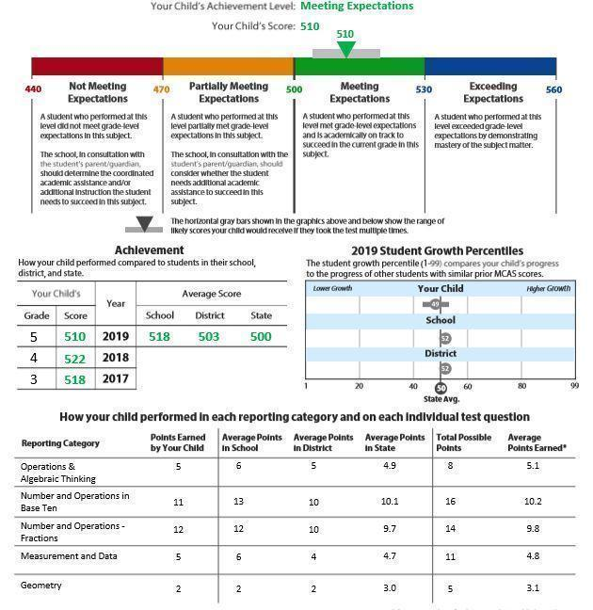
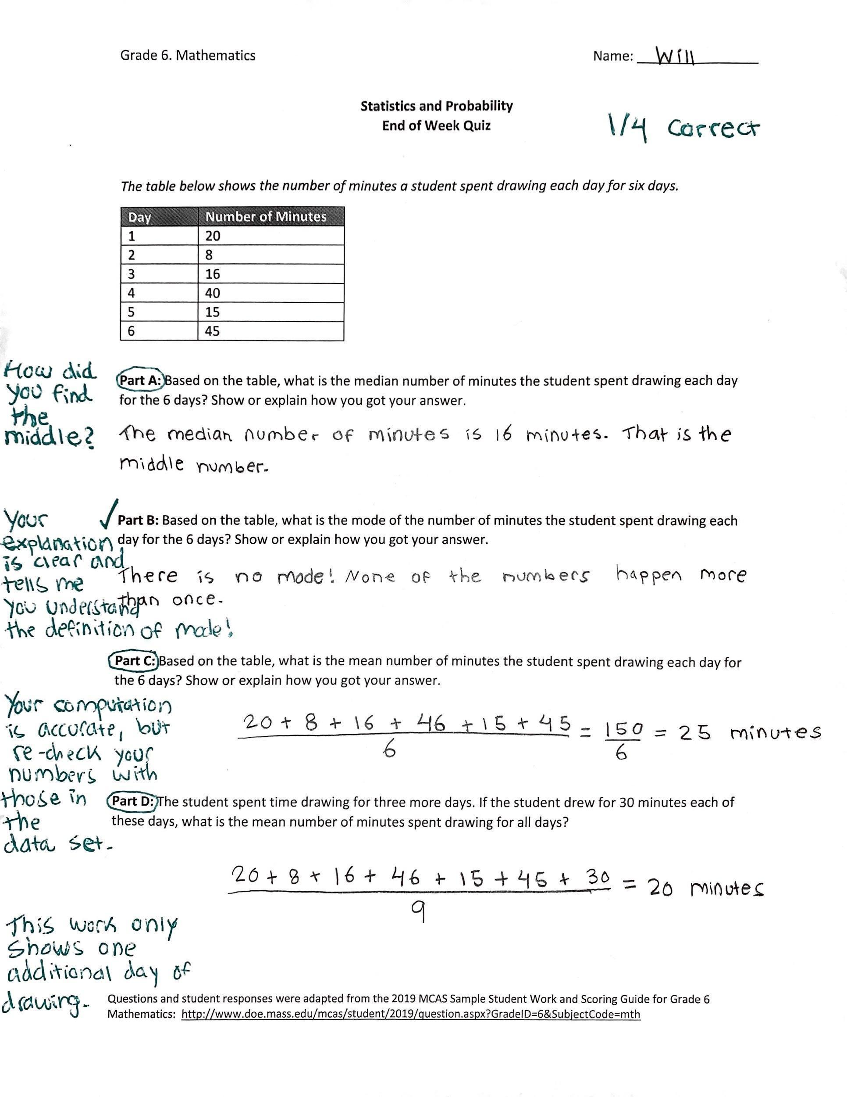

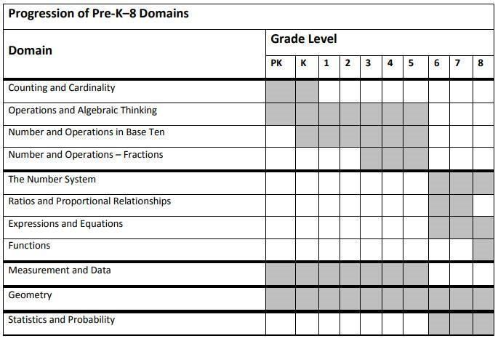

Scorer Rubric

The candidates’ scenario performance and written responses will be scored according to the following criteria:
Criteria | Not Meeting | Approaching | Meeting
Candidate creates a welcoming dynamic that establishes a positive relationship with the parent, minimizes power dynamics, and is culturally responsive and sustaining | - Candidate creates an environment that is unwelcoming and does not support relationship-building  - Candidate interrupts, makes assumptions, or shuts the parent down  - Candidate maintains strict power dynamics by acting as the bearer of knowledge or speaking down to the parent  - Candidate utilizes a deficit-based approach when speaking about the student and family | - Candidate creates a welcoming, but overly formal or transactional, environment, with limited relationship-building  - Candidate listens, but responses feel perfunctory or performative  - Candidate states that they are partners, but maintains formal power dynamics  - Candidate utilizes a neutral -approach when speaking about the student and family | - Candidate takes time to build a relationship, express gratitude, and encourage partnership  - Candidate listens actively, affirms what is shared, and engages in genuine dialogue  - Candidate interacts with the parent as a partner, speaking with them as an equal contributor  - Candidate utilizes an asset-based approach when speaking about the student and family
Candidate interprets ​assessment​ ​results​ accurately and clearly explains student performance | - Candidate provides an inaccurate or absent explanation of assessment results and context  - Candidate does not share student strengths or areas for improvement, focuses only on areas for improvement, or indicates that expectations should be lowered for Gabriel  - Candidate shuts down or minimizes parent questions | - Candidate provides a confusing or partially inaccurate explanation of assessment results and context  - Candidate shares general student strengths and areas for improvement, with under or over emphasis on high expectations  - Candidate responds to parent questions if they are raised | - Candidate provides a clear, accurate, and parent-friendly explanation of assessment results and context  - Candidate references specific student strengths and areas for improvement, celebrating understanding and growth while holding high expectations  - Candidate welcomes and fully responds to parent questions
Candidate partners with the parent to develop an appropriate and actionable academic plan to support student learning | - Candidate frames the meeting as a mechanism to present a predetermined plan  - Candidate leads a one-sided meeting with limited to no solicitation of parent input  - Candidate does not contribute any ideas or dictates a rigid plan and is not open to adaptations  - By the end of the meeting, the plan and next steps are unclear, there is no reference to ongoing communication | - Candidate frames the meeting as time to review and make tweaks to an outlined plan  - Candidate offers some opportunities for parent input, mostly in response to their own ideas  - Candidate makes minor changes, but the plan remains largely unchanged  - By the end of the meeting, the plan and next steps are loose, there may be a reference to ongoing communication | - Candidate frames the meeting as a collaborative effort to develop a plan together  - Candidate consistently acknowledges, invites, and internalizes parent expertise and ideas  - Candidate shares initial ideas, but they evolve in partnership with the parent  - By the end of the meeting, a plan, next steps, and preferences for ongoing communication are clear

Comments

Must-Sees for Scorer Calibration

Prior to administering this task, scorers are advised to calibrate around what it means to “Meet” expectations. The form below is an “answer key” specific to this mixed-reality scenario and associated assessment materials. Rather than outlining all possible outcomes, the form identifies the “must-sees” that must be present in a candidate’s performance and written responses in order for them to receive a rating of “Meets Expectations” for each criterion.

Criteria | Meeting Expectations | What Must You See in a Candidate’s Scenario Performance or Written Reflection in order to Mark Meeting Expectations?
Candidate creates a welcoming dynamic that establishes a positive relationship with the parent, minimizes power dynamics, and is culturally responsive and sustaining | - Candidate takes time to build a relationship, express gratitude, and encourage partnership  - Candidate listens actively, affirms what is shared, and engages in genuine dialogue  - Candidate interacts with the parent as a partner, speaking with them as an equal contributor  - Candidate utilizes an asset-based approach when speaking about the student and family | - Candidate greets Mr. Bolanos, introduces him or herself by name, and asks what the parent would like to be called  - Candidate’s body language is open and connected (leans in, smiles, makes eye contact)  - Candidate makes space for parent contributions - pausing for responses, soliciting input, and pivoting based on what is shared  - Candidate shows signs of active listening (nods, asks follow-up questions, restates what they heard, builds onto ideas, references prior comments)  - Candidate shares positive updates about Gabriel (enjoys science, quiet but engaged, gets along well with peers)  - Candidate thanks parent, expresses gratitude for contributions
Candidate interprets ​assessment​ ​results​ accurately and clearly explains student performance | - Candidate provides a clear, accurate, and parent-friendly explanation of assessment results and context  - Candidate references specific student strengths and areas for improvement, celebrating understanding and growth while holding high expectations  - Candidate welcomes and fully responds to parent questions | - Candidate explains that the MCAS is summative and the quiz is formative  - Candidate represents MCAS performance as meeting expectations each of last three years, with a slight dip in the most recent year  - Candidate explains that statistics and probability is brand new 6th grade content that was not taught or assessed in 5th grade  - Candidate explains what Gabriel is currently able to do well (understands definitions, good computation) and what he is currently struggling with (showing and organizing his mathematical thinking, moving quickly and mis-representing numbers in computation - i.e 46 instead of 40)  - Candidate’s language is clear and does not rely on educational jargon, but also doesn’t over-simplify explanations or talk down to Mr. Bolanos  - Candidates responses validate parent questions and concerns
Candidate partners with the parent to develop an appropriate and actionable academic plan to support student learning | - Candidate frames the meeting as a collaborative effort to develop a plan together  - Candidate consistently acknowledges, invites, and internalizes parent expertise and ideas  - Candidate shares initial ideas, but they evolve in partnership with the parent  - By the end of the meeting, a plan, next steps, and preferences for ongoing communication are clear | - Candidate uses collaborative language  - “We are a team”  - “Work together to generate ideas”  - “Hoping we can co-create a plan”  - Candidate offers initial suggestions specific to stated areas for improvement (strategies for modeling thinking, organizing work, checking over work)  - Candidate’s ideas include ways to build on Gabriel’s existing knowledge/strengths and celebrate small wins  - Candidate explicitly seeks out input and refers back to what was shared  - “What are you noticing at home?”  - “What worked well last school year?”  - “What do you think Gabriel needs?”  - “You know Gabriel best…”  - “Please stop me if you have questions”  - “Earlier you mentioned…”  - Candidate is willing to re-evaluate his or her own evidence and ideas  - “Based on what you shared…”  - “That was really helpful information”  - “What if we…instead?”  - “I want to incorporate your idea to…”  - Candidate reiterates the agreed upon plan and confirms that Mr. Bolanos feels it is clear and realistic  - Candidate explicitly plans for ongoing communication and asks Mr. Bolanos what frequency/format will work best for him

According to the Guidelines, given the necessity to scaffold early field-based experiences in order to meet the developmental needs of individual candidates and build towards full readiness for the licensure role, the pre-practicum may be considered to include two, potentially overlapping, stages. Stage 1 supports a candidate’s initial introduction to the PSTs and SMKs through activities such as guided observations, mixed-reality simulations, and mock teaching embedded into coursework.
The must-sees for this gateway task were modeled after and informed by Julie Cohen and Vivian Wong’s (2019) work at Teach SIM

