2014-2015 Educator Preparation
Formal Review Cycle
Culminating Report

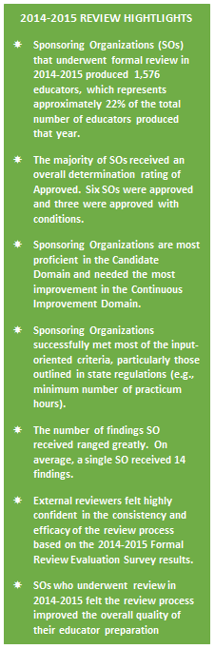
Executive Summary
The Massachusetts Department of Elementary and Secondary Education (ESE) believes that regular program review ensures continued growth, improvement, and ultimately, educator preparation provider effectiveness. ESE is committed to ensuring that preparation in Massachusetts results in effective educators ready to support the success of all students. We are pleased to release the 2014-2015 Formal Review Culminating Report, which documents the trends and lessons learned as a result of the 2014-2015 cohort of reviews. This report demonstrates the state’s commitment to transparency, to share best practices when identified, to reflect on ESE’s own efficacy in executing reviews, and to inform the field of educator preparation by identifying common areas of growth as they relate to ESE’s Program Approval Criteria. More specifically, we produced this report so that:
- Sponsoring Organizations (SOs) that underwent review in 2014-2015 can see how their individual results fit into the cohort of SOs that participated in review.
- Other Sponsoring Organizations not under review can observe trends relative to this small subset of SOs and begin to think and prepare more effectively relative to their own practices.
- Interested stakeholders are provided with a glimpse into the field of educator preparation in Massachusetts.
It is important to note that this report is not designed to be representative of all organizations in the state. This is a summary report of those that participated in review. Therefore, conclusions in this report should not be generalized to all SOs in the Commonwealth. Additionally, in an effort to ensure that SOs are able to focus primarily on making improvements as a result of the review, individual organization data is not provided. All results are shared only in the aggregate.

Major Takeaways
The majority of Sponsoring Organizations under review in 2014-2015 are meeting the rigorous expectations outlined by the state and are well-serving candidates.
- 6 were Approved.
- 3 were Approved with Conditions.

Chart 1.1: Approval Statuses of SOs under review in 2014-2015
Sponsoring Organization | Approval Status
American International College | Approved with Conditions
Berklee College of Music | Approved with Conditions
Boston University | Approved
Catherine Leahy Brine | N/A – rescheduled due to blizzard
City on a Hill | Approved with Conditions
Collaborative for Educational Services | Approved
MATCH | Approved
Northeastern University | Approved
PRISM Education Consultants | N/A - Expired
Springfield Public Schools | N/A - Expired
UMass Amherst (NCATE) * | Approved
Wheelock College (NCATE) * | Approved
*- these two programs underwent review according to partnership agreements with national accreditation agencies. As a result, this report primarily provides data on seven SOs who underwent formal review in 2014-2015.

Sponsoring Organizations were most often found to need improvement in the area of Continuous Improvement.
The 2012 Program Approval Standards placed a new emphasis on the expectations associated with organizations’ efforts to continuously improve; so, in some ways, this result is not unsurprising. It does, however, signal an important area of focus for all providers. Many SOs even self-identified this as an area under development within their organizations. The review did find that many SOs struggled to put in place the resources and infrastructures necessary to support this work and had not yet begun to consistently use data to inform strategic decisions within the SO. Findings in this area also indicate that organizations may not be monitoring individual program efficacy for quality assurance as robustly as is expected by the state.
- 43% of SOs received a rating of Unsatisfactory in this domain.
- 29% of SOs received a rating of Needs Improvement.
- 14% of SOs received a rated on Proficient.
- 14% of SOs received a rating of Exemplary.
To further support SOs, ESE plans to build out more Edwin Analytics Reports, develop and disseminate more stakeholder perception surveys, and build an early indicator system to benchmark provider performance. While this will give providers more and better access to data, it will still require that SOs use the data and information to drive improvement within their organization.

The majority of Sponsoring Organizations were unable to meet expectations for the training, support and development of Supervising Practitioners and Program Supervisors.
- This was the most common finding. 86% of SOs received a finding on the criterion: “Supervising Practitioners and Program Supervisors receive training, support and development from the SO that impacts candidate effectiveness” in the Field-Based Experience Domain.
The expectation from the state has been heightened because of the new Candidate Assessment of Performance and candidates’ anticipated levels of readiness. Two difficulties that SOs frequently cited were encouraging supervisors to participate in training that was offered and training that focused on logistics (e.g., paperwork expectations) rather than skill development that could be linked directly to improving candidate practice. To support SOs in this area, ESE plans to work with the field to establish a certification mechanism for Program Supervisors that can be used to train and assess the ability of individuals to provide high-quality feedback and support to candidates. In addition, ESE has released CAP training modules that can be used as a piece of a supervisor training.

ESE implemented a review process that is efficient, effective, and consistently rigorous.
“Overall I am impressed with the DESE Ed Prep team effort and see the program being a learning tool to create a consistent vision as well as checks and balances to best ensure quality teacher prep across the state.”
~ Ed Prep Reviewer
Overall, we are pleased with the evidence-based judgments that were made during the 2014-2015 reviews, but we recognize there are aspects of the process that require ongoing attention and revision (see Conclusion section for more details).
Overall, we were pleased with the evidence-based judgments that were made during the 2014-2015 reviews. In general, the external reviewers and SOs who participated in the review agreed that the state has a process that is efficient, effective and consistently rigorous:
- 100% of SOs (n=7) that participated in review agreed that the Ed Prep formal review process generated conversations about quality educator preparation at their respective organization.
- 71% of SOs (n=7) agreed that their organization will better prepare educators as a result of engaging in the Formal Review Process.
- 81% of reviewers surveyed (n=32) felt highly confident that the review process implemented at the organization they reviewed was consistent with the other organizations in the state. No reviewers expressed low confidence in either the consistency or efficacy of the review process.
Overall, results from the first implementation of this new process indicate that ESE is making progress in balancing the expectation of improvement and the requirement of accountability across the state. While baseline comparisons from previous iterations of state reviews are unavailable, we believe that this cohort of reviews resulted in the greatest extent of differentiation within and among organizations. ESE will continue to work with the field to improve the process as well as support the efforts to improve the quality of preparation delivered to candidates in the state.

Questions about the information contained in the report should be directed to ESE’s Educator Preparation Team at edprep@doe.mass.edu.
Table of Contents
Executive Summary 1
Major Takeaways 2
Cohort Background Information 5
Organization Type 5
Completion and Employment Rates 5
Type of Programs 6
Number of Programs 7
Summary Judgments 8
Overall Approval Status 8
Sponsoring Organization Expirations 8
ESE Approval & National Accreditation 8
Domain Ratings 9
Criteria Ratings 10
Commendations 10
Criteria Met 11
Diversity Criteria 12
Findings 13
Evaluation of the Process 14
Formal Review Consistency 14
Reviewers 14
Sponsoring Organizations 15
Formal Review Efficacy 16
Sponsoring Organizations 16
Focus Group Participants (Candidates) 17
Formal Review Efficiency 17
Time & Cost Estimates 17
Conclusion 18
Appendix A: Review Context 19
Standards and Process 19
Standards 19
Process 20
Decision-making and Approval Statuses 21
Appendix B: 2014-2015 Program Approval Criteria List 23
Appendix C: Data Snapshots 26

Cohort Background Information
Prior to reviewing the results of this culminating report, it is helpful to know the context of individual providers in the cohort. The information below will provide background on the type, size, employment rates, etc. for each organization under review. This data, of course, provides an incomplete picture of each organization and is included here only to provide context for the reviews. The data profile for each Sponsoring Organization can be found in the Data Snapshots included in Appendix C.

Organization Type
Out of the 12 Sponsoring Organizations (SOs) scheduled for review, six are Institutions of Higher Education and six are alternative providers.

There was equal representation between Institutes of Higher Education and alternative providers among the 12 SOs that participated in formal review in 2014-2015. Regardless of SO type, organizations are held to the same standards and go through the same review process (see Appendix – for details about the review process).

Completion and Employment Rates
In 2011-2012, Sponsoring Organizations that underwent formal review produced 1,576 educators, which represents approximately 22% of the total number of educators produced that year by all sponsoring organizations (n=7,014).

Chart 2.1: Number of Completers and Employment Rates in Massachusetts Public Schools for SOs under Review, 2011-2012
Sponsoring Organization | # of Completers | Employment Rate
American International College | 540 | 87%
Berklee College of Music | 15 | 33%
Boston University | 288 | 42%
Catherine Leahy Brine | 105 | 95%
City on a Hill | 5 | n/a
Collaborative for Educational Services | 77 | 87%
MATCH Charter Public School | 23 | 52%
Northeastern University | 170 | 58%
PRISM Education Consultants | 20 | 95%
Springfield Public Schools | 14 | 97%
UMass Amherst | 200 | 49%
Wheelock College | 119 | 55%
Total: | 1,576 | 68%

Type of Programs
Sponsoring Organizations varied in size in terms of licensure types and fields. The number of programs ranged from one to 61. Most programs under review were initial teacher licensure programs.

Table 2.2 and Table 2.3 show the number of programs, licensure types and licensure fields for each SO. It is important to note that these are the number of programs each SO had at the beginning of the review. It does not account for new or expired programs.

Chart 2.2: Licensure Types of Programs at SOs at the Beginning of the Review, 2013-2014
Sponsoring Organization | # Initial | # of Professional | Total
American International College | 26 | 3 | 29
Berklee College of Music | 1 | 0 | 1
Boston University | 59 | 0 | 59
Catherine Leahy Brine | 35 | 26 | 61
City on a Hill | 9 | 0 | 9
Collaborative for Educational Services | 24 | 0 | 24
MATCH Charter Public School | 19 | 0 | 19
Northeastern University | 33 | 2 | 35
PRISM Education Consultants | 14 | 0 | 14
Springfield Public Schools | 21 | 0 | 21
UMass Amherst | 50 | 2 | 52
Wheelock College | 8 | 4 | 12
Total: | 299 | 37 | 336

Chart 2.3: Licensure Field of Programs at SOs at the Beginning of the Review, 2013-2014
Sponsoring Organization | # of Teacher | # of Admin | # of Support Staff | # of Specialist | Total
American International College | 20 | 5 | 3 | 1 | 29
Berklee College of Music | 1 | 0 | 0 | 0 | 1
Boston University | 49 | 6 | 2 | 2 | 59
Catherine Leahy Brine | 61 | 0 | 0 | 0 | 61
City on a Hill | 9 | 0 | 0 | 0 | 9
Collaborative for Educational Services | 23 | 0 | 0 | 1 | 24
MATCH Charter Public School | 19 | 0 | 0 | 0 | 19
Northeastern University | 26 | 3 | 5 | 1 | 35
PRISM Education Consultants | 14 | 0 | 0 | 0 | 14
Springfield Public Schools | 21 | 0 | 0 | 0 | 21
UMass Amherst | 46 | 2 | 2 | 2 | 52
Wheelock College | 11 | 0 | 0 | 1 | 12
Total: | 300 | 16 | 12 | 8 | 336

Number of Programs
Because of triggers built into the review, there was a 38% decrease (from 393 to 245) in the number of programs under review in the 2014-2015 cycle.

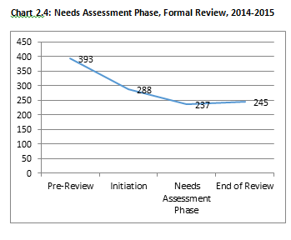
The sharpest decrease in the number of programs approved at each Sponsoring Organization occurred during the initiation phase of the review (see Chart 2.4). At this phase, ESE requires that SOs assess the breadth and depth of their program offerings, particularly for largely dormant programs. SOs then choose which program(s) to expire or attempt to demonstrate a need for. Through this process, SOs opted to discontinue 105 programs that were either low or zero-enrollment.
During the Needs Assessment phase, SOs must demonstrate state-specific need for the program as well as the ability to meet that state-specific need. This is an effort to preserve the state’s capacity to review programs and to ensure that programs have the necessary capacity to produce effective educators. Please see the Needs Assessment Policy Advisory for more information. Fifty-one programs were discontinued at this phase.
There were eight new programs approved as part of the formal review in 2014-2015, leaving 245 total programs approved to be included as part of the review.

Summary Judgments

Overall Approval Status
The majority of Sponsoring Organizations received an overall determination rating of Approved. Overall, six SOs were Approved and three were Approved with Conditions.

Chart 3.1: Overall Approval Status, Disaggregated, Formal Review 2014-2015
Sponsoring Organization | Approval Status
American International College | Approved with Conditions
Berklee College of Music | Approved with Conditions
Boston University | Approved
Catherine Leahy Brine | N/A – rescheduled due to weather
City on a Hill | Approved with Conditions
Collaborative for Educational Services | Approved
MATCH Teacher Residency | Approved
Northeastern University | Approved
PRISM Education Consultants | N/A – Expired
Springfield Public Schools | N/A – Expired
UMass Amherst (NCATE) | Approved
Wheelock College (NCATE) | Approved

Sponsoring Organization Expirations
While under the process of review, two organizations decided to no longer be an SO in Massachusetts and formally ceased operation. Those SOs are PRISM Education Consultants and Springfield Public Schools. The decision to expire approval was made by each provider. PRISM withdrew following the Needs Assessment phase of the review and Springfield Public Schools withdrew after submitting an initial offsite folio.

ESE Approval & National Accreditation
The Council for the Accreditation of Educator Preparation (CAEP) is the recently consolidated body governing national accreditation in the U.S. However, in the 2014-2015 academic year, there were two organizations that pursued national accreditation according to the state’s 2007 partnership agreement with the National Council for the Accreditation of Teacher Education (NCATE). These NCATE legacy visits, as they are referred to by CAEP, occurred at Wheelock College and The University of Massachusetts Amherst. Under this partnership agreement, several components of the state process of review (as outlined in Appendix A) are altered. Most significantly, NCATE’s standards (2008 NCATE Standards) and protocols were the primary ones used in the review. ESE worked closely with the SOs and NCATE to implement a review in accordance with partnership agreement, while also supporting the changing context within the state (2012 standards) and NCATE (transition to CAEP). We are grateful to our organizations for their support in the transition. However, because ESE did not execute the full state review process (particularly in terms of onsite protocols) with these two organizations, we have excluded them from the trends analysis that follows.

Domain Ratings
Domains are the major categories upon which organizations are evaluated. There are five domains that are assessed at the organization level.
- The Organization (ORG): Is the organization set up to support and sustain effective preparation?
- Partnerships (PAR): Is the organization meeting the needs of the PK-12 system?
- Continuous Improvement (CI): Is the organization engaging in continuous improvement efforts that result in better prepared educators?
- The Candidate (CAN): Is the candidate’s experience in the program contributing to effective preparation?
- Field-Based Experiences (FBE): Do candidates have the necessary experiences in the field to be ready for the licensure role?

Sponsoring Organizations are most proficient in the Candidate Domain and needed the most improvement in the Continuous Improvement Domain.

Over half of organizations that participated in formal review received a Proficient rating in the Candidate domain (see Chart 3.2). The majority of SOs received a rating of Needs Improvement or Unsatisfactory in the Continuous Improvement domain. The Organization domain had the most inconsistency. About half of SOs received a rating of Proficient and the other half received a rating of Unsatisfactory.
The following bar graph shows overall domain ratings in the aggregate by domain for seven Sponsoring Organizations. 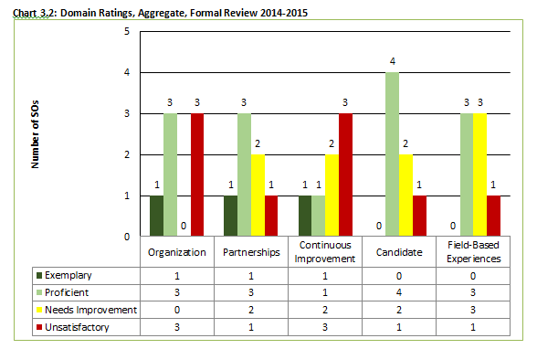
Criteria Ratings

Commendations
During the 2014-2015 reviews, ESE awarded 13 commendations to Sponsoring Organizations. There were no trends in commendations across reviews. Commendations are reserved for truly exceptional, innovative or outstanding practices and are awarded at the criterion level. In order for ESE to award a commendation, it also requires compelling evidence, particularly evidence of impact associated with the criteria. Two of the practices that received commendations are highlighted below.
Commendation Spotlight: Full Year Field-Based Experience at City on a Hill
Criteria: Candidates participate in field-based experiences that cover the full academic year.
City on a Hill’s Urban Teaching Fellowship is an on-site licensure program in which candidates are fully immersed in a school while taking graduate courses toward a Master’s degree in Education. The school year starts early for the Fellows; they arrive in mid-August and participate in “Freshmen Academy,” a two-week orientation for incoming ninth graders. During this time, they observe classes; participate in professional development sessions; and begin the Urban Teaching Seminar, a yearlong course taught by the Director of Certification. Their immersion continues when they participate in faculty orientation as full members of their department. And once the school year begins, they are fulltime employees of the school—apprenticing under a mentor teacher, slowly ramping up to taking full responsibility of two classes for the entire second half of the school year. During an onsite focus group interview, one previous completer said, “By the end of the Fellowship, you feel it was a year of successful teaching.” - City on a Hill
Commendation Spotlight: Supervisor Training at Match Teacher Residency
Criteria: Supervising Practitioners and Program Supervisors receive training, support and development from the SO that impacts candidate effectiveness.
The Match Teacher Residency (MTR) training for Supervising Practitioners addresses three key goals: (1) develop a clear instructional vision and vocabulary that’s aligned to and coherent with the practices that residents learn in their coursework; (2) facilitate coaching sessions that isolate high-leverage growth goals for residents, and then maximize the amount of time spent practicing and planning for the implementation of action steps; and (3) foster growth mindset through having frequent, transparent conversations with their residents about how they’re implementing feedback. MTR has developed detailed training manuals for coaches that include descriptions of core instructional practices, as well as numerous video clips of coaches facilitating feedback sessions. New coaches spend upwards of 12 hours working through this manual independently and submitting pre-work so program leaders can check their understanding of key concepts before they even come to an in-person training. The in-person sessions take place over two days and are focused primarily on watching video of classroom practice and then role-playing coaching sessions. MTR’s full-time director of coaching provides frequent on-going feedback to coaches using a rubric that outlines six core competencies. Every piece of feedback that is provided to candidates is catalogued and reviewed by the director of coaching. Additionally, coaches receive weekly feedback from the residents they coach via online surveys. - Match Teacher Residency

Criteria Met
Sponsoring Organizations most commonly met input-oriented criteria, particularly those outlined in state regulations (e.g., minimum number of practicum hours).

SOs most commonly met criteria outlined in regulations (e.g., minimum number of practicum hours). These criteria make it very clear what action SOs must take in designing the educator preparation program. For example, the criterion met by all SOs who participated in formal review in 2014-2015 was the criteria: “Practicum hours meet regulatory requirements as per 603 CMR 7.04 (4).” Given the regulatory nature of these criteria, they tend to be focused on the inputs of the provider rather than assessing the outcome or quality.
Beyond the input-oriented criteria, there were two criteria that were also commonly met across SOs.
Chart 3.3: Most Commonly criteria met, Formal Review 2014-2015
Domain | Criteria | Frequency
Organization | Faculty/instructors have current knowledge and experience in the content they teach. | 6 of 7 SOs met this criteria
Partnerships | Sponsoring Organization responds to district/school needs through focused recruitment, enrollment, retention, and employment (e.g., placement agreement with local district) efforts. | 6 of 7 SOs met this criteria

In the instance of both criteria outlined above, ESE and the review teams relied heavily on the evidence from stakeholders collected through surveys and focus groups. An SO would not have been deemed to meet these criteria if, for instance, their PK-12 partners could not provide specific examples of the ways in which providers had in fact been responsive to their needs.
Other than the trends outlined above, there did not appear to be a consistent pattern or distribution of criteria met across organizations. It was typical, however, to see themes and trends emerge within a provider as it pertains to the types of criteria that were met, commended or issued findings.

Diversity Criteria
Per the recommendations outlined by the Massachusetts Advocates for Diversity in Education (MADE) Taskforce, ESE was advised by MADE to “increase the transparency and accountability of preparation program efforts to diversify their enrollment and program completion.” In accordance with this recommendation, ESE has agreed to publish results of reviews pertaining to diversity criteria. For the criteria: “Recruitment efforts yield a diverse candidate pool,” the review resulted in four findings and three criteria met ratings in this area.
Specific demographic information for each provider can be found in the Data Snapshots as well as the ESE Profiles.

Findings
There was a wide range in the number of findings given to a single Sponsoring Organization. On average, a single SO received 14 findings.

Findings are areas of concern that require corrective action. Findings impact an SO’s overall approval status. SOs received the following five findings with the most frequency:
Chart 3.4: Most Common Findings, Formal Review, 2014-2015
Domain | Criteria | Frequency
Field-Based Experiences | Supervising Practitioners and Program Supervisors receive training, support and development from the SO that impacts candidate effectiveness. | 6 of 7 SOs did not meet this criteria
Candidate | Structures and processes ensure that candidates receive effective advising throughout the program. | 5 of 7 SOs did not meet this criteria
Continuous Improvement | The consistent and ongoing use of internal and external evidence, including ESE data, informs strategic decisions that impact the SO, the education programs, candidates and employing organizations. | 5 of 7 SOs did not meet this criteria
Organization | Systems/structures that support collaboration within departments and across disciplines improve candidate preparation. | 4 of 7 SOs did not meet this criteria
Partnerships | Sponsoring Organizations evaluate partnerships on an ongoing basis, sustain those that are effective and take steps to improve those that are not. | 4 of 7 SOs did not meet this criteria

Interestingly, there is equal distribution of findings among the five main domain areas (Organization, Partnerships, Continuous Improvement, Candidate, and FBE) relative to findings issued. What the data suggests then is that instead of the quantity of findings in any one area determining the domain rating, it is rather the magnitude or impact of individual findings that matter more in determining the overall domain rating or approval determination.
The area that needs most improvement is training for Supervising Practitioners and Program Supervisors. Only one SO met this criterion during this review cycle. The SO that met this criterion received a commendation in this area because of evidence that suggested that the training Supervising Practitioners and Program Supervisors received not only made them better mentors, but also better teachers themselves (see Commendations section for more details).

Evaluation of the Efficiency, Efficacy, and Consistency of the Process
In building and implementing a new system of review and accountability in the Commonwealth, ESE articulated three principles around which the process would be built. Any decision about the review process is made in support of one or more of these principles. The principles require ESE to deploy a review system that is:
- Consistent: within and across organizations both in terms of execution as well as the calibration of results.
- Effective: builds a solid evidentiary base for decision-making and appropriately differentiates within and among organizations.
- Efficient: streamlined, targeted and systematic; any investment of efforts leads to improved outcomes
ESE seeks to measure our own efficacy as it relates to these three areas. At the conclusion of the review process, ESE surveys all Sponsoring Organizations (SOs) who participated in formal review and external reviewers who assisted in carrying out the review. We are committed to continually improving the Formal Review Process for Educator Preparation Programs. The following sections outline the findings of the 2014-2015 formal review evaluation survey.

Formal Review Consistency

Reviewers
External reviewers felt highly confident in the consistency and efficacy of the review process based on the 2014-2015 Formal Review Evaluation Survey.

In implementing the 2014-2015 formal reviews, ESE relied greatly on the strength of individuals selected to serve as reviewers. Approximately half of the volunteer reviewer cohort was comprised of teachers or administrators from the PK-12 sector. The others were representatives from Sponsoring Organizations. Across all reviews, reviewers were highly favorable about their experience:
“Overall I am impressed with the DESE Ed Prep team effort and see the program being a learning tool to create a consistent vision as well as checks and balances to best ensure quality teacher prep across the state.”
~ Ed Prep Reviewer
- Approximately 69% of reviewers (n=32) were highly confident that the judgments made by the review team were consistent and calibrated with those made for other organizations in the state.
- 78% of reviewers (n=32) said they felt highly confident in the judgments made during the review.

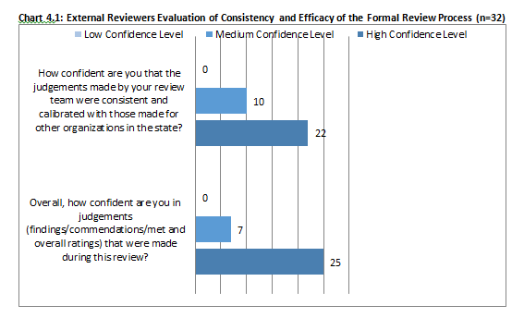

Sponsoring Organizations
Overall, Sponsoring Organizations felt highly confident about the consistency and efficacy of the Formal Review Process. However, unlike the external reviewers who were overwhelmingly confident, there was more variation in the results across the organizations.

Approximately 75% of SOs (n=8) felt highly confident that the judgments made were consistent and calibrated with those made for other organizations in the state. This indicates to us that there are sufficient structures in place within the process that make it evident that ESE is executing the reviews consistently across providers. Two SOs, however, did express low confidence in both these areas. SOs that received less favorable reviews, resulting in either significant findings or conditions, disagreed more often with the process and ultimately the judgments reached by the review team and ESE. Similarly, SOs that received full approval, despite also receiving findings, tended to express greater confidence in the consistency and efficacy of the review.
We found a similar pattern for the question about the overall consistency of the review process itself (Chart 4.2). Approximately 75% of SOs (n=8) were highly confident that the review process was consistent with that of other organizations in the state. While the majority of survey respondents were highly confident, there were individual cases of organizations expressing medium to low confidence in the consistency of the process across organizations.
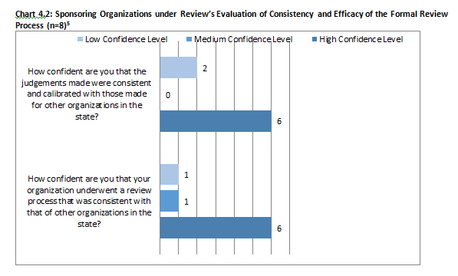

Formal Review Efficacy

Sponsoring Organizations
SOs who underwent review in 2014-2015 felt the review process improved the overall quality of their educator preparation programs.

- 86% agreed that the information contained within the review report would inform continuous improvement efforts within the organization.
- Approximately 71% of SOs agreed that their organization will better prepare educators as a result of engaging in the Formal Review process.
- 57% agreed that the judgments made in the report were based on evidence.
- 71% agreed that the criteria used to evaluate SOs articulated important aspects/components that are important to consider in the effective preparation of educators.
- 100% of SOs that participated in a review agreed that the Ed Prep formal review process generated conversations about quality educator preparation at their respective organization.

In comments, a two SOs encouraged ESE to pursue practices in the evaluation process that align more fully with a comprehensive research endeavor (although specific suggestions were not provided). Additionally, one concern raised in a few instances was the reliance on evidence generated through the onsite focus groups. Some individuals indicated that this evidence, which ESE considers evidence of impact, was weighted too much in the ultimate judgments. Overall, the majority of organizations stated that the process was transparent, supportive of their efforts, and ultimately, was a productive experience.

Focus Group Participants (Candidates)
In the 2014-2015 reviews, approximately 193 candidates and completers participated in focus groups across six SOs. At the end of each focus group, ESE asks participants to rate the experience of participating in the focus group. After analyzing this efficacy data for candidates and completers (the largest stakeholder group interviewed during onsite visits that generates evidence of impact), we found that:
- 79% of candidates and completers (n=193) agreed that during the focus group, they were asked to consider aspects of their experience that are important in preparing effective educators.
- 91% of candidates and completers (n=194) agreed that during the focus group, they were able to share feedback that reflects their experience with this organization.

Formal Review Efficiency
“I *very* much appreciate the specificity of the questions/prompts in the worksheets - such a huge step forward in terms of getting us to focus on the right kind of evidence. I also appreciate that we were challenged to be brief in our responses - which, again, forced us to focus on the right evidence and indicators.”
~ SO Representative

One way to develop a more efficient system is to focus the review in terms of expectations and required evidence from the Sponsoring Organization. This is evident most through the use of the Worksheets. The worksheet prompts are where SOs can provide evidence to show how they are meeting the criteria. The majority (5/7) of providers agreed or somewhat agreed that the worksheets helped generate specific evidence in support of the review criteria.
The efficiency of the review process depends heavily on the formal review timeline, which lays out all major deadlines for the yearlong review process. ESE’s commitment to SOs undergoing review is that all deadlines are met by ESE. In the first implementation, ESE delivered as promised on 91% of all deadlines.

Time & Cost Estimates
ESE polled external reviewers and Sponsoring Organizations that participated in formal reviews on how long it took to prepare for the review. The results of the poll were inconsistent. When we asked reviewers how long it took to prepare for and conduct the offsite and onsite portion of the review, we received just four responses from 32 reviewers. The median response was approximately 300 hours.
SOs under review had an even harder time pinpointing the amount of hours it took to prepare for the review process. All organizations who responded to the poll (n=4) reported that it took a significant amount of time. There was a wide reported range from 400 hours to 10,000 hours.
Similarly, the costs incurred as a result of the review also varied greatly. Two organizations reported spending approximately $1,000, one estimated $7,500 and another indicated more than $15,000. It was not clear from the responses what accounted for different estimates in either cost or time.
ESE will continue to monitor the amount of time for conducting reviews. It is our goal that program reviews do not detract from an organization’s efforts to effectively prepare educators and instead enhance and improve those outcomes.

Conclusion
Results from the first implementation indicate that ESE is making progress in balancing the expectation of improvement and the requirement of accountability across the state. At the same time, we are also committed to our continuous improvement and have plans to revise various components of the review process to ensure greater efficacy, efficiency, and consistency.

Prior to completing the 2014-2015 cohort of reviews, ESE had already initiated the second set of reviews. Onsite visits will occur in 2015-2016. Following the conclusion of the first implementation in July of 2015, ESE used the feedback collected and our own experience to make revisions to the process and criteria. Those improvements will take effect beginning with the 2016-2017 cycle of reviews. Key revisions include:
- Review Criteria: Updates to the Review Criteria and, by extension the worksheets and evaluation tools. An updated set of resources can be found at www.doe.mass.edu/edprep/pr.html
- Onsite Reviews: Adjustments to the organization and timing of onsite visits to support SOs in securing focus group participants, particularly candidates and completers.
- Program Reviewers: Additional calibration exercises for reviewers, shortened timelines between training and actions, and reduced requirements during the offsite review.
- Organization Accountability: Continuation of the shift in accountability from the program-level to the SO. This is reflected most heavily in the review criteria and has the greatest implication for how evidence is collected offsite and onsite.

Appendix A: Review Context

Standards and Process

Standards
The Department of Elementary and Secondary Education (ESE) conducted the 2014-2015 formal review in accordance with the regulations outlined in 603 CMR 7.00 and the Massachusetts Department of Elementary and Secondary Education’s (ESE) Guidelines for Program Approval. New standards for program approval were passed in June 2012, which elevated expectations for review and approval in the Commonwealth. Several key shifts articulated by the 2012 Program Approval standards are worth noting as context for this report:
- Expectation of Impact: Providers are required to demonstrate the impact of their preparation programs through the outcomes-based review. Although the process examines the practices that a provider uses to prepare educators, evidence of program impact is weighted more heavily during the evaluation. The review process also considers evidence of outcomes. Evidence of outcomes may include information collected and reported by the organization, but always includes state-reported output measures. For the 2014-2015 review cycle, these state-reported output measures included:
  - Completer totals
  - Employment data (placement overall and by district as well as retention data)
  - MTEL data (pass rates)
These output measures are also published on ESE’s public profiles. Future reviews will include additional state-reported output measures, including results from program surveys and evaluation ratings, as they become available.
- Emphasis at the Organizational Level: In Massachusetts, approval is granted to a Sponsoring Organization, then to discrete licensure programs. The authority granted to providers is significant in terms of both scope and duration; this means the Commonwealth places a great responsibility in SOs to maintain and improve high-quality programs during the period of approval. As a result, the summative evaluation that is the formal review seeks to ensure that there are systematic and structural elements in place at the organizational level, providing greater assurances that all programs are producing effective educators during the term of approval.

ESE has distilled the overarching expectations outlined in the 2012 Program Approval Standard into a set of concrete, actionable criteria. These criteria (see Appendix B), which are organized into larger categories called domains, are the foundation of the evaluation conducted by ESE. They are descriptive of expectations, not prescriptive of approach.

The Program Approval standards are placed into six categories, called domains, five of which are evaluated at the organizational level: The Organization, Partnerships, Continuous Improvement, The Candidate, and Field-Based Experiences. One is evaluated at the program level: Instruction. The table below articulates the essential question(s) associated with the criteria in each domain area.

Chart 6.1: Domain Guiding Questions
Organization | Is the organization set up to support and sustain effective educator preparation programs?
Partnerships | Is educator preparation from your organization meeting the needs of the PK-12 system?
Continuous Improvement | Is your organization driven by continuous improvement efforts that result in better prepared educators?
The Candidate | Is the candidate’s experience throughout the program contributing to effective preparation?
Field-Based Experiences | Do candidates have the necessary experiences in the field to be ready for the licensure role?
Instruction | Do candidates have the necessary knowledge and skills to be effective educators?

Process
In order to uphold the rigor articulated in the 2012 standards, ESE has built an improved formal review process. The 2014-2015 review year was the first full implementation of this process. In the design and development of the process, ESE sought to ensure that it is effective, efficient and consistently rigorous. The ultimate goal is that the review process builds a solid-evidence base for decision-making. Several integrated features of the system help achieve this goal, including:
- Evaluation Tools & Criteria – The Review Evaluation Tool is the centerpiece of ESE’s review system. It makes explicit the criteria against which Sponsoring Organizations are evaluated and guides the review team through the collection, analysis and evaluation of the evidence-base. The Eval Tool Overview provides the most comprehensive discussion of the development and planned implementation of the review process.
- Review Toolkit – The Toolkit provides instructions and materials for each phase of the review. It ensures that the process is streamlined and consistent.
- Elite cohort of Reviewers –ESE recruited, selected and trained an experienced group of educators to support the evaluation of Sponsoring Organizations.
The evidence base is comprised of three types of evidence (offsite, outputs, and onsite) that fit into a larger hierarchy. As Chart 6.2 below indicates, evidence of impact is weighted more heavily than evidence of plans or inputs.
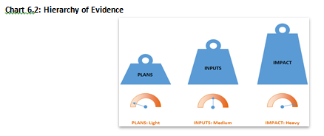
The evidence collected offsite (including the analysis of state output measures) as well as during the onsite portion of the review is evaluated based on the criteria according to the scale in the graphic below.
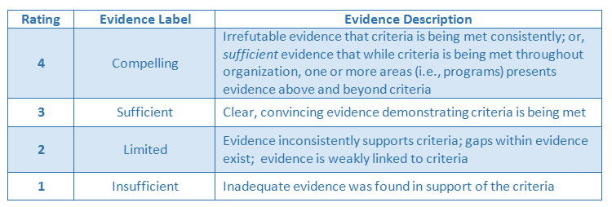

Decision-making and Approval Statuses
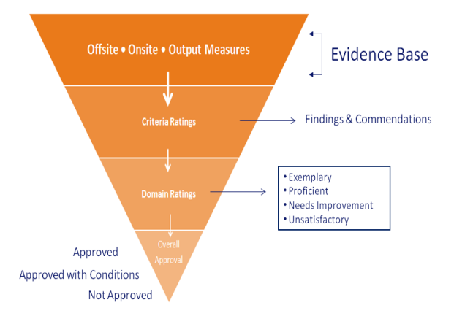
Decisions and recommendations occur at several different levels within the process.

Criteria Ratings: During the review, an individual reviewer’s summative criteria ratings are challenged and corroborated by the entire review team. The review team, under the guidance of the ESE Ed Prep Specialist, must work towards agreement for each finding and/or commendation cited in the report. ESE reserves the right to change a criterion rating based on an in-depth understanding of regulatory requirements or in order to maintain consistency across reviews. Criteria recommendations result in:
- Commendation: Commendations are reserved for truly exceptional, innovative or outstanding practices.
- Finding: Findings are areas of concern that require corrective action. Findings impact an SO’s overall approval status.

Domain Recommendations: Once the review team has rated all criteria in a domain, the team will make an overall recommendation weighing the cumulative impact and significance of the findings and commendations within that domain. Domain recommendations result in one of the following descriptions:
- Exemplary: The Exemplary level represents the highest level of performance. It exceeds the already high standard of Proficient. A rating of Exemplary is reserved for performance on a domain that is of such a high level that it could serve as a model for other providers in the organization, state, or nation.
- Proficient: Proficient is the expected, rigorous level of performance for SOs. It is a demanding but attainable level of performance.
- Needs Improvement: SOs whose performance on a domain is rated as Needs Improvement may demonstrate inconsistencies in implementation or weaknesses in a few key areas. They may not yet have fully developed systems to provide preparation in an effective way.
- Unsatisfactory: SOs whose performance on a domain is rated as Unsatisfactory is significantly underperforming as compared to the expectations.

Approval Determinations: Once all domain recommendations have been determined, the review team again weighs the cumulative impact and significance of all the domain ratings on an organization’s ability to effectively prepare educators and recommends one of the following approval determinations:
- Approved: A program that has been granted formal approval is recognized by the state to have met all standards for preparing effective educators in Massachusetts. Approved programs are authorized by the state to endorse candidates for licensure with full reciprocity benefits.
- Approved with Conditions: Approval with conditions may be granted after a formal or informal review. Sponsoring Organizations who have demonstrated overall program readiness and commitment to improvement, despite findings in a report, will be granted approval with conditions.
- Not Approved: Approval will not be granted if findings outlined in either a formal or informal review are determined to be significant. Therefore, neither full approval nor approval with conditions is granted.

Appendix B: 2014-2015 Program Approval Criteria List
The criteria used to evaluate Sponsoring Organizations are listed below. For a detailed overview of how these criteria were developed and how they will be used during the review, please see the Review Evaluation Overview located at http://www.doe.mass.edu/edprep/toolkit/.

Domain: The Organization
Leadership
- Organizational structure demonstrates sufficient capacity to carry out responsibility and decision-making for educator preparation programs.
- Systems/structures that support collaboration within departments and across disciplines improve candidate preparation.
Resources
- Budgets supports ongoing educator preparation program sustainability and allocate resources according to organizational goals.
- All candidates, regardless of program or delivery model, have equitable and consistent access to resources.
Faculty and Staff
- Recruitment, selection and evaluation processes result in the hiring and retention of effective faculty/instructors and staff.
- Faculty/instructors and staff engage in professional development and work in the field that has clear application to preparing effective educators.
- Faculty/instructors have current knowledge and experience in the content they teach.

Domain: Partnerships
- Partners make contributions that inform Sponsoring Organization’s continuous improvement efforts.
- Partnerships improve experience for preparation candidates and outcomes for PK-12 students.
- Sponsoring Organization responds to district/school needs through focused recruitment, enrollment, retention, and employment (e.g., placement agreement with local district) efforts.
- Sponsoring Organizations evaluate partnerships on an ongoing basis, sustain those that are effective and take steps to improve those that are not.

Domain: Continuous Improvement
- Resources and infrastructure (e.g., staff, technology, committees, etc.) support and sustain ongoing continuous improvement efforts.
- Faculty/instructors and staff contribute to a Sponsoring Organization’s continuous improvement efforts.
- The consistent and ongoing use of internal and external evidence, including ESE data, informs strategic decisions that impact the SO, the education programs, candidates and employing organizations.
- SO acts on feedback solicited from internal and external stakeholders (including candidates, graduates, district and school personnel and employers) in continuous improvement efforts.
- Yearly State Annual Report establishes goals in alignment with the continuous improvement process.
- Strategic plan includes activities, timelines and supports for meeting educator preparation programs’ annual goals.

Domain: The Candidate
Recruitment
- Recruitment efforts yield a diverse candidate pool.
Admission
- Admission criteria and processes are rigorous such that those admitted demonstrate success in the program and during employment in licensure role.
- Admission process supports the selection of a diverse candidate pool.
- Admission criteria for post-baccalaureate candidates verify content knowledge upon entrance to the program.
Advising
- Structures and processes ensure that candidates receive effective advising throughout the program.
- Career development and placement services support candidate employment upon completion.
- Candidates at-risk of not meeting standards are identified throughout the program (in pre-practicum, during coursework, and while in practicum) and receive necessary supports and guidance to improve or exit.
- Candidates are knowledgeable about the requirements for licensure.
- Waiver policy ensures that academic and professional standards of the licensure role are met.
- Candidates are endorsed for the approved program of study completed.

Domain: Field-Based Experiences
Structure
- Practicum hours meet regulatory requirements as per 603 CMR 7.04 (4)
- District partners are involved in the design, implementation and assessment of field-based experiences.
- Responsibilities in field-based experiences build to candidate readiness for full responsibility in licensure role.
- Candidates participate in field-based experiences that cover the full academic year.
- Field-based experiences are embedded in program coursework.
Supervision
- Supervising Practitioner qualifications meet regulatory requirements set forth in 603 CMR 7.02 and in Guidelines for Program Approval.
- Program Supervisors provide consistent guidance, support and feedback to candidates in the practicum.
- Supervising Practitioners and Program Supervisors receive training, support and development from the SO that impacts candidate effectiveness.
- Sponsoring Organization monitors candidate experiences with individual Supervising Practitioners and Program Supervisors, continuing those relationships that are effective and discontinuing those that are ineffective.
- Completion of Pre-Service Performance Assessment evaluates and indicates candidates have documented evidence in support of candidate readiness for the licensure role.
- Practicum agreements and meetings between candidate, Program Supervisor and Supervising Practitioner are documented in candidate files.
Placement
- SO secures and/or verifies placement(s) that meet regulatory requirements and SO’s expectations for all candidates.
- Field-based experiences are in settings with diverse learners (e.g., students from diverse ethnic, racial, gender, socioeconomic, and exceptional groups).

Domain: Instruction (evaluated per program)
Design
- Program of Study meets regulatory requirements for applicable licenses set forth in 603 CMR 7.03 (3) (a) and (b) and 7.04 (2) (c) 5. b. i. or c. i.
- Program of Study addresses all SMK requirements set forth in 603 CMR 7.06, 7.07, 7.09, and 7.11at the appropriate licensure level (if applicable).
- Program of Study addresses all Professional Standards set forth in 603 CMR 7.08 or 7.10 at the appropriate licensure level (if applicable).
- Course descriptions clearly state what candidates will know or be able to do by the end of the course.
- Program design results in a coherent program of study such that connections among and between courses are evident.
- Program of Study is sequenced to support the increased depth of skills and knowledge acquired and applied over time.
- Content is differentiated by subject area and level of licensure being sought.
Delivery
- Content delivery is calibrated for consistency within programs (e.g., different instructors of same course, in satellites, online, etc.).
- Candidate understanding and application of MA Curriculum frameworks is an embedded expectation in preparation coursework.
- Faculty/instructors model effective pedagogical and content practices of discipline.
- Faculty/instructors model practices and strategies to meet the needs of diverse learners.
Assessment
- Faculty/instructors use course formative and summative assessment data to target areas of candidate need.
- Courses assess what candidates know or are able to do by the end of each course.
- Candidates receive targeted feedback linked to appropriate SMK and/or Professional Standards (i.e., Professional Standards for Teachers) that improves their practice.

Appendix C: Data Snapshots
Click here to access to the Data Snapshots (separate document). Data Snapshots were created by ESE in an effort to support external reviewers in both gaining an understanding of the organization’s types of programs, size, and employment data, but also to use as a quick reference guide when evaluating state output measures as part of the review. The data source is ESE’s Public Profiles. All data used for the purposes of the state data pages is available on the profiles. The data available at the time was the 2011-2012 data, with the exception of types of programs, which was from 2013-2014. For more up-to-date data, please see the Public Profiles.
Data Snapshot for All Massachusetts Educator Prep Programs
Data Snapshot for American International College (AIC)
Data Snapshot for Berklee College of Music
Data Snapshot for Boston University
Data Snapshot for Cathy Leahy Brine Educational Consultants
Data Snapshot for City on a Hill (COH)
Data Snapshot for Collaborative for Educational Services (CES)
Data Snapshot for Match Teacher Residency
Data Snapshot for Northeastern University
Data Snapshot for Springfield Public Schools
Data Snapshot for Wheelock College

In the 2014-2015 cycle of formal reviews, 12 Sponsoring Organizations (SO) were scheduled for formal review. Of those 12 organizations, two decided to expire all programs prior to completing the process and one has been delayed due to a blizzard. In addition, two programs underwent review according to partnership agreements with national accreditation agencies. As a result, this report primarily provides data on seven SOs who underwent formal review in 2014-2015.
Findings are areas of concern that require corrective action. Findings impact an SO’s overall approval status.
Data from 2011-2012 is displayed as what was available at the beginning of the review cycle.
Number omits City on a Hill due to ESE’s suppression rule to protect anonymity of 6 or fewer individuals.
The numbers in Table 2.2 and Table 2.3 reflect Variety of Fields groupings, which include multiple programs within a grade band. As a result, these numbers are lower than those included in Chart 3.2 given that for purposes of need Variety of Fields groupings were counted as individual licensure areas. See the Variety of Fields advisory for more information.
See Appendix A for more details about the review process and expectations used to evaluate providers.
Although 12 Sponsoring Organizations were a part of the 2014-2015 Ed Prep Formal Review process, 2 chose to expire before completing the review cycle, one was rescheduled in fall 2015 due to inclement weather, and 2 completed NCATE legacy visits. Only data for SOs that went through the full implementation of the formal review are included in this data.
We are missing data for the first organization that underwent review. Data extract for these questions was not put in place until this visit occurred.
The 2014-2015 Launch Meeting was held in March of 2014. For some SOs, this was after their 12 month review window began.
Period of approval is seven years, unless the program ceases to meet requirements. Under 603 CMR 7.03(6) “The Department may conduct an interim review of an approved preparation program on an as-needed basis.”

