Executive Summary

Overview
2014-2018 Review Highlights
- From 2014 through 2018, the 33 Sponsoring Organizations completed, on average, 2,723 educators annually, representing 53 percent of the completers statewide.
- Across these four years, 1 SO was Approved with Distinction, 23 were Approved, 8 were Approved with Conditions, and 2 received Probationary Approval.
- The number of findings SOs received varied greatly, from zero to 32. On average, SOs received nine findings.
- External reviewers felt highly confident in the consistency and efficacy of the review process.
- 69 percent of SOs who underwent review agreed that the process will inform the continuous improvement of their programs.
The Massachusetts Department of Elementary and Secondary Education (DESE) believes that regular program review ensures the continued growth and improvement of our Sponsoring Organizations (SOs). We are committed to ensuring that preparation in Massachusetts results in effective educators who are ready to support the success of all students. We are pleased to release the 2017-2018 Formal Review Culminating Report to document trends and lessons learned since the formal review process was updated in 2013. Given the range and scale of Sponsoring Organizations (SOs) that have undergone review over the past four years, this year’s Culminating Report’s focus is better understanding trends across the four years of this review process.
This report demonstrates our commitment to transparency. In addition to reflecting on our own efficacy in executing reviews, we seek to inform the field of educator preparation by identifying common areas of growth as they relate to DESE’s Program Approval Criteria. It is important to note this report is not designed to be representative of all SOs in the Commonwealth; it is a summary report of 33 SOs that participated in a review since 2014, representing approximately one-half of the state’s providers. Therefore, our conclusions are not generalizable to all SOs in the Commonwealth. Throughout this report, we primarily share results in the aggregate.

Key Takeaways from the Formal Review Process, 2014-2018
SOs were most proficient in the Candidate (CAN) domain.
The CAN domain sets expectations for programmatic features such as recruitment, admission, advising, and identifying candidates-at-risk. Twenty-five SOs that received domain ratings were rated proficient or above in this domain. This data indicates that candidates are generally having a positive experience and are supported by admission, advising, and at-risk systems that contribute to their effectiveness in the licensure role. However, 40 percent of SOs received a finding for the criterion that requires recruitment and admission practices that result in an increase in the racial and ethnic diversity of the workforce, indicating that continued work needs to be done to ensure increased diversity in the workforce.
SOs most often needed improvement in the Field-Based Experiences (FBE) domain.
The FBE domain sets expectations for programmatic features such as the structure of the practicum, the placement process, and supervision. Across the four review cycles, SOs were most often rated Needs Improvement or Unsatisfactory in the FBE domain. Across many SOs, inadequate evidence of training and support for Supervising Practitioners and a lack of systems for involving district partners in the design of field-based experiences contributed to these ratings.
SOs are committed to Continuous Improvement (CI).
The CI domain sets expectations for the systems and structures SOs have in place to ensure individual programs are effective, utilize data to inform improvements, and act on stakeholder feedback. While SOs most often needed improvement in this domain from 2014-2016, SOs were most often proficient in this domain from 2016-2018. This indicates that SOs are increasingly using data and feedback to improve their educator preparation programs.
Similarly, four SOs from early cohorts who were previously determined to be Approved with Conditions have since demonstrated evidence that they met conditions outlined in their reports.
ESE implemented a review process that is effective and consistently rigorous, though SOs raised some concerns.
In general, the external reviewers and SOs who underwent review agreed that the state has a process that is effective, consistently rigorous, and leads to better prepared educators:
- 87 percent of reviewers (n=148) and 66 percent of SOs (n=32) that underwent review felt highly confident that judgments made in the review process were consistent and calibrated across the state.
- 53 percent of SOs (n=32) that underwent review agreed that their organization will better prepare educators as a result of undergoing the formal review process.
When asked about the efficacy of the review process, several SOs raised concerns about the weight given to evidence collected in focus groups and interviews with stakeholders as compared to the evidence submitted by the SO in the offsite submission. As is outlined in our Guidelines for Program Approval, DESE has an outcomes-driven review process that focuses most heavily on evidence of impact. DESE held an Evidence Workshop in 2018 for SOs under review in upcoming years to improve their understanding of outcomes-based evidence of impact and how to best collect and incorporate it in their offsite submission. DESE also disseminated an accompanying advisory. The response to that workshop was very positive, and SOs reported feeling more confident about analyzing evidence of impact and incorporating it in their offsite submissions.

Contents
Executive Summary 1
Overview 1
Key Takeaways from the Formal Review Process, 2014-2018 1
Background Information & Context 4
Needs Assessments 4
Overall Formal Review Determination Ratings 5
Changes in Approval Ratings 6
Domain Ratings 7
Criteria Ratings 9
Diversity Criteria 11
Commendations 12
Evaluation of the Consistency, Efficacy, and Efficiency of the Formal Review Process 12
Formal Review Consistency 13
Formal Review Efficacy 14
Time & Cost Estimates 15
Formal Review Informing Continuous Improvement Efforts 15
Appendix A: Full List of Sponsoring Organizations Reviewed, 2014-2018 17

Background Information & Context
Given the range and scale of Sponsoring Organizations (SOs) that have undergone review over the past four years, the focus of this year’s Culminating Report is on better understanding trends across the four years of this review process.
Forty-four SOs were scheduled to undergo formal review between 2014-2018. Eleven of these SOs chose to expire and no longer endorse candidates for licensure in Massachusetts; the remaining 33 SOs underwent review. One of these SOs underwent review in both 2014-2015 and 2017-2018 as a result of their initial Approval with Conditions designation.
These 33 SOs represent a variety of types of organizations, including public and private institutions of higher education, alternative programs, and other organizations. They range in size, from offering one licensure program to 58 different licensure programs, and graduating an average of three to over 540 completers each year. Across these SOs, on average, 2723 completers are endorsed for licensure each year, representing 53 percent of the total number of completers in the state each year (average 5113 across 2013-2016). On average, 68 percent of completers at these SOs are employed in Massachusetts each year. See Appendix A for a full list of these SOs, including their number of completers and employment data.

Needs Assessments
The first step in the Formal Review process is the Needs Assessment. This phase is specifically designed for programs that have had low completion or zero completion over the previous three years, or for new programs being submitted by a SO for state approval. During this phase, the SO must demonstrate state-specific need for the program and its capacity to meet those needs. The Needs Assessment ensures that both the SO’s resources and DESE’s review are focused on the programs that will continue to serve the Commonwealth’s need for effective educators.
The Needs Assessment phase led to a 38% reduction in the number of programs (from 1145 to 707).
Chart 1: Number of Programs by Phase of Formal Review, 2014-2018
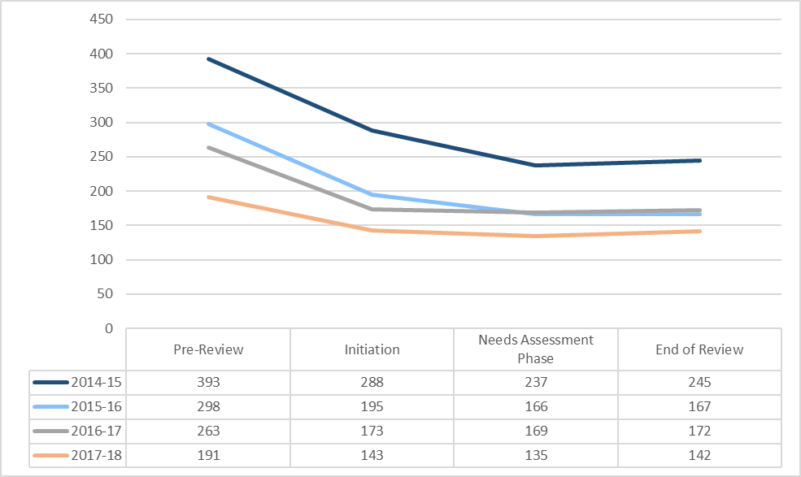
Between 2014 and 2018, SOs opted to expire 346 low or zero completion programs prior to the Needs Assessment. Of the remaining 92 programs with low or zero completion, 88 percent demonstrated need to continue operating. The percent of programs demonstrating need through the Needs Assessment has risen over the four years of formal review, from 82 percent in 2014-2015 to 94 percent in 2017-2018.
DESE also approved 19 new licensure programs during the 2014-2018 formal reviews, resulting in a total of 726 programs approved as part of formal review.
In 2013, just 46 percent of the 1,719 initial licensure teacher programs approved to operate in Massachusetts were active. The purpose of the Needs Assessment process is to ensure DESE resources are used to review and approve only those programs that are going to actively recruit, enroll, and produce educators for the Commonwealth. The 38 percent reduction rate in the number of programs indicates that SOs are expiring a portion of those dormant programs, though it will remain important to vet low completer programs with a high bar to ensure SO and DESE resources are focused on active programs.

Overall Formal Review Determination Ratings
Formal review results in an approval determination for the SO reflecting the cumulative impact of all judgements made throughout the review. From 2014-2016, the approval determinations were: Approved, Approved with Conditions, and Not Approved. To further differentiate performance within the Commonwealth, DESE expanded the levels of approval in 2016. The updated approval determinations are: Approved with Distinction, Approved, Approved with Conditions, Probationary Approval, and Not Approved. Since that change, four of the five approval status have been used: Approved with Distinction, Approved, Approved with Conditions, and Probationary Approval. The range of approval statuses used signals that the formal review process effectively captures evidence and differentiates the extent to which an SO is meeting state expectations.
Of the 34 Sponsoring Organizations that underwent review, 23 received the “Approved” rating.
Chart 2: Approval Ratings, Formal Review, 2014-2015 through 2017-2018
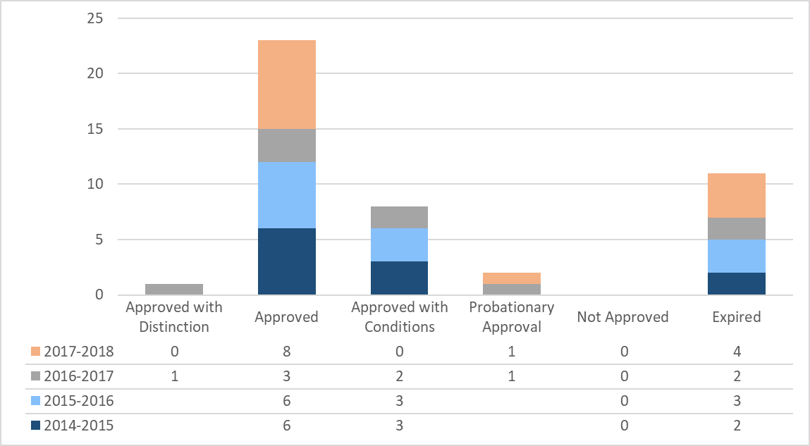
Between 2014 and 2018, 11 SOs (or 25 percent) chose to expire before their formal review. These SOs no longer endorse candidates for licensure in the Commonwealth.
Of the 33 SOs that underwent review, 23 (53 percent) were Approved. This approval rating indicates that the SO has met all standards for preparing effective educators in Massachusetts, though criteria may be identified that are not yet fully meeting expectations. One SO exceeded the rigorous state expectations and was Approved with Distinction, demonstrating evidence that it serves as a model of exemplary performance. Eight (24 percent) were Approved with Conditions, demonstrating that, despite evidence that not all state expectations are being met, the SO has overall program readiness and commitment to improvement. Two (6 percent) received Probationary Approval, signaling that state standards are being insufficiently met such that candidates are not guaranteed a quality experience.

Changes in Approval Ratings
The above chart reflects the approval determinations as of the formal review. Four SOs originally Approved with Conditions (Berklee College of Music, City on a Hill, Worcester Polytechnic Institute, and Massachusetts College of Art) have since demonstrated with evidence that they have met the conditions outlined in their reports based on their review. As such, their approval status is now Approved.

Domain Ratings
Domains are the major categories upon with DESE evaluates SOs. There are five domains assessed that the organization level.
- The Organization (ORG): Is the organization set up to support and sustain effective preparation?
- Partnerships (PAR): Is the organization meeting the needs of the PK-12 system?
- Continuous Improvement (CI): Is the organization engaging in continuous improvement efforts that result in better prepared educators?
- The Candidate (CAN): Is the candidate’s experience in the program contributing to effective preparation?
- Field-Based Experience (FBE): Do candidates have the necessary experiences in the field to be ready for the licensure role?

Between 2014-2018, SOs were most often Proficient in the CAN domain and most often needed improvement in the FBE domain. In the CI domain, ratings for SOs improved beginning in 2016.

Chart 3: Domain Ratings, Formal Review, 2014-2015 through 2017-2018
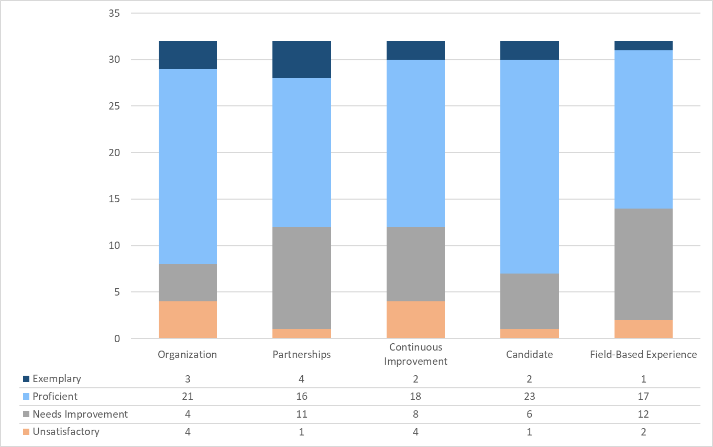

SOs were most proficient in the Candidate (CAN) domain.
The CAN domain sets expectations for programmatic features such as recruitment, admission, advising, and identifying candidates at-risk. In aggregate and in three of the four years (2014-2015, 2015-2016, 2016-2017) the domain in which SOs were most often rated Proficient or Exemplary was the CAN domain. This data indicates that candidates are generally having positive experiences in programs that are contributing to their effectiveness in the licensure role and ability to be hired upon completion. While 25 SOs (over 75 percent) of SOs met overall expectations for the CAN domain criteria related admission, advising, supporting candidates at-risk, and waivers, 12 (40 percent) lacked evidence of systems to recruit and admit candidates that result in increased racial and ethnic diversity in the workforce. This suggests that, while the systems to admit and support candidates throughout their programs are in place overall, continued work needs to be done to ensure increased diversity in the workforce. More information about this criterion is included below.
SOs most often needed improvement in the Field-Based Experiences (FBE) domain.
The FBE domain sets expectations for programmatic features such as the structure of the practicum, the placement process, and supervision. Across the four review cycles, the domain in which SOs were most often rated Needs Improvement or Unsatisfactory was the FBE domain. Looking at individual years, this domain had the fewest SOs proficient in 2015-2016 and 2016-2017. In 2014-2015 and 2016-2017, FBE was the second weakest domain. Across many SOs, inadequate evidence of training and support for Supervising Practitioners and a lack of systems for involving district partners in the design of field-based experiences contributed to these ratings. Additionally, about one-third of SOs lacked systems to ensure candidates have field-based experiences in settings with diverse learners and/or that a performance assessment is implemented consistently and rigorously across programs.
SOs are getting stronger in the Continuous Improvement (CI) domain.
The CI domain sets expectations for programmatic features such as the ongoing and consistent use of internal and external evidence and the solicitation and implementation of stakeholder feedback. While the CI domain generated the most Needs Improvement or Unsatisfactory ratings in 2014-2015 and 2015-2016, there was a shift beginning in 2016-2017. In that year, Continuous Improvement domain generated the highest numbers of Proficient ratings, and in 2017-2018, it yielded the second highest number of Proficient ratings. This data suggests that SOs are making efforts to improve their systems for monitoring the quality of programs, using internal and external data to inform programmatic changes, and acting on stakeholder feedback. This timing also suggests that SOs may be leveraging newly available data on Edwin (first released in 2014 and expanded in 2017) and additional technical assistance provided by DESE.
Fewer SOs in 2017-2018 were rated Proficient in the Partnerships (PAR) domain than in prior years.
The PAR domain sets expectations for programmatic features that are designed to meet the needs of partner schools/districts, including ensuring that partners inform continuous improvement and that partnerships improve outcomes for PK-12 students and preparation for candidates. While 70 percent of SOs were rated Proficient or above in the PAR domain between 2014-2017, only 44 percent were rated Proficient in 2017-2018. DESE has been increasingly explicit about the expectation that partnerships serve the needs of PK-12 schools/districts. Within the group of SOs reviewed in 2017-2018, there was limited evidence of partnerships that went beyond mere transactional relationships (e.g. field-based experience placements only) to be more systemic in nature.
Across all five domains, while most SOs received a rating of Proficient, reviewers utilized the full rating scale in making determinations.
This indicates that the formal review process is effectively identifying and differentiating between SOs at various levels of meeting DESE’s expectations. The ratings in the ORG and CAN domains demonstrate that most SOs are set up to support and sustain effective preparation and ensure candidates have an experience that prepares them to be effective.

Criteria Ratings
Each domain is comprised of 4 to 12 criteria, which are the expectations against which evidence is evaluated. Program Approval Criteria are derived from the Program Approval Standards and are designed to distill high-level concepts into a set of concreate, actionable expectations. Criteria were intentionally developed to be descriptive of expectations, not prescriptive of approach.
For each criterion, an SO receives a rating of met, finding, or commendation. A met rating demonstrates that the evidence indicates the SO is meeting the expectation described in the criteria. Findings are areas of concern that require corrective action and may impact an SO’s overall approval status because they indicate that a program approval criterion is not being met. Commendations are reserved for truly exceptional, innovative, or outstanding practices that would serve as a model for other SOs.

Most SOs received a finding in the area of training supervisors and half of SOs received a finding in the area of acting on feedback from stakeholders. On average, SOs received nine findings; the number of findings ranged from 0 to 32.

Chart 4: Most Common Findings, 2014-2018
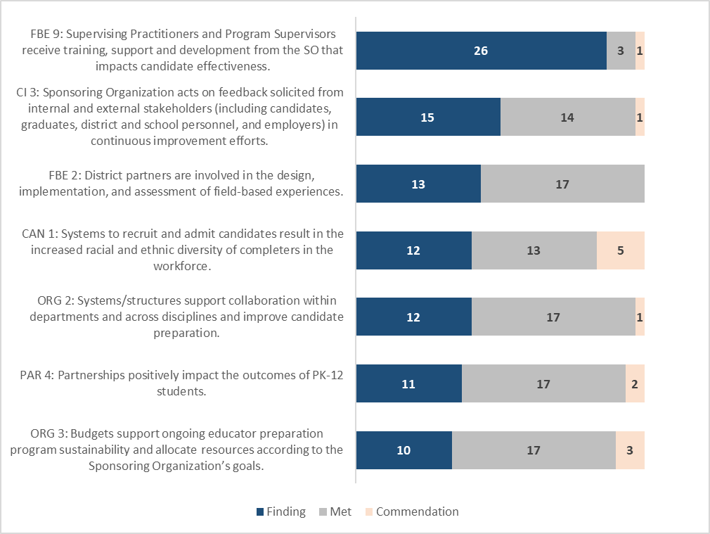
The most common finding across all four years is Criteria FBE 9: Supervising Practitioners and Program Supervisors receive training, support and development from the SO that impacts candidate effectiveness. While robust training for supervisors is of critical importance to meeting expectations outlined in the Candidate Assessment of Performance, for most SOs, this was a finding due to the lack of systems to train and support Supervising Practitioners specifically. DESE has addressed the need for support in this area by providing SOs with tools and resources for training, including CAP Training Modules, the Online Calibration Tool, and the Teacher Educator Effectiveness Practices Framework.
Though the domain with the most SOs needing improvement is FBE, the four criteria with the fewest findings across reviews are all from that domain. This indicates that, while many SOs lack systems to ensure Supervising Practitioners are trained and supported or ensure partners are involved in the design of field-based experiences, most SOs have other programmatic structures for field-based experiences in place.
Chart 5: Criteria with Fewest Findings, 2014-2018

Diversity Criteria
The Massachusetts Advocates for Diversity in Education (MADE) Taskforce advised DESE to “increase the transparency and accountability of preparation program efforts to diversify their enrollment and program completion.” In accordance with this recommendation, DESE publishes results of reviews pertaining to diversity criteria. For the criteria of “Systems to recruit and admit candidates result in the increased racial and ethnic diversity of completers in the workforce” (CAN 1), DESE gave five “commendations,” thirteen “met” ratings, and twelve “findings.” The proportion of findings for this criterion is reflected in the stagnant growth in completers of color statewide during this period. In 2014-2015, 89 percent of program completers identified as white, compared to 88 percent in 2015-2016, 89 percent in 2016-2017, and 88 percent in 2017-2018.

Commendations
Commendations are reserved for truly exceptional, innovative, or outstanding practices that would serve as a model for other SOs. A commendation requires compelling evidence, particularly evidence of impact. DESE awarded 46 commendations across nine SOs between 2014-2018. One SO received 15 commendations. The other eight SOs received between 1 and 11 commendations.
Though CAN 1: Systems to recruit and admit candidates result in the increased racial and ethnic diversity of completers in the workforce was among the criteria with the most findings, it was also one of two criteria with five commendations granted across the four years. The SOs that received commendations in this area demonstrated intentional systems to recruit, admit, and support diverse candidates. Several of these SOs recruit from partner districts/schools and through events with undergraduate and/or high school students of color. Several SOs offered additional advising and academic support, scholarships, and/or conditional admittance offers to students from historically underserved communities, and some SOs increased efforts to diversify their faculty to better reflect the communities they serve. While each SO used unique strategies, they all demonstrated the impact of their work through higher-than-average and often increasing percentages of diverse candidates and completers.
The other criterion with five commendations was CAN 2: Admission criteria and processes are rigorous such that those admitted demonstrate success in the program and during employment in the licensure role. The SOs that received commendations in this criterion demonstrated established systems for ensuring that only those candidates with the dispositions and commitment to working as an educator gained admittance to their programs. Common structures included interviews, mini lessons, and group or individual activities in which prospective candidates demonstrated specific skills and dispositions. Several of these SOs had evidence of impact that their completers were employed in Massachusetts public schools and were more effective than their peers.

Evaluation of the Consistency, Efficacy, and Efficiency of the Formal Review Process
DESE articulates three expectations around which the review process is built. The formal review process is designed to be:
- Consistent: within and across organizations in terms of execution and calibration of results.
- Effective: built on a solid evidentiary base for decision-making and appropriately differentiates within and among organizations.
- Efficient: streamlined, targeted, and systematic; any investment of efforts leads to improved outcomes.
DESE surveys both SOs who underwent review and the reviewers that volunteered to evaluate the quality of preparation against the program approval criteria. DESE uses this data to inform efforts to continuously strengthen the formal review process, and shares the high-level results as a way to indicate our analysis and associated next steps.

Across the four years of data, the results from the Formal Review Feedback survey indicate an increasing level of confidence in the consistency and efficacy of the process for external reviewers versus a decreasing level of confidence from SOs who underwent review.

Formal Review Consistency
Chart 6: Perceptions of Review Consistency, 2014-2018

SOs under review expressed comparatively less confidence in the consistency of the review process as compared to reviewers. The level of confidence of SOs has also decreased from 78 percent reporting a high confidence level in 2014-2015 to 50 percent in 2017-2018. During this same period, reviewers’ level of confidence in the consistency of the review process had the opposite trend: it increased from 73 percent reporting a high confidence level in 2014-2015 to 97 percent in 2017-2018.
Consistency is one of the hallmarks of the review process. The state holds all SOs to the same rigorous expectations and they, therefore, undergo the same review process. To establish consistency across reviews, DESE uses the same materials with all SOs, including: toolkits and worksheets, guidance documents, evaluation tools, program approval criteria, and interview and focus group protocols. Reviewers all undergo the same training and are required to complete calibration exercises. DESE maintains the level of integrity across all reviews with internal vetting structures in place to ensure consistency in judgments across reviews.
The increasing level of confidence in the consistency of the review process from reviewers is a strong indication that the stakeholders involved in the behind-the-scenes collection and analysis of evidence and determination of ratings can see how these efforts lead to consistency across reviews. DESE will continue to improve communications with SOs to ensure the steps taken to ensure consistency across reviews are similarly clear.

Formal Review Efficacy
Chart 7: Perceptions of Review Efficacy, 2014-2018

Each year, SOs under review have reported lower agreement than the reviewers that the judgments made in the formal review report were based on evidence. While reviewer’s level of agreement has trended up, from 89 percent agreeing or somewhat agreeing in 2014-2015 to 100 percent in 2017-2018, there are no clear trends in the SO data, which ranges from a low of 43 percent agreeing or somewhat agreeing in 2016-2017 to a high of 87 percent in 2015-2016. Across all years, and particularly from 2016-2018, SOs noted that their low agreement rates related to three concerns in particular:
- The rating scale: The rating scale for evidence collected by DESE throughout the review process is the same: agree, somewhat agree, neither agree nor disagree, somewhat disagree, and disagree. SOs raised concerns that DESE reports on the percentage of stakeholders that ‘agree’ with each prompt and does not aggregate those responses with the percentage who selected ‘somewhat agree.’ When making criterion-level rating decisions, reviewers consider the full scale of responses and any variation that occurred to inform their judgments. The quantitative data is also compared with qualitative data collected during open-ended portions of focus groups or surveys to help inform decision-making. DESE maintains high expectations for SOs across the state, and typically reports on the percentage of stakeholders who indicate ‘agree’ because the definition shared with stakeholders of ‘agree’ indicates that a practice is happening both consistently and at a high level.
- Triangulation of data: The formal review process weighs evidence of impact more heavily than evidence of plans or inputs. During the onsite portion of the visit, DESE collects evidence of impact from stakeholder groups in focus groups and interviews. This evidence, and any additional evidence of impact or outcomes shared by the SO during the offsite portion of the review, serves as the most significant body of evidence supporting decision-making. As such, focus group data is often weighed more heavily than evidence of plans or inputs shared by the SO as part of the offsite submission and is cited more frequently in the formal review report shared with SOs. To improve SO’s understanding of evidence of impact and how to best share it with reviewers, DESE held an Evidence Workshop in 2018 for SOs scheduled for review after 2018-2019 and published a High-Quality Evidence of Impact Advisory. The response to that workshop was very positive and SOs reported feeling more confident about analyzing evidence of impact and incorporating it in their offsite submissions.
- Low sample sizes: DESE relies on SOs under review to recruit stakeholders to attend interviews and focus groups during the onsite visit. As noted above, the evidence collected during the onsite visit is impact data that, often, is relied on heavily during the decision-making process. To help SOs ensure participation in the focus groups, DESE has responded to feedback from SOs that scheduling some stakeholder groups during the day is challenging. DESE has added additional evening focus group time slots that better accommodate educators’ schedules. Additionally, DESE has better aligned the stakeholder survey with questions asked during focus groups and is incorporating these surveys into the formal review to further strengthen the amount of evidence analyzed.
While some reviewers noted similar concerns about sample size and the rating scale, the concerns did not appear to outweigh their overall agreement that the judgments made in the formal review process were based on evidence.

Time & Cost Estimates
SOs under review have had a difficult time pinpointing the amount of time or money it took to prepare for the formal review. Responses ranged from 400 hours to 10,000 hours and from $1,000 to over $20,000. While some variation is attributable to the different sizes and complexities of each SO, there were no clear trends to better explain the wide range of responses.

Formal Review Informing Continuous Improvement Efforts
Chart 8: Perceptions of Formal Review Informing Continuous Improvement Efforts, 2014-2018

While it is not the primary intent of the review process, one measure of the efficacy and efficiency of the formal review process is whether the information gathered and decisions made inform continuous improvement efforts to ensure educators are well-prepared by SOs. Across all years, the majority of SOs indicated that they will better prepare educators as a result of engaging in the review process and that the information in the formal review report will inform continuous improvement efforts at their organization.

Appendix A: Full List of Sponsoring Organizations Reviewed, 2014-2018
Review Year | Sponsoring Organization | Average # Completers each year (2013-2016) | Average Employment Rate in MA Public Schools (2013-2016) | Approval Determination | Current Approval Status
2014-2015 | American International College | 540 | 89.1% | Approved with Conditions | Probationary Approval
 | Berklee College of Music | 15 | 40.2% | Approved with Conditions | Approved
 | Boston University | 245 | 49.7% | Approved | Approved
 | City on a Hill | 4 | - | Approved with Conditions | Approved
 | Collaborative for Educational Services | 46 | 86.8% | Approved | Approved
 | MATCH | 34 | 81.5% | Approved | Approved
 | Northeastern University | 108 | 65.7% | Approved | Approved
 | PRSIM Educational Consultants | Expired approval – no longer endorses candidates for licensure in MA
 | Springfield Public Schools | Expired approval – no longer endorses candidates for licensure in MA
 | UMASS Amherst (NCATE) | 189 | 62.7% | Approved | Approved
 | Wheelock College (NCATE) |  |  | Approved | Merged with Boston University
2015-2016 | Boston Teacher Residency | 34 | 87.8% | Approved | Approved
 | Cambridge Public Schools | Expired approval – no longer endorses candidates for licensure in MA
 | Catherine Leahy Brine | 109 | 93.5% | Approved | Approved
 | College of the Holy Cross | 8 | 48.0% | Approved | Approved
 | Eastern Nazarene College | 33 | 63.5% | Approved with Conditions | Approved with Conditions
 | Harvard Graduate School of Education | 93 | 31.6% | Approved | Approved
 | MA School of Professional Psychology | Expired approval – no longer endorses candidates for licensure in MA
 | Newton Teacher Residency | 4 | - | Approved | Approved
 | Nichols College | Expired approval – no longer endorses candidates for licensure in MA
 | Smith College | 29 | 39.0% | Approved | Approved
 | Worcester Polytechnic Institute | 3 | - | Approved with Conditions | Approved
 | UMASS Boston (TEAC) | 255 | 72.1% | Approved with Conditions | Approved with Conditions
2016-2017 | Becker College | Expired approval – no longer endorses candidates for licensure in MA
 | Boston Conservatory | Expired approval – no longer endorses candidates for licensure in MA
 | Boston College | 195 | 51.2% | Approved | Approved
 | Clark University | 31 | 65.5% | Approved with Distinction | Approved with Distinction
 | Massachusetts College of Art | 19 | 44.6% | Approved with Conditions | Approved
 | Tufts University | 62 | 62.8% | Approved with Conditions | Approved with Conditions
 | UMASS Dartmouth | 59 | 80.3% | Probationary Approval | Probationary Approval
 | UMASS Lowell | 62 | 82.8% | Approved | Approved
 | Westfield State University | 216 | 73.0% | Approved | Approved
2017-2018 | American International College | 540 | 89.1% | Probationary Approval | Probationary Approval
 | Anna Maria College | 14 | 66.9% | Approved | Approved
 | Brandeis University | 41 | 49.8% | Approved | Approved
 | DeLet Teacher Preparation Program | Expired approval – no longer endorses candidates for licensure in MA
 | French River Education Center | Expired approval – no longer endorses candidates for licensure in MA
 | MGH Institute of Health Professions | 52 | 39.9% | Approved | Approved
 | Montserrat College of Art | 5 | 68.7% | Approved | Approved
 | Northeast Consortium for Staff Development | Expired approval – no longer endorses candidates for licensure in MA
 | South Coast Educational Collaborative | Expired approval – no longer endorses candidates for licensure in MA
 | Springfield College | 153 | 57.3% | Approved | Approved
 | Stonehill College | 41 | 61.8% | Approved | Approved
 | Wellesley College | 12 | 36.6% | Approved | Approved
 | Wheaton College | 13 | 36.7% | Approved | Approved
 | Total: | 2723 | Average: 68.2%

For more information about Needs Assessments, please see the 2016 Needs Assessment Policy Advisory.
For more information about approval determinations, and how other judgments impact the overall determination rating, please see the Program Approval Guidelines.
For 2014-2015 and 2015-2016, no data appears for Approved with Distinction or Probationary Approval because these approval ratings did not exist at that time.
One SO underwent review in both 2014-2015 and 2017-2018 as a result of Approval with Conditions in 2014-2015. The approval determinations from both formal reviews are included.
For more information about the domain ratings, please see the Program Approval Guidelines.
This chart includes data from 32 formal reviews. Of the 33 SOs that have undergone review, two underwent National Council for Accreditation of Teacher Education (NCATE) approval and did not receive domain ratings. One SO was reviewed in both 2014-2015 and 2017-2018 and the ratings from both reviews are included.
For more information, see the Partnership Advisory.
For more information about program approval criteria, please see the Program Approval Guidelines.
Both charts in this section include data from 32 formal reviews. Of the 33 SOs that have undergone review, two underwent NCATE approval and did not receive domain ratings. One SO was reviewed in both 2014-2015 and 2017-2018 and the ratings from both reviews are included.
The Program Approval Criteria were modified for clarity and to reduce redundancy after the 2015-2016 review cycle. The criteria on this list remained the same for all four years, with the following exceptions: CAN 1 was formerly two criteria, one addressing recruitment and the other addressing admission. Only one SO received different criterion ratings for these criteria. This SO received a finding for their recruitment efforts, but the admission processes criteria was met. They are reflected in this data as a finding. PAR 4 was previously combined with the criterion “Partnerships positively impact the preparation of candidates.” Any SO that received a finding in either the combined criterion in 2014-2016 or PAR 4 in 2016-2018 is reflected as a finding in this chart.
Prior to 2016-2017, this criterion was addressed with two separate criteria, one regarding recruitment efforts and the other admission processes supporting the selection of a diverse candidate pool. Only one SO received different criterion ratings for these criteria. This SO received a finding for their recruitment efforts, but the admission processes criteria was met. They are reflected in this data as a finding.
For a full description of the rating scale used in both formal review and Stakeholder Surveys, see the Teacher Completer Survey.
This SO underwent review according to a partnership agreement with NCATE. As such, they were not given domain or criteria ratings. This report primarily provides data on the SOs who underwent the DESE formal review process in 2014-2018.
See above.
This SO underwent review according to a partnership agreement with the Teacher Education Accreditation Council (TEAC). Through this process, domain and criteria ratings were identified and are reflected in the above report.

