Educator Preparation: 2014 Field Feedback Survey Results

The Massachusetts Department of Elementary and Secondary Education (ESE) conducted a survey of Sponsoring Organizations in May 2014 to assess the effectiveness of the work of the Educator Preparation Team during the 2013-2014 academic year. The survey was designed to collect data that would drive the Ed Prep Team’s efforts at continuous improvement and aimed to:
1. Assess the engagement and interactions with the field
2. Improve the quality of our interactions with the field
3. Inform effective planning for future Ed Prep work
4. Gauge the depth of impact that key ESE initiatives have had on the field

Eighty-one Sponsoring Organizations were surveyed. There were 71 organizations that responded (87%); more than one respondent replied for five organizations. A total of 78 respondents answered the survey.

Data from the survey was compiled and analyzed with support from the Office of Planning and Research at ESE. The Office of Planning and Research prepared this report in support of the Ed Prep Team’s desire to make public and transparent the work and efforts of the team. The Ed Prep Team has prepared a response to the survey which can be found at www.doe.mass.edu/edprep.

Overview of Field and Ed Prep Interactions

FREQUENCY OF INTERACTIONS
Most respondents indicated relatively frequent engagement with the educator preparation team, with over three quarters of respondents having contact at least a few times a month.

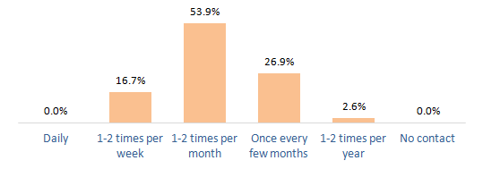

TYPE OF INTERACTIONS
When asked to indicate the ways in which the field interacted with the Ed Prep team, the vast majority of respondents said that they were seeking technical assistance or guidance.

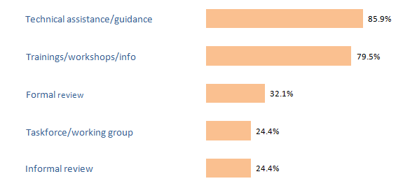

PRIMARY INITIATORS OF CONTACT
The respondents were asked to identify who was the primary initiator of the interactions—ESE or the field—and half of the respondents reported that the contact was equally initiated between the two entities. Additionally, there was a large percentage (35%) of the respondents who reported themselves to be the primary initiators.

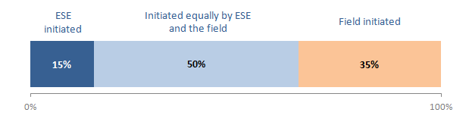

Quality of Engagement with Ed Prep Team

The field was generally positive about its interactions with the Ed Prep Team.

OVERALL QUALITY OF COMMUNICATION
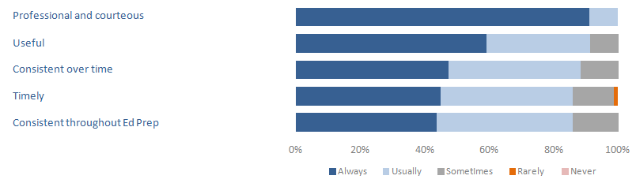

QUALITY INDICATORS FOR ENGAGEMENT 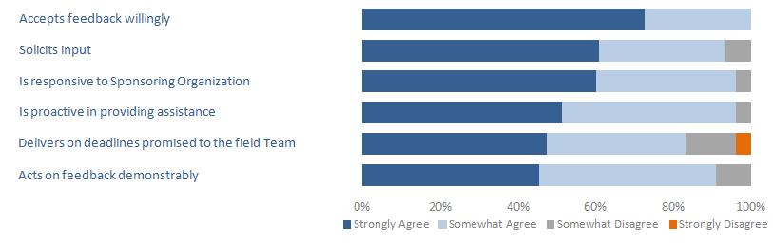

WHAT WAS YOUR BEST INTERACTION?  When asked to identify the best interaction with the Ed Prep Team, more than any other factor, the field referenced individual members of the Ed Prep team (about 1/3 of all comments). Another theme among responses was the overall improvement in response to field inquiries and meeting deadlines (20% of all comments).  “We have been waiting on a review report for some time. After talking with the Ed Prep Team, there was clear responsibility for the situation, a solutions-oriented response and an even exchange.” | “We have been waiting on a review report for some time. After talking with the Ed Prep Team, there was clear responsibility for the situation, a solutions-oriented response and an even exchange.”  “Our first technical assistance e call with [the Ed Prep Team] to discuss our upcoming program review was quite helpful. They were proactive in scheduling the call and left us with numerous valuable resources to move forward in our planning. I also truly appreciate the opportunity to participate this year on a Task Force. I felt like my voice was valued and the work was very meaningful.”
WHAT WAS YOUR WORST INTERACTION?  On the other end, when asked about the worst interaction, there were relatively few high-frequency trends in the comments. One quarter of all comments (26%) indicated there was “no worst interaction,” while about 15% of comments referenced difficulties with the implementation of the SEI/RETELL requirements and review. | “We are in the process of trying to update course curricula to meet SEI criteria. While ESE personnel have been courteous, I still find the immobility of the process is difficult to translate to my faculty…It is a process that requires a timeframe and turnaround that has been difficult to work within.”

Engagement and Effectiveness of Key Initiatives

ENGAGEMENT
The chart below shows the extent to which Sponsoring Organizations felt connected to key Ed Prep initiatives.

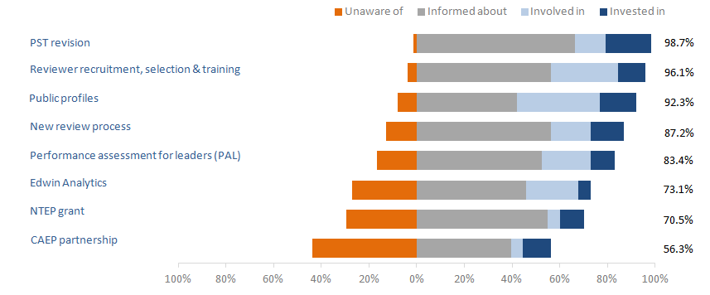

More than 90 percent of respondents were informed, involved, or invested in the PST revision; Reviewer recruitment, selection and training; and the Public Profiles. Twenty percent of respondents, however, were unaware of the Network for Transforming Educator Preparation (NTEP) Grant work. Additionally, more than 40 percent of respondents reported that they had no knowledge of the CAEP partnership.

EFFECTIVENESS
For each of the major initiatives the field engaged in this year, the Ed Prep Team wanted to know the quality of several components related to implementation. The field was asked to rate the overall effectiveness of each initiative across four categories:
- Initial and Ongoing Communication
- Follow Through on Commitments & Deadlines
- Useful Resources Developed & Shared
- Reasonable and Appropriate Timeline
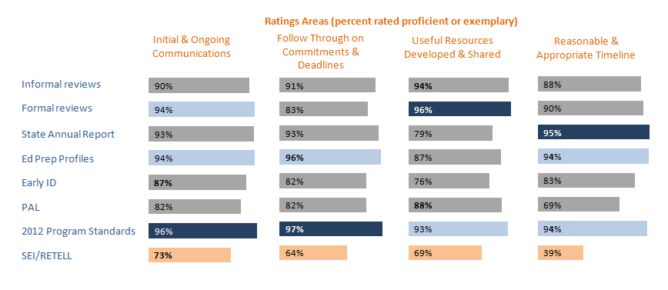

Implementation of the 2012 Program Approval Standards was consistently rated proficient of exemplary by at least 93% of respondents across all four categories and received the highest effectiveness rating of all initiatives with 97% proficient/exemplary on Follow Through on Commitments & Deadlines. Initial & Ongoing Communication was rated as the most effective category overall (average 88% proficient or exemplary). Implementation of SEI/RETELL requirements was consistently rated as the least effective (unsatisfactory or needs improvement) across each category.

Ed Prep Team’s Continuous Improvement Efforts

What is the most important thing the Ed Prep Team is doing that should continue? | - 60% of comments indicated that the Ed Prep Team should continue to engage in strategies for effective communication, including consistency, timeliness, clarity and openness.  - 15% of comments referenced the value of in-person meetings.
What is the most important thing the Ed Prep Team can do to improve? | - Highest frequency comment (about 20%) indicated the need to improve IT challenges.  - Other themes that received anywhere from 6-10 individual comments were:  - Host more frequent meetings  - Meet deadlines to the field  - Slow down the pace of implementation  - Maintain consistency of staff  - Increase the capacity of the team to support the field

“The current team has put great effort into communicating and collaborating with the SOs.”

“The ongoing work to shift the program review process to a set of more rigorous, outcomes-based measures is far and away the most important work of the Ed Prep Team.”

ESE Vision for Educational Improvement

The majority of respondents agreed that ESE has articulated a clear vision which will lead to educational improvement, and the Ed Prep Team has been effective in its efforts to prepare educators to support the success of all students.
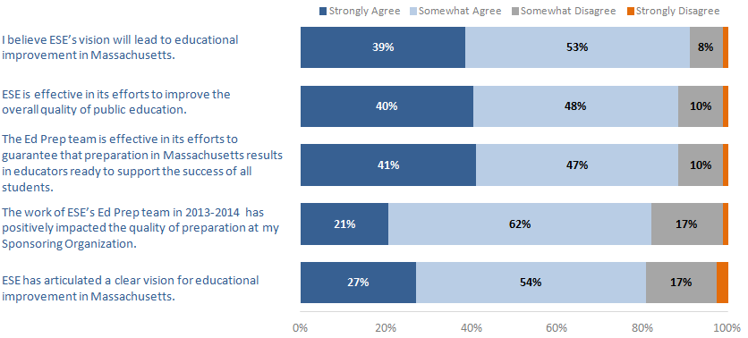
Conclusion

ESE is grateful to the respondents from the field that completed the survey. The Ed Prep Team will use the data from the survey to improve our supports to preparation providers and increase the overall effectiveness of our efforts to guarantee that preparation in Massachusetts results in effective educators. A detailed memo outlining the Ed Prep Team’s response to the 2014 Field Feedback Survey can be found at www.doe.mass.edu/edprep. The second annual feedback survey will be issued to the field in June 2015.

Please contact edprep@doe.mass.edu with questions or comments.

