Educator Preparation: 2015 Field Feedback Survey Results

The Massachusetts Department of Elementary and Secondary Education (ESE) conducted a survey of Sponsoring Organizations in May 2015 to assess the effectiveness of the work of the Educator Preparation Team during the 2014-2015 academic year. The survey was designed to collect data that would drive the Ed Prep Team’s efforts at continuous improvement and aimed to:
1. Assess the engagement and interactions with the field
2. Improve the quality of our interactions with the field
3. Inform effective planning for future Ed Prep work
4. Gauge the depth of impact that key ESE initiatives have had on the field

Eighty-one Sponsoring Organizations were surveyed. There were 50 organizations that responded (62%); more than one respondent replied for seven organizations. A total of 59 respondents answered the survey.

Data from the survey was compiled and analyzed with support from the Office of Planning and Research at ESE. The Office of Planning and Research prepared this report in support of the Ed Prep Team’s desire to make public and transparent the work and efforts of the team. The Ed Prep Team has prepared a response to the survey which can be found at www.doe.mass.edu/edprep.

Overview of Field and Ed Prep Interactions

FREQUENCY OF INTERACTIONS
Most respondents indicated relatively frequent engagement with the educator preparation team, with over 80% of respondents having contact at least a few times a month.

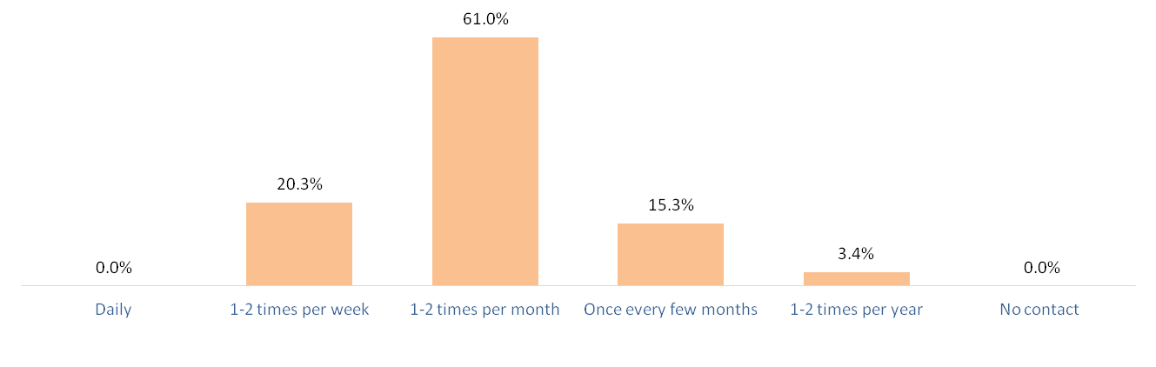

TYPE OF INTERACTIONS
When asked to indicate the ways in which the field interacted with the Ed Prep team, the vast majority of respondents said that they used the Ed Prep Inbox.
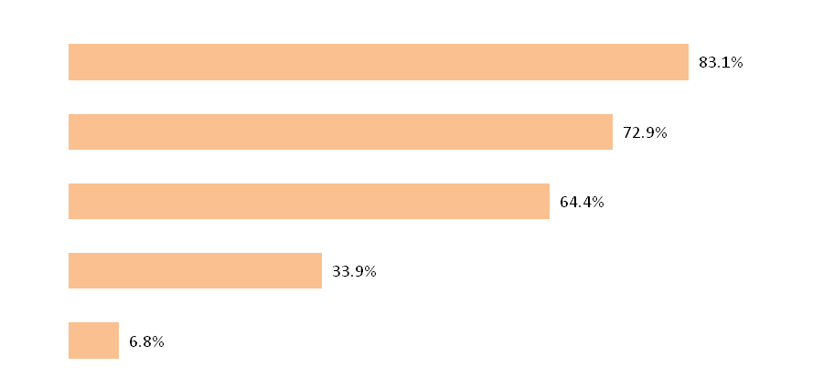
Ed Prep Inbox

Trainings/Workshops

Info sessions and Webinars

Formal Review

Informal Review

PRIMARY INITIATORS OF CONTACT
The respondents were asked to identify who was the primary initiator of the interactions—ESE or the field—and almost seven out of ten respondents reported that the contact was equally initiated between the two entities.

Mostly Initiated by ESE Equally Initiated Mostly Initiated by Field

Quality of Engagement with Ed Prep Team

The field was generally positive about its interactions with the Ed Prep Team.
Numbers in parentheses indicate changes from 2014 in % Always + Usually.

OVERALL QUALITY OF COMMUNICATION
Professional and courteous (+0%)

Useful (+3.8%)

Consistent over time (+3.2%)

Consistent throughout Ed Prep (+4.0%)

Timely (+2.2%)

QUALITY INDICATORS FOR ENGAGEMENT
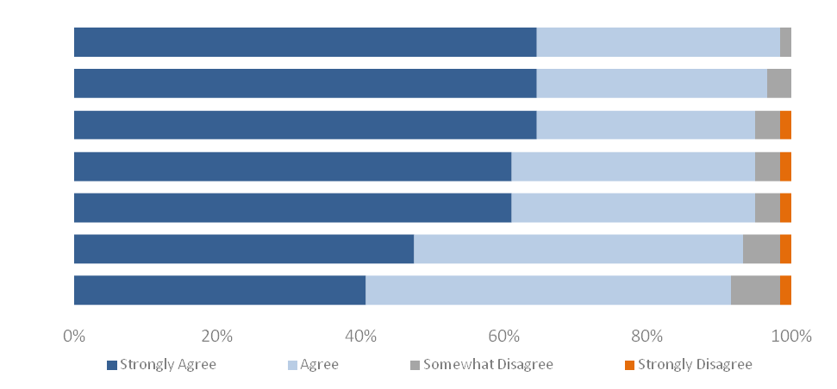
Has provided useful resources and guidance (N/A)
Solicits input (+3.1%)
Accepts feedback willingly (-5.1%)
Is responsive to needs of Sponsoring Org. (-1.3%)
Is proactive in providing assistance (-1.3%)
Delivers on deadlines promised to the field (+9.8%)
Acts on feedback demonstrably (+0.5%)

WHAT WAS YOUR BEST INTERACTION?  When asked to identify the best interaction with the Ed Prep Team, more than any other factor, the field referenced helpful, personalized answers to their inquiries (83%). Another theme among responses was the overall high quality of the trainings (20% of all comments).  “We have been waiting on a review report for some time. After talking with the Ed Prep Team, there was clear responsibility for the situation, a solutions-oriented response and an even exchange.” | “As a new chair, the team was amazing in answering the large numbers of questions, leading me to the right videos, and supporting new initiatives. They were amazing. They were also patient and provided guidance on all aspects coming out of the office. I feel as though we are a team working together for the students.”  “The best demonstration of ESE's team to organizations was the response to workshop participants who asked that an ED Prep person attend the PST events. Made ALL the difference. Thank you!”
WHAT WAS YOUR WORST INTERACTION?  On the other end, when asked about the worst interaction, there were relatively few high-frequency trends in the comments. 17% of comments referenced difficulties with the implementation of the SEI/RETELL requirements and review. A smaller number (around 8%) expressed concerns about Early ID and State Annual Report technical difficulties. | “There is still a great deal of disconnect between sponsoring organizations, Ed Prep, Licensing, and the ESE office of language acquisition and student achievement with regard to RETELL, in particular the SEI endorsement. There's confusion in the requirements, in particular the SEI prohibitions…”  “I encountered a great deal of technical difficulty initially with Early ID and therefore SAR, since our organization was not listed as approved for all licenses on DESE website. This was eventually resolved but it was frustrating at the time.”

Engagement and Effectiveness of Key Initiatives

ENGAGEMENT
The chart below shows the extent to which Sponsoring Organizations felt connected to key Ed Prep initiatives. Compared to 2014 data, most initiatives showed a marked improvement in Sponsoring Organization involvement.

Professional Standards for Teachers
Edwin Analytics
Program Review Process
Ed prep Reviewer Recruitment
Candidate Assessment of Performance
Ed Prep Survey Development
NTEP
Performance Assessment for Leaders
CAEP Partnership

Ninety percent or more of respondents were informed, involved, or invested in the PST implementation; Reviewer recruitment, selection and training; Edwin Analytics; the Ed prep program review process; Ed prep survey development; and the new candidate assessment of performance. Approximately 25% percent of respondents, however, were unaware of the Network for Transforming Educator Preparation (NTEP) grant work or the Performance Assessment for Leaders. Additionally, more than 35 percent of respondents reported that they had no knowledge of the CAEP partnership agreement.

EFFECTIVENESS
For each of the major initiatives the field engaged in this year, the Ed Prep Team wanted to know the quality of several components related to implementation. The field was asked to rate the overall effectiveness of each initiative across four categories:
- Initial and Ongoing Communication
- Follow Through on Commitments & Deadlines
- Useful Resources Developed & Shared
- Reasonable and Appropriate Timeline
Ratings Areas
(percent proficient or exemplary)

Initial & Ongoing Communication | Follow-through on Commitments & Deadlines | Useful Resources Developed & Shared | Reasonable & Appropriate Timeline

Informal Reviews
Formal Reviews
State Annual Report
Edwin Analytics
USED Proposed Regulations
Performance Assessment for Leaders
Professional Standards alignment
Candidate Assessment of Performance

Implementation of the new Formal Review process was consistently rated proficient or exemplary by at least 92% of respondents across all four categories and received the highest effectiveness rating of all initiatives with 95% proficient/exemplary on Follow Through on Commitments & Deadlines (tied with Informal Reviews, which also received 95% proficient/exemplary on Follow Through on Commitments & Deadlines). Follow Through on Commitments and Deadlines was also rated as the most effective rating area overall. The new Candidate Assessment of Performance (CAP) was consistently rated as the least effective across each category.

Ed Prep Team’s Continuous Improvement Efforts

What is the most important thing the Ed Prep Team is doing that should continue? | - A majority of comments indicated that the Ed Prep Team should continue to engage in strategies for effective communication, including consistency, timeliness, high frequency, clarity, and openness.  - Multiple people commented on the continued importance of the PST alignment and the CAP implementation
What is the most important thing the Ed Prep Team can do to improve? | - Highest frequency comment indicated the need to improve IT challenges, especially in the Early ID system and the State Annual Report.  - Other themes that received anywhere from 6-10 individual comments were:  - Slow down the pace of implementation  - The overwhelming number of new requirements  - Provide more training and support to the field

“Focusing on the most effective ways to educate teachers. You have a quality team who appears to understand that there is more than one way to reach this goal, and you are committed to strong communication with the field.”

“The development of CAP is very important. The PPA no longer meets the needs of the field…”

ESE Vision for Educational Improvement

The majority of respondents agreed that ESE has articulated a clear vision which will lead to educational improvement, and the Ed Prep Team has been effective in its efforts to prepare educators to support the success of all students.
ESE has articulated a clear vision for educational improvement in MA
Overall, I feel connected to a network that is improving educator preparation in MA
The work of ESE’s Ed Prep team in 2014-2015 has positively impacted the quality of preparation at my Sponsoring Organization
I believe ESE’s vision will lead to educational improvement in Massachusetts
The Ed Prep team is effective in its efforts to guarantee that preparation in MA results in educators ready to support the success of all students
ESE is effective in its efforts to improve the overall quality of public education
Conclusion

ESE is grateful to the respondents from the field that completed the survey. The Ed Prep Team will use the data from the survey to improve our supports to preparation providers and increase the overall effectiveness of our efforts to guarantee that preparation in Massachusetts results in effective educators. The next annual feedback survey will be issued to the field in July 2016.

Please contact edprep@doe.mass.edu with questions or comments.

