| ESE Star Logo | ***Educator Preparation: 2017 Field Feedback Survey Results*** |
| --- | --- |

The Massachusetts Department of Elementary and Secondary Education (ESE) conducted a survey of Sponsoring Organizations in June of 2017 to assess the effectiveness of the work of the Educator Preparation Team during the 2016-2017 academic year. The survey was designed to collect data to drive the Ed Prep Team’s efforts at continuous improvement. Specifically, it aimed to:

1. Assess the engagement and interactions with the field   
2. Improve the quality of ESE’s interactions with the field  
3. Inform effective planning for future Ed Prep work  
4. Gauge the depth of impact that key ESE initiatives have had on the field

Seventy-six Sponsoring Organizations were surveyed. Of the 76, 66 organizations responded fully (87%); more than one respondent replied for 14 organizations. A total of 83 respondents answered the survey.

Data from the survey were compiled and analyzed with support from the Office of Planning and Research at ESE. The Office of Planning and Research prepared this report in support of the Ed Prep Team’s desire to make public and transparent the work and efforts of the team.

**Overview of Field and Ed Prep Interactions**

**FREQUENCY OF INTERACTIONS**

Most respondents indicated relatively frequent engagement with the educator preparation team, with approximately two-thirds of respondents having contact at least a few times a month.

Daily - 1.2%
1-2 Times Per week - 13.3%
1-2 Tiems per Month - 53.0%
Once every Few months - 27.7%
1-2 times per year 4.8%
No contact 0%

**TYPES OF INTERACTIONS**

When asked to indicate the multiple ways in which the field interacted with the Ed Prep team, the majority of respondents said that they used the Ed Prep Inbox.

Ed Prep Inbox 77.1%
Trainings/Workshops 67.5%
Info Sessions 51.8%
COMTEC, MACTE Or SCOPE Meetings 48.2%
Advisory or Working Groups 39.8%
Formal Reviews 27.7%
Informal Reviews 10.8%


**PRIMARY INITIATORS OF CONTACT**

The respondents were asked to gauge the extent to which their engagement with ESE was initiated by ESE or by themselves (the field). Respondents most often reported that the contact was about equally initiated by both ESE and the field. Overall, however, 60% of respondents reported that ESE was the primary initiator of contact.

8% of the Field indciated communication was totally initaitived by ESE

About 40% said equally initiatited

5% say totally initiated by the field

**Quality of Engagement with Ed Prep Team**

The field was generally positive about its interactions with the Ed Prep Team.

*Numbers in parentheses indicate changes from 2016 in % Always + %Usually and, for the bottom chart, %Agreeing.*

**OVERALL QUALITY OF COMMUNICATION**

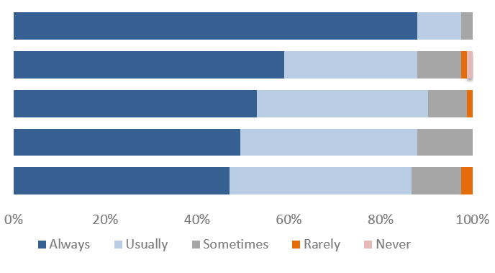

Professional and courteous (-1.2%)

Consistent throughout Ed Prep (-8.3%)

Consistent over time (-7.1%)

Useful (-5.7%)

Timely (+4.5%)

**QUALITY INDICATORS FOR ENGAGEMENT**

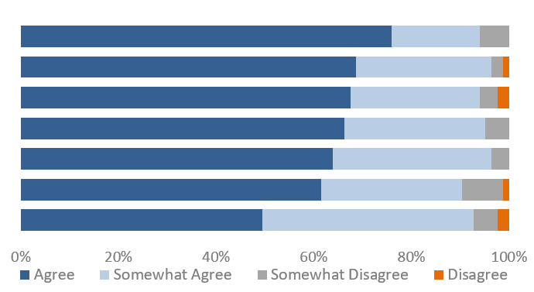

Solicits input (-1.0%)

Accepts feedback willingly (-2.4%)

Delivers on deadlines promised to the field (-4.8%)

Has provided useful resources and guidance (-1.1%)

Is responsive to the needs of my org. (+1.4%)

Is proactive in providing assistance (-5.9%)

Acts on feedback demonstrably (+0.3%)

| **WHAT WAS YOUR MOST EFFECTIVE INTERACTION?**  When asked to identify the **most effective interaction** with the Ed Prep Team, more than any other factor, the field referenced helpful, timely, personalized answers to their inquiries (~90%). Many respondents recognized Ed Prep Team staff members for being well-informed and extremely supportive. | *“Every time I have emailed an individual with a specific question about licensure or CAP or the like, I've received a prompt and very helpful response.”*  *“We conducted a conference call with ESE in November to confirm some details about a licensure program. The Ed Prep team was very responsive to setting up the phone meeting and answering all our questions. They were also willing to quickly respond in writing to the conclusions of our meeting as this was important to our institution's leadership.”* |
| --- | --- |
| **WHAT WAS YOUR LEAST EFFECTIVE INTERACTION?**  On the other hand, when asked about the **least effective interaction**, there were no high-frequency trends in the comments. A few respondents commented that they would prefer more personal communications. | *“I wish there were more opportunities to talk to specialist by phone. Most times, an email will suffice. However, there have been times where it has been challenging to decipher meaning on both ends.”*  *“I miss personal interaction. It would be great to have a limited window of time that we could call in a pinch.”* |

**Engagement and Effectiveness of Key Initiatives**

**ENGAGEMENT**

The chart below shows the extent to which Sponsoring Organizations felt connected to key Ed Prep initiatives. Compared to past years, several initiatives showed a slight increase in Sponsoring Organization involvement, including the Candidate Assessment of Performance, the Licensure Regulation Changes, and the Ed Prep Survey Development.

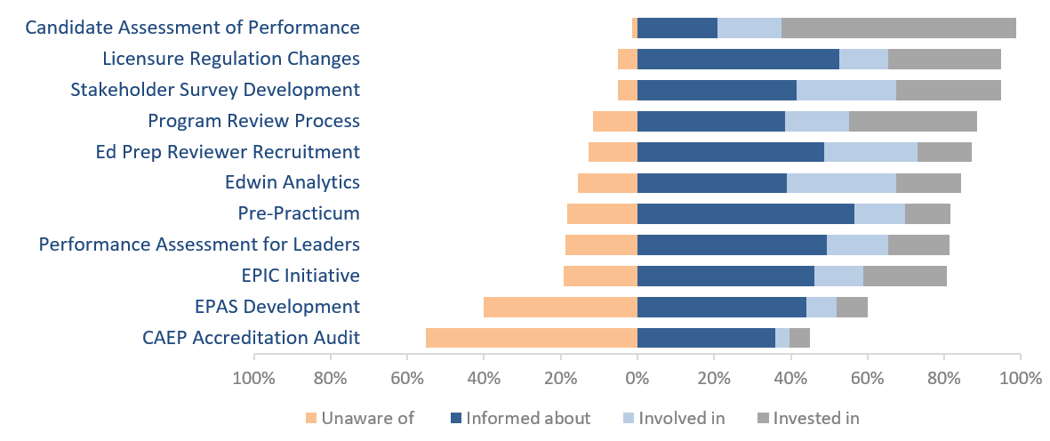

Almost 99 percent of respondents were informed, involved, or invested in the Candidate Assessment of Performance. Other programs that showed a high level (~95%) of awareness among respondents were the licensure regulations reform and the stakeholder survey development. However, approximately 40% of respondents were unaware of the development of the Educator Preparation Annual Snapshot, and 55% were unaware of the CAEP Accreditation Audit.

**EFFECTIVENESS**

For each of the major initiatives the field engaged in this year, the Ed Prep Team wanted to know the quality of several components related to implementation. The field was asked to rate the overall effectiveness of each initiative across four categories:

* Initial and Ongoing Communication
* Follow-through on Commitments and Deadlines
* Useful Resources Developed and Shared
* Reasonable and Appropriate Timeline

**Ratings Areas**

**(percent proficient or exemplary)**

| Initial & Ongoing Communication | Follow-through on Commitments & Deadlines | Useful Resources Developed & Shared | Reasonable & Appropriate Timeline |
| --- | --- | --- | --- |
|  |  |  |  |
| For Initial and Ongoing Communication, Follow-through on Commitments and Deadlines, Useful Resources Developed and Shared, and Reasonable and Appropriate Timelines, major ESE initiatives were rated in the following order (from most exemplary to least): State Annual Report, Formal reviews, Candidate Assessment of Performance, Informal reviews, SEI Endorsement,  Edwin Analytics, and Performance Assessment for Leaders. | | | |
|  | | | |

State Annual Report

Formal Reviews

Candidate Assessment of Performance

Informal Reviews

SEI Endorsement

Edwin Analytics

Performance Assessment for Leaders

The Performance Assessment for Leaders and Edwin Analytics were consistently rated least proficient/exemplary this year, relative to the other initiatives. Conversely, the State Annual Report and Formal Reviews were consistently solid across the board. Relative to past years where ratings were often dispersed among major initiatives, this year we observed more clustering and uniformity in the ratings.

**Ed Prep Team’s Continuous Improvement Efforts**

| What is the most important thing the Ed Prep Team is doing that should continue? | * Reaching out to the Ed Prep higher ed programs to solicit input and for serving on various initiatives that are pertinent to our work. * Developing the CAP and fine-tuning all of the procedures around it. Great tool to assess candidates. * Keep sending emails as reminders of upcoming deadlines and programs. * Seeking substantive input from Sponsoring Organizations as initiatives are taking shape—so as to inform the shape rather than respond to the draft. |
| --- | --- |
| What is the most important thing the Ed Prep Team can do to improve? | * I think consistent and reliable communication is essential. I would continue to work on that as much as possible. * Additional and regular communication around the SEI endorsement would be helpful.   More suggestions for strengthening/establishing partnerships   * Streamline/condense the CAP paperwork |

The majority of respondents agreed that the Ed Prep Team has positively impacted the quality of preparation at their organizations, and that they feel like they are connected to a network that’s focused on improvement. Overall, the results suggest the Ed Prep Team has helped establish a clear vision for the work, and that Sponsoring Organizations believe ESE’s efforts are effective.  
*Numbers in parentheses indicate changes from 2016 in % Agreeing.*

The work of ESE’s Ed Prep team in 2016-2017 has positively impacted the quality of preparation at my Sponsoring Organization (+4.2%)
Agree 63.5%, Somewhat Agree 31.1%, Somewhat Disagree 5.4%, Disagree 0%


Overall, I feel connected to a network that is improving educator preparation in MA (+2.9%)
Agree 60.5%, Somewhat Agree 32.9%, Somewhat Disagree 6.6%, Disagree 0%


ESE has articulated a clear vision for educational improvement in MA (-1.2%)
Agree 58.7%, Somewhat Agree 33.3%, Somewhat Disagree 8.0%, Disagree 0%


The Ed Prep team is effective in its efforts to guarantee that preparation in MA results in educators ready to support the success of all students (+6.1%)
Agree 56.0%, Somewhat Agree 36.0%, Somewhat Disagree 8.0%, Disagree 0%


ESE is effective in its efforts to improve the overall quality of public education (+1.7%)
Agree 52.1%, Somewhat Agree 37.0%, Somewhat Disagree 11.0%, Disagree 0%


I believe ESE’s vision will lead to educational improvement in Massachusetts (+0.7%)
Agree 48.6%, Somewhat Agree 39.2%, Somewhat Disagree 12.2%, Disagree 0%


The work of ESE’s Ed Prep team in 2016-2017 has positively impacted the quality of preparation at my Sponsoring Organization (+4.2%)

Overall, I feel connected to a network that is improving educator preparation in MA (+2.9%)

ESE has articulated a clear vision for educational improvement in MA (-1.2%)

The Ed Prep team is effective in its efforts to guarantee that preparation in MA results in educators ready to support the success of all students (+6.1%)

ESE is effective in its efforts to improve the overall quality of public education (+1.7%)

I believe ESE’s vision will lead to educational improvement in Massachusetts (+0.7%)

**Conclusion**

ESE is grateful to the respondents from the field that completed the survey. The Ed Prep Team will use the data from the survey to improve the supports it provides to preparation providers and increase the overall effectiveness of those efforts to guarantee that preparation in Massachusetts results in effective educators. The next annual feedback survey will be issued at the end of the 2017-2018 academic year.

Please contact [edprep@doe.mass.edu](mailto:edprep@doe.mass.edu) with questions or comments.