Milagros “Milly” Arbaje-Thomas
president & ceo | Metropolitan Council for Educational Opportunity
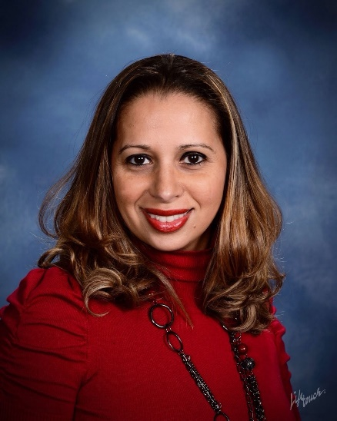
Milagros “Milly” Arbaje-Thomas is a seasoned executive with over 20 years experience overseeing non-profit organizations. She is currently the President/CEO of the Metropolitan Council for Educational Opportunity (METCO), the largest and second longest-running school desegregation program in the country. METCO places 3200 students from Boston into 33 participating suburban school districts with the goal of reducing racial isolation and increasing diversity. Prior to that, she spent 15 years at ABCD, Boston’s antipoverty agency, supporting more than 85,000 low-income residents through its city-wide network of neighborhood-based organizations. Milly oversaw neighborhood sites in Parker Hill/Fenway, Mattapan, and Jamaica Plain as well as the Citywide Hispanic Center, and then served as Deputy Director of Field Operations for all sites. Milly also co-founded and served as President of the Roxbury
Presbyterian Church Social Impact Center (SIC) for 14 years. She began her career as a clinical social worker at Brookside community health center in Jamaica Plain. Born in the Dominican Republic, Milly holds a Bachelor Degree in Psychology with minors in Education and Women Studies, a Master in Clinical Social Work from Boston College, a Certificate in Non-Profit Management from Boston University School of Management, and an Honorary Doctorate Degree in Humane Letters from Emmanuel College.

Marilyn Cochran-Smith
professor | Lynch School of Education and Human Development, Boston College
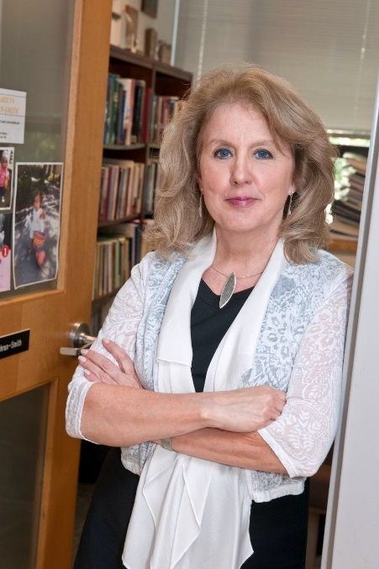
Marilyn Cochran-Smith is the Cawthorne Professor of Teacher Education at the Lynch School of Education and Human Development, Boston College. Beginning her career as an elementary school teacher, Cochran-Smith has been a teacher education practitioner, scholar, and researcher for more than 40 years. She has written 10 books, seven of which have won national awards, and more than 200 articles, chapters, and editorials. Her co-authored book, Reclaiming Accountability in Teacher Education (Cochran-Smith, Carney, Keefe, Burton, Chang, Fernández, Miller, Sánchez & Baker, Teachers College Press, 2018), won the 2020 Best Book Award from the American Association of Colleges of Teacher Education (AACTE) and the American Educational Research Association’s (AERA) Division K’s 2019 Distinguished Contributions to Research award. Cochran-Smith is an elected member of the National Academy of Education and a former president of AERA. The focus of her current work, with co-author Emilie Reagan, is making equity the centerpiece of teacher preparation evaluation.

Joseph Corazzini
Assistant Superintendent | Framingham Public Schools
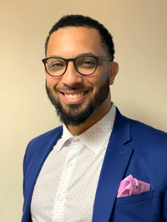
Mr. Joseph Corazzini earned a Bachelor of Arts degree in History and a Master of Science degree in Nonprofit Management from Worcester State University. He is also a recent graduate of the AASA/Howard University Urban Superintendents Program. Joe has served as the Director of Community Resource Development for the Framingham Public Schools since 2012, and in this time he has expanded the Out of School Time programs and community partnerships in the district. Prior to his work in Framingham, he worked for a number of youth development organizations, including Citizen Schools, Dynamy, the Worcester Education Collaborative and the United Way of Central Massachusetts. At the United Way, he served on the senior leadership team that developed one of the first nationally recognized Promise Neighborhoods, a student-centered wraparound support initiative developed under the Obama Administration. He has extensive experience supporting non-profit organizations in strategic planning, organizational development and diversity initiatives. Joe currently serves on the Board of the Metrowest Non-Profit Network and on the Board of the Metrowest Medical Center.
Ashley Davis
Principal | Pauline A. Shaw elementary School
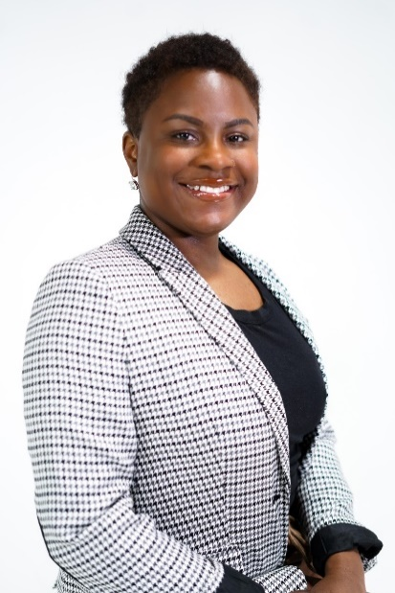
Ashley Davis, a 31 year old Cincinnati, Ohio native, graduated from Kentucky State University in May of 2013 with a major in English Literature and a minor in Journalism. At Kentucky State University, Ashley joined the prestigious Lambda Chapter of Sigma Gamma Rho Sorority, Incorporated where she served as Vice President for years. Upon graduation, Ashley moved to Boston and taught 9th Grade English for 5 years while also leading as a Varsity Cheerleading Coach, Classroom Climate Coach & Leadership Team Liaison, and Journalism Elective Teacher. Now a third year principal at the Pauline A. Shaw Elementary School (a Boston Public School) in Mattapan, Ashley has her Master's Degree in Effective Teaching and recently completed the Lynch Leadership Academy for Educational Administration at Boston College.

Andrew Dean Ho
Psychometrician | Harvard Graduate School of Education
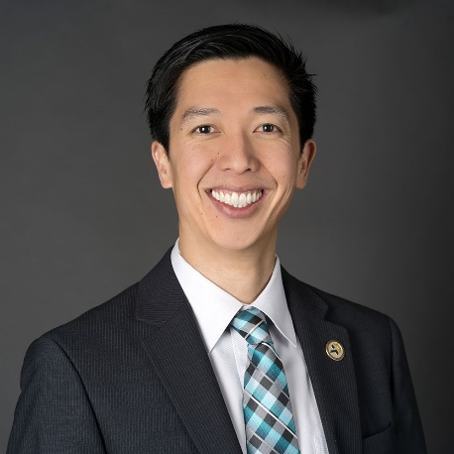
Andrew Dean Ho is the Charles William Eliot Professor of Education at the Harvard Graduate School of Education. He is a psychometrician whose research aims to improve the design, use, and interpretation of test scores in educational policy and practice. Professor Ho is known for his research documenting the misuse of proficiency-based statistics in state and federal policy analysis. He has also clarified properties of student growth models for both technical and general audiences. His scholarship advocates for designing evaluative metrics to achieve multiple criteria: metrics must be accurate, but also transparent to target audiences and resistant to inflation under high stakes.
Professor Ho is a director of the National Council on Measurement in Education (NCME) and the Carnegie Foundation for the Advancement of Teaching. He completed his 8-year term as a member of the National Assessment Governing Board (NAGB) in 2020. He has chaired the research committee for the Vice Provost for Advances in Learning (VPAL) at Harvard University, which governed research on "massive" open online courses (MOOCs). He holds his Ph.D. in Educational Psychology and his M.S. in Statistics from Stanford University. Before graduate school, he taught middle school creative writing in his hometown of Honolulu, Hawaii, and high school Physics and AP Physics in Ojai, California.
Ron Ferguson
Economist | Harvard Kennedy School
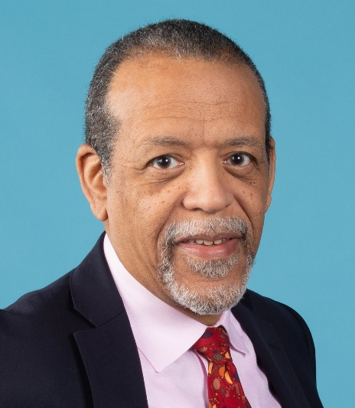
Ron Ferguson is an MIT-trained economist whose teaching, research, and social entrepreneurship across almost four decades at Harvard Kennedy School have covered topics ranging from state and local economic development, to teacher quality, to early childhood parenting. A full-time member of the faculty beginning in 1983, he shifted into an adjunct role in 2014 and remains a faculty associate at the Malcolm Wiener Center for Social Policy. Ron’s current priority is an initiative that he launched as faculty director of the Achievement Gap Initiative at Harvard, that mobilizes communities for infant and toddler learning and brain development. See <thebasics.org>. His most recent book, coauthored with Tatsha Robertson and published in 2019, is The Formula: Unlocking the Secrets to Raising Highly Successful Children. He grew up in Cleveland, Ohio before earning an undergraduate degree from Cornell University and a PhD from MIT, both in economics.

Lorena Lopera
Executive Director | Latinos for Education
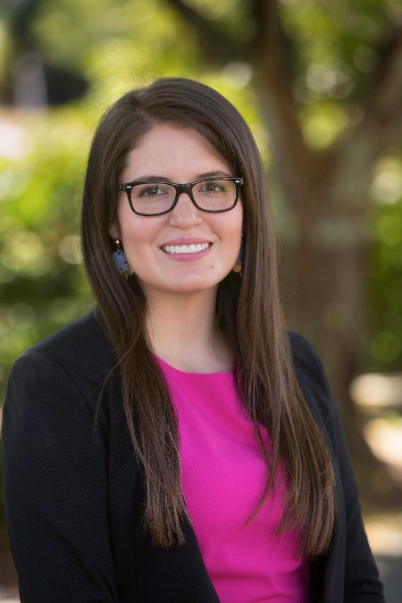
Lorena Lopera is Executive Director, New England at Latinos for Education. Lorena is responsible for the local vision, strategy and execution of Latinos for Education’s work in New England. Lorena leads and oversees external engagement activities such as organizing and coordinating with Latino serving organizations, speaking publicly on behalf of L4E, and executing on our strategic marketing and communications plan. Previously, she served as Director of Development at BES, where she led fundraising efforts nationwide. Prior to this, Lorena worked with various organizations including City Year, The Posse Foundation, Epiphany School and Sociedad Latina, focusing her work on education equity. She emigrated from Colombia as a child and knows how much hard work, resilience, and support goes into finding the right opportunities for success. She graduated from Boston College and holds a B.A. in Hispanic Studies. Lorena is a proud BPS Parent and current Co-Chair of the Hurley K-8 School Site Council as well as serves on the board for EdVestors.

Kenann McKenzie
Assistant Adjunct professor & Director | Aspire Institute, BU Wheelock College of Education & Human Development
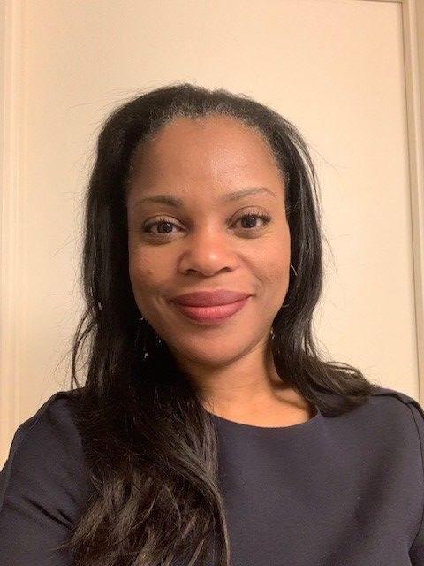
Dr. Kenann McKenzie is an assistant adjunct professor and the Director of the Aspire Institute at BU Wheelock’s College of Education and Human Development. The institute’s primary goal is to support the Pre-K-12 educational sector with professional development based within a social justice framework and to provide technical assistance to education partners, school districts and states. Dr. McKenzie also teaches Research Methods and serves as the Educational Leadership & Policy Studies’ faculty representative to Wheelock’s Equity, Diversity & Inclusion Committee. Her background includes over 25 years in education in all sectors as a practitioner, policy analyst and researcher. In the K-12 sector she has been an administrator, analyst, and researcher; in post-secondary undergraduate education she has been an instructor and college academic counselor. In addition, at the US Department of Education, she served as the Executive Director of the National Board for Education Sciences. Further, she has conducted research, trainings and written on matters of equity, school choice, and civic engagement. In her civic life, Dr. McKenzie currently serves on the School Committee for the city of Beverly, MA and she also serves on the Racial Imbalance Advisory Council for the state of Massachusetts’ Department of Elementary and Secondary Education. Dr. McKenzie holds a BA in Africana Studies from Cornell University, an M.Ed. in Social Foundations of Ed. from the University of Virginia, and a Ph.D. from Teachers College, Columbia University, in Politics and Education.

Takeru “TK” Nagayoshi
Teacher | New Bedford
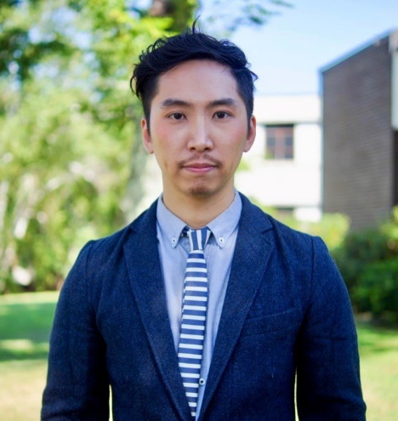
Takeru “TK” Nagayoshi is the 2020 Massachusetts Teacher of the Year. He teaches high school AP English and research in New Bedford, MA. As an education advocate, TK has focused on policy around diversifying our schools and supporting leadership roles and opportunities for teachers of color. He has written op-eds on culturally responsive work; helped recruit educators of color through the MA Department of Education; and serves on several state committees, task forces, and advisory boards to fight for equitable and anti-racist policy recommendations. A nationally recognized educator, TK also leads trainings and workshops around the country, ranging on topics from pedagogy, curriculum and content, to education policy and community organizing work. TK has received recognitions such as the Horace Mann Award for Teaching Excellence (2021), Sue Lehmann Excellence in Teacher Leadership Award (2019), Boston University Young Alumni Award (2019), and Sontag Prize in Urban Education (2018). He graduated magna cum laude from Brown University with an honors B.A. in international relations and from Boston University an M.Ed in Curriculum and Teaching. As a son of Japanese immigrants and a gay person of color, TK leverages his identities to fight for and center equity in his teaching and teacher leadership.
Claudia Rinaldi, Ph.D.
chair | Joan Weiler Arnow ’49 Professor of Education, Lasell University
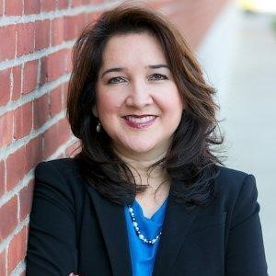
Claudia Rinaldi, Ph.D., is Chair of the Joan Weiler Arnow '49 Professor of Education, a three-year endowed position awarded for excellence in teaching and community impact. Her areas of research are the implementation of the Multi-Tier System of Supports (MTSS) framework in urban settings with English learners, teacher education in bilingual special education, and diversifying the teacher pipeline. Claudia has authored peer-reviewed publications and a book for educators called Practical Ways to Engage All Struggling Readers. She leads a graduate certificate program in Teaching Bilingual Students with Disabilities for general, ESL, and special education teachers geared towards applying research-informed practices to the questions and processes of identifying whether it is a language difference or a learning disability.
Additionally, Claudia developed a college mentoring program called Pathways to Teacher Diversity for districts and teacher education programs to partner in identifying and supporting underrepresented high school students interested in teaching careers to access and persist in college successfully. She serves on various boards, including the National Center for Learning Disabilities, and serves as an expert for Understood.org and the National Center for Intensive Interventions. She also previously served in the International Council for Exceptional Children Board of Directors and led their international that hosted over 5,000 teachers, faculty, and researchers.
Professor Claudia Rinaldi believes that it is critical to prepare teacher leaders who may serve as advocates and allies for all students. She believes that teachers must respond to the belief that all students can learn and succeed beyond barriers like culture, language, disability, poverty, and marginalization in our country and globally.
Jalene Tamerat
dean | Charles Sposato Graduate School of education
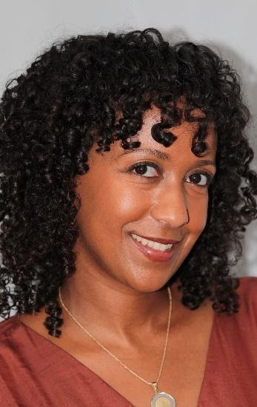
Dr. Jalene Tamerat is the Dean of the Charles Sposato Graduate School of Education, a practice-based master's program for aspiring teachers in the Boston area. Prior to coming to Sposato, Jalene worked for three years as the Director of New Teacher Development in Boston Public Schools, where she oversaw induction and licensure programs for novice teachers. Jalene has also served as adjunct faculty at BU Wheelock, teaching methods courses to TFA Corps members as well as graduate-level courses in adolescent development. She began her career in education in 2003 as a classroom educator in BPS, teaching core subjects such as science, mathematics and social studies at the middle school level. Jalene holds an Ed.D. from Boston University ('18), an Ed.M. from Harvard University, an M.A.T. from Emmanuel College, and a B.A. from the University of Massachusetts Amherst.

Ron Walker
Executive Director | Coalition of schools educating boys of color
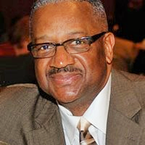
Ron Walker has served in the noble profession of education for 5 decades. During that time, Ron has served as a teacher, assistant principal, principal, staff developer and co-director of a national school K12 transformation organization called ATLAS Communities. Since 2007, Ron has served as the founding Executive Director of the Coalition of Schools Educating Boys of Color (COSEBOC). The mission of COSEBOC is to advance the affirmative social, emotional, cultural, and academic development of boys and young men of color. This occurs through the provision of highquality professional development and supports for school, district, family, and community advocates. Ron believes that COSEBOC must continue to focus on intentional efforts to disrupt and eliminate the school to prison pipeline and any policies and practices that dehumanize boys and young men of color in pre-K-12 school environments. Ron has been recognized at the national, state, and local levels for his efforts to illuminate best and promising practices that serve to accelerate the potential and genius of boys and young men of color. Ron often shares his mantra that guides his work “There is a difference between schooling and education. Schooling too often leads one to compliant thinking, Education leads one to liberation.”

