 | Partnership Toolkit  Creating a Comprehensive Student Teaching Partnership | 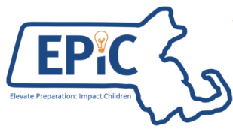

Effective student teaching partnerships between school districts and educator preparation providers can support the preparation, recruitment and development of Massachusetts teachers in a manner that strengthens student learning and the long-term sustainability of our teaching workforce.
According to evidence from Massachusetts and nationally:
- Student teachers are three times more likely to teach where they complete their practicum, creating a natural pipeline between student teaching placement and district employment.
- Student teachers who complete their practicum in urban settings are more likely to stay in urban schools once employed, combating the higher rates of teacher turnover that persist in these districts.
- Partnerships between districts and educator preparation organizations can result in the development and placement of more effective teachers in the often hard-to-staff roles.
- An effective student teaching placement model can significantly improve the student achievement of classrooms where that student teacher is placed.

Student Teaching Partnership Consortium
In the 2016-2017 school year, Massachusetts convened three partnerships between educator preparation providers and districts to build and strengthen systems for student teaching placement, support, and recruitment. These three partnerships comprised the Student Teaching Partnership Consortium:
- Salem Public Schools and Salem State University
- Boston Public Schools and Boston University
- Brockton Public Schools and Bridgewater State University
The objective of this Consortium was to support the development of rich partnerships that focused on student teacher placements that will improve teacher candidate effectiveness, hiring, retention, and student outcomes. As part of this work, each partnership followed an evidence-based model for partnership initiation, implementation, and continuous improvement. In addition to two convenings, partnerships met monthly to engage in vision and goal setting, strategic action planning, data sharing, and implementation preparation. Brief case studies of their work are available as appendices to this Toolkit.

The Partnership Toolkit
This Toolkit articulates the evidence-based model for partnership initiation, implementation, and continuous improvement utilized by Consortium members, and includes supportive tools and resources developed through their work. The purpose of this Toolkit is to help other educator preparation and district partnerships develop systems for placing and supporting student teachers with the goal of improving student outcomes and building a pipeline from student teaching to employment.

Building & Sustaining a Comprehensive Student Teaching Partnership
Building effective and sustainable student teaching partnerships involves three stages:
- Initiation: Forming the partnership, identifying the pipeline needs, and initial visioning and goal setting
- Implementation: Collaboratively selecting and supporting participants, ensuring alignment between partners, regularly meeting and spending time in partner schools.
- Continuous Improvement: Ongoing program review and refinement.
Stage | Key Activities | Tools & Resources
INITIATION | - Form a partnership and define expectations.  - Analyze educator preparation pipeline data and district human capital needs.  - Set an initial vision and goals for the partnership.  - Develop a partnership implementation action plan. | - Partnership Compact  - District Pipeline Advisory: Preparation to Employment Pipeline Information  - District Pipeline Report (available upon request)  - Partnership Data Roadmap  - Partnership Self-Assessment  - Setting the Vision Protocol  - Defining Pipeline Needs Activity  - Developing SMART Goals  - Action Plan Template  - Sustainability Planning Resources
IMPLEMENTATION | - Jointly select and train Supervising Practitioners and strategically place teacher candidates.  - Align coursework and field-based experiences with district language and priorities.  - Establish systems for ongoing communication and feedback. | - Action Plan Review Protocol  - Online Calibration Training Tool  - CAP Resources  - Supervising Practitioner Job Description (sample)  - Supervising Practitioner Selection Criteria (sample)  - Student Teacher Cohort Liaison Position Description (sample)
CONTINUOUS IMPROVEMENT | - Use evidence to assess progress and outcomes.  - Make adjustments to the partnership in order to improve teacher candidate readiness and PK-12 student outcomes.  - Secure sustainable funding. | - Partnership Data Roadmap  - Data Sharing Agreement (sample)  - Refining the Vision (Vision Assessment Tool)  - Partnership Spotlights  - Sustainable Funding Project

Stage 1: Initiation
1. Form a partnership and define expectations. In the initiation phase, the educator preparation program and district agree to form a new partnership or strengthen an existing one. Partnership teams should include organizational leaders and key decision-makers with the capacity and authority to lead the work. This may include, from the district: Superintendent/Assistant Superintendent, Principals, Human Resource Professionals, and Supervising Practitioners. From the educator preparation program side, it may include Deans, Directors of Educator Preparation/Placement, Program Supervisors, and Faculty.
2. Analyze educator preparation pipeline data and district human capital needs. Partners review data related to teacher pipeline, performance, and retention, as well as student demographic and performance data. This data analysis allows partners to define current and future human capital needs and inform student teacher recruitment and placement. (See Featured Resource: Partnership Data Roadmap)
3. Set an initial vision and goals for the partnership. Partnerships create an initial vision and specific goals for their work. Focus areas include defining the partnership model, determining the number and type of student teacher placements, training and support needs, establishing implementation benchmarks, and identifying expected outcomes.
4. Develop a partnership implementation action plan. Outlining an action plan helps the team identify key action steps, timelines, necessary resources, and measures of success. A completed plan will typically span 3-5 years in length and should include short, interim, and long-term objectives, and a preliminary plan for securing sustainable funding.
Featured Resource: Partnership Data Roadmap
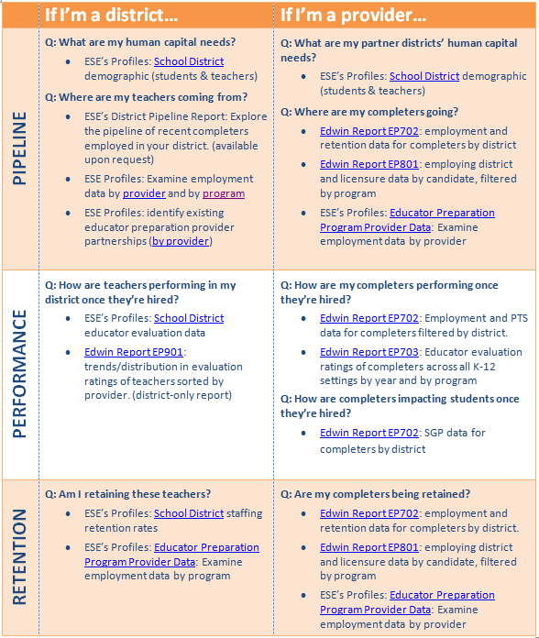
The Partnership Data Roadmap is a useful tool to frame initial conversations around the partnership’s goals and objectives. Prompts and related data sets provide answers to targeted questions about the existing pipeline, teacher performance, and teacher retention. The Roadmap can also frame subsequent conversations around progress monitoring and continuous improvement.

Stage 1 Tools and Resources
- Partnership Compact
A strong commitment from both partners is essential to success. All stakeholders need to be present, with decision-makers at the table. This compact helps articulate expectations and agreements from the onset.

- District Pipeline Advisory: Preparation to Employment Pipeline Information
Resource providing PK-12 district leaders with information about the current pipeline of recent completers employed in their district, as well as next steps for shaping this pipeline more strategically.

  - District Pipeline Report
Where are your teachers coming from? This report displays the number of teacher completers recently employed in your district by preparation program; data can be filtered by geographic proximity and year. (Available upon request: email all requests to edprep@doe.mass.edu.)

  - Partnership Data Roadmap (featured resource)
The Partnership Data Roadmap includes questions for both members of the partnership that are designed to illuminate data related to the current teacher pipeline, teacher and student performance outcomes, and retention.

- Partnership Self-Assessment
Tool for assessing the current state of the partnership and identifying next steps or focus areas.
- Setting the Vision Protocol
Protocol for setting an initial vision for the partnership.
- Defining Pipeline Needs Activity
Protocol for defining and articulating a district’s pipeline needs using internal and external data sources.

- Developing SMART Goals
Tool for drafting and vetting a SMART Goal associated with the partnership’s vision.

- Action Plan Template
Excel template for building a comprehensive action plan that defines action steps, timeframe, roles & responsibilities, projected outcomes, and resources needed.

- Sustainability Planning Resources
How will you sustain this partnership over time? These resources are designed to jumpstart thinking around sustainable funding models that will support your partnership.

Stage 2: Implementation
5. Jointly select and train supervising practitioners and strategically place teacher candidates. Partners benefit from a shared understanding of the qualities of a strong teacher candidate, an effective supervisor, and a meaningful placement. Establishing these agreed-upon criteria is invaluable in the early stages of a partnership.
6. Align coursework and field-based experiences with district language and priorities. By aligning coursework to field-based experiences in a district, partnerships contribute to a coherent learning experience for teacher candidates, build a bridge between education theory and the realities of a PK-12 setting, and strengthen the continuum between preparation and employment.

7. Establish systems for ongoing communication and feedback. Setting regular times for the team to come together and oversee activities, troubleshoot challenges, and monitor progress toward interim and summative outcomes is essential to the success and sustainability of the partnership.

Featured Resource: Online Calibration Training Tool
The Online Calibration Training Tool uses videos of classroom instruction from ESE’s Calibration Video Library to simulate brief, unannounced observations. Groups of educators, such as school leaders or educator preparation program supervisors, watch a lesson video, assess the teacher’s practice related to specific elements from the Model Classroom Teacher Rubric, and then provide the teacher with written feedback. Through real-time data displays, the group members can then see how their conclusions compare with each other as well as with educators throughout the state.
* sample data displays
Calibration on Evidence and Feedback
Districts and educator preparation programs can use the online calibration training tool to address the following key questions:
- How do educators in our district or organization interpret instructional practice?
- Do our instructional expectations differ from others across the state?
- How do we develop and reinforce common expectations for high-quality instruction and feedback?
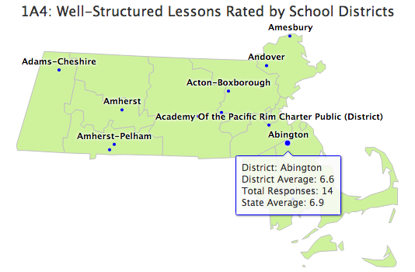
Accompanying training modules for each video prompt groups to tackle these questions and catalyze meaningful discussions about expectations for quality instructional practice and feedback.
Using the Online Calibration Training Tool
Innovative options for benefiting from this resource include:
- Focused calibration on high-priority elements of practice
- Cross-role calibration to develop a shared understanding of practice across educators
- Joint district/educator preparation partner training to define common expectations
To access the Online Calibration Training Tool’s videos and workshop guides, please visit:
Within-District/SO Calibration
Cross-District/SO Calibration
http://www.doe.mass.edu/edeval/resources/calibration/tool/

Stage 2 Tools and Resources
  - Action Plan Review Protocol: Impact/Lift Analysis
Use this protocol to review your partnership’s action plan, evaluate and prioritize activities based on impact and lift, and assess progress toward short- and long-term outcomes.

  - Online Calibration Training Tool (featured resource)
Use this training tool to build a shared understanding across partnership members around what proficient practice and high quality feedback look like for student teachers in their field-based placements.

- CAP Resources
The Candidate Assessment of Performance (CAP) is the performance assessment that all teacher candidates must complete during their student teaching experience (the practicum. Visit this website to learn more about these expectations and access resources related to supervisor roles, responsibilities, and training.

- Supervising Practitioner Job Description (sample template)
Use this sample template to build out your own job description for high-quality supervising practitioners. Criteria include requirements and responsibilities associated with CAP supervision, skills associated with effective teacher educators, and a place for additional responsibilities that may be unique to your partnership.

- Supervising Practitioner Selection Criteria (sample)
This resource provides a sample of supervising practitioner selection-criteria co-developed by the BU and BPS partnership.

- Student Teacher Cohort Liaison Position Description (sample)
This resource provides a sample position description for a site-based coordinator responsible for the management, development and support of a student teacher cohort in a school. The role is based on a highly effective position developed by the Minneapolis Public Schools and partner sponsoring organizations as a key component of their student teacher pipeline model.

Stage 3: Continuous Improvement
8. Use evidence to assess progress and outcomes. Throughout the year, teams should routinely review data on teacher pipelines, performance, and student outcomes.

9. Make adjustments to the partnership in order to improve teacher candidate readiness and PK-12 student outcomes. Educator preparation providers can be responsive to district needs by flexibly adapting pipelines and programs to better meet the needs of the district.

10. Secure sustainable funding. Partnerships can lose momentum if they develop a strong vision without integrating a corresponding funding sustainability plan into the model. At this point in the partnership, the partnership team should be invested in a long-term funding model that will sustain the partnership over time.

Stage 3 Tools and Resources
  - Partnership Data Roadmap
The Partnership Data Roadmap includes questions for both members of the partnership that are designed to illuminate data related to the current teacher pipeline, teacher and student performance outcomes, and retention.

- Data Sharing Agreement (sample)
This sample data sharing agreement, developed by the Minneapolis Public Schools for use with partner sponsoring organizations, may be adapted for Massachusetts partnerships as a tool to facilitate the sharing of relevant data on pipelines, performance, and student outcomes.

- Refining the Vision (Vision Assessment Tool)
Survey adapted from the "Vision Assessment Tool" in Curtis, R.E. & City, E.A. (2009). Strategy in action: How school systems can support powerful learning and teaching. Cambridge: Harvard Education Press.

- Partnership Spotlights
Successful practices of two partnerships from the Student Teaching Partnership Consortium.

- The Sustainable Funding Project at Bank Street College of Education
This report tackles quality sustained clinical practice as one part of the affordability question.

Spotlight: Bridgewater State University and Brockton Public Schools

The Bridgewater/Brockton Partnership joined the Consortium in an effort to bring a longstanding partnership into closer alignment with the district’s pipeline needs. In addition to identifying criteria for effective teacher candidates, the partnership focused on developing a mentor training sequence for supervisors in conjunction with a more intentional student teacher placement model that was responsive to articulated school and district needs related to a diverse pipeline and the development of teachers in hard-to-staff roles.
Monthly Partnership Meeting at the Huntington Elementary School in Brockton, MA.

Key Components of a Strong Partnership
The BSU/BPS partnership identifies its greatest success in the relationships between BSU staff and district teachers. Not only are BSU staff welcome and supported in the schools, students see BSU staff so often that they assume they work for the district. How did BSU and Brockton Public Schools form such a close working relationship? They did so by prioritizing the partnership as a critical component of teacher development, embedding BSU staff into the partner sites, and committing leadership to its sustainability. Key drivers of this successful partnership are described below:
- Monthly Leadership Meetings. Regular meetings to support partnership work contribute to its continuous improvement and sustainability. Each month, educators from both organizations, including leadership, meet to discuss the partnership and ways to continue to strengthen it. They set schedules for upcoming work, define who is doing what, and set goals and action steps. In between meetings, members from both organizations work together to accomplish tasks.
- Shared Faculty Expertise. District staff members with expertise are encouraged to work with the University. For example, the district reading coordinator also teaches reading classes as an adjunct professor for BSU.
- District-Aligned Coursework & Professional Development. University staff work with district staff to reinforce instructional practices and professional development topics occurring at the site school (e.g. Reader’s Workshop) with student teachers. This is done by the coordination of curriculum leaders, methods instructors and the teachers. This practice builds student teachers’ experience and expertise with K-12 instructional priorities and builds a foundation for a potential pipeline for any future teaching vacancies at the school, as those recent graduates will have the background in core instructional practices at that school.
- Regular Faculty Involvement. The partnership continuously seeks ways to bring University staff to the schools. For example, they obtained a grant where a different BSU science professor will come in to one grade level monthly to conduct interactive lessons. Other examples include professors who come in and read to classes, and invitations to BSU staff to participate in school events (e.g. attending the Memorial Day parade).
- Collaborating to Promote Shared Goals and Efficiencies. BSU leverages resources to support their programs and those of the district. The partnership regularly helps with bringing in additional resources into the schools. For example, a professor at BSU is working with graduate level TESOL interns to run language classes for families at the school. This fills a need for English language instruction for parents that used to be funded by the district but was cut in a previous budget, and provides real practical application for BSU students.
- Continuous Improvement. They work collaboratively to identify new areas that will strengthen and refine their partnership. Their newest collaborations include integrating effective classroom management techniques directly into the methods courses, and developing a shared protocol for what would make an ideal student teacher candidate (such as criteria for student teacher selection).

Spotlight: Boston University and Three Boston Public Schools

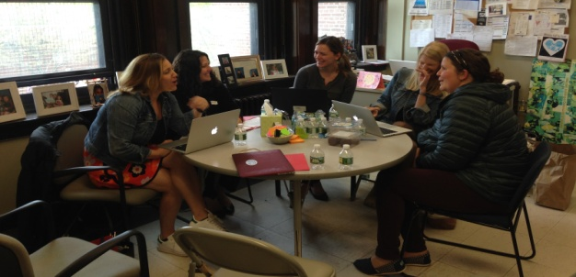
Through its participation in the Consortium, the BU/BPS partnership expanded an existing relationship with a single school into a 3-school student teacher placement network. This model supports field-based experiences from pre-practicum through practicum within three Boston-area schools, where supervising practitioners are selectively chosen and trained in small cohorts, teacher candidates are carefully screened and intentionally placed to meet the needs of each school, and completers are better prepared as prospective new hires in a high-needs urban school environment.

Building Capacity and Expanding Partnerships
The key to this partnership’s success was the opportunity to work directly with three schools to support targeted, intentional student placement from pre-practicum through practicum. School leaders articulated specific expectations for high quality student teachers that would meet the unique needs of their buildings, and university program leaders used these criteria to craft a comprehensive vision for the selection, support, and placement of teacher candidates in individual classrooms.
Partnership Meeting at the Mendell Elementary School in Roxbury, MA
Challenges Always Exist. Even with successful partnerships, BU and BPS school leaders face ongoing challenges related to scheduling the regular meetings and prioritizing the partnership work with everything else going on. In addition, sustainable funding continues to be a challenge as existing efforts are currently grant funded.
Planning is Essential. Without a plan, BU/BPS felt that the work would feel overwhelming. Comprehensive action planning with monthly check-ins and progress reports helped keep them on track and moving forward.
Data-Driven Work. Utilizing data was an essential component of their partnership. Some of the data used included:
- Student surveys - satisfaction with their placements
- CAP data across the programs, including what types of feedback candidates are (or are not) receiving
- Staff and student demographics, including trends related to growing Spanish-speaking student population
Moving forward, the partnership intends to utilize teacher candidate performance data to inform development and placement. In addition, university faculty will regularly solicit principal feedback (now that they have made more intentional connections) to better understand candidate preparedness and to identify what adjustments they need to make to their programs to better align them to school and district needs.
Sharing Expectations. This partnership prioritized the establishment of shared expectations for Supervising Practitioners, Program Supervisors, and candidates. Developing the criteria for these roles and responsibilities was one of the most beneficial components of this partnership during the first year.
Purposeful Teacher Candidate Recruitment. The Partnership Committee feels that their partnership will result in more intentional recruitment and placement of student teachers in high-needs classrooms, along with the supports they need to be successful. Their conversations and planning meetings have given BU faculty a clearer sense of what teacher candidates should expect in pre-practicum and practicum placements, and it’s refined their thinking about the qualities/characteristics candidates need to be successful in specific settings. From licensure requirements to content expertise, the partnership has informed clarity around dual certification needs, as well as more intentional preparation and placement trajectories based on individual school needs associated with inclusive classroom models. For example, if the district is looking for someone who has worked in an inclusive setting and is special education certified, then the student placement can and should correspondingly be in an inclusive classroom.
Better Selection, Training and Supports for High Quality Supervising Practitioners. Intentional modeling and mentoring of SPs is essential in this partnership. Although finding the time to train SPs can be a challenge, they are making it a priority. By articulating specific expectations and criteria for the role, the partnership is able to better select and support SPs from the outset. That said, being an SP can be a learning process. They say, “We know you’re a great teacher… you’re learning to be a great SP and that’s okay.” They position the role of the SP as an opportunity for teacher leadership and professional development in adult learning and mentoring. This is a great step towards administrative or coaching roles.

Glossary of Terms
Field-Based Experience: Experiences such as observation of a variety of classrooms, pre-practicum, practicum/practicum equivalent, internship, apprenticeship, or administrative internship that are integral components of any program for the preparation of educators. Field-based experiences shall cover a range of time periods within the school year.
Practicum/Practicum Equivalent: A field-based experience within an approved program in the role and at the level of the license sought, during which a candidate's performance is supervised jointly by the sponsoring organization and the supervising practitioner and evaluated in a Performance Assessment for Initial License. See 603 CMR 7.04 (4) for practicum hours. The duration of any equivalent to a practicum shall be no fewer hours than provided for the practicum in 603 CMR 7.04 (4). An equivalent to a practicum may include an apprenticeship, the initial five-month period of service as teacher or administrator of record under a Preliminary license, or others approved by the Department.
Pre-practicum: Early field-based experiences with diverse student learners, integrated into courses or seminars that address either the Professional Standards for Teachers as set forth in 603 CMR 7.08 or the Professional Standards for Administrative Leadership as set forth in 603 CMR 7.10. For candidates serving an apprenticeship or employed as educator of record, these experiences may occur simultaneously with the practicum or practicum equivalent.
Program Supervisor: The supervisor from the sponsoring organization, under whose immediate supervision the candidate for licensure practices during a practicum.
Supervising Practitioner: The educator who has at least three full years of experience under an appropriate Initial or Professional license and has received an evaluation rating of proficient or higher, under whose immediate supervision the candidate for licensure practices during a practicum. For the educator of record, a comparably qualified educator will function as the supervising practitioner during the practicum equivalent.

Partnership Compact
A strong commitment from both partners is essential to success. All stakeholders need to be present, with decision-makers at the table. The compact below will help articulate expectations and agreements from the onset.

This Student Teaching Partnership Compact articulates important conditions that must be in place for a partnership to develop a robust student teacher pipeline benefiting both the educator preparation provider and the school district.

The partners commit to the following activities:
- Establishment of a partnership committee comprised of key stakeholders from the district and the educator preparation provider with authority to make programmatic and resource allocation decisions.

- Establishment of a regular meeting schedule for committee members to develop, implement, and monitor the partnership.

- Determination of pipeline needs through data analysis, and development of a multi-year plan that defines criteria and conditions for acceptance of teacher candidates that meet these pipeline needs.

- Partnership model definition (e.g. fellowship, cluster model, etc) and articulation of all implications of this model (such as costs/funding, incentives for participation, and course sequence).

- Development of goals (interim and summative) and an action plan for the multi-year partnership.

The signatures below commit our organizations to the above conditions.

_________________________________ ________________________________
Dean & Date Superintendent of Schools & Date

Educator Preparation  Partnership Data Roadmap | 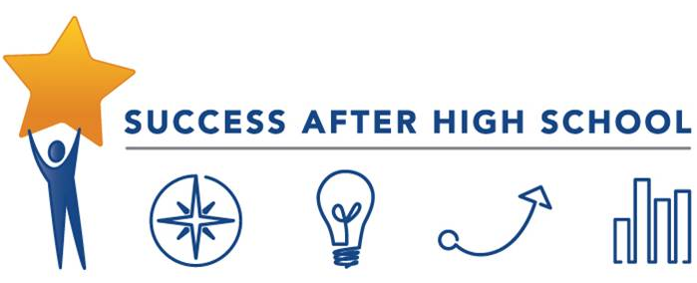

 | If I’m a district… | If I’m a provider…
PIPELINE | Q: What are my human capital needs?  - ESE’s Profiles: School District demographic (students & teachers)  Q: Where are my teachers coming from?  - ESE’s District Pipeline Report: Explore the pipeline of recent completers employed in your district. (available upon request)  - ESE Profiles: Examine employment data by provider and by program  - ESE Profiles: identify existing educator preparation provider partnerships (by provider) | Q: What are my partner districts’ human capital needs?  - ESE’s Profiles: School District demographic (students & teachers)  Q: Where are my completers going?  - Edwin Report EP702: employment and retention data for completers by district  - Edwin Report EP801: employing district and licensure data by candidate, filtered by program  - ESE’s Profiles: Educator Preparation Program Provider Data: Examine employment data by provider
PERFORMANCE | Q: How are teachers performing in my district once they’re hired?  - ESE’s Profiles: School District educator evaluation data  - Edwin Report EP901: trends/distribution in evaluation ratings of teachers sorted by provider. (district-only report) | Q: How are my completers performing once they’re hired?  - Edwin Report EP702: Employment and PTS data for completers filtered by district.  - Edwin Report EP703: Educator evaluation ratings of completers across all K-12 settings by year and by program  Q: How are completers impacting students once they’re hired?  - Edwin Report EP702: SGP data for completers by district
RETENTION | Q: Am I retaining these teachers?  - ESE’s Profiles: School District staffing retention rates  - ESE’s Profiles: Educator Preparation Program Provider Data: Examine employment data by program | Q: Are my completers being retained?  - Edwin Report EP702: employment and retention data for completers by district.  - Edwin Report EP801: employing district and licensure data by candidate, filtered by program  - ESE’s Profiles: Educator Preparation Program Provider Data: Examine employment data by provider

For more specific information or additional support in these efforts, contact edprep@doe.mass.edu.

Partnership Self-Assessment
Resource for assessing and reflecting on an existing or new partnership.

Objective:
- Complete this assessment to reflect on where the partnership is currently in order to set goals for continued improvement. If possible, it is recommended to transfer this survey to an electronic format (i.e. Google Forms) in order to quickly collect and analyze the data in a group setting.

Who:
- Members of the Partnership Committee (or equivalent leadership team)

Select a rating for each statement.
1. Our district understands the talent pipeline and discusses these needs with our educator preparation program. | Strongly Agree | Agree | Disagree | Strongly Disagree
2. In our partnership, we have set a vision and goals together, with a focus on relationship-building and trust. | Strongly Agree | Agree | Disagree | Strongly Disagree
3. We have a shared understanding of the key expectations (Professional Standards for Teachers, as assessed through CAP) for program graduates). | Strongly Agree | Agree | Disagree | Strongly Disagree
4. In our partnership, we share and look at data together to make decisions and drive action. | Strongly Agree | Agree | Disagree | Strongly Disagree
5. We jointly select and train supervising practitioners and strategically place candidates. | Strongly Agree | Agree | Disagree | Strongly Disagree
6. We ensure coursework matches the clinical experiences and district language. | Strongly Agree | Agree | Disagree | Strongly Disagree
7. We communicate and meet frequently. | Strongly Agree | Agree | Disagree | Strongly Disagree
8. We spend significant time in schools together. | Strongly Agree | Agree | Disagree | Strongly Disagree
9. We are open to change and regularly step back to honestly discuss progress and challenges. | Strongly Agree | Agree | Disagree | Strongly Disagree
10. We ensure that district needs drive shifts in teacher preparation programs’ pipelines, structures and systems. | Strongly Agree | Agree | Disagree | Strongly Disagree

Setting a Vision Protocol
Protocol for setting an initial vision for the partnership.

Objective:
- Draft a vision statement that sets the expectation for a strong working relationship, what success looks like, what the focus area is of the partnership, and inclusive of using data to drive the partnership
The vision statement communicates an ideal end result, a vision. It reflects values and beliefs, and should inspire and challenge. A vision statement does not describe what a partnership does, nor does it describe how a partnership operates. Rather, a vision statement details an ideal end result, a state of being that the partners would like to achieve.
Who:
- Members of the Partnership Committee (or equivalent leadership team)
- School leaders
Steps:
- In groups of 2-3, draft a vision for the ultimate vision of your partnership. (10 min)
- As a full partnership team, each pair will share their initial vision statements, and the team will combine them into one vision statement. The team will then write that statement on large chart paper. (50 min)
- (Time Permitting) Share a representation of the vision in one of the following ways.
  - A visual representation of the vision (a picture or photograph)
  - A small paragraph with the vision statement written out in terms of what that looks like in practice.
  - A song with lyrics that depict the vision statement
  - A small skit that acts out your vision statement
  - A Google slide or Prezi that describes the vision statement

Sample Vision Statements
Below are three sample vision statements created by members of the Student Teaching Partnership Consortium.
- Boston University/Trotter School: We are committed to growing a BU-BPS teacher pipeline that increases employment opportunities for BU teacher education graduates, provides BPS a pool of highly-qualified teachers, and contributes to ongoing supports for novice teachers in the district.
- Bridgewater State University/Brockton Public Schools: As partners committed to excellence, BPS and BSU strive to provide quality instruction and hold high academic expectations for all. Our partnership is grounded in research-based practice and data based decision making.
- Salem State University/Salem Public Schools: Salem Public Schools and Salem State University’s commitment to the improvement of teacher education will result in practicum placements that model best practices, strong mentoring relationships, and professional growth for supervising practitioners and student teachers. Both institutions are dedicated to recruiting and selecting a diverse and talented workforce and to increasing teacher effectiveness and teacher candidate success.

SMART Goal Activity
It’s time to set a goal that will translate the vision of your partnership into a concrete action statement.

Objective: Utilize the vetting protocol below to ensure that your partnership’s goal meets the SMART criteria.
Who: Partnership Committee Members (or equivalent leadership team)
Draft SMART Goal:

Use of Data. What data did we review to help identify this goal area?
Specific and Strategic. What will the goal accomplish? Is the goal too broad or is it narrowed in focus?

Measurable. How will we measure whether or not the goal has been reached?

Action-Oriented. What key actions, required to achieve the goal, are stated?

Rigorous, Realistic and Results Focused. What is the result of the goal? Is the goal achievable? Is it rigorous enough?
Time and Tracked: What is the established completion date? When are the benchmark dates?

Revised SMART Goal:

Sample SMART Goal (from Bridgewater State University and Brockton Public Schools): By June of 2018, BPS and BSU will develop and implement a refined mentor training sequence and student teacher placement model which will be informed by an articulated pipeline, as measured by CAP surveys, demographic data on the placement of teacher candidates, pipeline needs survey data, and a developed pipeline database.

Defining Pipeline Needs Activity
Protocol for defining and articulating a district’s pipeline needs.
Available District Data Sources:
- District Pipeline Report (available by request to edprep@doe.mass.edu)
- District Pipeline Advisory
- EDWIN Report EP901
- ESE Profiles Reports (student & teacher demographics, achievement & evaluation data, staffing retention rates)
- Internal databases on staffing & retention
Objectives:
- Review available data to understand current and future human capital needs
- Build a database to capture the pipeline needs for each of the schools in our partnership.

Who:
- Partnership Committee Members (or leadership team equivalent)
- School leaders

Steps:
- Data Review: Current Staffing Trends
  - Describe what the data “tells you”. Do any patterns emerge?
  - What are the implications for this in terms of your pipeline needs?

- Leadership Perspective:
  - Beyond the data just reviewed, what do you anticipate as your school’s human capital needs for the future? Be as specific as possible.
  - How many teachers are needed, in which grade-levels/subject areas?
  - What demographic needs do you have for your pipeline?
  - What district/school applied instructional strategies and curriculum are you focusing on that you will you need to offer support and PD to your student teachers?

- Pipeline Needs Spreadsheet:
  - Record pipeline needs by school.

School Name | Grades Needed | Demographic Needs | Subject Needs | Licensure Needs | Other

Action Plan Template
Utilize the action plan template below to define your action steps.

SMART Goal
Vision Statement
Related Data
Action Step  (Samples of action steps below) | Timeframe | Primary Person(s) Responsible | Individuals Involved | Defined Output(s) | Defined Outcome(s) | Resources Needed
Strategically select and train mentor teachers and place candidates
Align coursework so that is matches clinical experiences and district language
Develop a regular district/preparation program partner meeting schedule with objectives for meetings (aligned with the vision, goals, and action plan)
Facilitate joint observation calibration training (with EPP and district partners) using the online calibration training tool (with a focus on CAP elements)

Action Plan Review: Lift/Impact Analysis
Building a Shared Understanding of the Work Ahead

Objective: A full action plan review within the first year of implementation will support refinement of the action plans and allow the partnership team to review and vet the scope of work. This helps to ensure that the action plan remains realistic and achievable.
Who: Partnership Committee Team (or equivalent leadership team)
Task: Organize into small groups of 2-3 (individuals from the district and prep provider should be in each group) with printed and electronic copies of the action plan draft and participate in the review protocol below.
Time Required: approximately 2 hours
Action Plan Review Protocol

I. REFLECT ON BEST PRACTICES (45-60 minutes)
Does your Action Plan reflect the following best practices embedded in its action steps? If so, check the box. If not, revise accordingly.
- Identifies talent pipeline & district needs (which teacher roles are most critical to the district?)
- Sets initial vision and goals together (# placements, key expectations for program graduates)
- Sets shared expectations for what Supervising Practitioners and candidates should be able to know/do before and after a student teaching placement
- Identifies data to share and drive action
- Jointly selects and trains Supervising Practitioners and strategically places candidates
- Aligns coursework to clinical experiences & the candidate performance assessment (CAP)
- Partnership members communicate and meet frequently
- Assesses progress and outcomes at defined intervals
- Reflects on district needs to drive changes in educator prep program pipelines and systems once the partnership in underway

II. ACTION STEPS REVIEW: IMPACT/LIFT (45-60 minutes)
Review your action steps and assess each one with regard to the following:
- IMPACT: will completion of this step have a large, moderate, or small impact on the effectiveness of your partnership? The quality of your pipeline?
- LIFT: will completion of this step require a large, moderate, or small outlay of resources (time, money, personnel, etc.)
Chart each action step below.
LIFT
IMPACT
Tag each step by Impact/Lift in your action plan:
- 1 (highest impact/highest lift)
- 2 (moderate impact/moderate lift)
- 3 (lower impact and/or lower lift)

III. OUTPUTS/OUCOMES REVIEW (15 minutes)
As you review the outputs/outcomes associated with your partnership’s goals, can you identify the following? If not, revise accordingly.
- Define the evidence of impact (outcomes) one year out. (What will you be able to point to as evidence of impact?)
- If time… Define the evidence of impact (outcomes) two years out. (What will you be able to point to as evidence of impact?)

Supervising Practitioner Job Description: SAMPLE
Criteria include requirements and responsibilities associated with CAP supervision, skills associated with effective teacher educators, and a place for additional responsibilities unique to your partnership.
Position Overview:
The Supervising Practitioner (SP) plays a critical role in a teacher candidate’s field-based experience by providing a model of high-quality practice and a link between theory and the realities of a PK-12 classroom. As practicum supervisor and member of the Candidate Assessment of Performance (CAP) Triad, the SP is both coach and evaluator, assessing the teacher candidate’s practice while also providing the feedback and support that a candidate needs to improve.
Adapt this template for use by your Sponsoring Organization or district.
Key Responsibilities (see CAP Handbook):
- Provide consistent guidance, support, and high-quality feedback to the teacher candidate that improves practice;
- Assess and document evidence of teacher candidate readiness across the Six Essential Elements of CAP;
- Identify appropriate assessment(s) to measure candidate impact on student learning and support the candidate to set goals and collect and analyze data;
- Conduct at least three observations, including pre- and post-observation conferences, and collect, synthesize, and analyze evidence of practice relative to the Six Essential Elements;
- Calibrate observations and feedback with the Program Supervisor to ensure consistent messaging and targeted feedback to the candidate;
- Support the teacher candidate in administering student feedback surveys;
- Participate in Three-Way Meetings with the Program Supervisor and candidate to discuss evidence collected to date, set goals, evaluate progress, and determine plans for ongoing improvement;
- Determine, in collaboration with the Program Supervisor, whether the candidate is ready to teach.
In addition to these responsibilities, SPs should also be prepared to demonstrate the following practices of effective teacher educators (see Teacher Educator Effectiveness Practices):
- Construct coherent learning experiences for the teacher candidate that bridge theory and practice and provide him/her the opportunity for authentic assessment of teaching practices;
- Model professional expectations including commitment to high standards, collaboration with colleagues, inclusive practice, data-informed decision-making, and continuous learning.
- Facilitate candidate practice through high-quality models, unpacking of teaching into explicit practices, and multiple opportunities for mastery.
- Provide high-quality feedback, consistent and continuous communication, and evidence-based judgments.
Eligibility Requirements (See 603 CMR 7.02):
- Interest by educator
- Three full years of experience under an initial or professional license
- Summative performance rating of proficient or exemplary on most recent evaluation
- Recommendation from principal/school building administrator
Additional Criteria:
[Insert Sponsoring Organization or district-specific criteria here]

Supervising Practitioner Selection Criteria
This resource provides a sample of supervising practitioner selection criteria co-developed by the BU and BPS partnership in the Student Teaching Partnership Consortium.

Outstanding Supervising Practitioners:
Mentor Practice | - Are willing and able to mentor and teach adult learners.  - Are willing and able to offer actionable feedback to novice teachers.  - Are willing and able to offer feedback to novice teachers that is both positive and constructive in order to support novice teacher learning.  - Are willing and able to make their own teaching practice transparent to a learner (including planning, enactment, and reflection).  - Allow novice teachers to take risks in the classroom; they are willing to relinquish some control so the novice can engage in a productive struggle.
SPED-specific Mentor Practices | - Are willing and able to support novice teachers to make sense of the different types of inclusion models.  - Are willing and able to support novice teachers to make instructional decisions about what makes the most sense for the students in this room.  - Are willing and able to support novice teachers to navigate inclusive classrooms where station-based, center-based teaching is often the norm and it is a-typical for a teacher to be alone.
Classroom Practice | - Foster positive student relationships (with their K-12 learners)  - See students’ strengths & assets, can see them, use them, and model this for a novice teacher.  - Deeply understand academic content.
Professional Practice  &  Demeanor | - Are positive and enthusiastic  - Are reflective and interested in being learners (they may not require as much prompting to reflect on their teaching)  - Have the time to support someone who is still learning.  - Communicate well by phone and/or e-mail in order to stay in touch with novice teachers and university liaisons

Student Teacher Cohort Liaison Position Description (sample)
This resource provides a sample position description for a site-based coordinator responsible for the management, development and support of a student teacher cohort in a school. The role is based on a highly effective position developed by the Minneapolis Public Schools and partner sponsoring organizations as a key component of their student teacher pipeline model.

Position Description: Student Teaching Cohort Liaison
Overview: The Student Teaching Cohort Liaison is a site-based instructional leader responsible for supporting a district and educator preparation program partnership that leverages student teaching to enhance student achievement. The STC Liaison’s primary responsibility is the development, management, and support of a student teacher cohort at a given school site.
Adapt this position description for use by your Sponsoring Organization or district.
Reports to: School Principal and Ed Prep Field-Based Experiences Coordinator/Director.

Qualifications:
- Experience as a Supervising Practitioner, coach, and/or mentor
- Appropriate initial or professional license

Responsibilities:
- Support the selection of teacher candidates and match them with highly effective supervising practitioners using criteria agreed-upon by the partnership
- Support teacher candidates to successfully complete the practicum experience, facilitating regular meetings and providing mentorship and guidance as needed.
- Support supervising practitioners with effectively supervision and implementation of CAP, facilitating regular meetings and professional development as needed.
- Serve as the main point-of-contact for the ed prep program at the school site.

Job Expectations:
- Attend CAP Orientation Training
- Attend Monthly Liaison Meetings
- Attend Quarterly Partnership Meetings
Salary: 0.2 FTE

Data Sharing Agreement (sample)
This sample data sharing agreement, developed by the Minneapolis Public Schools for use with partner sponsoring organizations, may be adapted for Massachusetts partnerships as a tool to facilitate the sharing of relevant data on pipelines, performance, and student outcomes.
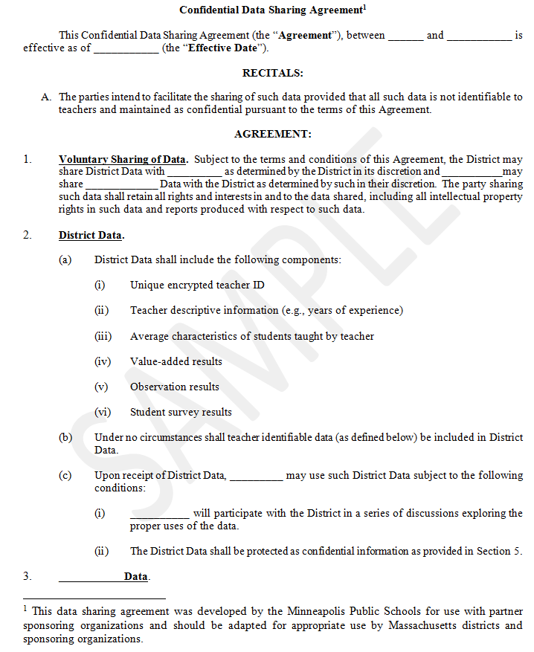
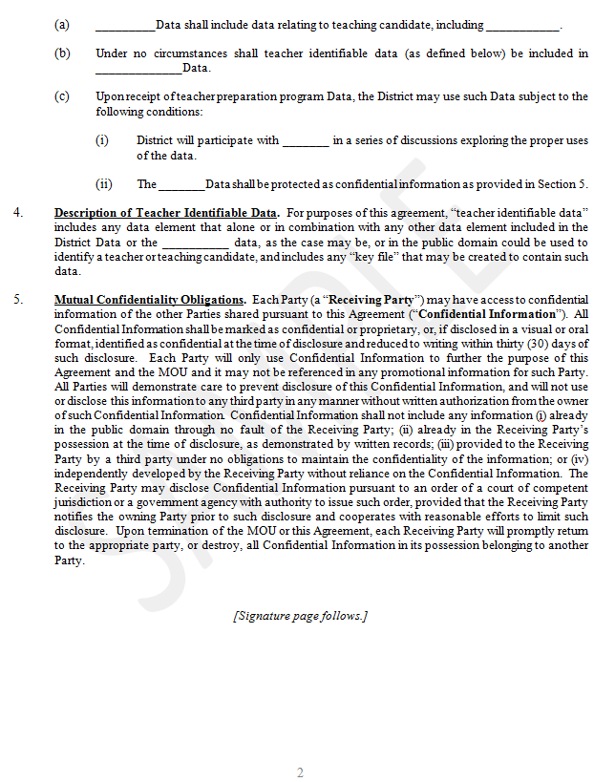

Vision Assessment Tool
The following survey was adapted from the "Vision Assessment Tool" in Curtis, R.E. & City, E.A. (2009). Strategy in action: How school systems can support powerful learning and teaching. Cambridge: Harvard Education Press.

On a scale of 1 to 5, with 5 being the highest, how would you rate the following against your draft vision?
Criteria | 1 | 2 | 3 | 4 | 5
All-encompassing: Does the vision define what success looks like? Does it state the focus area of the partnership?
Data Based: Is our vision inclusive of using data to drive the partnership?

Relationships and Trust: Does our vision have a focus on relationship building and trust? Does it explicitly discuss expectation for a strong working relationship?
Clear: Is our vision clear? When you read it or hear it, can you picture it?

Shared: Is our vision shared by the entire team, including any individuals playing a key role in the implementation of the plan?
Audacious: How bold is our vision?

Comments: If you wish to do so, you can offer any additional comments about the current vision statement.

“Ensuring High-Quality Teacher Talent,” Education First (2016). Retrieved on July 18, 2017 at http://education-first.com/wp-content/uploads/2016/01/Ensuring-High-Quality-Teacher-Talent.pdf.
The framework utilized by the Student Teaching Partnership Consortium was based on the three stages of partnership development outlined in “Ensuring High-Quality Teacher Talent: How Strong, Bold Partnerships between School Districts and Teacher Preparation Programs are Transforming the Teacher Pipeline.” Education First (2016). Key activities listed here are unique to the partnerships’ work in the Consortium and not directly attributable to the Education First framework.
This position description is adapted from the Minneapolis Public Schools’ University Cluster Site Liaison position.

