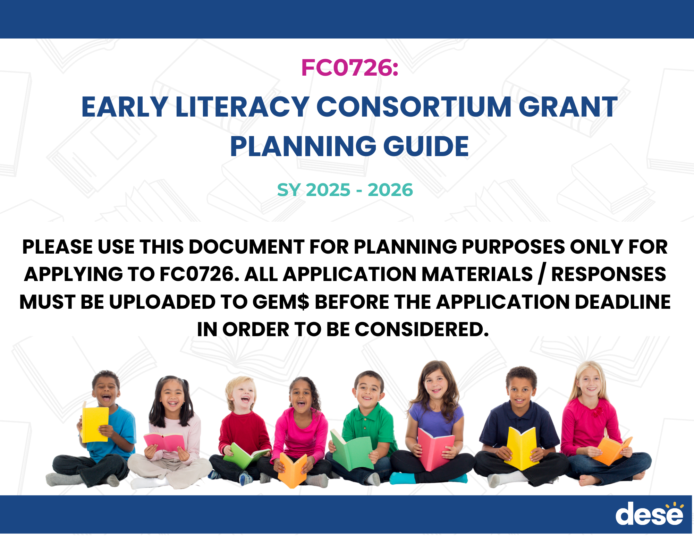

|  |
| --- |
| **Part 1: Participant Information** |
| For each of the districts in your consortium, list the curricular materials currently used to teach early literacy in K-2 classrooms. How will curricular materials be used / shared as part of your consortium's work? (5,000 character max) |
|  |
| How do the districts in your consortium ensure student access to a multi-tiered system of support (MTSS) for early literacy instruction? How do your EPP partners engage with districts' MTSS? |
|  |
| For each educator preparation provider in your consortium, name the number of faculty/staff who plan to engage in the consortium's work as well as their intended role in the consortium. |
|  |

|  |
| --- |
| **Part 2: Narrative Responses** |
| Summarize your plan to either develop (Category 1), launch (Category 2), or advance (Category 3) a consortium (1,000 character max) |
|  |
| Provide a detailed timeline for your consortium's grant activities. For each activity on the timeline, include a summary of the activity as well as its goals, budget, and participants (5,000 character max) |
|  |
| Describe how proposed grant activities and fund use will be mutually beneficial for the educator preparation programs and the districts in your consortium. (5,000 character max) |
|  |
| How will your consortium measure its success in driving toward ALL three goals of the grant: improved teacher preparation, classroom practices, and student outcomes in early literacy? (5,000 character max) |
|  |
| If you are applying as a Category 3 applicant, provide a description of the consortium's mission and an outline of the consortium's scope of work to date. (5,000 character max) |
|  |
| Is there anything else that DESE staff should know about how your consortium meets the priority areas listed in the request for proposals? (5,000 character max) |
|  |

|  |  |
| --- | --- |
| **Part 3: Forms (to be uploaded to GEM$)** |  |
| **Grant Assurances Form :** | [FY26 FC0726 Grant Assurances](https://www.doe.mass.edu/edprep/resources/fy2026-fc0726-grant-assurances.docx) |
| **Vendor Scope of Work Assurance:** | [FY26 FC0726 Vendor Scope of Work Assurance](https://www.doe.mass.edu/edprep/resources/fy2026-fc0726-work-asurance.docx) |
| **Contact List:** | [FY26 FC0726 Contact List](https://www.doe.mass.edu/edprep/resources/fy2026-fc0726-contact-list.docx) |