# Overview: Defining and Planning for the Gradual Increase in Responsibility During the Practicum

icon of pen in ink jar to represent author **CONTRIBUTOR**

Teacher preparation program at a small liberal arts college

Icon of a document with lines of text and a folded corner**WHAT is this resource?**

This document, which could be included in a Practicum Handbook, clearly explains, in narrative and graphic form, how and when the Teacher Candidate begins to take on more responsibility in the classroom during the practicum.  It also gives a suggested timeline, by week, of this shift in teaching responsibilities.

Icon of a calendar with multiple blocks to represent time **WHEN could this resource be used?**

This resource is best used before the practicum begins so that the Program Supervisor, Supervising Practitioner - here referred to as the Mentor Teacher - and the Teacher Candidate know how to plan for the increasing responsibility of the Teacher Candidate.

Icon with a group of five people standing together  **WHO could use this resource?**

The faculty member responsible for preparing Teacher Candidates for the practicum, as well as the **Program Supervisor, Supervising Practitioner** and **Teacher Candidate** could all use this resource.

**icon with a checkmark in a circle HOW could this resource best be used?**

This resource is shared with the Program Supervisor, Supervising Practitioner and the Teacher Candidate at the beginning of the Practicum to clearly delineate the roles and responsibilities and develop a timeline for the increase in responsibility.

***Note:*** *This resource was submitted for inclusion in the Candidate Assessment of Performance (CAP) Resource Hub. It is intended to serve as a reference and source of guidance for others engaged in the CAP process. While it reflects one approach, users should adapt its content to fit the specific context and needs of their own evaluations.*

## Defining and Planning for the Gradual Increase in Responsibility During the Practicum

The Teacher Candidate takes on increasing responsibility in the classroom over the course of the practicum.

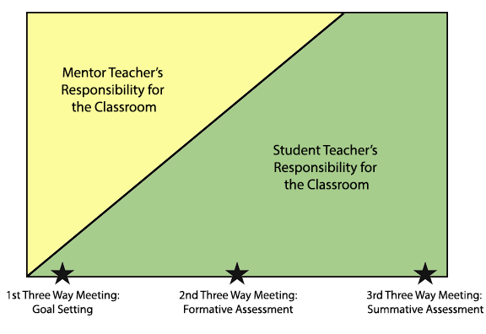

**Graduated Responsibility within the Practicum Experience**

During the practicum, the Teacher Candidate takes on increasing responsibility for the work of an educator in a classroom. Our expectation is that the Supervising Practitioner (also referred to as the Mentor Teacher), Program Supervisor, and the Teacher Candidate will negotiate a “ramping up” of responsibilities until some point towards the middle of the semester when the student teacher will assume primary responsibility for the classes.

The gradual increase in responsibility as the Teacher Candidate takes on more of the daily work of the classroom will vary among individuals and settings, but this is an overview of what it might look like.

See the next page for a timeline of the increase in responsibility for the Teacher Candidate.

|  |  |  |  |
| --- | --- | --- | --- |
| **Weeks 1-2**  **Getting Oriented**  **Early January** | **Weeks 3-4**  **January** | **Week 5**  **January-February** | **Weeks 6-7 to the End of the Semester** |
| Mentor Teacher begins by modeling lessons, sharing curriculum materials, and regularly debriefing with the Teacher Candidate.  Teacher Candidate observes Mentor Teacher and works with students individually and in small groups.  Daily meetings occur to plan, debrief and process. A longer weekly meeting should also be scheduled to consider upcoming lessons/units of study.  The Mentor Teacher may arrange for the Teacher Candidate to observe other teachers in the department and in the school.  The Mentor Teacher introduces the Teacher Candidate to administrative personnel and to other important individuals in the building (guidance counselors, social adjustment counselor, dean, special educator, etc.).  The Mentor Teacher provides the Teacher Candidate with the written policies of the department, school site, district. | The Mentor Teacher continues modeling lessons and joint planning with the Teacher Candidate.  Based on the judgment of all parties, the Teacher Candidate begins to team teach, take over parts of lessons, and upon readiness, teaches full classes.  The Mentor Teacher provides ongoing support and regular feedback.  The Mentor Teacher should invite the Teacher Candidate to attend all faculty, department and team meetings.  **Announced Observation #1** by the Program Supervisor and Mentor Teacher takes place during this time. | The Teacher Candidate gradually takes over full class(es) and assumes responsibility for planning and assessment.  Regular feedback and debriefing of teaching/learning continues.  It is recommended that ALL observations for the semester be scheduled at this time.  The Teacher Candidate, Mentor Teacher, and Program Supervisor meet to design a schedule for the Teacher Candidate to assume independent responsibility for classes at the **First Three-Way (Trio) Meeting**.  The Mentor Teacher and Program Supervisor should negotiate the time and sequence for such a transition.  The Teacher Candidate should gradually take on responsibility so that they have at least 150 hours of full responsibility in the classroom. | The Mentor Teacher should observe the Teacher Candidate on a regular basis, although the Teacher Candidate should have some time alone in the room.  The Teacher Candidate and Mentor Teacher should have regular meetings to consult on individual students, planning, and class progress. |