Overview: Assessment and Instruction Decision Tree for Students Experiencing Reading Difficulties

Resource Key Focus Areas
- Evidence-based Content Knowledge
  - Phonological Awareness
  - Phonics (decoding and encoding)
  - Fluency
  - Comprehension
  - Oral Language
- Opportunities for Candidates to Acquire, Practice and Demonstrate Skills
- Field-based Experiences

Resource Description and Timing for Use
This resource presents a decision tree for educators to use when a student is not meeting grade level expectations. Since reading is a complex skill made up of subskills, it is crucial to understand which subskill or subskills are areas in which a student needs to develop skills or areas for targeted intervention. Working through a systematic series of assessments, an educator can uncover the area(s) of difficulty which will then inform the corresponding course of instruction to address them effectively. The decision tree can be used with teacher candidates throughout their educator preparation program.

Supplemental Resources
Massachusetts Early Literacy Screening Guidance
MA DESE list of approved early literacy universal screeners

Resource Alignment and Context
Proficiency Level: Introduce, Practice and Demonstrate
Alignment to Early Literacy Program Approval Criteria: INS.1.A.a-e., INS.A.5.,INS.B.1.a-c., INS.C.1.a., INS.C.2.a-b., INS.C.3.a-c., INS.C.4.a-b., INS.C.5.a-b., INS.D.1.a, FBE.B.2.
Alignment to Mass Literacy:
- Components of the Core Literacy Block
- Skills for Early Reading
- Students Experiencing Reading Difficulties
- Data-Based Decision Making
- Oral Language

Contributor: The Reading Circuit, Inc. 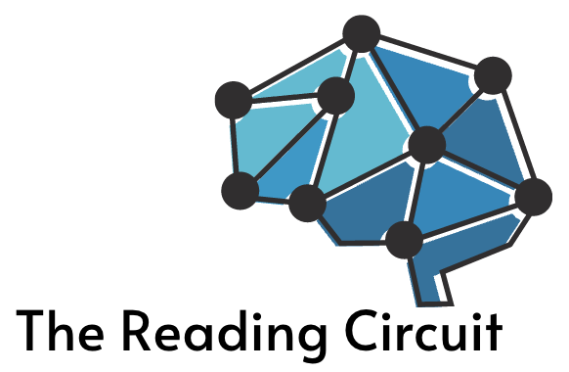
Date Posted: December 2025

Note: This resource was submitted for inclusion in the Evidence-Based Early Literacy Professional Learning Resource Hub. It is intended to serve as a reference and source of guidance for Educator Preparation Programs as they implement the Early Literacy Program Approval Criteria. While it reflects one approach, users should adapt its content to fit the specific context and needs of their own institutions.
Assessment and Instruction Decision Tree for Students Experiencing Reading Difficulties

Reading is a complex skill composed of many interrelated subskills. When a student is experiencing reading difficulties, it is crucial to understand which subskill or subskills are areas of struggle. Working through a systematic series of assessments, an educator can uncover the area(s) of difficulty which will then inform the corresponding course of instruction to address them effectively.

The following assessment decision chart is based on the simple view of reading which conceptualizes the complexity of reading comprehension as the product of fluent word reading skills and language comprehension skills.

Fluent Word Reading

Language Comprehension

Reading Comprehension
In the same way, assessments (and the corresponding instructional plans) follow a fluent word recognition skills pathway and/or language comprehension skills pathway.

Note: This decision chart only reflects a pathway if the skills are below grade level. If the skills are on or above grade level, no further assessments are necessary and core instruction can continue.

The flowchart/decision tree, for use in Massachusetts, was adapted from similar decision trees developed by Cox Campus and Reading Universe.

The decision tree does not specify which assessment measure to use. When selecting a measure, it must be valid, reliable and report results according to a grade level or percentile. For guidance, refer to the MA DESE list of approved early literacy universal screeners that meet or partially meet expectations.

The following decision tree can be used with students who have been taught sufficient decoding skills to read words (typically 1st Grade and up). For students in Kindergarten and the first part of 1st grade, refer to the Massachusetts Early Literacy Screening Guidance.

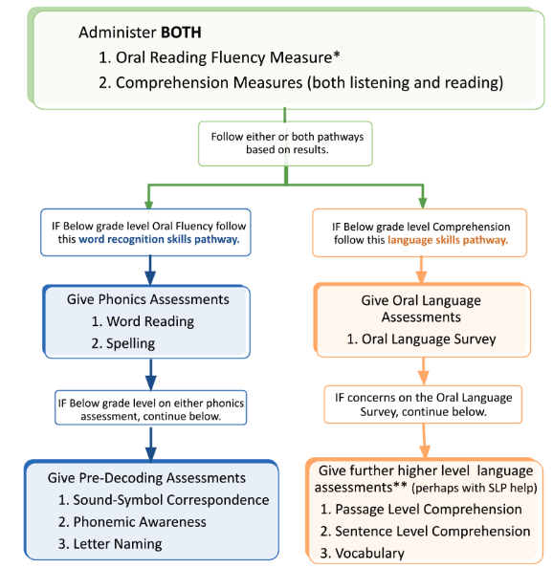

* If the Oral Fluency Measure does not include a measure of Rapid Automatized Naming (RAN), administer a separate RAN measure to determine if automaticity weaknesses are present. The At-A-Glance document, found on this page will indicate if the Massachusetts approved early literacy screener has a RAN measure or not. For example, in the description of DIBELS 8th Edition, it states that the Letter Naming Fluency (LNF) subtest on DIBELS 8th Edition serves as the indicator of Rapid Naming ability.
** Assessments for higher level language skills should include measures of inferencing and comprehension monitoring.

Based on more recent advances in reading research, the ‘decoding’ side of the equation in the Simple View of Reading, may be referred to as fluent word reading. This term acknowledges the importance of automaticity and fluency in word reading. See Mass Literacy for more information.

