Overview: An Integrated Early Literacy and Visual Arts Unit (Sample Assignment)

Resource Key Focus Areas
- Opportunities for Candidates to Acquire, Practice and Demonstrate Skills
- Shifts to Programmatic Alignment with ELPAC
- Field-based Experiences

Resource Description and Timing for Use
This assignment requires teacher candidates to compile material for an integrated early literacy and visual arts unit. The material gathered for this assignment is a supplement to a curriculum to support knowledge building through visual arts and books.

This assignment can also serve as evidence for the Candidate Assessment of Performance (CAP) and as preparation for an early literacy observation focused on engagement with complex text.

Resource Alignment and Context
Proficiency Level: Practice - Demonstrate

Alignment to Early Literacy Program Approval Criteria:
- INS.A.1.b., INS.A.1.f., INS.B.2.a-b., INSB.4.c., INS.B.4.f.

Alignment to Mass Literacy:
- Components of the Core Literacy Block
- Choosing and Using Complex Text
- Equity in Early Literacy

Reference: Red Leaf Press grants permission to use the image of the book All the Colors We Are: The Story of How We Get Our Skin Color in this resource for the Massachusetts Department of Elementary and Secondary Education’s Early Literacy Resource Hub.

Disclaimer: The literary works, curricular material and references in this resource were provided, as examples, by the authors and contributors to the resource, independent of the Massachusetts Department of Elementary and Secondary Education (DESE). Their inclusion in the resource does not imply endorsement by DESE.

Contributors:
- Carmen Ocón, PhD., Associate Professor of Practice, Education, Clark University
- Kevin McGowan, Ph.D., Department of Elementary and Early Childhood Education, Bridgewater State University

Date Posted: December 2025

Note: This resource was submitted for inclusion in the Evidence-Based Early Literacy Professional Learning Resource Hub. It is intended to serve as a reference and source of guidance for Educator Preparation Programs as they implement the Early Literacy Program Approval Criteria. While it reflects one approach, users should adapt its content to fit the specific context and needs of their own institutions.
An Integrated Early Literacy and Visual Arts Unit (Sample Assignment)

Alignment with Candidate Assessment of Performance (CAP)
CAP Essential Elements:
- II-A-3: Inclusive Instruction
- II-B-2: Safe Learning Environment
- IV-A-1: Reflective Practice

Alignment with the Early Literacy Observation Form Tool:
Engaging with Complex Text:
- Using high-quality, culturally relevant, complex texts and text sets that are rich in academic language, provide diverse and nuanced perspectives and promote critical thinking (I-A-1)
- Modeling the process of making meaning from reading through read and think alouds (I-A-1)

Course Overview
Teacher Educators in Support of Undergraduate Teacher Candidates
English Language Arts/Literacy and Visual Arts Integrated Unit
Essential Course Question: How can we integrate the visual arts and ELA/Literacy?
Learner Outcome: Create a space that encourages visual arts and ELA/Literacy integration.

Assignment Overview
This assignment consists of you making selections connected to your unit topic. An example unit topic is: Skin - Essential Question: Why do we have different skin colors?

There are two parts to this assignment:
- First, you will make a visual arts selection of one painting or drawing of famous/historical reproductions to display in the classroom (see example at the end of this document).
- For the second part, you will create a book list of five associated books for continued learning and display (see example at the end of this document).

You must explain why, how, intent and purpose for selecting this painting and how it connects to your book list. In your explanation, highlight or note features that you will use to develop ELA/Literacy content concepts connected to the visual arts.

Grade Level/Standards
For this assignment, also list the grade level and standards from the MA ELA/Literacy Curriculum Framework.

For example, Kindergarten:
- English Language Arts and Literacy. Reading Literature, Key Ideas and Details.
  - RL.K.1 - With prompting and support, ask and answer questions about key details in a text.
  - RL.K.2 - With prompting and support, retell familiar stories, including key details. draw pictures to illustrate characters and their interactions at important points in the story.
  - RL.K.3 - With prompting and support, identify characters, settings, and major events in a story.
- Arts. Visual Arts. Responding.
  - PK-K.V.R.07 - Perceive and analyze artistic work. With prompting and support, identify similarities between multiple pieces of art.
  - PK-K.V.R.08 - Interpret intent and meaning in artistic work. Describe what is seen in an artwork (e.g., “I see a dot; I see yellow in the corner; I see a round part”), interpret a possible meaning, and explain why the meaning makes sense.
  - PK-K.V.R.09 - Apply criteria to evaluate artistic work. Select a work that evokes feelings and describe the connection between the work and the emotional response.

Rubric/Scoring Guide

Criteria | Target | Acceptable | Emerging
Visual Arts Selection | The painting or drawing is highly relevant to the unit topic and clearly supports the learning objectives. The selection is a famous or historical reproduction. | The painting or drawing is relevant to the unit topic and generally supports the learning objectives. The selection is a famous or historical reproduction. | The painting or drawing has a weak connection to the unit topic. The selection may not be a famous or historical reproduction.
Book List | The book list includes five books that are all directly and clearly associated with the unit topic, offering varied perspectives and opportunities for continued learning. | The book list includes five books that are associated with the unit topic, providing some opportunities for continued learning. | The book list includes less than five books. Some have a weak or unclear association with the unit topic.
Explanation & Connection | The explanation clearly and thoroughly articulates the why, how, intent, and purpose for selecting the painting and its connection to the book list. The highlighted features for ELA/Literacy content concepts are specific, well-defined, and directly link to the visual arts selection. | The explanation articulates the why, how, intent, and purpose for selecting the painting and its connection to the book list. The highlighted features for ELA/Literacy content concepts are present but may lack specificity. | The explanation is general or unclear regarding the why, how, intent, and purpose of the selections. The highlighted ELA/Literacy features are vague or not directly connected to the visual arts selection.
Grade Level & Standards | The correct grade level is listed, and all relevant MA ELA/Literacy and Visual Arts Curriculum Framework standards are accurately cited, including the number and full description. The standards are highly appropriate for the chosen topic and grade level. | The correct grade level is listed, and most relevant MA ELA/Literacy and Visual Arts Curriculum Framework standards are accurately cited. | The grade level or standards listed are incorrect or incomplete. Standards may be missing the number or full description.
Overall Organization | The assignment is well-organized, demonstrates a strong understanding of the content, and is presented professionally with no errors. | The assignment is organized and demonstrates a good understanding of the content. There are minimal errors. The response meets all assignment requirements. | The assignment is disorganized and shows a limited understanding of the content. There are noticeable errors. The response barely meets requirements.

Sample Visual Art and Book Selections with Discussion Points and Prompts
Visual Art Selection Examples:
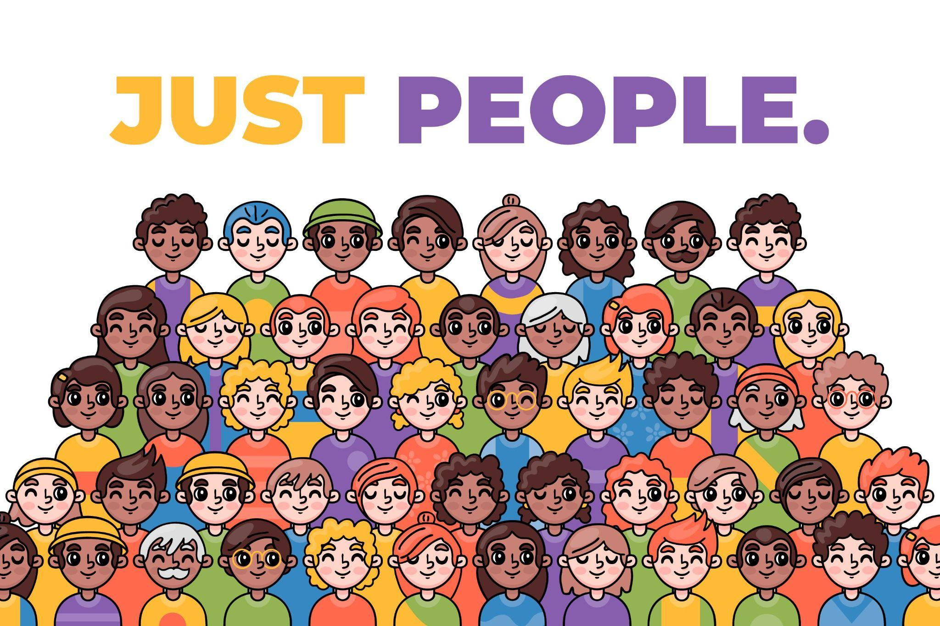



Another example is the Norman Rockwell painting entitled The Golden Rule (1961). Visit the Norman Rockwell Museum website for information on downloading this image for classroom use.

Book Example - All the Colors We Are
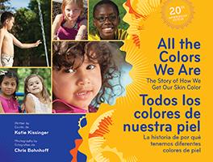
All the Colors We Are: The Story of How We Get Our Skin Color

Kissinger, Katie. All the Colors We Are: The Story of How We Get Our Skin Color (Bilingual Spanish). Illustrated by Chris Bohnhoff. Zaner-Bloser, 2013. ISBN 9780736793223. Reviewed by Social Justice Books.

Note: One example of a book is presented here. The assignment requires that teacher candidates select five books.

Key Discussion Points:
The Norman Rockwell painting, The Golden Rule, and the book, All the Colors We Are: The Story of How We Get Our Skin Color can be used to explain why adults and children have different skin colors. The book explains why we have different skin colors highlighting that we get our skin color from our parents, the sun, and melanin. The children may not know about melanin so this is an opportunity to talk about melanin and the role it plays in our skin color. In the Rockwell painting, children can identify and discuss the different skin colors. This is also an opportunity to reiterate that having different skin colors is what makes our world an interesting place.

Discussion Prompts/Questions
- What did you notice about adults and children in the book?
- Do you think that your skin color looks like some of the skin colors discussed in the book?
- Do you remember what the book said about melanin?
- What do you notice about the adults and children in the Rockwell painting?
- Do you think that your skin color looks like some of the adults and children from the Rockwell painting?
- The title of the Rockwell painting is The Golden Rule. When we are thinking about skin color, this rule reminds us that everyone should be treated fairly from adults and children with lots of melanin in their skin to adults and children without as much melanin.

