This planning guide provides a detailed overview of the Launch and Initial Inquiry stages of the Early Literacy Interim Review process, which span from Notification in the fall prior to the SO’s interim review year through the completion of focus groups and interviews during the first half of the review year.

# Launch Stage Overview and Purpose

The purpose of the Launch stage is to familiarize sponsoring organizations (SOs) with the overarching review process and prepare SOs for the Initial Inquiry stage. During the Launch stage, DESE will seek a general understanding of the SO’s program information and any specific context needed to prepare for stakeholder engagement. Several deliverables will be requested to gather this information.

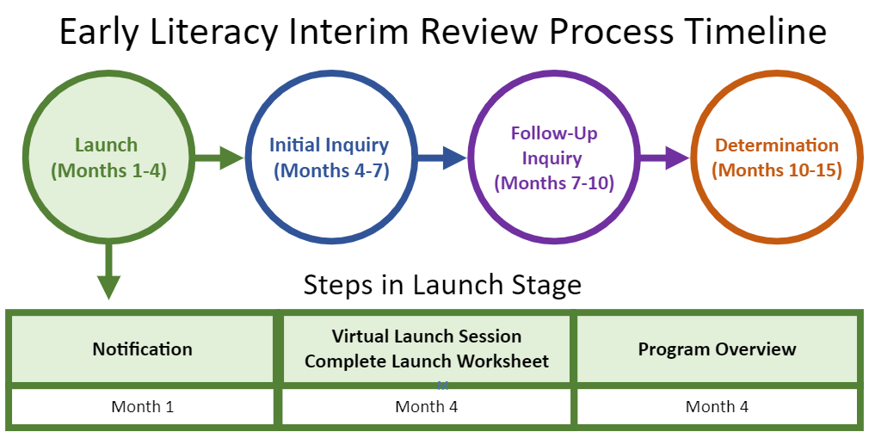

# Initial Inquiry Overview and Purpose

The purpose of the Initial Inquiry stage is to collect data through engagement with stakeholders to better understand their experiences. This data, along with state-collected data, will be used to determine where there is sufficient evidence indicating a criterion is met, and where additional information is needed via the Follow-Up Inquiry to address gaps or inconsistencies or elevate areas of strength.

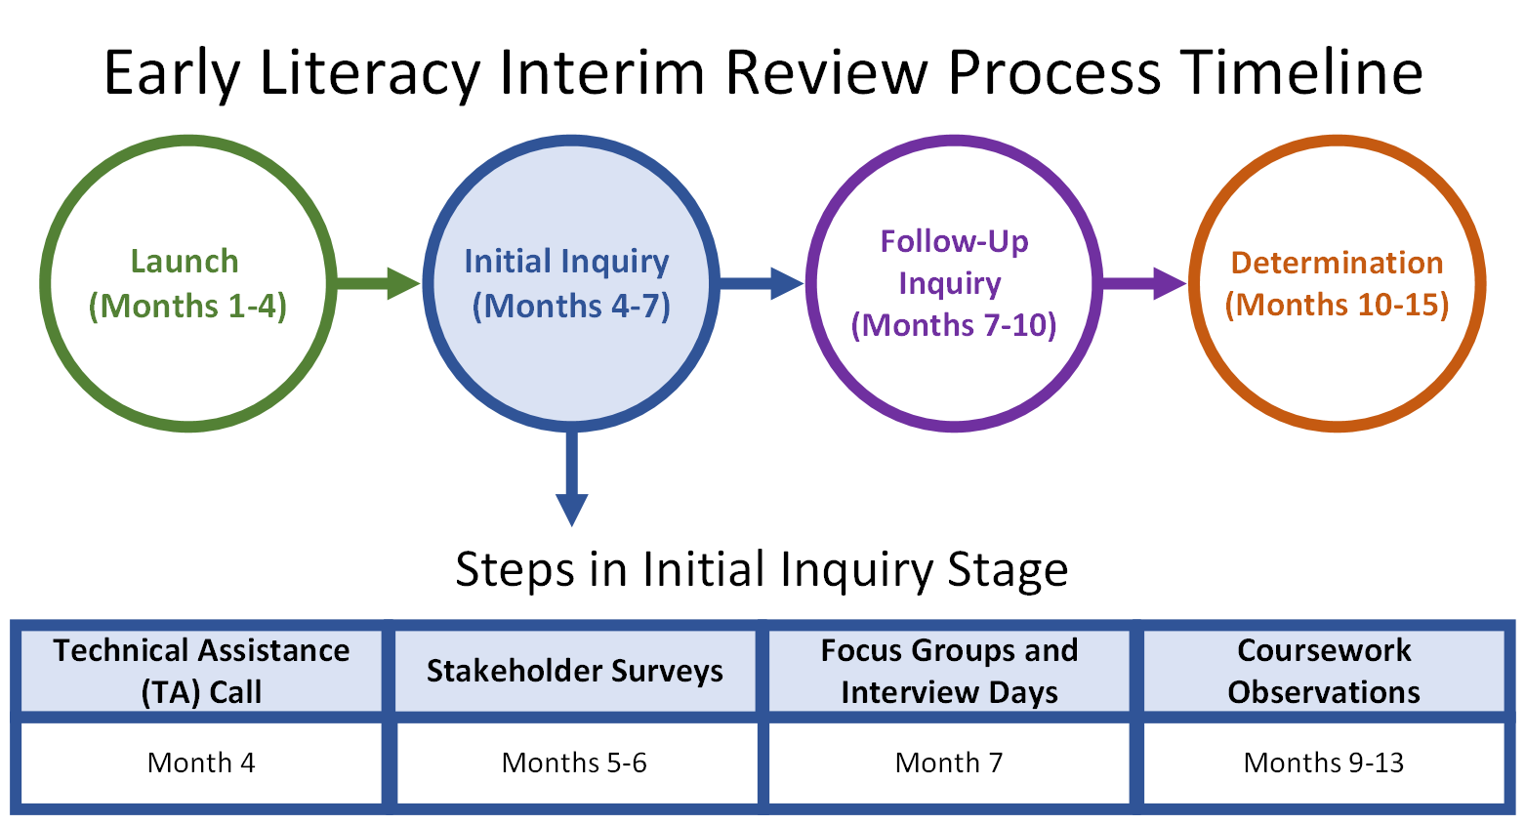

# Step-by-Step Guide for the Launch and Initial Inquiry Stages

**Step 1:** Notification

**Step 2:** Launch Session & Complete Launch Materials

* **Step 2a:** Launch Worksheet
* **Step 2b:** Program Overview Worksheet, Required Documents, Candidate Artifacts​

Step 3**:** Stakeholder Surveys

**Step 4:** Initial Inquiry Technical Assistance (TA) Call

**Step 5:** Coursework Observations

**Step 6:** Focus Group and Interview Days

​**Appendix A:** Sample Recruitment Language

**Appendix B**: Sample Notification to Literacy Faculty​

**Appendix C**: Tips for Survey and Focus Group Recruitment

# Step 1: Notification

### What happens during this step?

* The DESE Early Literacy Interim Review Specialist notifies the SO that the Early Literacy Interim Review is upcoming, which officially launches the review.
* The notification includes a timeline and a high-level overview of the review process for Elementary, Early Childhood, and Moderate Disabilities PK-2 and/or PK-8 programs.
  + The timeline reflects all relevant dates for the SO’s Early Literacy Interim Review.

### When does this step happen?

* Month 1 *(Note: Notification takes place at least 3 months before the Cohort Launch Session. Each SO will receive a timeline with specific dates for each step of the review process. All timelines referenced throughout this and the other Planning Guides denote the minimum time that will be provided between each step.)*

### Important Details

* DESE tries to accommodate shifts in the timeline if there are major conflicts elevated by the SO at this time.
* After the SO confirms there are no conflicts, DESE and the SO move forward with the agreed-upon timeline.
* If significant unforeseen circumstances arise that require additional shifts, DESE coordinates with the SO to determine whether adjustments to the timeline are possible.

### Helpful Tips

* When reviewing the proposed timeline, the SO should consider conflicts with holidays, academic breaks, major institutional events, or times when faculty will not be under contract. While DESE aims to ensure that portions of the review are when faculty who are most likely to be involved do not have notable conflicts, it is ultimately the responsibility of the SO to ensure the appropriate personnel are available during the dates for stakeholder engagement (the Initial Inquiry) and preparation of the targeted submission (the Follow-Up Inquiry).

### Deliverables

* Provide DESE with the name and contact information for the SO’s Early Literacy Review Designee (the person to be responsible for communication with and submissions to DESE relative to the Early Literacy Interim Review).
* Confirm the timeline for the review or notify DESE of any major conflicts.

# Step 2: Launch Session

### What happens during this step?

* DESE hosts a virtual Launch Session for all SOs undergoing interim review in the same academic year. The session provides a more detailed overview of the Early Literacy Interim Review process and timeline, evidence sources, and guidance for the initial submission materials.
* DESE reviews how SOs will complete the Launch Worksheet to provide foundational context about stakeholder groups and licensure programs. This information enables DESE to adjust surveys, focus groups, and interviews based on the organization’s unique structure and terminology.
* The SO completes out a tab of the Launch Worksheet with information about any PK-12 partnerships, external (non-PK-12) partnerships, and satellite campuses if these are relevant for any early literacy programs.
* The SO also fills out the [[Early Literacy Matrix](https://www.doe.mass.edu/edprep/review/toolkit/matrices.html)](https://www.doe.mass.edu/edprep/review/toolkit/informal/early-literacy-matrix.docx) to provide additional context for courses in Baccalaureate and Post-Baccalaureate Elementary, Early Childhood, or Moderate Disability PK-2 and/or PK-8 programs.

### When does this step occur?

* March prior to the year of the SO’s review

### Important Details

* The Launch Session takes place virtually and a Zoom link will be shared.
* Up to five SO personnel, including the Early Literacy Interim Review Designee, may participate in the Launch Session. While these personnel are determined by the SO, we recommend focusing on those with decision-making power and those who will be responsible for preparing deliverables.

### Deliverables

* Launch Worksheet
* [Early Literacy Matrix](https://www.doe.mass.edu/edprep/review/toolkit/matrices.html)

## Instructions for Completing the Launch Worksheet

### Program Chart tab:

* DESE prepopulates the completer numbers. These reflect the last three years of available data in ELAR.
* The SO confirms with DESE’s Literacy Interim Review Specialist that the list is an accurate representation of their completer numbers.
* Completer numbers are used to determine minimum participation thresholds for surveys and focus groups.

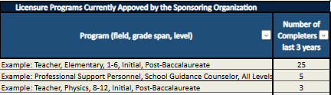

### Stakeholder Groups tab:

* The Stakeholder Groups tab includes questions specific to each group from which DESE will collect evidence through focus groups, interviews, and/or surveys. The questions focus on whether groups exist within the organization, the language the SO uses to refer to them, and other information that may impact stakeholder groupings throughout the review.
* Within the Stakeholder Groups tab, the SO should complete the prompts in columns C, D, E and F that correspond to the stakeholder group identified in each row. Some types of personnel may not exist as a separate role in the organization; if this is the case, please indicate what other role fulfills the function described for that stakeholder group.

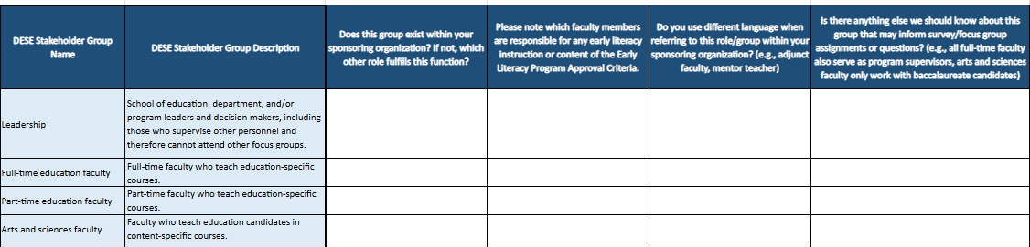

**Personnel List tab:**

* The Personnel List tab is designed to collect information about the people employed by the organization who support Elementary, Early Childhood, and/or Moderate Disabilities PK-2/PK-8 programs. DESE uses this information to tailor stakeholder group assignments, set minimum participation thresholds, and track survey completion and focus group/interview RSVPs.
* Within the Personnel List tab, the SO should fill out columns A and B with the names and titles for all currently employed education leadership, education faculty, arts and sciences faculty, candidate support staff, field-based experiences staff, and program supervisors who are involved with Elementary, Early Childhood, and/or Moderate Disabilities PK-2/PK-8 programs. The SO should then add Xs in columns C through J to indicate which role(s) each individual holds for these programs. If the individual supervises other personnel, this should be noted and briefly described in column K.

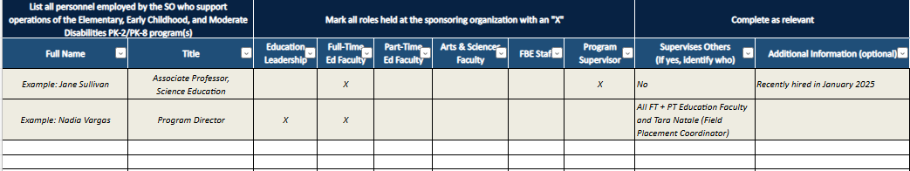

**PK-12 Partnerships tab:**

* In the PK-12 Partnerships tab the SO provides information about its partnerships with PK-12 schools and districts that support the organization’s Elementary, Early Childhood, and/or Moderate Disabilities PK-2/PK-8 programs. This may include a variety of partnerships including, but not limited to, those focused on field-based experiences placements, professional development, and hiring pipelines.

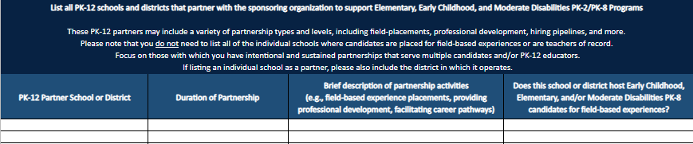

**External Partnerships tab:**

* In the External Partnerships tab, the SO identifies any non-PK-12 partnerships that are integral to the Early Childhood, Elementary, and/or Moderate Disabilities PK-2/PK-8 programs’ oversight, operations, or decision-making.
* 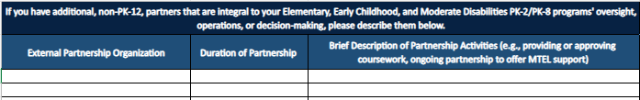

Satellite Campuses tab:

* In the Satellite Campuses tab, the SO identifies any satellite locations that are integral to Early Childhood, Elementary, and/or Moderate Disabilities PK-2/PK-8 programs, including a brief description and information about candidate enrollment and completion at the satellite location.

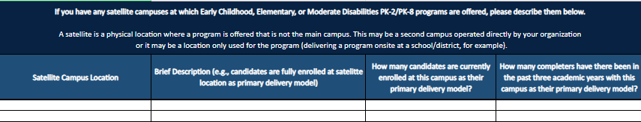

## Instructions for Completing the Early Literacy Matrix

As applicable, the SO completes a separate [Early Literacy Matrix](https://www.doe.mass.edu/edprep/review/toolkit/matrices.html) for each of the eight relevant programs to identify the required coursework in which the described knowledge and skills are being demonstrated **up to and at** the requisite practice level:

* Initial, Baccalaureate
  + Early Childhood
  + Elementary
  + Moderate Disabilities PK-2
  + Moderate Disabilities PK-8
* Initial, Post-Baccalaureate
  + Early Childhood
  + Elementary
  + Moderate Disabilities PK-2
  + Moderate Disabilities PK-8

Step 2b: Program Overview

### What happens during this step?

* The SO completes the Program Overview Worksheet and compiles all required documents and candidate artifacts.
* If an SO has participated in an Early Literacy Formative Feedback Review conducted by TPI-US, the SO may choose to submit any artifacts connected with the FFR as evidence in the Follow-Up Inquiry. These materials will not be accepted during the Program Overview.

### When does this step occur?

* The Program Overview and the required documents will be introduced during the Launch session in March prior to the [review year](https://www.doe.mass.edu/edprep/resources/accelerated-early-literacy.html)
* The Program Overview and all required documents and artifacts are due late June prior to the review year

### Important Details

* DESE reserves the right to ask for additional documents or artifacts - either in type or number - during the Follow-Up Inquiry phase of the Early Literacy Interim Review.

### Deliverables

* Program Overview Worksheet (use template)
* Required Documents
* Candidate Artifacts

## Submit Program Overview, Required Documents, and Candidate Artifacts

## The Program Overview Worksheet

The Program Overview Worksheet requests high-level information relative to the Elementary, Early Childhood, and/or Moderate Disabilities PK-2/PK-8 programs. It is an opportunity to orient DESE to the SO’s unique structure and its approach to early literacy in educator preparation. Responses will provide DESE with foundational information for engaging with stakeholders during focus groups and interviews.

**DESE’s Use of the Term ‘Program’:** Throughout the review process, when DESE refers to a “program,” we mean the license for which completers will be endorsed (listed below). Each of the following is considered a separate program:

* + Early Childhood PK-2, Initial, Baccalaureate
  + Elementary 1-6, Initial, Baccalaureate
  + Moderate Disabilities PK-2, Initial, Baccalaureate
  + Moderate Disabilities PK-8, Initial, Baccalaureate
  + Early Childhood PK-2, Initial, Post-Baccalaureate
  + Elementary 1-6, Initial, Post-Baccalaureate
  + Moderate Disabilities PK-2, Initial, Post-Baccalaureate
  + Moderate Disabilities PK-8, Initial, Post-Baccalaureate

Evidence will be collected and reviewed separately for each program. Moderate Disabilities PK-2/PK-8 may be reviewed together if they are at the same level (e.g., both are baccalaureate programs).

## Required Documents

As a part of the Early Literacy Interim Review process, DESE reviews several key documents from the SO (listed in the table below). Additional documents may be requested as part of the Follow-Up Inquiry based on evidence gathered during the Launch and Initial Inquiry stages of the review. Please note that all files must be submitted electronically.

|  |  |  |
| --- | --- | --- |
| **Domain** | **Document Category** | **Description** |
| PAR | Partnership MOU(s) | Memorandums of Understanding (MOUs) for any formalized PK-12 school/district and non-PK-12 external partnerships, as applicable. |
| FBE | Practicum Handbook(s) | Details about practicum policies and procedures (typically in the form of a practicum handbook). |
| All | Program(s) of Study | **For each licensure program,** the SO submits a program of study that outlines the course titles (required and elective), the intended course progression, and any additional program components (e.g., field-based experiences). If a program has multiple pathways (e.g., a traditional practicum pathway and a residency pathway both leading to a post-baccalaureate Elementary endorsement), a separate program of study should be submitted for each pathway. Any required pre-practicum or practicum experiences should be noted with their corresponding course(s).   Tip: SOs should not need to create this for the DESE Early Literacy Interim Review. They may have a similar document with a different name already in existence (e.g., advising sheets, course checklists). |
| All Early Literacy Program Approval Criteria | Early Literacy Matrix | The SO completes a separate Early Literacy Matrix for each Elementary, Early Childhood, and/or Moderate Disabilities PK-2/PK-8 program to identify the required coursework in which the described knowledge and skills are being demonstrated **up to and at** the requisite practice level. |

## Candidate Artifacts

As a part of the Early Literacy Interim Review process, DESE also reviews candidate artifacts. For additional guidance on records retention, please see the [Candidate Record Retention Advisory](https://www.doe.mass.edu/edprep/resources/guidelines-advisories/).

|  |  |  |  |
| --- | --- | --- | --- |
| **Domain** | **Artifact Category** | **Description** | **Sample** |
| FBE | Performance Assessments - Taken from Random Sample | Evidence of how the SO implements performance assessments consistently within and across programs to improve practice and ensure only candidates who are ready for full responsibility in the licensure role complete the program.    Each CAP file should include:   * CAP Form * CAP Observation Form for all required observations (including completed Early Literacy Observation Form) * Formative Assessment Form * Summative Assessment Form     Files should document the types of feedback provided to candidates after observations conducted by the program supervisor and/or supervising practitioner. | Completers randomly selected by DESE   (sample size determined based on number of completers over the last 3 years)~~.~~    DESE will ensure that the sample includes completers from each of the relevant Early Literacy programs and that the sample only includes candidates for whom the Early Literacy Observation Form was required  Random sample list will be provided to the SO by April prior to the review year. |

# Step 3: Stakeholder Surveys

### What are they?

* DESE-created surveys for each stakeholder group, with survey items designed to better understand completers’ perceptions relative to the Early Literacy Program Approval Criteria. Surveys are completed in the spring prior to the review year. This information will help DESE tailor focus group and interview questions.

When does this step occur?

* DESE shares survey links with each SO in late March/ early April prior to the review year. SOs are required to share these links with all relevant stakeholders from the last three years; SOs may conduct additional outreach as needed to increase participation.
* Surveys are open for a minimum of 60 calendar days.

### Important Details

* SOs are responsible for recruiting stakeholders to complete the surveys (e.g. candidates and completers of the relevant programs, field supervisors for these programs, faculty who teach literacy courses, etc.). DESE will set minimum thresholds for survey participation based on the size of each stakeholder group, including specific minimum thresholds for candidates/completers from each early literacy program, to ensure there is a sufficient evidence base on which to make judgments through the review process.
* The survey should take respondents 10 minutes to complete.
* Suggested language for outreach is included in Appendix A. While SOs may adapt this template, initial outreach **must** include the highlighted language and **must** be sent to all relevant stakeholders from the prior three years.
* SOs may not provide guidance to any stakeholder group beyond logistical information and a brief description of the purpose of the surveys. Any perception that the SO has unduly influenced survey responses may result in action by DESE.
* Surveys will be open for a minimum of 60 calendar days.

### Helpful Tips

* Suggestions for increasing participation include:
  + Send out emails early and often.
  + Be clear about *the why*: how each participant’s response will help the SO demonstrate what it is doing well and learn more about areas for continued growth.
  + Ask faculty and staff to do personal outreach to candidates, completers, and supervising practitioners they have worked with in the past.
  + Ask candidates and completers to do outreach to their peers after they have completed their own survey.

### Deliverables

By the survey closure date, the SO will:

* Submit evidence of survey recruitment list by the due date specified on the SO’s timeline.
* Meet survey minimum thresholds for each stakeholder group (DESE will provide updates on completion numbers).

# Step 4: Initial Inquiry Technical Assistance (TA) Call

### What happens during this step?

* DESE goes over what to expect during the focus group, interview, and course observation portions of the Initial Inquiry stage and answers the SO’s questions. During the call, DESE:
  + Reviews how to fill in the Focus Group, Interview, and Coursework Observation Schedule template
  + Elevates key details from the items shared in advance:
    - Why are we talking to each of the SO’s stakeholder groups?
    - What are promising practices for recruiting for survey responses and focus group participation?
    - What can the SO adjust? What cannot be changed?
    - What are the expectations for the Interview and Focus Group participation?
    - What are the expectations for coursework observations?

### **When does it happen?**

* The Initial Inquiry TA Call will happen between August – October; the call will be scheduled eight weeks before Interview and Focus Group Days.

### Helpful Tips

* The SO should invite members of its team or personnel who will be directly managing logistics for the focus groups and interview days.

### Deliverables

Prior to the Initial Inquiry TA Call, the SO completes the following:

* Read the documents and communication shared by the DESE Early Literacy Interim Review Specialist in advance of the call.
* Send list of SO personnel who will be joining the technical assistance call. This should include key members responsible for recruitment or logistics for the Focus Group and Interview Days.

# Step 5: Coursework Observations

### What happens during this step?

* DESE Literacy Content Specialists complete observations of core early literacy courses.

### When does this step occur?

* Observations can happen at any point in the review year and are based on the SO’s Early Literacy Matrix. DESE will work with the review designee to schedule observations anytime between October and March.

### Important Details

* After reviewing the SO’s completed early literacy matrices and program(s) of study, DESE determines which course sessions to observe to collect the most relevant evidence.
  + DESE will provide an overview of the observation process as well as the specific courses to be observed. Content specialists will work with faculty to determine a schedule for the observations.
    - For each identified course for observation, DESE Literacy Content Specialists will observe no more than two course sessions.
    - Course observations may happen before or after the Focus Group and Interview Days; the observation schedule will be collaboratively determined and depend on when courses are on offer.
* DESE Literacy Content Specialists will use an observation protocol grounded in the *Early Literacy Program Approval Criteria* to ensure consistency within and across organizations.
* To support successful observations, the SO’s review designee should anticipate being available (via phone or email) to answer questions and support logistics for the scheduled observations.
* If course content is delivered asynchronously, DESE may request access to the learning management system/course platform.

### Deliverables

* After the Initial Inquiry TA Call, the SO will:
  + Complete and submit the Observation Schedule Template (shared during TA Call).
  + Notify early literacy faculty of upcoming observation(s) (see Appendix B).

# Step 6: Focus Group and Interview Days

### What happens during this step?

* The DESE team hears directly from the SO’s stakeholders through virtual focus groups, interviews, and meetings with the SO team. A typical schedule includes:
  + Day 1: Focus groups, interviews
  + Day 2: Additional focus groups and interviews as needed

### When does this step occur?

* Scheduled during the fall semester

### Important Details

* DESE:
  + Provides a template schedule and overview for the Focus Group and Interview Days, which includes a list of all required stakeholder groups and instructions for adjusting the schedule to better align with the SO and its stakeholders’ needs.
  + Sets minimum thresholds for focus group participation based on the size of each stakeholder group to ensure there is a sufficient evidence base on which to make judgments through the review process.
  + Sends the final Focus Group and Interview Day schedule along with all Zoom links at least two weeks in advance of the Focus Group and Interview Days.
* All questions asked during focus groups and interviews are related to the Early Literacy Program Approval Criteria.
* Facilitators for each focus group and interview use template materials to ensure consistency within and across organizations. The materials are tailored based on the evidence collected in the Launch stage.
* To support a successful visit, the SO’s Early Literacy Interim Review Designee should anticipate being available (via phone or email) to answer questions and support logistics for the duration of focus groups and interviews.
* SOs may not provide guidance to any stakeholder group beyond providing logistical information and a brief description of the purpose of the focus groups and interviews. Any perception that the SO has unduly influenced participants’ responses may result in action by DESE.

### Deliverables

#### After the Initial Inquiry TA Call, the SO:

* Completes and submits the Early Literacy Interim Review Focus Group and Interview Day schedule template.
* Recruits focus group and interview participants (see details below).
* Provides proof of advertisement of focus groups to all currently enrolled candidates and those who were enrolled in Elementary, Early Childhood, and/or Moderate Disabilities PK-2/PK-8 programs during the *previous three academic years* (specific years will be provided for each SO).
  + - All initial outreach **must** include language highlighted in Appendix A and must be sent to all relevant members of each stakeholder group.
    - Messages may be forwarded to the DESE Early Literacy Interim Review Specialist or be provided as PDFs.
* Provides names and emails of anticipated focus group and interview participants with DESE in advance of the visit.

#### After the Focus Group and Interview Days, the SO:

* Shares a digital copy of any visuals or resources shared during the interviews, if applicable.

## Focus Group and Interview Recruitment Details

The SO is responsible for recruiting stakeholders to participate in focus groups and interviews. While DESE aims to collect a significant amount of evidence through surveys, hearing directly from stakeholders and asking follow-up questions in a live conversation is an invaluable component of the Early Literacy Interim Review process.

The SO may not provide guidance to any stakeholder group beyond logistical information and a brief description of the purpose of the focus groups and interviews. Any perception that the SO has unduly influenced focus group and interview participants may result in action by DESE.

### 

### Focus Group and Interview Stakeholder Groups

* DESE adjusts the list below based on the responses provided in the Stakeholder Groups tab in the Launch Worksheet. If personnel are involved in more than one of the groups listed below, please inform the DESE Early Literacy Interim Review Specialist to make appropriate adjustments.
* Personnel in supervisory roles should not participate in a focus group that includes any personnel they supervise.

|  |  |
| --- | --- |
| Structure | Minimum Number of Participants |
| **Leadership Interview:** School of education, department, and/or program leaders and decision-makers, including those who supervise other personnel and therefore cannot attend other focus groups | All |
| Field-Based Experience Staff Interview:  Field placement/coordinator(s) | All staff members who manage field placements for Elementary, Early Childhood, and/or Moderate Disabilities PK-2/PK-8 programs. |
| Program Supervisor Focus Group | Set by DESE based on the total number of program supervisors who support candidates in Elementary, Early Childhood, Moderate Disabilities PK-2, and Moderate Disabilities PK-8 programs and size of the SO’s programs. |

### *Focus Group and Interview Stakeholder Groups (continued)*

|  |  |
| --- | --- |
| Structure | Minimum Number of Participants |
| **Literacy Faculty Focus Group** Faculty responsible for delivering literacy content. | Set by DESE based on information provided in the Early Literacy Matrix and Program Overview. DESE will work with the SO to determine the best schedule and/or structure for this faculty group to collect the most relevant evidence. |
| Supervising Practitioner Focus Group | Set by DESE based on the total number of Elementary, Early Childhood, Moderate Disabilities PK-2, and Moderate Disabilities PK-8 candidates and completers.    Helpful tip: Prioritize participation of supervising practitioners who have recently worked with candidates in the practicum (rather than host teachers from the pre-practicum only) and those who have used the Early Literacy Observation Tool. |
| Candidate/Completer Focus Group | DESE will set minimum thresholds for focus group participants for each program grouping based on its number of completers of Elementary, Early Childhood, Moderate Disabilities PK-2, and Moderate Disabilities PK-8 programs.  Meeting this threshold ensures DESE collects sufficient evidence to inform decision-making in the review. |

### Recruitment

The SO must advertise the opportunity to participate in focus groups to all currently enrolled candidates in an Elementary, Early Childhood, Moderate Disabilities PK-2, and Moderate Disabilities PK-8 program and anyone who was enrolled in those programs during the three years leading up to the review.

* Suggested language for outreach is included in Appendix A. While the SO may adapt this template, **all initial outreach must include the highlighted language.**
* Helpful tips:
  + The SO should prioritize recent completers and candidates who have experienced most of their program of study including some of their practicum, as these individuals can best speak to the focus group questions.
  + Ensure email subject lines s are compelling and the text of the email clearly indicates why candidates/completers should make time to participate in the focus group.

# Appendix A: Sample Recruitment Language

To: All currently enrolled candidates and those enrolled in [***INSERT previous three academic years***]

Subject: Sign Up for an Important Focus Group to Share Feedback with the State

Dear ____,

The Department of Elementary and Secondary Education (DESE) works to guarantee that preparation in Massachusetts results in effective educators ready to support the success of all students. All educator preparation program providers must undergo periodic review by DESE to maintain the ability to endorse candidates for licensure in Massachusetts. [Sponsoring Organization’s] preparation programs are currently undergoing this important review.

During the next few months, DESE will lead surveys and focus groups for candidates, faculty and staff, PK-12 partners, program supervisors, and supervising practitioners to share feedback on their experiences with early literacy in our educator preparation programs. Hearing from stakeholders is a critical part of DESE's review process and we encourage you to share about your experiences. All current and recently enrolled candidates are invited to participate.

[Email Language for Surveys]

Please note that DESE hopes to engage as many stakeholders as possible in the survey to learn about your organization. This will help DESE prepare for discussions and dig deeper into your experiences during live discussions. Please complete this survey [add link] **between now and [ENTER DATE].**

[Email Language for Focus Groups]

On the afternoon/evening of [**ENTER focus group dates**], DESE will conduct virtual focus groups. Many of DESE’s former focus group participants have signaled these discussions are interesting and a valuable use of their time. We hope you will feel the same.

If you are interested in joining a focus group, please [fill out this brief survey, email the designee etc.] to sign up by [date]. We will send a reminder in advance, but you may access the focus group using this Zoom link: [Add link}

For more information about the review of preparation providers in the Commonwealth please visit: https://www.doe.mass.edu/edprep/review/. If you have any questions, please contact [review designee name] at [contact information].

Thank you,

[Sender’s name]

# Appendix B: Sample Language for Notifying Early Literacy Faculty

To: All part-time and full-time faculty of courses in which early literacy content is covered

Subject: State Observations of Literacy Coursework

Dear ____,

The Department of Elementary and Secondary Education (DESE) works to guarantee that preparation in Massachusetts results in effective educators ready to support the success of all students. All educator preparation program providers must undergo periodic review by DESE to maintain the ability to endorse candidates for licensure in Massachusetts. Elementary, Early Childhood, Moderate Disabilities PK-2, and Moderate Disabilities PK-8 licensure programs must also undergo an early literacy-specific review by DESE to ensure that teacher candidates in these are prepared, through coursework and opportunities for practice and high-quality feedback, in evidence-based early literacy as outlined in the Mass Literacy Guide. Sponsoring Organization’s] preparation programs are currently undergoing this important review.

As part of this review process, DESE will be conducting an on-site observation of your course, [Insert Course Title]. These coursework observations will be conducted by a DESE Literacy Content Specialist who will use an observation protocol grounded in the *Early Literacy Program Approval Criteria*.

Please contact [literacy-specific review designee name] at [contact information] to collaboratively determine the schedule for these observations.

Thank you,

[Sender’s name]

# Appendix C: Tips for Survey and Focus Group Recruitment

During the Initial Inquiry Stage of the Early Literacy Interim Review process, sponsoring organizations (SOs) are responsible for recruiting stakeholders to complete surveys and sign up for focus groups and interviews. Throughout the review, DESE takes plans for improvement and organizational inputs into consideration but **weigh evidence of impact most heavily**. Surveys, focus groups, and interviews provide DESE with evidence of impact from the stakeholders most impacted by the SO’s work. As such, effective recruitment for surveys, focus groups, and interviews, is essential for facilitating a thorough review.

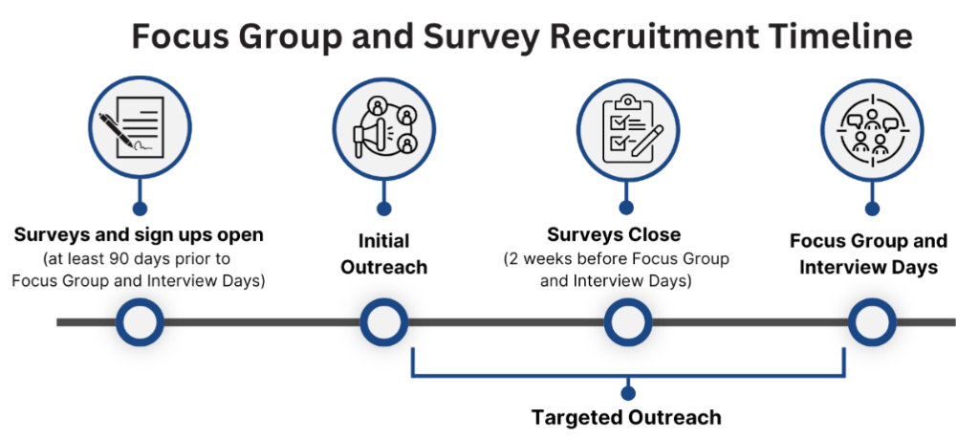

## Tips for Initial Outreach (at least 90 days before Focus Group and Interview Days)

* Include important information in the outreach
  + Give a brief explanation about the purpose of surveys and focus groups within the SO’s Formal Review.
  + Explain the importance of the SO's relationship with DESE in continuing to endorse candidates for licensure.
  + Assure respondents that responses are anonymous (to the greatest extent possible).
  + Email structure
    - Ensure email subject lines are compelling and the text of the email clearly indicates why stakeholders should make time to participate in the surveys and focus groups.
    - Send one longer email with all the information and then shorter emails with follow-up links in every email.
* Reach out early and often
  + Start outreach as early as possible.
  + Send multiple reminders.
  + Include survey close dates and convey urgency as survey close dates are approaching.
* Utilize multiple means of communication
  + Ask faculty members to help spread the word.
  + Ask faculty members to spend one minute at the start or end of class reiterating the importance of these opportunities, where to find more information, and the deadlines to participate.
  + Post a banner/announcement on your Learning Management Systems (LMS), such as Canvas or Blackboard, with the link to sign up.
  + Consider sending out a flyer, email, or social media post that provides a heads up to your stakeholders that these surveys and focus groups will be happening soon.
    - View a [sample Instagram post](https://www.canva.com/design/DAGgCf-I76o/20f1tbNYXWOMW8z4_Q2vKg/view?utm_content=DAGgCf-I76o&utm_campaign=designshare&utm_medium=link&utm_source=publishsharelink&mode=preview) that informs stakeholders about the upcoming DESE opportunities.
* Consider incentives for participation
  + SOs can consider incentives, such as a raffle or offer food, for participation for stakeholder surveys, interviews, and focus groups.
  + The SO may not provide guidance to any stakeholder group beyond logistical information and a brief description of the purpose of the focus groups and interviews. Any perception that the SO has unduly influenced focus group and interview participants may result in action by DESE.

# Tips for Targeted Outreach (about every 2 weeks until Focus Group and Interview Days)

Every few weeks, the DESE specialist will reach out to the SO designee to provide updates on survey completion and signups for focus groups and interviews. This information will be helpful for SOs to provide targeted outreach to specific audiences.

* Send personalized emails/messages to targeted stakeholder groups
* If a specific stakeholder group has low numbers, then the SO might consider reaching out to the faculty members that work closely with those stakeholders to send additional reminders.
* Share participant numbers with stakeholders
* Share DESE minimums and response numbers with stakeholders to raise awareness of the current status and need for additional participants.