Determination Stage Overview and Purpose
During the Determination stage, DESE works with the review team to calibrate ratings and rationales, draft the report, vet the report for consistency, and share a Factual Accuracy draft with the sponsoring organization (SO). Once the report is updated, the Commissioner’s Office determines approval status. Your SO’s deliverables are minimal during this stage; the purpose of this Planning Guide is to support understanding of the decision-making process.
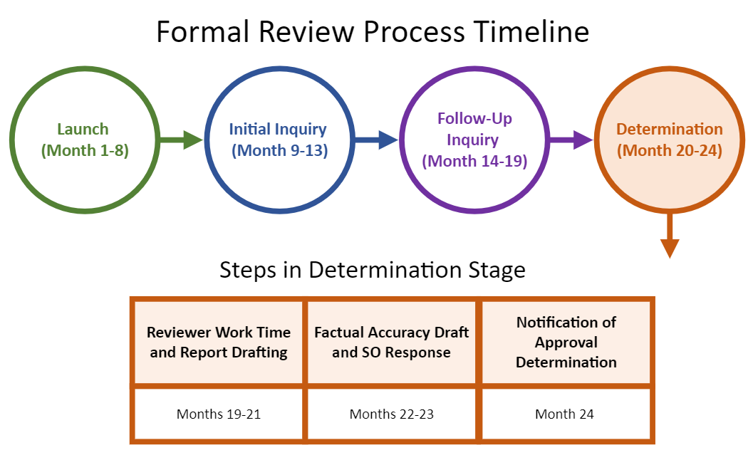

Step-by-Step Guidance for the Determination Stage
Step 1: Reviewer Work Time and Report Drafting
Step 2: Factual Accuracy Draft and SO Response
Step 3: Notification of Approval Determination
Rejoinder Response and Hearing Requests

Step 1: Reviewer Work Time and Report Drafting

What happens during this step?
- The DESE team provides training to the review team (see Initial Inquiry Planning Guide) to support their review of the evidence.
- The review team analyzes the evidence collected across the formal review process and makes judgments regarding criterion and domain-level ratings.
- The review team collectively reviews recommendations and ensures they are based in evidence and aligned with the expectations described in the Program Approval Criteria.
- The DESE Specialist takes the recommendations from the review team and write a draft report summarizing ratings for each criterion and domain.
- An internal DESE vetting panel reviews the report and confirm that all ratings are evidence-based, equity-oriented, and consistent across SOs.

When does this step happen?
- Months 19-21

Important Details
- The SO review designee should be available by email during this step to answer any clarifying questions from the reviewers or the DESE vetting panel.

Deliverables
- None

Step 2: Factual Accuracy Draft Response

What happens during this step?
- DESE shares a Factual Accuracy Report with the SO outlining the criterion- and domain-level ratings and rationales. The SO’s overall approval determination will not be included in the Factual Accuracy Draft.
- The SO has 10 business days to review the draft and notify DESE of any factual errors.
- DESE reviews the SO’s response carefully and amends the report as deemed appropriate.
- DESE shares the approval recommendation with the commissioner, who makes the final approval determination.

When does this step occur?
- Months 22-23

Important Details
- Given the substantive nature of the review and calibration checkpoints built into the process, the SO may submit corrections to factual mistakes in the report but may not provide additional evidence or refute judgments made by the review team at this time.

Helpful Tips
- During this stage, the SO has access to the draft report in a private SharePoint folder. This file is view only by the SO designee, who can share view-only access with additional team members as needed. The SO may identify any factual inaccuracies via in-line track changes and comments.

Deliverables
- Send DESE the Factual Accuracy Report response identifying any inaccuracies according to the SO’s timeline.

Step 3: Notification of Approval Determination

What happens during this step?
- DESE notifies the SO of its overall approval determination and each program-specific approval determination in writing. The possible determinations include:
  - Approved with Distinction
  - Approved
  - Approved with Conditions
  - Probationary Approval
  - Not Approved

When does this step occur?
- Month 24

Important Details
- If your SO receives an approval determination of Approved with Conditions or Probationary Approval, DESE works with the designee to determine timelines and next steps in response to conditions in accordance with the Guidelines for Program Approval.
- DESE publishes the SO’s approval determination and the approval determination for each of its programs on Public Profiles. DESE emails the SO when the updates are complete.

Deliverables
- Complete the Formal Review Feedback Survey.
- Review the approval determination and list of approved licensure programs on Public Profiles and inform DESE if anything is inaccurate based on the Formal Review report.

Rejoinder Response and Hearing Requests

What happens during this step?
- Any SO with an approval determination of Approved with Conditions, Probationary Approval, or Not Approved at the organization- and/or program-level may contest judgments or decisions reflected in the report by submitting a rejoinder response within 30 days of receipt of the final report and approval letter.
These SOs shall have all rights of review required by G.L. c. 30A,s. 13 and 801 CMR 1.00. All requests for hearings, where hearings are provided by statute, shall be in writing, addressed to the commissioner, and must be received within 30 days of receipt by the SO of the notice of approval determination.

Important Details
- All rejoinders or hearings must include new evidence for consideration.
- All rejoinders must be submitted using the DESE rejoinder template (available upon request).

