Initial Inquiry Overview and Purpose
This planning guide provides an overview of the Initial Inquiry stage of the Formal Review. The purpose of the Initial Inquiry stage is to collect data through engagement with stakeholders to better understand their experiences. This data, along with state-collected data, will be used to determine where there is sufficient evidence indicating a criterion is met, or whether additional information is needed via the Follow-Up Inquiry to address gaps or inconsistencies or elevate areas of strength.
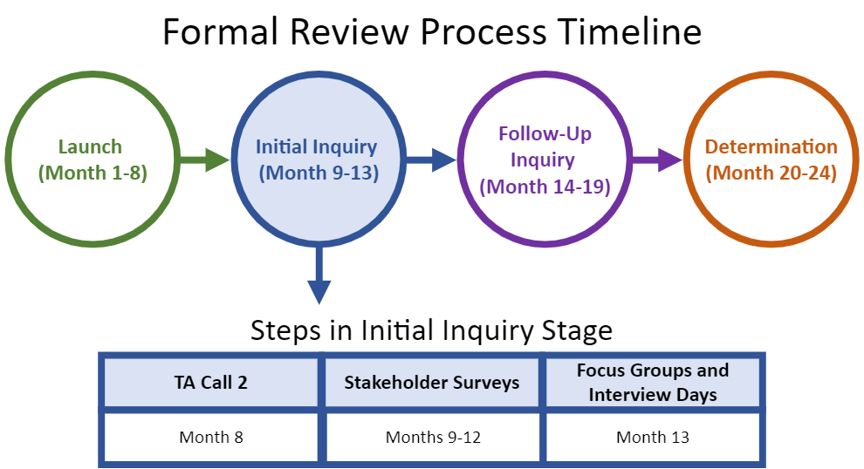

Step-by-Step Guide for the Initial Inquiry Stage

Step 1: Technical Assistance (TA) Call 2
Step 2: Stakeholder Surveys
Recruitment
Step 3: Focus Group and Interview Days
Recruitment
Welcome Meeting
Exit Meeting
Review Team
Appendix A: Sample Recruitment Language

Step 1: Technical Assistance Call 2

What happens during this step?
- DESE goes over what to expect during the Initial Inquiry stage and answer the SO’s questions. During the call, DESE:
  - Reviews how to fill in the Focus Group and Interview Schedule template
  - Elevates key details from the items shared in advance:
    - Why are we talking to each of your stakeholder groups?
    - What are best practices for recruiting for survey responses and focus group participation?
    - What can your SO adjust? What cannot be changed?
    - What are the expectations for the Welcome Meeting and Focus Group participation?

When does it happen?
- Month 8

Helpful Tips
- The SO should invite members of its team or personnel who will be directly managing logistics for the surveys, focus groups, and interview days.

Deliverables
- Read the documents and communication shared by the DESE specialist in advance of the call.
- Send list of SO personnel who will be joining the technical assistance call. This should include key members responsible for recruitment or logistics for the Stakeholder Surveys and Focus Group and Interview Days.

Step 2: Stakeholder Surveys

What are they?
- SOs are responsible for recruiting participants to complete DESE-created surveys prior to the focus group and interview days. This information will help DESE and the review team understand how to tailor focus group and interview questions.

When does this step occur?
- Months 9-12

Important Details
- SOs are responsible for recruiting stakeholders to complete the surveys. DESE will set minimum thresholds for survey participation based on the size of each stakeholder group to ensure there is a sufficient evidence base on which to make judgments through the review process.
- Suggested language for outreach is included in Appendix A. While SOs may adapt this template, all initial outreach must include the highlighted language.
- SOs may not provide guidance to any stakeholder group beyond providing logistical information and a brief description of the purpose of the surveys. Any perception that the SO has unduly influenced survey responses may result in action by DESE.

Helpful Tips
- Suggestions for increasing participation include:
  - Send out emails early and often.
  - Be clear about the why: how each participant’s response will help the SO demonstrate what it is doing well and learn more about areas for continued growth.
  - Ask faculty and staff to do personal outreach to candidates, completers, and supervising practitioners they have worked with in the past.
  - Ask candidates and completers to do outreach to their peers after they have completed their own survey.

Deliverables
- Send survey invitations and reminders to all relevant stakeholders.
- Meet survey minimum thresholds for each stakeholder group (DESE will provide updates on completion numbers).

Step 3: Focus Group and Interview Days

What happens during this step?
- The DESE team hears directly from the SO’s stakeholders through virtual focus groups, interviews, and meetings with the SO team. A typical schedule includes:
  - Day 1: Welcome Meeting, focus groups, interviews
  - Days 2-3: Additional focus groups and interviews as needed
  - Day 3 or 4: Exit Meeting

When does this step occur?
- Month 13

Important Details
- DESE provides a template schedule and overview for the Focus Group and Interview Days, which includes a list of all required stakeholder groups and instructions for adjusting the schedule to better align with the SO and its stakeholders’ needs.
- DESE sets minimum thresholds for focus group participation based on the size of each stakeholder group to ensure there is a sufficient evidence base on which to make judgments through the review process.
- DESE sends the final Focus Group and Interview Day schedule along with all Zoom links at least two weeks in advance of the Focus Group and Interview Days.
- Facilitators for each focus group and interview use a template to ensure consistency within and across organizations. This is tailored based on the evidence collected in the Launch stage, Stakeholder Surveys and/or state-collected output data to support the reviewers to build on that evidence base.
- Questions asked are all directly related to the Program Approval Criteria.
- To support a successful visit, the SO’s review designee should anticipate being ‘on-call’ (via phone or email) to answer questions and support logistics for the duration of focus groups and interviews.

Deliverables
- Complete the Formal Review Focus Group and Interview Day schedule template.
- Recruit focus group and interview participants (see details below).
- Provide proof of advertisement of focus groups and surveys to all currently enrolled candidates and those who have completed programs during the previous three academic years (years will be specific for individual SOs under review).
  - Must include language highlighted below.
  - Messages may directly CC the DESE Specialist, be forwarded, or be provided as PDFs.
- Provide names and emails of anticipated focus group and interview participants with DESE in advance of the visit.
- Share Welcome Meeting presentation, including a digital copy of any visuals or resources shared during the meeting.

Focus Group and Interview Recruitment Details
The SO is responsible for recruiting stakeholders to participate in focus groups and interviews during this step of the review. While DESE aims to collect a significant amount of evidence through surveys, hearing directly from stakeholders and asking follow-up questions in a live conversation is an invaluable component of the formal review process.
The SO may not provide guidance to any stakeholder group beyond logistical information and a brief description of the purpose of the focus groups and interviews. Any perception that the SO has unduly influenced focus group and interview participants may result in action by DESE.

Sponsoring Organization Personnel
- DESE will adjust the list below based on the responses provided in the Stakeholder Groups tab in the Launch Worksheet. If personnel are involved in more than one of the groups listed below, please inform the DESE Specialist to make appropriate adjustments.
- Personnel in supervisory roles should not participate in a focus group that includes personnel whom they supervise.

Structure | Minimum Number of Participants
Leadership Interview: School of education, department, and/or program leaders and decision-makers, including those who supervise other personnel and therefore cannot attend other focus groups | All
Field-Based Experience Staff Interview:  Field placement/coordinator(s) | All staff members who manage field placements for educator preparation programs.
Program Supervisor Focus Group | Set by DESE based on the total number of program supervisors and size of the SO’s programs.
Part-Time Education Faculty Focus Group | Set by DESE based on the total number of part-time education faculty and size of the SO’s programs.
Full-Time Education Faculty Focus Group | All full-time faculty members. If an extenuating circumstance prevents a full-time faculty member from participating live, please email your DESE Specialist to provide a survey link, allowing for their asynchronous participation.
Arts & Sciences Faculty Focus Group:  Faculty from content areas who teach educator preparation candidates | Set by DESE based on the size and structure of the SO’s programs.
Advising Staff Interview: Advisors or other support staff that work with educator preparation candidates | Key advising personnel representing all program groupings.
Partner Focus Group: PK-12 school/district partners, including principals, superintendents, and other district  personnel as relevant | As many as possible (minimum of six).  Helpful tip: Participating partners should be representative of schools/districts with high placement and employment rates.
Supervising Practitioner Focus Group: Supervising Practitioners representing all program groupings. | Set by DESE based on the size of the SO’s programs.  Helpful tip: Prioritize participation of supervising practitioners who have recently worked with candidates in the practicum (rather than host teachers from the pre-practicum only).

Candidate/Completer Focus Groups
- Candidate/Completer Focus Groups will be organized by program grouping. All licensure programs within each program grouping must be represented in the focus group participants.
- DESE will set minimum thresholds for focus group participants for each program grouping based on its number of completers. Meeting this threshold ensures DESE collects sufficient evidence to inform decision-making in the review.
Program Grouping | Minimum Number of Participants
Program Grouping 1:  - Licensure field, grade span, type, and level 1  - Licensure field, grade span, type, and level 2  - Licensure field, grade span, type, and level 3 | Will be determined by DESE based on the size of the program(s).
Program Grouping 2:  - Licensure field, grade span, type, and level 1  - Licensure field, grade span, type, and level 2  - Licensure field, grade span, type, and level 3 | Will be determined by DESE based on the size of the program(s).

Recruitment
- The SO must advertise the opportunity to participate in focus groups to all currently enrolled candidates and those who have completed programs during the three years leading up to the review.
- Suggested language for outreach is included in Appendix A. While the SO may adapt this template, all initial outreach must include the highlighted language.
- Helpful tips:
  - The SO should prioritize recent completers and candidates who have experienced most of their program of study including some of their practicum, as these individuals can best speak to the focus group questions.
  - Ensure email subjects are compelling and the body of the email clearly indicates why candidates/completers should make time to participate in the focus group.

Welcome Meeting
The Welcome Meeting typically starts the first Focus Group and Interview Day. This gives the SO an opportunity to orient DESE and the review team to your educator preparation approach and highlight key elements of your programs for the reviewers. The structure of the virtual meeting can be determined by the SO. The SO may also choose to provide a pre-recorded presentation instead of a live Welcome Meeting. The meeting will not exceed one hour in length.

Important Details
- DESE will prepare a Zoom link in advance
- The host can be anyone of your choosing
- Suggested topics include:
  - How your SO is preparing culturally responsive & linguistically sustaining educators
  - How your SO ensures the use of evidence-based practices throughout programming
  - Any additional contextual information you think the review team will need to understand your SO’s structure or work
- Reviewers will attend focus groups and interviews having reviewed the information provided by the SO in the Program Overview Worksheet and the Welcome Meeting, along with the evidence collected through Stakeholder Surveys.

Exit Meeting
The day after the the final focus groups and interviews, the DESE Specialist will conclude the visit by providing a brief overview of focus group and interview attendance and next steps in the review process. The DESE Specialist will not share preliminary Follow-Up Inquiry questions, criterion ratings, or other decisions at this meeting; the review team will not have completed their review of the Initial Inquiry evidence at this time. The SO review designee is required to attend and may invite additional participants from the SO if desired.

Review Team
Each formal review is facilitated by DESE specialists in close collaboration with an external review team comprised of representatives from both educator preparation programs and PK-12 schools and districts. Reviewers are carefully selected and trained to make evidence-based judgments in alignment with the 2023 Program Approval Criteria.

Role in Initial Inquiry
Prior to the Focus Group and Interview Days, DESE and the review team will review evidence from the Stakeholder Surveys and state-collected data. They will use this information to tailor focus group and interview questions. On the Focus Group and Interview Days, reviewers will attend the Welcome Meeting and co-facilitate focus groups and interviews. After the conclusion of the focus groups and interviews, DESE will compile the Initial Inquiry evidence for the review team. The review team will use this evidence to make recommendations for the Follow-Up Inquiry.

Review Team Members
During the TA Call 2, the SO will receive a list of the reviewers participating in their formal review, including their current title and organization.
Name | Title | Role on Visit

Appendix A: Sample Recruitment Language
To: All currently enrolled candidates and [INSERT previous three academic years] completers
Subject: Sign Up for an Important Focus Group to Share Feedback with the State

Dear ____,

The Department of Elementary and Secondary Education (DESE) works to guarantee that preparation in Massachusetts results in effective educators ready to support the success of all students. All educator preparation program providers must undergo periodic review by DESE to maintain the ability to endorse candidates for licensure in Massachusetts. [Sponsoring Organization’s] preparation programs are currently undergoing this important review.

During the next few months, DESE will lead surveys and focus groups for candidates, faculty and staff, PK-12 partners, program supervisors, and supervising practitioners to share feedback on their experiences with our educator preparation programs. Hearing from stakeholders is a critical part of DESE's review process and we encourage you to share about your experiences. All current candidates and recent completers are invited to participate.
Surveys
Please note that DESE hopes to engage as many stakeholders as possible in the survey to learn about your. This will help DESE prepare for discussions and dig deeper into your experiences during live discussions. Please complete this survey [add link] between now and [ENTER DATE].

Focus Groups
On the afternoon/evening of [ENTER focus group dates] DESE will conduct virtual focus groups. Many of DESE’s former focus group participants have signaled these discussions are interesting and a valuable use of their time. We hope you will feel the same.
If you are interested in joining a focus group, please [fill out this brief survey, email the designee etc.] to sign up by [date]. We will send a reminder in advance, but you may access the focus group using this Zoom link: [Add link}

For more information about the review of preparation providers in the Commonwealth please visit: https://www.doe.mass.edu/edprep/review/. If you have any questions, please contact [review designee name] at [contact information].

Thank you,
[Sender’s name]

