Launch Stage Overview and Purpose
This planning guide provides a detailed overview of the Launch stage of the Formal Review process. The purpose of the Launch stage is to familiarize sponsoring organizations (SOs) with the overarching review process and prepare SOs for the Initial Inquiry stage. During the Launch stage, DESE will seek a general understanding of the SO’s program information and any specific context needed to prepare for stakeholder engagement. Several deliverables will be requested to gather this information. This stage is also when the SO determines which programs it will propose to move forward for review.
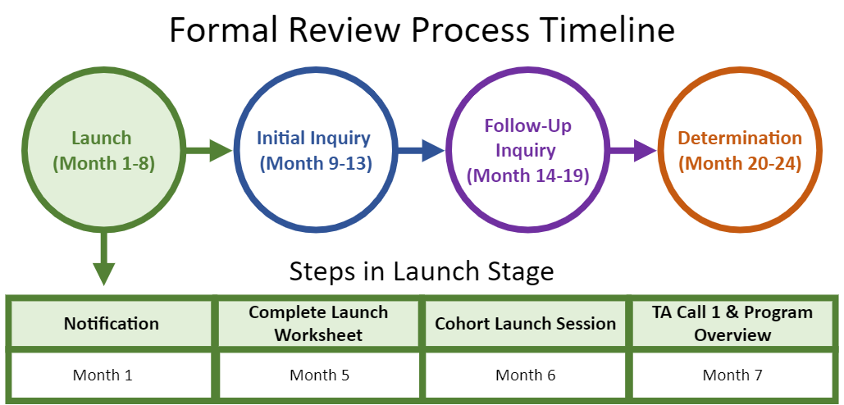

Step-by-Step Guide for the Launch Stage
Step 1: Notification
Step 2: Complete Launch Worksheet
Step 3: Cohort Launch Session
Step 4: Technical Assistance (TA) Call 1 and Program Overview
Required Documents
Candidate Artifacts

Step 1: Notification

What happens during this step?
- The DESE Specialist notifies your SO that the Formal Review is upcoming, which officially launches the review.
- The notification includes a timeline and a high-level overview of the review process.
- The timeline reflects all relevant dates for your SO’s Formal Review.

When does this step happen?
- Month 1 (Note: Notification takes place at least 6 months before the Cohort Launch Session. Each SO will receive a timeline with specific dates for each step of the review process. All timelines referenced throughout this and the other Planning Guides denote the minimum time that will be provided between each step.)

Important Details
- DESE tries to accommodate shifts in the timeline if there are major conflicts elevated by the SO at this time.
- After the SO confirms there are no conflicts, DESE and the SO move forward with the agreed-upon timeline.
- If significant unforeseen circumstances arise that require additional shifts, DESE coordinates with the SO to determine whether adjustments to the timeline are possible.

Helpful Tips
- When reviewing the proposed timeline, the SO should consider conflicts with holidays, academic breaks, major institutional events, or times when faculty will not be under contract. While DESE aims to ensure that portions of the review are when faculty who are most likely to be involved do not have notable conflicts, it is ultimately the responsibility of the SO to ensure the appropriate personnel are available during the dates for stakeholder engagement (the Initial Inquiry) and preparation of the targeted submission (the Follow-Up Inquiry).

Deliverables
- Provide DESE with the name and contact information for the SO review designee. The review designee is the person appointed by the SO to be responsible for all review communication with and submissions to DESE.
- Confirm the timeline for the review or any major conflicts.

Step 2: Complete Launch Worksheet

What happens during this step?
- The SO completes the Launch Worksheet to provide foundational context about stakeholder groups and licensure programs, which enables DESE to adjust surveys, focus groups, and interviews based on the organization’s unique structure and terminology.
- DESE provides the SO with a list of all approved programs and the number of corresponding completers over the past three academic years. If the SO wishes to continue offering programs with six or fewer completers over the three years preceding review, the SO needs to complete a Needs Assessment or High Needs Affidavit (see below for additional details). Programs that will undergo a more detailed review for alignment with the Early Literacy Criteria will also be identified at this time.

When does this step occur?
- Month 5

Instructions for Completing the Launch Worksheet
Program Chart tab:
- DESE prepopulates the completer numbers. These reflect the last three years of available data in Edwin, which is also available on your SO’s EP701 report. For each program, DESE identifies whether the number of completers in the program meets or exceeds the low enrollment threshold. If your SO wishes to expire a program that meets or exceeds the threshold, please inform your DESE Specialist at this time.
- If the program is below the enrollment threshold, DESE indicates whether the SO may pursue reapproval by completing a Needs Assessment or a High Needs Affidavit. Your SO decides about whether to continue to offer those programs.
- Your SO completes the last column in the Launch Worksheet by selecting the appropriate action for each program that is identified as having low enrollment (this column is automatically greyed out for programs that meet or exceed the enrollment threshold):
- Submit a Needs Assessment
- Submit a High Needs Affidavit (only an option for programs listed on the High Needs webpage)
- Choose to expire the program

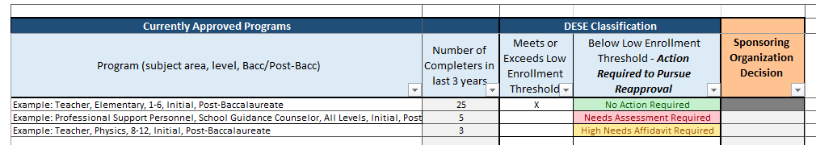

Stakeholder Groups tab:
- The Stakeholder Groups tab includes questions specific to each group in your organization from which DESE will collect evidence through focus groups, interviews, and/or surveys. The questions focus on whether groups exist within your organization, the language your SO uses to refer to them, and other information that may impact stakeholder groupings throughout the review.
- Within the Stakeholder Groups tab, your SO should complete the prompts in columns C, D, and E that correspond to the stakeholder groups identified in each row. Some types of personnel may not exist as a separate role in your organization; if this is the case, please indicate what other role fulfills the function described for that stakeholder group.
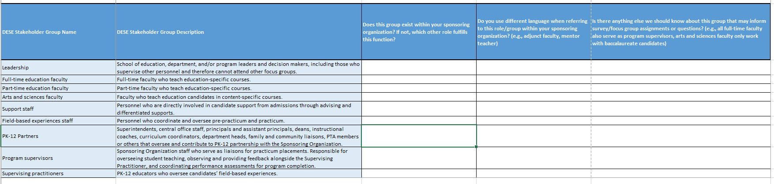

Helpful Tips
- SOs should continuously monitor their program completer numbers so that they are aware which programs may have low enrollment and consider whether to continue offering those programs in anticipation of their Formal Review.

Key Resources
- Needs Assessment Advisory (High Needs Affidavit template is in Appendix D)
- High Needs List

Deliverables
- Launch Worksheet
- Needs Assessments (If applicable)
- High Needs Affidavits (If applicable)

Completing Needs Assessments and High Needs Affidavits
What is a Needs Assessment and when is it required?
- To continue operating a low enrollment program or propose a new program in most licensure areas, the SO is responsible for demonstrating need for the program and providing evidence that the SO has the capacity to meet that need. This evidence is submitted through the Needs Assessment form.
What if the program is a DESE-Identified High Needs License?
- DESE maintains a list of license areas identified as high-needs areas using a combination of preparation program data and in-service educator shortage area data. Programs in these licensure areas are eligible to continue operating if the SO completes a High Needs Affidavit, ensuring the SO will monitor outcomes data and attempt to increase enrollment.
If your SO chooses not to complete an affidavit, or if insufficient need or capacity is demonstrated through the Needs Assessment, DESE will not review the program(s), and the program(s) will expire at the conclusion of the Formal Review.

Completing the Needs Assessment
The first several sections of the Needs Assessment form provide your SO with guidance and ask for basic program information. The form then prompts you to identify a category of need and provide aligned evidence.
Program Groupings
- All Professional programs may be grouped together at this time.
- All School Support Personnel programs may be grouped together at this time.
- All Administrator programs may be grouped together at this time.
- All Endorsement programs may be grouped together at this time.
- Specialist Teacher programs may not be grouped.
- Initial Teacher licensure programs may be grouped together if they meet all of the following criteria:
  - They are at the same level (i.e., baccalaureate programs cannot be grouped with post-baccalaureate programs)
  - They have very similar programs of study.
  - The SMK Guidelines for the programs reference the same MA Curriculum Framework(s).
Note: If, across programs in a grouping created based on these criteria, the combined of completers is greater than six, please contact the DESE team.
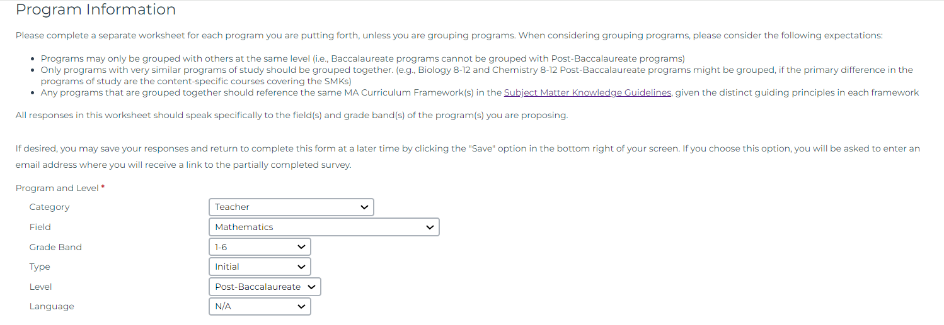

Categories of Need
There are four categories through which SOs can demonstrate need: district need, candidate interest, increasing diversity in the workforce, and impact/effectiveness of completers. To move a program forward for review, the SO must demonstrate need in one of these categories.
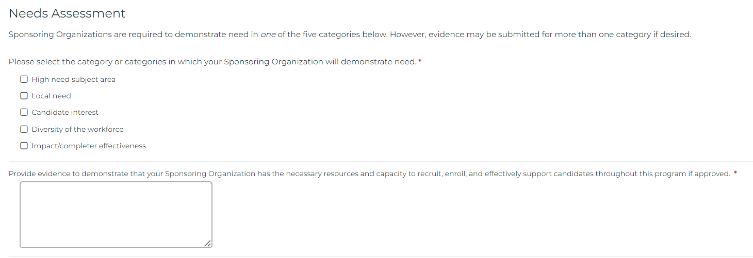

Completing a High Needs Affidavit
SOs may use the template language in Appendix D of the 2023 Needs Assessment Advisory to attest to their commitment to monitoring the quality of low/zero-completer programs in DESE-Identified high needs areas. The completed affidavit should be on official SO letterhead and signed by the SO’s President/Executive Director.

Step 3: Cohort Launch Session

What happens during this step?
- DESE hosts a half-day Cohort Launch Session for all SOs undergoing review in the same academic year. The session provides a more detailed overview of the review process and timeline, evidence sources, and guidance for the initial submission materials.

When does this step occur?
- Month 6

Important Details
- The Cohort Launch Session takes place at DESE’s office at 135 Santilli Highway in Everett.
- For SOs with programs requiring a Needs Assessment or Affidavit and/or programs that require an Early Literacy review, additional information will be shared immediately following the full group session.

Deliverables
- Invite up to five SO personnel, including the review designee, who will be key members of the review process. While these personnel are determined by the SO, we recommend focusing on those with decision-making power and those who will be responsible for preparing deliverables.
- Participate in the Cohort Launch Session

Step 4: Technical Assistance (TA) Call 1 and Program Overview

What happens during this step?
- DESE leads a call with the SO to discuss details in the Launch Worksheet, including results of the Needs Assessment(s) and/or Affidavit(s), and provide support for completing the Program Overview Worksheet and submitting all required documents and candidate artifacts.

When does this step occur?
- Month 7

Important Details
- Review the following items (DESE will share these in advance of the call):
  - Review Timeline (review upcoming steps to ensure expectations are clear)
  - Program Overview Worksheet
  - Required Documents and Candidate Artifacts Overview
- DESE reserves the right to ask for additional documents or artifacts - either in type or number - during the Follow-Up Inquiry phase of the Formal Review.

Deliverables
- Send list of SO personnel who will be joining the technical assistance call. This should include key members completing the Program Overview and/or assembling the required documents and artifacts. This may also include personnel that serve as department leads or support with field-based experiences and licensure.
- Program Overview Worksheet
- Required Documents (see table below)
- Candidate Artifacts (see table below)

Submit Program Overview, Required Documents, and Candidate Artifacts
What is the Program Overview?
The Program Overview Worksheet requests high-level information relative to each domain. It is an opportunity to orient DESE and the review team to your organization’s unique structure and approach to educator preparation. Responses will provide reviewers and DESE staff with foundational information prior to engaging with stakeholders during focus groups and interviews.
Identifying Program Groupings: In the Instruction domain section of the Program Overview Worksheet, you may identify programs to be grouped together for the purpose of Formal Review. The review of evidence in the Initial Inquiry and Follow-Up Inquiry will align with these groupings. Each grouping will have its own Instruction domain worksheet in the Follow-Up Inquiry.

- All Professional programs may be grouped together at this time.
- All School Support Personnel programs may be grouped together at this time.
- All Administrator programs may be grouped together at this time.
- All Endorsement programs may be grouped together at this time.
- Specialist Teacher programs may not be grouped.
- Initial Teacher licensure programs may be grouped together if they meet all of the following criteria:
  - They are at the same level (i.e., baccalaureate programs cannot be grouped with post-baccalaureate programs)
  - They have very similar programs of study.
  - The SMK Guidelines for the programs reference the same MA Curriculum Framework(s).

Required Documents
As a part of the Formal Review process, DESE reviews several key documents from the SO (listed in the tables below). Additional documents may be requested as part of the Follow-Up Inquiry based on evidence gathered during the Launch and Initial Inquiry stages of the review.
Please note that all files must be submitted electronically.
Organization Domain
Domain and Criterion | Document Category | Description
ORG 1 | Organizational Chart(s) | Organizational chart(s) for the SO at large and the educator preparation unit, including personnel names.
CAN 1 | Admissions Policy | Admissions policy explaining the SO’s admission requirements for approved educator preparation programs.  If individual program(s) or groups of programs have distinct admissions policies, each policy should be submitted with the included program(s) clearly identified.
CAN 2 | Advising Policy | Advising policy describing how the SO positions candidates to be successful in their program, licensure, and career through guidance and comprehensive support systems. This policy should cover both individual and group advising and resources to navigate higher education and PK-12 systems.  If individual program(s) or groups of programs have distinct advising policies, each policy should be submitted with the included program(s) clearly identified.
CAN 4 | Waiver Policy | Waiver policy outlining which, if any, of the following program requirements may be waived based on individual candidate experience and circumstances:  - Individual courses  - Pre-practicum  - Up to half of practicum/practicum equivalent  - Practicum setting requirements (except for the use of the MA Curriculum Frameworks)  - Supervising Practitioner requirements (appropriate license, years of experience, and/or educator evaluation rating)  If no waivers are permitted, the SO must submit a written policy documenting that decision.  If individual program(s) or groups of programs have distinct waiver policies, each policy should be submitted with the included program(s) clearly identified.  Additional details can be found in Implementation of Waivers in Approved Programs section of the Guidelines for Educator Preparation Program Approval.
FBE: Multiple Criteria | Practicum Handbook(s) | Practicum policies and procedures (may be in the form of a practicum handbook).
FBE 5 | Performance Assessment | For each Administrator, School Support Personnel, and Specialist Teacher program, the SO should submit the performance assessment guidance and materials provided to candidates, including any rubric(s) used for the performance assessment.
INS: Multiple Criteria | Program(s) of Study | For each licensure program, the SO should submit a program of study that outlines the course titles (required and elective), the intended course progression, and any additional program components (e.g., field-based experiences). If a program has multiple pathways (e.g., a traditional practicum pathway and a residency pathway both leading to a post-baccalaureate Math 8-12 endorsement), a separate program of study should be submitted for each pathway.  Tip: SOs should not need to create this for the DESE Formal Review. SO may have a similar document with a different name already in existence (e.g., advising sheets, course checklists).

Candidate Artifacts
As a part of the Formal Review process, DESE also reviews candidate artifacts. The following tables indicate the categories of files that are required for review. For categories that are relevant to all candidates, DESE generates a random sample for which files must be shared. For categories that do not apply to all candidates, the SO selects relevant files. For additional guidance on records retention, please see the Candidate Record Retention Advisory.

Domain and Criterion | Artifact Category | Description | Sample
CAN 3 | Differentiated Support | Evidence of how the SO identified, provided differentiated interventions, and counseled candidates who needed additional support in coursework, fieldwork, or for their general well-being.  Sample records should be provided for candidates identified in coursework, candidates identified in fieldwork (pre-practicum and practicum), candidates who ultimately successfully completed the licensure program, and candidates who chose to or were counseled to select a different path.  An optional cover sheet may be included to provide a high-level overview for each candidate to DESE and the review team. | Completers selected by the SO (sample size determined based on number of completers over the last 3 years)
CAN 4 | Waivers | Evidence of how the SO applies its waiver policy equitably across programs and candidates and ensures that academic and professional standards of the licensure role are met.  Records should be provided for any requirements that have been waived by the SO. Each file should include a clear rationale for why the waiver was or was not granted. This may include waivers for:  - Individual courses  - Pre-practicum  - Practicum/practicum equivalent  - Practicum setting requirements  - Supervising practitioner requirements | Completers selected by the SO (sample size determined based on number of completers over the last 3 years)
FBE 5 | Performance Assessments | Evidence of how the SO implements performance assessments consistently within and across programs to improve practice and ensure only candidates who are ready for full responsibility in the licensure role complete the program.  The random sample includes candidates from all licensure areas offered by the SO for which performance assessments are required. The Performance Assessments during Practicum/Practicum Equivalent Experiences section of the Guidelines for Educator Preparation Program Approval details performance assessment expectations for each relevant licensure area:  - Initial Teacher licenses  - Specialist Teacher licenses  - School Support Personnel licenses  - Administrator licenses  Each CAP file should include:  - CAP Form  - CAP Observation Form for all required observations  - Student feedback instruments  - Formative Assessment Form  - Summative Assessment Form  Files should document the types of feedback provided to candidates after observations conducted by the program supervisor and/or supervising practitioner.  For all Administrator, School Support Personnel, and Specialist Teacher candidate files, the SO should include similar forms and information. | Completers randomly selected by DESE  (sample size determined based on number of completers over the last 3 years)
FBE 6 | Field-Based Experiences Regulations | Evidence that the SO’s field-based experiences meet regulatory requirements:  - Practicum hours, including hours of full responsibility in the licensure role, as per 603 CMR 7.04 (4)  - Placement(s) as per 603 CMR 7.04 (4)  - Supervising practitioner qualifications as per 603 CMR 7.02.  This information should be captured in all performance assessment cover sheets. | Completers randomly selected by DESE  (sample size determined based on number of completers over the last 3 years)

