Subject Matter Knowledge Matrix
Autism Endorsement

Students in Massachusetts must meet rigorous academic standards. To do so, they must have access to educators with strong content knowledge and pedagogical skills, the building blocks of effective instructional practice.

In support of this, the Subject Matter Knowledge Guidelines set forth the content knowledge expectations for educator licensure in Massachusetts. Through these expectations, the Massachusetts Department of Elementary and Secondary Education (DESE) seeks to ensure that educators entering the workforce have sufficient content knowledge in their licensure area to support students in mastering academic standards.

Educators must move beyond basic or functional knowledge to a level of fluency or expertise with the academic standards such that they can teach and support students in mastering the content. The figure below shows a steady progression, not in the amount of information one knows, but in the depth and ability to use that information for a specific purpose. The boxes below the continuum outline some assessments used to determine varying levels of content knowledge. The depth at which the knowledge and application of content knowledge must be demonstrated is dependent on the stage of development for an individual educator (i.e. Basic, Functional, Fluent, or Expert) and/or license type (Provisional, Initial, or Professional).

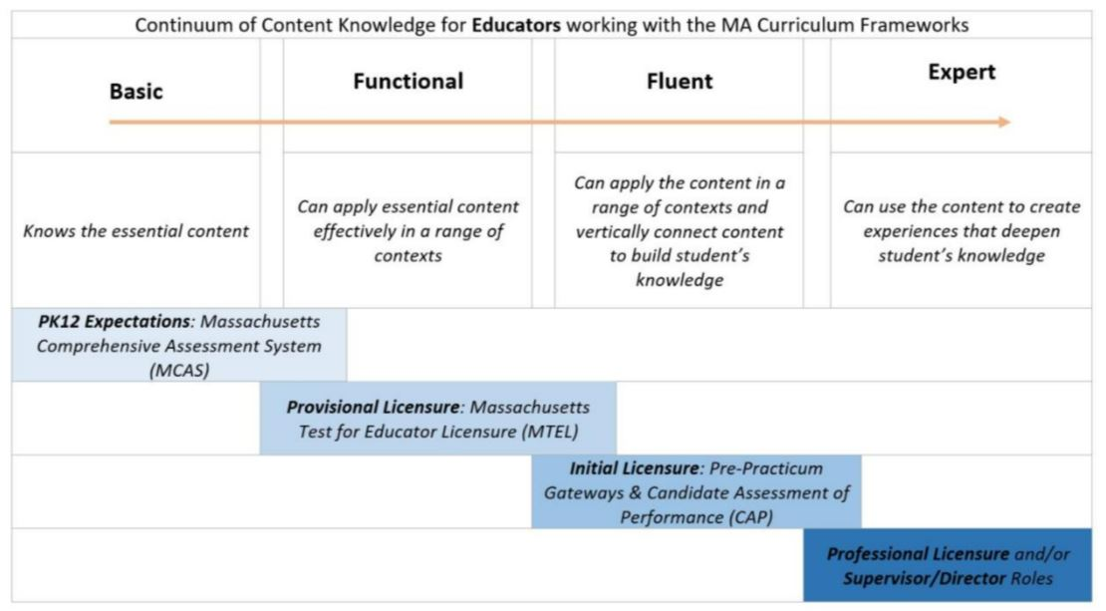

Instructions: Please list the numbers/abbreviations/titles of the sponsoring organization’s required courses where each indicator is targeted, explicit, and coherently addressed. Course identifiers should match the numbers/abbreviations/titles of submitted syllabi to support DESE’s review. Indicators should not be spread across too many courses.

Initial licensure program candidates must reach the fluent level to be endorsed. They must be able to apply content in a range of contexts and vertically connect content to build students’ knowledge. Sponsoring Organizations must have at least one course at the fluent level for each practice.

Then, briefly describe where in the syllabus the content is covered (i.e., unit name, week number, objective number).

 | 1. Foundations and Characteristics of Autism Indicators  Candidates for the Autism Endorsement should develop a knowledge base in the following areas: | Fluent  Initial  Licensure
 | Example Row | EDU 101 – Weeks 5-7
 | - Understands current diagnostic criteria for autism, including unique characteristics as related to communication, social/emotional development, behavior, sensory processing, cognition, and learning and the range of presentation across the spectrum.
 | - Understands the differences between a medical diagnosis of autism and the definition of the term autism under state and federal special education laws.
 | - Understands how autism is distinguished from other conditions, including the potential for secondary mental health issues and other comorbid conditions, and understands how they contribute to characteristic presentation, educational needs, and impact on multilevel family systems.
 | - Knows the medical, neurodevelopmental, and biological etiology of autism and impact on learning across the lifespan.
 | - Knows the history and range of theories, specialized and individualized programs, services, supports and interventions used across all settings including home, school and community supported by peer reviewed research to the extent practicable, to address academic, communication, behavioral, social, emotional, and sensory issues.
 | - Knows the laws specific to autism at the federal and state level, including the Autism IEP Act (M.G.L. c71Bȿ3) and how they apply to practice.
 | - Understands the link between communication, social/emotional development, and behavior.
 | - Understands strengths and challenges related to specific diagnostic presentation and communication profiles, and that limited communication does not infer limited cognition.
 | - Knowledge of how to use naturally occurring reinforcing social responses and feedback to foster ongoing language development.
 | - Understands typical and atypical patterns and features of receptive and expressive language, including use of augmentative and alternative communication (AAC) for students who are nonverbal or have limited speech and social pragmatics.
 | - Understands behavior and self-regulation including adaptive behavior, self-injurious behavior, stereotypy, and behavior that interferes with learning from a functional perspective.
 | - Understands the importance of using self-advocate (first-person) accounts and research to understand the nature and scope of behavior associated with autism
 | - Understands sensory processing, and sensory motor development and the range of supports available in the educational environment as well as during transitions between environments
 | 2. Assessment Indicators  Candidates for the Autism Endorsement will develop knowledge and skills related to assessment based on known best practices and peer-reviewed research to the extent practicable, that are specific to the population of students with autism, including: | Fluent  Initial  Licensure
 | - Knows how to use a range of formative and summative assessments, including associated data collection activities, to inform instruction, services and supports; monitor progress and rates and patterns of skill acquisition; and ensure the maintenance and generalization of skills across settings that are best suited to unique characteristics of students with autism, and as identified in MGL c 71B ȿ 3.
 | - Understands the impact of cultural and linguistic diversity on the evaluation of students with autism.
 | - Knowledge of how to plan for transition, including assessment of outcomes, maintenance of skills, self-determination, and personally relevant curriculum for students with autism.
 | - Understands the purpose of assessment in the classroom and the importance of assessing individual students’ strengths, skills, and learning styles.
 | - Understands the role of functional behavioral assessment and its role in the development of behavior support plans.
 | 3. Program, Services, and Supports Indicators  Candidates for the autism endorsement will develop knowledge and skills related to programs, services, and supports for students with autism as supported by peer reviewed research to the extent practicable including: | Fluent  Initial  Licensure
 | - Knows the range of intervention techniques, strategies, and methodologies to increase access to curriculum and identifies and works to support/reduce behaviors that interfere with learning in students with autism.
 | - Understands the range of services, supports, aids, programs and strategies that can support students with autism in academic and non-academic settings and how to promote student learning, generalization, and maintenance across multiple environments, including home, and community.
 | - Knows how to identify and select educational practices to meet the student's unique needs in the general education setting to the maximum extent possible.
 | - Understands how to identify, select, and utilize appropriate individualized supports and services and create educational opportunities to support development of receptive, expressive, and pragmatic language.
 | - Understands the use of specialized, and individualized social curriculum, to support social development.
 | - Understands how to use an array of positive behavioral interventions/strategies and supports, mutual respect, and safety to support behavioral needs associated with autism.
 | - Knowledge of appropriate AAC and AT devices, functional communication training and devices and services for meaningful academic, communication and social purposes across the school day, home, and community settings.
 | - Understands how to implement and monitor strategies to foster successful development and generalization of vocational, adaptive, and community-based skills.
 | - Knowledge of how to implement individualized programs and services to address sensory needs in the educational environment, during transitions, and across school, home and community settings in collaboration with appropriate specialists and related service providers.
 | - Understands the importance of literacy as a critical skill and how to facilitate meaningful reading and writing instruction for all students with autism, including those with communication challenges, as a primary goal
 | - Understands how to develops and/or implement specialized instruction to explicitly teach and practice pragmatic language and social interaction in natural and structured contexts.
 | - Can articulate the concepts of peer reviewed publications and evidence-based practices and can demonstrate how to identify programs, services and supports that meet these standards.
 | 4. Collaboration and Coordination Indicators  Candidates for the Autism Endorsement will develop knowledge and skills related to collaboration and professional leadership, including: | Fluent  Initial  Licensure
- Develops skills to communicate in an effective and culturally and linguistically competent way with families, including using protocols for regular communication in the manner and frequency appropriate to meet the needs of the child and ensure generalization.
- Recognize that families may need support to engage in the IEP process.

- Understands the importance of collaboration with professionals in the school and community to facilitate coordinated assessment and educational planning.
- Understands existing autism-specific information and peer-reviewed research, as well as autism related laws, including the importance of remaining current on new research and laws.
- Understands the importance of the student and family perspective being represented in all education decisions, programs and services/coordination of services. In addition, understands the importance of and resources occurs across settings to respond to the fluid and dynamic needs of students with autism and their families.
- Develops and maintains relationships with organizations providing resources to individuals with autism within the community, including collaborative transition planning.

