Subject Matter Knowledge Matrix
Bilingual Education Endorsement

Students in Massachusetts must meet rigorous academic standards. To do so, they must have access to educators with strong content knowledge and pedagogical skills, the building blocks of effective instructional practice.

In support of this, the Subject Matter Knowledge Guidelines set forth the content knowledge expectations for educator licensure in Massachusetts. Through these expectations, the Massachusetts Department of Elementary and Secondary Education (DESE) seeks to ensure that educators entering the workforce have sufficient content knowledge in their licensure area to support students in mastering academic standards.

Educators must move beyond basic or functional knowledge to a level of fluency or expertise with the academic standards such that they can teach and support students in mastering the content. The figure below shows a steady progression, not in the amount of information one knows, but in the depth and ability to use that information for a specific purpose. The boxes below the continuum outline some assessments used to determine varying levels of content knowledge. The depth at which the knowledge and application of content knowledge must be demonstrated is dependent on the stage of development for an individual educator (i.e. Basic, Functional, Fluent, or Expert) and/or license type (Provisional, Initial, or Professional).

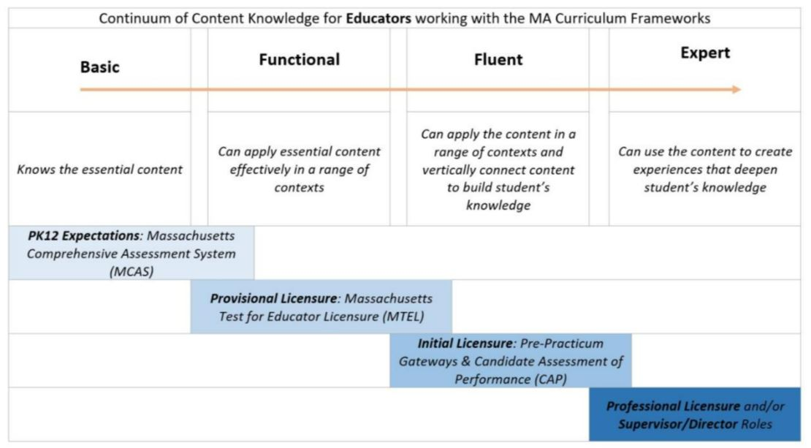

Instructions: Please list the numbers/abbreviations/titles of the sponsoring organization’s required courses where each indicator is targeted, explicit, and coherently addressed. Course identifiers should match the numbers/abbreviations/titles of submitted syllabi to support DESE’s review. Indicators should not be spread across too many courses.

Initial licensure program candidates must reach the fluent level to be endorsed. They must be able to apply content in a range of contexts and vertically connect content to build students’ knowledge. Sponsoring Organizations must have at least one course at the fluent level for each practice.

Then, briefly describe where in the syllabus the content is covered (i.e., unit name, week number, objective number).

 | 1. Knowledge of the foundations of bilingual education, including dual language education or two-way immersion and transitional bilingual education, as defined in M.G.L.c.71A, § 2, and the concepts of bilingualism and biculturalism.  Candidates for the Bilingual Education Endorsement should develop a knowledge base in the following areas: | Fluent  Initial  Licensure
 | Example Row | EDU 101 – Weeks 5-7
 | - The candidate is knowledgeable about contemporary theories and concepts associated with the study of bilingualism and biliteracy development of the individual learner in the social contexts of family, community, and schooling. (NDLETPS Component 1.2.a)
 | - The candidate demonstrates understanding of time and partner languages, scheduling; programmatic classification, including appropriate and available language assessments in the partner language and English. (NDLETPS Component 6.2.a)
 | - The candidate understands the linguistic and sociocultural relationships between oral language, bilingualism, biliteracy, and instructional materials. (NDLETPS Component 3.3.c)
 | - The candidate is knowledgeable about the history of bilingual education policy in the United States.
 | 2. Bilingual language acquisition factors as they affect access to the Massachusetts content and language standards.  Candidates for the Bilingual Education Endorsement will develop knowledge and skills related to language acquisition factors as they affect access to the Massachusetts content and language standards including: | Fluent  Initial  Licensure
 | - The candidate demonstrates a general understanding of how two or more languages are acquired, structured, and organized yet subject to influences of a cognitive and maturational nature, including language relatedness and the learner’s age, motivation, and identity development. (NDLETPS Component 1.2.b)
 | - The candidate demonstrates understandings that one’s degree of bilingualism and biliteracy are best represented along a continuum that can vary contextually and over the lifetime of a learner. (NDLETPS Component 1.2.c)
 | - The candidate understands that there is no single best approach to promoting bilingualism and biliteracy for all learners in all dual language contexts (e.g., sequential versus simultaneous versus translanguaging literacy development approaches; grouping of learners; time and subject area allocation, etc.) and can understand and explain why the approach may be better suited than another for a particular context. (NDLETPS Component 1.3.b)
 | 3. Social-cultural, social-emotional, political, and other salient factors in bilingual language acquisition.  Candidates for the Bilingual Education Endorsement will develop knowledge and skills related to social-cultural, social-emotional, political, and other salient factors in bilingual acquisition including: | Fluent  Initial  Licensure
 | - The candidate understands how the learners’ sense of identity is intimately linked to his or her past, present, and future. (NDLETPS Component 2.1.a)
 | - The candidate demonstrates understandings that language ideologies may not be generally neutral and that they are sometimes used to benefit certain segments of a given society to the detriment of others. (NDLETPS Component 1.1.a)
 | - The candidate understands that teachers are central to enacting established micro level language policy and planning, may mitigate the implementation of a policy and plan, and are key to evaluating the improving micro level language policy. (NDLETPS Component 1.3.c)
 | - The candidate understands the various political, social, economic, psychological and linguistic events of the past and present that influence the learners’ sense of identity whether privileged or subordinated locally, regionally, nationally, or globally. (NDLETPS Component 2.1.b)
 | - The candidate demonstrates the ability to critically reflect on how his or her own sociohistorical positioning (e.g., based on race, gender, language, class, etc.) might influence the quality of interactions with members of the school and community. (NDLETPS Component 2.2.a)
 | 4. Implementation of strategies for coordinating non-English partner language instruction and English language development instruction for English learners.  Candidates for the Bilingual Education Endorsement will develop knowledge and skills related to implementation of strategies for coordinating non-English partner language instruction and English language development including: | Fluent  Initial  Licensure
 | - Independently or with a co-teacher (depending on the program model), the candidate is able to map instructional standards across languages to create a cohesive instructional plan that promotes biliteracy development and the transfer of learning objectives. (NDLETPS Component 3.1.c)
 | - The candidate is able to design and implement instructional activities that promote the transfer of learning objectives across languages with an emphasis on the significance of student-relevant lessons that facilitate and encourage students to utilize broad linguistic repertoires from an assets-based perspective. (NDLETPS Component 3.2.d)
 | - The candidate demonstrates understanding of the phonological, lexical, and syntactic differences between the two languages and scaffolds instruction accordingly. (NDLETPS Component 3.4.d)
 | 5. Practices and approaches of teaching reading and writing in two languages, including the importance of oral language development as a foundation for literacy.  Candidates for the Bilingual Education Endorsement will develop knowledge and skills related to Practices and approaches of teaching reading and writing in two languages, including the importance of oral language development as a foundation for literacy. | Fluent  Initial  Licensure
 | - The candidate demonstrates lesson delivery that incorporates a variety of grouping strategies to promote students’ active engagement and to provide sufficient opportunities to practice all four language modalities. (NDLETPS Component 3.2.b)
 | - The candidate demonstrates pedagogical practices that afford students’ use of grammatical, pragmatic, discourse, and metalinguistic competencies, with ample opportunities for structured and unstructured language production, in both the partner language and in English. (NDLETPS Component 3.3.d)
 | - The candidate demonstrates knowledge and skills with regard to scaffolding for the language of instruction and separation of languages along with appropriate points for transliteracy. (NDLETPS Component 3.4.c)
 | - The candidate effectively uses a variety of materials to foster the development of biliteracy and the transfer of concepts. (NDLETPS Component 3.3.b)
 | 6. Practices and approaches for assessing content knowledge, reading and writing skills and comprehension in English and the non-English partner language for English learners who are at different levels of proficiency in English and the non-English partner language.  Candidates for the Bilingual Education Endorsement will develop knowledge and skills related to assessment based on known best practices and peer-reviewed research to the extent practicable, which are specific to bilingual education programs, including: | Fluent  Initial  Licensure
 | - The candidate understands assessment of biliteracy and demonstrates knowledge of how to use multiple, inclusive, holistic, valid, and reliable measures to assess literacy development, oral language development, and content concepts in both the partner language and in English. (NDLETPS Component 4.1.a)
 | - The candidate demonstrates skills and knowledge related to assessment and equity. This includes understand dual language learners’ myriad, complex features that impact the assessment process. (NDLETPS Component 4.2.b)
 | - The candidate demonstrates knowledge and skills reflective of a broad range of informal, student-centered, formative assessment strategies to gather information on student learning and adjust pedagogical patterns accordingly in both the partner language and in English. (NDLETPS Component 4.3.c)
 | - The candidate demonstrates appropriate assessment data-analysis and data-management skills aligned with biliteracy development, dual language programmatic features, and national, state, and local systems of accountability to accurately depict students’ progress for content-based learning and biliteracy development in both the partner language and in English. (NDLETPS Component 4.4b)
 | 7. Understanding and implementation of culturally relevant teaching materials and practices.  Candidates for the Bilingual Education Endorsement will develop understanding and implementation of culturally relevant reaching materials and practices including: | Fluent  Initial  Licensure
- The candidate demonstrates student-centered, asset-based pedagogies that draw upon all students’ linguistic, cultural, and academic funds of knowledge. (NDLETPS Component 3.2.a)
- The candidate is able to identify racist, stereotypical or culturally biased content within the prescribed or mandated curriculum. (NDLETPS Component 2.3.a)
- The candidate is able to locate, modify, and create curricular content that is equitable and enhances the learners’ sociocultural competence. (NDLETPS Component 2.3.b)
- The candidate understands that the learners possess deep personal, familial, and communal cultural knowledge and draws on such knowledge to co-construct new cultural knowledge. (NDLETPS Component 2.3.c)
- The candidate is able to plan and design activities aimed at building a mutual appreciation and respect for the targeted cultural groups among the families and community members. (NDLETPS Component 2.4.c)
- The candidate understands that advocating, confronting, speaking up, managing conflicts, taking risks, taking a stance, questioning authority, or exercising one’s agency can vary across cultures, social classes, race, ethnicity, gender, and legal status. (NDLETPS Component 5.1.c)

