**Crosscutting Subject Matter Knowledge Matrix**

Students in Massachusetts must meet rigorous academic standards. To do so, they must have access to educators with strong content knowledge and pedagogical skills, the building blocks of effective instructional practice.

In support of this, the [Subject Matter Knowledge Guidelines](https://www.doe.mass.edu/edprep/domains/instruction/smk-guidelines.docx) set forth the content knowledge expectations for educator licensure in Massachusetts. Through these expectations, the Massachusetts Department of Elementary and Secondary Education (DESE) seeks to ensure that educators entering the workforce have sufficient content knowledge in their licensure area to support students in mastering the Massachusetts Curriculum Frameworks.

The figure below shows a steady progression, not in the amount of information one knows, but in the depth and ability to use that information for a specific purpose. The boxes below the continuum outline some assessments that may be used to determine varying levels of content knowledge. The depth at which the knowledge and application of content knowledge must be demonstrated is dependent on the stage of development for an individual educator (i.e. Basic, Functional, Fluent, or Expert) and/or license type (Provisional, Initial, or Professional).

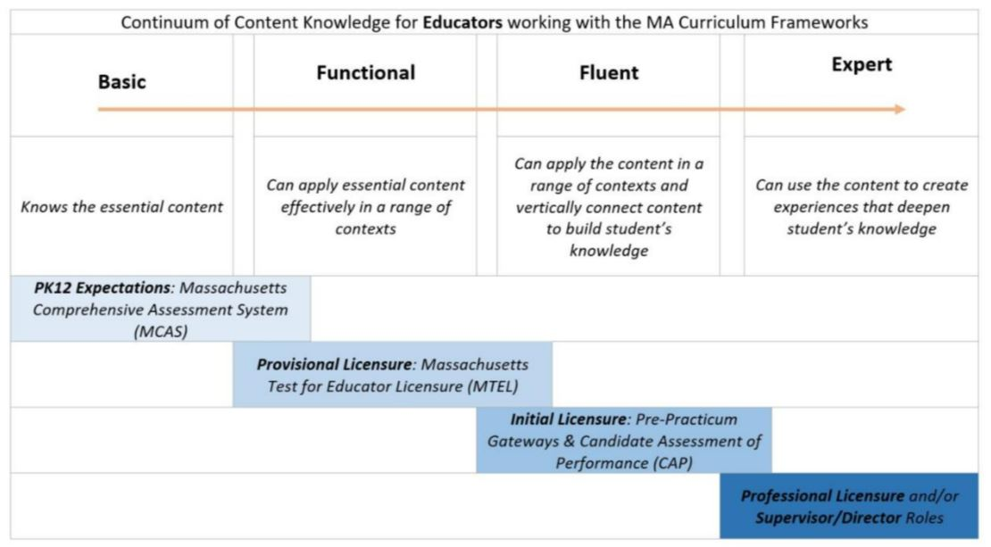

Two matrices are included below:

* The **Crosscutting SMK Matrix** is required for:

All Initial Teacher programs

* The **Crosscutting SMK Matrix for Foundations of Reading** is required for the following programs:

Early Childhood, Pre-K—2

Elementary, 1-6

Teacher of Students with Moderate Disabilities, PK-2, PK-8, 5-12

Teacher of the Deaf and Hard of Hearing

Teacher of the Visually Impaired, All

# Crosscutting Subject Matter Knowledge Matrix (All Initial Teacher Programs)

|  |
| --- |
| **Instructions*:***This matrix should be **completed for all Initial Teacher preparation programs**. Initial licensure program candidates must reach a level of fluent content knowledge to be endorsed. They must be able to apply content in a range of contexts and vertically connect content to build students’ knowledge.  Please list the numbers/abbreviations/titles of the **sponsoring organization’s required courses where each indicator is targeted, explicit, and** **coherently addressed**. Course identifiers should match the numbers/abbreviations/titles of submitted syllabi to support DESE’s review. Indicators should not be spread across too many courses. Then, **briefly describe where in the syllabus the content is covered** (i.e., unit name, week number, objective number). |

|  |  |
| --- | --- |
| **Crosscutting Subject Matter Knowledge** | **Course(s)** |
| *Example Row* | *EDU 101 - Week 5* |
| 1. Support the integration of standards for literacy across the content areas as outlined in the [2017 English Language Arts and Literacy Framework.](https://www.doe.mass.edu/frameworks/ela/2017-06.pdf)     *Specifically:*   * + *Provide daily access to grade level complex texts for all students.*   + *Promote the building of knowledge systematically.*   + *Provide active, frequent practice in reading, writing, speaking, and listening.* |  |
| 1. Apply basic principles and concepts for digital literacy and computer science in Computing and Society, Digital Tools and Collaboration, and Computing Systems as outlined in the [2016 Digital Literacy Computer Science Framework](https://www.doe.mass.edu/frameworks/dlcs.pdf).   *Specifically:*   * *Computing and Society:*    + *Understand basic online safety, security concepts, and safe information sharing.*   + *Explore what it means to be a good digital citizen including demonstrating responsible use of technology and digital content and practicing appropriate personal interactions.*   + *Observe and describe how people use technology and the impact of inequitable access to technology.*   + *Demonstrate basic understanding of digital media messaging (e.g., bias) and how tech can influence people.* * *Digital Tools and Collaboration:*   + *Use digital tools and computing skills to communicate or exchange digital information including the creation of multimedia artifacts.*   + *Develop intermediate research skills needed to create artifacts and attribute credit.* * *Computing Systems:*    + *Understand that computing devices can take many forms (e.g., laptop, smartphone, Chromebook) and have different components (e.g., keyboard, touchpad, mouse).*   + *Use a variety of computing devices and be able to troubleshoot and solve simple device problems.*   + *Differentiate between tasks that are best done with computers and those done by humans alone.*   + *Understand the components of a school network and basic network authentication (for example, use of usernames and passwords for school devices vs. websites vs. wifi connections).* |  |
| 1. Apply the theories of cognitive, social, emotional, language, and physical development from childhood through adolescence. |  |
| 1. Understand the characteristics and instructional implications of moderately and severely disabling conditions. |  |
| 1. Apply special education policies and procedures. |  |
| 1. Support English learners through English learner education instruction. |  |

# Crosscutting Subject Matter Knowledge Matrix – Foundations of Reading (Subset of Initial Teacher Programs)

|  |
| --- |
| **Instructions*:***This matrix should **only be completed for the following subset of Initial Teacher preparation programs** whose candidates are expected to demonstrate the knowledge needed to support students in mastering the foundations of reading:  Early Childhood, Pre-K—2  Elementary, 1-6  Teacher of Students with Moderate Disabilities, PK-2, PK-8, 5-12  Teacher of the Deaf and Hard of Hearing  Teacher of the Visually Impaired, All |

|  |  |
| --- | --- |
| **Crosscutting Subject Matter Knowledge – Foundations of Reading** | **Fluent** |
| *Example* | *EDU 101 – Week 5* |
| 1. Knowledge of the significant theories, approaches, practices, and programs for developing reading skills and comprehension:    1. Current research-based theories and practices for developing proficient and strategic readers; familiarity with programs and approaches for teaching literacy/reading.    2. Principles and research-based practices for developing proficient readers (phonics and word recognition, vocabulary, reading fluency, comprehension, and the reading-writing connection).    3. Theories, research, and instructional practices for supporting readers with diverse cultural and linguistic backgrounds, strengths, and challenges.    4. Knowledge of reading standards as outlined in the 2017 English Language Arts and Literacy Curriculum Framework: reading for key ideas and details, craft and structure, integration of knowledge and ideas, and range of reading and text complexity.    5. Instructional practices for supporting comprehension in a variety of genres and content areas.    6. Knowledge of selection criteria for classroom literary and informational texts. |  |
| 1. Principles and research-based instructional practices for developing emergent reader skills (alphabetic principle, concepts of print, phonological and phonemic awareness). |  |
| 1. Phonemic awareness and phonics; principles, knowledge, and instructional practices. |  |
| 1. Use of assessment for instruction and intervention. |  |
| 1. Knowledge of a variety of formal and informal reading assessment tools. |  |
| 1. Use of data from screening, diagnostic, and formative assessments to identify individual strengths and weaknesses and differentiate instruction (prepare mini lessons, select materials, form flexible groups). |  |
| 1. Knowledge of Response to Intervention models/components, including tiered instruction, shared responsibility and decision-making, research-based interventions, and progress monitoring.    1. Diagnosis and assessment of reading skills using standardized, criterion- referenced, and informal assessment instruments. |  |