Subject Matter Knowledge Matrix
English Language Arts and Literacy Curriculum Framework

Students in Massachusetts must meet rigorous academic standards, which are outlined in the Massachusetts Curriculum Frameworks. To do so, they must have access to educators with strong content knowledge and pedagogical skills, the building blocks of effective instructional practice.

In support of this, the Subject Matter Knowledge Guidelines set forth the content knowledge expectations for educator licensure in Massachusetts. Through these expectations, the Massachusetts Department of Elementary and Secondary Education (DESE) seeks to ensure that educators entering the workforce have sufficient content knowledge in their licensure area to support students in mastering the Massachusetts Curriculum Frameworks.

While the Curriculum Frameworks serve as an anchor, the intent is not that educators should simply know the content included in the Frameworks. Rather, educators must move beyond basic or functional knowledge to a level of fluency or expertise with the academic standards such that they can teach and support students in mastering the content.

The figure below shows a steady progression, not in the amount of information one knows, but in the depth and ability to use that information for a specific purpose. The boxes below the continuum outline some assessments that may be used to determine varying levels of content knowledge. The depth at which the knowledge and application of knowledge must be demonstrated is dependent on the stage of development for an individual educator (i.e. Basic, Functional, Fluent, or Expert) and/or license type (Provisional, Initial, or Professional).

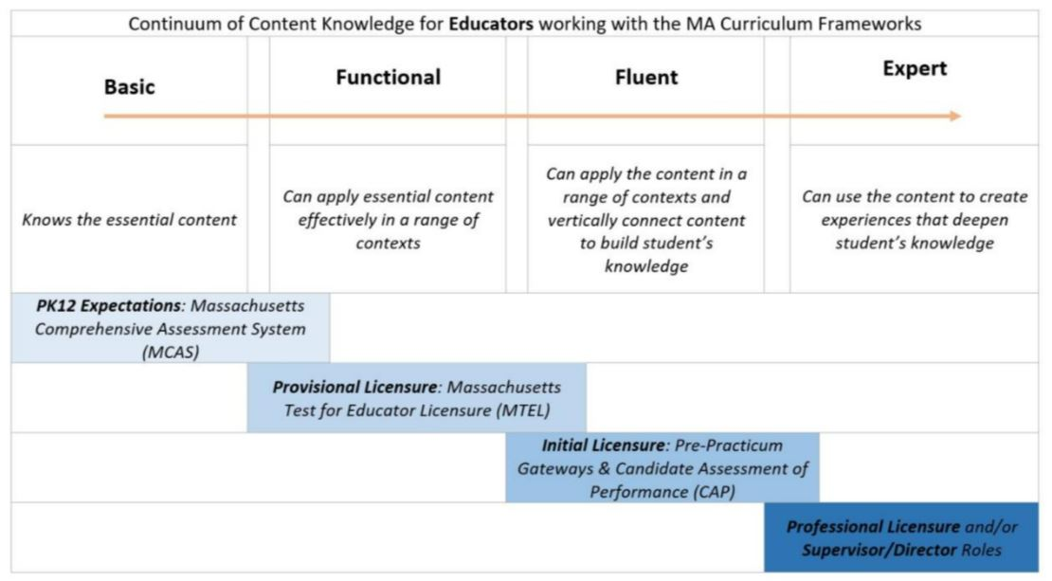

This worksheet should be completed for licensure programs with Subject Matter Knowledge expectations in the English Language Arts and Literacy Curriculum Framework, including:

☐ English, 5-12
☐ Speech, All Levels

English Language Arts and Literacy Anchor Standards
The English Language Arts and Literacy Anchor Standards define general, cross-disciplinary literacy expectations that must be met for PK-12 students to be prepared to enter college and the workforce ready to succeed.

To create a strong vertical progression of learning, educators should have the content knowledge to support PK-12 students in mastering the anchor standards across grade levels. Teachers need to be able to access knowledge from prior grades, and teachers who are aware of later content can make better choices about what to emphasize, what language to use, and what larger contexts to provide for their students. This expectation allows teachers to meet students where they are and prepare them for where they are going.

Instructions: The content knowledge below must either be covered directly through program coursework or screened during the admissions process. For each row, list the numbers/abbreviations/titles of the sponsoring organization’s required courses where the anchor standards are explicitly targeted and coherently addressed. Then, briefly describe where in the syllabus each anchor standard is covered (i.e., unit name, week number, objective number). Course identifiers should match those of submitted syllabi and content knowledge for each grade level should not be spread across too many courses.

The PK-12 grade-specific standards found in the full English Language Arts and Literacy Curriculum Framework define end-of-year expectations for each grade level relative to the anchor standards. As such, the Framework, including the Guiding Principles which are also available in Appendix A of this document, should be consulted when designing programs to ensure appropriate content coverage and rigor for each licensure field’s grade span. sponsoring organizations should prioritize content fluency in the grade span for the license while ensuring functional content knowledge in the two grade levels below and above the grade span.

Key Ideas and Details | Course(s) or Screening
Example Row | EDU 101 – Weeks 5-7
Reading 1. Read closely to determine what a text states explicitly and to make logical inferences from it; cite specific textual evidence when writing or speaking to support conclusions drawn from a text.
Reading 2. Determine central ideas or themes of a text and analyze their development; summarize the key supporting details and ideas.
Reading 3. Analyze how and why individuals, events, and ideas develop and interact over the course of a text.
Craft and Structure | Course(s) or Screening
Reading 4. Interpret words and phrases as they are used in a text, including determining technical, connotative, and figurative meanings, and analyze how specific word choices shape meaning or tone.
Reading 5. Analyze the structure of texts, including how specific sentences, paragraphs, and larger portions of a text relate to each other and the whole.
Reading 6. Assess how point of view or purpose shapes the content and style of a text.
Integration of Knowledge and Ideas | Course(s) or Screening
Reading 7. Integrate and evaluate content presented in diverse media and formats, including visually and quantitatively, as well as in words.
Reading 8. Delineate and evaluate the argument and specific claims in a text, including the validity of the reasoning as well as the relevance and sufficiency of the evidence.
Reading 9. Analyze how two or more texts address similar themes or topics to build knowledge or to compare the approaches the authors take.
Reading 10. Independently and proficiently read and comprehend complex literary and informational texts.
Text Types and Purposes | Course(s) or Screening
Writing 1. Write arguments to support claims in an analysis of substantive topics or texts, using valid reasoning and relevant and sufficient evidence.
Writing 2. Write informative/explanatory texts to examine and convey complex ideas and information clearly and accurately through the effective selection, organization, and analysis of content.
Writing 3. Write narratives to develop experiences or events using effective literary techniques, well-chosen details, and well-structured sequences.
Production and Distribution of Writing | Course(s) or Screening
Writing 4. Produce clear and coherent writing in which the development, organization, and style are appropriate to task, purpose, and audience.
Writing 5. Develop and strengthen writing as needed by planning, revising, editing, rewriting, or trying a new approach.
Writing 6. Use technology to produce and publish writing and to interact and collaborate with others.
Research to Build and Present Knowledge | Course(s) or Screening
Writing 7. Conduct short as well as more sustained research projects based on focused questions, demonstrating understanding of the subject under investigation.
Writing 8. When conducting research, gather relevant information from multiple print and digital sources, assess the credibility and accuracy of each source, and integrate the information while avoiding plagiarism.
Writing 9. Draw evidence from literary or informational texts to support analysis, interpretation, reflection, and research.
Range of Writing | Course(s) or Screening
Writing 10. Write routinely over extended time frames (time for research, reflection, and revision) and shorter time frames (a single sitting or a day or two) for a range of tasks, purposes, and audiences.
Comprehension and Collaboration | Course(s) or Screening
Speaking and Listening 1. Prepare for and participate effectively in a range of conversations and collaborations with diverse partners, building on others’ ideas and expressing their own clearly and persuasively.
Speaking and Listening 2. Integrate and evaluate information presented in diverse media and formats, including visually, quantitatively, and orally.
Speaking and Listening 3. Evaluate a speaker’s point of view, reasoning, and use of evidence and rhetoric.
Presentation of Knowledge and Ideas | Course(s) or Screening
Speaking and Listening 4. Present information, findings, and supporting evidence such that listeners can follow the line of reasoning and the organization, development, vocabulary, and style are appropriate to task, purpose, and audience.
Speaking and Listening 5. Make strategic use of digital media and visual displays of data to express information and enhance understanding of presentations.
Speaking and Listening 6. Adapt speech to a variety of contexts and communicative tasks, demonstrating command of formal English when indicated or appropriate.
Conventions of Standard English | Course(s) or Screening
Language 1. Demonstrate command of the conventions of standard English grammar and usage when writing or speaking.
Language 2. Demonstrate command of the conventions of standard English capitalization, punctuation, and spelling when writing.
Knowledge of Language | Course(s) or Screening
Language 3. Apply knowledge of language to understand how language functions in different contexts, to make effective choices for meaning or style, and to comprehend more fully when reading or listening.
Vocabulary Acquisition and Use | Course(s) or Screening
Language 4. Determine or clarify the meaning of unknown and multiple-meaning words and phrases by using context clues, analyzing meaningful word parts, and consulting general and specialized reference materials, as appropriate.
Language 5. Demonstrate understanding of figurative language, word relationships, and nuances in word meanings.
Language 6. Acquire and use accurately a range of general academic and domain-specific words and phrases sufficient for reading, writing, speaking, and listening at the college and career readiness level; demonstrate independence in gathering vocabulary knowledge

English Language Arts and Literacy Practices
The English Language Arts and Literacy Practices describe abilities that English educators at all levels should seek to develop in their PK-12 students. They are not standards themselves but instead offer a portrait of students who meet the standards set out in this document and are ready for college, careers, and civic participation. These practices complement the content standards so that students increasingly engage with the subject matter as they grow in maturity and expertise throughout the elementary, middle, and high school years.
Instructions: Initial licensure program candidates must reach a level of fluent content knowledge in order to be endorsed. They must be able to apply content in a range of contexts and vertically connect content to build students’ knowledge. As such, sponsoring organizations must have at least one course covering the practices at the fluent level.

Please list the numbers/abbreviations/titles of the required courses where practices are explicitly targeted and coherently addressed. Then, briefly describe where in the syllabus each practice is covered (i.e., unit name, week number, objective number). Course identifiers should match those of submitted syllabi and practices should not be spread across too many courses.

English Language Arts and Literacy Practices | Fluent  Initial  Licensure
Example Row | EDU 101 – Weeks 5-7
1. Demonstrate independence. Students can, without significant scaffolding, comprehend and evaluate complex texts across a range of types and disciplines, and they can construct effective arguments and convey intricate or multifaceted information. Likewise, students are able independently to discern a speaker’s key points, request clarification, and ask relevant questions. They build on others’ ideas, articulate their own ideas, and confirm they have been understood. Without prompting, they demonstrate command of standard English and acquire and use a wide-ranging vocabulary. More broadly, they become self-directed learners, effectively seeking out and using resources to assist them, including teachers, peers, and print and digital reference materials.
2. Build strong content knowledge. Students establish a base of knowledge across a wide range of subject matter by engaging with works of quality and substance. They become proficient in new areas through research and study. They read purposefully and listen attentively to gain both general knowledge and discipline-specific expertise. They refine and share their knowledge through writing and speaking.
3. Respond to the varying demands of audience, task, purpose, and discipline. Students adapt their communication in relation to audience, task, purpose, and discipline. They set and adjust purpose for reading, writing, speaking, listening, and language use as warranted by the task. They appreciate nuances, such as how the composition of an audience should affect tone when speaking and how the connotations of words affect meaning. They also know that different disciplines call for different types of evidence (e.g., documentary evidence in history and experimental evidence in science).
4. Comprehend as well as critique. Students are engaged and open-minded—but discerning—readers and listeners. They work diligently to understand precisely what an author or speaker is saying, but they also question an author’s or speaker’s assumptions and premises and assess the veracity of claims and the soundness of reasoning.
5. Value evidence. Students cite specific evidence when offering an oral or written analysis or interpretation of a text. They use relevant evidence when supporting their own points in writing and speaking, making their reasoning clear to the reader or listener, and they constructively evaluate others’ use of evidence.
6. Use technology and digital media strategically and capably. Students employ technology thoughtfully to enhance their reading, writing, speaking, listening, and language use. They tailor their searches online to acquire useful information efficiently, and they integrate what they learn using technology with what they learn offline. They are familiar with the strengths and limitations of various technological tools and mediums and can select and use those best suited to their communication goals.
7. Come to understand other perspectives and cultures. Students appreciate that the twenty-first-century classroom and workplace are settings in which people from often widely divergent cultures and who represent diverse experiences and perspectives must learn and work together. Students actively seek to understand other perspectives and cultures through reading and listening, and they can communicate effectively with people of varied backgrounds. They evaluate other points of view critically and constructively. Through reading great classic and contemporary works of literature representative of a variety of periods, cultures, and worldviews, students can vicariously inhabit worlds and have experiences much different than their own.

Appendix A: English Language Arts and Literacy Guiding Principles
The following principles are philosophical statements that underlie the pre-kindergarten through grade 12 English Language Arts and Literacy Framework standards and resources. These principles should guide the design and evaluation of programs in both PK-12 and higher education settings.

Guiding Principle 1. Students should receive explicit instruction in skills, including phonics and decoding. Explicit skill instruction is especially important in narrowing opportunity gaps.

Guiding Principle 2. To become successful readers, students need to develop a rich academic vocabulary and broad background knowledge.

Guiding Principle 3. Educators should help students develop a love of reading by:
- Selecting high-quality works of literature and nonfiction.
- Reading aloud in class.
- Providing students with ample opportunity and encouragement for sustained independent reading, both for school and on their own.

Guiding Principle 4. Students should be exposed to complex and challenging texts at their grade level and above, with extra support and scaffolding as needed, reflecting high expectations for all students.

Guiding Principle 5. Students should read a diverse set of authentic texts balanced across genres, cultures, and time periods. Authentic texts are intact and unadapted texts in their original complexity; they are texts composed for purposes other than being studied in school.

Guiding Principle 6. Students should have frequent opportunities for discussing and writing about their readings to develop critical thinking skills and to demonstrate understanding.

Guiding Principle 7. Reading well-crafted texts is an essential foundation for developing effective writing skills.

Guiding Principle 8. Developing the ability to write well demands regular practice across multiple forms and genres of writing and opportunities to write for a variety of audiences, including expository, analytical, persuasive, narrative, and creative writing, as well as explicit instruction in vocabulary and standard English conventions.

Guiding Principle 9. Educators and families should view each other as resources who are both invested in supporting students’ skills in reading, writing, speaking, and listening.

Guiding Principle 10. Social and emotional learning can increase academic achievement, improve attitudes and behaviors, and reduce emotional distress. Students should practice recognizing aspects of themselves in texts (self-awareness), struggling productively with challenging texts (self-management), tailoring language to audience and purpose (social awareness), grappling vicariously with choices faced by others (responsible decision making), and collaborating respectfully with diverse peers (relationship skills).

Guiding Principle 11. Educators should select works of fiction and nonfiction that instill in students a deep appreciation for art, beauty, and truth, while broadening their understanding of the human condition from differing points of view. Reading, discussing, and writing about high-quality prose and poetry should also help students develop empathy for one another and a sense of their shared values and literary heritage, while learning about who they are as individuals and developing the capacity for independent, rigorous thinking.

