Subject Matter Knowledge Matrix
English as a Second Language, PK-6 and 5-12

Students in Massachusetts must meet rigorous academic standards. To do so, they must have access to educators with strong content knowledge and pedagogical skills, the building blocks of effective instructional practice.

In support of this, the Subject Matter Knowledge Guidelines set forth the content knowledge expectations for educator licensure in Massachusetts. Through these expectations, the Massachusetts Department of Elementary and Secondary Education (DESE) seeks to ensure that educators entering the workforce have sufficient content knowledge in their licensure area to support students in mastering academic standards.

Educators must move beyond basic or functional knowledge to a level of fluency or expertise with the academic standards such that they can teach and support students in mastering the content. The figure below shows a steady progression, not in the amount of information one knows, but in the depth and ability to use that information for a specific purpose. The boxes below the continuum outline some assessments used to determine varying levels of content knowledge. The depth at which the knowledge and application of content knowledge must be demonstrated is dependent on the stage of development for an individual educator (i.e. Basic, Functional, Fluent, or Expert) and/or license type (Provisional, Initial, or Professional).

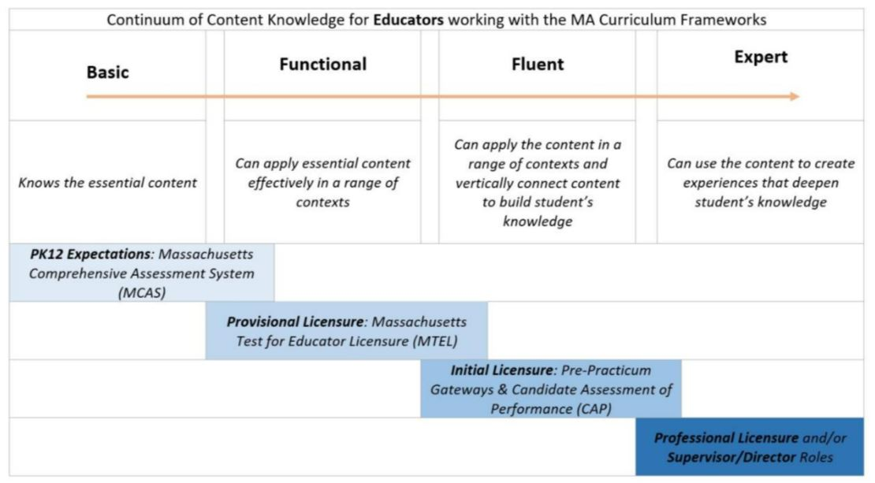

Instructions: Please list the numbers/abbreviations/titles of the sponsoring organization’s required courses where each indicator is targeted, explicit, and coherently addressed. Course identifiers should match the numbers/abbreviations/titles of submitted syllabi to support DESE’s review. Indicators should not be spread across too many courses.

Initial licensure program candidates must reach the fluent level to be endorsed. They must be able to apply content in a range of contexts and vertically connect content to build students’ knowledge. Sponsoring Organizations must have at least one course at the fluent level for each practice.

Then, briefly describe where in the syllabus the content is covered (i.e., unit name, week number, objective number).

Subject Matter Knowledge  English as a Second Language, PK-6 and 5-12 | Fluent  Initial  Licensure
Example Row | EDU 101 – Weeks 5-7
- Language and Linguistics.
  - Language as a system: functions and registers of language.
  - The structure and nature of language: Phonology, morphology, syntax, semantics, pragmatics, discourse varieties, aspects of social and academic language, rhetorical registers, and writing conventions.
  - Language variation and change.
- Language acquisition and literacy development.
  - Theory and research in first and second language acquisition.
  - Knowledge of the significant theories and practices for developing reading skills and reading comprehension in English as a first language at different educational levels.
  - Relevance of linguistic differences between the first and the second language for reading instruction in English.
  - Differences in initial reading instruction in English (including phonemic awareness and phonics) for students who may or may not be literate in their first language: effects of first language literacy on second language learning and literacy.
  - Formal and informal measures for assessing development in reading skills and their use with second language learners.
  - Development of listening, speaking, reading, and writing vocabulary.
  - Approaches and practices for developing writing skills and the use of writing tools.
  - Writing process and formal elements of writing.
  - Oral/Aural fluency in English at different proficiency levels.
  - Social and academic English and academic language for the content areas.
  - Development of metalinguistic skills and vocabulary appropriate to cognitive, academic, and language proficiency levels.
- Instructional approaches and best practices for teaching ESL
  - Foundations of ESL instruction.
  - Theories and sheltered strategies for developing English language skills in listening, speaking, reading, and writing for English language learners in bilingual or multilingual classrooms from the primary grades on.
  - Research-based practices for English language development.
  - Program models and teaching strategies for developing and integrating language skills.
  - Planning and implementing standards-based ESL and content instruction.
- Socio-cultural and socio-emotional considerations in teaching ESL.
  - Regional, socioeconomic, and developmental factors influencing language variation and bilingualism or multilingualism.
  - The nature and role of culture and its intersection with teaching and learning.
  - Cultural, racial, ethnic, and linguistic identity.
  - Intercultural communication in the classroom.
  - Special populations and situations: long-term English language learners, English learners with disabilities, and students with limited or interrupted formal education.
  - The role of the community, families, and schools in English language learner education.
- Formal and informal English language assessment procedures and instruments for English language learners: selection, administration, and interpretation; identification of bias and normal variation in performance, as well as possible differentiation from learning disabilities.
- Federal and state laws pertaining to the education of English language learners.

- Theoretical, political, and historical foundations of education for English language learners.

- Instruction, assessments, resources, research, and advances in the field of ESL.

- Strategies for school collaboration, family outreach, and community involvement for English language learners.

