Subject Matter Knowledge Matrix
Library, All

Students in Massachusetts must meet rigorous academic standards. To do so, they must have access to educators with strong content knowledge and pedagogical skills, the building blocks of effective instructional practice.

In support of this, the Subject Matter Knowledge Guidelines set forth the content knowledge expectations for educator licensure in Massachusetts. Through these expectations, the Massachusetts Department of Elementary and Secondary Education (DESE) seeks to ensure that educators entering the workforce have sufficient content knowledge in their licensure area to support students in mastering academic standards.

Educators must move beyond basic or functional knowledge to a level of fluency or expertise with the academic standards such that they can teach and support students in mastering the content. The figure below shows a steady progression, not in the amount of information one knows, but in the depth and ability to use that information for a specific purpose. The boxes below the continuum outline some assessments used to determine varying levels of content knowledge. The depth at which the knowledge and application of content knowledge must be demonstrated is dependent on the stage of development for an individual educator (i.e. Basic, Functional, Fluent, or Expert) and/or license type (Provisional, Initial, or Professional).

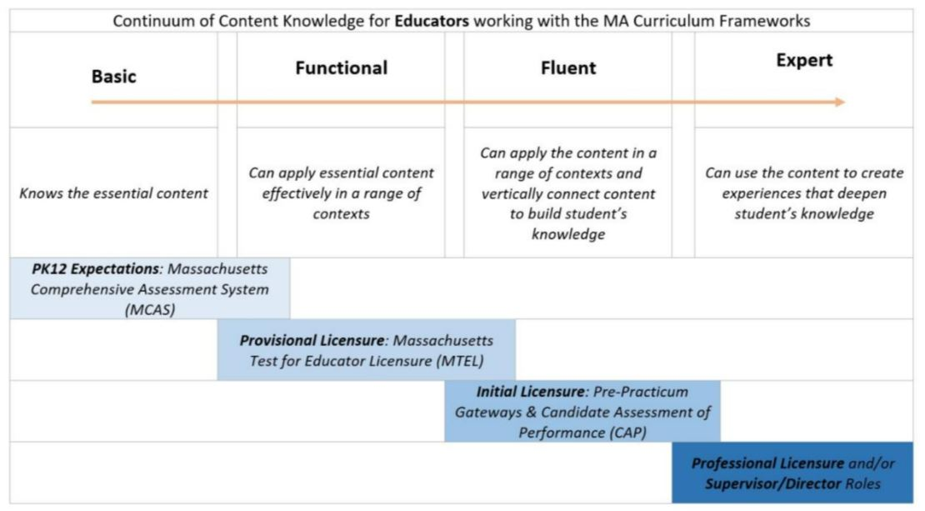

Instructions: Please list the numbers/abbreviations/titles of the sponsoring organization’s required courses where each indicator is targeted, explicit, and coherently addressed. Course identifiers should match the numbers/abbreviations/titles of submitted syllabi to support DESE’s review. Indicators should not be spread across too many courses.

Initial licensure program candidates must reach the fluent level to be endorsed. They must be able to apply content in a range of contexts and vertically connect content to build students’ knowledge. Sponsoring Organizations must have at least one course at the fluent level for each practice.

Then, briefly describe where in the syllabus the content is covered (i.e., unit name, week number, objective number).

Subject Matter Knowledge  Library, All | Fluent  Initial  Licensure
Example Row | EDU 101 – Weeks 5-7
- Characteristics, uses, and design of information systems, for standard reference sources and appropriate technologies.
- Selection, acquisition, organization, and maintenance of information resources.

- Appropriate equipment for using information resources.

- Development, organization, management, and evaluation of school library media programs and resource centers.

- Literature for children and young adults.

- Selection, adaptation, and production of instructional materials.

- Federal and state laws and regulations pertaining to media, including those governing access to and reproduction of materials.
- Ethical issues affecting library media services.

- Community and governmental resources.

