Subject Matter Knowledge Matrix
Transition Specialist Endorsement

Students in Massachusetts must meet rigorous academic standards. To do so, they must have access to educators with strong content knowledge and pedagogical skills, the building blocks of effective instructional practice.

In support of this, the Subject Matter Knowledge Guidelines set forth the content knowledge expectations for educator licensure in Massachusetts. Through these expectations, the Massachusetts Department of Elementary and Secondary Education (DESE) seeks to ensure that educators entering the workforce have sufficient content knowledge in their licensure area to support students in mastering academic standards.

Educators must move beyond basic or functional knowledge to a level of fluency or expertise with the academic standards such that they can teach and support students in mastering the content. The figure below shows a steady progression, not in the amount of information one knows, but in the depth and ability to use that information for a specific purpose. The boxes below the continuum outline some assessments used to determine varying levels of content knowledge. The depth at which the knowledge and application of content knowledge must be demonstrated is dependent on the stage of development for an individual educator (i.e. Basic, Functional, Fluent, or Expert) and/or license type (Provisional, Initial, or Professional).

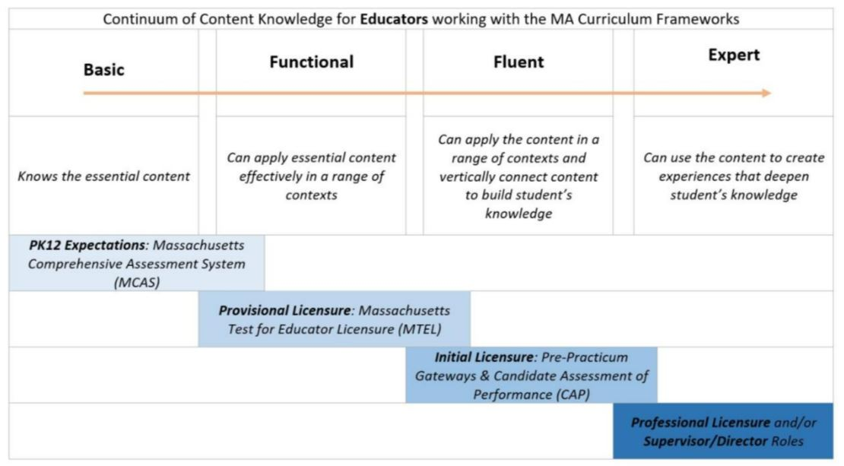

Instructions: Please list the numbers/abbreviations/titles of the sponsoring organization’s required courses where each indicator is targeted, explicit, and coherently addressed. Course identifiers should match the numbers/abbreviations/titles of submitted syllabi to support DESE’s review. Indicators should not be spread across too many courses.

Initial licensure program candidates must reach the fluent level to be endorsed. They must be able to apply content in a range of contexts and vertically connect content to build students’ knowledge. Sponsoring Organizations must have at least one course at the fluent level for each practice.

Then, briefly describe where in the syllabus the content is covered (i.e., unit name, week number, objective number).

1. The Foundations and Implementation of Transition Education and Transition Services: Foundations and implementation of transition education and transition services, including but not limited to: state and federal legislation; inclusive models, research, best practice, community-based education and post-school options; and knowledge of transition planning and service delivery for all students with Individualized Education Programs, including culturally and linguistically diverse youth. 603 CMR 7.14(4)(d)(1). | Fluent  Initial  Licensure
Example Row | EDU 101 – Weeks 5-7
- The historical foundations of the transition movement.

- State and Federal transition-related legislation and policies, and implications for providing transition services at the local level, including but not limited to: policy issues related to Social Security benefits and work incentives, workforce laws and regulations, and accommodations for individuals with disabilities.
- Knowledge of self-determination principles and self-advocacy skills.

- Understand the skills necessary for postsecondary success, including but not limited to time management, planning and prioritizing, study skills, social skills, healthcare skills, and safety in school and community environments.
- The Massachusetts definition of College and Career Readiness14 and other state and national college and career readiness initiatives.
- Evidence-based transition practices (e.g. person-centered planning, collaborative teaming, community-building, resource mapping) including whole school college and career readiness practices.
- Understanding of complex adult services systems (e.g., higher education, vocational rehabilitation, SSI and Medicaid, developmental disability services, workforce development, benefits specialists, and community rehabilitation providers).
- The rights and responsibilities of the student and family in the transition process.

- Fundamental issues that influence secondary transition, including but not limited to: healthcare or mental health challenges, foster care placement, involvement in the justice system, socio-economic challenges, cultural and linguistic diversity, residency status, guardianship, and issues faced by students who are at risk of dropping out of school.
- Understanding of various models for the role of Transition Specialists, including nationally accepted standards for experienced professionals in special education.
- Plan, develop, implement, evaluate and promote culturally responsive transition services for youth with a wide range of abilities and disabilities.
- Promote self-determination and self-advocacy skill building.

- Facilitate resource mapping and program goal setting to create district and community policies and agreements that will support transition-aged youth.
- Facilitate training, professional development and technical assistance to colleagues and families related to transition law and practices.
- Develop and disseminate transition information to transition-aged students and their families, including those in out-of-district placements
- Develop effective outreach strategies to reach underserved youth and families and coordinate the translation of all transition materials into appropriate languages.
2. Individual Transition Assessment and System Evaluation: Individual transition assessment and system evaluation, including conducting, interpreting, and overseeing individualized formal and informal transition assessments to ascertain interests, strengths, preferences, aptitudes and needs related to competitive employment, education, training, and independent living; developing individualized appropriate measurable postsecondary goals, and annual IEP goals based on the individualized transition assessment results; and transition service delivery. 603 CMR 7.14(4)(d)(2). | Fluent  Initial  Licensure
- Legal requirements and rationale for conducting comprehensive, individualized, ongoing formal and informal secondary transition assessments.
- Familiarity with a variety of culturally responsive formal and informal secondary transition assessment instruments for students aged 14-22 to ascertain interests, strengths, preferences, aptitudes and needs related to integrated competitive employment, postsecondary education/training, independent living, and community participation.
- Role of assistive technology and individualized accommodations in the assessment process.

- Knowledge of self-determination and self-advocacy assessment tools.

- Strategies for recruiting and engaging a team in individualized transition assessment, including the student, family, school personnel, and community agencies.
- Use of assessment data to determine the interests, skills, abilities and corresponding supports necessary to address educational, competitive employment, independent living, and community participation needs, including social, communication and functional skills (including work ethic and professionalism, effective communication and interpersonal skills, and other employer identified soft skills.
- Content and process to develop annually updated, individualized, appropriate, measurable postsecondary goals and annual IEP goals, and transition services, based on the individualized transition assessment results.
- Administer a variety of culturally responsive formal and informal tools, including assistive technology where appropriate, to assess students’ individual strengths, preferences, interests and needs directly related to: academic, vocational, independent living, and community participation, including but not limited to social skills, functional behavior, and self-determination abilities and self-advocacy skills.
- Conduct and manage transition assessment activities across domains of self-determination, academic, vocational, independent living, and community participation.
- Include students in assessment planning, interpretation, and analysis activities to promote self- awareness, self-determination, and self-regulation.
- Interpret results of assessments, provide educationally relevant recommendations and develop individualized, measurable postsecondary goals and annual IEP goals based upon assessment results.
- Integrate information from transition assessments into students’ Transition Planning Form and IEP, and also to the Summary of Performance.
- Report results in appropriate language and terms to facilitate student and family understanding.

- Create work-based learning plans and individual learning plans based on appropriate assessments.

3. How to Develop Transition Systems and Supports: How to develop transition systems and supports which include best practices in postsecondary education, competitive integrated employment (including supported employment), independent living, and community participation including, but not limited to, implementation of social skills training, positive behavioral supports, assistive technology as related to transition goals, and development of self-determination skills across all settings. 603 CMR 7.14(4)(d)(3). | Fluent  Initial  Licensure
- Understanding of the Massachusetts Definition of College and Career Readiness.

- Understanding of best practices and methods to evaluate existing transition-related services and systems including but not limited to disability specific considerations and vulnerable populations e.g. students with autism, intellectual disabilities, and emotional disabilities; students involved in the foster care or justice system; and students facing economic, cultural, and linguistic barriers.
- The rationale for and elements of self-determination as the foundation of successful postsecondary outcomes including self-awareness, self-acceptance, self-monitoring, self-advocacy and the philosophy of ‘dignity of risk’.
- Methods to develop evidence-based transition-specific materials and curricula that promote self-determination and self-advocacy, are aligned with MA Curriculum Frameworks/Common Core Standards and include soft skills development across secondary and postsecondary settings.
- Awareness of the strengths and weaknesses of commercially available transition-specific curriculum/training methods and materials.
- Knowledge of postsecondary learning options, admission and disability documentation requirements, the role of ADA, 504, and Disability Services in higher education and the range of supports and accommodations available to all students with disabilities, including students with autism and intellectual disabilities.
- Vocational education and career preparation methods, models, and curricula including career development, job development, facilitating natural positive supports on the job, job placement and training, models of supported employment and awareness of social and interpersonal skills identified by employers that promote job retention.
- The role of adult agencies and support personnel including but not limited to the MA Rehabilitation Commission, independent living programs, and Personal Care Attendants, and knowledge of community-based recreation and leisure opportunities.
- Knowledge of how to use positive behavioral supports in work, college, and community settings.

- Augmentative and Alternative Communication (AAC) devices, the range of devices, and related best practices.

- Awareness of age of majority options and family resources, including decision-making alternatives and guardianship.

- Develop a coordinated set of individualized activities aligned with students’ assessments, postsecondary goals and annual IEP goals.
- Apply techniques to help students develop a course of study related to their postsecondary education and career interests and plan to build related necessary skills.
- Implement a variety of methods and strategies to support the full participation of students with disabilities in college and career awareness, exploration and immersion activities as identified in the MA Career Development Education Guide and Glossary.
- Perform job matching, job carving, and job placement including identifying supports in community-based work training environments and facilitating students’ self-advocacy for accommodations within work and community environments.
- Connect students with adult service, community providers, and vocational rehabilitation services as part of student career plans.
- Use the Massachusetts Work-Based Learning Plan (WBLP) to support competitive employment.

- Develop community-based independent living activities and provide community-based instruction.

- Connect students and families to community resources and provide assistance regarding effectively hiring, supervising, and utilizing PCAs.
- Implement culturally responsive social or soft skills training in a range of postsecondary settings as they relate to students’ postsecondary goals in employment, education, independent living and community participation.
- Train students on use of educational and assistive web-based tools and technology designed to improve functional skills and independence in college, jobs, and community.
- Assist students in understanding the relationship between their individual strengths and desires and their future goals, identifying accommodations, and provide opportunities to make choices, set goals, and self-advocate.
- Manage transition services and activities across domains of self-determination, academic, vocational, independent living, and community participation.
4. Effective Collaboration with all Stakeholders: Collaboration including strategies for active participation of students and families in IEP development, transition education and services, and support networks; development of partnerships with employers, institutes of higher education, public agencies, and community service agencies; and provision of technical assistance and professional development to school personnel. 603 CMR 7.14(4)(d)(4). | Fluent  Initial  Licensure
- Methods for increasing student leadership in transition planning, student and family knowledge and engagement related to transition, including IEP development, transition education and services, self-determination, support networks, referral to adult service agencies, benefits planning, health benefits, and social security.
- Techniques for identifying and linking appropriate learning environments to increase cooperative transition service delivery through whole-school initiatives, interagency agreements, braided funding, and partnerships with employers, institutes of higher education, public agencies, and community service agencies.
- Systems improvement, conflict management and consensus building methods, and recognition of the impact of language, diversity, culture, and religion on transition.
- Initiate/participate in transition-focused interagency coordinating bodies.

- Match community resources with student needs and help students and families establish a support network.

- Develop and manage collaborative partnerships with school/district college and career readiness staff, human service agencies, community service agencies, higher education, employers, and work force development organizations, making referrals as needed.
- Build cooperative systems that promote student self-determination and self-advocacy skill building.

- Develop coordinated interagency strategies to collect, share, and use students’ information, ensuring confidentiality and consent of students and families.
- Facilitate trainings, professional development, technical assistance and information dissemination related to transition laws, practices, and establishing support networks e.g. adult services, post-school options, integrated employment options, self-determination, guardianship and other transition related issues.
- Initiate opportunities and learning experiences in employment and community settings, including working with employers to negotiate job customization and accommodations to meet students’ individual needs.
- Provide educators, guidance staff, community agency personnel, employers, and other community partners with disability awareness training and information in collaboration with students and family members e.g. universal access and design, auxiliary aids for youth with disabilities, reasonable accommodations, assistive technology, funding streams, employer tax incentives, and other pertinent topics.
- Coordinate individualized student guidance regarding appropriate course of studies during high school to meet postsecondary academic, vocational and community/adult living goals and match local area college and career readiness initiatives, employment opportunities, and community resources with student needs.

