Edwin Analytics: Finance
How to use the Finance Cube – Part 1: Data Guide
An ad-hoc “cube” is available to provide insight into school and district finances, connecting financial information, student, teacher and school building data. The cube goes a step beyond the five available reports by facilitating more in-depth and flexible querying allowing the user to tailor the query to his needs. The cube is available to users with access to school and district aggregate reports within the Education Data Warehouse (EDW).

Accessing the Cube in Edwin Analytics 1
Cube Structure 3
Dimensions 3
Overview 3
Dimensions in the Finance Cube 5
Measures 16
Overview 16
Measures in the Finance Cube 17

Accessing the Cube in Edwin Analytics
Log-in to the ESE Security Portal (https://gateway.edu.state.ma.us). Select Edwin Analytics from the main page. Select District, and then Finance. Under Multi-Dimensional Analysis, select Finance Cube (circled in green in Figure 1). A new tab will open in your browser.

Figure 1
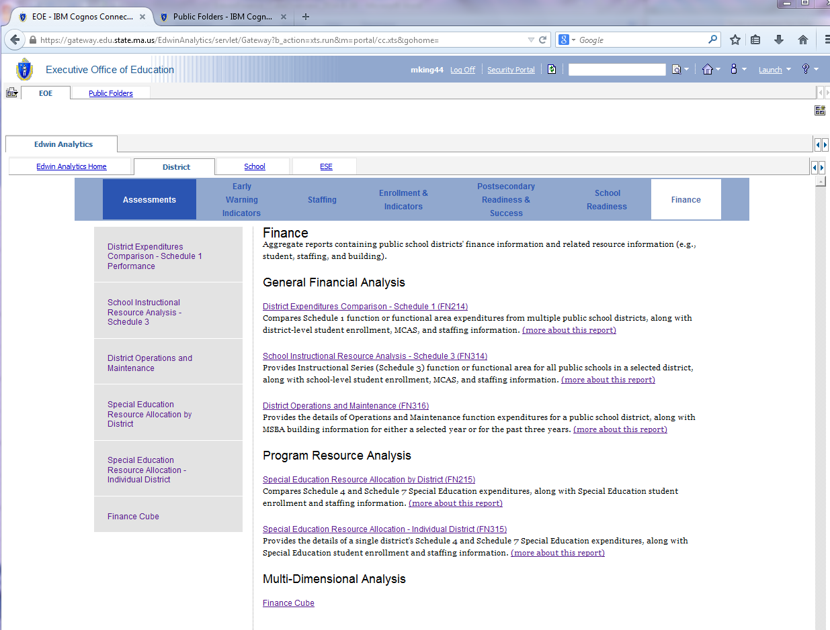

Figure 2

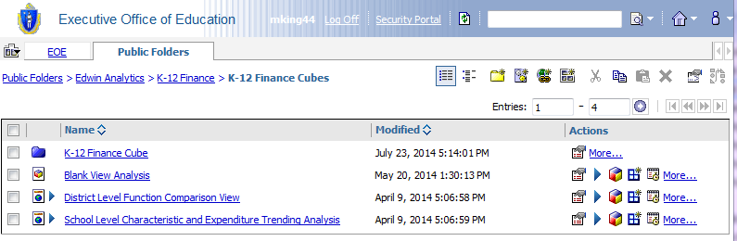

Cube Structure
If you’ve used pivot tables in Microsoft Excel, the cube interface should look pretty familiar. The viewing pane on the left (outlined in red in Figure 3) contains the dimensions and measures available for use in the cube. They can be dragged and dropped into the crosstab (outlined in green in Figure 3). The crosstab lets you compare and contrast values between or across items and must include at least two dimensions (one in the Rows section and one in the Columns section) and one measure.

Figure 3
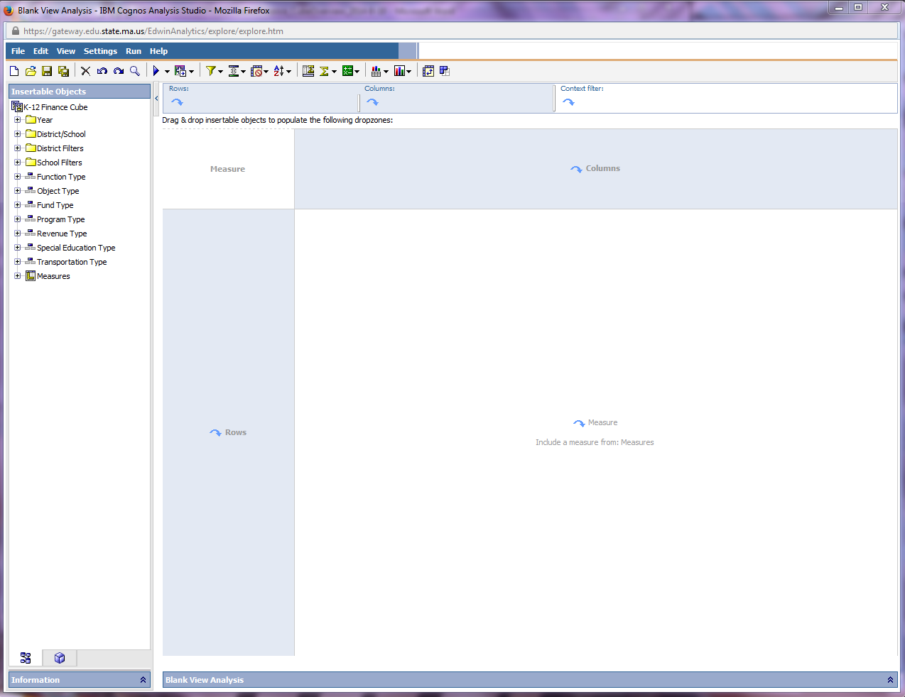

Dimensions

Overview
A dimension is a broad grouping of descriptive data about a major aspect of a district or district spending. The Finance Cube has dimensions that allow you to filter down to a limited set of districts or schools, including:
- District type
- Student characteristics
- Student performance
See Figure 4.

Figure 4
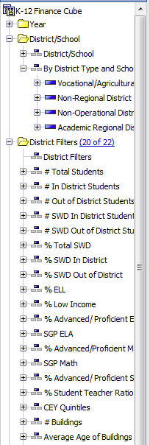

It also has dimensions that characterize spending, including:
- Function type (administration, instructional leadership, etc.)
- Program type (regular day, special education, etc.)
Figure 5
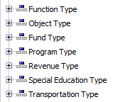

Each dimension includes different levels of members in one or more hierarchies and an optional set of calculated members or special categories. Dimensions can be dragged into the rows, columns, or context filter part of the crosstab.

Be aware that that not all dimensions correspond to all measures (and not all dimensions line up with each other).

Dimensions in the Finance Cube
The below tables list the available data element, related definitions and business rules, and for some categories, pre-defined bands. These bands provide the user with sensible buckets with which to filter down to a small number of comparable districts.

Year
Data | Definition & Business Rules
School Year | - The school year  - Year (2008, 09, 10, 11, 12, 13, 14)  - Latest Year (2013)  - Last 3 Years (2011-13)  - Last 5 Years (2009-13)

District
Data | Definition & Business Rules
District | - District/School – You can select individual districts or districts by type.  - District/School  - By District Type and School Level (Vocational Agricultural Regional, Non-Regional, Non-Operating, Academic Regional)
District Type

District Filters
Data | Definition & Business Rules | Pre-Defined Bands
Student Information
Total Students | - The total number of students enrolled both in and out-of-district in the selected school year as of the October 1st SIMS snapshot.  - Students with  - a Reason for Reporting of “Receiving” or “Sending” (DOE011 in 01, 02, 03)  - an Enrollment Status of “Enrolled in-district” (DOE012 is 01) | - 0  - 1 – 499  - 500-999  - 1,000-1,999  - 2,000-2,999  - 3,000-3,999  - 4,000 – 9,999  - 10,000+
# In-district Students | - The total number of students enrolled in-district in the selected school year as of the October 1st SIMS snapshot.  - Students with  - a Reason for Reporting of “Receiving” (DOE011 in 01 or 03)  - an Enrollment Status of “Enrolled in-district” (DOE012 is 01) | - 0  - 1– 499  - 500-999  - 1,000-1,999  - 2,000-2,999  - 3,000-3,999  - 4,000 – 9,999  - 10,000+
# Out-of-district Students | - The total number of students enrolled out-of-district in the selected school year as of the October 1st SIMS snapshot.  - Students with  - a Reason for Reporting of “Sending” (DOE011 in 02)  - an Enrollment Status of “Enrolled in-district” (DOE012 is 01)  - Includes out-of-district special education students. Does not include charter, choice students. | - 0  - 1-4  - 5-19  - 20-39  - 40-79  - 80+
# SWD In-district | - The total number of SWD students enrolled in-district in the selected school year as of the October 1st SIMS snapshot.  - Students with  - a Reason for Reporting of “Receiving” (DOE011 in 01 or 03)  - an Enrollment Status of “Enrolled in-district” (DOE012 is 01)  - a Special Education Placement, ages 3-5 (DOE032) other than codes 00, 01, or 05, or a Special Education Placement, ages 6-21 (DOE034) other than codes 00 or 01 in the October snapshot | - 0  - 1 – 49  - 50-99  - 100-199  - 200-299  - 300-399  - 400 – 999  - 1000+
# SWD Out-of-district | - The total number of SWD students enrolled out-of-district in the selected school year as of the October 1st SIMS snapshot.  - Students with  - a Reason for Reporting of “Sending” (DOE011 in 02)  - an Enrollment Status of “Enrolled in-district” (DOE012 is 01)  - a Special Education Placement, ages 3-5 (DOE032) other than codes 00, 01, or 05, or a Special Education Placement, ages 6-21 (DOE034) other than codes 00 or 01 in the October snapshot | - 0  - 1-4  - 5-19  - 20-39  - 40-79  - 80+
% Total SWD | - Percentage of SWD both in and out-of-district students out of all students both in and out-of-district  $$\% Total SWD= \frac{\left(\# SWD Indistrict+\#SWD Out of District\right)}{Total Students}$$ | - 0-4  - 5-9  - 10-14  - 15-19  - 20+
% In-district SWD | - Percentage of SWD in-district out of all SWD students both in and out-of-district  $$\% In District SWD= \frac{\# In District SWD}{Total Students}$$ | - 0-4  - 5-9  - 10-14  - 15-19  - 20+
% Out-of-district SWD | - Percentage of SWD out-of-district out of all SWD students both in and out-of-district  $$\% Out of District SWD= \frac{\# Out of District SWD}{Total Students}$$ | - 0-4  - 5-9  - 10-14  - 15-19  - 20+
% ELL | - Percentage of in-district ELL students  $$\% ELL= \frac{Total In District ELL Students}{Total In District Students}$$  - Total In-District ELL Students = The total number of ELL students enrolled in-district in the selected school year as of the October 1st SIMS snapshot and who does not speak English or whose native language is not English, and who is not currently able to perform ordinary classroom work in English (Limited English Proficiency DOE025 is 01) as of the October 1st SIMS snapshot | - 0-4  - 5-9  - 10-14  - 15-19  - 20+
% Low Income | - Percentage of in-district Low Income students  $$\% Low Income= \frac{Total In District Low Income Students}{Total In District Students}$$  - Total In-District Low Income Students = The total number of low income students enrolled in-district in the selected school year as of the October 1st SIMS snapshot and who are eligible for free or reduced-price lunch (DOE019 in 01 or 02) as of the October 1st SIMS snapshot | - 0-9  - 10-14  - 15-24  - 25-34  - 35+

Data | Definition & Business Rules | Pre-Defined Bands
MCAS Performance
Note: These follow the standard business rules for reporting MCAS results for the district, which include both in and out-of-district students
% Advanced/ Proficient ELA | - Percentage of students tested in ELA in-district who received an achievement level of either Advanced or Proficient | - 0-19  - 20-39  - 40-59  - 60-79  - 80+
SGP ELA | - Median SGP of all ELA tested students in-district | - 1-39  - 40-60  - 61-99
% Advanced/Proficient Math | - Percentage of students tested in Math in-district who received an achievement level of either Advanced or Proficient | - 0-19  - 20-39  - 40-59  - 60-79  - 80+
SGP Math | - Median SGP of all Math tested students in-district | - 1-39  - 40-60  - 61-99
% Advanced/Proficient Science | - Percentage of students tested in Science in-district who received an achievement level of either Advanced or Proficient | - 0-19  - 20-39  - 40-59  - 60-79  - 80+

Data | Definition & Business Rules | Pre-Defined Bands
Staffing
Student-Teacher Ratio | - Number of students in the school as of October 1st divided by the teacher FTE as of the October 1st EPIMS for active work assignments  $$Student Teacher Ratio= {\# students in school}/{\# FTE teachers in school}$$  - The standard teacher definition applies | - 0-15  - 15-17  - 18-20  - 21+

Data | Definition & Business Rules | Pre-Defined Bands
General Information
# Buildings | - Total number of school buildings in-district for the school year  - Building data is from MSBA | - 1  - 2-4  - 5-9  - 10+
Total Sq. Footage | - The total square footage throughout all school buildings in-district for the school year  - Building data is from MSBA | - <100,000  - 100,000 – 249,999  - 250,000 – 499,999  - 500,000-749,999  - 750,000-999,999  - 1,000,000+
Total Sq. Footage per Student | - The total square footage per all students in the school  $${Feet}^{2 }per Student= \frac{Total {Feet}^{2}}{Total Number of Students in School}$$ | - <100  - 100-199  - 200-299  - 300-399  - 400+
Average Age of Building | - The average age of all school buildings in-district  - Average Age = (AVG (<YYYY> - Opened Year) for each building)  - Average age is rounded to the nearest whole number  - Building data is from MSBA | - 0-9  - 10-19  - 20-19  - 30-39  - 40-49  - 50+
CEY Quintiles | - Combined Effort Yield (CEY) % of Foundation  - District Combined Effort Yield (CEY) percentage representation of wealth  - Provided by EOYR database for the school year from Chapter 70 file | - Lowest 20%  - Second 20%  - Middle 20%  - Fourth 20%  - Highest 20%  These quintiles will be calculated year over year.

School Filters

Data | Business Rules | Pre-Defined Bands
Student Information
Total Students | - The total number of students enrolled in the school in the selected school year as of the October 1st SIMS snapshot.  - Students with  - a Reason for Reporting of “Receiving” (DOE011 in 01 and 03)  - an Enrollment Status of “Enrolled in-district” (DOE012 is 01) | - 0  - 1-199  - 200-349  - 350-499  - 500-999  - 1,000+
% SWD | - Percentage of SWD students in the school out of all students in the school  - Students with  - a Special Education Placement, ages 3-5 (DOE032) other than codes 00, 01, or 05, or a Special Education Placement, ages 6-21 (DOE034) other than codes 00 or 01 in the October snapshot  $$\% Total SWD= \frac{\left(\# SWD \right)}{Total Students}$$ | - 0-4  - 5-9  - 10-14  - 15-19  - 20+
% ELL | - Percentage of ELL students in the school out of all students in the school  - Students identified as a student who does not speak English or whose native language is not English, and who is not currently able to perform ordinary classroom work in English (Limited English Proficiency DOE025 is 01) in the October snapshot  $$\% ELL= \frac{Total ELL Students}{Total Students}$$ | - 0-4  - 5-9  - 10-14  - 15-19  - 20+
% Low Income | - Percentage of Low Income students in the school out of all students in the school  - Students eligible for free or reduced-price lunch (DOE019 in 01 or 02) in the October snapshot  $$\% Low Income= \frac{Total In District Low Income Students}{Total In District Students}$$ | - 0-19  - 20-39  - 40-59  - 60-79  - 80+

Data | Definition & Business Rules | Pre-Defined Bands
MCAS Performance
- Note: These follow the standard business rules for reporting MCAS results for the school
% Advanced/Proficient ELA | - Percentage of students tested in ELA in the school who received an achievement level of either Advanced or Proficient | - 0-19  - 20-39  - 40-59  - 60-79  - 80+
SGP ELA | - Median SGP of all ELA tested students in the school | - 1-39  - 40-60  - 61-99
% Advanced/Proficient Math | - Percentage of students tested in Math in the school who received an achievement level of either Advanced or Proficient | - 0-19  - 20-39  - 40-59  - 60-79  - 80+
SGP Math | - Median SGP of all Math tested students in the school | - 1-39  - 40-60  - 61-99
% Advanced/Proficient Science | - Percentage of students tested in Science in the school who received an achievement level of either Advanced or Proficient | - 0-19  - 20-39  - 40-59  - 60-79  - 80+

Data | Definition & Business Rules | Pre-Defined Bands
Staffing
Student Teacher Ratio | - Number of students in the school as of October 1st divided by the teacher FTE as of the October 1st EPIMS for active work assignments  $$Student Teacher Ratio= {\# students in school}/{\# FTE teachers in school}$$  - The standard teacher definition applies | - 0-15  - 15-17  - 18-20  - 21+

Data | Definition & Business Rules | Pre-Defined Bands
General Information
School Square Footage | - The total square footage of the school building for the school year  - Building data is from MSBA | - 0-9,999  - 10,000-19,999  - 20,000-29,999  - 30,000-39,999  - 40,000-49,999  - 50,000+
School Built Year | - The year the school building was built, as provided by MSBA | - <1965  - 1965-1979  - 1980-1999  - 2000 – 2009  - 2010+
School Renovation Year | - The year of the last renovation of the building, as provided by MSBA | - <1965  - 1965-1979  - 1980-1999  - 2000 – 2009  - 2010++No Renovation

Function Type

Schedules 1 and 3
- Administration (1000s)
  - School Committee (1110)
  - Superintendent (1210)
  - Assistant Superintendents (1220)
  - Other Districtwide Administration (1230)
  - Business and Finance (1410)
  - Human Resources and Benefits (1420)
  - Legal Service for School Committee (1430)
  - Legal Settlements (1435)
  - Districtwide Information Management and Technology (1450)
- Instructional Leadership (2100-2315)
  - Curriculum Directors (Supervisory) (2110)
  - Department Heads (Non-Supervisory) (2120)
  - School Leadership (2210)
  - Curriculum/Department Leaders (School Level) (2220)
  - Administrative Technology (School Level) (2250)
  - Instructional Coordinators (Non-Supervisory) (2315)
- Teachers (2305, 2310)
  - Classroom Teachers (2305)
  - Specialist Teachers (2310)
- Other Teaching Services (2320-2340)
  - Medical/Therapeutic Services (2320)
  - Substitute Teachers (2325)
  - Paraprofessionals (2330)
  - Librarians/Media Center Directors (2340)
- Professional Development (2350s)
  - PD Leadership (2351)
  - Instructional Staff – Professional Days (2353)
  - Substitutes for PD (2355)
  - PD Stipends, Providers, Expenses (2357)
- Instructional Materials, Equipment and Technology (2400s)
  - Textbooks, Related Software/Media/Materials (2410)
  - Other Instructional Materials (Libraries) (2415)
  - Instructional Equipment (2420)
  - General Classroom Supplies (2430)
  - Other Instructional Services (2440)
  - Classroom Instructional Technology (2451)
  - Other Instructional Hardware (Libraries) (2453)
  - Instructional Software (2455)
- Guidance, Counseling and Testing (2710-2800)
  - Guidance, including Adjustment Counselors (2710)
  - Testing and Assessment (2720)
  - Psychological Services (2800)
- Pupil Services (3000s)
  - Attendance and Parent Liaison Services (3100)
  - Medical Health Services (3200)
  - Transportation Services (3300)
  - Food Services (3400)
  - Athletics (3510)
  - Other Student Activities (3520)
  - School Security (3600)
- Operations and Maintenance (4000s)
  - Custodial Services (4110)
  - Heating of Buildings (4120)
  - Utility Services (4130)
  - Maintenance of Grounds (4210)
  - Maintenance of Buildings (4220)
  - Building Security System (4225)
  - Maintenance of Equipment (4230)
  - Extraordinary Maintenance (4300)
  - Networking and Telecommunications (4400)
  - Technology Maintenance (4450)
- Insurance, Retirement Programs and Other (5000s)
  - Employer Retirement Contributions (5100)
  - Employee Separation Costs (5150)
  - Insurance for Active Employees (5200)
  - Insurance for Retired School Employees (5250)
  - Other Non-Employee Insurance (5260)
  - Rental Lease of Equipment (5300)
  - Rental Lease of Buildings (5350)
  - Short Term Interest RANs (5400)
  - Other Fixed Charges (5500)
  - School Crossing Guards (5550)
- Payments to Out-of-District Schools (9000s)
  - Tuition to Mass Schools (9100)
  - Tuition for School Choice (9110)
  - Tuition to Commonwealth Charter Schools (9120)
  - Tuition to Horace Mann Charter Schools (9125)
  - Tuition to Out-of-State Schools (9200)
  - Tuition to Non-Public Schools (9300)
  - Tuition to Collaboratives (9400)
- Out-of-District Transportation (9600)
  - Calculated based on reporting in Schedule 7
  - Includes Regular Educaton – Outside the District, Vocational Education – Outside the District, School Choice/Charter, Homeless to Outside the District
- Community Activities (6000s)
  - Civic Activities (6200)
  - Recreation Services (6300)
  - Health Services to Non-Public Schools (6800)
  - Transportation to Non-Public Schools (6900)
  - Non-public Transportation In-District (6910)
    - Calculated based on reporting in Schedule 7
  - Non-public Transportation out-of-district (6920)
    - Calculated based on reporting in Schedule 7
- Fixed Assets (7000s)
  - Purchase of Lands and Buildings (7100, 7200)
  - Capital Technology (7350)
  - Equipment (7300, 7400)
  - Motor Vehicles (7500, 7600)
- Debts and BANs (5450, 8000s)
  - Short Term Interest BANs (5450)
  - Debt Retirement/School Construction (8100)
  - Debt Service/School Construction (8200)
  - Debt Service/Education and Other (8400)
  - Debt Service/Education and Other (8600)
    - All Debt Service in this category is in function 8600.
- Regional Assessments (9500)
- Indirect Cost Transfers (5990)

Other EOY Schedules
- Schedule 4 Only
  - Districtwide Academic Leadership (2100)
  - School Building Leadership (2200)
  - Instruction – Teaching Services (2300)
  - Instructional Materials and Equipment (2400)
  - Guidance, Counseling and Testing (2700)
  - SPED from Grants, Revolving (SPGR)
- Schedule 7 Only
  - Public Transportation Assessment (NIC Expenditures) (3399)
- Schedule 19 Only
  - District Administration (1000)
  - Instruction (2000)
  - Attendance/Health (Schedule 19, NSS) (3132)
  - Athletics/Activities/Security (Sched 19, NSS) (3512)
  - Operations and Plant Maintenance (4000)
  - Community Services (6000)
  - Fixed Assets (7000)

Object Type
Not all functions include object level detail.
- Professional Salaries
- Clerical Salaries
- Other Salaries
- Supplies and Materials
- Other Expenses
- No Objects Defined

Fund Type
- School Committee
- City/Town
- Federal and State Grants
  - Federal SFSF
  - Federal DOE
  - Federal Other
  - State DOE
  - State Other
- Revolving and Special Funds
  - Revolving and Special Funds (Total)
  - State Circuit Breaker
  - Private
  - Tuitions
  - Athletic
  - Other Local Receipts
  - School Lunch
- Other
  - General Fund
  - General Fund/Circuit Breaker (SpEd)
  - Grants and Revolving Funds (SpEd)

Program Type
- Regular Day
- Special Education
- Vocational Technical
- Adult Education
- Other Programs
- Undistributed
- Grants and Revolving Funds

Program Types Available for Schedule 7 Only
- Preschool
- Day Care Programs
- Homeless Students
- Choice and Charter
- Racial Imbalance

Revenue Type
- General Fund
  - Assessments received by regional schools
  - E&D fund appropriation (regionals only)
  - Tuition from individuals
  - Tuition from other MA districts
  - Tuition from other states
  - Carry forward
  - Transportation fees
  - Earnings on investments
  - Rental of school facilities
  - Other revenue
  - Medical care and assistance
  - Non-revenue receipts
- State Aid
  - Chapter 70 School Aid
  - Charter school reimbursements
  - Charter school facilities aid
  - Pupil transportation – Chapter 71, 74
  - Foundation reserve
  - MSBA Annual Contract Revenues
  - MSBA One-Time Revenues
  - Circuit Breaker
- Federal Grants
  - SFSF
  - Federal Grants – DOE
  - Federal Grants – Other
- State Grants
  - State Grants – DOE
  - State Grants - Other
- Revolving and Special Funds
  - School lunch receipts
  - Athletic receipts
  - Tuition receipts – school choice
  - Tuition receipts – other
  - Other local receipts
  - Private grants

Special Education Type (Only use with Schedule 4 Measures)
- 3-5 year olds
- Public school programs
- Public separate day
- Private separate day
- Private residential
- Homebound/hospital
- Public residential institutions
- Screening and evaluation
- Non-SpEd

Transportation Type (Only use with Schedule 7 Measures)
- Reimbursable/school buses
- Reimbursable/public utility
- Non-reimbursable
- SPED transportation
- Depreciation
- Other funds

Measures

Overview
A performance indicator that is quantifiable and used to determine how well a district is operating. The main categories of measures are shown below in Figure 6.

Figure 6
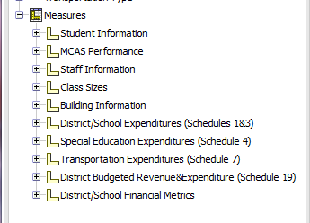

Again, be aware that that not all measures can be combined with each other, and not all measures work with all available dimensions/filters.

Measures in the Finance Cube

Data | Definition & Business Rules | Pre-Defined Bands
Student Information
Total Students | - The total number of students enrolled both in and out-of-district in the selected school year as of the October 1st SIMS snapshot.  - Students with  - a Reason for Reporting of “Receiving” or “Sending” (DOE011 in 01, 02, 03)  - an Enrollment Status of “Enrolled in-district” (DOE012 is 01) | - 0  - 1 – 499  - 500-999  - 1,000-1,999  - 2,000-2,999  - 3,000-3,999  - 4,000 – 9,999  - 10,000+
# In-district Students | - The total number of students enrolled in-district in the selected school year as of the October 1st SIMS snapshot.  - Students with  - a Reason for Reporting of “Receiving” (DOE011 in 01 or 03)  - an Enrollment Status of “Enrolled in-district” (DOE012 is 01) | - 0  - 1– 499  - 500-999  - 1,000-1,999  - 2,000-2,999  - 3,000-3,999  - 4,000 – 9,999  - 10,000+
# Out-of-district Students | - The total number of students enrolled out-of-district in the selected school year as of the October 1st SIMS snapshot.  - Students with  - a Reason for Reporting of “Sending” (DOE011 in 02)  - an Enrollment Status of “Enrolled in-district” (DOE012 is 01) | - 0  - 1-4  - 5-19  - 20-39  - 40-79  - 80+
# SWD In-district | - The total number of SWD students enrolled in-district in the selected school year as of the October 1st SIMS snapshot.  - Students with  - a Reason for Reporting of “Receiving” (DOE011 in 01 or 03)  - an Enrollment Status of “Enrolled in-district” (DOE012 is 01)  - a Special Education Placement, ages 3-5 (DOE032) other than codes 00, 01, or 05, or a Special Education Placement, ages 6-21 (DOE034) other than codes 00 or 01 in the October snapshot | - 0  - 1 – 49  - 50-99  - 100-199  - 200-299  - 300-399  - 400 – 999  - 1000+
# SWD Out-of-district | - The total number of SWD students enrolled out-of-district in the selected school year as of the October 1st SIMS snapshot.  - Students with  - a Reason for Reporting of “Sending” (DOE011 in 02)  - an Enrollment Status of “Enrolled in-district” (DOE012 is 01)  - a Special Education Placement, ages 3-5 (DOE032) other than codes 00, 01, or 05, or a Special Education Placement, ages 6-21 (DOE034) other than codes 00 or 01 in the October snapshot | - 0  - 1-4  - 5-19  - 20-39  - 40-79  - 80+
% Total SWD | - Percentage of SWD both in and out-of-district students out of all students both in and out-of-district  $$\% Total SWD= \frac{\left(\# SWD In District+\#SWD Out of District\right)}{Total Students}$$ | - 0-4  - 5-9  - 10-14  - 15-19  - 20+
% In-district SWD | - Percentage of SWD in-district out of all SWD students both in and out-of-district  $$\% In District SWD= \frac{\# In District SWD}{Total Students}$$ | - 0-4  - 5-9  - 10-14  - 15-19  - 20+
% Out-of-district SWD | - Percentage of SWD out-of-district out of all SWD students both in and out-of-district  $$\% Out of District SWD= \frac{\# Out of District SWD}{Total Students}$$ | - 0-4  - 5-9  - 10-14  - 15-19  - 20+
% ELL | - Percentage of in-district ELL students  $$\% ELL= \frac{Total In District ELL Students}{Total In District Students}$$  - Total In-District ELL Students = The total number of ELL students enrolled in-district in the selected school year as of the October 1st SIMS snapshot and who does not speak English or whose native language is not English, and who is not currently able to perform ordinary classroom work in English (Limited English Proficiency DOE025 is 01) as of the October 1st SIMS snapshot | - 0-4  - 5-9  - 10-14  - 15-19  - 20+
% Low Income | - Percentage of Low Income students in the school out of all students in the school  - Students eligible for free or reduced-price lunch (DOE019 in 01 or 02) in the October snapshot  $$\% Low Income= \frac{Total In District Low Income Students}{Total In District Students}$$ | - 0-9  - 10-14  - 15-24  - 25-34  - 35+

Data | Definition & Business Rules | Pre-Defined Bands
MCAS Performance
- Note: These follow the standard business rules for reporting MCAS results for the district, which include both in and out-of-district students
# Tested ELA | - Number of students tested in an ELA subject test in-district
% Advanced/ Proficient ELA | - Percentage of students tested in ELA in-district who received an achievement level of either Advanced or Proficient | - 0-19  - 20-39  - 40-59  - 60-79  - 80+
SGP ELA | - Median SGP of all ELA tested students in-district | - 1-39  - 40-60  - 61-99
# Tested Math | - Number of students tested in a Math subject test in-district
% Advanced/Proficient Math | - Percentage of students tested in Math in-district who received an achievement level of either Advanced or Proficient | - 0-19  - 20-39  - 40-59  - 60-79  - 80+
SGP Math | - Median SGP of all Math tested students in-district | - 1-39  - 40-60  - 61-99
# Tested Science | - Number of students tested in a Science subject test in-district
% Advanced/Proficient Science | - Percentage of students tested in Science in-district who received an achievement level of either Advanced or Proficient | - 0-19  - 20-39  - 40-59  - 60-79  - 80+

Data | Definition & Business Rules | Pre-Defined Bands
Staffing Information
<Staff Category> FTE | - Cumulative staff FTEs in the entire district as identified in the October 1st EPIMS snapshot for active work assignments.  - The following staff classification are available and follow the standard staff definitions:  - Teachers  - Instructional Coaches  - Paraprofessionals  - Instructional Support  - SPED Instructional Support  - This includes educators with an employment status of ‘Working’ or ‘Paid Leave’. | - 0-49  - 50-99  - 100-149  - 150-299  - 300-499  - 500+
FTE Special Education Teachers  FTE Special Education Paraprofessionals | - Cumulative Special Education teaching staff FTEs in the entire district as identified in the October 1st EPIMS snapshot for active work assignments  - Special Education Teaching Staff is defined as teachers (with an Assignment with a Program Code of Special Education (02) as defined in EPIMS.  - The standard teacher definition applies.  - This includes educators with an employment status of ‘Working’ or ‘Paid Leave’. | - 0-9  - 10-19  - 20-39  - 40-59  - 60+
Student Teacher Ratio | - Number of in-district students as of October 1st divided by the teacher FTEs as of the October 1st EPIMS for active work assignments.  $$Student-Teacher Ratio=\frac{\# In District Students}{\# of FTE Teachers}$$  - The standard teacher definition applies. | - 0-15  - 15-17  - 18-20  - 21+
Average Age – Teachers | - The average age of the teachers in-district as of October 1st of the selected year.  - Average Age = (AVG (10/1/<YYYY> - Birth Date) for each teacher)  - The teachers age is based on their EPIMS reported age.  - Average age is rounded to the nearest whole number and is represented in years.  - This calculation is weighted by teacher FTEs.  - The standard teacher definition applies. | - <40  - 40-56  - 57+
Average Years Since First License - Teachers | - The average number of years between the date of the teaching staff’s 1st initial license and October 1st of the selected year for all teachers in-district.  - Average Years = (AVG (10/1/<YYYY> - License Issue Date) for each teacher) for licenses with a “Licensed” status.  - The teacher’s License Issue Date is based on information in ELAR.  - Average Years is rounded to the nearest whole number.  - This calculation is weighted by Teacher FTEs.  - The standard teacher definition applies. | - 0-2  - 3-5  - 6-9  - 10-14  - 15+

Data | Definition & Business Rules  Pre-Defined Bands
Class Sizes
% Classrooms <15 | $$Percent of classrooms with less than 15 students =\frac{\# of Classrooms with less than 15 students}{Total \# of Classrooms}$$
% Classrooms 15-20 | $$Percent of classrooms with between 15 and 20 students =\frac{\# of Classrooms with between 15 and 20 students}{Total \# of Classrooms}$$
% Classrooms 21-25 | $$Percent of classrooms with between 21 and 25 students =\frac{\# of Classrooms with between 21 and 25 students}{Total \# of Classrooms}$$
% Classrooms 26-30 | $$Percent of classrooms with between 26 and 30 students =\frac{\# of Classrooms with between 26 and 30 students}{Total \# of Classrooms}$$
% Classrooms >30 | $$Percent of classrooms with greater than 30 students =\frac{\# of Classrooms with greater than 30 students}{Total \# of Classrooms}$$

Data | Definition & Business Rules | Pre-Defined Bands
Building Information
Total Sq. Footage | - The total square footage of the school building for the school year  - Building data is from MSBA |  | - 0-9,999  - 10,000-19,999  - 20,000-29,999  - 30,000-39,999  - 40,000-49,999  - 50,000+
Total Sq. Footage per Student | - The total square footage per all students in the school  $${Feet}^{2 }per student=\frac{Total {Feet}^{2 }}{Total \# students in school}$$ |  | - <100  - 100-199  - 200-299  - 300-399  - 400+
Year Built | - The year the school building was built, as provided by MSBA |  | - <1965  - 1965-1979  - 1980-1999  - 2000 – 2009  - 2010+
Last Renovation Year | - The year of the last renovation of the building, as provided by MSBA |  | - <1965  - 1965-1979  - 1980-1999  - 2000 – 2009  - 2010++No Renovation

Data | Definition & Business Rules
District/School Expenditures
Schedule 1 Revenue | $$=Revenue from Local Sources+Revenue from State Aid+Revenue from Federal Grants+Revenue from State Grants+Revenue in Revolving \& Special Funds$$
Schedule 1 & 3 Expenditures | $$=Expenditures on Administration+Instructional Leadership+Teachers+Other Teaching Services+PD+Instructional Materials+Guidance+Pupil Services+Operations+Insurance+Payments to Out of District Schools+Community Activities+Fixed Assets+Debt+Regional Assessments$$
Expenditure per All Students | $$=\frac{Schedule 1 \& 3 Expenditures}{Total Students}$$
Expenditure per In-District Student | $$=\frac{Schedule 1 \& 3 Expenditures}{Total In District Students}$$

Data | Definition & Business Rules
Special Education Expenditures
Schedule 4 Expenditure | - EOY Line 3950  - Total Schedule 4 expenditures, inclusive of in-district spending and out-of-district spending.  - All funds (General Fund, Circuit Breaker, Grants & Revolving Funds  - Note: If you pull in Function Type/Schedule 4 only, you’ll only see the in-disitrct spending categories. To see total Schedule 4 expenditures, use the Special Education Type dimension, which cuts the data by placement.
Expenditure per In-District Student | $$=\frac{Schedule 4 Expenditure}{\# SWD In District}$$
Expenditure per Out-of-District Student | $$=\frac{Schedule 4 Expenditure}{\# SWD Out of District}$$

Data | Definition & Business Rules
Transportation Expenditures
Schedule 7 Expenditures | - Program Total + Total Payments from Revolving and Special Funds  - Can use with:  - Program Type  - Fund Type (“Other” and Revolving & Special Funds)  - Transportation Type  - Function Type (Only use this if you are looking just for line 4310 in EOYR “Public Transportation Assessment,” function 3399 in Finance Database)
# Riders | - Total might double count riders?  - Program Total + Riders paid from Revolving and Special Funds

Data | Definition & Business Rules
District Budgeted Revenue & Expenditures
Schedule 19 Revenue | $$= \sum{Schedule 19 Part B "Revenue from Local Sources"}$$  (p95 of 2014 EOY book)
Schedule 19 Expenditure | $$=Sch 19 A.1. Total School Committee+Sch 19 A.2.Total Municipal Expenditures$$

Data | Definition & Business Rules
District/School Financial Metrics
Total In District Operating Expenditures | - Total Spending from Schedule 1 from all Funds and Functions excluding functions in the 6000, 7000, 8000 and 9000 series, Indirect Cost Transfers (5990), and Short Term Interest BANs (5450)  - Note: This doesn’t work with any dimensions (cannot be further disaggregated.)
Total Operating Expenditures | - Total Spending from Schedule 1 from all Funds and Functions excluding functions in the 6000, 7000, 8000 series, Indirect Cost Transfers (5990), and Short Term Interest BANs (5450)  - Note: This doesn’t work with any dimensions (cannot be further disaggregated.)
Total Special Education Expenditures | - Cumulative of Instructional Services (2000), In District Transportation, Payments to Other Districts (9000), Out of District Transportation, Grants and Revolving Funds, and Non-Public Health Services (6800)  - Schedule 4 and Schedule 7  - Note: This doesn’t work with any dimensions (cannot be further disaggregated.)
Total Out of District Special Education Expenditures | - From Schedule 4, cumulative of the 9000 function code series across all special education placements and screening and team evaluation  - From Schedule 7, out-of-district transportation  - Note: This doesn’t work with any dimensions (cannot be further disaggregated.)
Total Teacher Salaries | - The total teacher Salaries cumulative of the following:  From Schedule 3, Function Codes Teachers, Classrooms (2305),Teachers, Specialists (2310), and Teacher/Instructional Staff-Professional Days (2353) under Object Codes Professional Salaries (01) and No Objects Defined (07) for all Fund Codes
Total Teacher Salaries per Teacher FTE | - Total Teacher Salaries as defined by the teacher category in the EOYR database per Teacher FTEs as of Oct 1st from EPIMS  - Total Teacher Salaries per Teacher FTE = Total Teacher Salaries / number of Teacher FTEs as of Oct 1st from EPIMS  The standard teacher definition applies
Instructional Expenditures | - Total of all Instructional Expenditures cumulative of the following:  From Schedule 3 all functions, objects, funds, and programs
Instructional Expenditures per Student | - Total Instructional Expenditures (2000) per student in the school as of Oct 1st  Expenditures Per Student = Total Instructional Expenditures / total number of students in school as of October 1st SIMS
CEY % of Foundation | - Combined Effort Yield (CEY) % of Foundation  - District Combined Effort Yield (CEY) percentage representation of wealth  Provided by EOYR database for the school year from Chapter 70 file

For more information on these and other resources in Edwin,
visit www.doe.mass.edu/edwin, email edwin@doe.mass.edu, or follow us on Twitter @Edwin_DESE.

All enrollments used in this cube are based on October 1st.
SIMS = Student Information Management System (http://www.doe.mass.edu/infoservices/data/sims/)
Education Personnel Information Management System (http://www.doe.mass.edu/infoservices/data/epims/)
Massachusetts School Building Authority
Chapter 70 and CEY explained (http://www.doe.mass.edu/finance/chapter70/chapter_15_explain.html)
For more information on EOY reporting and Chart of Accounts, visit: http://www.doe.mass.edu/finance/accounting/eoy/
Teaching Staff is cumulative of teacher FTEs as identified in the October 1st EPIMS snapshot for active work assignments. Teaching staff may be identified by the following: - Job Classification Codes: All job classifications in the Instructional Staff category, excluding Instructional Coach (2330) and Long Term Substitute (2325). This includes: - Teacher (2305), Co Teacher (2306), Virtual Teacher (2307), Virtual Co Teacher (2308), and Teacher – support content instruction (2310) This includes educators with an employment status of ‘Working’ or ‘Paid Leave’
Chapter 70 and CEY explained (http://www.doe.mass.edu/finance/chapter70/chapter_15_explain.html)

