Edwin Analytics: Finance
How to use the Finance Cube – Part 2: Walkthrough
An ad-hoc cube is available to provide insight into school and district finances, connecting financial information, student, teacher and school building data. The cube goes a step beyond the five available reports by facilitating more in-depth and flexible querying allowing the user to tailor the query to his needs. The cube is available to users with access to school and district aggregate reports within the education data warehouse.

Accessing the Cube in Edwin Analytics 1
Cube Structure 3
Using the Default Views 3
District Level Function Comparison View 4
School Level Characteristics and Expenditure Trending Analysis 9
Starting with a Blank View 13
Getting Started 13
Example Queries 20
Schedule 4/Special Education 20
Grants and Other Funds (Non-General Fund) 24
Schedule 7/Transportation 29

Accessing the Cube in Edwin Analytics
Log-in to the ESE Security Portal (https://gateway.edu.state.ma.us). Select Edwin Analytics from the main page. Select District, and then Finance. Under Multi-Dimensional Analysis, select Finance Cube (circled in green in Figure 1). A new tab will open in your browser.

Figure 1
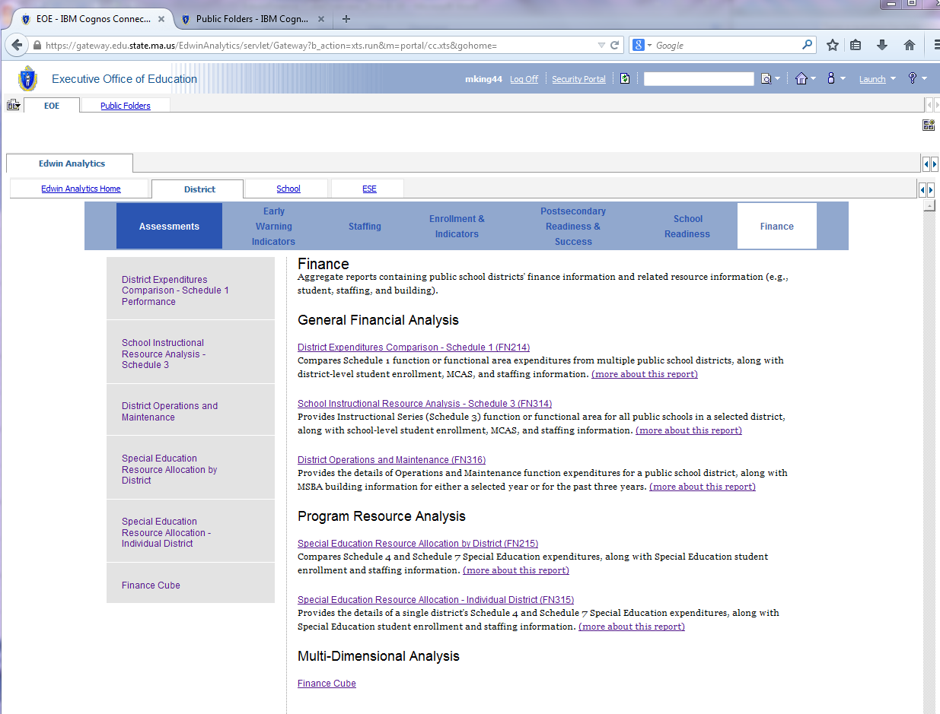

Figure 2

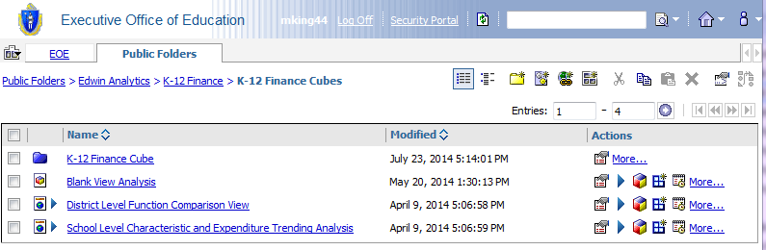

Cube Structure
If you’ve used pivot tables in Microsoft Excel, the cube interface should look pretty familiar. The viewing pane on the left (outlined in red in Figure 3) contains the dimensions and measures available for use in the cube. They can be dragged and dropped into the crosstab (outlined in green in Figure 3). The crosstab lets you compare and contrast values between or across items and must include at least two dimensions (one in the Rows section and one in the Columns section) and one measure.

Figure 3
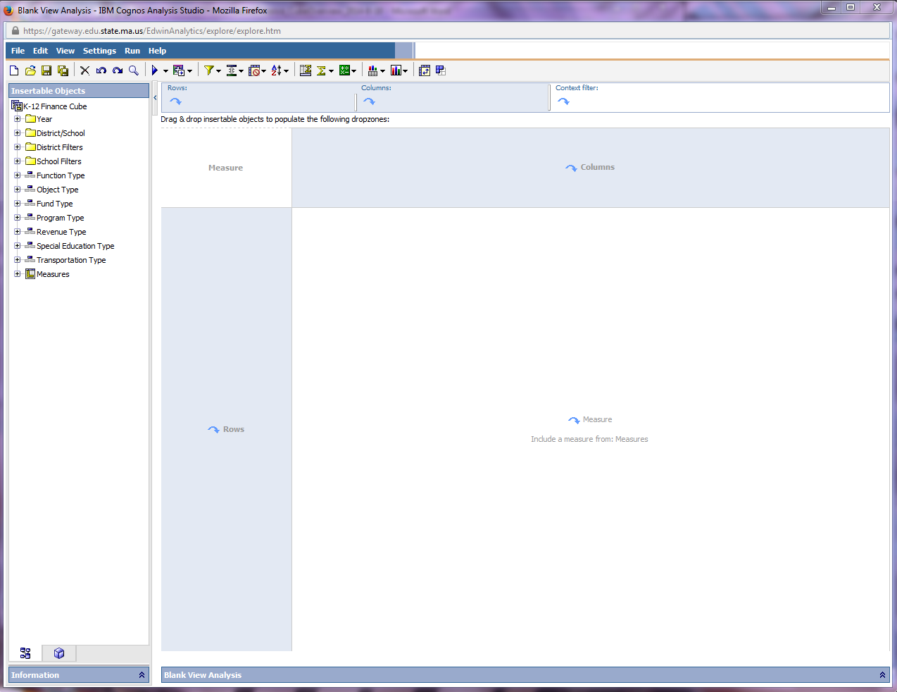

Using the Default Views
There are two default views available to jump start your analysis.
- District Level Function Comparison View
- School Level Characteristics and Expenditure Trending Analysis

Figure 7
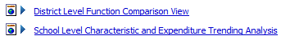

District Level Function Comparison View
The “District Level Function Comparison View” sets up the main dimensions and measures you would need to look at a set of districts’ Schedule 1 expenditures for a function and its related objects in the latest available year. To open this pre-defined view, click the cube icon. A new window will open. (See Figure 8 and Figure 9.) Let’s zoom in on just the top section of the cube view (outlined in red).

Figure 8

Figure 9
- Context Filters
Dimensions can be dragged into this section of the cube to pare down the resulting dataset. It allows you to come up with a like group of districts, for example, and pull just their data for further analysis.

This view comes pre-populated with the latest year’s data. This can be changed by:
- Right-clicking the Latest Year dimension under Context Filter.
- Selecting Delete. This will remove the filter from the analysis. Now, you have all available years data included (summed into one value for each district.)
- From the list of dimensions and measures on the left hand side. Expand Year, and select a different year.
- Rows
Dimensions can be dragged into this section of the cube. In this default view, the data is organized by district, and all districts are displayed. There are several options for changing the districts’ displayed:
- Drill down to one district: To drill down to one district, right click the dimension under Rows, and select the one district you are interested in (Figure 10). You will then see just that district’s schools and the total for the district. You can also do this by left-clicking the desired district in the cube itself (Figure 11). The resulting view is shown in Figure 12.
- Select a new set of districts: Right-click the dimension under Rows and select Delete. This will remove it from the cube on which you are working. If, for example, you are interested in just regional vocational districts, expand the dimension “By District Type and School Level” and drag “Vocational/Agricultural Regional District” into the Rows section.

Figure 10
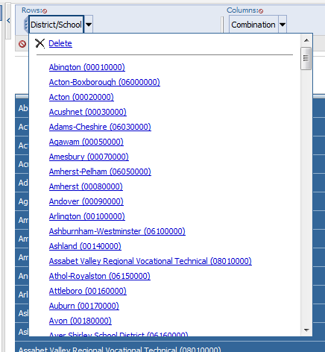

Figure 11

Figure 12
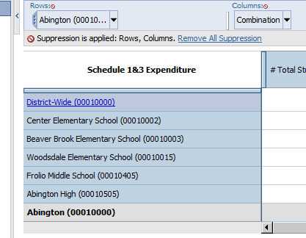

Figure 13
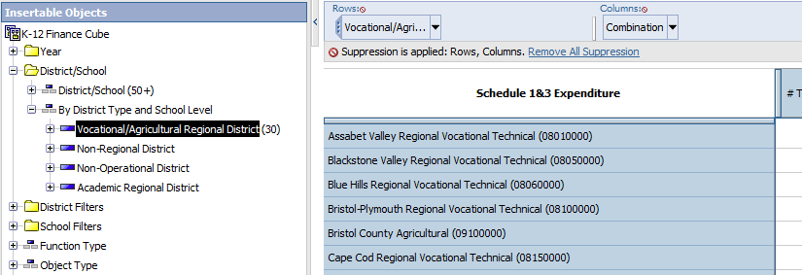

- Use another set of dimensions to further filter the district list: There is a set of district filters available for you to sort and/or filter the data down to something more manageable. For example, let’s say you want to include just those districts with large enrollment.
  - Expand the District Filters folder, and then expand the “# of Total Students” dimension. There are several available enrollment bands.
  - If you want to still see all districts, and which band they fall into, nest the dimension by dragging “# of Total Students” into the Rows section, before the District/School dimension. Like a pivot table, it will show the number of total students and then the districts in that band. See Figure 14.
  - If you want to only see the districts within a particular band, drag the desired band into the context filter. See Figure 15.

Figure 14
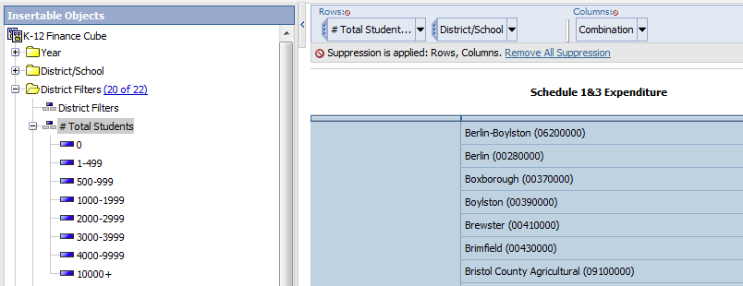

Figure 15
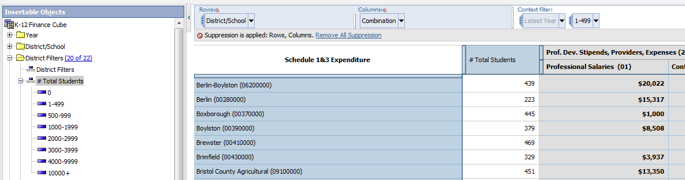

- Columns
Dimensions can also be dragged into this section of the cube. In this default view, three dimensions are included: # Total Students, Function Type (professional development is currently the only function displayed), and Object Type (all objects displayed). There are some basic things you can do to manipulate the dimensions included in this cube.
- Delete one or more of the dimensions:
- Change one or more of the dimensions:
- Drill down or roll-up function and/or object type:

Figure 16
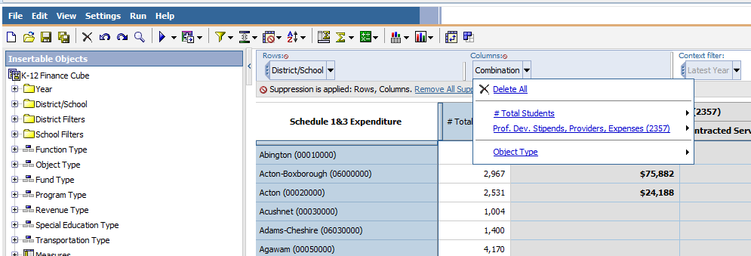
Figure 17
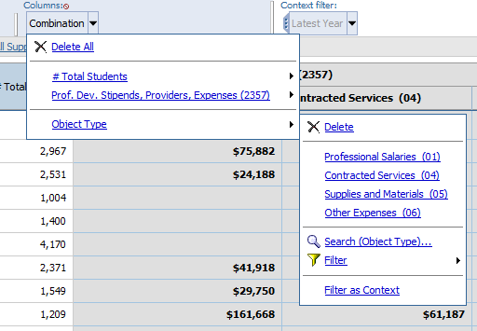

- Measures
The Measures section of the crosstab is the heart of your analyses; it contains the quantitative data corresponding to your chosen dimensions. Only measures, listed last in the side pane, can be dragged here.

Suppression

Figure 18
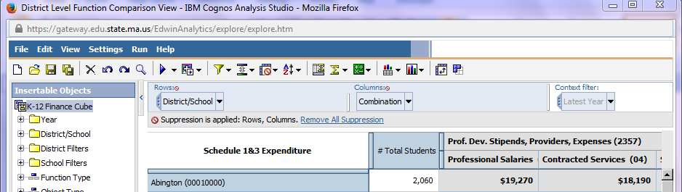
D
C
B
A

School Level Characteristics and Expenditure Trending Analysis
The “School Level Characteristics and Expenditure Trending Analysis” default view sets up the main dimensions and measures you might start with to look at school level data, including data on students, staff and spending. To open this pre-defined view, click the cube icon. A new window will open. Let’s zoom in on just the top section of the cube view (outlined in red in Figure 19).

Figure 19
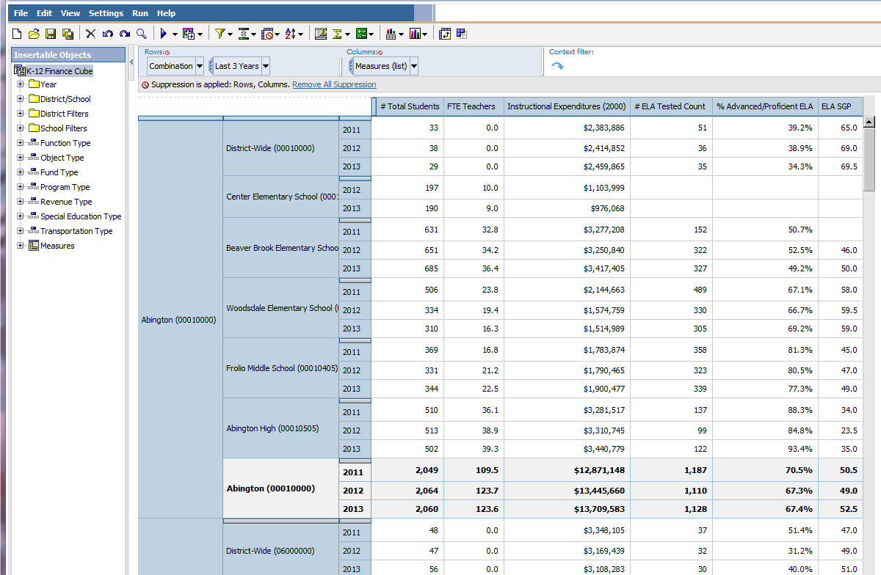
- Context Filters: This default view loads with no context filters. See below for directions on how to add filters to pare down the number of schools.

- Rows: Dimensions can be dragged into this section of the cube. In this default view, the data is organized by district, then school, and then the year and all districts are displayed. There are several options for changing the districts’ displayed:
  - Drill down to one district or school: To drill down to one district or school, right click the dimension under Rows, and select the one district or school you are interested in. You will then see just what you’ve selected. You can also do this by left-clicking the desired organization in the cube itself (Figure 20). The resulting view is shown in Figure 21. In the below example, Abington High School was selected.
Figure 20
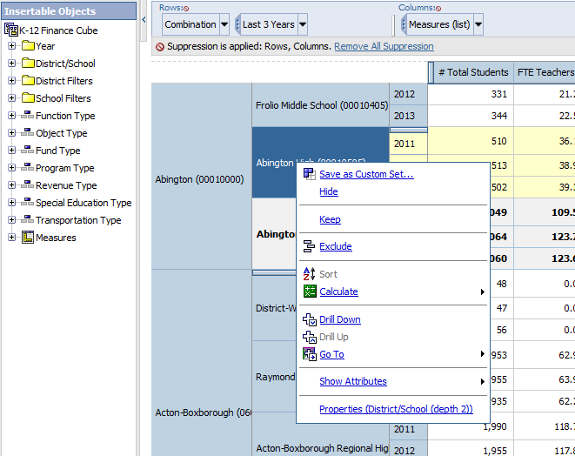

Figure 21
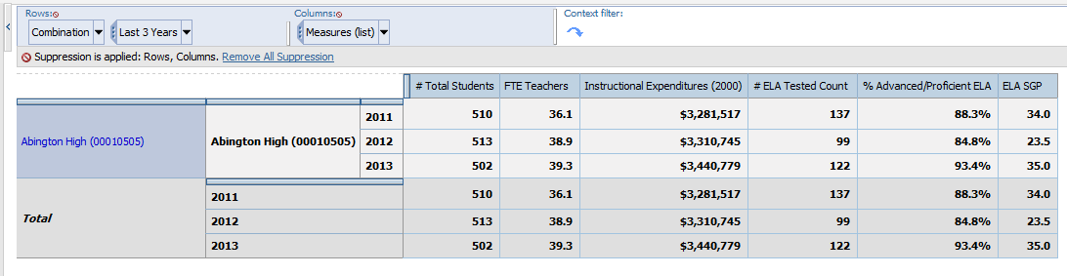

  - Select a new set of districts (see above).
  - Use another set of dimensions to further filter the district and/or school list: There is a set of district and school filters available for you to sort and/or filter the data down to something more manageable. Guidance on how to approach the district filters is included above, so let’s focus on the school filters. For example, let’s say you want to include just those schools with a low percentage of students with disabilities (SWD).
    - Expand the School Filters folder, and then the % SWD dimension.
    - Drag 0-4 %SWD into the context filter. Because suppression is applied, you will just be left with those schools that fit the filter criteria.

Figure 22
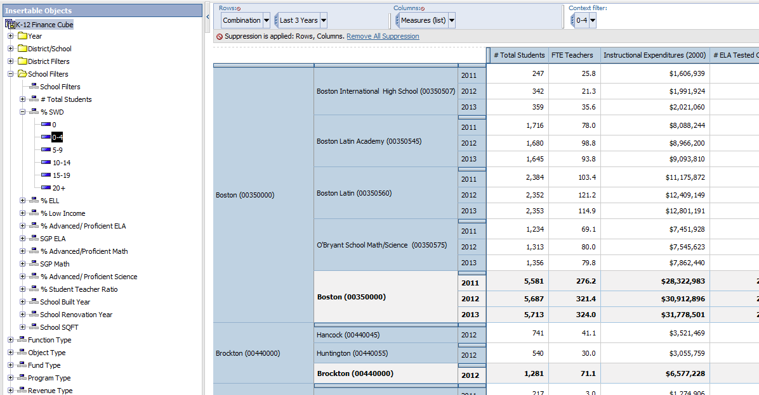

    - Notice that sub-totals and totals are displayed, but only include those schools that meet the criteria. In this case, it’s not useful to retain the sub-totals and totals, so they should be excluded. Select Settings in the top bar, and then Totals and Sub-Totals. A menu box will open at the bottom of the cube (see Figure 23). De-select “Subtotal included”, and “Overall Total.”
  - Adjust the time span: The default view displays a 3-year trend. To select one of those years, right-click the dimension in the top pane and click the desired year. To change the time span altogether, delete in from the rows, open the Year folder in the side pane and drag in the year(s) you want. (Note: If the cube is suddenly blank, pull the year(s) into the context filter instead.)

Figure 23
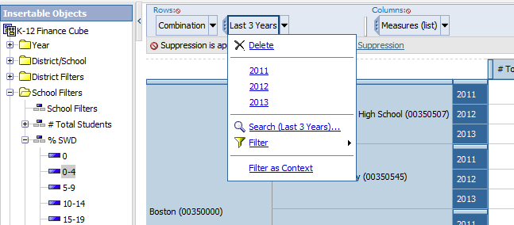

Figure 24
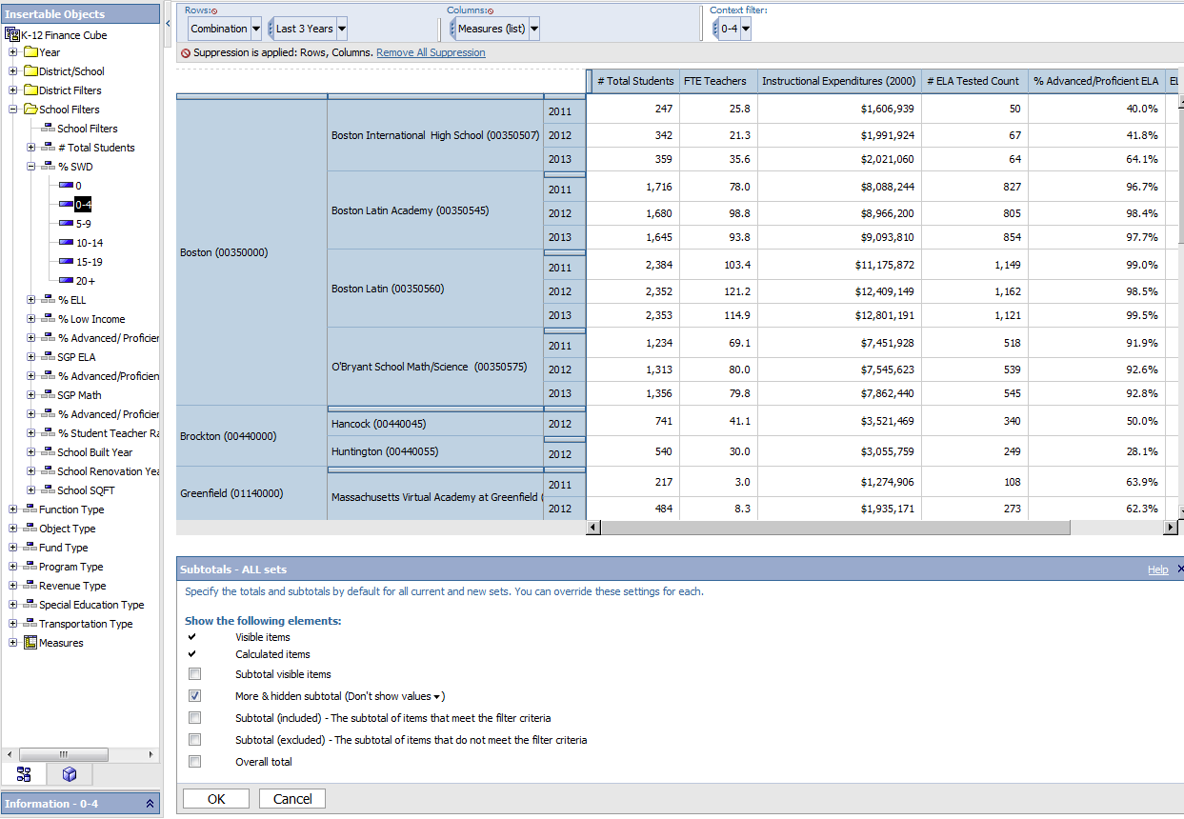
- Columns: Dimensions and measures can be dragged into this section of the cube. In this default view, a selection of measures is displayed for each school.

Figure 25
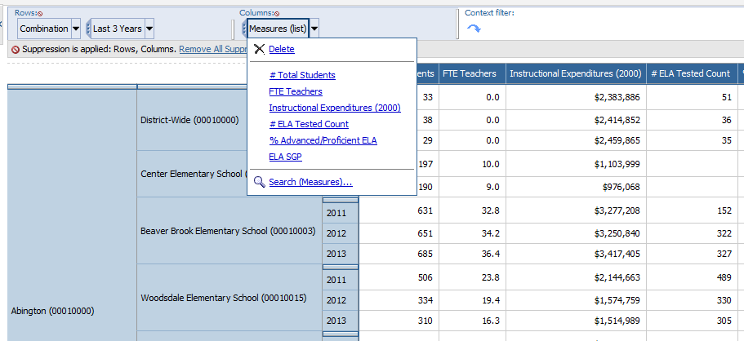

- Customize the presented measures
  - You can delete one of the measures by right-clicking on a measure in the cube itself and selecting delete. In Figure 26, FTE Teachers is highlighted and the menu displayed.
Figure 26
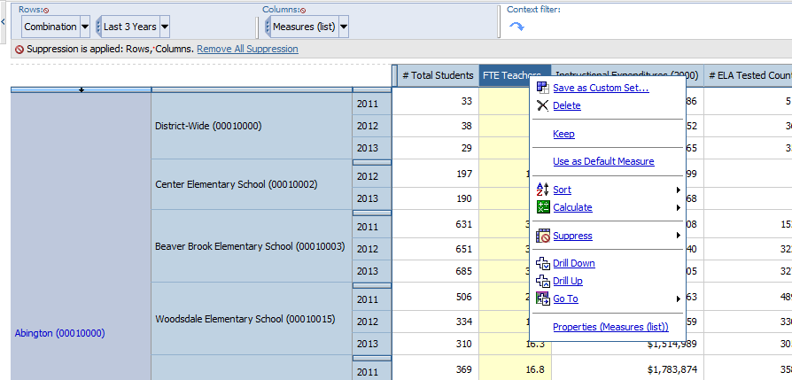
  - Measure(s) can also be added. Select a measure from the side pane and drag it into the Rows section of the cube. Be careful to drag it to where it highlights the space before # Total Students (see the red circle in Figure 26), otherwise it will replace the contents. This way, you can display multiple measures.

- Measures: This default view includes several measures.
  - #Total Students
  - FTE Teachers
  - Instructional Expenditures (2000s) – Instructional expenditures are the only category of spending reported at the school level. They account for approximately two-thirds of district spending.
  - # ELA Tested Count
  - % Advanced/Proficient ELA
  - ELA SGP

Starting with a Blank View

Getting Started
To build your analysis from scratch, start with the Blank View Analysis. There are many ways to approach setting up your analysis. This set of steps gives you one route.

Figure 27

- Select the Year to Display: Expand the Year dimension and either drag a year value to the context filter section in the top panel or right-click on the year value and select the Filter as Context option.
Figure 28
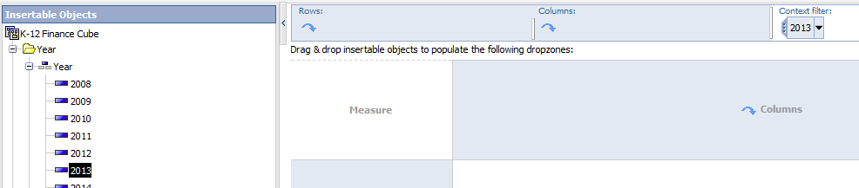

- Select Column Dimensions: Expand the Function Type dimension and either drag a “Function Type,” in this case Administration, to the columns section in the cube or to the columns section in the top panel. The bigger category of Administration, when dragged into the cube, expands into a set of sub-functions, with a total on the far right.

Figure 29
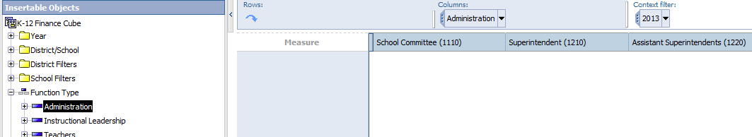

- Select Row Dimensions: Expand the “District/School” dimension and either drag the District/School to the rows section in the cube or to the rows section in the top panel. All districts display.

Figure 30
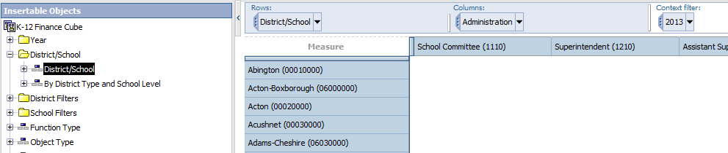

- Select Measures: Expand the Measures group and the “District/School Expenditures (1&3)” group and either drag the “Schedule 1&3 Expenditures” measure into the measure section in the center of the cube or to the measures section in the top left corner of the cube.

Figure 31
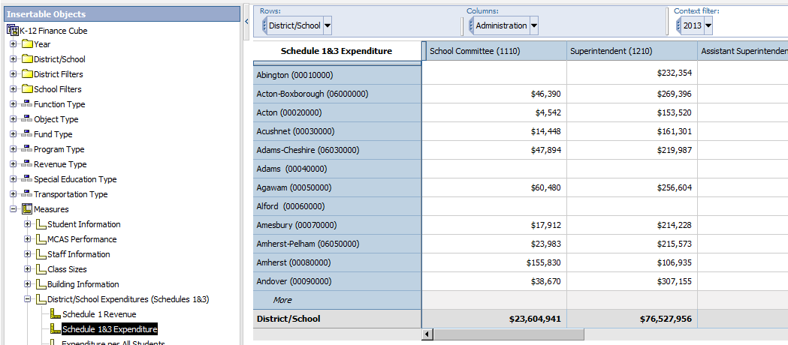

At this point, you’ve pulled in all the necessary components to do some simple analysis. Here are some additional steps to add some details.
- Add column groupings to the selected measure: If you’re interested in which fund these costs are paid from, select the “Fund Type” dimension and drag it to the columns section below the existing Function code. You can also drag into the top panel after the function type.

Figure 32
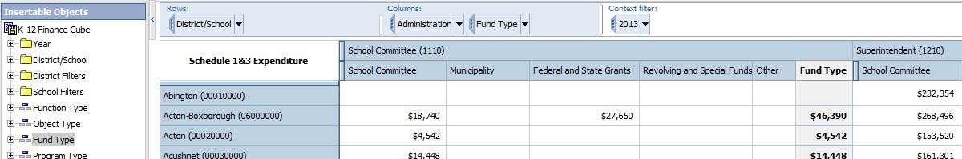

- Add an additional measure: Let’s say you also are interested in the number of students in each district. Expand the Measures group and the Student Information group and either drag the measure (in this case, # Total Students) to the Columns section of the cube between were you want it to appear.
  - Tip #1: It needs to be added between the existing columns or it will replace the values.
  - Tip #2: Measures with groups/levels should be added first to avoid repeating information.
Figure 33
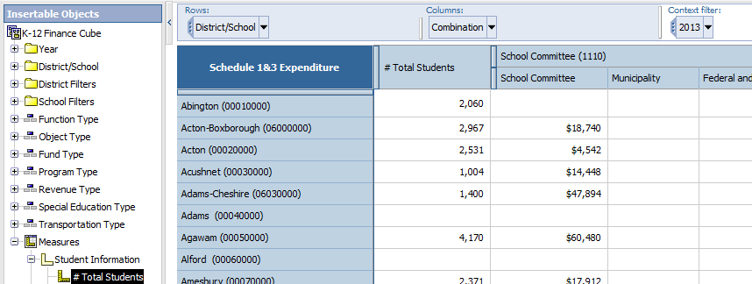

- Change Context Filters: If you’d like to view a previous year’s data, for example, you can change the context filter without removing and re-adding the year. In the top pane (see Figure 34), left click on the dimension in the context filter section of the top pane. Select a new value.

Figure 34
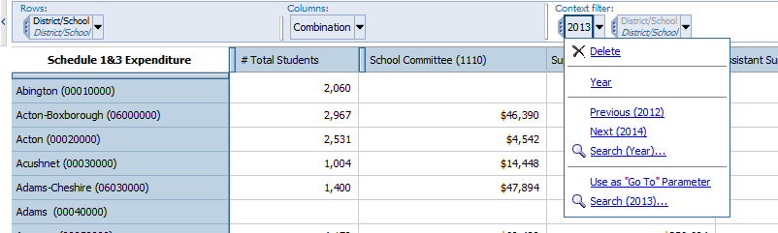

- Select Multiple Filter Values: Select the drop down from the context filter field in the top panel and select Use as “Go To” Parameter. Select the Run icon from the tool bar and select an output format (Run Report (HTML)).

Figure 35
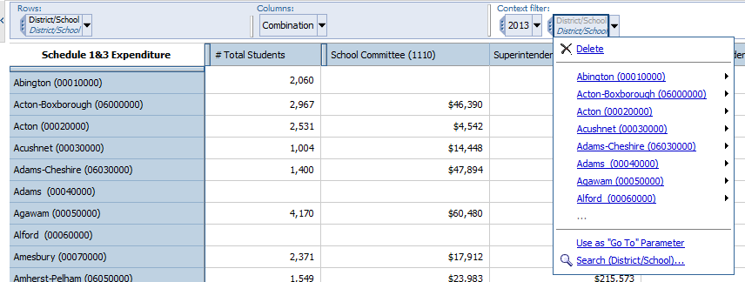

Figure 36
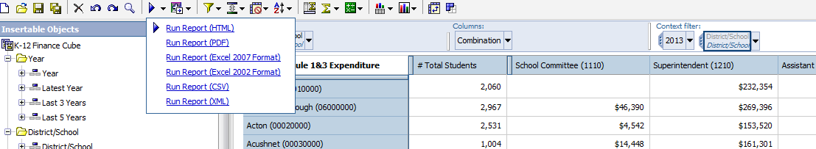

  - This will launch a prompt window (see Figure 37) to select multiple values and then the report will run in the selected output.
  - Tip #1: It’s best to do this once you’ve finished selecting all of your dimensions and measures and are just interested in limiting the output to a select group (5 districts, for example).

Figure 37
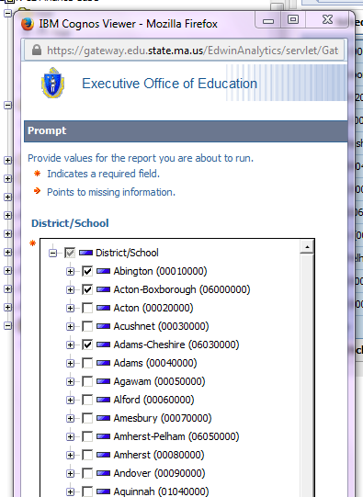

Figure 38
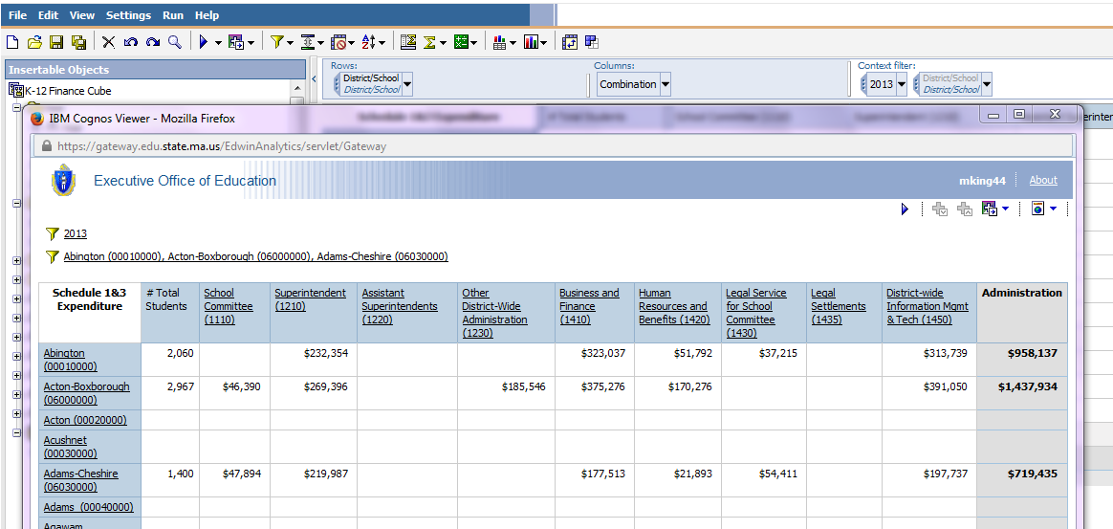

- Suppression: Sometimes you’ll want to hide any row and/or column that contain all zeros or missing values. For example, when you use a district filter without suppression, any district that doesn’t meet the filter criteria will show up as a blank row. With suppression, you will just get the districts that meet the criteria, which is a much tighter dataset.
  - Select the cross-tab icon from the tool bar and select the type of suppression.

Figure 39
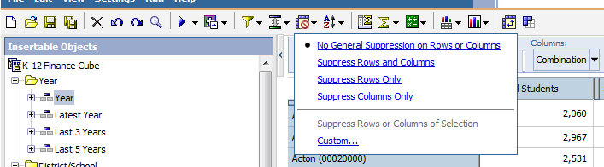

  - As shown in Figure 40, only the districts with between 1 and 499 students are showing data. The rest contain zeros (or no values) and so are suppressed from view.

Figure 40
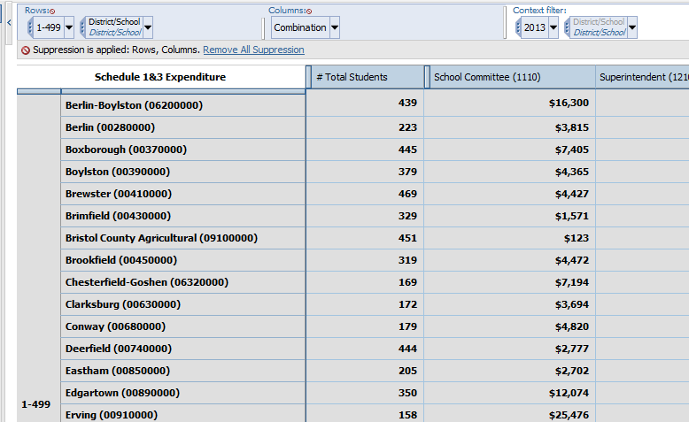

- Hide Sub-Totals: Either select the subtotals icon from the toolbar or select Totals and Subtotals from the Settings menu. You may be prompted to select a dataset (see Figure 41 and Figure 42). This will launch the Subtotals window for the field. Deselect the “More & hidden subtotal” option.

Figure 41
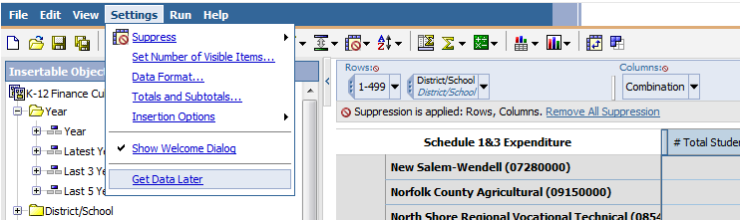
Figure 42
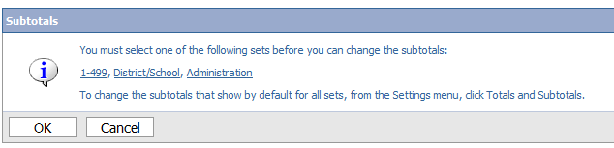

Figure 43
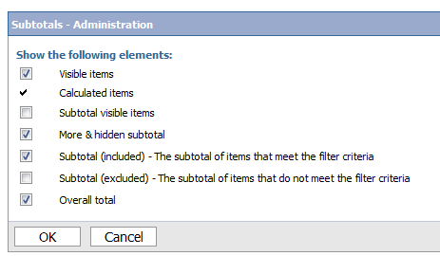

- Export Results: Once you’ve pulled the raw data you wish to analyze, it can be exported into Excel for further work. Select the Run icon from the toolbar and select the export format.

Figure 44
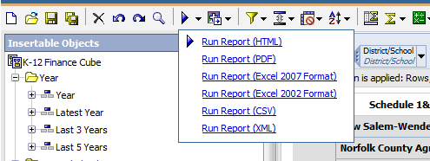

Example Queries

Schedule 4/Special Education
What data do I need to start comparing districts’ special education expenditures?

First, keep in mind that there are two Edwin reports that pull together a lot of special education data. Start there and then if you discover that you need a different swath of data, move on to the cube. The example included here is geared towards giving you practice in manipulating data in the cube.

Let’s say you are trying to pull data on academic regional districts’ special education resources. You are just starting to analyze this issue, and are trying to pull some basic comparison data. Here’s how to get started.
- Select a year to display. Drag the year dimension into the context filter.
- Select districts. In this case, drag the academic regional district folder into the rows section.
  - If you are interested in a smaller sub-set of regional districts (i.e. those of a certain size), drag the desired dimensions into the context filter. Make sure to suppress rows and columns with zero or missing values.

Figure 45
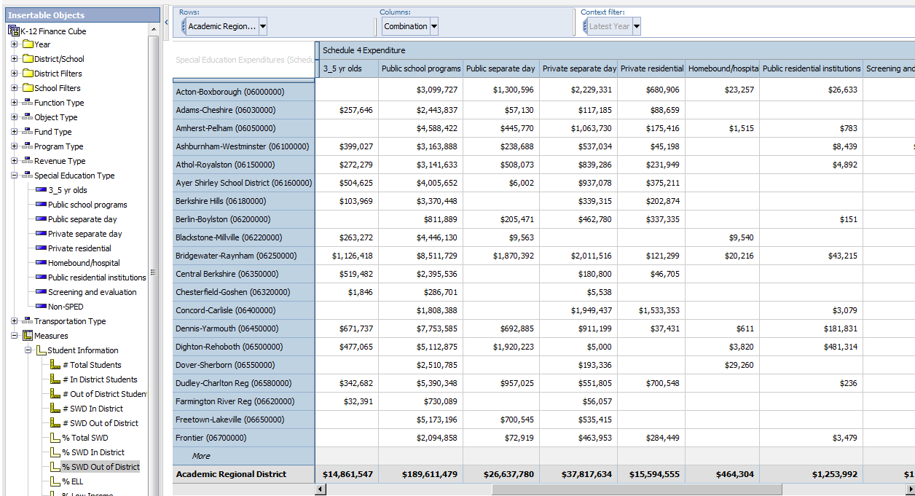
2
1

- Special Education Expenditures
  - Expand Special Education Expenditures under Measures. Drag Schedule 4 Expenditures into the Measure section of the cube. You won’t see any data yet. Then, drag the same measure into the Column section of the cube. You will see total Schedule 4 expenditures for each district once the measure’s been added to both the column and measures sections.

Figure 46
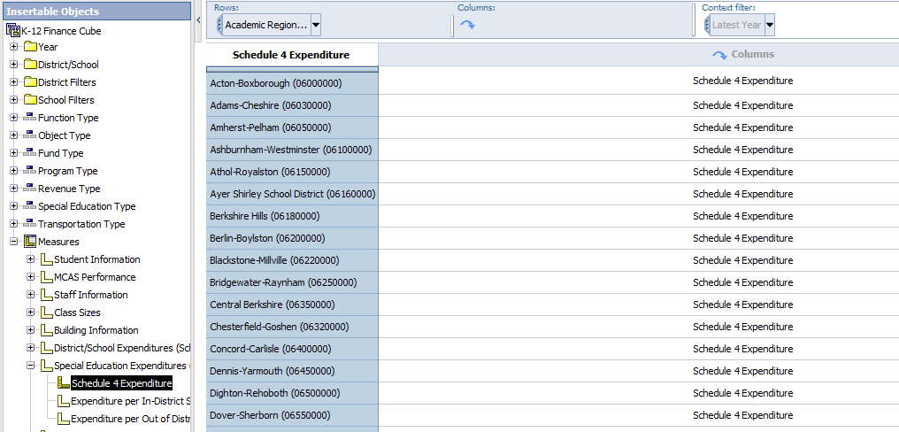
3

Figure 47
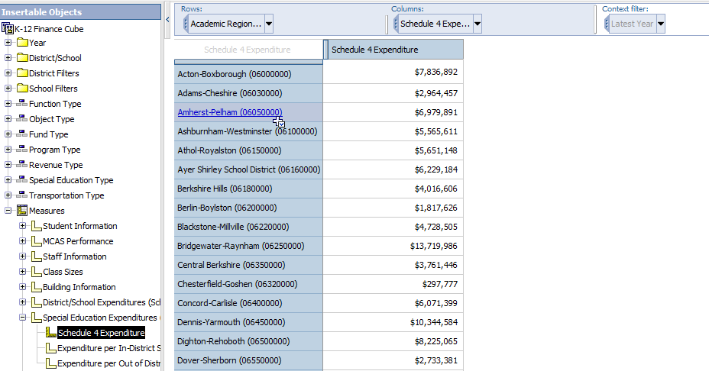
3

  - If you want this disaggregated by placement, drag Special Education Type into the column section after Schedule 4 Expenditures. See Figure 48.

Figure 48
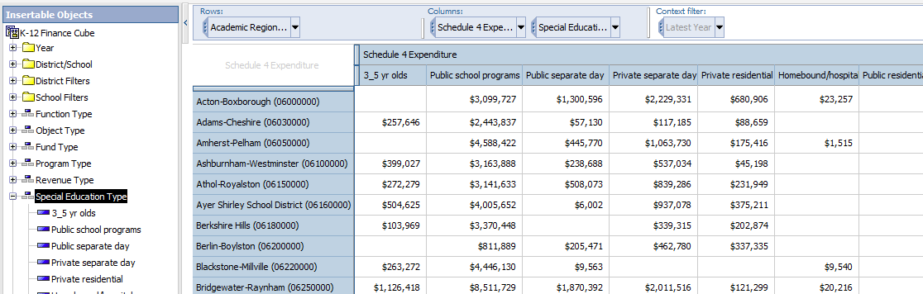

  - You might also want to compare expenditures per student. There are two measures using Schedule 4 data in this manner: Expenditure per In-District SWD and Expenditure per Out of District SWD. To display them in addition to what’s already included, drag them from the side pane to the cube and drop in the space before Schedule 4 expenditures. When you hover over the right spot in the column, a little arrow will appear. This will add, rather than replace, to what’s already there. See Figure 49 and Figure 50.

Figure 49
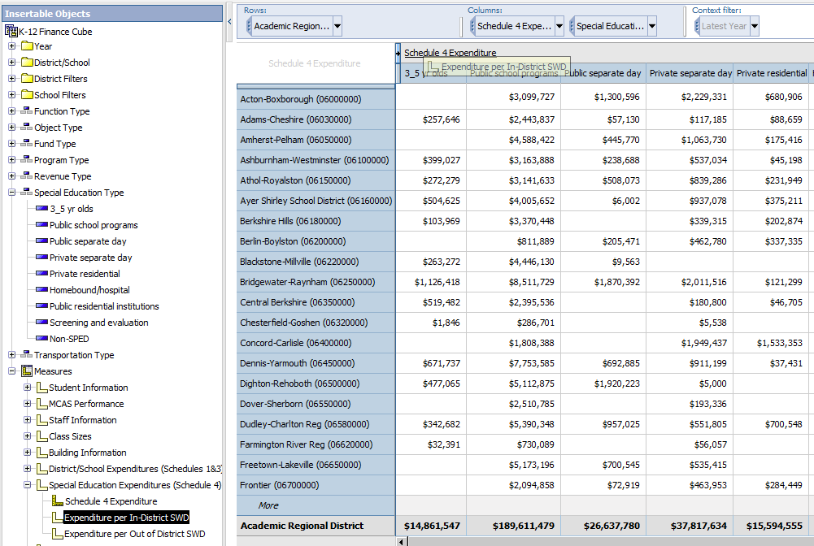

Figure 50
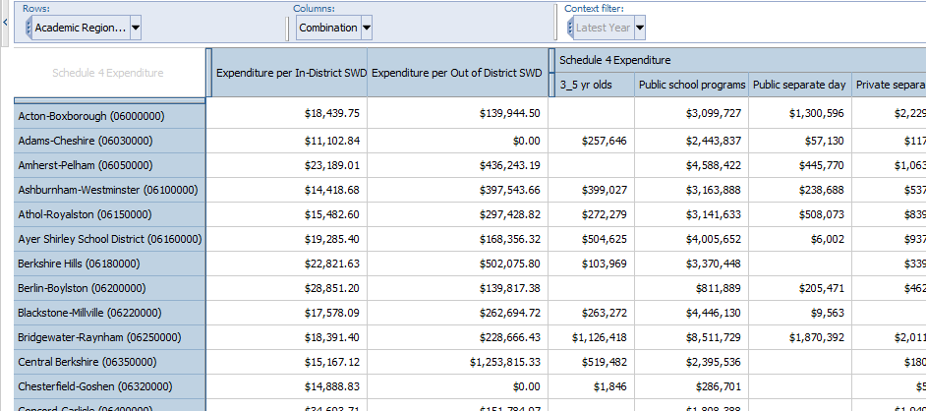

  - To figure out which districts are the most similar, you may want to add some student information. Drag the desired measures, in this case % SWD in and out of district, in the same manner as expenditures per student. See Figure 51.

Figure 51
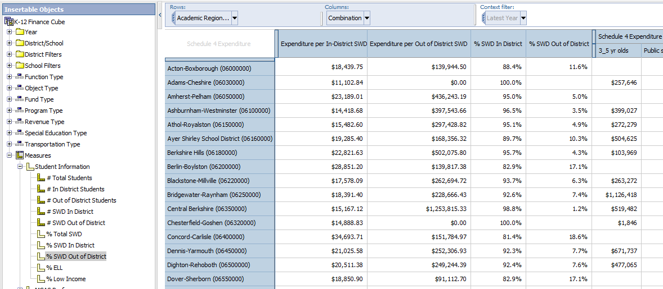

At this point, you have everything you need to do some basic comparative analysis. You can continue to add measures, refine your district list, etc, or just download the data into Excel for further work.

Grants and Other Funds (Non-General Fund)

Who spends a lot from private grants and gifts (part of revolving and special funds)? What do those districts have in common (if anything)? What are they spending it on?

You might be interested in expanding your district’s public and private partnerships, but are not sure the revenue to be gained is worth the additional effort. You’d also like to know which districts to reach out to, and how they spend money from private grants and gifts.
Start by:
- Select a year to display.
- Select districts. (Consult earlier examples for more information on #1 and 2.)
- District Expenditures from Non-General Funds
  - Under Measures, expand District/School Expenditures. Drag Schedule 1&3 Expenditures into the Measures section of the cube. You will see total Schedule 1 expenditures for each district once the measure has been added to both the Measures and the Columns sections of the cube.

Figure 52
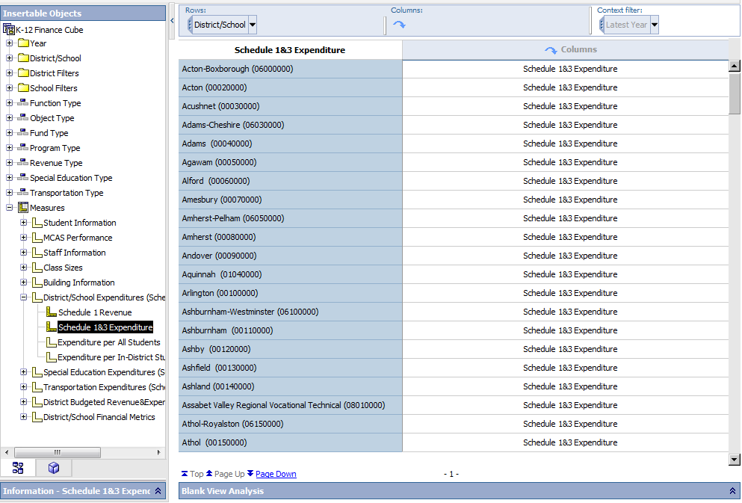

  - Drag Schedule 1&3 Expenditures into the Columns section of the cube. At this point you should see one value for each district, as shown in Figure 53. You now have all district expenditures, but you are just looking for a subset, so this will need to be narrowed down.

Figure 53
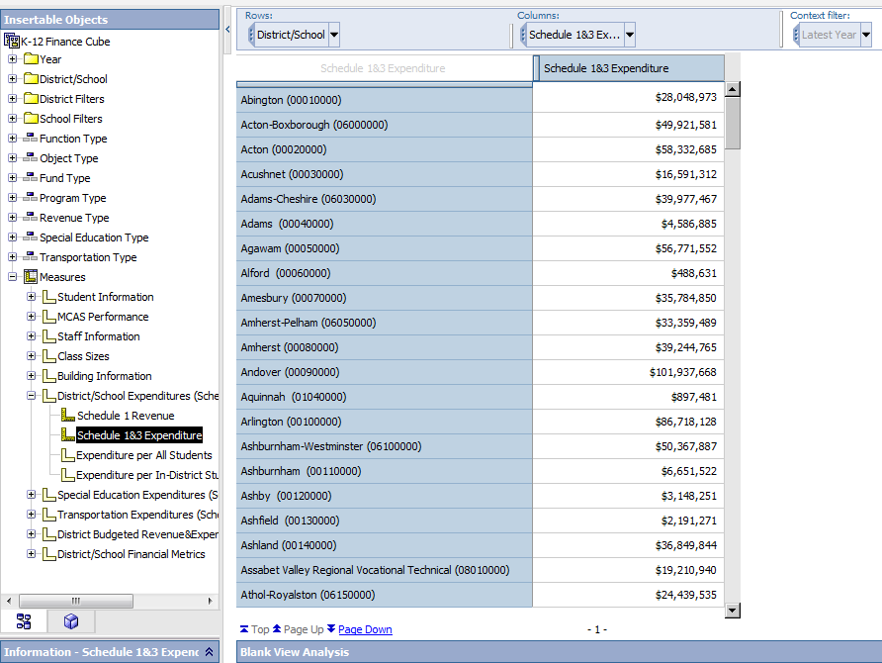

- Expand Fund Type, and the Revolving and Special Funds. Drag “Private (08)” into the Columns section, before Schedule 1&3 Expenditures. This will ensure that the amount spent from private grants and gifts appears as an additional column, instead of replacing the existing information.

Figure 54
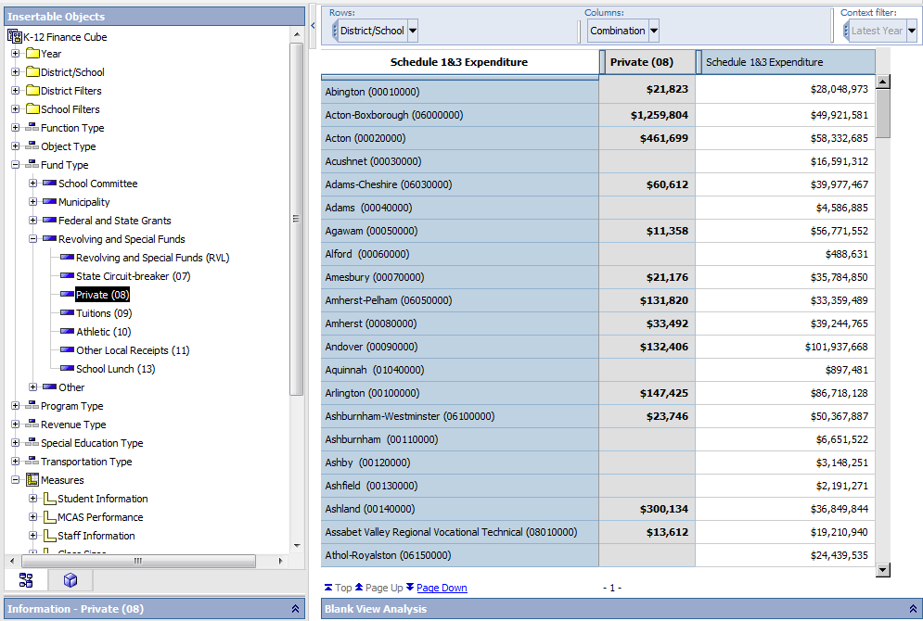

- In this case, you are just interested in those districts reporting spending in these funds, so right-click on the column for which you which to suppress districts with no spending (in this case, “Private”), select Suppress, and then Suppress Rows of Selection.
Figure 55
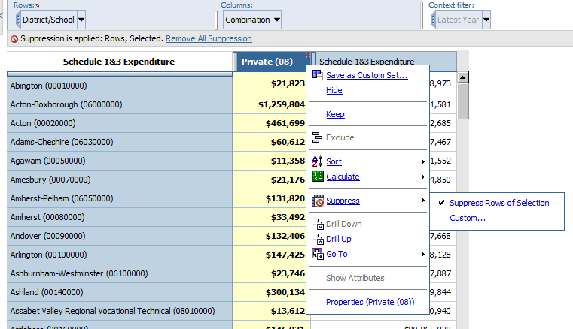
- Also, sort the results to see which districts report the most spending in these funds. Again, right-click on Private, but this time, select Sort and then Descending. See Figure 57 for the sorted results.
Figure 56
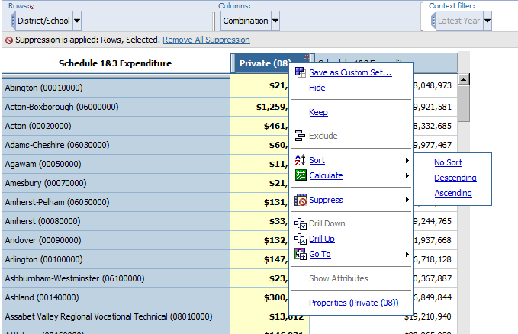

Figure 57
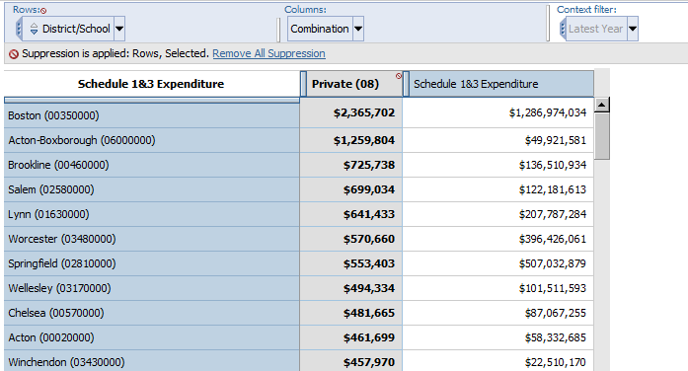
Sorted by dollars spent from private grants and gifts
- If you’re interested in exploring what these districts may have in common, or perhaps doing some other calculations once the data is downloaded into Excel, you can pull in some additional measures.
  - Drag any of the measures you are interested in to the right of the expenditures. In this example, combined effort yield as a percent of foundation budget, expenditures per in-district student, percent low income and number of total students are included as additional measures. See Figure 58 and Figure 59.
Figure 58
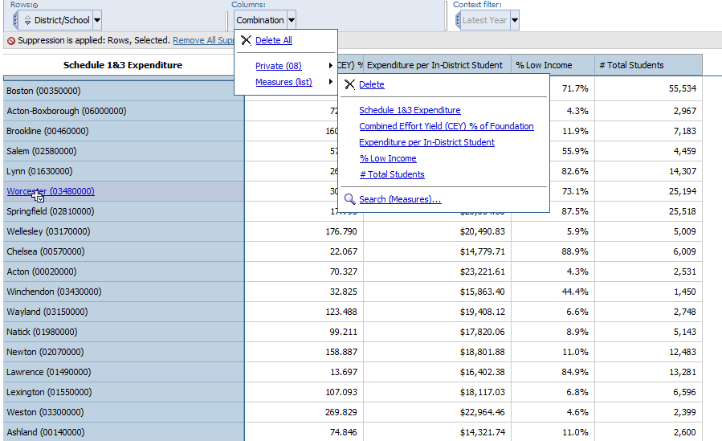

Figure 59
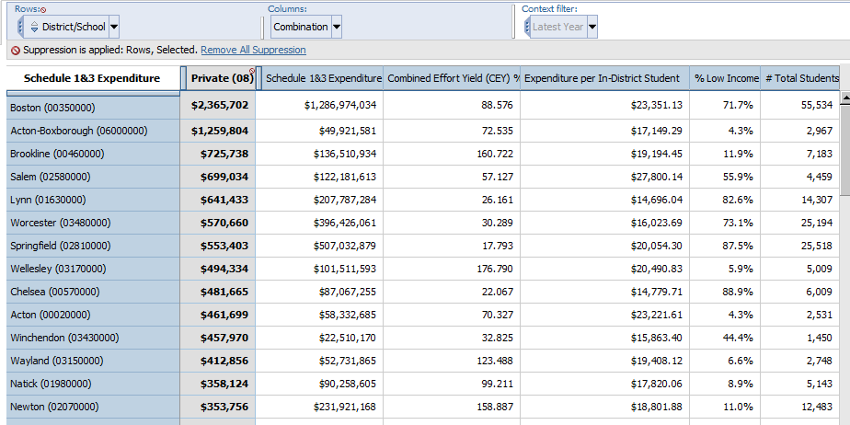

And you’re done! At this point, you can continue to tweak the presentation or download it into Excel.

Schedule 7/Transportation

Who has homeless transportation costs? Of these districts, to whom should I compare myself?

Your school committee wants more information on other similar districts’ homeless transportation spending. To answer their question, you’ll need expenditures and ridership information from Schedule 7 of the EOY, and other contextual data to narrow down the list of districts.

Start by:
- As in the previous two examples, select a year and a set of districts. In this example, only non-regional districts are included.
- Expenditures made for the transportation of homeless students are collected in Schedule 7 of the EOY report. From the available measures, drag Schedule 7 Expenditures into the Measures section of the cube, and then into the Columns section. Then also drag # Riders into the Columns section. See Figure 60.

Figure 60
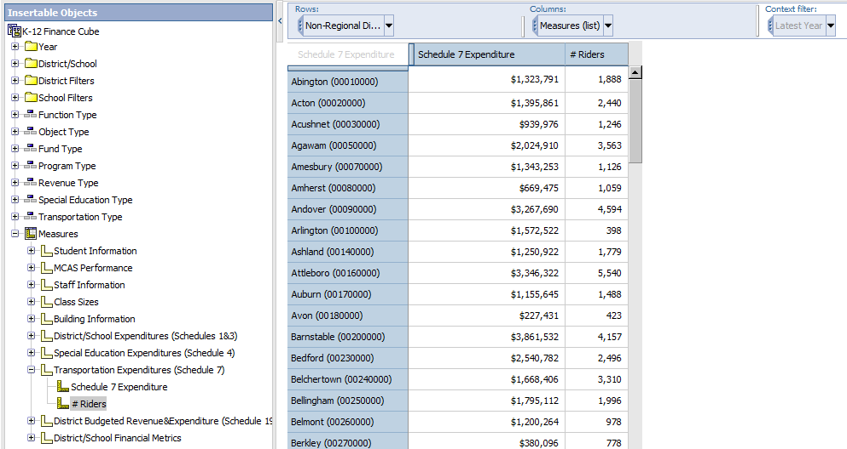

- To just view homeless transportation, pull Fund Type into the Columns section above the measures Schedule 7 Expenditures and #Riders. This will disaggregate expenditures by program, displaying all programs as shown in Figure 61. To select just homeless transportation, left-click on Program type in the top pane and select Homeless Students, as is shown in Figure 62.

Figure 61
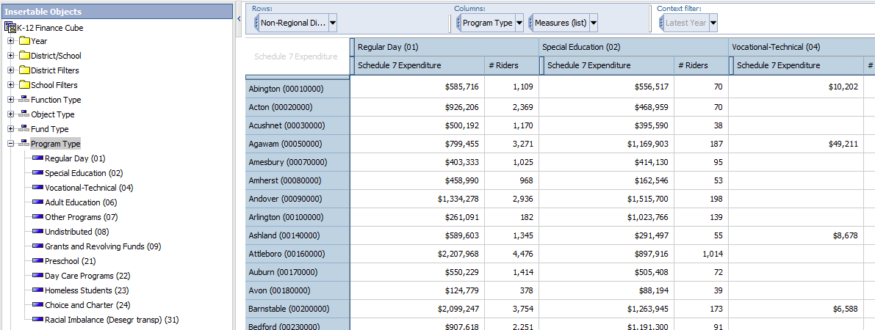

Figure 62

- If you just want to see districts that spent in this area, suppress zero values by right-clicking on homeless students and applying suppression.

Figure 63
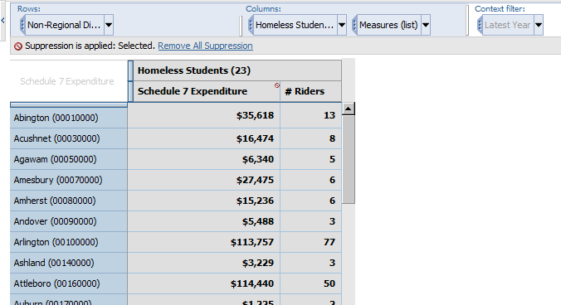
- At this point, you have all information you need to start an analysis. But let’s say that you’d like to reduce the size of this dataset to something more manageable, and you’re really just interested in the subset of districts that are demographically similar to you.
  - Expand the list of District Filters.
  - You can choose any numbers of ways to filter the district list, but in this example, I’ve used district size (# Total Students) and poverty (% Low Income). Each filter is organized into several bands, so you can select the one that includes your district (see Figure 64).

Figure 64
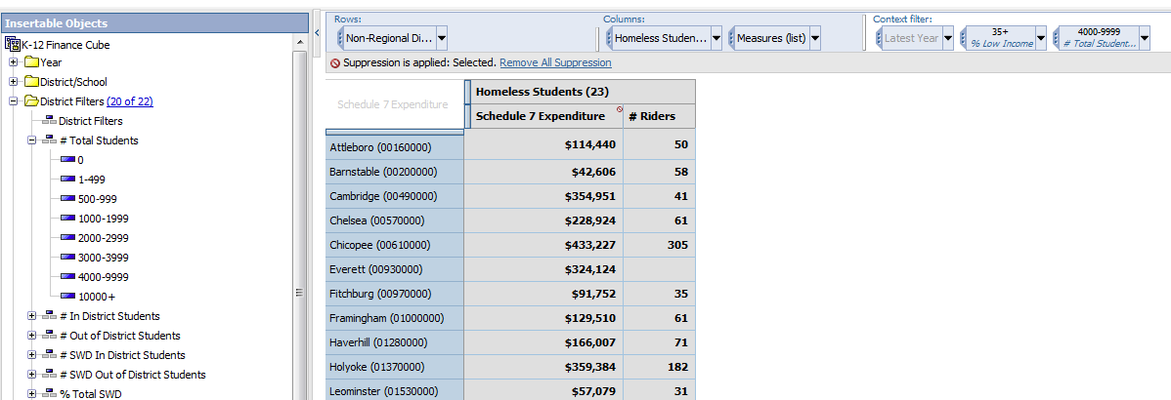

- Figure 65 displays the final result. In addition to the basic expenditure data necessary to the analysis, you can pull in some additional contextual measures. In this case, the number of total students, percent low income and total Schedule 7 expenditures were included.
Figure 65
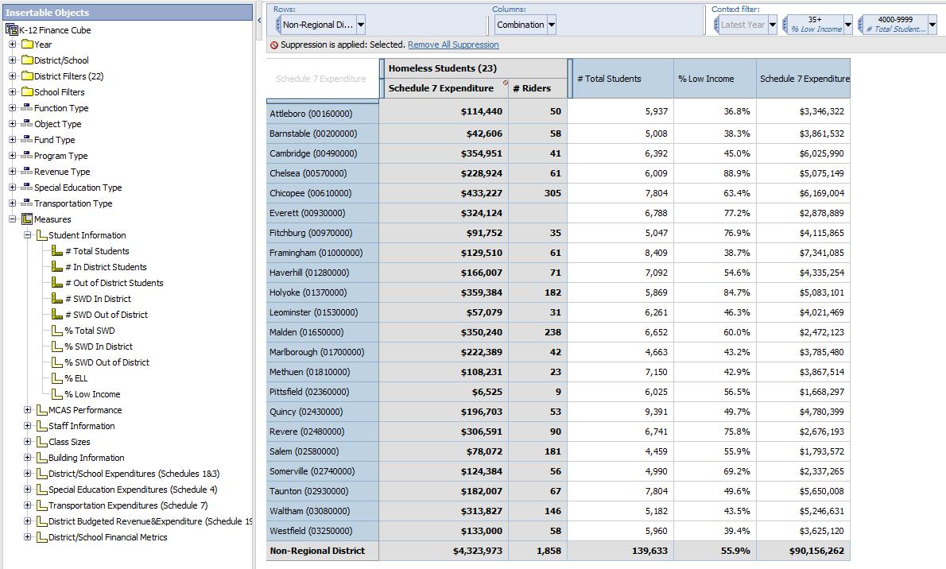

For more information on these and other resources in Edwin,
visit www.doe.mass.edu/edwin, email edwin@doe.mass.edu, or follow us on Twitter @Edwin_DESE.

Suppression is really important here. See that section of this manual for more information.

