Deep Dive: Instructional Practices to Support Multilingual Learners (MLs)
DESE Instructional Planning and Observation Tools Collection

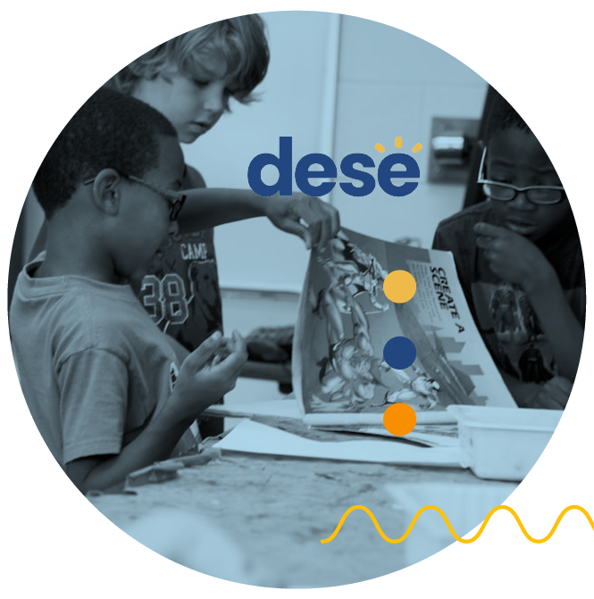
About this Tool
This Deep Dive supports educators in implementing promising practices for multilingual learners (MLs). It
brings the Multilingual Learning Look-for Tool to life through concrete classroom examples that show clear connections
between teacher actions and student outcomes. By providing specific, observable indicators of success, the Deep Dive helps
educators recognize and implement promising practices in their classrooms.

Aligned with the DESE Educational Vision, MA Blueprint for English Learner Success, and Standards of Effective Practice, these
evidence-based practices apply across all ML instructional contexts. Whether in sheltered content instruction, ESL classes, or bilingual/dual language programs, and regardless of ESL delivery approach (push-in, pull-out, standalone, embedded, or co-teaching), educators will find practical strategies to support ML success.
Section 4: Rigorous & Meaningful Opportunities to Learn
Instruction is standards-aligned and intellectually stimulating, promoting real-world, relevant problem-solving through purposeful, grade-appropriate tasks. It helps students learn and use strategies for thinking and using language and develop increasing autonomy through appropriate and flexible scaffolds, productive struggle and regular feedback.

Connections:
- Blueprint for EL Success:
  - Pillar 2 (Access to Educators), Building Block 2 (Educators with high standards for English learners)
  - Pillar 3 (Opportunity and Support), Building Block 1 (Meaningful and rigorous learning opportunities that build on English learner's assets)
- Standards of Effective Practice: I-A-3. I-B, I-C-3, II-A

Element 4A: Language Objectives and Unit Progression
- Educators … facilitate instruction with an explicit daily language objective, which builds toward larger unit language expectations, helping students learn and practice specific languages forms, features, and genres characteristic of the discipline. (aligned with MA Frameworks and WIDA ELD Standards). | - Students … Engage with grade-appropriate content, texts, and tasks, using appropriate scaffolds as needed to make sense of new concepts.
If educators… | Then students are more likely to…
- Align language and content objectives (e.g., integrate WIDA ELD standards with MA frameworks, identify language skills needed for content activities to design language objectives and goals)  - Design instruction around disciplinary practices, genres, language functions, and language forms (e.g., highlight language patterns in the discipline, model discipline-specific genres and text structure)  - Make language expectations explicit (e.g., provide examples of target genres, functions, and features; share clear success criteria)  - Make explicit connections between immediate daily objectives and longer unit language expectations and goals (e.g., sequence daily language objectives progressively to support unit goals). Reference how current learning builds on previous lessons and preview upcoming objectives. | - Apply disciplinary language purposefully (e.g., use appropriate academic vocabulary, follow discipline-specific text structures, engage in content-area discussions using target language)  - Demonstrate growing mastery of disciplinary practice, genres, language functions, and language forms (e.g., produce increasingly sophisticated written and oral texts, employ genre-specific features, adapt language for different academic purposes, recognize language patterns)  - Monitor their own progress toward language objectives (e.g., self-assess against success criteria, track use of target genres, functions, and features, identify areas for growth)  - Build language skills systematically (e.g., connect new language learning to prior knowledge, apply learned structures in new contexts, demonstrate increasing independence with academic language)

Resources:
- Massachusetts Department of Elementary and Secondary Education Collaboration Tool (MA DESE)
  - Creating Focus Language Goals (MA DESE)
  - Comprehensive Overview: The Collaboration Tool (MA DESE)
  - Collaboration Tool Try Out: Step by Step (MA DESE)
- WIDA English Language Development Standards Framework, 2020 Edition (Section 2: Understanding the WIDA ELD Standards Framework) (WIDA)
- Next Generation ESL Language Objectives (MA DESE

Element 4B: Strategic Scaffolding & Gradual Release
- Educators... implement carefully sequenced and structured activities aligned to objectives and unit expectations that build in complexity, with supports and scaffolds (including assessment accommodations) appropriate to students' English proficiency levels. They model and scaffold students from guided practice to independent application. | - Students... engage with grade-appropriate content, texts, and tasks, using appropriate scaffolds as needed to make sense of new concepts.
If educators… | Then students are more likely to…
- Design learning sequences that build in complexity (e.g., sequence tasks from concrete to abstract and from simple to complex)  - Plan structured and scaffolded opportunities for practice (e.g., demonstrate thinking processes, share worked examples, explain decision-making steps, offer guided practice with peers, structure collaborative learning experiences, design supported independent work)  - Differentiate supports based on proficiency levels (e.g., provide tiered scaffolds, adjust linguistic complexity, implement assessment accommodations)  - Monitor, adjust, and differentiate support levels in real time (e.g., assess student needs frequently during instruction, pause for self-assessment, gather student feedback on learning process, modify supports based on student responses, ensure appropriate challenge)  - Structure gradual release of responsibility (e.g., move from "I do" to "we do" to "you do,” remove scaffolds gradually) | - Progress through increasingly complex tasks (e.g., demonstrate growing independence with grade-level content, tackle more challenging material with appropriate support, build from basic to advanced skills)  - Engage actively and confidently in learning experiences (e.g., participate meaningfully in guided practice, collaborate effectively with peers, attempt new skills with scaffolding, work through challenges systematically)  - Access grade-level content successfully (e.g., use provided supports strategically, demonstrate understanding through various means, engage with challenging texts and materials using appropriate tools)  - Build confidence and demonstrate growth (e.g., recognize when supports are/aren't needed, persevere through challenging tasks, show growth in both content and language at their proficiency level)  - Transfer skills and demonstrate increasing independence (e.g., apply learned strategies in new situations, adapt approaches for different tasks, work independently when ready, track and articulate their own progress)

Resources:

- WIDA Proficiency Level Descriptors (pages 31-34 in the 2020 Edition) (WIDA)
- WIDA Snapshot: WIDA Proficiency Level Descriptors (WIDA)
- WIDA Language Charts (WIDA)
- Can Do Descriptors (WIDA)
- How to Provide Effective Scaffolding Instruction to Support Multilingual Learners (SupportEd)

Element 4C: Assessment and Evidence of Learning
- Educators are… checking for understanding, gathering evidence of student learning and language development through formative and summative assessment, and adjusting instruction accordingly. | - Students are… receiving and giving regular feedback (via teachers and peers) on their learning and language development and incorporating this feedback to make revisions.
If educators… | Then students are more likely to…
- Implement varied assessment approaches (e.g., use formative checks during instruction, gather evidence through multiple methods, conduct summative evaluations)  - Monitor both content and language progress (e.g., track language development alongside academic growth, document learning across domains)  - Provide specific, actionable feedback (e.g., give targeted suggestions, identify areas for growth, highlight effective strategies)  - Adjust instruction based on assessment data (e.g., modify approaches based on student performance, provide additional support where needed, accelerate when appropriate) | - Demonstrate learning in multiple ways (e.g., engage in different types of assessments, show growth through various modes, provide evidence of both content and language learning)  - Use feedback to improve performance (e.g., incorporate suggestions into revisions, adjust learning strategies based on feedback, make targeted improvements)  - Engage in peer feedback processes (e.g., offer constructive comments to peers, use feedback protocols effectively, participate in collaborative assessment)  - Monitor their own progress (e.g., track learning against criteria, identify areas needing attention, recognize growth over time)

Resources:
- Next Generation ESL Best Practices Quick Reference Guide on Formative Assessment (MA DESE)
- Next Generation ESL Curriculum Modules: Assessing English Language Acquisition Effectively (MA DESE)
- Formative Assessment Considerations (English Learner Success Forum)

Element 4D: Success Criteria
- Educators are… setting clear success criteria, fostering student ownership over learning and language goals, and providing frequent and meaningful feedback to students on their progress. | - Students are… setting short-term and long-term goals for their content-learning and language growth, using student-friendly rubrics and success criteria; reflecting on their growth and monitoring progress toward goals through self-assessment.
If educators… | Then students are more likely to…
- Establish clear success criteria and provide frequent and meaningful feedback to students on their progress (e.g., establish clear benchmarks, share exemplars of quality work, provide visible and understandable expectations for each task level)  - Co-develop learning goals with students (e.g., facilitate goal-setting discussions, create student-friendly rubrics)  - Create opportunities for reflection and self-assessment (e.g., model reflection practices, structure regular progress reviews, provide tools for tracking progress, teach goal-monitoring strategies)  - Build student agency (e.g., develop metacognitive skills, promote self-directed learning) | - Set meaningful learning goals (e.g., establish realistic short-term objectives, plan long-term language growth, align learning objectives with personal goals)  - Work purposefully toward clear targets (e.g., refer to success criteria while working, check work against models)  - Collect and analyze own performance data and reflect on progress (e.g., reference success criteria, rubrics, and checklists while working, monitor progress and revise work based on success criteria, assess growth over time)  - Take ownership of learning (e.g., make informed choices about learning strategies, advocate for needed support and challenge, pursue personal learning goals)

Resources:
- Next Generation ESL Assessment Framework (MA DESE)
- Next Generation ESL Best Practices Quick Reference Guide: Formative Assessment (MA DESE)
- Next Generation ESL Modules: Assessing English Language Acquisition Effectively (MA DESE)
- WIDA Language Charts (WIDA)

Glossary
- Academic conversations: Conversations where students use knowledge and language to build up ideas in a content area. In practice, educators help students go from simply choosing answers to posing questions, exploring different points of view, and building meanings with others (Source: Zwiers, 2019).
- Asset-Based: Approaches that build on the strengths and capacities that learners and educators bring to school, including their languages, cultures, and experiences, and leverages them for success. In contrast, deficit-based approaches highlight problems and inadequacies of students and educators.
- Assets: Strengths or funds of knowledge students and their families can contribute to students' learning. These strengths come from cultural and linguistic backgrounds, previous academic and life experiences, etc. They include, among others: knowledge of different cultures and languages, daily routines (budgeting, childcare, maintenance/repairs, etc.), skills for developing social networks to gather and exchange resources, career-specific skills and knowledge (engineering, management, etc.), as well as traditions, moral knowledge, and ethics (Source: Moll et al., 1992).
- Authentic Interactions: Interactions characterized by consistency, accountability, responsibility, transparency, nurturance, sensitivity, and sincerity (Source: Strengthening Partnerships, 2020).
- Collaborative Learning: Active learning group activities where students creating new knowledge together. In these activities, students progress individually while working towards a common goal with other students. Success depends on students' individual strengths (everyone doing their part) and the ability of the group to bring those parts together (Source: ResourceEd and WIDA, 2014).
- Cooperative Learning: Group activities that involve 3-5 students working together to produce a quality piece of work. These activities focus on group performance: "If you win, I win!" so group members help, assist, encourage, and support each other's efforts to be accountable to one another. The teacher's role is to observe and intervene when necessary (Source: Johnson et al., 2006; SEI Smart Card).
- Metacognitive Awareness: people's ability to consciously reflect on how they think and learn, including by examining learning strategies, what works and why, and adjusting strategies as needed (Source: WIDA English Language Development Standards Framework, 2020).
- Metalinguistic Awareness: the ability to reflect about language and how it works, the choices one makes with language, how language influences and is influenced by context, as well as how language use creates meanings and enacts relationships among people and things (Source: WIDA ELD Standards Framework, 2020).
- Multilingual Learners: Students who regularly interact with and use several languages. The term encompasses a variety of student groups including dual-language learners, newcomers, students with interrupted formal schooling, long-term ELs, ELs with disabilities, gifted and talented ELs, heritage language learners, and students who speak non-dominant/non-standard and indigenous varieties of English (Source: WIDA ELD Standards Framework, 2020).
- Scaffold: A temporary support given to a student that enables the student to perform a task until such time that the student can perform this task independently. Scaffolding entails changing the quality and quantity of support provided to a student during a teaching cycle. The teacher adjusts the level of guidance to fit the student's current level of performance. This ties closely to the skill of contingent pedagogy (or responsive teaching) and formative assessment. When scaffolding for ELs, educators must be able to monitor and understand, in the moment of teaching, the process by which students are making meaning of what is being taught, and their development and comprehension of language of learning in the moment.
- Supports: Tools, services, or processes used to leverage the strengths English Learners (ELs) and their families bring and meet their needs to promote success. These may include instructional tools, services, and processes such as sketches, charts, and other visual aids, modeling, exemplars, sentence and paragraph frames, wait time, partners, etc. used to scaffold language and content learning. Supports also include tools, services and processes used to remove barriers to access and participation in schooling activities (transportation services, interpretation/translation services, childcare, etc.).
Additionally, please see the NGESL Interactive Glossary.

