Overview
Co-Teaching ESL Aligns to:

- Definition of ESL Instruction
- Blueprint for English Learner Success
- NGESL Theory of Action
- Features of High-Quality ESL Instruction
- WIDA ELD Standards Framework and MA Curriculum Frameworks
Co-Teaching ESL is a unique form of teacher collaboration where two teachers (an ESL and a grade level/content area teacher) fully share teaching responsibilities for a common group of students. The co-teachers jointly plan for, deliver, and assess dedicated, systematic, explicit, and sustained standards-based and language-focused ESL instruction that connects to content area topics and analytical practices. Co-teaching ESL is part of English learners and co-teachers’ regular schedule. It is taught in grade level/content area classrooms.

Leadership Best Practices for Structuring and Supporting Co-Teaching ESL
The following best practices highlight ways school and district leaders can support Co-teaching ESL. For educators at the classroom level, the Features of High-Quality ESL Instruction outlines instructional practices educators can leverage to teach ESL across instructional delivery approaches.

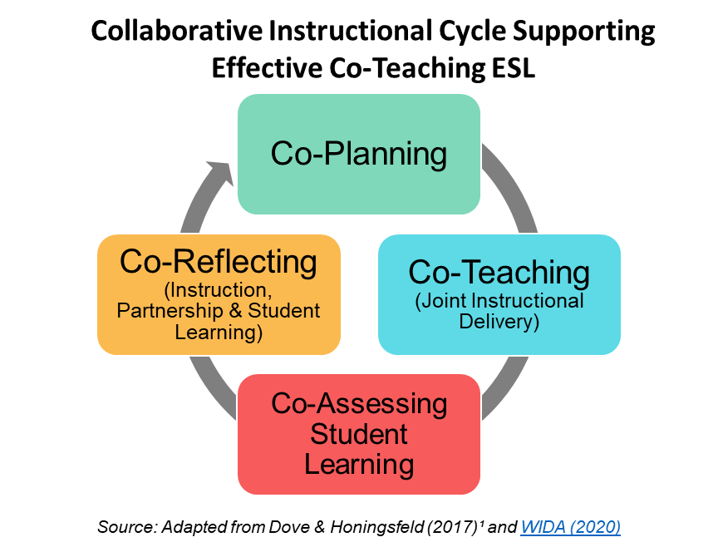
- Establish a collaborative school culture and supporting conditions.
Source: Adapted from Dove & Honingsfeld (2019) and WIDA (2020)
- Build trust, psychological safety, and skills for joint work to support a collaborative approach promoting the success of all students.
- Co-develop shared school mission and vision, student learning goals, collaborative professional strategies, and instructional practices to support English learners’ success with educators, staff, students, and families.
- Model collaborative and distributed leadership practices with relevant leaders (teachers, coaches, department heads and team leaders, families, students, community etc.).

- Collaboratively develop a vision for Co-Teaching ESL.
- Engage in professional learning with other school leaders and educators to build a shared understanding about Co-teaching ESL.
- Develop a vision for Co-teaching ESL that describes what it is, how it supports students’ language development as part of the school’s English Learner Education program, and shared co-teaching models, practices and/or strategies to implement it.
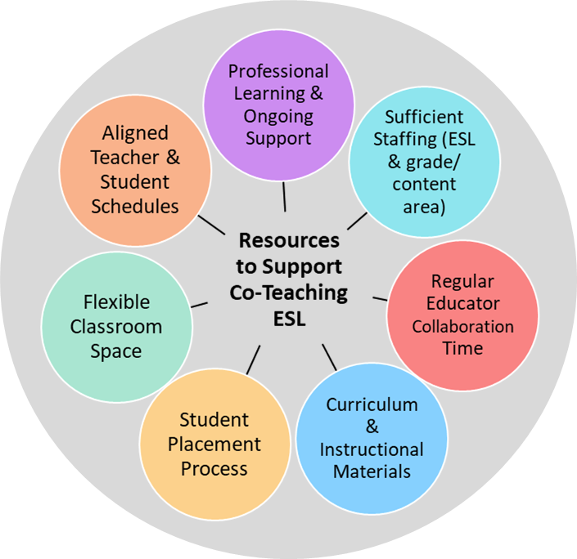
- Establish a multi-year rollout plan and leverage resources to support Co-Teaching ESL.
- Conduct a needs assessment to evaluate current school climate, student needs, and educator collaborative practices.
- Develop short- and long- term goals and plans for acquiring and/or developing needed resources and conditions to support Co-teaching ESL.
- Identify and recruit an initial cadre of ESL and grade/content area teachers interested in piloting co-teaching ESL and expand from there.

- Carefully develop and support educator’s co-teaching partnerships.
- Establish clear expectations and roles for co-teachers based on individual teacher expertise and shared responsibility for English learners’ success. Give examples of what these expectations look like in practice and develop tools for identifying whether expectations are met (walkthrough or classroom observation tools, etc.).
- Provide ongoing and sustained joint professional learning focused on co-teaching ESL practices and strategies.
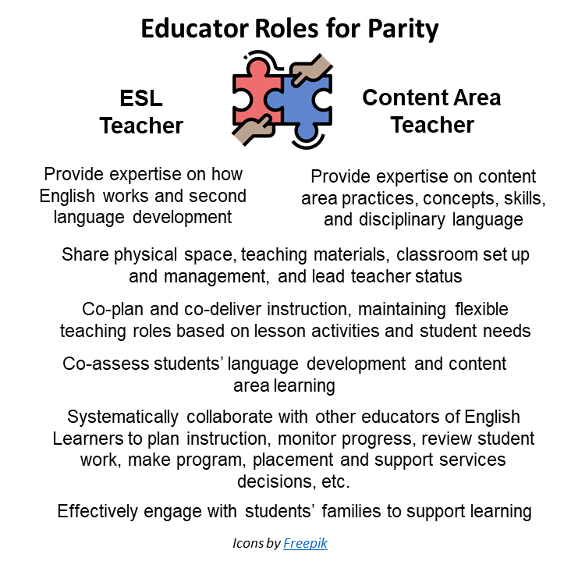
- Hold all teachers accountable for their role in supporting English learner success through educator evaluation processes.

- Provide dedicated, regular, and sustained collaboration time for co-teachers and other educators of English learners.
- Design school and teacher schedules to support co-teaching (providing enough time for teachers to engage in key tasks across the co-teaching cycle; providing paid time in the summer for teachers to set up their partnership and develop ESL curriculum for co-teaching before they start delivering instruction together, etc.).
- Provide collaboration time, space and other resources for co-teachers and others to collaborate on key instructional tasks.
- Protect collaborative planning time from changes in the school schedule.

- Collaboratively develop school and teacher schedules to incorporate Co-Teaching ESL.
- Provide sufficient dedicated time for ESL instruction (at least a full class period).
- Collaborate with ESL, content area, special education teachers and other relevant staff (such as guidance counselors) when planning schedules to ensure ESL does not interfere with English learners’ access to core content instruction, support services, available opportunities that support student growth (electives, specials, advanced courses, extracurriculars, etc.) or opportunities for educator collaboration.
- Carefully monitor ESL teachers’ schedules to ensure a manageable caseload (1-3 co-teaching partnerships balanced by sufficient planning time, etc.).
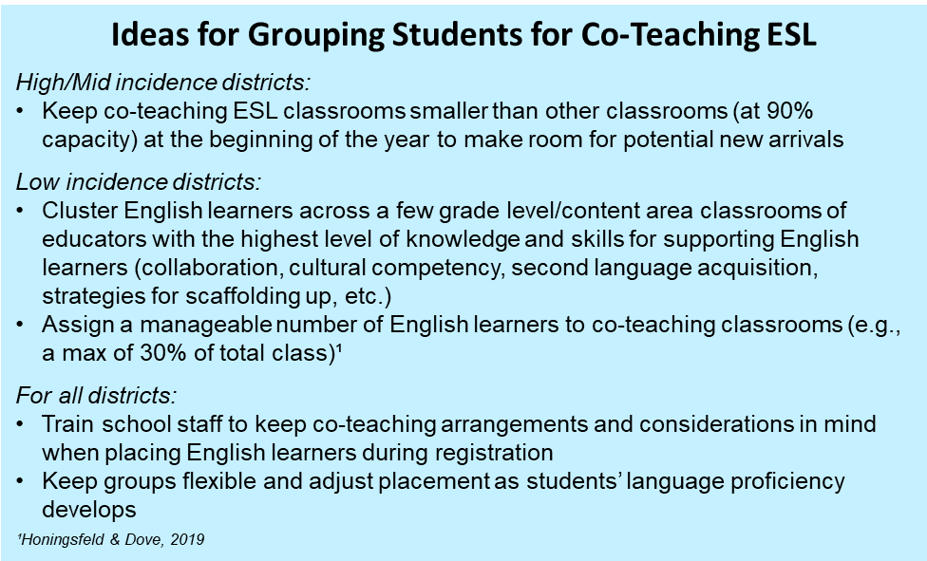
- Strategically assign students to co-taught classrooms.
- Attend to students’ English language proficiency levels, grade levels, strengths, previous literacy and school experiences, first language, exceptional abilities, need for additional services, etc. when developing schedules.
- Ensure classroom space is appropriate for co-teaching (appropriate size and flexible furniture that can be arranged differently based on co-teaching models, etc.).
- Review individual students’ schedules to ensure they receive recommended hours of ESL instruction.

- Provide resources for co-teachers to develop and/or select an ESL core curriculum and related instructional materials that are grade-level appropriate, rigorous, language-driven, and integrated.
- Support development and/or selection of ESL curriculum focused on how English works and drawing topics and habits of mind from content standards to ensure language is taught within rich, contextualized, and meaningful circumstances.
- Ensure curriculum and instructional materials capitalize on students’ full language repertoires (first language and English), connect to and positively represent students’ racial/ethnic, language, and cultural backgrounds, promote critical consciousness and civic engagement, and support social and emotional learning.
- Provide time, funds, professional learning, and collaboration time to support joint ESL curriculum development.

- Promote co-teachers’ use of data to make instructional, programmatic and placement decisions.
- Identify formative assessment and other data from Self-Contained ESL that would be most helpful for teams serving the same group of English learners to review.
- Provide regular opportunities for teachers to discuss student performance/student work data from content area, electives, and/or specialist classes during collaboration time or professional development.
- Establish data systems and processes for ESL and other educators to collaboratively gather, analyze, and use evidence about English learners’ progress.

WHAT TO LOOK FOR in Co-Teaching ESL Classrooms

The following tool can be used to identify practices associated with the Features of High-Quality ESL Instruction as defined in Massachusetts (icons in the table below represent where Features are incorporated). It is not intended as a comprehensive list for classroom observation or evaluation. Rather, it is intended as tool for capturing a quick scan or snapshot of relevant student and teacher actions one would expect to during Co-teaching ESL instruction.

Learning Environment
Physical Space:  - Is clean, safe, well-lit, and organized  - Includes flexible furniture and sufficient space to accommodate co-teaching models  - Showcases student work  - Showcases parity among co-teachers (shared space for personal belongings and teaching materials, etc.) |  |  | Support for Social and Emotional Learning (SEL):  - Posted norms/shared expectations for positive interactions  - Charts with examples of positive discourse, thinking moves, and high expectations for achievement  - Posted information/visuals promoting SEL competencies (self- and social awareness, self- and relationship management, etc.)  - Clear, scaffolded/supported presentation of classroom routines and expectations for behavior | Culturally & Linguistic Sustaining Environment:  - Wide range and abundance of books and print material  - Culturally relevant literature depicting students’ cultures in a balanced way  - Bilingual books and media  - Posters/charts/visuals related to relevant cultural, linguistic, ethnic and/or racial topics and representative of students’ backgrounds | Equal Status Between Co-Teachers:  - Students interact comfortably with both teachers  - Teachers share roles & responsibilities throughout lesson (co-teaching, co-assessing, managing behavior, etc.)  - Student grouping and teacher roles reflect co-teaching models appropriate for each activity (two teach; one teaches and one assesses; etc.)  - Teachers demonstrate respect and collegiality for each other  - Teachers move fluidly through lesson (showcasing co-planning)
Instruction
 |  | Assets Orientation: Instruction leverages students’ first languages, cultures, funds of knowledge, previous experiences and other assets or strengths and connects to students’ life outside of school. It builds on what students can do and incorporates deliberate and appropriate scaffolds. It is carefully planned and adjusted in real time based on student progress.
Students:  - Connect and integrate ideas using language/s (home and/or English), cultural assets, and prior knowledge  - Deepen understandings by building on prior knowledge/ideas and/or the ideas of others; acknowledge and value the ideas of peers  - Use multimodal materials and scaffolds for purposeful learning of content, analytical practices, and language  - Use and encourage/promote peers to express ideas in their home language/s  - Use learning supports, scaffolds and tools to engage in productive struggle with complex texts, tasks, concepts, and topics  - Communicate in ways that are respectful of diverse perspectives and inclusive of voices represented in the classroom |  |  |  | Teachers:  - Model/provide models of expectations, support students in understanding a task, and gradually increase student independence  - Promote bi/multilingualism as a resource for engaging and cognitively challenging students, and supporting language development (use translanguaging strategies, provide primary language support, etc.)  - Implement carefully sequenced and structured activities based on students’ strengths and needs and building in complexity  - Draw from students’ prior knowledge, cultural and linguistic resources, and skills during instruction  - Provide varied and flexible scaffold and supports, and adjust instruction based on student progress and needs  - Incorporate perspectives from groups traditionally underrepresented, especially those reflecting students’ backgrounds, in relationship to topics discussed
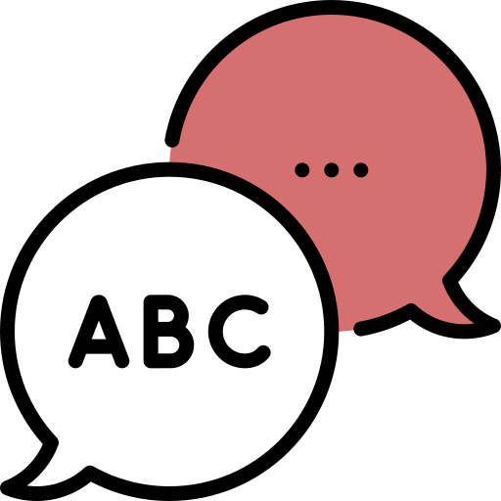 | Language Focus and Authentic Interactions: Instruction promotes students’ ability to use English for academic, social, and instructional purposes across modes of communication. It makes language visible, focusing on discourse practices, grammatical structures, and vocabulary in English within rich, contextualized, and meaningful circumstances. It provides multiple and extended opportunities to develop understanding of concepts.
Students:  - Refine their communication using formulaic expressions, multiple representations, metaphors, and examples  - Negotiate meaning using peers as resources  - Engage in discussions and interactions requiring authentic communication  - Use target language functions and features to make meaning and communicate across modes (listening, speaking, viewing, writing, representing, and viewing)  - Are actively engaged in learning as evidenced by participation  - Showcase deep learning about a topic or text, their own ideas or perspectives about a topic or text, and/or engagement with culturally and linguistically relevant topics orally and/or in writing  - Practice language resources across language dimensions (word/phrase, sentence, discourse) |  |  |  | Teachers:  - Use purposeful, flexible student grouping and co-teaching models depending on the focus/purpose of the lesson  - Provide opportunities for engagement, reciprocal interaction, and student talk (teacher and student co-facilitation, discussions, dialogue, debates, cooperative learning structures, etc.)  - Differentiate tasks and interactions based on students’ needs  - Provide visuals or charts with academic conversation moves, protocols, and language (models/exemplars, student/class generated, variety of text types, processes for group work, etc.)  - Explicitly teach language resources via modeling, analysis of multimodal texts, and opportunities to use language for different purposes, audiences, and roles  - Balance teaching of language forms and functions with activities focused on meaning making and communication
 | Rigorous Opportunity to Learn: Instruction is standards-based and intellectually stimulating, incorporating purposeful and grade-level appropriate tasks. It helps students to learn and use strategies for thinking (metacognitive) and using language (metalinguistic). It is based on evidence from ongoing formative assessment and other evaluation methods, providing opportunities for teachers and students to use this information for learning.
Students:  - Engage in productive struggle to accomplish tasks in the "zone of proximal development"  - Offer peers respectful, accurate, and useful feedback  - Adjust learning tactics and language use based on feedback received from peers or teacher  - Engage with relevant, grade appropriate concepts and practices connected to substantive topics (social and instructional language, content areas, civic life, college and career, social justice, etc.)  - Engage in interactions and activities focused on analytical practices (analyzing, asking questions, elaborating, justifying, critiquing, synthesizing, etc.) and key language uses (argue, inform, explain, etc.)  - Take language and cognitive risks, asking questions and sharing ideas even when they do not have the “right answer” |  |  |  | Teachers:  - Use specific moves to invite and support students to participate in productive struggle (strategic questions, accountable talk moves, etc.)  - Provide rigorous, grade-level and intellectually challenging instructional tasks, materials, and resources  - Incorporate outcomes (unit goals and lesson objectives/targets) aligned to standards (WIDA English Language Development Standards Framework, 2020 Edition and Massachusetts Curriculum Frameworks)  - Provide learning opportunities that are open-ended and connected to meaningful real-life contexts (performance tasks, inquiry- and/or project-based learning, etc.)  - Provide opportunities for student choice, voice, and self-advocacy  - Incorporate various formative assessment strategies to monitor student progress and adjust instruction

Instructional Planning Resources

DESE Practical Tools and Resources
Acceleration Roadmap provides tools for teachers and leaders to support acceleration of student learning in the 2021–22 school year. It is designed to provide a focused and phased approach to supporting students as they return to school in the new academic year (see Classroom Educator Edition, especially Phase 4 - Priority 3: Reflect on Instructional Practices and Set Professional Learning Goals on p. 20, Appendix A: Actions and Resources to Provide Instruction with Just-in-Time Scaffolds on p. 21-23, and High-Quality Instructional Materials and Grade-Appropriate Assignments on p. 25-26).
English Learner Collaboration Tool and Interactive Collaboration Tool helps curriculum writers develop unit-level language goals that integrate language development and analytical practices connected to content areas.
ESL Model Curriculum Units and Instructional Videos provide sample ESL units aligned to the Massachusetts definition of ESL across grade levels and related videos showcasing units being implemented educators can adapt to use in their own context.
Culturally Responsive Look-Fors for OPTIC Focus Elements lists observable, culturally responsive teacher and student actions, or look-fors, for a subset of focus elements from the Classroom Teacher Model Rubric. These look-fors represent great teaching for all students and can be used to support calibration training, professional development, observations, feedback, and/or coaching.
Culturally Responsive Schools and Classrooms Online Module/Guide presents a framework and ideas for providing culturally responsive instruction.
Culturally Responsive Teaching & Leading provides resources that define cultural responsiveness and address its importance in our schools and classrooms, including professional development tools supporting culturally responsive teaching (such as the Culturally Responsive Teaching Rubric).
Inclusive Practice Tool: Master Schedule Review provides guiding questions and pointers for reviewing master schedules to ensure alignment with best practices for inclusion.
Mass Literacy provides resources to empower educators with the evidence-based practices for literacy that all students need, including evidence-based instruction, for students in grades K-3.
Next Generation ESL Resource Guide provides tools and resources for developing curriculum aligned to the Massachusetts definition of ESL instruction and Next Generation ESL curriculum development approach.
Next Generation ESL Toolkit provides resources for implementing Self-Contained ESL such as the Features of High-Quality ESL, Foundational Understandings (includes the Next Generation ESL Theory of Action), and tools and resources for curriculum development.

DESE Guidance
Dual Language Education Programs provides information for supporting English learners in Two-Way and One-Way Immersion Programs, which include ESL as a key component.
English Learners with Disabilities provides information and resources for supporting this population of students (within the Guidance for Supporting ELs with Disabilities, see p. 7-8 for ideas on how to select appropriate accommodations and English Learner Education Programs and students with Disabilities - p.14-15).
ESL Best Practices QRGs provide guidance on key groups of English learners (Newcomers, students designated as Long-term English learners, English learners with Disabilities, Students with Interrupted and/or Limited Formal Education) and topics (Focus on Oral Language Development for English Learners, Early Literacy and English Learners, Formative Assessment, Collaboration with Content Area Teachers, Social Justice and Racial Equity and School Leadership).
ESL Implementation QRGs provide guidance for structuring different ESL instructional delivery approaches beyond co-teaching ESL (pull-out, push-in, embedded, and self-contained ESL).
Guidance for Sheltered English Immersion (SEI) Programs provides information for supporting English learners in SEI programs, including Appendix F: Scenarios include sample schedules for students and schools, several of which showcase Self-Contained ESL (Scenario 1: Middle School Student Schedule, p. 2-5; Scenarios 3 and 5: High School Student and ESL Schedules, p. 10-12 and 16-18; Scenario 4: Elementary Master and ESL Teacher Schedule, p. 13-15).
Students with Limited or Interrupted Formal Education (SLIFE) Definition and Guidance provides information and resources for supporting SLIFE students (see Part 3 and Appendix E of the Definition and Guidance document for instructional planning resources).
Transitional Bilingual Education (TBE) Programs provides information for supporting English learners in TBE Programs, which include ESL as a key component.
What ESL instructional delivery approach works best for a given district or school? describes key considerations to keep in mind when developing programming for English learners.

Federal Resources
Aligning Structural And Instructional Practices To Promote English Learner Success During the 2020–21 School Year outlines a Theory of Action (TOA) for English Learners’ education and related evidence-based strategies for instruction and systemic action. Systemic Actions and Leadership Strategies to Support Quality Instruction (slides 53-62) provides recommendations for school leaders.
Culturally Responsive School Practices to Promote the Success of Hispanic English Learners outlines strategies for supporting English learners including classroom level strategies for being culturally responsive (slide 29), translanguaging strategies (slides 30-31), culturally responsive social and emotional learning (slides 33-36) and culturally responsive strategies for promoting student voice (slides 37-40).
Teacher Collaboration: Aligning Content and Language Instruction examines the policy context for content and language teacher collaboration, shares research-based practices and resources, and highlights promising practices for teacher collaboration and professional development to better support English learners (see also webinar recording).

Other Featured Resources
50 Ways to Keep your Co-Teachers: Strategies for Before, During and After Co-Teaching presents actions school leaders and educators can take to structure, implement, and support effective co-teaching.
A Functional Approach to Language Development for Dual Language Learners provides an overview of how educators can use functional approaches drawing on the WIDA English Language Development Standards Framework, 2020 Edition.
Collaborative Planning for Content and Language Integration provides an example showcasing initial steps educators can take to promote language development in content area learning using the WIDA ELD Standards, 2020 Edition. Educators can adapt this process and use it to collaborative develop curriculum for ESL instruction (p. 234 - 250).
Collaboration: Working Together to Serve Multilingual Learners defines collaboration, outlines co-teaching models for content area and ESL teachers, and provides examples of how to use WIDA tools to support it.
Effective Collaboration and Co-teaching Practices for ELL Success provides information about the expertise educators in different roles bring to co-teaching partnerships (slides 12-14), a description of co-teaching models or approaches (slides 21-33) and look fors that indicate teacher parity in co-teaching contexts (slide 35).
Communicating and Collaborating in Co-Taught Classrooms describes ways co-teachers can understand and respond effectively to their co-teacher’s interpersonal style to maximize the professional satisfaction
and success of co-teaching arrangements.
Culturally Sustaining Pedagogy for/with Emergent Bilinguals presents an introduction to culturally sustaining pedagogy for mathematics classrooms. Ideas presented in this section (and in remaining sections of this online course) can be incorporated into ESL instruction.
Creating a Shared Sense of Responsibility for Teaching English Learners defines shared responsibility and presents a framework school leaders and educators can use to advocate for English learners and support development of shared responsibility for their success (see Professional Development to Share Responsibility for Teaching English Learners (p. 32 and following).
Deliberative Discourse Idealized and Realized: Accountable Talk in the Classroom and in Civic Life outlines instructional practices to support forms and norms of discourse that promote equity and access to rigorous academic learning.
Effective Literacy and English Language Instruction for English Learners in the Elementary Grades and Teaching Academic Content and Literacy to English Learners in Elementary and Middle School outline research-based practices for promoting English learners’ literacy development in grades K-8.
EmpoweringELLs outlines recommendations for teaching English learners from the perspective of an ESL teacher, including general resources that describe co-teaching arrangements (The Models of Co-Teaching and Questions that Drive Co-Teaching), indicators of effective co-teaching partnerships, and suggestions for developing partnerships through the collaboration instructional cycle (see From Temporary Co-Planning to Lasting Engagement, Sustained Co-Planning: Drawing From Your Well, Collaboration Through the End: Co-Constructing Assessments, and BATS: Co-planning deliverables).
English Learner Toolkit of Strategies - Chapter 4: Instructional Strategies (p. 24 and following) describes strategies for supporting English Learners during instruction.
Essential Actions Handbook describes and illustrates the standards-referenced components and elements of language learning within WIDA’s standards framework. Each Essential Actions is derived from current theory and research and ideas for how educators could implement them.
Finding Time for Collaborative Planning presents six strategies for finding sufficient time for educator collaboration and examples of how schools implemented the strategies.
Future Protocol a.k.a. Back to the Future provides a protocol educators can use to expand and clarify vision of what they are trying to achieve, identify opportunities and avenues for strategic planning, guide purposeful actions that consider challenges, timeline, resources, and outcomes and increase the likelihood that the vision becomes reality.
Guidebook on Designing, Delivering and Evaluating Services for English Learners presents promising practices for teaching English learners, many of which correspond to the Features of High-Quality ESL (see p. 42-54 for explanations of promising practices, Appendix M: Core ESL Instructional Practices Teacher Self-Assessment Guide, and Appendix W: Educating ELs at the High School Level).
Maintaining High Challenge and High Support for Diverse Learners discusses how a balance of high challenge and high support provides the right context for learning and growth.
Meaningful Classroom Talk: Supporting English Learners’ Oral Language Development presents guidelines for ensuring all English learners have opportunities to use oral language in academic settings and for teachers to leverage classroom interactions to promote language development, content knowledge and analytical practices.
Quality Student Interactions: Why Are They Crucial to Language Learning and How Can We Support Them? provides a rationale for the essential role of social interactions for students, describes quality student interactions and ways to make them happen, and provides a classroom vignette illustrating them.
Scheduling for Coteaching and Other Inclusive Practices presents strategies for structuring co-teaching with special education teachers. Educators can build on ideas presented and adapt them to support co-teaching ESL (see ideas for scheduling (p. 2-3), a three-part co-planning model (p. 17, 20-21), a co-panning protocol (p.19), and resources for co-planning (p. 22).
St. Louis Co-Teach ELL Regional Initiative presents one district’s example of implementing co-teaching ESL, including resources used (co-teaching school based agreement, co-teaching lesson plan template and agenda, observation tool, and student placement recommendations).
The GO TO Strategies: Scaffolding Options for Teachers of English Language Learners, K-12 presents strategies teachers can use for ESL instruction.
The Politics of Collaborative Expertise describes what a model of collaborative expertise would look like and what educators need to do to make it a reality.
What Can Collaboration Look Like with the WIDA ELD Standards Framework? presents steps ESL and content area teachers can take to collaborate on behalf of English learners using the 2020 Edition of the standards.
WIDA English language development standards framework, 2020 edition: Kindergarten–grade 12 presents standards and related resources for supporting English learners’ language development.

For additional resources you mayhttps://www.doe.mass.edu/ele/esl-toolkit/tools-resources/ wish to consult, click here

Little, 1990. The Persistence of Privacy: Autonomy and Initiative in Teachers’ Professional Relations. Teachers College Record 91 (4) 509-536.
In Massachusetts, English Learner Education (ELE) programs include Dual Language Education, Transitional Bilingual Education Programs, and Sheltered English Immersion.

