Overview
Embedded ESL Aligns to:

- Definition of ESL Instruction
- Blueprint for English Learner Success
- NGESL Theory of Action
- Features of High-Quality ESL Instruction
- WIDA ELD Standards Framework and MA Curriculum Frameworks
Embedded ESL is taught by a dually licensed teacher within grade level/content area classrooms. In these cases, the teacher is licensed in both the grade level/content area and ESL, so ESL is built within the school’s master schedule and individual English learners’ schedules. Embedded ESL provides dedicated, systematic, explicit, and sustained standards-based and language-focused instruction connecting to content area topics and analytical practices. It is common at the elementary level and can be especially effective in contexts where a large majority of students are English learners.

Leadership Best Practices for Structuring and Supporting Embedded ESL
The following best practices highlight ways school and district leaders can support Embedded ESL. For educators at the classroom level, the Features of High-Quality ESL Instruction outlines instructional practices educators can leverage to teach ESL across instructional delivery approaches.

- Set a clear vision for how Embedded ESL fits within established programs for English learners.
- Engage educators, English learners, and their families in developing the vision considering local context (school mission, goals, resources, etc.).
- Ensure the vision explains who Self-Contained ESL will support students’ language development alongside other components of the school’s English Learner Education program.
- Include instructional practices that all educators of English learners will implement to support the vision.

- Protect dedicated time for Embedded ESL within the regular schedule.
- Ensure there is a block of time dedicated for Embedded ESL instruction on the schedule (ideally, daily).
- Ensure Embedded ESL does not interfere with students access to core academic instruction.
- Follow up to make sure instructional time for ESL is reallocated, rather than eliminated, when changes to the regular schedule inevitably occur.

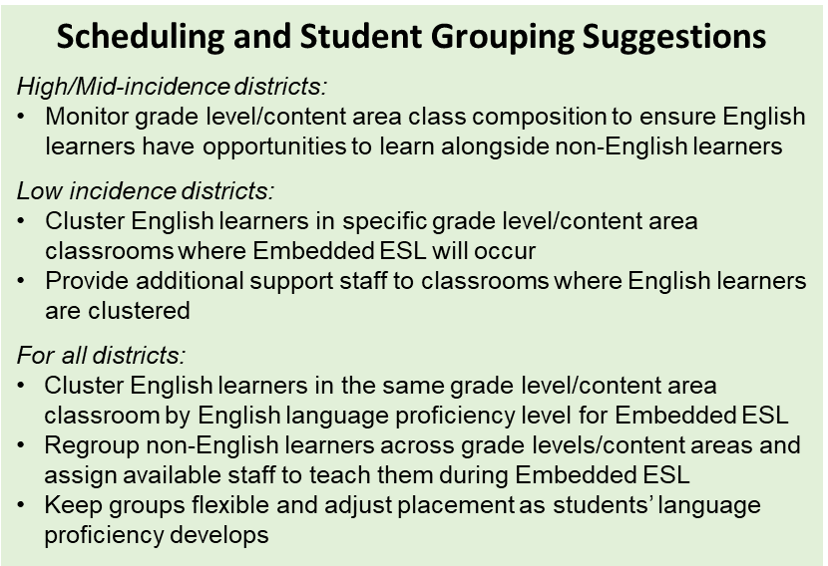
- Strategically develop student schedules and groupings for Embedded ESL.
- Develop student schedules and groupings based on key considerations, such as English language proficiency levels, grade levels, strengths, previous literacy experiences and schooling, first language, exceptional abilities, specific needs for additional support services, years in the U.S., etc.
- Cluster students in classrooms with dually licensed teachers, making sure the number of English learners in one grade level/content area classroom is appropriate for capitalizing on students’ assets and supporting their individual needs.
- Review individual English learners’ schedules to ensure their participation in Embedded ESL does not interfere with their ability to participate in other available opportunities they are interested in, and/or services or supports they need.

- Develop teacher schedules considering how Embedded ESL will be structured.
- Coordinate existing staff, courses (such as specials or electives), and duty schedules to support dedicated ESL instructional time.
- Consider organizing grade level team schedules so students are regrouped for Embedded ESL (English learners staying in classrooms with dually licensed teachers for ESL instruction while non-English learners are taught by other grade level teachers).

- Develop a plan for non-English learners.
- Explicitly discuss plans for non-English learners during ESL instruction, such as literacy centers, small group or independent work related to content area instruction in the same classroom.
- Explore alternatives for grouping and regrouping non-English learners across a grade level/content area team during Embedded ESL.

- Model collaborative practices and provide dedicated, regular, and sustained collaboration time for educators of English learners.
- Design school and teacher schedules to support collaboration among teachers who serve the same group of English learners.
- Focus collaboration time on key instructional tasks (planning units and lessons, shared instructional practices for language development in different contexts, monitoring student progress and adjusting instruction based on data, etc.).
- Discuss what collaboration looks like in practice and provide professional learning on relevant practices.

- Provide resources for developing and/or selecting an ESL core curriculum and related instructional materials that are grade-level appropriate, rigorous, language-driven, and integrated.
- Support development and/or selection of ESL curriculum focused on how English works and drawing topics and practices from content standards to ensure language is taught within rich, contextualized, and meaningful circumstances.
- Ensure curriculum and instructional materials capitalize on students’ full language repertoires (first language and English), connect to and positively represent students’ racial/ethnic, language, and cultural backgrounds, promote critical consciousness and civic engagement, and support social and emotional learning.
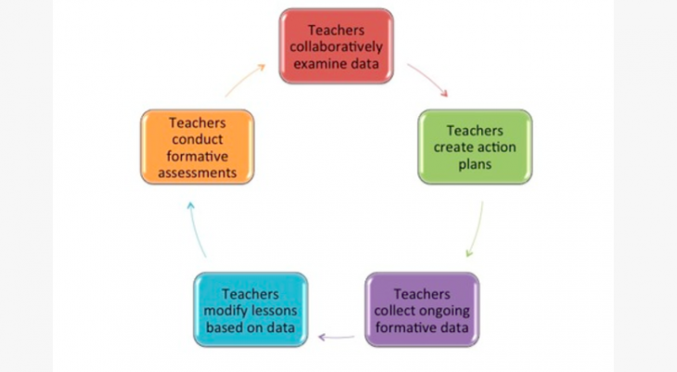
- Provide time, funds, professional learning, and collaboration time to support joint ESL curriculum development.
Data Inquiry Cycle
Source: Adapted from EL Education

- Promote educator use of data to make instructional, programmatic and placement decisions.
- Identify formative assessment and other data from Embedded ESL and content area instruction that would be most helpful to review regularly to monitor student progress.
- Discuss data points that would be helpful for the dually licensed teacher to review with other educators and provide regular opportunities for teachers to discuss student performance/student work data during collaboration time.
- Establish data systems and processes for ESL and other educators to collaboratively gather, analyze, and use evidence about English learners’ progress.

- Hire, develop, support, and empower effective dually licensed educators.
- Explain dual expectations (teaching grade level/content area and ESL) as part of the Embedded ESL teaching role from the beginning. Discuss how performance in each area will be evaluated and incorporate expectations in educator evaluation processes.
- Observe the teacher delivering each type of instruction (grade level/content area and ESL) to ascertain their high expectations for English learners’ success and ability to provide effective, asset-based and culturally relevant/sustaining ESL instruction during designated times.
- Regularly gather input about what logistical items (scheduling, student grouping, etc.) work and what needs improvement from Embedded ESL teachers and use it to inform relevant decision making, such as staffing, student placement, strategic and improvement planning, school and district wide professional learning opportunities, etc.
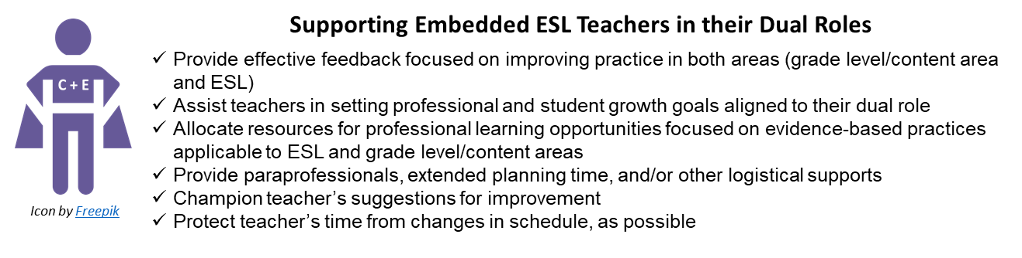

WHAT TO LOOK FOR in Embedded ESL Classrooms

The following tool can be used to identify practices associated with the Features of High-Quality ESL Instruction as defined in Massachusetts (icons in the table below represent where Features are incorporated). It is not intended as a comprehensive list for classroom observation or evaluation. Rather, it is intended as tool for capturing a quick scan or snapshot of relevant student and teacher actions one would expect to see during Embedded ESL instruction.

Learning Environment

Physical Space:  - Is clean, safe, well-lit, and organized  - Includes appropriate equipment and resources to support instruction  - Showcases student work  - Includes appropriate number of students to support a learning community (not too large, not too small), differentiation, and scaffolding |  |  |  | Support for Social and Emotional Learning (SEL):  - Posted norms/shared expectations for positive interactions  - Charts with examples of positive discourse, thinking moves, and high expectations for achievement  - Posted information/visuals promoting SEL competencies (self- and social awareness, self- and relationship management, etc.)  - Clear, scaffolded/supported presentation of classroom routines and expectations for behavior |  | Culturally & Linguistic Sustaining Environment:  - Wide range and abundance of books and print material  - Culturally relevant literature depicting students’ cultures in a balanced way  - Bilingual books and media  - Posters/charts/visuals related to relevant cultural, linguistic, ethnic and/or racial topics and representative of students’ backgrounds
Instruction

 |  |  | Assets Orientation: Instruction leverages students’ first languages, cultures, funds of knowledge, previous experiences and other assets or strengths and connects to students’ life outside of school. It builds on what students can do and incorporates deliberate and appropriate scaffolds. It is carefully planned and adjusted in real time based on student progress.
Students:  - Connect and integrate ideas using language/s (home and/or English), cultural assets, and prior knowledge  - Deepen understandings by building on prior knowledge/ideas and/or the ideas of others; acknowledge and value the ideas of peers  - Use multimodal materials and scaffolds for purposeful learning of content, analytical practices, and language  - Use and encourage/promote peers to express ideas in their home language/s  - Use learning supports, scaffolds and tools to engage in productive struggle with complex texts, tasks, concepts, and topics  - Communicate in ways that are respectful of diverse perspectives and inclusive of voices represented in the classroom |  |  |  |  | Teachers:  - Models/provides models of expectations, supports students in understanding a task, and gradually increases student independence  - Promotes bi/multilingualism as a resource for engaging and cognitively challenging students, and supporting language development (use translanguaging strategies, provide primary language support, etc.)  - Implements carefully sequenced and structured activities based on students’ strengths and needs and building in complexity  - Draws from students’ prior knowledge, cultural and linguistic resources, and skills during instruction  - Provides varied and flexible scaffold and supports, and adjusts instruction based on student progress and needs  - Incorporates perspectives from groups traditionally underrepresented, especially those reflecting students’ backgrounds, in relationship to topics discussed
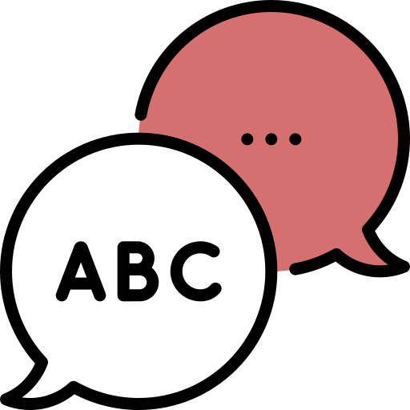 | Language Focus and Authentic Interactions: Instruction promotes students’ ability to use English for academic, social, and instructional purposes across modes of communication. It makes language visible, focusing on discourse practices, grammatical structures, and vocabulary in English within rich, contextualized, and meaningful circumstances. It provides multiple and extended opportunities to develop understanding of substantive topics.
Students:  - Refine their communication using formulaic expressions, multiple representations, metaphors, and examples  - Negotiate meaning using peers as resources  - Engage in discussions and interactions requiring authentic communication  - Use target language functions and features to make meaning and communicate across modes (listening, speaking, viewing, writing, representing, and viewing)  - Are actively engaged in learning as evidenced by participation  - Showcase deep learning about a topic or text, their own ideas or perspectives about a topic or text, and/or engagement with culturally and linguistically relevant topics orally and/or in writing  - Practice language resources across language dimensions (word/phrase, sentence, discourse) |  |  |  |  | Teacher:  - Uses purposeful, flexible student grouping and facilitation strategies (teacher with all students, teacher with small group, small groups, students in pairs, etc.)  - Provides opportunities for engagement, reciprocal interaction, and student talk (teacher and student co-facilitation, discussions, dialogue, debates, cooperative learning structures, etc.)  - Differentiates tasks and interactions based on students’ needs  - Provides visuals or charts with academic conversation moves, protocols, and language (models/exemplars, student/class generated, variety of text types, processes for group work, etc.)  - Explicitly teaches language resources via modeling, analysis of multimodal texts, and opportunities to use language for different purposes, audiences, and roles  - Balances teaching of language forms and functions with activities focused on meaning making and communication
 |  | Rigorous Opportunity to Learn: Instruction is standards-based and intellectually stimulating, incorporating purposeful and grade-level appropriate tasks. It helps students to learn and use strategies for thinking (metacognitive) and using language (metalinguistic). It is based on evidence from ongoing formative assessment and other evaluation methods, providing opportunities for teachers and students to use this information for learning.
Students:  - Engage in productive struggle to accomplish tasks in the "zone of proximal development"  - Offer peers respectful, accurate, and useful feedback  - Adjust learning tactics and language use based on feedback received from peers or teacher  - Engage with relevant, grade appropriate concepts and practices connected to substantive topics (social and instructional language, content areas, civic life, college and career, social justice, etc.)  - Engage in interactions and activities focused on analytical practices (analyzing, asking questions, elaborating, justifying, critiquing, synthesizing, etc.) and key language uses (argue, inform, explain, etc.)  - Take language and cognitive risks, asking questions and sharing ideas even when they do not have the “right answer” |  |  |  |  | Teacher:  - Uses specific moves to invite and support students to participate in productive struggle (strategic questions, accountable talk moves, etc.)  - Provides rigorous, grade-level and intellectually challenging instructional tasks, materials, and resources  - Incorporates outcomes (unit goals and lesson objectives/targets) aligned to standards (WIDA English Language Development Standards Framework, 2020 Edition and Massachusetts Curriculum Frameworks)  - Provides learning opportunities that are open-ended and connected to meaningful real-life contexts (performance tasks, inquiry- and/or project-based learning, etc.)  - Provides opportunities for student choice, voice, and self-advocacy  - Incorporates various formative assessment strategies to monitor student progress and adjust instruction

Instructional Planning Resources

DESE Practical Tools and Resources
Acceleration Roadmap provides tools for teachers and leaders to support acceleration of student learning in the 2021–22 school year. It is designed to provide a focused and phased approach to supporting students as they return to school in the new academic year (see Classroom Educator Edition, especially Phase 4 - Priority 3: Reflect on Instructional Practices and Set Professional Learning Goals on p. 20, Appendix A: Actions and Resources to Provide Instruction with Just-in-Time Scaffolds on p. 21-23, and High-Quality Instructional Materials and Grade-Appropriate Assignments on p. 25-26).
English Learner Collaboration Tool and Interactive Collaboration Tool helps curriculum writers develop unit-level language goals that integrate language development and analytical practices connected to content areas.
ESL Model Curriculum Units and Instructional Videos provide sample ESL units aligned to the Massachusetts definition of ESL across grade levels and related videos showcasing units being implemented educators can adapt to use in their own context.
Culturally Responsive Look-Fors for OPTIC Focus Elements lists observable, culturally responsive teacher and student actions, or look-fors, for a subset of focus elements from the Classroom Teacher Model Rubric. These look-fors represent great teaching for all students and can be used to support calibration training, professional development, observations, feedback, and/or coaching.
Culturally Responsive Schools and Classrooms Online Module/Guide presents a framework and ideas for providing culturally responsive instruction.
Culturally Responsive Teaching & Leading provides resources that define cultural responsiveness and address its importance in our schools and classrooms, including professional development tools supporting culturally responsive teaching (such as the Culturally Responsive Teaching Rubric).
Inclusive Practice Tool: Master Schedule Review provides guiding questions and pointers for reviewing master schedules to ensure alignment with best practices for inclusion.
Mass Literacy provides resources to empower educators with the evidence-based practices for literacy that all students need, including evidence-based instruction, for students in grades K-3.
Next Generation ESL Resource Guide provides tools and resources for developing curriculum aligned to the Massachusetts definition of ESL instruction and Next Generation ESL curriculum development approach.
Next Generation ESL Toolkit provides resources for implementing Self-Contained ESL such as the Features of High-Quality ESL, Foundational Understandings (includes the Next Generation ESL Theory of Action), and tools and resources for curriculum development.

DESE Guidance
Dual Language Education Programs provides information for supporting English learners in Two-Way and One-Way Immersion Programs, which include ESL as a key component.
English Learners with Disabilities provides information and resources for supporting this population of students (within the Guidance for Supporting ELs with Disabilities, see p. 7-8 for ideas on how to select appropriate accommodations and English Learner Education Programs and students with Disabilities - p.14-15).
ESL Best Practices QRGs provide guidance on key groups of English learners (Newcomers, students designated as Long-term English learners, English learners with Disabilities, Students with Interrupted and/or Limited Formal Education) and topics (Focus on Oral Language Development for English Learners, Early Literacy and English Learners, Formative Assessment, Collaboration with Content Area Teachers, Social Justice and Racial Equity and School Leadership).
ESL Implementation QRGs provide guidance for structuring different ESL instructional delivery approaches beyond embedded ESL (pull-out, push-in, co-teaching, and self-contained ESL).
Guidance for Sheltered English Immersion (SEI) Programs provides information for supporting English learners in SEI programs, including Appendix F: Scenarios include sample schedules for students and schools, several of which showcase Self-Contained ESL (Scenario 1: Middle School Student Schedule, p. 2-5; Scenarios 3 and 5: High School Student and ESL Schedules, p. 10-12 and 16-18; Scenario 4: Elementary Master and ESL Teacher Schedule, p. 13-15).
Students with Limited or Interrupted Formal Education (SLIFE) Definition and Guidance provides information and resources for supporting SLIFE students (see Part 3 and Appendix E of the Definition and Guidance document for instructional planning resources).
Transitional Bilingual Education (TBE) Programs provides information for supporting English learners in TBE Programs, which include ESL as a key component.
What ESL instructional delivery approach works best for a given district or school? describes key considerations to keep in mind when developing programming for English learners.

Federal Resources
Aligning Structural and Instructional Practices To Promote English Learner Success During the 2020–21 School Year outlines a Theory of Action (TOA) for English Learners’ education and related evidence-based strategies for instruction and systemic action. Systemic Actions and Leadership Strategies to Support Quality Instruction (slides 53-62) provides recommendations for school leaders.
Culturally Responsive School Practices to Promote the Success of Hispanic English Learners outlines strategies for supporting English learners including classroom level strategies for being culturally responsive (slide 29), translanguaging strategies (slides 30-31), culturally responsive social and emotional learning (slides 33-36) and culturally responsive strategies for promoting student voice (slides 37-40).
English Learner Toolkit Chapter 2 Tool #2 provides guiding questions to consider when selecting programs for English learners (p. 6-7).

Other Featured Resources
A Functional Approach to Language Development for Dual Language Learners provides an overview of how educators can use functional approaches drawing on the WIDA English Language Development Standards Framework, 2020 Edition.
Culturally Sustaining Pedagogy for/with Emergent Bilinguals presents an introduction to culturally sustaining pedagogy for mathematics classrooms. Ideas presented in this section (and in remaining sections of this online course) can be incorporated into ESL instruction.
Data Inquiry Circles presents a process for examining student data regularly through inquiry circles.
Deliberative Discourse Idealized and Realized: Accountable Talk in the Classroom and in Civic Life outlines instructional practices to support forms and norms of discourse that promote equity and access to rigorous academic learning.
Effective Literacy and English Language Instruction for English Learners in the Elementary Grades and Teaching Academic Content and Literacy to English Learners in Elementary and Middle School outline research-based practices for promoting English learners’ literacy development in grades K-8.
English Learner Toolkit of Strategies - Chapter 4: Instructional Strategies (p. 24 and following) describes strategies for supporting English Learners during instruction.
Essential Actions Handbook describes and illustrates the standards-referenced components and elements of language learning within WIDA’s standards framework. Each Essential Actions is derived from current theory and research and ideas for how educators could implement them.
Finding Time for Collaborative Planning presents six strategies for finding sufficient time for educator collaboration and examples of how schools implemented the strategies.
Future Protocol a.k.a. Back to the Future provides a protocol educators can use to expand and clarify vision of what they are trying to achieve, identify opportunities and avenues for strategic planning, guide purposeful actions that consider challenges, timeline, resources, and outcomes and increase the likelihood that the vision becomes reality.
Guidebook on Designing, Delivering and Evaluating Services for English Learners presents promising practices for teaching English learners many corresponding to the Features of High-Quality ESL (see p. 42-54 for explanations of promising practices, Appendix M: Core ESL Instructional Practices Teacher Self-Assessment Guide, and Appendix W: Educating ELs at the High School Level).
Maintaining High Challenge and High Support for Diverse Learners discusses how a balance of high challenge and high support provides the right context for learning and growth.
Meaningful Classroom Talk: Supporting English Learners’ Oral Language Development presents guidelines for ensuring all English learners have opportunities to use oral language in academic settings and for teachers to leverage classroom interactions to promote language development, content knowledge and analytical practices.
Quality Student Interactions: Why Are They Crucial to Language Learning and How Can We Support Them? provides a rationale for the essential role of social interactions for students, describes quality student interactions and ways to make them happen, and provides a classroom vignette illustrating them.
Reimagining the School Day: Innovative Schedules for Teaching and Learning presents strategies and examples for developing school schedules that incorporate time planning and collaboration, flexible instructional blocks to differentiate content to student need, and opportunities for small group instruction or student-directed learning.
Selecting the Right Instructional Approach for Your Students provides information for needs assessment, a process, and key considerations for selecting instructional approaches for English learners.
The GO TO Strategies: Scaffolding Options for Teachers of English Language Learners, K-12 presents strategies teachers can use for ESL instruction.
TIPS for Administrators, Teachers, and Families: How to Share Data Effectively outlines strategies different stakeholders can use to share student progress data and examples of how these strategies could be put in practice.
Vignette Collection of the California ELA/ELD Standards provides sample scenarios of English Language Development (ELD) instruction. Several designated ELD vignettes showcase embedded and self-contained instruction corresponding to Massachusetts’ definition of ESL instruction (vignette 3.2 on p. 9-12; 3.4 on p. 18-22, 4.2 on p. 40-44, 4.4 on p. 50-54, 5.2 on p. 61-65, 5.4., p. 72-75, and 6.2 on p. 84-88).
What Can Collaboration Look Like with the WIDA ELD Standards Framework? presents steps ESL and content area teachers can take to collaborate on behalf of English learners using the 2020 Edition of the standards.
WIDA English language development standards framework, 2020 edition: Kindergarten–grade 12 presents standards and related resources for supporting English learners’ language development.

For additional resources you may wish to consult, click here

In Massachusetts, English Learner Education (ELE) programs include Dual Language Education, Transitional Bilingual Education Programs, and Sheltered English Immersion.

