Overview
Push-In ESL Aligns to:

- Definition of ESL Instruction
- Blueprint for English Learner Success
- NGESL Theory of Action
- Features of High-Quality ESL Instruction
- WIDA ELD Standards Framework and MA Curriculum Frameworks
Push-in ESL is taught by a licensed ESL teacher within grade level or content area classrooms during designated times in a students’ schedule. It provides dedicated, systematic, explicit, and sustained standards-based and language-focused instruction connecting to content area topics and analytical practices. Push-in ESL may be most appropriate for elementary levels, given instructional and logistical characteristics of secondary settings (large number of students assigned to different content area teachers, scheduling, etc.).
How is Push-in ESL Different from Co-Teaching ESL?

Effective Push-in ESL, as all other ESL delivery instructional approaches aligned to the Massachusetts definition of ESL, requires collaboration among ESL and grade level/content area educators. However, the level and amount of collaboration supporting Push-in ESL may vary. For example, teachers may have regular opportunities to discuss curriculum and student progress or may have dedicated time for jointly developing units and lessons and reviewing student work. This means in practice Push-in ESL may closely resemble Co-teaching ESL. However, Co-teaching ESL involves two educators (ESL and a grade level/content area) sharing full responsibility for a group of students and related instructional tasks (co-planning, co-teaching, co-assessing, and co-reflecting) to support their language development and content learning. Although Push-in ESL teachers may engage in a range of collaborative practices with grade level/content area educators, they do not share instructional responsibilities to the same degree as educators in Co-teaching ESL contexts.

Leadership Best Practices for Structuring and Supporting Push-In ESL
The following best practices highlight ways school and district leaders can support Push-in ESL. For educators at the classroom level, the Features of High-Quality ESL Instruction outlines instructional practices educators can leverage to teach ESL across instructional delivery approaches.
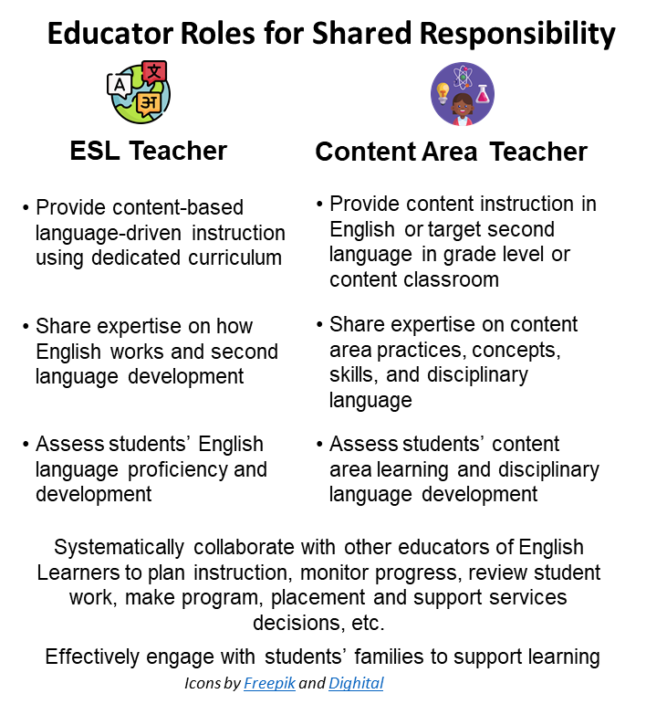
- Set a clear vision for how Push-In ESL fits within established programs for English learners.
- Engage educators, English learners, and their families in developing the vision considering local context (school mission, goals, resources, etc.).
- Ensure the vision explains who Push-in ESL will support students’ language development alongside other components of the school’s English Learner Education program.
- Include instructional practices that all educators of English learners will implement to support the vision.

- Define teacher roles and responsibilities connected the vision in ways that promote shared responsibility and expertise.
- Highlight how each teacher serving English learners is responsible for their area of instruction (i.e., ESL teachers focus on language driven instruction while content area teachers are responsible for content instruction and content area language).
- Discuss expectations for collaboration between grade/level and Push-in ESL teachers that support designated time for language-focused instruction. Provide examples of how collaboration looks like in practice, and routinely follow up to learn about how roles and responsibilities are being implemented.
- Hold all teachers accountable for their role in supporting English learner success through educator evaluation processes.

- Model collaborative practices and provide dedicated, regular, and sustained collaboration time for Push-in ESL teachers and other educators of English learners.
- Design school, teacher, and student schedules to support educator collaboration.
- Focus collaboration time on key instructional tasks (planning units and lessons, shared instructional practices for language development in different contexts, monitoring student progress and adjusting instruction based on data, etc.).
- Provide professional learning focused on collaborative practices to support English learners.

- Designate instructional space within grade level/content classrooms that is conducive to learning.
- Support Push-in ESL and grade level or content area teachers in developing a flexible plan for how classroom space will be shared.
- Ensure space is appropriate for the size of the group and includes appropriate equipment to support instruction.

- Collaboratively develop schedules to incorporate Push-In ESL.
- Collaborate with ESL, content area, special education teachers and other relevant staff (such as guidance counselors) when planning schedules. Discuss how students will transition from grade level/content area instruction to Push-in ESL.
- Ensure sufficient dedicated time for ESL (at least a full class period). Ensure amount of time provided is in keeping with recommended hours for ESL instruction.
- Protect Push-in ESL time from fluctuations in grade level/content area schedules and develop plans to make up lost instructional time due to changes (early release, field trips, assemblies, standardized testing, etc.).
- Schedule Push-in ESL at a time that does not interfere with English learners’ access to core content instruction, support services, and the range of activities available (electives, specials, advanced courses, extracurriculars, etc.) or opportunities for educator collaboration.

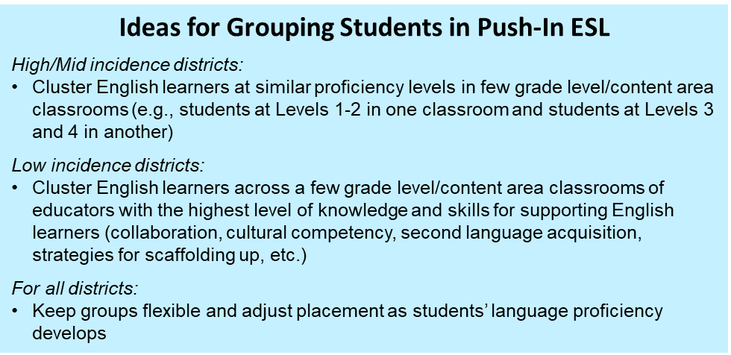
- Strategically group students for Push-in ESL to support scaffolding up and meaningful access to standards-based rigorous instruction.
- Attend to students’ English language proficiency levels, grade levels, strengths, previous literacy and school experiences, first language, etc. when developing schedules.
- Ensure small groups participating in Push-in ESL include enough students to provide a community of learning where students can have quality interactions with each other.
- Review individual students’ schedules to ensure their participation in Push-in ESL does not interfere with their participation opportunities and services of interest or needed by the student.

- Provide resources for developing and/or selecting an ESL core curriculum and related instructional materials that are grade-level appropriate, language driven, and integrated.
- Support development and/or selection of ESL curriculum focused on how English works and drawing topics and practices from content standards to ensure language is taught in rich, contextualized, meaningful circumstances.
- Ensure curriculum and instructional materials capitalize on students’ full language repertoires (first language and English), connect to and positively represent students’ racial/ethnic, language, and cultural backgrounds, promote critical consciousness and civic engagement, and support social and emotional learning.
- Provide time, funds, professional learning, and collaboration time to support joint ESL curriculum development.

- Promote educator use of data to make instructional, programmatic and placement decisions.
- Identify formative assessment and other data from Push-in ESL that would be most helpful for teams to review.
- Provide regular opportunities for teachers to discuss student work during collaboration time or professional development and establish data systems and processes for ESL and other teachers to collaboratively gather, analyze, and use data.

- Hire, develop, and empower effective ESL educators.
- Highlight ESL teachers’ expertise, champion their equal status among educators, and advocate for their role. Ensure they are included in team and school meetings and have an active role in decision-making affecting English learners.
- Monitor ESL teachers push-in caseload and schedule to ensure it is manageable given the range of students they serve.
- Regularly gather input from ESL teachers about what is working/what needs improvement and provide logistical support (changing schedules, physical space, instructional resources, time for collaboration, etc.).
WHAT TO LOOK FOR in Push-In ESL Learning Environments

The following tool can be used to identify practices associated with the Features of High-Quality ESL Instruction as defined in Massachusetts (icons in the table below represent where Features are incorporated). It is not intended as a comprehensive list for classroom evaluation or observation. Rather, it is intended as tool for capturing a quick scan or snapshot of relevant student and teacher actions one would expect to see during Push-in ESL instruction.

Learning Environment

Physical Space:  - Includes appropriate equipment and resources to support small group instruction  - Is appropriate to accommodate the learning community (enough space to comfortably accommodate students and teacher)  - Is free from unnecessary distraction and noise levels that interfere with instruction |  |  | Support for Social and Emotional Learning (SEL):  - Clear, scaffolded/supported presentation of learning routines and expectations for behavior  - Handouts or table resources supporting positive discourse, thinking moves, high expectations for achievement, and SEL competencies (self- and social awareness, self- and relationship management, etc.) |  | Culturally & Linguistic Sustaining Environment:  - Culturally relevant/responsive instructional materials (representative of students’ backgrounds, depicting students’ cultures in a balanced way, connected to students’ experiences, etc.)  - Bi/multilingual books and media
Instruction

 |  | Assets Orientation: Instruction leverages students’ first languages, cultures, funds of knowledge, previous experiences and other assets or strengths and connects to students’ life outside of school. It builds on what students can do and incorporates deliberate and appropriate scaffolds. It is carefully planned and adjusted in real time based on student progress.
Students:  - Connect and integrate ideas using language/s (home and/or English), cultural assets, and prior knowledge  - Deepen understandings by building on prior knowledge/ideas and/or the ideas of others; acknowledge and value the ideas of peers  - Use multimodal materials and scaffolds for purposeful learning of content, analytical practices, and language  - Use and encourage/promote peers to express ideas in their home language/s  - Use learning supports, scaffolds and tools to engage in productive struggle with complex texts, tasks, concepts, and topics  - Communicate in ways that are respectful of diverse perspectives and inclusive of voices represented in the classroom |  |  |  | Teachers:  - Models/provides models of expectations, supports students in understanding a task, and gradually increases student independence  - Promotes bi/multilingualism as a resource for engaging and cognitively challenging students, and supporting language development (use translanguaging strategies, provide primary language support, etc.)  - Implements carefully sequenced and structured activities based on students’ strengths and needs and building in complexity  - Draws from students’ prior knowledge, cultural and linguistic resources, and skills during instruction  - Provides varied and flexible scaffold and supports, and adjusts instruction based on student progress and needs  - Incorporates perspectives from groups traditionally underrepresented, especially those reflecting students’ backgrounds, in relationship to topics discussed
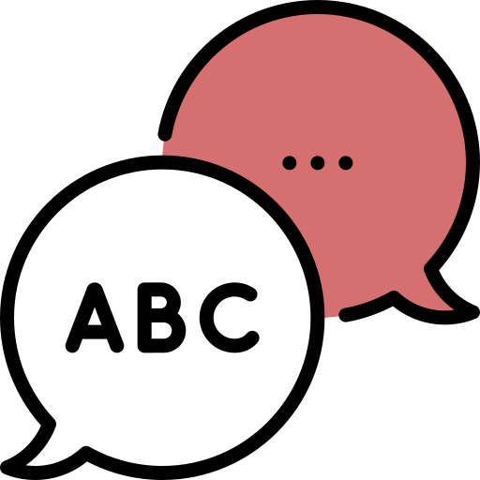 |  | Language Focus and Authentic Interactions: Instruction promotes students’ ability to use English for academic, social, and instructional purposes across modes of communication. It makes language visible, focusing on discourse practices, grammatical structures, and vocabulary in English within rich, contextualized, and meaningful circumstances. It provides multiple and extended opportunities to develop understanding of substantive topics.
Students:  - Refine their communication using formulaic expressions, multiple representations, metaphors, and examples  - Negotiate meaning using peers as resources  - Engage in discussions and interactions requiring authentic communication  - Use target language functions and features to make meaning and communicate across modes (listening, speaking, viewing, writing, representing, and viewing)  - Are actively engaged in learning as evidenced by participation  - Showcase deep learning about a topic or text, their own ideas or perspectives about a topic or text, and/or engagement with culturally and linguistically relevant topics orally and/or in writing  - Practice language resources across language dimensions (word/phrase, sentence, discourse) |  |  |  | Teacher:  - Provides opportunities for engagement, reciprocal interaction, and student talk (teacher and student co-facilitation, discussions, dialogue, debates, cooperative learning structures, etc.)  - Differentiates tasks and interactions based on students’ needs  - Provides resources (handouts, charts, etc.) with academic conversation moves, protocols, and language (models/exemplars, student/class generated, variety of text types, processes for group work, etc.)  - Explicitly teaches language resources via modeling, analysis of multimodal texts, and opportunities to use language for different purposes, audiences, and roles  - Balances teaching of language forms and functions with activities focused on meaning-making and communication
 | Rigorous Opportunity to Learn: Instruction is standards-based and intellectually stimulating, incorporating purposeful and grade-level appropriate tasks. It helps students to learn and use strategies for thinking (metacognitive) and using language (metalinguistic). It is based on evidence from ongoing formative assessment and other evaluation methods, providing opportunities for teachers and students to use this information for learning.
Students:  - Engage in productive struggle to accomplish tasks in the "zone of proximal development"  - Offer peers respectful, accurate, and useful feedback  - Adjust learning tactics and language use based on feedback received from peers or teacher  - Engage with relevant, grade appropriate concepts and practices connected to substantive topics (social and instructional language, content areas, civic life, college and career, social justice, etc.)  - Engage in interactions and activities focused on analytical practices (analyzing, asking questions, elaborating, justifying, critiquing, synthesizing, etc.) and key language uses (argue, inform, explain, etc.)  - Take language and cognitive risks, asking questions and sharing ideas even when they do not have the “right answer” |  |  |  | Teacher:  - Uses specific moves to invite and support students to participate in productive struggle (strategic questions, accountable talk moves, etc.)  - Provides rigorous, grade-level and intellectually challenging instructional tasks, materials, and resources  - Incorporates outcomes (unit goals and lesson objectives/targets) aligned to standards (WIDA English Language Development Standards Framework, 2020 Edition and Massachusetts Curriculum Frameworks)  - Provides learning opportunities that are open-ended and connected to meaningful real-life contexts (performance tasks, inquiry- and/or project-based learning, etc.)  - Provides opportunities for student choice, voice, and self-advocacy  - Incorporates various formative assessment strategies to monitor student progress and adjust instruction

Instructional Planning Resources

DESE Practical Tools and Resources
Acceleration Roadmap provides tools for teachers and leaders to support acceleration of student learning in the 2021–22 school year. It is designed to provide a focused and phased approach to supporting students as they return to school in the new academic year (see Classroom Educator Edition, especially Phase 4 - Priority 3: Reflect on Instructional Practices and Set Professional Learning Goals on p. 20, Appendix A: Actions and Resources to Provide Instruction with Just-in-Time Scaffolds on p. 21-23, and High-Quality Instructional Materials and Grade-Appropriate Assignments on p. 25-26).
English Learner Collaboration Tool and Interactive Collaboration Tool helps curriculum writers develop unit-level language goals that integrate language development and analytical practices connected to content areas.
ESL Model Curriculum Units and Instructional Videos provide sample ESL units aligned to the Massachusetts definition of ESL across grade levels and related videos showcasing units being implemented educators can adapt to use in their own context.
Culturally Responsive Look-Fors for OPTIC Focus Elements lists observable, culturally responsive teacher and student actions, or look-fors, for a subset of focus elements from the Classroom Teacher Model Rubric. These look-fors represent great teaching for all students and can be used to support calibration training, professional development, observations, feedback, and/or coaching.
Culturally Responsive Schools and Classrooms Online Module/Guide presents a framework and ideas for providing culturally responsive instruction.
Culturally Responsive Teaching & Leading provides resources that define cultural responsiveness and address its importance in our schools and classrooms, including professional development tools supporting culturally responsive teaching (such as the Culturally Responsive Teaching Rubric).
Inclusive Practice Tool: Master Schedule Review provides guiding questions and pointers for reviewing master schedules to ensure alignment with best practices for inclusion.
Mass Literacy provides resources to empower educators with the evidence-based practices for literacy that all students need, including evidence-based instruction, for students in grades K-3.
Next Generation ESL Resource Guide provides tools and resources for developing curriculum aligned to the Massachusetts definition of ESL instruction and Next Generation ESL curriculum development approach.
Next Generation ESL Toolkit provides resources for implementing Self-Contained ESL such as the Features of High-Quality ESL, Foundational Understandings (includes the Next Generation ESL Theory of Action), and tools and resources for curriculum development.
Push-In ESL Scenarios showcase how this instructional delivery approach may look like in practice.

DESE Guidance
Dual Language Education Programs provides information for supporting English learners in Two-Way and One-Way Immersion Programs, which include ESL as a key component.
English Learners with Disabilities provides information and resources for supporting this population of students (within the Guidance for Supporting ELs with Disabilities, see p. 7-8 for ideas on how to select appropriate accommodations and English Learner Education Programs and students with Disabilities - p.14-15).
ESL Best Practices QRGs provide guidance on key groups of English learners (Newcomers, students designated as Long-term English learners, English learners with Disabilities, Students with Interrupted and/or Limited Formal Education) and topics (Focus on Oral Language Development for English Learners, Early Literacy and English Learners, Formative Assessment, Collaboration with Content Area Teachers, Social Justice and Racial Equity and School Leadership).
ESL Implementation QRGs provide guidance for structuring different ESL instructional delivery approaches beyond push-in ESL (pull-out, self-contained, co-teaching, and embedded ESL).
Guidance for Sheltered English Immersion (SEI) Programs provides information for supporting English learners in SEI programs, including Appendix F: Scenarios include sample schedules for students and schools, several of which showcase Self-Contained ESL (Scenario 1: Middle School Student Schedule, p. 2-5; Scenarios 3 and 5: High School Student and ESL Schedules, p. 10-12 and 16-18; Scenario 4: Elementary Master and ESL Teacher Schedule, p. 13-15).
Students with Limited or Interrupted Formal Education (SLIFE) Definition and Guidance provides information and resources for supporting SLIFE students (see Part 3 and Appendix E of the Definition and Guidance document for instructional planning resources).
Transitional Bilingual Education (TBE) Programs provides information for supporting English learners in TBE Programs, which include ESL as a key component.
What ESL instructional delivery approach works best for a given district or school? describes key considerations to keep in mind when developing programming for English learners.

Federal Resources
Aligning Structural And Instructional Practices To Promote English Learner Success During the 2020–21 School Year outlines a Theory of Action (TOA) for English Learners’ education and related evidence-based strategies for instruction and systemic action. Systemic Actions and Leadership Strategies to Support Quality Instruction (slides 53-62) provides recommendations for school leaders.
Culturally Responsive School Practices to Promote the Success of Hispanic English Learners outlines strategies for supporting English learners including classroom level strategies for being culturally responsive (slide 29), translanguaging strategies (slides 30-31), culturally responsive social and emotional learning (slides 33-36) and culturally responsive strategies for promoting student voice (slides 37-40).
English Learner Toolkit Chapter 2 Tool #2 provides guiding questions to consider when selecting programs for English learners (p. 6-7).

Other Featured Resources
A Functional Approach to Language Development for Dual Language Learners provides an overview of how educators can use functional approaches drawing on the WIDA English Language Development Standards Framework, 2020 Edition.
Creating a Shared Sense of Responsibility for Teaching English Learners presents a framework school leaders and educators can use to advocate for English learners and support development of shared responsibility for their success (see Professional Development to Share Responsibility for Teaching English Learners (p. 32 and following).
Collaborative Planning for Content and Language Integration provides an example showcasing initial steps educators can take to promote language development in content area learning using the WIDA ELD Standards, 2020 Edition. Educators can adapt this process and use it to collaborative develop curriculum for ESL instruction (p. 234 - 250).
Effective Literacy and English Language Instruction for English Learners in the Elementary Grades and Teaching Academic Content and Literacy to English Learners in Elementary and Middle School outline research-based practices for promoting English learners’ literacy development in grades K-8.
English Learner Toolkit of Strategies - Chapter 4: Instructional Strategies (p. 24 and following) describes strategies for supporting English Learners during instruction.
Essential Actions Handbook describes and illustrates the standards-referenced components and elements of language learning within WIDA’s standards framework. Each Essential Actions is derived from current theory and research and ideas for how educators could implement them.
Finding Time for Collaborative Planning presents six strategies for finding sufficient time for educator collaboration and examples of how schools implemented the strategies.
Future Protocol a.k.a. Back to the Future provides a protocol educators can use to expand and clarify vision of what they are trying to achieve, identify opportunities and avenues for strategic planning, guide purposeful actions that consider challenges, timeline, resources, and outcomes and increase the likelihood that the vision becomes reality.
Guidebook on Designing, Delivering and Evaluating Services for English Learners presents promising practices for teaching English learners many corresponding to the Features of High-Quality ESL (see p. 42-54 for explanations of promising practices, Appendix M: Core ESL Instructional Practices Teacher Self-Assessment Guide, and Appendix W: Educating ELs at the High School Level).
Maintaining High Challenge and High Support for Diverse Learners discusses how a balance of high challenge and high support provides the right context for learning and growth.
Meaningful Classroom Talk: Supporting English Learners’ Oral Language Development presents guidelines for ensuring all English learners have opportunities to use oral language in academic settings and for teachers to leverage classroom interactions to promote language development, content knowledge and analytical practices.
Quality Student Interactions: Why Are They Crucial to Language Learning and How Can We Support Them? provides a rationale for the essential role of social interactions for students, describes quality student interactions and ways to make them happen, and provides a classroom vignette illustrating them.
Reimagining the School Day: Innovative Schedules for Teaching and Learning presents strategies and examples for developing school schedules that incorporate time planning and collaboration, flexible instructional blocks to differentiate content to student need, and opportunities for small group instruction or student-directed learning.
Selecting the Right Instructional Approach for Your Students provides information for needs assessment, a process, and key considerations for selecting instructional approaches for English learners.
The GO TO Strategies: Scaffolding Options for Teachers of English Language Learners, K-12 presents strategies teachers can use for ESL instruction.
TIPS for Administrators, Teachers, and Families: How to Share Data Effectively outlines strategies different stakeholders can use to share student progress data and examples of how these strategies could be put in practice.
What Can Collaboration Look Like with the WIDA ELD Standards Framework? presents steps ESL and content area teachers can take to collaborate on behalf of English learners using the 2020 Edition of the standards.
WIDA English language development standards framework, 2020 edition: Kindergarten–grade 12 presents standards and related resources for supporting English learners’ language development.

For additional resources you may wish to consult, click here

In Massachusetts, English Learner Education (ELE) programs include Dual Language Education, Transitional Bilingual Education Programs, and Sheltered English Immersion.

