Overview
Newcomers are a special population of English learners who have recently arrived in the United States. They bring rich experiences, language, cultures, customs, and backgrounds that can help them adapt and thrive in a new community. Many also arrive while still building proficiency in both English academic and social instructional language thus require specific instructional considerations and supports to succeed in and out of school. Some newcomers may also have experienced trauma as part of the immigration process. Effective, equitable instruction for newcomers incorporates culturally responsive and sustaining instruction that supports academic achievement, language, and social and emotional learning (SEL).
Who are Newcomers?

“ ‘Newcomer’ is an umbrella term that includes various categories of immigrants who are born outside of the United States. For example, all immigrants are not necessarily English learners as some are fluent in English, while others speak little or no English. Students identified as English learners require assistance with language acquisition, though more than 40 percent of identified English learners are born in the United States.”

Newcomer Toolkit (USDOE, 2017, p. 3)

Potential Strengths and Common Challenges of Newcomers

Challenges  - Adapting to a new country and new culture  - Navigating and understanding a new school system  - Family/Caregiver engagement  - Undocumented status  - Trauma associated with immigration  - Attendance  - High dropout rate  - Completing graduation requirements  - Rolling admissions  - Competing responsibilities (e.g., jobs, child care, etc.) | Opportunities  - Introducing students and families to community resources  - Building empowering school-newcomer family partnerships  - Integrating social-emotional learning into instructional materials, methods, and learning environment  - Creating school teams to monitor attendance and academic concerns  - Keeping expectations and rigor high  - Developing student leaders/mentors to support newly arrived peers  - Providing flexible scheduling whenever possible

Strategies and Best Practices
Supporting newcomers requires specific instructional considerations as educators seek to balance providing rigorous core content instruction while also prioritizing rapid English language development and proficiency. Strategies that work best with this population integrate communication modes (reading, writing, listening, speaking, etc.), foster student-to-student interaction, maintain academic rigor, showcase student learning, and integrate culturally proficient and sustaining SEL practices. To support newcomers, educators can:
- Maintain high expectations aligned to standards and tailor instruction and support to what students can do. Rigorous instruction, rather than “watered down” curriculum, is crucial to newcomers’ success, especially for adolescent newcomers who often have limited time to develop English proficiency and content understanding. It is also an expectation for all educators of English learners, as outlined in the Massachusetts Vision for English Learner Education and Blueprint for English Learner Success (see Pillar 2). The Next Generation ESL approach, tools, resources, and Model Curriculum Units (MCUs) can be a great resource for educators in this endeavor.
Designing and Delivering Rigorous Instruction for Newcomers

- Review Massachusetts Definition of ESL Instruction, related Features of High-Quality ESL Instruction as well as standards (content and language) to understand grade level instructional expectations.
- Incorporate culturally responsive teaching and other appropriate scaffolds and supports to ensure students can meaningfully engage in rigorous instruction.
- Calibrate grading and instruction to what students can do with language to ensure the type of productive struggle conducive to learning.
- Connect to and build from what students know, partnering with families and the community to support classroom learning.

- Teach, model, and scaffold academic conversations. Giving time for newcomers to speak and listen to others is essential, as oral language growth is critical for developing literacy and is a focus of the Massachusetts Curriculum Frameworks. Educators can explicitly teach talk moves, provide related anchor charts and sentence frames, and ensure students have time to talk in class. They can also use strategies such as turn and talks to engage students in academic conversations.

- Teach, model, and scaffold academic writing. Newcomers need instruction focused on the writing process and on expectations of academic writing in the United States. This is especially important as writing styles often differ across cultures. For example, educators can use an adapted Writing with Colors Protocol to demystifies the writing process for newcomers. By using colors to represent elements of good writing such as the topic/theme, explanation, textual evidence, and transition words, newcomers are better able to visualize what is needed in a response and use the colors as a “code” for crafting their own.

- Build background knowledge and connect to students’ lives. To learn new content, all learners must make connections between their prior knowledge and new concepts, but this is often an added challenge for newcomers because their backgrounds and cultures are often different from those presented texts and classrooms. Instead of viewing newcomers’ background knowledge as a deficit, educators can keep in mind that newcomers bring rich experiences and perspectives and tap into this knowledge to support students’ meaning making in classrooms. Educators can first start by getting to know their students, then incorporating what they know into instruction. For example, they can select fictional or informational texts that connect to students’ backgrounds and identities as well as language and content instruction topics and themes.

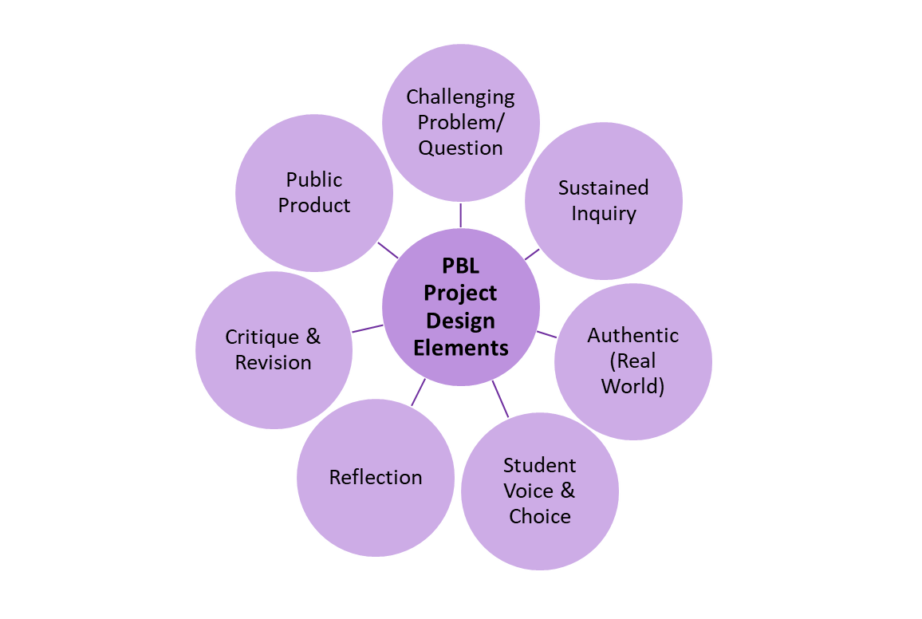
- Incorporate Project Based Learning (PBL). PBL is an engaging and effective way to meet the needs of newcomers who are learning both content and language simultaneously. PBL connects critical thinking, communication, collaboration, and creativity to support student learning. Moreover, high-quality PBL is grounded in SEL competencies including problem solving, reflection, teamwork, evaluating, and showing leadership. It provides newcomers an opportunity to dive deeper into a topic or concept, and showcase understanding. Educators can think critically about projects through communication modes (reading, writing, speaking, listening, etc.) to build language throughout the process by asking themselves: What will newcomers read, write, speak, and listen to? How will the project showcase knowledge and skills across communication modes?
Adapted from Gold Standard PBL: Essential Project Design Elements, PBL Works

- Ensure equitable grading. Examine grading policies to ensure they are fair and connected to expectations for what newcomers can do across English language proficiency levels. Review grading policies using relevant criteria (such as the Five Pillars of Equitably Grading ELLs) as a collaborative team (administrators, teachers, family/caregivers, and students). Rather than defaulting to regular grading policies or giving Pass/Fail grades, ensure that newcomers have multiple ways to engage in and demonstrate learning, and that grades reflect relevant factors including demonstrated learning, effort, motivation, engagement/participation, as well as improvement over time.
Pillars of Equitable Grading for ELs

- Define the standards (content and language)
- Incorporate scaffolding and supports for English learners’ mastery of standards
- Assess English learners’ progress equitably
- Collaborate with other educators, English learners, and their families

Adapted from Staehr Fenner, Kester, & Snyder, 2019

Suggestions for Low, Middle and High-Incidence Districts
Educators across all districts can support newcomers by building on what students can already do, especially drawing on their heritage language(s) to support learning through translanguaging and other strategies.
Educators serving newcomers in low and mid-incidence districts can:
- Provide staff and educators professional learning focused on meeting the specialized needs of newcomers, including strategies for supporting students who recently arrived in the United States.
- Cluster newcomers in classrooms with educators who have demonstrated success in supporting English learners at early English language proficiency levels.
Educators serving newcomers in high-incidence districts can:
- Develop specialized courses and/or programs for newcomers that incorporate literacy development alongside content area and ESL instruction.
- Cluster newcomers who speak similar heritage language(s) in similar classrooms to maximize opportunities for connecting to and drawing from students’ strengths and assets.

Special Considerations: Promoting Newcomers’ Social and Emotional Learning
Creating a welcoming environment is essential for newcomers across instructional settings. Prioritizing SEL for newcomers and attending to their social and emotional learning is an important way to foster a sense of belonging, boost achievement, increase attendance, and maximize student engagement for learning. Educators can promote newcomers’ SEL by:
- Creating a school culture where newcomers and their families are respected, valued, and part of the school. This is especially important for newcomers who may not have other experiences in a U.S. school system. The Massachusetts Blueprint for English Learner Success Pillar 1 Quick Reference Guides provide guidance for establishing effective school cultures for newcomers’ success.
- Implementing Restorative Justice Circle practices to build community and restore relationships, empower victims, and promote accountability as needed. They can benefit English learners by helping educators elevate student voice and address underlying issues that newcomers can face, especially at the high school level. Educators can dedicate time during advisory, homeroom, and/or other classrooms to restorative justice circle dialogues. In low-incidence districts where newcomers are spread out across various classrooms or schools, consider holding these circle discussions virtually.
- Celebrating successes and fostering community connections. Educators can showcase newcomers’ achievements and work and invite students, their families, and community members to school to celebrate them. Displaying student work and encouraging student speakers empowers students and can help create opportunities for positive dialogue between students, family members, and the community. Additionally, community members can share information and resources helpful to newcomers and their families, who may need orientation to available services as recent arrivals.
- Leveraging home visits to learn about newcomers and their families’ strengths, backgrounds, goals, and needs. Home visits demonstrate a commitment to fostering relationships between teachers and newcomer parents and guardians. It allows families to get to know educators in a space they feel comfortable in and can deepen their level of understanding, involvement, and trust in schools. Use Zoom, Google Meets, and WhatsApp to conduct home visits virtually when face-to-face options are not available.
- Integrating content, language, and social and emotional learning. Educators can make connections between their unit and various social-emotional learning competencies by using the CASEL SEL Competency Wheel (see p. 2) during planning. They can select a SEL competency or a sub-competency as the focus for a lesson, group of lessons, or unit alongside other content and language goals or objectives. Linking SEL skills with target language and content can support newcomers in engaging with lessons and units, maximizing their learning. The English Learner Collaboration Tool can also be helpful to groups of educators working together to integrate instruction in these key areas to support the whole child.

Actions-at-a-Glance
Actions for Classroom Educators
- Use academic conversation scaffolds to promote high-quality peer-to-peer interactions.
- Teach newcomers to use bilingual dictionaries and other strategies to scaffold and support academic writing.
- Design PBL projects with newcomers in mind, integrating content, language, and social-emotional learning.
- Develop and implement standards-based high-quality instruction and curriculum drawing from current frameworks (content area, language, SEL) and related resources.
- Continually reflect on the extent to which your learning environment, materials and methods leverage strengths and meet needs of newcomers.
- Use the Next Generation ESL approach and Collaboration Tool to develop language-driven curriculum units.

Actions for School and District Leaders
- Showcase newcomers’ school work and invite families and community members to participate and share resources.
- Implement a home visit program and other strategies to build partnerships with newcomers’ families.
- Consider implementing Restorative Justice Circle practices at the school level to develop supportive school cultures and amplify student voice in classroom, school, and community discussions.
- Develop newcomer programming in ways that do not interfere with core content area instruction (e.g., newcomer programs that include ESL as well as core content area instruction).
- Provide professional learning focused on the specific needs of newcomers.

Instructional Planning Resources

DESE Practical Tools and Resources
ESL Model Curriculum Units provide exemplars of complete units of instruction. Units labeled Levels 1-2 are appropriate for Newcomers and span a range of topics and grade levels including access to clean water, family stories, weathering and erosion, and emotions, among others.
ESL Tools and Resources provides guidance for designing effective ESL instruction, including the Unit and Lesson Planning Thinking Processes and Templates.
English Learner Collaboration Tool supports educators of English learners (ESL, bilingual, grade level/content area, special education) in developing language-driven curriculum aligned to state content area and language standards.
Translanguaging in Curriculum and Instruction provides examples of translanguaging in action at the elementary, middle, and high school level connected to content area standards and sample instructional units at various grade levels that include performance tasks which could be readily implemented with English learners.

DESE Guidance
ESL Best Practices Quick Reference Guides provides guidance on a variety of key topics (formative assessment, racial equity and social justice, early literacy, etc.) as well as English learner student groups (students designated as long-term English learners, English learners with disabilities, etc.).
Guidance on Placement, Progress Monitoring and Reclassification Procedures of English Learners outlines guidance for placing and monitoring English learners at various stages of English proficiency.
Massachusetts Blueprint for English Learner Success unpacks the Massachusetts Vision for English Learner Education, outlining essential conditions and actions educators at the classroom, school, district, and state levels can take to support student success.
Next Generation ESL Curriculum Resource Guide provides support for collaborative ESL curriculum development, including collaborative tools, processes, protocols, and resources used in the development of ESL MCUs.
Social and Emotional Learning in Massachusetts provides guidance and resources for developing students SEL across classrooms and schools.

Federal Resources
Newcomer Toolkit provides a comprehensive guide to challenges and barriers newcomers face, legal requirements of schools towards newcomers, as well as best practices and strategies for supporting newcomers’ success. Chapters provide tools and resources related to key areas for teaching newcomers such as welcoming newcomers (Chapter 2), instruction (Chapter 3), SEL (Chapter 4), and partnering with newcomers’ families (Chapter 5).
Featured Topics: Newcomers provides papers on dedicated programs, academic supports, and social and emotional supports for newcomers, as well as an annotated bibliography and list of government resources to help educators and other key stakeholders to understand and meet the needs of newcomers.

Other Featured Resources
Helping Newcomers Succeed in Secondary Schools and Beyond provides case studies and recommendations for supporting newcomers at the high school level.
Making Your First ELL Home Visit: A Guide for Classroom Teachers provides a process and tips for educators as they start implementing home visits.
WIDA Model Assessment provides a suite of English language proficiency assessments for grades K-12 that educators can use to assess newcomers on arrival and at key points throughout the school year, in between standardized assessments.

For additional resources you may wish to consult, click here.

Massachusetts Department of Elementary and Secondary Education. (2018). Culturally Responsive Social-Emotional Competency Development; Schlund, J., Jagers, R., & Schlinger, M. (2020). Emerging Insights on Advancing Social and Emotional Learning (SEL) as a Lever for Equity and Excellence. Illinois: CASEL.
Wright, W. E. (2015). Foundations for Teaching English Language Learners: Research, Theory, Policy, and Practice (2nd ed.). Pennsylvania: Caslon Publishing; Zwiers, J., & Crawford, M. (2011). Academic conversations: Classroom talk that fosters critical thinking and coherent understandings. Maine: Stenhouse Publishers.
Hansen, C. B. (2019). The heart and science of teaching: Transformative applications that integrate academic and social-emotional learning. New York: Teachers College Press.
CASEL. (2020). CASEL’s SEL Framework. Collaborative for Academic, Social, and Emotional Learning, p. 2.
WIDA. (2020). WIDA English language development standards framework, 2020 edition: Kindergarten–grade 12. Board of Regents of the University of Wisconsin System, p. 28-29.
Jung, L. & Guskey, T. (2010). Grading Exceptional Learners. Educational, School, and Counseling Psychology Faculty Publications. 4.
Short, D. J., & Boyson, B. A. (2012). Helping newcomer students succeed in secondary schools and beyond. Washington, DC: Center for Applied Linguistics. Chapter 4:Connections among newcomer Programs, Families, and Community and Social Institutions, p. 51-60.

