Language Objectives in the Next Generation ESL Model Curriculum Units (MCUs)
When it is clear what teachers are teaching and what students are learning, student achievement increases (Hattie, 2011). In effective ESL lesson planning, language objectives are designed with the intention of making expectations of ESL instruction transparent, explicit, and understood, to both to the teacher and students. Teachers need clear language learning objectives to assess students in an ongoing way, to provide effective feedback to students about how to be successful along the way, and to guide next teacher and student moves in the learning process. The most valuable consumer of language objectives is the student. Students must understand expectations, how the lesson’s tasks and activities relate to those expectations for learning, and how much closer they have come to achieving them by the end. Students help themselves when they understand the intention of learning expectations, and criteria for success.
Teachers help themselves by creating objectives that are as precise as possible. The more precise the language objective, the better the teacher can design and get the lesson accomplished without getting lost. Language objectives help us by explicitly specifying:
- What students need to do.
- What students need to know to be able to do it.
- A way to know that students have done it.
The language objective, aligned to Stages 1 and 2 of the unit, informs and drives the assessment section. The formative assessment component that accompanies the language objective is critical: when connected to visible learning, it allows for data collection and creates opportunities for feedback. Spending a few extra minutes developing well-designed language objectives increases the efficiency of lesson planning.
Language objectives are included in written curricula because ESL teachers use their knowledge of English learners and of the content to design effective curricula that impact students and move them along a continuum of language growth. Each step along this continuum involves teacher assessment and student self-assessment, setting new expectations in the form of language objectives that lead to new language growth. Seeing results, understanding progress, and formulating clear next steps are important to both the teacher and learner. If objectives serve their purpose, and teachers and students use them jointly in the classroom, with purpose, the result for the student is self-motivation, power, and agency in their own learning process and success. Research shows it also results in increased achievement (Hanover Research, 2014).
Language Objectives within the Written Curriculum vs. the Classroom
In written ESL units and lessons, language objectives provide a step-by-step set of curricular expectations and building blocks to larger goals and language growth. They also inform the design of a learning sequence for a particular group of English learners and are based on many forms of student data, assessment data, and knowledge about both students and the subject matter.
In the classroom, and during lessons, posting written language objectives (or reading them out loud) does not necessarily create the visibility and understanding that will help students and teachers working toward the objective. Teachers must also help students develop a deep understanding of what they are supposed to learn, and what success will look like. Language objectives help students see how lesson tasks relate to expectations for learning, and what they are expected to learn by the end of the lesson.
Next Generation ESL Project MCU language objective models—and their component parts, as presented below—explicitly reflect the big picture intention of the focus of ESL instruction: success in language development and academic classes. Language objectives will come alive as educators and students discuss, understand, and co-construct the learning process.
ESL MCU Language Objective Components and Features
- Language function. Language objectives include the language functions inherent in unit FLGs. Sample language functions include, but are not limited to, WIDA English Language Development Standards Framework, 2020 edition Key Language Uses (Narrate, Explain, Argue, and Inform) and the micro functions listed in the English Learner Collaboration Tool (e.g., describe, sequence, evaluate, justify), or ways in which language is used to meaningfully communicate ideas across different contexts. This strategic language use or function is present at all levels of the curriculum and assessment, from the yearlong map to the unit level (through Focus Language Goals or FLGs) to the lesson level (through specific language objectives). Each is part of the language development continuum and houses language development within rich meaningful context.

- Forms and features of academic language. At the lesson level, the language objectives contain the most fine-grain and specific forms and features for language instruction that are embedded in the language functions and Key Uses of Academic Language. Within the WIDA framework, dimensions of language use (WIDA 2020, p. 32-33) are represented across the word/phrase dimension (such as the term “graph”), the sentence dimension (such as the type of sentence: simple, compound, complex, etc.) and the discourse dimension (such as the way in which coherence is achieved through the use of pronouns). Academic language forms and features in the word/phrase, sentence, and discourse dimensions need to be explicitly taught to English learners, and these discrete language building blocks contribute to the broader strategic language uses/functions. Forms and features articulated in the language objective represent an instructional planning prioritization and sequencing of language instruction at the lesson level that leads to longer-term growth and increasingly sophisticated language use.

- Content connection. Along with instruction of key language uses/functions and academic language features and forms, language objectives should include a content connection or analytical practice—something that makes visible the larger thinking that these pieces of language are expressing.
This acknowledges that that at every level of the curriculum, language is a tool for development and communication of meaning, and a lever to academic achievement. Language forms and features are presented as choices at the student’s disposal as he/she constructs and communicates meaning within a given context.
- Language domain. Teachers can include a language domain (listening, reading, writing, speaking) within the language objective. Alternatively, the objective can also be accompanied by a teacher-made visual/symbol referencing L, S, R, or W to further identify focus on a particular domain within which language forms, functions, and features in the lesson objective will be used.
- Differentiation by ELP level. Each lesson in the Next Generation ESL Project MCUs includes a language objective (or objectives) geared toward a range of students within the classroom identified in the unit plan. This is a result of the Stage 1 establishment of skills and knowledge for the unit, prioritized for the proficiency level range targeted in the unit. Even within an ELP level 1–2 classroom, for example, there may be a range of proficiencies across language domains. The teacher may opt to write multiple language objectives differentiated for students at various English language proficiency levels, or may use the same language objective for all students, with different supports and different timeframes for either practice or mastery of particular language uses or forms/features. The important thing is that objectives be intentionally designed based on student learning, making expectations for learning visible to every student and teacher.
- S.M.A.R.T.: Language objectives for each lesson should be:
S = Specific and Strategic. Language objectives should be specific so educators can determine whether they have been achieved. They should also be strategic, i.e., serve an important purpose for students.
M = Measurable. Language objectives should be measurable so that progress toward a goal can be evaluated and managed.
A = Action-oriented. Language objectives should have active, not passive verbs, to showcase how students will engage with lesson tasks and texts to achieve the goal.
R = Rigorous, Realistic, and Results-focused. Language objectives should make clear what will change because this goal has been achieved. Language objectives need to describe a realistic yet ambitious result, stretching students toward learning but not be out of reach.
T = Timed. Language objectives need a final deadline, or expectations for when students will engage with the knowledge and/or skill they incorporate. In this context, we are encouraging teachers to have a clear vision of what students will be able to do by the end of the lesson.
Language Objective Models Incorporating ESL MCU Features
Model 1 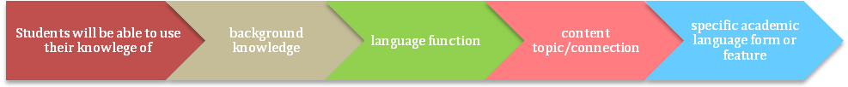
Example:
- Students will be able to use their knowledge of characterization to compare and contrast characters in Maniac Magee using similar to, different from, greater than, and smaller than.
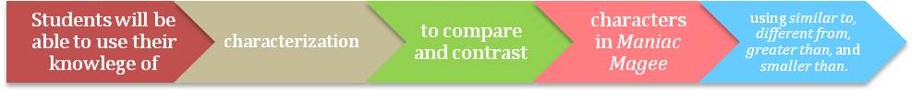
Model 2 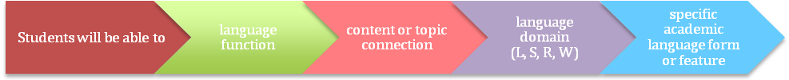
Examples:
- Students will be able to compare and contrast historical accounts from different points of view orally by using similar to, different from, in contrast, and similarly.
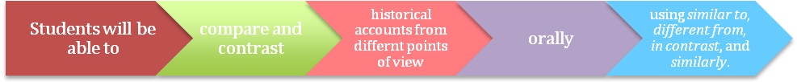
- Students compare and contrast characters using similar to, different from, greater than, and smaller than in a written paragraph.
Model 3 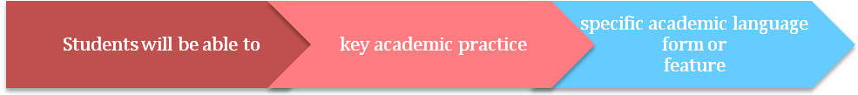
Example:
- Students will be able to state a claim about the Dream Act in a full sentence using the simple present tense.
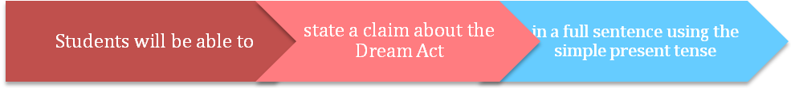
Model 4
Examples:
- Students will be able to compare events of the Civil War using adjectives (e.g., the most significant event, more obstacles than…) and a graphic organizer.
- Students will compare characters in To Kill a Mockingbird using adverb clauses (e.g., Scout…even though…, Although Atticus…) with a partner.
Model 5
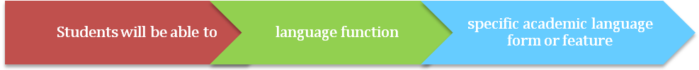
Example:
- Students will be able to report a group consensus using past tense citation verbs: determined, concluded.
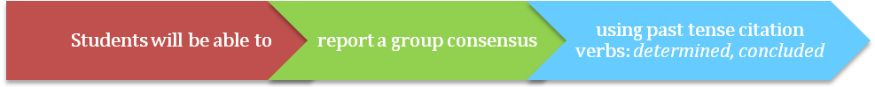
References
WIDA. (2020). WIDA English language development standards framework, 2020 edition: Kindergarten–grade 12. Board of Regents of the University of Wisconsin System.

Adapted from Massachusetts Department of Elementary and Secondary Education (2014), p. 4.

