# Collaboration in ESL Planning

Massachusetts [**guidance**](http://www.doe.mass.edu/ele/guidance/)  for English Learner Education (ELE) programs require that English Learners (ELs) receive both grade-level academic content and English as a Second Language (ESL) instruction that is aligned to both [**WIDA**](https://wida.wisc.edu/) and the [**state curriculum frameworks.**](http://www.doe.mass.edu/frameworks/current.html) The [**Collaboration Tool**](http://www.doe.mass.edu/ele/instruction/collaboration-tool.docx) can help language and content educators collaboratively develop ESL curriculum that is rooted in academic content, and addresses both WIDA *and* state standards.

## How do I use this Guide?

Use this guide to explore the **Collaboration Tool** in more detail. Be sure to have the tool in front of you   
for reference. This guide will walk you through how the Collaboration Tool can be used in ESL   
curriculum development, starting with Focus Language Goals.

## What is a Focus Language Goal?

[WIDA Standards Framework](https://wida.wisc.edu/sites/default/files/resource/WIDA-Standards-Framework-and-its-Theoretical-Foundations.pdf)

At the core of an ESL unit are **Focus Language Goals (FLGs).** The FLGs help to set the **priorities for language-driven curriculum, instruction, and assessment** that address both WIDA and state curriculum frameworks. When thoughtfully planned, FLGs reflect the essential next steps in the students’ development of the English language, while also working toward the skills, knowledge, and analytical practices embedded in the content standards.

[ESL Unit](http://www.doe.mass.edu/ele/instruction/mcu/)

[State Curriculum Frameworks](http://www.doe.mass.edu/frameworks/current.html)



**FLGs**

Using the Collaboration Tool, educators can develop FLGs that drive stage 1 of [Understanding](http://www.ascd.org/research-a-topic/understanding-by-design-resources.aspx) [by Design](http://www.ascd.org/research-a-topic/understanding-by-design-resources.aspx) curriculum planning.

The Collaboration Tool also achieves numerous objectives outside of FLGs, outlined in the Next Generation ESL Project Curriculum [**Resource Guide.**](http://www.doe.mass.edu/ele/guidance/?section=resource-guide#resource-guide)

*THIS DOCUMENT WAS PREPARED BY THE MASSACHUSETTS DEPARTMENT OF ELEMENTARY AND SECONDARY EDUCATION*

# A Close Look at Focus Language Goals



*“The language piece of instruction can sometimes get lost with all the content instruction.* ***The Collaboration Tool*** *helps educators make sure the language instruction isn’t forgotten and is at the forefront of ESL curriculum planning!”*

*–* Liz Hilton, ESL educator, Holden, MA

A **FLG** has two main parts: **key academic practice** (or content standard) and

**language function** (macro or micro).

Generally, key academic practices represent a synthesis of the standards-based practices that students use across classrooms, and language functions are the purposes for which we use language. In our ESL MCU units, we use macro and micro language functions.

Below is an example FLG from the grade band 1-2 [**ESL Model Curriculum Unit (MCU),**](http://www.doe.mass.edu/ele/instruction/mcu/eslg1-2-animals.docx)[**“Animals and Where They Live”.**](http://www.doe.mass.edu/ele/instruction/mcu/)

**EXPLAIN by elaborating to build and present knowledge on a substantive topic**

**Macro Micro Key Academic Practices Grade-level Content Topic**

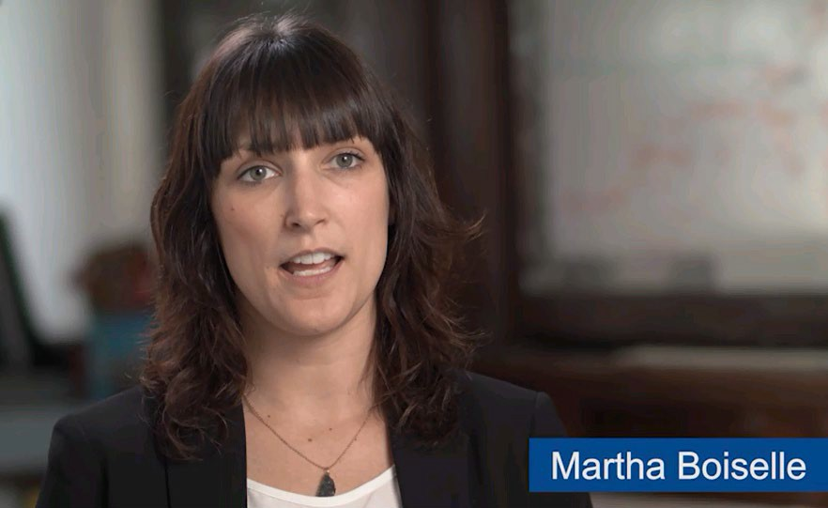We’ll break down the steps to developing a FLG in the next sections.

### Students at the Center

Most of the Model Curriculum Units (MCUs) have no more than 2 FLGs. Keep in mind that FLGs prioritize specific learning outcomes and depth of knowledge versus covering a very wide range in one unit. It is important that FLGs are designed with students at the center and allow ample opportunities for deep learning through contextualized experiences. **We want our students to become increasingly aware and strategic in their use of language to negotiate meaning in various contexts.**

[HEAR FROM A BOSTON EDUCATOR ON THE VALUE OF FLGS](https://youtu.be/-V6RKEEA2Jg)

# Building a Focus Language Goal

Each part of the Collaboration Tool focuses on a core component to an effective FLG. We’ll start with making the content connection.

**Step 1: Make the Content Connection**



Check mark **First, know your students:** What is the grade level or grade band and what is the ELP range?

check mark **Next, determine the content area** to which your ESL unit will connect.

**When choosing a content area for your unit,** think about your...

* Short-term plans: Within your current sequence of units, development of language, knowledge, and analytical skills, what are your students’ immediate needs in terms of language and academic practices?
* Long-term plans: What are your district’s curriculum maps? How will you address the language of the different content areas, and WIDA’s overarching standards, throughout the year?

At the top of the Collaboration Tool, you’ll see a space to identify the content area, or the equivalent of the five broad WIDA standards.

*The unit will address the language of the content area:*

[**WIDA Standards:**](https://wida.wisc.edu/sites/default/files/resource/2012-ELD-Standards.pdf) *Social Instructional Language (SIL), Language of Language Arts (LoLA), Language of Math (LoMA), Language of Science (LoSci), Language of Social Studies (LoSS)*

#### Check mark Now, build in the specific academic context.

Each content area uses a *wide range* of language. ESL units need to prioritize high-leverage language instruction so students have the tools they need to **meaningfully engage in academic practices** in all classrooms.

**Discuss the specific academic context with the content educator…**

* What is the focus of upcoming units or standards?
* Based on the performance assessments of upcoming units, what knowledge and skills will students be expected to demonstrate?
* What recurring themes is the content educator addressing throughout the year?

Example: An ESL educator and content educator are working together to design an ESL unit for 7th grade ELs in the ELP range of 1-2. They determine their content connection will be Language of Social Studies (LoSS), and the specific academic context will be the History/Social Studies unit “Model United Nations: Access to Clean Water” with a social justice theme.

**SPECIFIC ACADEMIC CONTEXT**

Grade-level unit, theme, or cluster of standards

**SPECIFIC ACADEMIC CONTEXT**

7th grade Model United Nations Unit: Access to Clean Water with a [**social justice theme.**](http://www.doe.mass.edu/ele/guidance/)

#### CONTENT CONNECTION LoSS

**CONTENT CONNECTION**

WIDA Standard: SIL, LoLA, LoMA, LoSci, LoSS

## Step 2: Determine the Key Academic Practice(s)



The ESL Access to Clean Water unit was developed around the Key Academic Practice of “create evidence-based claims to engage in argument.”

Review the

[**ESL Access to Clean Water unit**](https://www.youtube.com/watch?v=hD3Pl-ZYB30&index=2&list=PLTuqmiQ9ssqvx_Yjra4nBfqQPwc4auUBu)

[**See the MCU in action**](https://www.youtube.com/watch?v=hD3Pl-ZYB30&amp;index=2&amp;list=PLTuqmiQ9ssqvx_Yjra4nBfqQPwc4auUBu)



The next step in building a FLG is to determine the Key Academic Practices (standards) that the language goal will address.

The list of Key Academic Practices you see on the Collaboration Tool in blue is a targeted list of common high-level practices that students need across all classrooms. The Key Academic Practices were drawn from an analysis of state curriculum frameworks.

Use this list as a starting point to identify the Key Academic Practices present in your Specific Academic Context (content unit).

The Key Academic Practice can also be replaced with a state standard of the content area in which you’re focused.

## Step 3: Select Key Uses of Academic Language – Macro and Micro Functions

Now, based on the content unit’s Key Academic Practices, what are the most strategic language functions that can help students engage in the grade-level expectations at hand?

Macro language functions are overarching communicative purposes. They are essential high-leverage uses of language that students encounter across all classrooms.



**RECOUNT**

**EXPLAIN**

**ARGUE**



**DISCUSS**

Micro functions are smaller linguistic building blocks that help to co-construct the macro functions.

For example, to EXPLAIN a topic (macro) you may need the language of cause and effect (micro). In order to ARGUE (macro), one micro function you will need is to state opinions and claims.

#### Macro function: EXPLAIN

**One micro function to help student to EXPLAIN: Cause and effect**

**Micro Functions:** Researchers have identified 14 micro functions that are integral to academic success. This is not an exhaustive list of functions—you may find others for your unit.

**Sample Language Progressions**

The micro functions listed on your Collaboration Tool and below are linked to sample progressions—but these are neither prescriptive nor exhaustive. These progressions are evolving examples of how ELs might use language in the classroom, and may help you unpack aspects of academic language to create clear but flexible instructional paths. They include examples of tasks, words, sentence frames, and question stems that are commonly associated with each function.

[**Cause/Effect**](http://www.doe.mass.edu/ele/instruction/01-causeeffect.docx)[**Classify**](http://www.doe.mass.edu/ele/instruction/02-classifycategorize.docx)[**Compare/contrast**](http://www.doe.mass.edu/ele/instruction/03-comparecontrast.docx)[**Contradict/disagree**](http://www.doe.mass.edu/ele/instruction/04-contradictdisagree.docx)[**Describe**](http://www.doe.mass.edu/ele/instruction/05-describe.docx)[**Elaborate**](http://www.doe.mass.edu/ele/instruction/06-elaborate.docx)[**Evaluate**](http://www.doe.mass.edu/ele/instruction/07-evaluate.docx)[**Identify/ Name/ Label**](http://www.doe.mass.edu/ele/instruction/08-identify.docx)[**Inquire**](http://www.doe.mass.edu/ele/instruction/09-inquire.docx)[**Justify**](http://www.doe.mass.edu/ele/instruction/10-justify.docx)[**Predict**](http://www.doe.mass.edu/ele/instruction/11-predict.docx)[**Sequence**](http://www.doe.mass.edu/ele/instruction/12-sequence.docx)[**State opinion/claims**](http://www.doe.mass.edu/ele/instruction/13-stateopinion.docx)[**Summarize**](http://www.doe.mass.edu/ele/instruction/14-summarize.docx)

# Student Proficiency Levels



As you build FLG(s) for your unit, analyze your students’ current proficiency levels and how the demands of the goal will fit with where they currently are. Remember to maintain an asset-based view and consider evidence for all your students can do. Is the language expectation on target with your ELs?

A snapshot of the Performance Definitions is included on your Collaboration Tool.

The [**WIDA Performance Definitions**](http://www.doe.mass.edu/ele/instruction/definitions.docx) delineate what various levels of English Proficiency look like, and these are informed by the

[**Features of Academic Language**.](https://wida.wisc.edu/sites/default/files/resource/Features-of-Academic-Language.pdf)

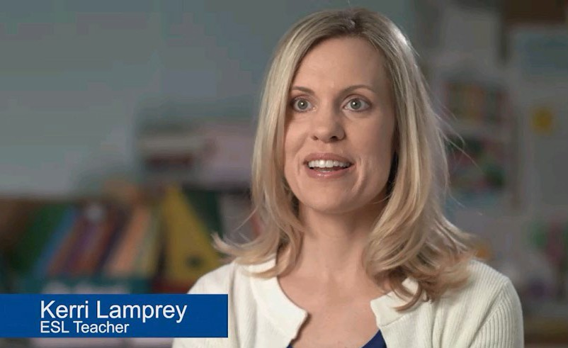

**ELP LEVEL 1**

**ELP LEVEL 2**

**ELP LEVEL 3**

**ELP LEVEL 4**

**ELP LEVEL 5**

**ELP LEVEL 6**

**Although there are similar broad stages of linguistic development, ELP levels are not static or linear,** and students are constantly developing with great variability across all four language domains.

**How Can I Use the Thinking Space?**

The Thinking Space on page 2/backside of your Collaboration Tool provides an area to begin brainstorming how you will take your students from where they currently are to your unit’s end goals. By identifying what students can do, given evidence from their work, you can begin to envision “teacher moves” and “student moves” toward the unit’s FLGs. What moves are needed in terms of language development and meaning-making? This data-analysis and assessment can help you determine possible entry points for the new unit.

**Example Focus Language Goals**

As with other ESL MCUs, the FLGs for *ESL: Describing and Explaining Weathering and Erosion, Grades 3-5, ELP Levels 1-2* were refined throughout the planning process. The FLGs for the unit are:

**FLG 1.** DISCUSS by identifying evidence from a given landscape that includes simple landforms and rock layers to support a claim about the role of erosion or deposition in the formation of the landscape.

FLG 2. EXPLAIN by describing cause and effect supported with reasoning and evidence.

For **FLG 1,** the key use of academic language (macro function) is **DISCUSS.** This micro function is **identify.** The key academic practices in this goal are using *evidence* and *supporting a claim.*

For **FLG 2,** students will focus on the macro language function of **EXPLAIN** and the micro language function of **describing cause and effect.** The key academic practice is again, *supporting a claim with reasoning and evidence.*

These FLG examples show one “formula” for creating a FLG, but there are many flexible pathways to developing them. Your Collaboration Tool and Curriculum Resource Guide list several “formulas,” and you may find other pathways that work for your students.

**Using the Performance Assessment**



You have many options for getting started in building a FLG for an ESL unit. One great place to start is a content unit’s performance assessment. The assessment tells you what the student will need to be able to demonstrate at the end of a unit and what language will be needed.

[**Watch a video**](https://youtu.be/aF9Aa_9DaRk) demonstration of how to unpack a performance assessment to create a FLG.

# Curriculum Resources

#### Access the Next Generation ESL [Curriculum Resource Guide](http://www.doe.mass.edu/ele/guidance/?section=resource-guide)

**Access the Next Generation ESL** [**Model Curriculum Units and Videos**](http://www.doe.mass.edu/ele/instruction/mcu/)