ESL: Historical Perspectives
Language of Social Studies, Grades 3–5—English Language Proficiency Levels 3-4

For more information on the design process for the ESL MCUs, please see the Next Generation ESL Project: Curriculum Resource Guide

This unit is intended to deliver systematic, explicit, and sustained English language development in the context of the Massachusetts Curriculum Frameworks. Through the unit, students will learn to communicate information, ideas, and concepts necessary for academic success in the content areas of English language arts and social studies. They will also learn to communicate for social and instructional purposes within the school setting.
The embedded language development of this unit centers on two of the Key Uses of Academic Language:
- Explain by comparing and contrasting the most important points and perspectives presented in two texts on the same topic.
Argue by stating a claim and supporting it with reasoning and relevant evidence.
These unit-level Focus Language Goals were created through an analysis of the driving language demands of the existing Model Curriculum Unit on social studies for grade 3: “Whose Story Is It?” However, this ESL unit is not the same as a sheltered social studies unit. It is intended to be taught by an ESL teacher, and collaboration with the content teacher is essential. It is also important to keep in mind that in addition to the dedicated, language-focused instruction outlined in this unit, English learners (ELs) must also have access to all core academic content instruction.
This unit offers students contextualized, extended practice with discourse, sentence, and word/phrase dimensions of academic language targeted in the unit. By the end of the unit, students are equipped with academic language useful for evaluating sources of historical information and thinking critically about an author or illustrator’s perspective. Students will demonstrate their learning by comparing and contrasting informational texts, stating their own opinions, and supporting their opinions with reasoning and evidence.
This document was prepared by the Massachusetts Department of Elementary and Secondary Education, Mitchell D. Chester, Ed.D., Commissioner.
The Massachusetts Department of Elementary and Secondary Education, an affirmative action employer, is committed to ensuring that all of its programs and facilities are accessible to all members of the public. We do not discriminate on the basis of age color, disability, national origin, race, religion, sex, or sexual orientation.
© 2016 under the terms of the Creative Commons Attribution-NonCommercial-ShareAlike 3.0 Unported License. Additionally, the unit may also contain other third party material used with permission of the copyright holder. Please see Image and Text Credits for specific information regarding third copyrights.
Every effort has been made to acknowledge copyright. Any omissions brought to our attention will be corrected in subsequent editions.
See Image and Text Credits at the end of the unit.

The contents of this Model Curriculum Unit were developed under a grant from the U.S. Department of Education. However, those contents do not necessarily represent the policy of the U.S. Department of Education, and you should not assume endorsement by the federal government.
Massachusetts Department of Elementary and Secondary Education, 75 Pleasant St, Malden, MA 02148-4906. Phone 781-338-3300, TTY: N.E.T. Relay 800-439-2370, www.doe.mass.edu

Table of Contents
Unit Plan 4
Lesson 1 10
Lesson 2 22
Lesson 3 31
Lesson 4 48
Lesson 5 66
Lesson 6 77
Lesson 7 88
Lesson 8 94
Lesson 9 109
Lesson 10 114

Unit Plan
Stage 1—Desired Results
ESTABLISHED FOCUS GOALS G  Focus Language Goals/Standards  The Language of Social Studies  G.1 Explain by comparing and contrasting the most important points and perspectives presented in two texts on the same topic.  G.2 Argue by stating a claim and supporting it with reasoning and relevant evidence.  Content Connections  The student is building toward:  CCSS.ELA-Literacy.RL.3.6—Distinguish their own point of view from that of the narrator or those of the characters.  CCSS.ELA-Literacy.RI.3.7—Use information gained from illustrations (e.g., maps, photographs) and words in a text to demonstrate understanding of the text (e.g., where, when, why, and how key events occur).  CCSS.ELA-Literacy.RI.3.8—Describe the logical connections between particular sentences and paragraphs in a text (e.g., comparison, cause/effect, first/second/third in a sequence).  CCSS.ELA-Literacy.RI.3.9—Compare and contrast the most important points and key details presented in two texts on the same topic.  CCSS.ELA-Literacy.SL.3.1—Engage effectively in a range of collaborative discussions (one-on-one, in groups, and teacher-led) with diverse partners on grade 3 topics and texts.  CCSS.ELA-Literacy.W.3.2—Write informative/explanatory texts to examine a topic and convey ideas and information clearly.  CCSS.ELA-Literacy.RI.3.4—Determine the meaning of general academic and domain-specific words and phrases in a text relevant to a grade 3 topic or subject area.  History/Social Science  HSS.3.5—Explain important political, economic, and military developments leading to and during the American Revolution.  HSS. 3.12—Explain how objects or artifacts of everyday life in the past tell us how ordinary people lived and how everyday life has changed. | Transfer
Students will be able to independently use their learning to… T
T.1 Communicate for social and instructional purposes within the school setting.
T.2 Communicate information, ideas, and concepts necessary for academic success in the content area of Social Studies.
T.3 Analyze history from different points of view to better understand an event and/or time period.
 | Meaning
 | UNDERSTANDINGS U  Students will understand that…  U.1 Studying different historical texts can help us to analyze varying points of view.  U.2 Opinions should be supported with reasoning and evidence.  U.3 Analyzing multiple sources can inform our opinions.  U4 When reading historical texts, it is important to consider the perspective of the author. |  | ESSENTIAL QUESTIONS Q  Q.1 How can you use language to effectively communicate your opinion?  Q.2 How can studying the past help us to understand the present?  Q.3 Why should we examine a historical event or time period from multiple perspectives?
 | Language Acquisition in the Four Domains
 | KNOWLEDGE: Academic Language K  Students will know…  K.1 Prepositions used to indicate time and sequence (first, before, during, after; first, next, then, last).  K.2 Past tense verb forms (including irregular past tense verbs) for common verbs used to describe historical events or time periods (e.g., fight/fought, start/started, order/ordered, blame/blamed).  K.3 Compare and contrast language used to indicate similarities and differences (and, but, however, therefore)  K.4 Argument language useful for stating opinions and supporting them with evidence (e.g., In my opinion, I believe, I agree/disagree, I think, evidence).  K.5 Complex sentence structure with because. |  | SKILLS: Academic Language S  Students will be skilled at…  S.1 Determining the meaning of words and phrases used in a text, including vocabulary specific to history/social studies and general academic vocabulary.  S.2 Analyzing informational texts to identify facts and opinions or perspectives.  S.3 Presenting a claim using reasoning and evidence.  S.4 Creating complex sentences with because.  S.5 Using past tense to explain historical events and perspectives.  S.6 Comparing and contrasting ideas in informational texts.
Stage 2—Evidence
EVALUATIVE CRITERIA |  | ASSESSMENT EVIDENCE: Language Development
Appropriate use of targeted content-related vocabulary orally and in writing.  Effective use of verbs in simple past tense (e.g., fight/fought, start/started, order/ordered, blame/blamed) to explain historical events and perspectives.  Effective use of prepositions (e.g., first, before, during, after; first, next, then, last) to indicate time order.  Well-crafted opinions supported by reasoning, incorporating related language (e.g., In my opinion, I believe, I agree/disagree, I think, evidence)  Accurate comparison and contrast of different perspectives (and, but, however, therefore)  - Skillful use of oral presentation skills (e.g., comprehensibility, consistently projecting voice, speaking clearly, appropriate body language) |  | CURRICULUM EMBEDDED PERFORMANCE ASSESSMENT (Performance Tasks) PT  After comparing and contrasting several historical texts about the American Revolution from the perspectives of the American colonists and the British, students will assume the role of a historian to present their opinion of whether the colonists were justified in their actions at the Boston Tea Party.* Students will use reasoning and evidence to support their opinion. They will also present their opinion orally at the opening of a historical exhibit in a museum.  Goal: Presenting an opinion about a particular event leading up to/during the American Revolution and supporting it with evidence gathered from several historical texts.  Role: Historian presenting at the opening of a museum exhibit about the American Revolution.  Audience: Museum staff, curators, attendees, and fellow historians.  Situation: Presenting an opinion supported by evidence about a particular event leading up to/during the American Revolution to fellow historians or to museum attendees.  Product performance and purpose: An oral presentation supported by related text and visuals.  * Note: This unit provides suggestions for modifying the prompt of the CEPA.
OTHER EVIDENCE OE
Formative assessments: think-pair-share, turn-and-talk, total physical response, image analysis sheet, color-coded text, Venn diagram, sentences using compare and contrast language, written opinions using sentence frames
Stage 3—Learning Plan
SOCIOCULTURAL IMPLICATIONS
Register:
- Presenting an opinion based on historical evidence may be a new concept for students.
The language used to explain different perspectives about a historical event or period may be unfamiliar to students.
Topic:
- Students may not be familiar with the history of Massachusetts or the American Revolution.
Students may have experienced the effects and impacts of war or conflict, and the topic may trigger strong emotions.
Task/Situation:
- Students may be more comfortable expressing themselves orally, rather than in writing.
- Students may not be familiar with using opinion language in a presentation.
- Students may have little experience examining a historical event or time period from different points of view.
Students may need direct instruction reading informational texts, identifying evidence, using technology, and creating a presentation.
Identity/Role:
Some students may think others who agree with their opinion do so because they “like” them, and that those who disagree with their opinion do not “like” them. This may interfere with their ability to form/state their own opinion when other peers or the teacher hold different points of view.
SUMMARY OF KEY LEARNING EVENTS AND INSTRUCTION
Lesson 1: Day 1—Building Background about the American Revolution
- Language objective: Students will be able to orally describe observations about an illustration of a historical event using content area vocabulary (e.g., colonist, redcoat, British soldier, victim, fire, killed, massacre, patriot).
Brief overview of lesson: Students will learn vocabulary and background information about the Boston Massacre and events leading up to it. Students will analyze an illustration of the Boston Massacre and describe their observations of the image using targeted academic vocabulary. They will also review prior knowledge about the American Revolution.
Lesson 2: Day 2—Describing Historical Events or Time Periods Using the Past Tense
- Language objective: Students will be able to describe a historical event using the past tense.
Brief overview of lesson: Students will learn about the past tense and how to use it to recount what happened during the Boston Massacre. They will learn the past tense form of common regular and irregular verbs with illustrated flashcards, and practice using them by describing actions depicted in an illustration of the Boston Massacre.
Lesson 3: Day 3—Describing Historical Events Using Prepositions
- Language objective: Students will be able to sequence events using prepositions or sequencing signal words (first, next, then, finally).
Brief overview of lesson: Students will learn how to sequence events using prepositions or sequencing signal words. They will learn prepositions useful for putting events in order and use them to describe a sequence of everyday events. They will then practice using these sequencing words and past tense verbs to write sentences explaining the sequence of events leading to and during the Boston Massacre.
Lesson 4: Days 4 and 5—Identifying Facts and Opinions and Articulating Perspectives in Informational Texts
- Language objectives:
- Students will be able to articulate opinions/perspectives represented in texts and images depicting historical events.
- Students will be able to describe historical events by creating fact and opinion statements using related signal words (e.g., I think, In my opinion, According to).
Brief overview of lesson: Students will learn about signal words used to state facts and opinions. They will apply their learning to identify facts and opinions in text and images depicting historical events, expanding their knowledge about these concepts. Students will also annotate texts to identify and articulate historical perspectives or points of view about the Boston Massacre represented in these texts and images.
Lesson 5: Day 6—Comparing and Contrasting Historical Perspectives
- Language objective: Students will be able to compare and contrast perspectives presented in a text and images depicting historical events using related signal words (e.g., and, but, however, similar, different, both, same).
Brief overview of lesson: Students will learn language useful for comparing and contrasting points of view about historical events or time periods. They will learn and practice using compare and contrast signal words in Venn diagrams as they analyze a text and images of the Boston Massacre. They will also write sentences comparing and contrasting information from a text.
Lesson 6: Day 7—Identifying an Author’s Perspective (Language Checkpoint)
- Language objective: Students will be able to identify a historical perspective and articulate it in writing using signal words of fact and opinion (e.g., according to, I think).
Brief overview of lesson: Students will continue analyzing perspectives in a written text. They will read two short texts about the Boston Massacre, one written from the British perspective and another from a colonist perspective. They will identify facts and opinions in these texts, then use this information to identify and write a statement about the perspective showcased in each text.
Lesson 7: Day 8—Stating Opinions and Supporting Them with Evidence
- Language objective: Students will be able to state an opinion about a historical event and support it with evidence using because.
Brief overview of lesson: Students will learn how to support their opinions with relevant evidence/reasoning. Students will analyze two opinions shared by the teacher, one supported by evidence and another not supported by evidence. They will discuss these two examples and how evidence can strengthen an opinion. Then students will have an opportunity to formulate their own opinion about what they think happened at the Boston Massacre, why it happened, and who (British, colonist) was to blame for the event, and support it using evidence learned in previous lessons. They will also share their opinions with a peer who has a different perspective.
Lesson 8: Days 9 and 10—CEPA: Part I—Comparing and Contrasting Texts
- Language objectives: Students will be able to Explain by comparing and contrasting the most important points and perspectives presented in two texts on the same topic.
Brief overview of lesson: Students will start to create the CEPA. In this lesson, students will learn about two other events leading up to the American Revolution (such as the Stamp Act, the Quartering Act, the Boston Tea Party, or the Intolerable/Coercive Acts) and related content vocabulary. Students will choose which event they would like to investigate further and present in their CEPA. Then students will compare and contrast historical texts and images presenting differing perspectives about their chosen event. Student analysis of the historical texts and images will help inform student creation of claims supported by evidence in subsequent lessons.
Lesson 9: Day 11—CEPA: Part II—Formulating Claims Supported with Relevant Evidence
- Language objective: Students will be able to argue by stating their opinion about a historical event and supporting it with reasoning and relevant evidence.
Brief overview of lesson: Students will continue to develop their CEPAs. They will formulate their own opinion of whether the colonists were justified in their actions at the Boston Tea Party using reasoning and evidence gathered from texts and images they analyzed to support their opinions in writing. Then they will create their museum presentations.
Lesson 10: Day 12—CEPA: Part III—Presentations
- Language objectives:
- Students will be able to argue by stating their opinion about a historical event and supporting it with reasoning and relevant evidence in an oral presentation.
- Students will be able to explain by comparing and contrasting the most important points and perspectives presented in two texts on the same topic in an oral presentation.
- Brief overview of lesson: During the culminating lesson of the unit, students will demonstrate language they have learned throughout the unit by comparing and contrasting texts presenting different perspectives on a historical event, and arguing their opinion about this event by presenting supporting evidence. Each student will assume the role of a historian and orally present their opinion of what happened in their chosen event, along with supporting evidence, to an audience of other historians and museum attendees at a museum exhibit opening.
Adapted from Understanding by Design®. © 2012 Grant Wiggins and Jay McTighe. Used with permission.

Lesson 1  Day 1 | Building Background about the American Revolution | Estimated Time: 60 minutes
Brief overview of lesson: Students will learn vocabulary and background information about the Boston Massacre and events leading up to it. Students will analyze an illustration of the Boston Massacre and describe their observations of the image using targeted academic vocabulary. They will also review prior knowledge about the American Revolution. As you plan, consider the variability of learners in your class and make adaptations as necessary.

What students should know and be able to do to engage in this lesson:
- Basic knowledge of concepts and ideas surrounding events leading up to and during the American Revolution (Note: This lesson provides suggested resources for building additional background knowledge on the Boston Massacre. Based on student background knowledge on the American Revolution, consider building additional background knowledge on the events leading up to the Boston Massacre).
Basic familiarity with simple and compound sentences, simple past tense, sequencing words, adjectives to compare, pronouns, subject/verb agreement, wh- questions, cause and effect language, and using evidence to support a claim.
LESSON FOUNDATION
Unit-Level Focus Language Goals to Be Addressed in This Lesson |  | Unit-Level Salient Content Connections to Be Addressed in This Lesson
G.1 Explain by comparing and contrasting the most important points and perspectives presented in two texts on the same topic. |  | CCSS.ELA-Literacy.RI.3.4—Determine the meaning of general academic and domain-specific words and phrases in a text relevant to a grade 3 topic or subject area.  CCSS.ELA-Literacy.RI.3.7—Use information gained from illustrations (e.g., maps, photographs) and words in a text to demonstrate understanding of the text (e.g., where, when, why, and how key events occur).  HSS.3.5—Explain important political, economic, and military developments leading to and during the American Revolution.
Language Objective |  | Essential Questions Addressed in This Lesson
Students will be able to orally describe observations about an illustration of a historical event using content area vocabulary (e.g., colonist, redcoat, British soldier, victim, fire, killed, massacre, patriot). |  | Q.2 How can studying the past help us to understand the present?
Assessment
- Formative assessment: Assess student application of learned language (e.g., content area language and vocabulary) to participate in class discussion.
- Formative assessment: Assess student application of learned language (e.g., content area language and vocabulary) to complete step 1 of the “Image Analysis Sheet.”
- Self-assessment: Students will use metacognitive strategies (e.g., activating background knowledge, reflecting on what they learned in relation to the lesson objective) to self-monitor learning.
Thinking Space: What Academic Language Will Be Practiced in This Lesson?
Discourse Dimension | Sentence Dimension |  | Word Dimension
Social instructional language; brief written and/or audiovisual sequence of events in order and/or introduction of a topic with some supporting details and sentences containing content-area recounts and/or explanations in grade-appropriate text with limited cohesion between sentences; describing an illustration. | Simple sentences in present and past tense; questions with wh- words. |  | Content area vocabulary (e.g., event, freedom, people, objects, colonist, redcoat, British, American Revolution, artifacts, point of view, perspective, arms, shoot, fight, throw, fall); language for describing (I see/notice/think, looks like).
Instructional Tips/Strategies/Suggestions for Teacher
- When determining what scaffolds may be needed to help students access the curriculum, consider the following: native language support, working with partners, and/or using gestures.
- Depending upon student familiarity with the American Revolution and the Boston Massacre, consider extending this lesson to provide additional time for background building and concept development. When introducing the Boston Massacre, review the event and both parties involved. Consider clarifying this event and others leading up to it by posting and explaining a visual timeline.
- Use formative assessments to assess student progress towards lesson language objective(s) and unit goals. Make changes to instructions on following lessons/days, as needed, based on assessment results.
- Start two anchor charts to record the perspectives of American colonists (chart 1) and the British (chart 2) throughout the unit. As the class uncovers more information about each group’ perspective, add these to the charts. This graphic support can help students determine authors’ points of view as they analyze different images and pieces of text.
- Prompt image analysis by asking: “What do you see? Who do you see? What is happening? What do you see that makes you say that? What do you think happened? How can you describe what you see?”

STUDENT CONSIDERATIONS
Sociocultural Implications
- Some students may come from a region/country experiencing conflict or civil unrest. Discussing the Boston Massacre may evoke painful memories for these students.
- Some students may come from a region/country where questioning authority is unacceptable and they may view the actions of the colonists as being unacceptable.
Anticipated Student Pre-Conceptions/Misconceptions
- Some students may not be familiar with what happened during the Boston Massacre or the two opposing groups participating in the event.

THE LESSON IN ACTION
Lesson Opening

Post and explain the lesson’s language objective: “Students will be able to orally describe observations about an illustration of a historical event using content area vocabulary (e.g., colonist, redcoat, British soldier, victim, fire, killed, massacre, patriot).” To promote student ownership and self-monitoring of learning, consider having students record the objective in their notebooks or having students summarize the objective in their own words. At the end of the lesson, students can reflect on their learning in relation to the objective.

Begin by activating prior knowledge about the American Revolution. Post “American Revolution” on the board and ask students to think about what they know about it.

Have students think quietly, then turn and talk to a partner to share their ideas. Working with a partner or in a small group allows students time to build and share their own ideas before turning to the whole group, where not all students are as comfortable sharing their ideas.

Invite students to a whole class discussion about what the American Revolution was and what students know about it.

Ask students to brainstorm what they know about the Boston Massacre. Post “Boston Massacre” on the board and ask students to think about what they know about it.

Have students think quietly, then Turn and Talk to a partner to share their ideas.

Invite students to a whole class discussion about the massacre. As students share, create a know–want to know–learned (K-W-L) chart about the Boston Massacre and record student responses on the “know” column. Ask students to create a K-W-L chart and record information in the first column in their notebooks.

During the Lesson

Let students know that they are starting a new unit in which they will be learning the language needed to Explain by comparing and contrasting the most important points and perspectives presented in two texts on the same topic and to Argue by stating a claim and supporting it with reasoning and relevant evidence. Let them know that by the end of the unit, they will be able to compare and contrast informational texts, state their own claims about a historical event, and support their claims with reasoning and evidence. Consider showing students a sample CEPA; reviewing the final culminating performance assessment ahead of time can help students monitor their progress in relation to the CEPA.

When introducing the CEPA, consider discussing how historians collect and analyze historical sources (such as archives, images, artifacts, etc.) and present their theories/findings for a variety of purposes (e.g., to inform and educate the public, to add to understandings of historical events, to preserve the past). Let students know that just as historians collect and analyze documents, so will they.

Introduce the Boston Massacre by showing an illustration of the event (such as Paul Revere's Lithograph or another image) and/or giving students a printed version of the image.

Ask students to scan the image for details. Allow students to analyze the image quietly. To prompt student reflection, you may wish to ask them guiding questions such as: “What do you see? What questions do you have about this image? What do you know about this image? What do you know about the Boston Massacre? What do you want to know about this image? What do you want to know about the Boston Massacre?”

Have students discuss the image with a small group before inviting the whole class to discuss their observations. This allows students time to build and share their own ideas before turning to the larger group where not all students are as comfortable sharing their ideas. During the class discussion, record student responses on the “want to know” column of the K-W-L chart and ask students to write them down on their own charts.

Teach key content vocabulary, such as colonist, redcoat, British soldier, victim, fire, killed, massacre, patriot, etc. Create a word wall or list, provide images with definitions, allow students to use native language translations or visual dictionaries (such as Shahi), and/or have students record definitions, illustrate terms, and practice using the words in sentences in a vocabulary journal. These strategies can encourage students to write, use images, or build their own contextual examples of the vocabulary.

Review events leading up to/during the Boston Massacre. Connect to information students shared/what is recorded on the K-W-L chart to validate what students already know.

Explain how this event will be a focus of the unit and how it is controversial (an event for which there are different opinions). For example, say: “Today we are going to review/learn about an event that happened in Boston before the American Revolution. We will be working with this event throughout the unit. This event is called the Boston Massacre. Not everyone agrees on what happened that night. We will study this event and try to figure out what happened.”

Tell the story of the Boston Massacre, reviewing key elements such as where it happened, events leading up to it, and what happened during the event.
i. Start by explaining where it happened. Post the question: “Where did the Boston Massacre take place?” Project or provide students with a printed map of Massachusetts, or show Massachusetts on Google Maps. Ask students to find Boston on the map. Consider showing them where their school is in relation to Boston.
ii. Discuss events leading up to the event. Post the question: “What events led to the Boston Massacre?” Walk students through a visually supported timeline to help them contextualize events leading up to the Boston Massacre. This timeline can remain posted throughout the unit. For sample timelines of key events, see PBS’s “Timeline of the Revolution.” If a computer and projector are not available, post images, titles, dates, and a brief one- to two-sentence overview of each one these key events around the room and have students go on a gallery walk.
- Discuss what happened during the massacre. Post “What happened during the Boston Massacre?” on the board. Please note: fact and opinion will be explicitly taught in subsequent lessons. Refer to information about the Boston Massacre as facts to help students begin developing an understanding of these concepts.
- Depending upon student familiarity with the Boston Massacre, consider reading a story about it such as The Boston Massacre: Five Colonists Killed by British Soldiers by Allison Stark Draper, and/or showing a video recreating the event, such as the History Channel’s “Boston Massacre.” If showing a video, have students draw or write down one thing they see or notice in their notebooks and consider offering a video viewing station where students can watch the video independently, use translate captions, and pause/ask questions if they may need more clarity. Have students discuss what they noticed with a small group first, then as a whole class.
- Discuss information learned from reading and/or watching videos by creating a Boston Massacre anchor chart with students. Include basic information about the event in the chart, such as “Who was involved? When did it happen? Where did it happen? What happened? Why did it happen? How did it happen?” Ask students to record this information in their notebooks or an online notebook (e.g., Zoho Notebook).
- For additional resources about the Boston Massacre, see the Lesson 1 Resources section below.

Revisit the illustration of the Boston Massacre introduced in the lesson opening. Have students complete step 1 of the “Image Analysis Sheet,” listing people, objects, and activities, using the same illustration of the Boston Massacre. Provide sentence frames students can use to complete the sheet (e.g., “I see _______”; “I notice _______”; “It/He/She is _______”; “It looks like _______”; “I think _______”) and/or a vocabulary word bank (see an alternate version of the “Image Analysis Sheet” step 1 with these supports).
Provide options for physical action, such as completing the “Image Analysis Sheet” independently, with a partner, or in a small group.

Lesson Closing

Ask students to orally describe the image to a partner or small group. Provide a word bank and sentence frames for student reference, such as the ones suggested in the alternate version of the “Image Analysis Sheet,” and model how to use the sentence frames. Afterwards, have partners report out how they described the image and record their responses on chart paper for future reference.

Introduce the concept of perspective to help students begin to understand how texts and images may represent different points of view. Point out how differences in students’ responses reflect the fact that everyone has their own perspective of the image. Highlight how the artist also had a specific perspective he/she wanted to communicate when he/she created the illustration. Consider providing time for students to compare their perspectives.

Lesson 1 Resources

- Chart paper
- Markers
- Resources for teacher background information about the Boston Massacre:
  - The Boston Massacre of March 5, 1770: PRIMARY DOCUMENT TEACHING KIT. Excerpt provided below.
  - Boston Massacre Facts
- Illustration of the Boston Massacre, such as Paul Revere's Lithograph
- Timeline of key American Revolution events, such as:
  - PBS’s “Timeline of the Revolution”
- Boston Massacre resources for students:
- Sample text: The Boston Massacre: Five Colonists Killed by British Soldiers by Allison Stark Draper
  - Sample video: History Channel’s “Boston Massacre”
- “Image Analysis Sheet” and alternate version (adapted from ReadThinkWrite.org)

Sample Boston Massacre Illustration (Paul Revere’s Lithograph)
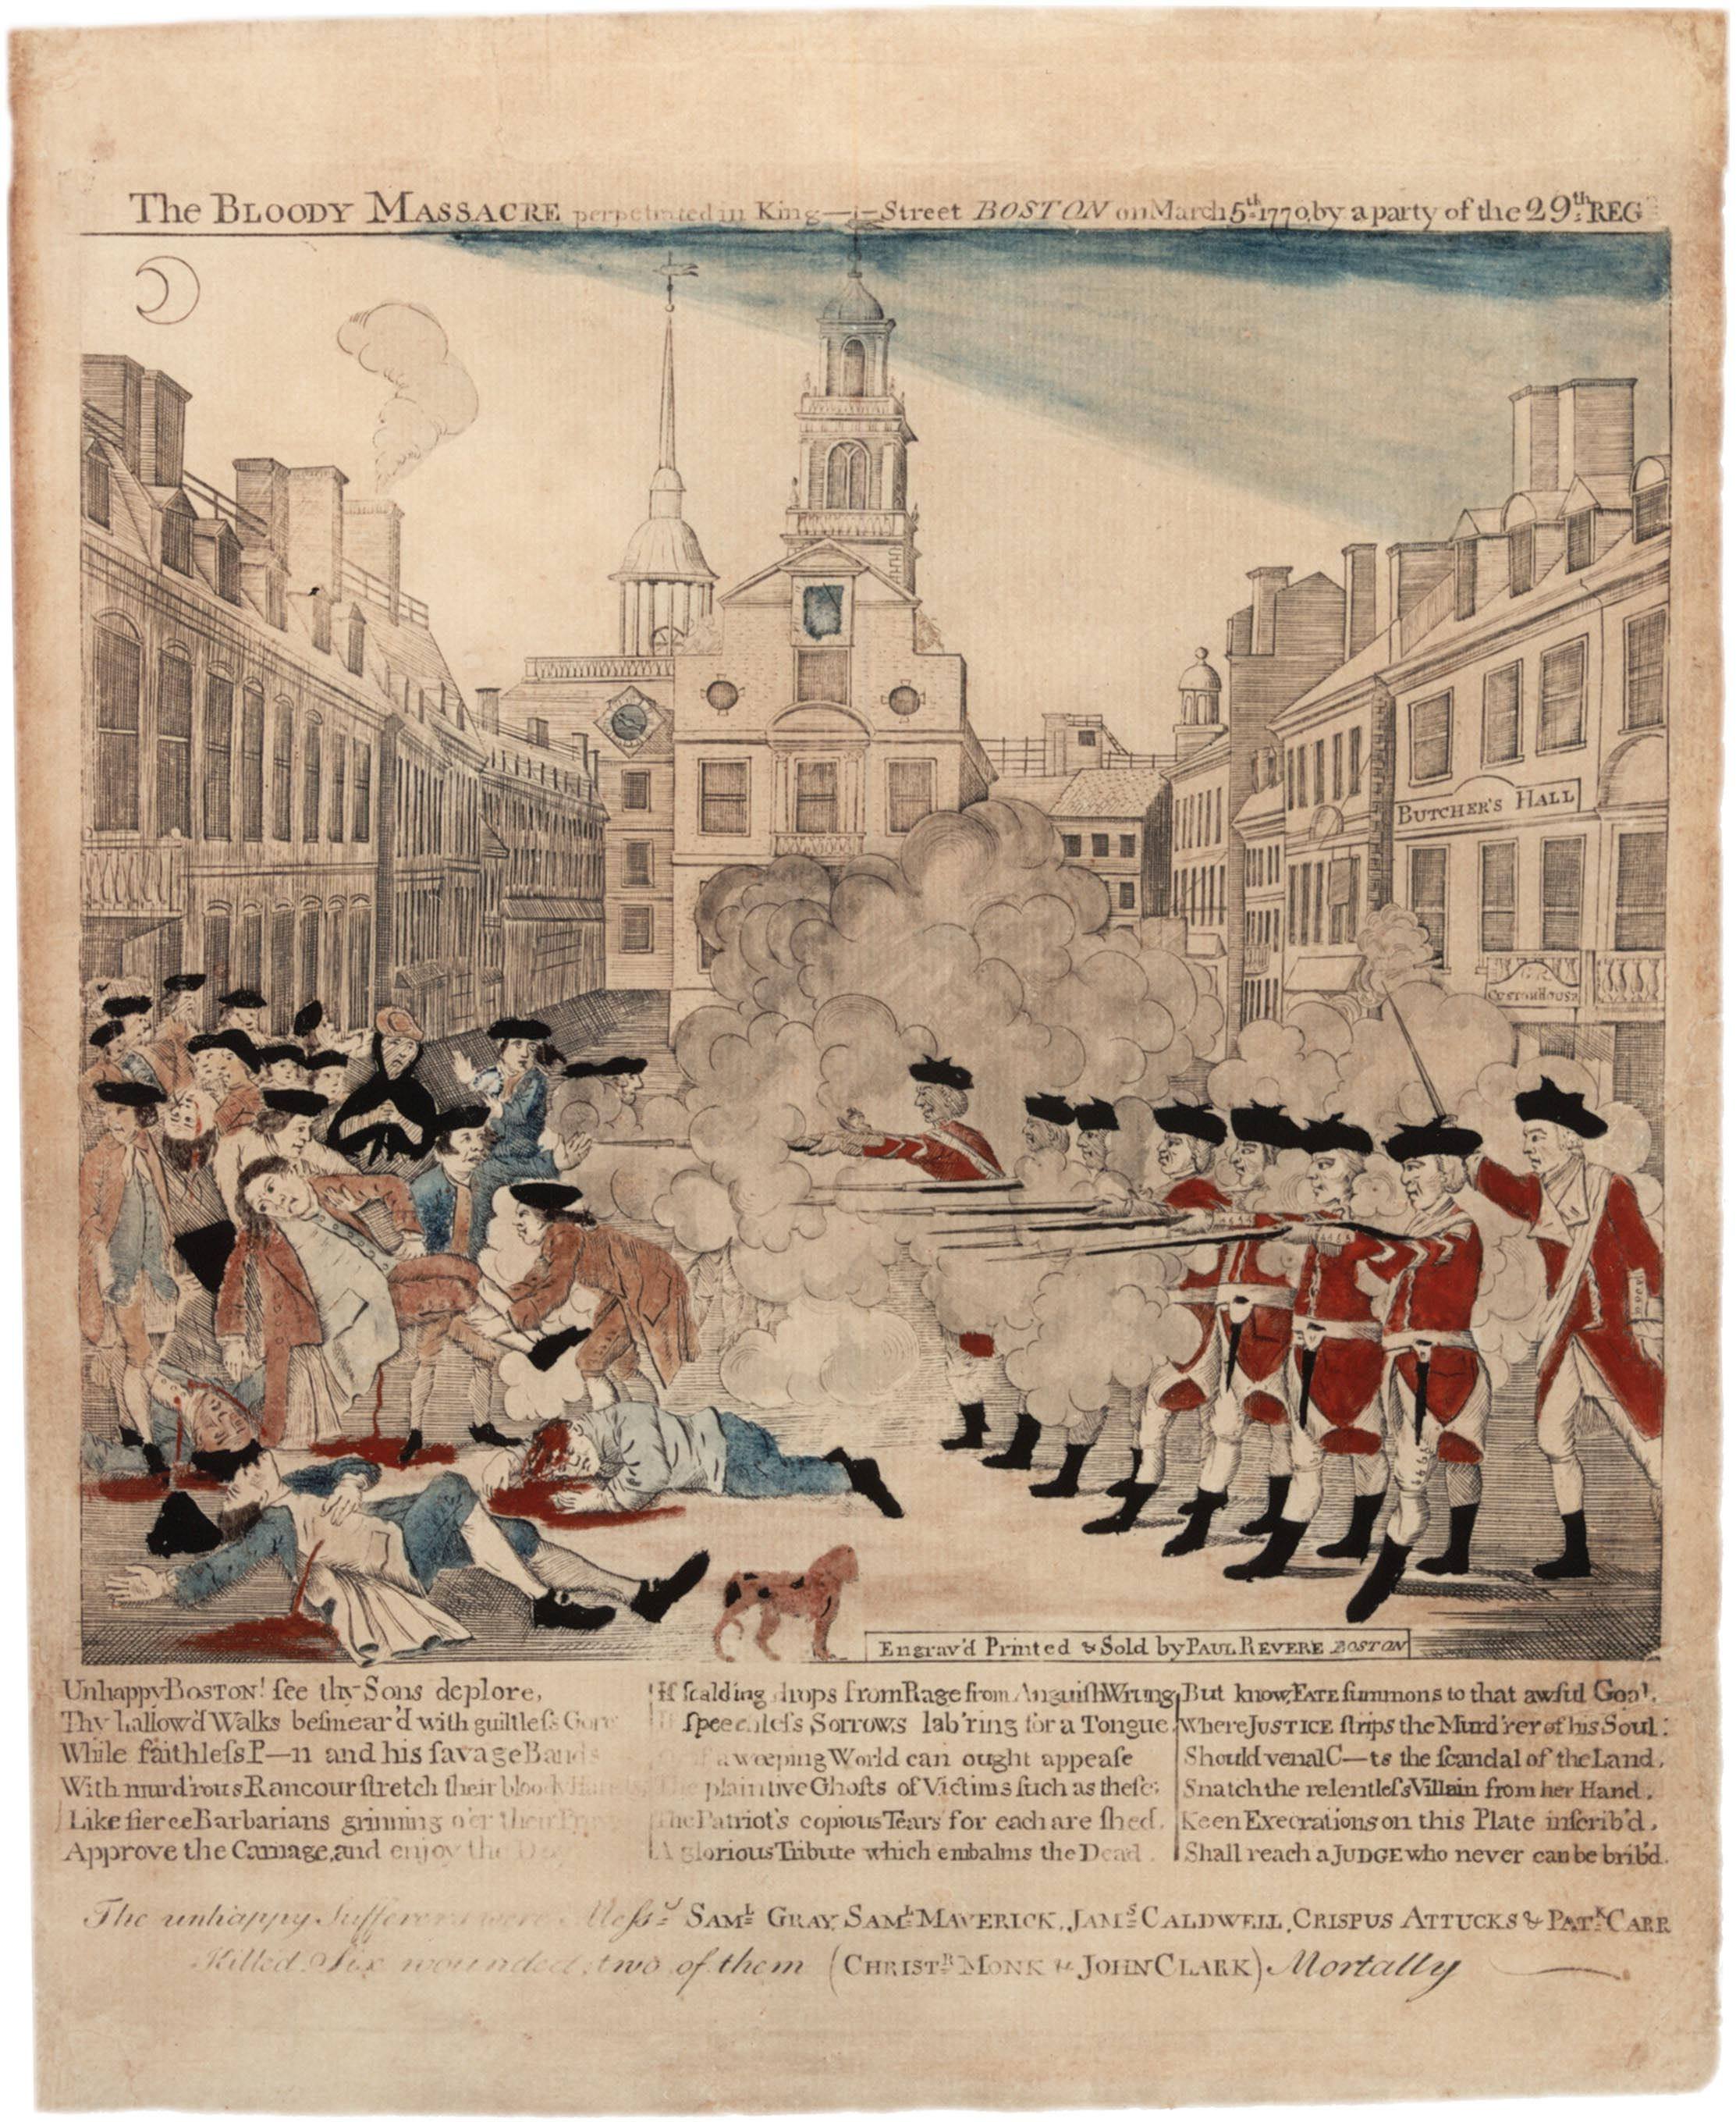
Source: https://www.gilderlehrman.org/sites/default/files/content-images/01868p1_1.jpg

Image Analysis Sheet
Name: __________________________ Date: ________________

STEP 1: Observations
- Study the image. Look at the whole image and the individual parts.
- List your observations below.

People | Objects | Activities

Step 2: Observations
Based on what you observed, write three sentences using the simple past and past progressive tense.

1. ____________________________________________________________________________________________________________

2. ____________________________________________________________________________________________________________

3. ____________________________________________________________________________________________________________

Step 3: Evidence
After you sequence the illustrations, write three sentences to describe the sequence of events.
1. ____________________________________________________________________________________________________________

2. ____________________________________________________________________________________________________________

3. ____________________________________________________________________________________________________________

Step 4: Perspective
Describe the perspective of the image. Use specific details from the image to support your answer.
1. ____________________________________________________________________________________________________________

2. ____________________________________________________________________________________________________________

3. ____________________________________________________________________________________________________________

Adapted from ReadWriteThink

Image Analysis Sheet Step 1 (Alternate Version)

Name: __________________________ Date: __________________________

STEP 1: Observations
- Study the image. Look at the whole image and the individual parts.
- List your observations below.
- Use sentence frames and the word bank to help you write observations

I see _________________  I notice ______________  It/He/She is ________  It looks like _________  I think _______________ | Colonists  Redcoats  British soldier  Victim  Hurt | Fight  Sword  Fell  Wounded | Fire  Killed  Patriot  Massacre

People | Objects | Activities

Adapted from ReadWriteThink

Background Information about the Boston Massacre for Teacher Reference

- The Boston Massacre of March 5, 1770: PRIMARY DOCUMENT TEACHING KIT. Note: this resource is for teacher reference. Information from the passage can be used as the basis for a dramatic reading.

“On October 1, 1768, two regiments of British troops—the 14th and 29th—arrived in Boston. Many Bostonians were no longer content to pay taxes to a country that did not allow them a say in the approval of those taxes. The troops had been sent to Boston to maintain order in an increasingly rebellious and violent town. The troops disembarked at the end of Long Wharf and marched up King Street (now State Street). As many as 2,000 soldiers would eventually be absorbed into a town of about 15,000 inhabitants. With soldiers encamped and posted throughout the town, disputes and fights broke out almost immediately. Two such outbreaks occurred in the weeks prior to the Boston Massacre, and increasingly strained the relationship between the soldiers and Boston’s inhabitants. On February 22, 1770, a rowdy and violent crowd gathered outside the shop of a known loyalist and informer. When a neighbor, Ebenezer Richardson, tried to break up the crowd, the crowd turned on him and began throwing rocks at his home. From his window, Richardson fired his gun the crowd and killed Christopher Seider, an 11 year old. Radical patriots turned the tragedy into a political rally, and over 2,000 people attended the boy’s funeral. About a week later, on March 2, 1770, a fight broke out at the ropewalks between a soldier looking for work and the ropewalk workers. A large group of soldiers joined the fight, but the ropewalk workers ultimately drove them off. This conflict further escalated the already heightened tension in Boston. Boston in 1770 had no street lamps. Monday, March 5th, was a cold and moonlit night. Snow covered the ground. Private Hugh White was the lone sentry on guard at the Custom House on King Street. What began as taunting between White and several young apprentices soon escalated to violence. After striking one of the young boys on the head with his musket, White found himself surrounded, pelted with curses, snowballs and chunks of ice. At about the same time, bells began to ring throughout the town. Bells at night meant fire, a disaster for the wooden-built town. Men and boys poured into the streets as shouts of “Fire” were heard. As more colonists gathered on King Street, taunting the sentry and daring him to fight, White began to fear for his life and called for the main guard in the barracks beside the Town House (Old State House). Although the troops could not forcefully disperse the gathered townspeople without civilian authority, they could defend themselves. Captain Thomas Preston marched out a party of seven Grenadiers, the biggest men in the Regiment. The Boston Massacre of March 5, 1770: PRIMARY DOCUMENT TEACHING KIT Page 5 Preston, Corporal William Wemms, and six privates – Carroll, Kilroy, Warren, Montgomery, Hartigan, and McCauley – marched to the sentry box with fixed bayonets. White joined the ranks. Preston was unable to march the eight soldiers back to the barracks because of the threatening crowd, armed with sticks, swords, rocks, ice and snow. The troops formed a defensive semi-circle in front of the Custom House stairs. While some among the crowd pleaded with Captain Preston to keep his soldiers calm and not to fire, others dared the soldiers to fire. Sticks and bayonets dueled. The taunting colonists thought the soldiers would not fire. Private Hugh Montgomery was hit with a stick and fell; on rising he fired his musket. Someone shouted, “Fire,” and more shots rang out in an uncontrolled volley. Private Kilroy fired and hit ropemaker Samuel Gray in the head. Crispus Attucks, a former slave of mixed African and Native American descent, was shot in the chest. Sailor James Caldwell was killed in the middle of King Street. Samuel Maverick, an apprentice to an ivory turner, was near the Town House when he caught a ricocheting bullet; he would die several hours later. Patrick Carr, an Irishman and maker of leather breeches, was shot in the hip. He would die on March 14th, the fifth person to die as a result of the Massacre. Six other colonists were wounded. Rushing from his North End home, acting Royal Governor Thomas Hutchinson arrived and addressed the crowd from the balcony of the Town House. He urged everyone to go home, stating, “The law shall have its course; I will live and die by the law.” A warrant was issued for Captain Preston, who was immediately taken into custody. The eight soldiers surrendered the next morning and were sent to jail. Preston and the eight accused soldiers stayed in jail for almost nine months before their trials. Public opinion was against them and they struggled to find someone to represent them. John Adams, who accepted the case, said that “Council ought to be the very last thing an accused Person should want (lack) in a free country.” The soldiers were tried before the Superior Court of Judicature, the highest court in Massachusetts. There were two trials, one for Preston, as the commanding officer, and one for his men. Captain Preston and most of the soldiers were found not guilty, but Privates Montgomery and Kilroy were found guilty of manslaughter. They escaped the death penalty by a practice called “benefit of clergy.” Through this archaic custom, the soldiers’ sentences were commuted to a branding on the thumb rather than execution because they were able to prove they could read from the Bible. “

Lesson 2  Day 2 | Describing Historical Events or Time Periods Using the Past Tense | Estimated Time: 60 minutes
Brief overview of lesson: Students will learn about the past tense and how to use it to recount what happened during the Boston Massacre. They will learn the past tense form of common regular and irregular verbs with illustrated flashcards, and practice using them by describing actions depicted in an illustration of the Boston Massacre. As you plan, consider the variability of learners in your class and make adaptations as necessary.

What students should know and be able to do to engage in this lesson:
- Basic knowledge of content area vocabulary, concepts, and ideas surrounding events leading up to/during the American Revolution.
Some familiarity with simple and compound sentences, simple past tense, basic sequencing words, adjectives, pronouns, and wh- question words. These features of language will be practiced and reinforced throughout the unit.
LESSON FOUNDATION
Unit-Level Focus Language Goals to Be Addressed in This Lesson |  | Unit-Level Salient Content Connections to Be Addressed in This Lesson
G.1 Explain by comparing and contrasting the most important points and perspectives presented in two texts on the same topic. |  | CCSS.ELA-Literacy.SL.3.1—Engage effectively in a range of collaborative discussions (one-on-one, in groups, and teacher-led) with diverse partners on grade 3 topics and texts.  HSS.3.5—Explain important political, economic, and military developments leading to and during the American Revolution.  HSS. 3.12—Explain how objects or artifacts of everyday life in the past tell us how ordinary people lived and how everyday life has changed.
Language Objective |  | Essential Questions Addressed in This Lesson
Students will be able to describe a historical event using the past tense. |  | Q.2 How can studying the past help us to understand the present?
Assessment
- Formative assessment: Assess student use of learned language (e.g., content language and vocabulary) to discuss the image.
- Formative assessment: Assess student application of learned language to identify and discuss verbs in the past tense (e.g., during the discussion of the video and in discussing the image).
- Formative assessment: Assess student application of learned language to use verbs in the past tense during the partner activity with flashcards.
- Formative assessment: Assess student application of learned language to create written phrases and/or sentences about an illustration of the Boston Massacre (“Image Analysis Sheet” step 2) using verbs in the past tense.
- Self-assessment: Students will self-monitor their learning by reflecting on previously learned language and reflecting on learning in relation to the lesson objective.
Thinking Space: What Academic Language Will Be Practiced in This Lesson?
Discourse Dimension | Sentence Dimension |  | Word Dimension
Social instructional language; brief written and/or audiovisual sequence of events in order and/or introduction of a topic with some supporting details and sentences containing content-area recounts and/or explanations in grade-appropriate text with limited cohesion between sentences; describing an illustration or image. | Simple sentences in present and past tense. |  | Present and past tense forms of topic-related verbs (e.g., shoot/shot/was/were shooting, fight/fought/was/were fighting, throw/threw/was/were throwing, feel/felt/was/were feeling, think/thought/was/were thinking, fall/fell/was/were falling); content vocabulary (e.g., history, event, freedom, people, objects, activities, what, where, when, why, how, who, colonist, redcoat, British, American Revolution, point of view, perspective, arms).
Instructional Tips/Strategies/Suggestions for Teacher
- When determining what scaffolds may be needed to help students access the curriculum, consider the following: native language support, working with partners, and/or using gestures.
- Use formative assessments to assess student progress towards lesson objective(s) and unit goals. Make changes to instructions on following lessons/days, as needed, based on assessment results.
- Prompt thinking by asking: “What were they doing? What was he doing? What was she doing?”

STUDENT CONSIDERATIONS
Sociocultural Implications
- Some students may come from a region/country experiencing conflict or civil unrest. Discussing the Boston Massacre may evoke painful memories for these students.
- Some students may come from a region/country where questioning authority is unacceptable, and they may view the actions of the colonists as being unacceptable.
- Languages vary in how they denote when an event occurred. For example, some languages are “tenseless” while others have multiple, distinct, past tenses.
Anticipated Student Pre-Conceptions/Misconceptions
- Students may require clarification regarding who was fighting in the Boston Massacre. Review the event and parties involved.

THE LESSON IN ACTION

Lesson Opening

Post and explain the lesson’s language objective: “Students will be able to describe a historical event using the past tense.” To promote student ownership and self-monitoring of learning, consider having students record the objective in their notebooks or having students summarize the objective in their own words. At the end of the lesson, students can reflect on their learning in relation to the objective.

Activate prior knowledge and formatively assess what students learned in Lesson 1 by posting the image of the Boston Massacre that students analyzed and asking them: “What do you remember about the Boston Massacre?” Have students first think about it independently, reviewing their notes and anchor charts, then allow them to share their ideas with a small group before discussing as a whole class.
Provide options for perception, such as providing students with a printed version of the image or having students view it on a computer.

Introduce the focus of the lesson: verbs in the past tense. For example, say: “Today we will learn language to help us talk about the Boston Massacre. We will focus on language that helps us talk about when the massacre happened.”

Ask: “When did the Boston Massacre occur?” Elicit student responses, such as “a long time ago” or “in the past.” Explain what the past tense is, and how it is used to talk about events in the past, or things that started and finished before today. For example, say: “That is correct. The Boston Massacre happened a long time ago. When we talk about history, we can use language to show how something happened in the past. We can use the past tense to talk about things that happened in the past. Today we will talk about how to form past tense verbs.” Consider defining the word past for students. Post a definition of the past tense on the board or create a past tense anchor chart for the unit.

Remind students that the verb is the word or words in the sentence that show the action. Explain how past tense will be used to explain what happened in the Boston Massacre. For example, say: “When we talk about the Boston Massacre, we will be using the past tense because the action occurred in the past. The Boston Massacre started and finished in the past.”

Pre-teach or review the simple past tense of regular verbs with students. Have students practice saying past tense verb forms in small groups. One student in the group pulls a card from a pile of verb flashcards. The student acts out the verb while the rest of the students in the small group have to guess the verb and say it in past tense. For example, if the verb on the flashcard is “jump,” then students should guess “jumped.” After the game, review the structure of a simple sentence in past tense: pronoun/noun + verb-ed (e.g., “He jumped”).

During the Lesson

Introduce the past tense of irregular verbs. For example, say: “Today we will learn how to form the past tense of irregular verbs. An irregular verb does not follow the normal rule of adding -ed or -d to the end of a verb. Each irregular verb has its own way to change to the past tense. There are many irregular verbs that we can use to describe what happened during the Boston Massacre. Today we will learn (add selected verbs for the lesson, such as shoot/shot, fight/fought, throw/threw, feel/felt, think/thought, fall/fell, hit/hit).”

Post selected verbs on the board or an anchor chart, or project them on an overhead. Consider providing images of each verb to support student comprehension.

Explain how each verb changes from the present to the past tense. For example, say: “In the present tense you say ‘I feel.’ In the past tense, you say ‘I felt.’” Repeat this process for each verb, and add past tense forms to the anchor chart. Teacher tip: Allow students to use native language translations; include images; use visual dictionaries, such as Shahi; create word walls; and/or keep vocabulary journals to support vocabulary development and encourage students to write, illustrate words, and/or build their own contextual examples of the vocabulary.

Optional activity: Depending on student familiarity and comfort with irregular past tense verbs, consider extending the lesson to include the past progressive. Explain what the past progressive is, how it is formed (was/were + verb-ing), show some examples, and provide opportunities to practice using it. For example, ask a student to act out a verb. When he/she is done, ask the class, “What was he/she doing,” to elicit the past progressive (e.g., “She was jumping”). Invite two students to act out another verb, and when they are done ask, “What were they doing,” to teach when to use was/were (e.g., “They were jumping”). Suggested past progressive verbs to review here include: was snowing, was/were throwing, was/were fighting, was/were falling, was/were hitting.

Practice using the past tense. Give students picture cards of the target verbs with the present tense form of the verb on one side and the image on the other side. Ask students to change the verb to past tense and label the image. As an extension, have students take turns acting out and guessing the verbs in past tense in small groups.

Practice using the past tense to discuss the Boston Massacre.

Show the same video about the massacre used in Lesson 1 (such as History Channel’s “Boston Massacre”) and ask students to focus on the verbs used in the video while they watch it.

Play the video, pausing after each verb to ask students to identify whether the verb is in the present or past tense. Tell them to write their answers on a whiteboard or in their notebooks. Then, if the verb is in present tense, ask students to change it to past tense (or past progressive). Sample verbs included in the video are: blamed, orders, fire, start, hit, died, clear, roams. Consider offering a video station where students can watch the video independently, use translate captions, and pause/ask questions if they may need more clarity.
Provide options for physical action, such as discussing with a small group first before sharing as a whole class.

Project the image of the Boston Massacre again and ask students to review it one more time, focusing on the actions or activities depicted in the image. Have students quietly review the image independently, then turn and talk to a partner, and finally list all actions shown in the image using the past tense as a whole class.
Provide options for perception, such as giving students a printed copy of the image or having them view it on a computer.

Model how to write a sentence about the image in past tense using the list of words brainstormed by the class and/or the targeted verbs introduced earlier in the lesson. Consider color-coding the verb for student reference (e.g., writing the verb in blue: “The colonist fell down”). Then co-write a sentence about the illustration using the past tense and/or past progressive with students.

Have students write three sentences about the illustration using past tense (or past progressive) individually, with a partner, or in small groups. Ask students to complete step 2 of the “Image Analysis Sheet” or the alternate version that includes sentence frames and a word bank.
Provide options for physical action and expression and communication, such as dictating sentences or using a speech-to-text reader, and/or writing extended sentences using the following sentence frame: “They _____ because ____.”

Lesson Closing

Ask students to orally share their sentences with a partner or small group. Select a few groups to share their sentences orally with the class.

Optional activities:

Ask students to read a text excerpt and identify whether verbs are in the present or past tense. For example, if students read a book in Lesson 1, re-read it focusing on the verbs. Have students circle or highlight the verbs, then say if it is in the past or present tense. Finally, change present tense verbs to the past tense.

Have students reflect on the Boston Massacre by drawing, writing, or orally discussing their reactions to the event with a partner, in small groups, or with the whole class.

Lesson 2 Resources
- Chart paper
- Markers
- Computer (optional)
- Projector
- Verb flashcards
- Resources for background information about the Boston Massacre:
  - The Boston Massacre of March 5, 1770: PRIMARY DOCUMENT TEACHING KIT. Excerpt provided in Lesson 1.
  - Boston Massacre Facts
- Illustration of the Boston Massacre such as Paul Revere's Lithograph
- Timeline of key American Revolution events, such as
  - PBS’s “Timeline of the Revolution”
- Boston Massacre resources for students:
- Sample text: The Boston Massacre: Five Colonists Killed by British Soldiers by Allison Stark Draper
  - Sample video: History Channel’s “Boston Massacre”
- “Image Analysis Sheet” and alternate version (adapted from ReadThinkWrite.org)

Sample Verb Flashcards
SHOOT  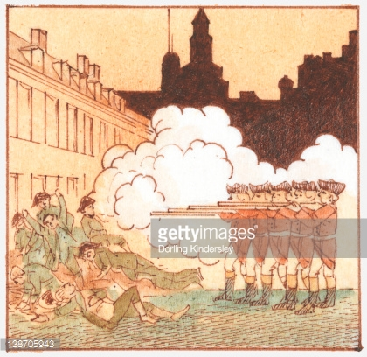 | FIGHT  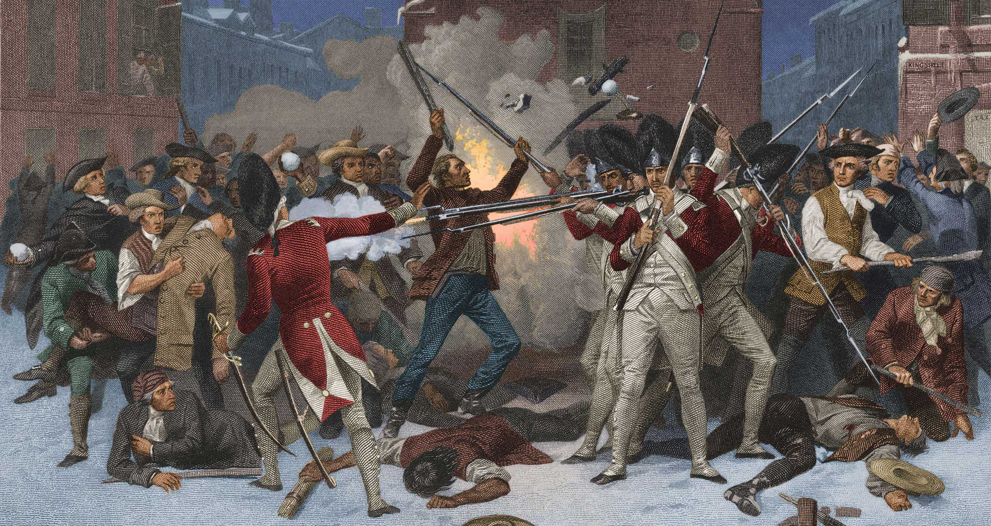  http://rosenlearningcenter.com/staticfiles/rosen-bookshelf/books/spotlightOnThirteenColonies/massachusetts/data/bookPages/img/ch_8a.jpg
THROW  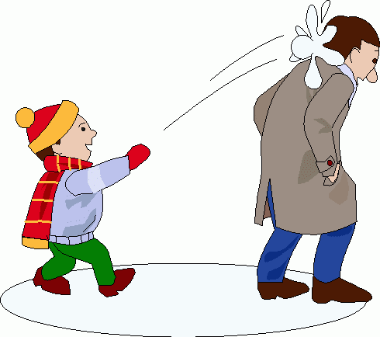 | FEEL  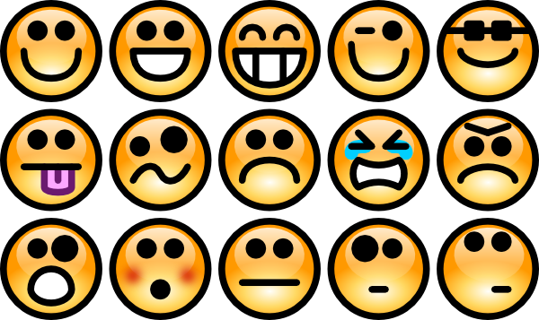

THINK | FALL
HIT  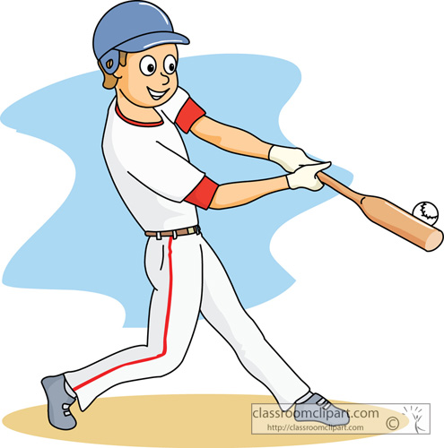 | BLEED  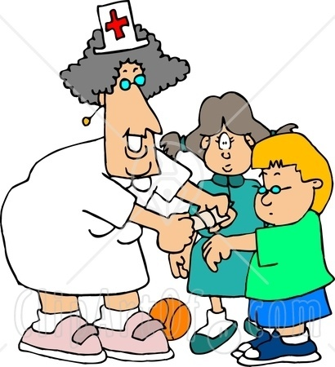

Image Analysis Sheet (Step 2 Alternate Version)
Step 2: Observations
Based on what you observed, write three sentences using the simple past and/or past progressive tense. Use content vocabulary.
- ____________________________________________________________________________
________________________________________________________________________________
________________________________________________________________________________
- ____________________________________________________________________________
________________________________________________________________________________
________________________________________________________________________________
- ____________________________________________________________________________
________________________________________________________________________________
________________________________________________________________________________
Source: https://www.gilderlehrman.org/sites/default/files/content-images/01868p1_1.jpg

Verbs of actions in the image: shoot, yell, fight, snow, die, bleed, fight, fire, think, feel, fall, hit, throw, start
Your verbs:
Lesson 3  Day 3 | Describing Historical Events Using Prepositions | Estimated Time: 60 minutes
Brief overview of lesson: Students will learn how to sequence events using prepositions or sequencing signal words. They will learn prepositions useful for putting events in order and use them to describe a sequence of everyday events. They will then practice using these sequencing words and past tense verbs to write sentences explaining the sequence of events leading to and during the Boston Massacre. As you plan, consider the variability of learners in your class and make adaptations as necessary.

What students should know and be able to do to engage in this lesson:
- Basic understanding of the simple past tense and/or the past progressive.
- Familiarity with content area vocabulary, concepts, and ideas surrounding the events leading up to and during the American Revolution.
- Familiarity with simple and compound sentences.
Some familiarity with basic sequencing words, adjectives, pronouns, and wh- questions. Please note: Familiarity here refers to a very basic understanding of these language features, as they will be practiced and reinforced throughout the unit.
LESSON FOUNDATION
Unit-Level Focus Language Goals to Be Addressed in This Lesson |  | Unit-Level Salient Content Connections to Be Addressed in This Lesson
G.1 Explain by comparing and contrasting the most important points and perspectives presented in two texts on the same topic. |  | CCSS.ELA-Literacy.RI.3.8—Describe the logical connections between particular sentences and paragraphs in a text (e.g., comparison, cause/effect, first/second/third in a sequence).  CCSS.ELA-Literacy.RI.3.7—Use information gained from illustrations (e.g., maps, photographs) and words in a text to demonstrate understanding of the text (e.g., where, when, why, and how key events occur).  HSS.3.5—Explain important political, economic, and military developments leading to and during the American Revolution.
Language Objective |  | Essential Questions Addressed in This Lesson
Students will be able to sequence events using prepositions or sequencing signal words (first, next, then, finally). |  | Q.2 How can studying the past help us to understand the present?
Assessment
- Formative assessment: Assess student application of learned language (e.g., content-specific language, vocabulary, verbs in the past tense, and transition words of sequence) during participation in class discussion.
- Formative assessment: Assess student application of learned language to use transition words of sequence to describe the sequence of events of a familiar event, events leading up to the Boston massacre, and events during the Boston Massacre.
- Formative assessment: Assess student use of learned language (e.g., transition words of sequence) to create written phrases and/or sentences for sequenced illustrations of the Boston Massacre (step 3 of the "Image Analysis Sheet").
- Self-assessment: Students will self-monitor their learning through use of metacognitive strategies (e.g., reflecting on learning in relation to the objective, making predictions, activating background knowledge).
Thinking Space: What Academic Language Will Be Practiced in This Lesson?
Discourse Dimension | Sentence Dimension |  | Word Dimension
Social instructional language; brief written and/or audiovisual sequence of events in order and/or introduction of a topic with some supporting details and sentences containing content-area recounts and/or explanations in grade-appropriate text with limited cohesion between sentences; recounting a sequence of events in order. | Simple sentences in past tense (and potentially, past progressive tense) incorporating sequencing words (first, next, then, etc.). |  | Present and past tense forms of topic-related verbs (e.g., shoot/shot/was/were shooting, fight/fought/was/were fighting, throw/threw/was/were throwing, feel/felt/was/were feeling, think/thought/was/were thinking, fall/fell/was/were falling); content vocabulary (e.g., history, event, freedom, people, objects, activities, what, where, when, why, how, who, colonist, redcoat, British, American Revolution, point of view, perspective, arms); sequencing words (first, next then, last, finally, etc.).
Instructional Tips/Strategies/Suggestions for Teacher
- When determining what scaffolds may be needed to help students access the curriculum, consider the following: native language support, working with partners, and/or using gestures.
- Use formative assessments to assess student progress towards lesson objective(s) and unit goals. Make changes to instructions on following lessons/days, as needed, based on assessment results.
- Prompt thinking by asking: “What do you see? Who do you see? What is happening? What do you see that makes you say that? What do you think happened first, before, during, after? How can you describe what you see?”

STUDENT CONSIDERATIONS
Sociocultural Implications
- Some students may come from a region/country experiencing conflict or civil unrest. Discussing the Boston Massacre may evoke painful memories for these students.
- Some students may come from a region/country where questioning authority is unacceptable and they may view the actions of the colonists as being unacceptable.
Anticipated Student Pre-Conceptions/Misconceptions
- Students may require clarification regarding the sequence of events in the Boston Massacre. Review what happened during this event.

THE LESSON IN ACTION

Lesson Opening

Post and explain the lesson’s language objective: “Students will be able to sequence events using prepositions or sequencing signal words (first, next, then, finally).” To promote student ownership and self-monitoring of learning, consider having students record the objective in their notebooks or having students summarize the objective in their own words. At the end of the lesson, students can reflect on their learning in relation to the objective.

Review vocabulary and past tense verbs introduced so far with a game. For example, divide students into teams and have them label images like the ones used in Lesson 2 with the past tense form of verbs depicted in the image. Time students so that the team that finishes labeling the images first is the winner. Alternatively, have students take turns selecting a card from a deck of vocabulary words and acting out the selected word. If the word is a verb, ask students to also say the past tense form of the verb.

Introduce the focus of the lesson: learning words to help describe the order in which events happened. For example, say: “We will continue to learn language that will help us discuss the past. Today we will learn sequencing language.”

During the Lesson

Introduce sequencing words with a familiar event.

Show illustrations of what happens before, during, and after a familiar event, such as a classroom routine (homeroom, getting ready to leave at the end of the day, etc.), out of order. Ask students to help you put the images back in order. Afterwards, explain how students can use words to figure out and/or explain the order of events.
Provide options for perception, such as giving students a printed version of the images or viewing the images on a computer.

Teach the sequencing signal words first, next, then, and finally. Use the sequencing words to label ordered images from the familiar event recently discussed. Create a sequencing words anchor chart, including a definition of what the words are. Ask students to include this information in their notebooks.

As a class, write four sentences together describing the sequence of events in the images using the newly introduced sequencing words and correct punctuation. Color-code the sentences to highlight sequencing words as visual support. Add these sentences to the sequencing words anchor chart.

Optional activities:

Ask students to act out the sequence to help reinforce that events in sentences need to be in logical order, just as they happen in a story or in real life.

Give students a reference sheet with more sequencing words, such as the “Time Order Words List.” Go over words on the list, explaining how they are synonyms for the main sequencing words learned and highlighting any nuances/differences in meaning. Then co-create sentences using the words with students.

Provide opportunities for students to practice using sequencing words to discuss events leading up to the Boston Massacre.

Explain how sequencing words can be used to discuss events that occurred in the past, such as the Boston Massacre. Instruct students to work with a partner to sequence three illustrations of events leading up to the Boston Massacre and then label them using sequencing words.
Provide options for physical action, such as using a computer or matching images with appropriate sequencing words.

Review the sequence of events leading up to the Boston Massacre as a whole class.

Optional activity: Ask students to act out the sequence.

Practice sequencing events that took place during the Boston Massacre.

Show a video recounting the massacre, such as History Channel’s “Boston Massacre,” before working with images.

Give students four images of events that occurred during the Boston Massacre. Ask them to arrange them in order and then label them with phrases and/or sentences describing what happened using sequencing words and past tense verbs.
Provide options for physical action, such as using a computer; matching labels and images; and/or working individually, with a partner, or in a small group.

Optional activity: Ask students to act out or draw their own illustrations of the sequence of events.

Lesson Closing

Project or show the illustration of the Boston Massacre used in previous lessons. Ask students to complete step 3 of the “Image Analysis Sheet” (or the step 3 alternate version, which includes a word bank), writing three phrases and or sentences to describe the sequence of events with a small group.

Explain how the “evidence” students will use is what they see in the image that helps them describe it. Consider discussing how historians use evidence collected in historical documents (e.g., images, archives, and artifacts) to inform their theories. Ask students to use sequencing language, past tense verbs, and content vocabulary.
Provide options for physical action, such as using a computer, working with a partner, and/or speech-to-text software.

Select a few groups to share their sentences orally with the class.

Give students an opportunity to reflect on the sequence of events of the Boston Massacre to help them interact with the material. Consider giving students a question to consider, such as: “Based on our analysis of the Boston Massacre, who do you think was more to blame? Based on our analysis of the Boston Massacre, what might happen next because of the event?”

Optional activity: Have students analyze a text to identify sequence signal words. Using a text can help provide more information about the Boston Massacre. Suggested texts include: experts from chapter 6 of Massachusetts Our Home by Mary Stockwell, “Boston Massacre for Kids,” and “American Revolution: Boston Massacre.” Since Paul Revere’s lithograph illustrates the colonists’ perspective, give students a text from the colonists’ perspective to analyze individually, with a partner, or as a whole class. If working as a whole class, read the text aloud to students as you project it on an overhead, and give students a printed version. Highlight sequencing words in the text or ask students to raise their hands to identify them as you read. Annotate the copy of the text on the overhead, making notes about what happened first, next, and last.

Lesson 3 Resources
- Whiteboard or chart paper
- Markers
- Computer (optional)
- Projector
- Sequencing words
- Sequencing images of a familiar event
- Sequencing images of events leading up to the Boston Massacre
- Sequencing images of events during the Boston Massacre
- Optional resource: sequencing words reference list (Time Order Words)
- Optional video: “Boston Massacre”
- Optional texts:
  - Massachusetts Our Home by Mary Stockwell
  - “Boston Massacre for Kids”
  - “American Revolution: Boston Massacre”

Sequencing Words
First
Next
Then
Finally

Sequencing Images of Familiar Classroom Routine (a Think-Pair-Share)
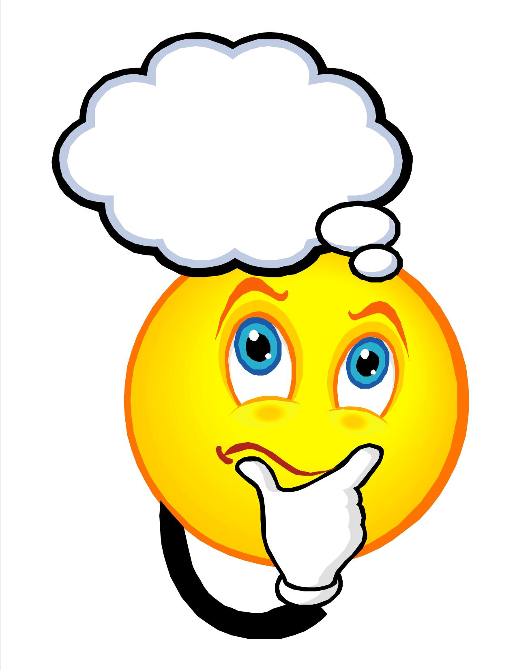

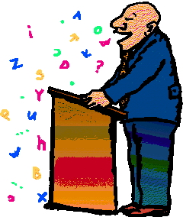

Sequencing Images for Events Leading Up to the Boston Massacre
The French and Indian War
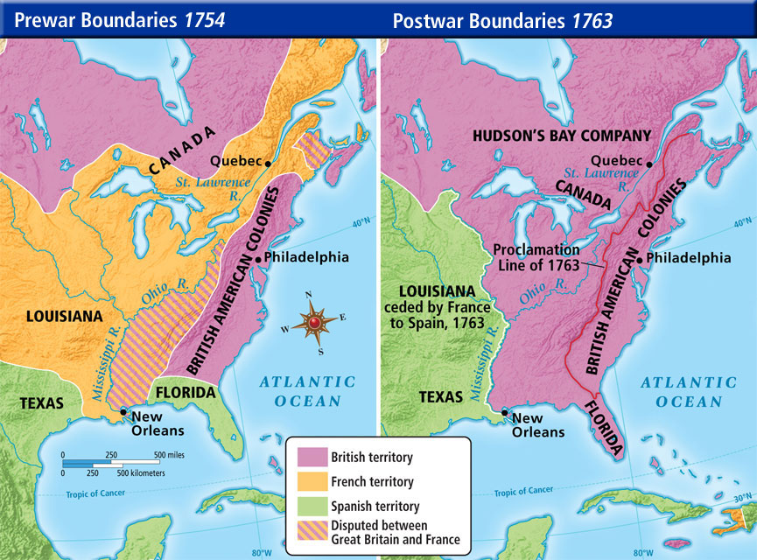
Source: http://teachyturcol.weebly.com/uploads/5/6/8/3/56831225/740306_orig.jpg

The Stamp Act
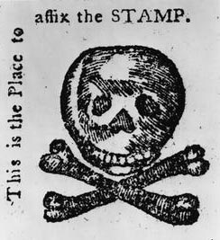
Source: http://www.learnnc.org/lp/media/uploads/2008/07/stampact-skull.jpg

The Boston Massacre
Source: https://www.gilderlehrman.org/sites/default/files/content-images/01868p1_1.jpg

Sequencing Images of Events During the Boston Massacre

Source: http://www.clipartheaven.com/clipart/holidays/christmas/winter-holiday-fun/boy-throwing-snowball-clipart.gif

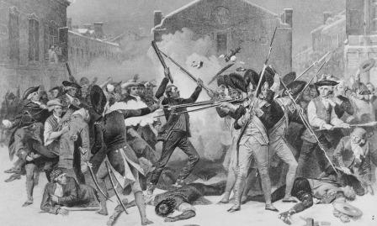
Source: http://myriverside.sd43.bc.ca/alexandray-2013/files/2014/03/tmp_boston_massacre-843546573-29t9g49.jpeg

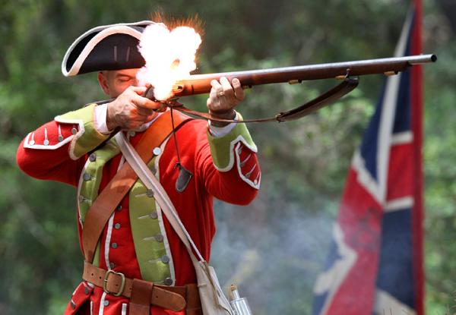
Source: http://sar-cdn.com/sites/default/files/imagecache/superphoto/W%20062511%20Mose%2001.jpg

Image Analysis Sheet—Step 3 Alternate Version
Step 3: Evidence
After you sequence the illustrations, write 3 sentences to describe the sequence of events. Use the simple past and/or past progressive tense. Use content vocabulary.
- ____________________________________________________________________________
________________________________________________________________________________
________________________________________________________________________________
- ____________________________________________________________________________
________________________________________________________________________________
________________________________________________________________________________
- ____________________________________________________________________________
________________________________________________________________________________
________________________________________________________________________________

Source: https://www.gilderlehrman.org/sites/default/files/content-images/01868p1_1.jpg

Verbs of actions in the image: shoot, yell, fight, snow, die, bleed, fight, fire, think, feel, fall, hit, throw, start
Your verbs:

Sequencing words: First, Next, Then, Finally
Lesson 4  Days 4 and 5 | Identifying Facts and Opinions and Articulating Perspectives in Informational Texts | Estimated Time: Two 60-minute sessions
Brief overview of lesson: Students will learn about signal words used to state facts and opinions. They will apply their learning to identify facts and opinions in text and images depicting historical events, expanding their knowledge about these concepts. Students will also annotate texts to identify and articulate historical perspectives or points of view about the Boston Massacre represented in these texts and images. As you plan, consider the variability of learners in your class and make adaptations as necessary.

What students should know and be able to do to engage in this lesson:
- Basic knowledge of the simple past tense and/or the past progressive.
- Familiarity with content area vocabulary, concepts, and ideas surrounding the events leading up to and during the American Revolution.
Some familiarity with basic sequencing words, adjectives, pronouns, and wh- questions. Please note: Familiarity here refers to a very basic understanding of these language features, as they will be practiced and reinforced throughout the unit.
LESSON FOUNDATION
Unit-Level Focus Language Goals to Be Addressed in This Lesson |  | Unit-Level Salient Content Connections to Be Addressed in This Lesson
G.1 Explain by comparing and contrasting the most important points and perspectives presented in two texts on the same topic.  G.2 Argue by stating a claim and supporting it with reasoning and relevant evidence. |  | CCSS.ELA-Literacy.RI.3.7—Use information gained from illustrations (e.g., maps, photographs) and words in a text to demonstrate understanding of the text (e.g., where, when, why, and how key events occur).  CCSS.ELA-Literacy.RL.3.6—Distinguish their own point of view from that of the narrator or those of the characters.  HSS.3.5—Explain important political, economic, and military developments leading to and during the American Revolution.
Language Objectives |  | Essential Questions Addressed in This Lesson
Students will be able to articulate opinions/perspectives represented in texts and images depicting historical events.  Students will be able to describe historical events by creating fact and opinion statements using related signal words (e.g., I think, In my opinion, According to). |  | Q.2 How can studying the past help us to understand the present?  Q.3 Why should we examine a historical event or time period from multiple perspectives?
Assessment
- Formative assessment: Assess student use of learned language (e.g., content-specific language and vocabulary, verbs in the past tense, transition words of sequence, signal words of fact and opinion) during participation in class discussions
- Formative assessment: Assess student application of learned language to complete step 4 of the “Image Analysis Sheet.”
- Formative assessment: Assess student application of learned language to analyze and identify statements of fact and opinion (familiar statements and statements about the Boston Massacre).
- Formative assessment: Assess student application of learned language to analyze and identify facts and opinions in a text.
- Formative assessment: Assess student application of learned language to create statements of fact and opinion (familiar statements and statements about the Boston Massacre).
- Self-assessment: Students will self-monitor learning by using metacognitive/metalinguistic strategies while reading and by reflecting on learning in relation to the lesson objective.
Thinking Space: What Academic Language Will Be Practiced in This Lesson?
Discourse Dimension | Sentence Dimension |  | Word Dimension
Social instructional language; brief written and/or audiovisual sequence of events in order and/or introduction of a topic with some supporting details and sentences containing content-area recounts and/or explanations in grade-appropriate text with limited cohesion between sentences; recounting a sequence of events in order; identifying and expressing opinions. | Simple and some complex sentence with because in present and past (and possibly past progressive) tense; questions with wh- words. |  | Present and past tense forms of topic related verbs (e.g., shoot/shot/was/were shooting, fight/fought/was/were fighting, throw/threw/was/were throwing, feel/felt/was/were feeling, think/thought/was/were thinking, fall/fell/was/were falling); content vocabulary (e.g., history, event, freedom, people, objects, activities, what, where, when, why, how, who, colonist, redcoat, British, American Revolution, point of view, perspective, arms); fact and opinion signal words/phrases (e.g., in my opinion, according to, I think).
Instructional Tips/Strategies/Suggestions for Teacher
- When determining what scaffolds may be needed to help students access the curriculum, consider the following: native language support, working with partners, and/or using gestures.
- Use formative assessments to assess student progress towards lesson objective(s) and unit goals. Make changes to instructions on following lessons/days, as needed, based on assessment results.
- When discussing facts and opinions, consider discussing how historians use facts collected from historical documents (e.g., archives, artifacts, images) to inform their opinions about historical events.
- Prompt thinking by asking: “Who looks good/bad in this image? What do you see that makes you say that? What point of view is portrayed in this image? Who do you think created this image? Who is the speaker/writer of this text? What are the perspectives in this text?”

STUDENT CONSIDERATIONS
Sociocultural Implications
- Some students may have experienced a violent event and discussing the Boston Massacre may bring up strong emotions.
- When discussing the mood of the image in the lesson closing, be cognizant of the scenarios used to illustrate the concept of mood.
- Some students may come from a region/country where questioning authority is unacceptable, and they may view the actions of the colonists as being unacceptable.
Anticipated Student Pre-Conceptions/Misconceptions
- Students may require clarification regarding the concept of perspective/point of view, especially how in a conflict there isn’t always a right and a wrong side.

THE LESSON IN ACTION

Day 4 Lesson Opening

Post and explain the lesson’s language objective: “Students will be able to articulate opinions/perspectives represented in texts and images depicting historical events,” and “Students will be able to describe historical events by creating fact and opinion statements using related signal words (e.g., I think, In my opinion, According to).” To promote student ownership and self-monitoring of learning, consider having students record the objective in their notebooks or having students summarize the objective in their own words. At the end of the lesson, students can reflect on their learning in relation to the objective.

Introduce the focus of the lesson: learning about facts and opinions. For example, say: “Today we will continue to learn language needed to discuss the Boston Massacre. We will talk about facts and opinions.”

Create two anchor charts: one for facts and one for opinions. Ask students to think individually about what a fact is, then have them turn and talk to a partner to share their ideas before sharing as a whole class. Record student responses on the fact anchor chart and add any additional pertinent information to complete a definition of fact. Sample definition: “A fact is a statement that can be proven. It tells about something that exists, it is true, and there is evidence of it (note: some students may need additional explanation of what it means that something can be proven, and what exists and evidence mean).”

Model examples of facts related to concrete things. Then ask students to first think of an example of facts independently, then turn and talk to compare their examples with a partner, and finally share in a class discussion. Record student examples on the anchor chart as well, making any corrections needed.

Repeat this process with the term opinion. Ask students to think individually about what an opinion is, then have them turn and talk to a partner to share their ideas before sharing as a whole class. Record student responses on the opinion anchor chart and add any additional pertinent information to complete a definition of opinion. Sample definition: “An opinion is a statement about thoughts, beliefs, feelings (note: some students may need additional explanation of what the words thoughts, beliefs, and feelings mean).”

Model examples of opinions related to concrete things. Then ask students to first think of an example of opinions independently, then turn and talk to compare their examples with a partner, and finally share in a class discussion. Record student examples on the anchor chart as well, making any corrections needed.

During the Lesson

Introduce fact and opinion signal words. Tell students that there are signal words or clues that can be used to identify and create fact and opinion statements. List the signal words on the anchor chart, explaining what they mean. For example, signal words of opinion could include: think, believe, feel, the best, the worst, as well as pronouns such as I and my. Signal words of facts could include: statistics, can be verified, numbers, according to, suggests.

Practice identifying facts and opinions. For example, say: “Now we are going to practice with a few statements. Tell me if the statements are facts or opinions.”

Share statements of fact and opinion orally and in writing on the board or projector, such as “I think math is fun”; “The name of our school is______________”; “Chocolate milk is the best”; “Today is ___________________”; “This is a pencil”; etc.

Have students hold up cards labeled “fact” or “opinion” based on what they think each statement is. After each response, debrief whether the statement was fact or opinion and have students share why they chose their answer.
Provide options for perception, such as giving students a printed version of the statements.
Provide options for physical action, such as using whiteboards to write down “fact” or “opinion,” voting through Plickers, or turning and talking with a partner before sharing responses with the class.

Provide opportunities to practice with statements about the Boston Massacre. For example, say: “Now that we have practiced with some facts and opinions, we are going to look at some information about the Boston Massacre. We are going to sort statements about the Boston Massacre. Some of the statements are facts. Some of the statements are opinions. Read each statement. Look for and highlight signal words of facts or opinions. Decide if the statements are facts or opinions. Use a T-chart to help you sort the facts and opinions.”

Model how to figure out whether a statement is fact or opinion using the signal words and how to sort responses on the T-chart.

Ask students to complete the T-chart, thinking about why they sorted a statement as a fact or opinion, and to be ready to share their thinking.
Provide options for perception, such as using text-to-speech readers, working in mentor/mentee pairings, highlighting signal words, and/or working with a small group.
Provide options for physical action, such as using a computer to complete.

After students have sorted facts and opinions, come together as a group to review their responses.

Practice creating fact and opinion statements.

Practice writing sentences with familiar images, such as an image of a textbook. Show the image of a social studies textbook and write below: “Fact: This is a social studies textbook. Opinion: I like studying social studies.” Discuss why each one of those statements is a fact or an opinion.

Give students (or project) additional images. Ask them to write or say a statement of fact and a statement of opinion for each image working independently or with a partner. As students are working, circulate so as to provide feedback and encouragement.
Provide options for physical action, such as using a computer or a speech-to-text software, and/or dictating statements.

Ask students to share statements with the whole class and explain why they are fact or opinion.

Practice writing statements about the Boston Massacre.

Show the image of the massacre used so far in the unit. Review factual information present in the image, such as: “There was a conflict. People were shot. It was winter. It happened in front of the Old State House.”
Provide options for engagement, such as asking students to identify which pieces of information in the image are factual as opposed to reviewing the information with students.

Use teacher moves/questions to prompt thinking. For example, post the following questions on the board and ask: “Who looks good/bad in this image? What do you see that makes you say that? What point of view is portrayed in this image? Who do you think created this image? Who is the speaker/writer of this text? What are the perspectives in this text?” Give students time to think about these questions independently, then discuss with a partner or small group.
Provide options for perception, such as giving students a handout with the questions.
Provide options for physical action, such as pointing to the image, writing down answers, or turning and talking to a partner.

Lesson Closing

Ask students to discuss their responses to the questions above using “I think …”

Have students complete step 4 of the “Image Analysis Sheet” (or the alternate version), where they will describe the mood of the image citing specific details from the image to support their answer. Before students begin to work, explain what mood means and model how to use details from an image of a common scene (e.g., students in a classroom excitedly raising hands or a birthday party with kids and presents) to describe the mood in the image.
Provide options for physical action, such as using a computer to complete, working independently, or working with a partner or small group.

Day 5 Lesson Opening

Review what facts and opinions are using a quick review game or asking students to share facts and opinions they wrote the previous day.

Show one to two new images depicting the Boston Massacre.

Review the factual information present in the image, such as: “There was a conflict. People were shot. It was winter.”
Provide options for engagement, such as asking students to independently identify which pieces of information in the image are factual Consider having student discuss this in a small group before discussing as a whole class.

Use teacher moves/questions to prompt thinking. For example, post the following questions on the board and ask: “Who looks good/bad in this image? What do you see that makes you say that? What point of view is portrayed in this image? Who do you think created this image? Who is the speaker/writer of this text? What are the perspectives in this text?” Give students time to think about these questions independently, then discuss with a partner or small group.
Provide options for perception, such as giving students a handout with the questions.
Provide options for physical action, such as pointing to the image, writing down answers, or turning and talking to a partner.

Ask students to discuss their responses to the questions above using “I think …” Teacher tip: To extend student thinking and responses, ask them to use evidence from the image to support their statements. To elicit the use of evidence, ask questions such as “What makes you say____?”
Provide options for physical action, such as using a computer to complete.

During the Lesson

Practice analyzing texts and identifying facts and opinions. For example, say: “We have analyzed two illustrations of the Boston Massacre, looking for factual information and evidence of opinions. We can do the same thing with texts. We are going to analyze a text about the Boston Massacre. As we read the text, we are going to look for factual statements and statements of opinions.”

Give students a visually supported text about the Boston Massacre and project it on the board or overhead. Model how to identify facts and opinions by looking at language used to describe each type of statement based upon the anchor chart created the day before. Pre-teach any metacognitive and/or metalinguistic strategies that may aid student analysis of the text (such as using context clues to determine the meaning of unknown words, summarizing the text in your own words, identifying the main idea and supporting details, etc.).

Ask students to read the text and identify facts and opinions independently or with partners (or have them analyze another image or a video instead of text). Ask students to annotate the text using different colors or marks for each type of statement (e.g., highlight facts in green and underline opinions). Circulate during the text analysis, and prompt student thinking by asking students why they are categorizing statements as fact or opinion. Look for student use of signal words to support their analysis, and offer feedback and encouragement as needed.
Provide options for perception, such as using text-to-speech readers.

Lesson Closing

Ask students to share fact and opinion statements they identified. Add these to the fact and opinion anchor charts.

Optional activity: Have students analyze opinion statements further by sorting them according to whose perspective they represent: the perspective or point of view of colonists or the perspective of the British soldiers/redcoats. For example, have students highlight colonists’ opinion statements in blue and British soldiers/redcoats opinion statements in red. Allow students to work independently or in pairs, and then have them report out to the whole class, explaining the reasoning behind their selection. Provide word banks and sentence frames for sharing, such as: “I think _____”; “I think _____ because _____”; “This is the opinion of _____ because _____.”

Ask students to reflect on the Boston Massacre images and/or texts that they analyzed by answering questions such as: “What did you learn about the Boston Massacre today? Which image or text do you agree with the most? Why?”
Provide options for physical action, such as writing, drawing, or describing their reactions.

Lesson 4 Resources
- Whiteboard and/or chart paper
- Markers, crayons, colored pencils
- Computer (optional)
- Projector
- Sample fact and opinion statements for opening activity
- Sample fact and opinions statements about the Boston Massacre
- Visually supported informational text about the Boston Massacre
- “Image Analysis Sheet” step 4 (or alternate version for previously introduced illustration and additional images)
- Class-generated vocabulary list, graphic organizer, sentence frames
- Optional: emotions/feelings chart with visuals (angry, upset, frustrated, scared, etc.),

Sample Fact and Opinion Statements for Lesson Opening

I think math is fun.
The name of our school is ______________.
Chocolate milk is the best.
Today is ___________________.
This is a pencil.
My favorite movie is __________________.
In class we are learning about the Boston Massacre.
I really like this song.
The school buses are yellow.
I love to read.
Taylor Swift is a singer.
Identifying Facts and Opinions about the Boston Massacre

Name: ______________________________________________________________

- Read each statement.
- Look for and highlight signal words of facts or opinions.
- Decide if the statements are facts or opinions.
- Use the T-chart to help you sort the facts and opinions.

- The Boston Massacre happened on March 5, 1770.
- The Boston Massacre happened on King Street.
- I think that the colonists were wrong to attack the British soldiers.
- Captain Preston should have never ordered his men to fire.
- There were nine British soldiers at the Boston Massacre.
- A British soldier (a redcoat) was hit by a colonist.
- Crispus Attucks was killed during the Boston Massacre.
- Five colonists were killed during the Boston Massacre.
- The colonists threw snowballs and oyster shells at the British soldiers (redcoats).
- I feel that the British taxes were unfair.
- The colonists believed that the British were invading Boston.
- Paul Revere’s illustration of the Boston Massacre is the best image of the event.

Facts | Opinions

Images for Fact and Opinion Statements
Fact:________________________________  ______________________________________  Opinion: ___________________________  ______________________________________ | Fact:________________________________  ______________________________________  Opinion: ___________________________  ______________________________________
Signal Words of Opinions: I think, I feel, I believe, I like, In my opinion, the best, the worst

Fact:________________________________  ______________________________________  Opinion: ___________________________  ______________________________________ | Fact:________________________________  ______________________________________  Opinion: ___________________________  ______________________________________
Signal Words of Opinions: I think, I feel, I believe, I like, In my opinion, the best, the worst

Image Analysis Sheet—Step 4 Alternate Version
Step 4: Perspective
Facts in the image:
_______________________________________________________________________________
_______________________________________________________________________________
_______________________________________________________________________________
_______________________________________________________________________________
_______________________________________________________________________________
Describe the perspective of the image. Use specific details from the image
to support your answer.
_______________________________________________________________________________
_______________________________________________________________________________
_______________________________________________________________________________
_______________________________________________________________________________
Source: https://www.gilderlehrman.org/sites/default/files/content-images/01868p1_1.jpg

Verbs of actions in the image: shoot, yell, fight, snow, die, bleed, fight, fire, think, feel, fall, hit, throw, start
Your verbs:

Questions to Prompt Thinking
In your group, take turns asking and answering the following questions:

- Who looks good/bad in this image?
- What do you see that makes you say that?
- What point of view is portrayed in this image?
- Who do you think created this image?
- Who is the speaker/writer of this text?
- What are the perspectives in this text?
Additional Image Analysis Sheets—Step 4
Image 2, Step 4: Perspective

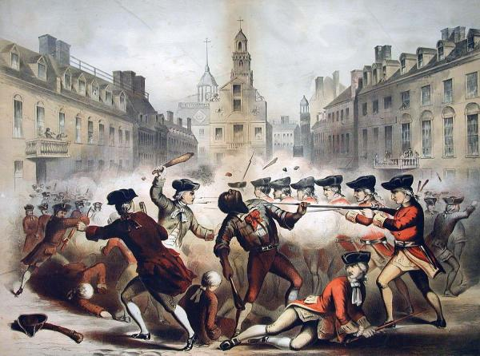
Facts in the image:
___________________________________________________________________________
___________________________________________________________________________
___________________________________________________________________________
___________________________________________________________________________
Thinking Prompts:
- Who looks good/bad in this image?
- What do you see that makes you say that?
- What point of view is portrayed in this image?
- Who do you think created this image?
- Who is the speaker/writer of this text?
- What are the perspectives in this text?

I think this image shows the _______________________ perspective because_________________________________________________________________

_________________________________________________________________________________________________________________________________________________

Source: http://www.teachushistory.org/files/imagecache/screen/resources/bostonmassacrebychampney.jpg

Image 3, Step 4: Perspective

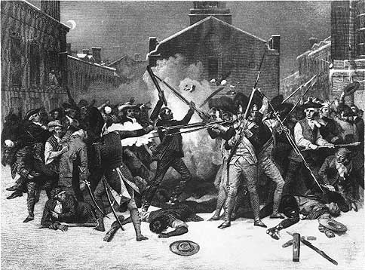
Facts in the image:
___________________________________________________________________________
___________________________________________________________________________
___________________________________________________________________________
___________________________________________________________________________
Thinking Prompts:
- Who looks good/bad in this image?
- What do you see that makes you say that?
- What point of view is portrayed in this image?
- Who do you think created this image?
- Who is the speaker/writer of this text?
- What are the perspectives in this text?

I think this image shows the _______________________ perspective because_________________________________________________________________

_________________________________________________________________________________________________________________________________________________

Source: http://historymatters.gmu.edu/mpimages/mp015.jpg

Sample Visually Supported Text about the Boston Massacre

Name: __________________________________________________________________

The Boston Massacre

DIRECTIONS: Read the text below and identify the language used to indicate perspective (feel, felt, was/were feeling, think, thought, was/were thinking). Use BLUE to show the colonists’ perspective or point of view. Use RED to show the British perspective or point of view. Use GREEN to show facts about the event.
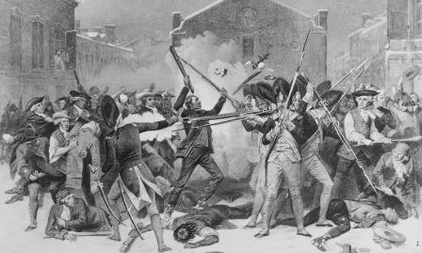
The Boston Massacre occurred on the evening of March 5, 1770. First, it began with a disagreement between a British soldier and a few colonists. The colonists were feeling upset with the British. The colonists thought the laws from King George were unfair. The British soldiers felt upset and responsible for enforcing the king’s laws. The soldiers thought the laws were fair and that the colonists should follow them.

The colonists and the soldiers were in Boston on King Street. It was winter. They were arguing. Then more colonists came and were throwing sticks and snowballs at the redcoats.

Later, the colonists felt scared and wanted help. More colonists came and then there were 50 colonists on the street with sticks and snowballs. The British were scared and needed help. They asked for more soldiers with arms (weapons). The colonists were feeling angry and shouted at the soldiers. The British were feeling angry and shouting back.

A British captain was trying to stop the fight, but one of his soldiers was hit by a stick and fell down. He then shot into the crowd of colonists. Next, more soldiers fired their arms at the crowd.

In the end, five colonists died. After, the colonists were feeling very frustrated with the British. This event was one of the events that led to the American Revolution.

Lesson 5  Day 6 | Comparing and Contrasting Historical Perspectives | Estimated Time: 60 minutes
Brief overview of lesson: Students will learn language useful for comparing and contrasting points of view about historical events or time periods. They will learn and practice using compare and contrast signal words in Venn diagrams as they analyze a text and images of the Boston Massacre. They will also write sentences comparing and contrasting information from a text. As you plan, consider the variability of learners in your class and make adaptations as necessary.

What students should know and be able to do to engage in this lesson:
- Basic understanding of signal words of fact and opinion and related signal words, sequencing words, the simple past tense, and/or the past progressive.
- Familiarity with content area vocabulary, concepts, and ideas surrounding the events leading up to and during the American Revolution.
Some familiarity with simple and compound sentences, adjectives, pronouns, and wh- questions. Please note: Familiarity here refers to a very basic understanding of these language features, as they will be practiced and reinforced throughout the unit.
LESSON FOUNDATION
Unit-Level Focus Language Goals to Be Addressed in This Lesson |  | Unit-Level Salient Content Connections to Be Addressed in This Lesson
G.1 Explain by comparing and contrasting the most important points and perspectives presented in two texts on the same topic.  G.2 Argue by stating a claim and supporting it with reasoning and relevant evidence. |  | CCSS.ELA-Literacy.RI.3.9—Compare and contrast the most important points and key details presented in two texts on the same topic.  CCSS.ELA-Literacy.RI.3.7—Use information gained from illustrations (e.g., maps, photographs) and words in a text to demonstrate understanding of the text (e.g., where, when, why, and how key events occur).  HSS.3.5—Explain important political, economic, and military developments leading to and during the American Revolution.
Language Objective |  | Essential Questions Addressed in This Lesson
Students will be able to compare and contrast perspectives presented in a text and images depicting historical events using related signal words (e.g., and, but, however, similar, different, both, same). |  | Q.1 How can you use your knowledge of the English language to effectively communicate your opinion?  Q.2 How can studying the past help us to understand the present?  Q.3 Why should we examine a historical event or time period from multiple perspectives?
Assessment
- Formative assessment: Assess student application of learned language (e.g., content-specific language and vocabulary, verbs in the past tense, transition words of sequence, compare and contrast language) during participation in class discussion.
- Formative assessment: Assess student application of learned language to analyze and organize information from texts and images to complete a Venn diagram comparing and contrasting ideas.
- Formative assessment: Assess student application of learned language to create written phrases and/or sentences using compare and contrast language.
Thinking Space: What Academic Language Will Be Practiced in This Lesson?
Discourse Dimension | Sentence Dimension |  | Word Dimension
Social instructional language; brief written and/or audiovisual sequence of events in order and/or introduction of a topic with some supporting details and sentences containing content-area recounts and/or explanations in grade-appropriate text with limited cohesion between sentences; comparing and contrasting information; identifying, expressing, and justifying opinions. | Simple and compound sentences with and and but in present and past (and possibly past progressive) tense; e.g., “Both the _______ and _______ were ___________. The ________ (past tense/past progressive) _________, but the _________ (past tense/past progressive) _________.” |  | Compare and contrast language (and, both, but, however); present and past tense forms of topic-related verbs (e.g., shoot/shot/was/were shooting, fight/fought/was/were fighting, throw/threw/was/were throwing, feel/felt/was/were feeling, think/thought/was/were thinking, fall/fell/was/were falling); content vocabulary (e.g., history, event, freedom, people, objects, activities, what, where, when, why, how, who, colonist, redcoat, British, American Revolution, point of view, perspective, arms); fact and opinion signal words/phrases (e.g., in my opinion, according to, I think).
Instructional Tips/Strategies/Suggestions for Teacher
- Depending upon student familiarity with language features used to compare and contrast, consider extending this lesson to provide additional practice. If extending the lesson, practice comparing and contrasting additional images and/or texts.
- When determining what scaffolds may be needed to help students access the curriculum, consider the following: native language support, working with partners, and/or using gestures.
- Consider discussing how historians collect and analyze various, and often contradictory, historical sources (such as archives and artifacts). Consider discussing how historians often need to determine and consider the perspectives of sources while determining how credible the source is.
- Prompt thinking by asking: “What is similar about the points of view of the colonists and the British? What is different? How can we compare and contrast these similarities and differences?”
- Use formative assessments to assess student progress towards lesson objective(s) and unit goals. Make changes to instructions on following lessons/days, as needed, based on assessment results.

STUDENT CONSIDERATIONS
Sociocultural Implications
- Some students may have experienced a violent event and discussing the Boston Massacre may produce negative emotions.
- Some students may be unfamiliar or uncomfortable analyzing the perspectives of historical images as this may seem like questioning the motives of the artist.
- Some students may come from a region/country where questioning authority is unacceptable, and they may view the actions of the colonists as being unacceptable.
Anticipated Student Pre-Conceptions/Misconceptions
- Students may require clarification to understand the difference between comparing and contrasting, and how specific features are used for each language function.
- Some students may think that history cannot be debated.

THE LESSON IN ACTION

Lesson Opening

Post and explain the lesson’s language objective: “Students will be able to compare and contrast perspectives presented in a text and images depicting historical events using related signal words (e.g., and, but, however, similar, different, both, same).” To promote student ownership and self-monitoring of learning, consider having students record the objective in their notebooks or having students summarize the objective in their own words. At the end of the lesson, students can reflect on their learning in relation to the objective.

Review historical perspectives identified in Lesson 4 by going over sample statements and asking students to identify which group—colonists or British soldiers—would agree with it. For example, say: “We are going to continue to learn language necessary to discuss historical events. Let’s revisit some of our opinion statements from yesterday.”

Show one of the opinion statements from Lesson 4 or provide students with printouts of the statements. Read the statement (e.g., “I think the colonists attacked the British soldiers”) and ask students: “Who do you think would agree with this, the colonists or the British?” Give students time to quietly reflect on the question, then turn and talk to a partner before writing their responses on a whiteboard or holding up a card that says “British” on one side and “colonists” on the other to show their answer.

Explain how our opinions reflect our perspective, or point of view, about something. Introduce a student-friendly definition of perspective, explaining how not everyone sees things the same way. Show a few images from previous lessons to illustrate the concept, and highlight differences in how students described them (e.g., show an image of the beach and highlight how some students thought it was a cool place while others may have said it was a boring place).

Extend student thinking by asking a reflection question such as: “Why do you think our perspectives are different?” Discuss it as a whole class. Possible responses include: “Because we have different backgrounds and/or know different information about things”; “Because of our personalities, we like different things”; “Because sometimes we want different things, so the same event looks different to different people”; etc.

During the Lesson

Introduce the terms compare and contrast.

Define what it means to compare (showcase similarities) and contrast (highlight differences) between two or more things. Create a compare and contrast anchor chart and add these definitions to it.

Introduce compare and contrast language, defining each word and writing it in the anchor chart as you go. Provide examples of how to use this language as well. Teacher tip: Go beyond merely orally stating or discussing the terms. Allow students to use native language translations; include images; use visual dictionaries, such as Shahi; create word walls; and/or keep vocabulary journals to support vocabulary development and encourage them to write, illustrate words, and/or build their own contextual examples of the vocabulary. Sample compare and contrast language to introduce here includes:
Compare: similar, both, same, and, similarities
Contrast: different, differences, however, but

Practice comparing and contrasting with a Venn diagram. For example, say: “Now that we have learned some language to help us compare two things, let’s practice comparing and contrasting. We will use a Venn diagram to help us organize the similarities and differences between two things.”

Project the Venn diagram and provide students with a blank, printed copy of it. Write the words “English Class” above one circle, “Math Class” above the other, and “both” above where the circles overlap. Alternatively, have students compare and contrast two images.

Ask students to think about what both classes have in common, or the similarities between the classes, and write those down under “both.” Have students reflect independently first, then share as whole class. Record student responses on the Venn diagram. Possible answers include: length of time, homework, etc.
Provide options for physical action, such as using a computer to complete and/or working in mentor/mentee pairings.

Ask students to identify the differences, writing information under each separate circle. Have students reflect independently first, then share as whole class. Record student responses on the Venn diagram. Possible answers include: “Math class: numbers, word problems, addition, subtraction, etc.; English class: read stories, write stories, plays, nouns, verbs, etc.”
Provide options for physical action, such as using a computer to complete and/or mentor/mentee pairings.

Discuss the importance of comparing and contrasting perspectives about historical events. Discuss how historians often compare and contrast various perspectives to inform their theories.

Explain how many people view the same event in different ways, so when studying history, students should be thinking about whose perspective is being presented and compare it to other perspectives to understand what happened. For example, say: “When we view historical texts and images, we need to think about whose story or perspective the text or image is showing us. We can use language to help us compare and contrast perspectives and figure out what happened. Let’s practice comparing two perspectives on the Boston Massacre.”

Project two images of the Boston Massacre and a blank Venn diagram. Ask students to review the images, thinking about similarities in both images. Have students write the similarities in the middle column of a Venn diagram.
Provide options for perception, such as giving students printed versions of the images and/or viewing the images on the computer.
Provide options for physical action, such as using a computer to complete and/or working in mentor/mentee pairings.

Ask students to share their ideas. Add their responses to a new Venn diagram posted or projected for the whole class to see. Provide and model how to use sentence frames for sharing, such as: “Both images ______”; There is/are ______ in this picture and there is/are ______ in this other picture”; etc. You may wish to make the connection for students that some of the pieces of information in both images are factual. Point out these pieces of information (such as “the Boston Massacre occurred in front of the Old State House,” “people were injured/killed,” etc.).

Ask students to contrast the images, noting the differences between them and writing their answers in a separate circle for each image within the Venn diagram.
Provide options for perception, such as giving students printed versions of the images and/or viewing the images on the computer.
Provide options for physical action, such as using a computer to complete and/or working in mentor/mentee pairings.

Ask students to share their ideas. Add their responses to a new Venn diagram posted or projected for the whole class to see. Provide and model how to use sentence frames for sharing, such as: “This image is different because _____”; “This image _____”; “However, the other image _____”; “This image _____, but this other image _____”; etc. Make the connection for students that some of the information in the images involve an inference (or opinion) and illustrate the point of view or perspective of the illustrator. Point out these pieces of information (such as “the colonists were unarmed and attacked by the British”; “the colonists had clubs and were hitting the British”).

Ask students reflective questions about identifying author’s perspective, such as: “What do you think the illustrator wanted us to think with these images? What makes you think so?”

Depending on student familiarity with comparing and contrasting two events or points of view, consider practicing with two additional images of the Boston Massacre before analyzing text in the next activity.

Practice comparing and contrasting ideas in a text. For example, say: “Now that we have practiced comparing and contrasting two images of the Boston Massacre, we will continue working with the text we used yesterday.”

Review the text used in Lesson 4, as well as language used to indicate opinions or perspectives/points of view.

Have students analyze the text and sort information in it using a Venn diagram.
First, discuss how to find similar perspectives about the event shared by both sides, identifying them in green and adding them to the middle column (PLEASE NOTE: In this case, the middle will contain the undisputed facts that both the British and the colonists agree on).
Then have students analyze the text to identify different perspectives. Draw student attention to the opinion statements they underlined in the text in the previous lesson and ask them to mark the British perspective in red and the colonist perspective in blue. Then have them transfer this information to their Venn diagrams.
Provide options for perception, such as using a text-to-speech reader and/or a computer.
Provide options for physical action, such as using a computer to complete and/or sorting sentence strips from the text.
Provide options for engagement, such as analyzing the text as a whole class, working individually, or working with a partner/small group.

After students have completed the Venn diagram, revisit language used to compare (both, and, similar, same) and contrast (however, but, different). Highlight/color-code the signal words of comparing and contrasting in the text.

Practice writing comparing and contrasting sentences.

Model how to write one comparing sentence and one contrasting sentence using language previously introduced (e.g., “Both the colonists and the British were angry”; “The colonists thought the laws were unfair, but the British soldiers thought they had to make people obey the king’s laws”).

Co-construct two more sentences with students.

Ask students to write two new sentences (one comparing and one contrasting) using different information from the text, content vocabulary, and compare and contrast language. Consider providing sentence frames, such as “Both the __________ and __________ were __________”; “The __________ __________ (verb in the past tense/past progressive), but the ___________ (verb in the past tense tense/past progressive).”
Provide options for physical action, such as using a computer to complete and/or working in mentor/mentee pairings.

Lesson Closing

Have students read their comparing and contrasting sentences to a partner. Ask a few volunteers to share with the class.

Optional activity: Show the Boston Massacre video from previous lessons again, or a different video about the event (such as “The Boston Massacre: America the Story of Us,” which discusses Paul Revere’s illustration of the event). The video can reinforce the concept of perspective for students. After the video, have students reflect upon the video, the illustration, Paul Revere’s perspective on the event depicted in the image, and how the author’s/illustrator’s perspective can impact our understanding of historical events. Consider providing students with a focus question, such as: “Based on what we learned today, how can the author’s/illustrator’s perspective affect our understanding of historical events?” Consider having students record their thoughts in a journal.

Lesson 5 Resources
- Illustrations/images of the Boston Massacre
- Visually supported text about the Boston Massacre
- Venn diagram
- Sentence frames
- Computer
- Student Notebooks
- Optional Video
- The Boston Massacre: America the Story of Us
- Projector

Sample Venn Diagram
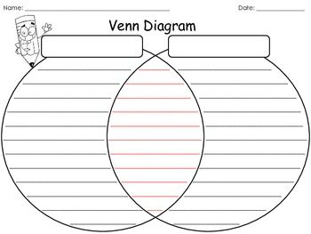
Source: https://s-media-cache-ak0.pinimg.com/736x/1a/94/f5/1a94f5a39716f6a00cfee047510efff9.jpg

Illustrations/Images about the Boston Massacre
Sources: https://www.gilderlehrman.org/sites/default/files/content-images/01868p1_1.jpg | http://www.teachushistory.org/files/imagecache/screen/resources/bostonmassacrebychampney.jpg

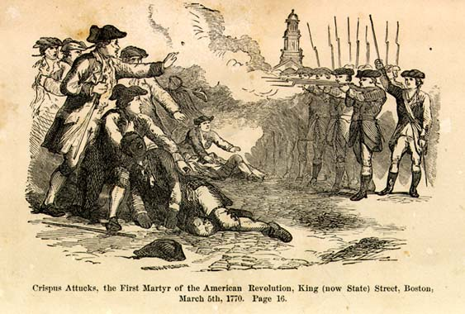
Sources: http://historymatters.gmu.edu/mpimages/mp015.jpg http://docsouth.unc.edu/neh/nell/nellfp.jpg

Lesson 6  Day 7 | Identifying an Author’s Perspective (Language Checkpoint) | Estimated Time: 60 minutes
Brief overview of lesson: Students will continue analyzing perspectives in a written text. They will read two short texts about the Boston Massacre, one written from the British perspective and another from a colonist perspective. They will identify facts and opinions in these texts, then use this information to identify and write a statement about the perspective showcased in each text. As you plan, consider the variability of learners in your class and make adaptations as necessary.

What students should know and be able to do to engage in this lesson:
- Basic understanding of signal words of fact and opinion, prepositions useful for sequencing events, simple past tense and/or past progressive tense, content area vocabulary, and concepts and ideas surrounding the events leading up to and during the American Revolution.
Familiarity with simple and compound sentences, basic adjectives, sequencing words, pronouns, wh- questions, and compare and contrast language. Please note: Familiarity here refers to a very basic understanding of these language features, as they will be practiced and reinforced throughout the unit.
LESSON FOUNDATION
Unit-Level Focus Language Goals to Be Addressed in This Lesson |  | Unit-Level Salient Content Connections to Be Addressed in This Lesson
G.2 Argue by stating a claim and supporting it with reasoning and relevant evidence. |  | CCSS.ELA-Literacy.RL.3.6—Distinguish their own point of view from that of the narrator or those of the characters.  CCSS.ELA-Literacy.RI.3.7—Use information gained from illustrations (e.g., maps, photographs) and words in a text to demonstrate understanding of the text (e.g., where, when, why, and how key events occur).  HSS.3.5—Explain important political, economic, and military developments leading to and during the American Revolution.
Language Objective |  | Essential Questions Addressed in This Lesson
Students will be able to identify a historical perspective and articulate it in writing using signal words of fact and opinion (e.g., according to, I think). |  | Q.1 How can you use your knowledge of the English language to effectively communicate your opinion?  Q.2 How can studying the past help us to understand the present?  Q.3 Why should we examine a historical event or time period from multiple perspectives?
Assessment
- Formative assessment: Assess student use of learned language to analyze a text (facts highlighted in green and underlined opinion statements).
- Formative assessment: Assess student use of learned language to identify and sort information into colonist and redcoat/British perspectives.
- Formative assessment: Assess student use of learned language (e.g., content-specific language, verbs in the past tense, language to compare and contrast) to create written phrases and/or sentences illustrating the central perspective of the text.
- Self-assessment: Students will self-assess and self-monitor learning through use of metacognitive and metalinguistic strategies while reading. Students will also reflect on their learning in relation to the lesson objective.
Thinking Space: What Academic Language Will Be Practiced in This Lesson?
Discourse Dimension | Sentence Dimension |  | Word Dimension
Social instructional language; brief written and/or audiovisual sequence of events in order and/or introduction of a topic with some supporting details and sentences containing content-area recounts and/or explanations in grade-appropriate text with limited cohesion between sentences; identifying, expressing, and justifying opinions. | Simple sentences in present and past (and possibly past progressive) tense (e.g., “In my opinion, __________”; “I believe ________”; “I agree/disagree with ________”). |  | Compare and contrast language (and, both, but, however); Present and past tense forms of topic-related verbs (e.g., shoot/shot/was/were shooting, fight/fought/was/were fighting, throw/threw/was/were throwing, feel/felt/was/were feeling, think/thought/was/were thinking, fall/fell/was/were falling); content vocabulary (e.g., history, event, freedom, people, objects, activities, what, where, when, why, how, who, colonist, redcoat, British, American Revolution, point of view, perspective, arms); fact and opinion signal words/phrases (e.g., in my opinion, according to, I think, I believe, I agree/disagree with).
Instructional Tips/Strategies/Suggestions for Teacher
- When determining what scaffolds may be needed to help students access the curriculum, consider the following: native language support, working with partners, and/or using gestures.
- When selecting textual excerpts for use in the lesson, consider what scaffolds may be needed to help students access the curriculum, such as providing students with a glossary, selecting two to three excerpts and adding images, and pre-teaching key vocabulary.
- Use formative assessments to assess student progress towards lesson objective(s) and unit goals. Make changes to instructions on following lessons/days, as needed, based on assessment results.
- Prompt students’ thinking while they analyze text by asking: “Why did you think a statement was a fact or an opinion? Why do you think the statement illustrates the British perspective or the colonists’ perspective?”

STUDENT CONSIDERATIONS
Sociocultural Implications
- Consider which students may have experienced a violent event.
- Consider which students may need encouragement in forming and voicing their own opinions, as well as disagreeing with their peers.
- Some students may come from a region/country where questioning authority is unacceptable and they may view the actions of the colonists as being unacceptable.
Anticipated Student Pre-Conceptions/Misconceptions
- Students may require clarification about the importance of having, stating, and voicing one’s own opinion.
- Some students may think that only historians can analyze historical documents or may think that history is static and cannot be reinterpreted.

THE LESSON IN ACTION

Lesson Opening

Post and explain the lesson’s language objective: “Students will be able to identify a historical perspective and articulate it in writing using signal words of fact and opinion (e.g., according to, I think).” To promote student ownership and self-monitoring of learning, consider having students record the objective in their notebooks or having students summarize the objective in their own words. At the end of the lesson, students can reflect on their learning in relation to the objective.

Review the Boston Massacre sequence of events and perspectives (both the British and the colonists’ points of view).

Review the text used in Lesson 5 and introduce two new texts about the Boston Massacre—one illustrating the British point of view and the other from the colonists’ perspective (sample adapted texts and primary sources are provided below in the Lesson 6 Resources, but feel free to select different primary source documents, texts, or images to analyze in this lesson). Tell students they will be learning about these two perspectives about the event, and that they will be identifying these perspectives in the texts they read in this lesson.

During the Lesson

Analyze the chosen texts to identify the British and colonist perspectives on the Boston Massacre.

Give students copies of the texts and project them on the overhead or board. Alternatively, students could analyze two texts, two primary sources, or two images about the massacre.
Provide options for perception, such as using a computer to read the text.

Pre-teach and model any metacognitive or metalinguistic strategies that may aid student analysis of the text (e.g., identifying the main idea and supporting details of the text, using context clues to determine the meaning of unknown words).

Analyze the text, highlighting any facts in green and underlining any opinion statements. Work together as a class, or have students work with a partner or in small groups depending on their familiarity with compare and contrast language and identifying different perspectives.

After each text has been analyzed, ask students to compare and contrast the points of view presented in the text(s). Consider having student use a Venn diagram to organize the information. If using a Venn diagram:
First, discuss the similar perspectives about the event shared by both sides, identifying them in green and adding them to the middle column (PLEASE NOTE: In this case, the middle will contain the undisputed facts that both the British and the colonists agree on, such as there was a crowd of colonists, there was a group of soldiers, the soldiers fired into the crowd of colonists, etc.).
Then, have students analyze the text(s) to identify different perspectives in the texts. Draw student attention to the opinion statements they underlined in the text. Consider asking students to mark the British perspective in red and the colonist perspective in blue. Then have them transfer this information to their Venn diagrams. (Sample responses may include: “COLONISTS: the colonists were being hit by the British; the colonists were upset and threw a few snowballs; the soldiers shot the colonists because they threw a few snowballs; the captain ordered the soldiers to fire”; “BRITISH: The soldiers were being threatened; the colonists threatened to hurt the soldiers; the colonists were armed with clubs; the captain did not order the soldiers to fire”).
While students are working, circulate and offer specific feedback on student analysis of the text and identification of fact and opinion statements.
Provide options for perception, such as using a text-to-speech reader and/or a computer.
Provide options for physical action, such as using a computer to complete and/or sorting sentence strips from the text.
After students have completed the Venn diagram, revisit language used to compare (both, and, similar, same) and contrast (however, but, different). Have students create statements comparing and contrasting the texts.

After the texts have been analyzed, ask students to use materials from prior lessons to help them review the opinion statements. Have students identify which statements showcase the colonists’ perspective and which showcase the British perspective with a partner or a small group.

As students work, circulate to informally assess student use of the past tense, signal words of fact and opinion, sequencing words, and content vocabulary; use a checklist that includes these features of language.

Summarize the British and colonist perspectives using information gathered from the texts.

Model how to write a sentence explaining the colonist or the British perspective using information from the texts and sentence frames that incorporate fact and opinion statements, such as: “According to the British, _______”; “According to the colonists, _______”; “I think the British perspective is _______”; “I think the colonists’ perspective is _______”; etc.

Ask students to individually write phrases and/or sentences illustrating the other perspectives on the Boston Massacre (the one not modeled in part a, above).
Provide options for physical action, such as using a computer and/or speech-to-text software.

Lesson Closing

Ask students to orally share their statements with a partner and then with the whole class.

Have students reflect on whose perspective (the colonists or the British) they think describes what really happened (the one they agree with). Students could reflect orally or in writing, discussing whose perspective they agreed with and why. Students could also create their own image of the Boston Massacre, illustrating their perspective of the event.

Lesson 6 Resources
- Illustration of the Boston Massacre
- Class-generated vocabulary list
- Boston Massacre texts illustrating the colonist and British perspectives of the event, such as:
- The Boston Massacre of March 5, 1770: PRIMARY DOCUMENT TEACHING KIT.
- Sample adapted first-hand accounts of the Boston Massacre
- Sample primary source documents about the Boston Massacre
- The Boston Massacre of March 5, 1770: PRIMARY DOCUMENT TEACHING KIT.
Sample Adapted First-Hand Accounts of the Boston Massacre

- Patriot Perspective:

Adapted Text:
Thirty or forty young colonists gathered in King Street. Captain Preston and a group of armed soldiers were by the custom house. I think that the soldiers were upset that the colonists were there and wanted the colonists to leave and so the soldiers pushed and pricked the colonists with their bayonets. A few colonists were feeling upset that they were being pushed and threw a few snowballs. Because of being hit with snow balls, the captain ordered his soldiers to fire (shoot). The colonists threw more snowballs and the captain said, “damn you, fire, be the consequence what it will!” One soldier then fired. A townsman with a club hit the soldier over the head so hard that he dropped his firelock. The townsman also hit the captain. The soldiers continued to shoot seven or eight more times. Some colonists say eleven guns were fired.
- Adapted from: The Boston Massacre of March 5, 1770: PRIMARY DOCUMENT TEACHING KIT.

Why did the colonists throw snowballs at the soldiers? ___________________________________________________________________________________________________

Why did the British fire their weapons? ___________________________________________________________________________________________________

According to this account, did the captain order the soldiers to fire? ___________________________________________________________________________________________________

Original Text:
Boston Gazette and Country Journal, Monday March 12, 1770: Thirty or forty persons, mostly lads, being by this means gathered in King Street, Capt. Preston with a party of men with charged bayonets, came from the main guard to the commissioner's house, the soldiers pushing their bayonets, crying, make way! They took place by the custom house and, continuing to push to drive the people off pricked some in several places, on which they were clamorous and, it is said, threw snow balls. On this, the Captain commanded them to fire; and more snow balls coming, he again said, damn you, fire, be the consequence what it will! One soldier then fired, and a townsman with a cudgel struck him over the hands with such force that he dropped his firelock; and, rushing forward, aimed a blow at the Captain's head which grazed his hat and fell pretty heavy upon his arm. However, the soldiers continued the fire successively till seven or eight or, as some say, eleven guns were discharged.
- From: The Boston Massacre of March 5, 1770: PRIMARY DOCUMENT TEACHING KIT.

- British Perspective:

Adapted text:
Deposition of Captain Thomas Preston, March 12, 1770
…I saw a large, angry, crowd of colonists. I heard the colonists use the most cruel and horrible threats against the troops. I was scared. The colonists immediately surrounded the guard… The colonists were threatening to hurt the guard with clubs and other weapons. The guard was scared. A colonist told me that the mob planned to take the soldier from his post and probably kill him… I immediately sent soldiers to protect both the guard and the king's money… The soldiers were able to get the colonists to back up a little … More colonists joined the angry crowd. The colonists began to strike their clubs against each other. All of my soldiers were afraid. The colonists yelled, “Come on you rascals, you bloody backs, you lobster scoundrels, fire if you dare, G-d damn you, fire and be damned, we know you dare not.” I was between the soldiers and the mob. I tried to calm everyone down and to get the colonists to leave peacefully… The whole event lasted around 20 minutes. When I asked the soldiers why they fired without me telling them to, they said they heard the word “fire” and thought it came from me. This might be the case, as many colonists called out “fire, fire.” I told the soldiers that I gave no such order. I said “don't fire, stop your firing.” It was too hard for the soldiers to know who said “fire,” or “don't fire,” or “stop your firing”…
- Adapted from the Deposition of Captain Thomas Preston: The Boston Massacre of March 5, 1770: PRIMARY DOCUMENT TEACHING KIT.

How would you describe the colonists? ____________________________________________________________________________________________________________

How did the soldiers feel? ____________________________________________________________________________________________________________________________

According to this account, did the captain order his soldiers to fire? _________________________________________________________________________

How would you describe the Boston Massacre? __________________________________________________________________________________________________

Original Text:
Deposition of Captain Thomas Preston, March 12, 1770
… I saw the people in great commotion and heard them use the most cruel and horrid threats against the troops. They immediately surrounded the sentry… and with clubs and other weapons threatened to execute their vengeance on him. I was soon informed by a townsman their intention was to carry off the soldier from his post and probably murder him… I immediately sent a non-commissioned officer and 12 men to protect both the sentry and the king's money, and very soon followed myself to prevent, if possible, all disorder… They soon rushed through the people, and by charging their bayonets in half-circles, kept them at a little distance… The mob still increased and were more outrageous, striking their clubs or bludgeons one against another, and calling out, “come on you rascals, you bloody backs, you lobster scoundrels, fire if you dare, G-d damn you, fire and be damned, we know you dare not,” and much more such language was used. At this time I was between the soldiers and the mob, parleying with, and endeavouring all in my power to persuade them to retire peaceably, but to no purpose… …The whole of this melancholy affair was transacted in almost 20 minutes. On my asking the soldiers why they fired without orders, they said they heard the word fire and supposed it came from me. This might be the case as many of the mob called out fire, fire, but I assured the men that I gave no such order; that my words were, don't fire, stop your firing. In short, it was scarcely possible for the soldiers to know who said fire, or don't fire, or stop your firing…

Sample Primary Source Documents about the Boston Massacre
Please note: The following documents are first-hand accounts of the Boston Massacre. These texts should be modified for use in the classroom. One tool to help modify the text is Rewordify. It is recommended that the teacher use small excerpts of original text to expose students to the style of text they may see in the content area classroom.

- Patriot Perspective: On Friday, the 2d instant, a quarrel arose between some soldiers of the 29th, and the ropemakers journeymen and apprentices, which was carried to that length, as to become dangerous to the lives of each party, many of them being much wounded. This contentious disposition continued until the Monday evening following, [March 5th] when a party of seven or eight soldiers were detached from the main guard, under the command of Captain Preston, and by his orders fired upon the inhabitants promiscuously in King Street, without the least warning of their intention, and killed three on the spot; another has since died of his wounds, and others are dangerously, some it is feared mortally, wounded. Captain Preston and his party are now in jail. An inquiry is now making into this unhappy affair . . . Sam Adams, John Hancock, and others, Committee of the Town of Boston.

- British perspective: A Fair Account of the late Unhappy Disturbance at Boston in New England: The people continued to insult and defy this party of soldiers... pelting them with sticks and balls of ice, and calling out to them “D—m you, you rescale, Fire! You dare not fire! Fire and be D—med.” These expressions were frequently repeated; during which time Captain Preston spoke often to the Mob, desiring them to be quiet and disperse; for that, if they continued their attack upon him and his party, he should be obliged to fire upon them. But his humane endeavors were to no purpose. The people continued their attack upon the soldiers till they were provoked beyond all patience. A large stick… or a piece of ice…, that was thrown at a grenadier on the right of the party, struck him with violence and made him stagger, upon which both he and the soldier next to him fired their pieces without any order from Captain Preston.
From: The Boston Massacre of March 5, 1770: PRIMARY DOCUMENT TEACHING KIT.

- Colonist Perspective: Deposition of Benjamin Burdick, Barber Deposition of Benjamin Burdick, Barber: On Monday evening, the 5th instant, March, 1770, being at the south part of town between the hours of nine and ten o’clock, I heard the bells in the centre of town ring, and fire cried, ran immediately for King Street, where I supposed it was, and to my great astonishment, I saw a number of soldiers with presented bayonets, commanded be an officer whom I did not then know; the soldiers formed a semicircle round the sentinel box to the Customhouse door—I went immediately up to them, and spoke to the fourth man from the corner, who stood in the gutter, and asked him if the soldiers were loaded, he replied Yes! I then asked if they intended to fire, was answered positively, “Yes! By Eternal God!” Then I looked round to see what number of inhabitants were in the street, and computed them to be about fifty, who were then going off as soon as possible; at the same time I observed a tall man standing on my left hand, who seemed not apprehensive of the danger he was in, and before I had time to speak to him, I heard the word “Fire!” and immediately the report followed, the man on my left dropped. I asked him if he was hurt, but received no answer, I then stooped down and saw him gasping and struggling with death. I then saw another laying dead on my right, but further up the street. I then saw the soldiers loading again, and ran up the street to get some assistance to carry off the dead and wounded…. We carried off the dead without regarding the soldiers. I then saw an officer pass before the soldiers and [push] up their arms, and said “stop firing, don’t fire anymore!” … I then went close up to them, and addressing myself to the whole, told them I came to see the faces that I might be able to swear to another day. Capt. Preston, who was the officer, turned round and ansdered, “perhaps you may.” After taking a view of each man’s face, I left them. They soon after ran up to the main guard house. I have nothing farther to say.
From: The Boston Massacre of March 5, 1770: PRIMARY DOCUMENT TEACHING KIT.

Lesson 7  Day 8 | Stating Opinions and Supporting Them with Evidence | Estimated Time: 60 minutes (the lesson could be extended over two days to allow for further practice with target language)
Brief overview of lesson: Students will learn how to support their opinions with relevant evidence/reasoning. Students will analyze two opinions shared by the teacher, one supported by evidence and another not supported by evidence. They will discuss these two examples and how evidence can strengthen an opinion. Then students will have an opportunity to formulate their own opinion about what they think happened at the Boston Massacre, why it happened, and who (British, colonist) was to blame for the event, and support it using evidence learned in previous lessons. They will also share their opinions with a peer who has a different perspective. As you plan, consider the variability of learners in your class and make adaptations as necessary.

What students should know and be able to do to engage in this lesson:
- Basic understanding of signal words of fact and opinion, prepositions useful for sequencing events, simple past tense and/or past progressive tense, content area vocabulary, and concepts and ideas surrounding the events leading up to and during the American Revolution.
Familiarity with simple and compound sentences, basic adjectives, sequencing words, pronouns, wh- questions, and compare and contrast language. Please note: Familiarity here refers to a very basic understanding of these language features, as they will be practiced and reinforced throughout the unit.
LESSON FOUNDATION
Unit-Level Focus Language Goals to Be Addressed in This Lesson |  | Unit-Level Salient Content Connections to Be Addressed in This Lesson
G.2 Argue by stating a claim and supporting it with reasoning and relevant evidence. |  | CCSS.ELA-Literacy.RL.3.6—Distinguish their own point of view from that of the narrator or those of the characters.  CCSS.ELA-Literacy.RI.3.7—Use information gained from illustrations (e.g., maps, photographs) and words in a text to demonstrate understanding of the text (e.g., where, when, why, and how key events occur).  HSS.3.5—Explain important political, economic, and military developments leading to and during the American Revolution.
Language Objective |  | Essential Questions Addressed in This Lesson
Students will be able to state an opinion about a historical event and support it with evidence using because. |  | Q.1 How can you use your knowledge of the English language to effectively communicate your opinion?  Q.2 How can studying the past help us to understand the present?  Q.3 Why should we examine a historical event or time period from multiple perspectives?
Assessment
- Formative assessment: Assess student use of learned language to create oral and written opinions supported by evidence.
- Formative assessment: Assess student use of learned language to discuss their opinion and the opinion of a peer (e.g., “I agree_____”; “I disagree _____”; “I agree because _____”; “I disagree _____ because _____”).
Thinking Space: What Academic Language Will Be Practiced in This Lesson?
Discourse Dimension | Sentence Dimension |  | Word Dimension
Social instructional language; brief written and/or audiovisual sequence of events in order and/or introduction of a topic with some supporting details and sentences containing content-area recounts and/or explanations in grade-appropriate text with limited cohesion between sentences; identifying, expressing, and justifying opinions. | Simple and complex sentences with because in present and past (and possibly past progressive) tense (e.g., “In my opinion, _______ because ____”; “I believe _____ because ______”; “I agree/disagree with _______ because ______”). |  | Compare and contrast language (and, both, but, however); present and past tense forms of topic-related verbs (e.g., shoot/shot/was/were shooting, fight/fought/was/were fighting, throw/threw/was/were throwing, feel/felt/was/were feeling, think/thought/was/were thinking, fall/fell/was/were falling); content vocabulary (e.g., history, event, freedom, people, objects, activities, what, where, when, why, how, who, colonist, redcoat, British, American Revolution, point of view, perspective, arms); fact and opinion signal words/phrases (e.g., in my opinion, according to, I think, I believe, I agree/disagree with).
Instructional Tips/Strategies/Suggestions for Teacher
- When determining what scaffolds may be needed to help students access the curriculum, consider the following: native language support, working with partners, and/or using gestures.
- If extending student practice with learned language over an additional day, consider having students practice creating claims supported by relevant evidence on the first day of the lesson. On the second day of the lesson, students could then practice sharing their opinions with a partner and distinguishing their own opinion from the opinion of their partner.
- Use formative assessments to assess student progress towards lesson objective/s and unit goals. Make changes to instructions on following lessons/days, as needed, based on assessment results.
- Prompt thinking by asking: “In your opinion, who do you feel was more at fault in causing the Boston Massacre and why? Do you agree/disagree with your classmates?”

STUDENT CONSIDERATIONS
Sociocultural Implications
- Some students may have experienced a violent event and discussing the massacre may provoke strong negative feelings.
- Some students may need encouragement to voice their own opinions and/or to disagree with their peers.
- Some students may come from a region/country where questioning authority is unacceptable, and they may view the actions of the colonists as being unacceptable.
Anticipated Student Pre-Conceptions/Misconceptions
- Some students may require clarification about the importance of having, stating, and voicing one’s own opinion.

THE LESSON IN ACTION

Lesson Opening

Post and explain the lesson’s language objective: “Students will be able to state an opinion about a historical event and support it with evidence using because.” To promote student ownership and self-monitoring of learning, consider having students record the objective in their notebooks or having students summarize the objective in their own words. At the end of the lesson, students can reflect on their learning in relation to the objective.

Review what facts and opinions are.

Revisit the fact and opinion class anchor chart.

Make a statement of opinion, using a familiar context, without reasoning or evidence (e.g., “In my opinion, you should go to bed early on a school night”). Show or project the statement on the board.

Set up two sides of the room as designated places for agreeing and/or disagreeing with your statement. Then ask students: “Who agrees or disagrees with my opinion? If you agree, go to this side of the room (point to the designated place for agreeing). If you disagree with me, go to that side of the room (point to the designated place for disagreeing).”

After students have chosen a position, extend their thinking by asking them: “Why do you agree? Why do you disagree?” Provide sentence frames for sharing, such as “I agree because ________” and “I disagree because ________.” Have students share the reasoning behind their position.

Have students sit down in their desks/chairs again.

Restate your opinion, supporting it with evidence this time (e.g., “In my opinion, you should go to bed early on a school night because your brain needs time to replay everything you learned that day”).

Ask students how this statement was different. Ask students to think about it quietly first and then share with a partner or small group. Afterwards, discuss as a whole class. Some students might bring up how opinions supported with evidence are more likely to persuade others, or help them to convince others to take the same point of view.

Ask students to discuss with a partner how the evidence you provided strengthened the opinion. Then discuss as a whole class. Explain how using evidence to support an opinion strengthens it, making it more likely that others will agree with our opinion or perspective.

Explain how the evidence you used was relevant (e.g., “your brain needs time to replay everything you learned that day” was directly tied to your opinion statement).

Depending upon student familiarity and comfort with making opinions/claims supported by relevant evidence, consider making an anchor chart on what an opinion statement or claim is/is not, what a claim is used for, what evidence is, and how to select relevant evidence to support an opinion/claim. Make the connection that historians analyze historical documents (e.g., images, artifacts, text, archives) to develop theories/opinions as to what happened and why it happened. Let students know that historians then present their opinions (orally or in writing) supported by reasoning and relevant evidence.

During the Lesson

Practice making opinion statements supported by evidence. For example, say: “We are now going to practice with some statements about the Boston Massacre. Before we begin, let’s review some information about the night of the Boston Massacre.”

Review the Boston Massacre sequence of events, as well as the colonist and British perspectives, using previously studied texts and illustrations.

Ask students to express their opinions about the massacre, asking questions such as: “What do you think happened at the Boston Massacre and why?” “Who do you think had more reasons to act the way they did and why?” “Why do you think the Boston Massacre happened?” Student responses may include comments such as “Colonists attacked the British,” or “The British attacked the colonists.”
Provide options for perception, such as projecting the questions, giving students a printed version of the questions, or allowing students to view the question on a computer.

Model writing an opinion statement related to a specific perspective of the Boston Massacre and supporting it with relevant evidence using sentence frames, such as “I think ______ because______”; “Based on ______, I think______ because ______”; “Based on ______, ______ because ______.” Be sure to reiterate how to select relevant evidence (i.e., evidence that directly ties to and supports the opinion statement).
Provide options for physical action, such as using a computer to complete.

Have students create an opinion statement supported by relevant evidence about who is more to blame for starting the Boston Massacre. Then ask students who think that the colonists were more at fault and provoked the incident to go to one corner, and those who think the British began the incident without sufficient provocation to go to the other corner.

Once in their respective groups, ask students to discuss their opinions and their reasoning behind it, using sentence frames, such as “I think ______ because ______”; “In my opinion ______ because ______”; “I believe that ______ because ______.”

Have students share their opinion with a peer who has a different opinion than them.

Model for students how to share their opinion and how to distinguish it from their partner’s opinion. For example, “In my opinion, the colonists were more to blame. The British were attacked and were acting in self-defense. I disagree with my partner who feels that the British were more to blame.” OR “In my opinion, the British were more to blame. The colonists were attacked without reason. I disagree with my partner who feels that the colonists were more to blame.”

Pair each student with another one who has a different opinion about who is responsible for starting the Boston Massacre. Have them discuss their opinion and distinguish it from their partner’s opinion. Consider providing sentence frames, such as: “In my opinion, ______”; “I disagree with ______ because ______”; “While I agree that ______, I disagree that ______”; “My partner feels that ______ because ______ . However, I disagree because ______”; “Based on ______, it appears that ______.”

Lesson Closing

Model for students how to orally state their opinions supported by relevant evidence to the class.

Students will orally state their opinions supported by relevant evidence to the class.
Provide options for physical action, such as having students share their opinions in a small group first.

Optional activity: Consider having students think about “Why should we examine a historical event or time period from multiple perspectives?” Students could record their thoughts in a reflection journal or share their thoughts with a partner.

Lesson 7 Resources
- Illustration of the Boston Massacre
- Sentence frames
- Chart Paper
- Student Notebooks
- Computer

Lesson 8  Days 9 and 10 | CEPA: Part I—Comparing and Contrasting Texts | Estimated Time: Two 60-minute sessions
Brief overview of lesson: Students will start to create the CEPA. In this lesson, students will learn about two other events leading up to the American Revolution (such as the Stamp Act, the Quartering Act, the Boston Tea Party, or the Intolerable/Coercive Acts) and related content vocabulary. Students will choose which event they would like to investigate further and present in their CEPA. Then students will compare and contrast historical texts and images presenting differing perspectives about their chosen event. Student analysis of the historical texts and images will help inform student creation of claims supported by evidence in subsequent lessons. As you plan, consider the variability of learners in your class and make adaptations as necessary.

What students should know and be able to do to engage in this lesson:
- Familiarity with language used to state an opinion and support it with reasoning and evidence, including signal words of fact and opinion.
- Basic understanding of prepositions useful for sequencing events, simple past tense and/or past progressive tense, content area vocabulary, and concepts and ideas surrounding the events leading up to and during the American Revolution.
Familiarity with simple and compound sentences, basic adjectives, sequencing words, pronouns, wh- questions, and compare and contrast language.
LESSON FOUNDATION
Unit-Level Focus Language Goals to Be Addressed in This Lesson |  | Unit-Level Salient Content Connections to Be Addressed in This Lesson
G.1 Explain by comparing and contrasting the most important points and perspectives presented in two texts on the same topic.  G.2 Argue by stating a claim and supporting it with reasoning and relevant evidence. |  | CCSS.ELA-Literacy.RL.3.6—Distinguish their own point of view from that of the narrator or those of the characters.  CCSS.ELA-Literacy.RI.3.7—Use information gained from illustrations (e.g., maps, photographs) and words in a text to demonstrate understanding of the text (e.g., where, when, why, and how key events occur).  CCSS.ELA-Literacy.RI.3.9—Compare and contrast the most important points and key details presented in two texts on the same topic.  CCSS.ELA-Literacy.RI.3.8—Describe the logical connections between particular sentences and paragraphs in a text (e.g., comparison, cause/effect, first/second/third in a sequence).  CCSS.ELA-Literacy.SL.3.1—Engage effectively in a range of collaborative discussions (one-on-one, in groups, and teacher-led) with diverse partners on grade 3 topics and texts.  CCSS.ELA-Literacy.W.3.2—Write informative/explanatory texts to examine a topic and convey ideas and information clearly.  CCSS.ELA-Literacy.RI.3.4—Determine the meaning of general academic and domain-specific words and phrases in a text relevant to a grade 3 topic or subject area.  HSS.3.5—Explain important political, economic, and military developments leading to and during the American Revolution.  HSS.3.12—Explain how objects or artifacts of everyday life in the past tell us how ordinary people lived and how everyday life has changed.
Language Objective |  | Essential Questions Addressed in This Lesson
Students will be able to Explain by comparing and contrasting the most important points and perspectives presented in two texts on the same topic. |  | Q.1 How can you use your knowledge of the English language to effectively communicate your opinion?  Q.2 How can studying the past help us to understand the present?  Q.3 Why should we examine a historical event or time period from multiple perspectives?
Assessment
- Formative assessment: Assess student ability to use learned language to analyze and compare and contrast information (e.g., perspectives) from images and texts.
- Self-assessment: Students will use the CEPA checklist to self-monitor their progress in relation to the creation of the CEPA.
Thinking Space: What Academic Language Will Be Practiced in This Lesson?
Discourse Dimension | Sentence Dimension |  | Word Dimension
Social instructional language; brief written and/or audiovisual sequence of events in order and/or introduction of a topic with some supporting details and sentences containing content-area recounts and/or explanations in grade-appropriate text with limited cohesion between sentences; identifying, expressing, and justifying opinions. | Simple and complex sentences with because in present and past (and possibly past progressive) tense (e.g., “In my opinion, _______ because ____”; “I believe _____ because ______”; “I agree/disagree with _______ because ______”). |  | Compare and contrast language (and, both, but, however); present and past tense forms of topic-related verbs (e.g., shoot/shot/was/were shooting, fight/fought/was/were fighting, throw/threw/was/were throwing, feel/felt/was/were feeling, think/thought/was/were thinking, fall/fell/was/were falling); content vocabulary (e.g., history, event, freedom, people, objects, activities, what, where, when, why, how, who, colonist, redcoat, British, American Revolution, point of view, perspective, arms); fact and opinion signal words/phrases (e.g., in my opinion, according to, I think, I believe, I agree/disagree with).
Instructional Tips/Strategies/Suggestions for Teacher
- When determining what scaffolds may be needed to help students access the curriculum, consider the following: native language support, working with partners, and/or using gestures.
- This lesson could be extended for an additional day to allow for additional time to analyze the images and text(s). If extending for an additional day, consider having students analyze images on one day and text(s) on the next day.
- Use formative assessments to assess student progress towards lesson objective(s) and unit goals. Make changes to instructions on following lessons/days, as needed, based on assessment results.

STUDENT CONSIDERATIONS
Sociocultural Implications
- Some students may have experienced a violent event and discussing the American Revolution may evoke strong negative feelings.
- Some students may be unfamiliar with museums and museum exhibits. Consider showing examples of museums and museum exhibits.
- Some students may come from a region/country where questioning authority is unacceptable, and they may view the actions of the colonists as being unacceptable.
Anticipated Student Pre-Conceptions/Misconceptions
- Students may require clarification about the difference between relevant evidence and irrelevant evidence, as well as the importance of supporting an opinion with evidence.

THE LESSON IN ACTION

Day 9 Lesson Opening

Post and explain the lesson’s language objective: “Students will be able to Explain by comparing and contrasting the most important points and perspectives presented in two texts on the same topic.” To promote student ownership and self-monitoring of learning, consider having students record the objective in their notebooks or having students summarize the objective in their own words. At the end of the lesson, students can reflect on their learning in relation to the objective.

Introduce the CEPA and review the CEPA checklist and CEPA rubric with students. Remind students that historians often review multiple sources (such as images and texts) to determine what they think happened and why they think it happened. Remind students that historians often present their work to different audiences, such as other historians and museum attendees. Let students know that they will take on the role of a historian, analyze the perspectives of the British and the colonists, and state their opinion supported with relevant evidence.

Consider administering a pre-assessment or leading a discussion about other events leading to the American Revolution to assess student background knowledge on the topic.

Modify the CEPA based on the variability of students’ background knowledge about the American Revolution. For example, if students are somewhat familiar with this topic, review two to three events leading up to the Revolution and allow students to choose one event they would like to explore further. If students need to build additional background knowledge on the topic, include an activity such as a carousel where students learn basic information about key events leading to the American Revolution and take notes. Alternatively, you may wish to focus on one event and have students analyze different perspectives of the event.

Modify the focus of the CEPA presentations based on student variability by selecting the most appropriate prompt(s) for your students. For example, ask students one of the following prompts as they prepare for their museum presentations:
“Which event to create an exhibit for?” (For students new to using language to compare and contrast, the museum exhibit could focus on comparing and contrasting different events, and students could state their opinion as to which event to include in the museum.)
“Which ‘story’ to tell?” (After reviewing the sequence of events, students could compare and contrast the perspectives of the British and the colonists and decide whose story to tell in the exhibit.)
“Were the colonists justified in rebelling against the British or not?” Or “Were the colonists justified in their actions at the Boston Tea Party?” (After reviewing the sequence of events, students could compare and contrast the points of view of the British and the colonists and state their opinion on whether the colonists were justified in rebelling.)
“Do you agree with the actions of the colonists at the Boston Tea Party?” (After reviewing the sequence of events, students can compare and contrast the points of view of the British and the colonists and state who they agree with more.)
“Should we include an exhibit on the Boston Tea Party?” (After reviewing the sequence of events and the points of view of the British and the colonists, students can state whether they feel that there should be an exhibit on the Boston Tea Party.)

Introduce and/or review one or two other events leading up to the American Revolution with visuals. Suggested events include the Stamp Act, the Quartering Act, the Boston Tea Party, and the Intolerable Acts/Coercive Acts. Please note: The instructional sequence that follows focuses on the Boston Tea Party and having students argue whether the colonists were justified in their actions there.

During the Lesson

Review the events leading up to the Boston Tea Party and what happened during the Boston Tea Party.

Introduce the event. For example, say: “Today, we are going to review and/or learn about another event that happened in Boston. We will work with this event for our presentations. We will learn facts leading up to the Boston Tea Party and facts about what occurred during the Boston Tea Party. Listen to the discussion. Record two events that led to the Boston Tea Party (two events that made the Boston Tea Party happen) and three facts about the Boston Tea Party.”
Provide options for physical action, such as using student notebooks, computers, and or Post-Its to record information. Post-Its could be placed on a class reference chart with two columns (events leading up to/what happened during the Boston Tea Party).

Ask: “Where did the Boston Tea Party take place?” Show a map of Massachusetts or give students a printed map, and ask them to find Boston. Alternatively, use Google Maps or Google Earth to show where the city is. Consider showing students where their school is in relation to Boston and highlighting where Griffin’s Wharf is.

Introduce key events leading up to the Boston Tea Party. For example, say: “Now that we know where the Boston Tea Party took place, let’s talk about events that led to the Boston Tea Party (or caused the Boston Tea Party to happen).” Show students a visually supported timeline of events leading up to the Boston Tea Party. Make connections between the Boston Massacre and the Boston Tea Party.

Provide opportunities for students to learn what happened during the Boston Tea Party itself. For example, say: “Now that we know what events led up to the Boston Tea Party, let’s talk about what happened.”
Give students a printed copy of the visual timeline introduced earlier and key focus questions useful for gathering information, such as: “What events led to the Boston Tea Party? What happened during the Boston Tea Party? Who was involved? When did it happen? Where did it happen? What happened? Why did it happen? How did it happen?”
Read a story such as The Boston Tea Party by Russell Freedman, The Boston Tea Party by Steven Kroll, Colonial Voices: Hear Them Speak by Kay Winters, What Was the Boston Tea Party? by Kathleen Krull, or You Wouldn’t Want to Be at the Boston Tea Party by Peter Cook. Read the books aloud, or have students read them independently or with a partner. Ask students to write down one thing they learn about the Boston Tea Party.
Alternatively, show a video recreating the event, such as “America the Story of Us: Boston Massacre and Boston Tea Party” (the recreation of the Boston Tea Party starts at the 8:00 minute mark). During the video, have students draw or write down one thing they notice about the event in their notebooks. Consider offering a video station where students can watch the video independently, use translate captions, and pause/ask questions if they need more clarity. Also consider using the Boston Tea Party Ships and Museum website to get students acquainted with the event.
Play some songs about the Boston Tea Party, such as “Tea Party—Schoolhouse Rock—No More Kings,” “Dump It Off—Boston Tea Party Song ('Shake It Off'),” and “The Boston Tea Party Song (Parody of Pharrell Williams—Happy).”

Have students discuss what they noted with a small group first, then share as a whole class. As students share, record information on a reference chart with the focus questions introduced earlier. Ask students to also record the information in their notebooks or an online notebook such as Zoho notebook.

Lesson Closing

Have students review CEPA details and the CEPA rubric together in small groups of three, and write down any questions they may have. Then, discuss and answer questions as a whole group.

Day 10 Lesson Opening

Let students know that they will be analyzing images and historical text about the Boston Tea Party. Tell them that they will begin by looking at images with different perspectives about the Boston Tea Party.

Have students analyze two images about the Boston Tea Party in small groups.

Begin by reviewing previously analyzed images with students, noting the steps students took to analyze the image using the “Image Analysis Sheet.”

Review the “Image Analysis Sheet” with students and ask them to use the same “Image Analysis Sheet” from the unit to analyze the images about the Boston Tea Party.

After analyzing the images, students can compare and contrast the images, noting the similarities and differences between the perspectives. Students can add their analysis to a Venn diagram.
Provide options for perception, such as using a computer to view images.
Provide options for physical action, such as using a computer to record responses.

During the Lesson

Have students review one or two historical texts about the Boston Tea Party to build understanding of the British and colonist perspectives on the event in small groups.

Ask students to read the texts, highlighting facts in green and underlining any opinion statements they identify. Review any metacognitive and/or metalinguistic strategies students may use to aid analysis of the text (e.g., identifying the main idea and supporting details, summarizing the text).

After reading, have students compare and contrast information uncovered in the texts, using a Venn diagram as needed. Note: Depending upon the excerpt(s) selected, students could compare and contrast the perspectives of two different texts or compare and contrast the perspectives of the British and the colonists as identified in one text.
Provide options for perception, such as using a computer or text-to-speech readers to view text, reading the text as a class, and/or working in mentor/mentee pairings.
Provide options for physical action, such as using a computer to complete the Venn diagram.

Lesson Closing

Have students orally discuss their notes with a partner and/or small group.

Lesson 8 Resources
- Illustrations and texts of selected events leading up to or during the American Revolution, such as images of the Boston Tea Party.
- Texts, videos, and/or songs about events leading to the American Revolution focused on during the lesson. If focusing on the Boston Tea Party, the following resources might be useful:
  - Books: The Boston Tea Party by Russell Freedman, The Boston Tea Party by Steven Kroll, Colonial Voices: Hear Them Speak by Kay Winters, What Was the Boston Tea Party? by Kathleen Krull, or You Wouldn’t Want to Be at the Boston Tea Party by Peter Cook.
  - Video: “The Boston Tea Party: America the Story of Us”
  - Songs: “Tea Party—Schoolhouse Rock—No More Kings,” “Dump It Off—Boston Tea Party Song ('Shake It Off'),” and “The Boston Tea Party Song (Parody of Pharrell Williams—Happy)”
- Websites with documents/sources about focused events. If focusing on the Boston Tea Party, the following resources might be useful:
  - Websites: History, Eye Witness to History, and Boston Tea Party Ships and Museum
  - An interactive reading of the Boston Tea Party by Anne Elizabeth Eaves
  - Resources from the Massachusetts Historical Society Collection
  - First-hand accounts of the event
  - Student-geared websites: Ducksters and Mr. Nussbaum
- CEPA checklist and sentence frames
- Sentence frames for stating an opinion supported by reasoning and evidence
- Performance Indicators
- CEPA rubric

CEPA Checklist
Were the colonists justified in their actions at the Boston Tea Party?

Step 1: Use the “Image Analysis Sheet” to analyze two images illustrating the Boston Tea Party. Compare and contrast the images.
Step 2: Analyze one to two texts about the Boston Tea Party. Identify the facts and opinion statements in the text. Compare and contrast the points of view of the British and the colonists OR compare and contrast the texts.
Step 3: Review all of the information you have on the Boston Tea Party. Think about the perspective of the colonists. Think about the perspective of the British. Based on your analysis, were the colonists justified in their actions at the Boston Tea Party? State your opinion and support it with reasoning and evidence.
Step 4: Create your presentation.
Step 5: Present!

Check your work!
__________ Did I use content vocabulary? (refer to word bank for suggested vocabulary)

__________ Did I use past tense verbs?

__________ Did I state my opinion and support it with reasoning (why you said what you said) and evidence (at least three facts directly connected to your opinion)? Use the sentence frames to help.

__________ Did I compare and contrast perspectives? (Offer at least two perspectives and at least two ways they are similar and different.)

Sentence Frames for stating an opinion supported by reasoning and evidence

In my opinion, ____________________________________ (state your opinion).
- First, ___________________________________________________________________________________________
- Next, _________________________________________________________________________________________
- Finally, _______________________________________________________________________________________

In my opinion______________________ because ______________________________________________________________________________________________________________.

Sample Images to Analyze for the Boston Tea Party
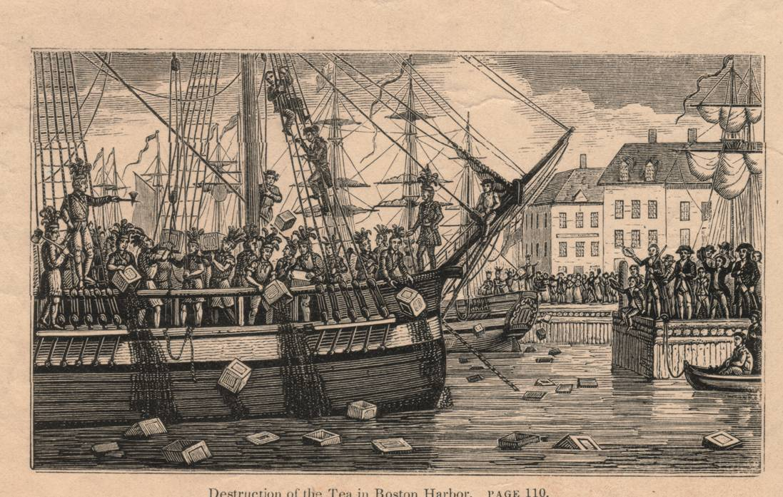
Source: http://blog.constitutioncenter.org/wp-content/uploads/2011/04/Boston-Tea-Party.jpg

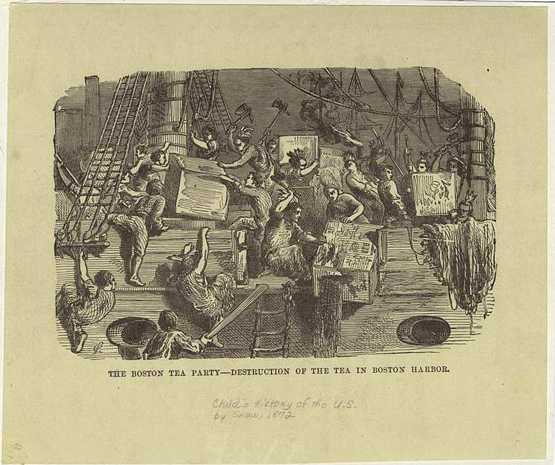
Source: http://www.bostonteapartyship.com/wp-content/themes/btps/images/patriots-destroying-tea-crates.jpg

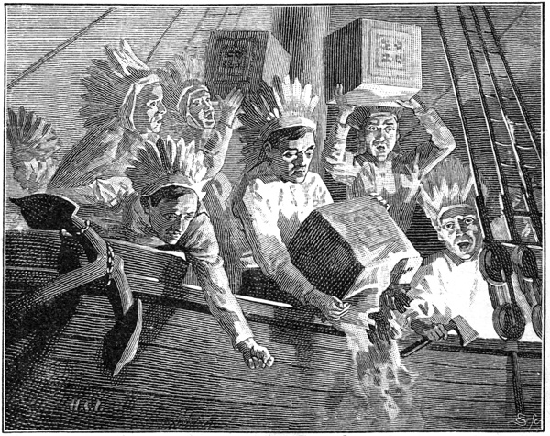
Source: http://ushistoryimages.com/images/boston-tea-party/fullsize/boston-tea-party-2.jpg

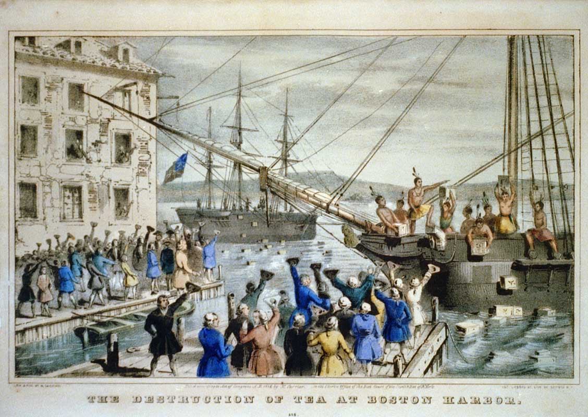
Source: https://upload.wikimedia.org/wikipedia/commons/5/52/Boston_Tea_Party_Currier_colored.jpg

Performance Indicators
WIDA Standard: The Language of Social Studies |  |  | WIDA PI Receptive Domain (Reading related to G.1):
Level 1—Entering  Work with partners to identify differing perspectives in a visually supported informational text using native language supports, gestures, and a word bank of language used to indicate perspective (feel, felt, was/were feeling, think, thought, was/were thinking). | Level 2—Emerging  Work with partners to distinguish facts and differing perspectives in a visually supported informational text using a word bank of language used to indicate perspective (feel, felt, was/were feeling, think, thought, was/were thinking). | Level 3—Developing  X |  | Level 4—Expanding  X | Level 5—Reaching  X
WIDA Standard: The Language of Social Studies |  |  | WIDA PI Productive Domain (Writing related to G.2):
Level 1—Entering  Record an opinion supported with evidence in simple sentences using an illustration, class-generated vocabulary list, partner, native language, graphic organizer, gestures, visually supported text, Venn diagram, and sentence frames. | Level 2—Emerging  Explain an opinion in writing supported with reasoning and simply detailed evidence using an illustration, class-generated vocabulary list, partner, graphic organizer, visually supported text, Venn diagram, and sentence frames. | Level 3—Developing  X |  | Level 4—Expanding  X | Level 5—Reaching  X

CEPA Rubric
CEPA Rubric Category | 4 | 3 | 2 | 1
Correct use of targeted academic vocabulary (Tier 1 and Tier 2) to convey meaning | Student used all Tier 1 and Tier 2 vocabulary correctly to describe their historical event and state their opinion. | Student used most Tier 1 and Tier 2 vocabulary correctly to describe their historical event and state their opinion. | Student used some Tier 1 and Tier 2 vocabulary correctly to describe their historical event and state their opinion. | Student did not use any Tier 1 and Tier 2 vocabulary correctly to describe their historical event and state their opinion.
Correct use of grammatical forms: simple past (including irregular tenses), past progressive, prepositions | Student used all grammatical forms correctly to describe their historical event and state their opinion. | Student used most grammatical forms correctly to describe their historical event and state their opinion. | Student used some grammatical forms correctly to describe their historical event and state their opinion. | Student did not use any grammatical forms correctly to describe their historical event and state their opinion.
State their opinion supported with reasoning and evidence | Student stated their opinion and supported it with relevant reasoning and evidence. | Student stated their opinion but supported it with irrelevant reasoning and evidence. | Student stated their opinion but did not support it with reasoning and evidence. | Student did not state their opinion or support it with relevant reasoning and evidence.
Compare and contrast different points of view by acknowledging a differing perspective when they state their opinion | Student used compare and contrast language to distinguish different points of view by acknowledging a differing perspective when they stated their opinion. | Student used compare and contrast language but did not effectively distinguish different points of view when they stated their opinion. | Student did not use compare and contrast language but did acknowledge different points of view when they stated their opinion. | Student did not use compare and contrast language to distinguish different points of view when they stated their opinion.
Presentation skills (comprehensibility) | Student consistently projected his/her voice, spoke clearly, and demonstrated appropriate body language. Student was comprehensible at all times. | Student somewhat projected his/her voice, spoke clearly, and demonstrated appropriate body language. Student was comprehensible most of the time. | Student attempted to project his/her voice, speak clearly, and demonstrate appropriate body language. However, student was hardly comprehensible. | Student did not project his/her voice, speak clearly, or demonstrate appropriate body language. Student was not comprehensible.

Lesson 9  Day 11 | CEPA: Part II—Formulating Claims Supported with Relevant Evidence | Estimated Time: 60 minutes
Brief overview of lesson: Students will continue to develop their CEPAs. They will formulate their own opinion of whether the colonists were justified in their actions at the Boston Tea Party using reasoning and evidence gathered from texts and images they analyzed to support their opinions in writing. Then they will create their museum presentations. As you plan, consider the variability of learners in your class and make adaptations as necessary.

What students should know and be able to do to engage in this lesson:
- Familiarity with language used to state an opinion and to support it with reasoning and evidence, including signal words of fact and opinion.
- Basic understanding of prepositions useful for sequencing events, simple past tense and/or past progressive tense, content area vocabulary, and concepts and ideas surrounding the events leading up to and during the American Revolution.
Familiarity with simple and compound sentences, basic adjectives, sequencing words, pronouns, wh- questions, and compare and contrast language.
LESSON FOUNDATION
Unit-Level Focus Language Goals to Be Addressed in This Lesson |  | Unit-Level Salient Content Connections to Be Addressed in This Lesson
G.1 Explain by comparing and contrasting the most important points and perspectives presented in two texts on the same topic.  G.2 Argue by stating a claim and supporting it with reasoning and relevant evidence. |  | CCSS.ELA-Literacy.RL.3.6—Distinguish their own point of view from that of the narrator or those of the characters.  CCSS.ELA-Literacy.RI.3.7—Use information gained from illustrations (e.g., maps, photographs) and words in a text to demonstrate understanding of the text (e.g., where, when, why, and how key events occur).  CCSS.ELA-Literacy.RI.3.9—Compare and contrast the most important points and key details presented in two texts on the same topic.  CCSS.ELA-Literacy.RI.3.8—Describe the logical connections between particular sentences and paragraphs in a text (e.g., comparison, cause/effect, first/second/third in a sequence).  CCSS.ELA-Literacy.SL.3.1—Engage effectively in a range of collaborative discussions (one-on-one, in groups, and teacher-led) with diverse partners on grade 3 topics and texts.  CCSS.ELA-Literacy.W.3.2—Write informative/explanatory texts to examine a topic and convey ideas and information clearly.  CCSS.ELA-Literacy.RI.3.4—Determine the meaning of general academic and domain-specific words and phrases in a text relevant to a grade 3 topic or subject area.  HSS.3.5—Explain important political, economic, and military developments leading to and during the American Revolution.  HSS.3.12—Explain how objects or artifacts of everyday life in the past tell us how ordinary people lived and how everyday life has changed.
Language Objective |  | Essential Questions Addressed in This Lesson
Students will be able to argue by stating their opinion about a historical event and supporting it with reasoning and relevant evidence. |  | Q.1 How can you use your knowledge of the English language to effectively communicate your opinion?  Q.2 How can studying the past help us to understand the present?  Q.3 Why should we examine a historical event or time period from multiple perspectives?
Assessment
- Formative assessment: Assess student use of learned language to create written opinion about a historical event supported by relevant evidence.
- Self-assessment: Students will self-assess and self-monitor their progress in completing the CEPA by using the CEPA checklist.
Thinking Space: What Academic Language Will Be Practiced in This Lesson?
Discourse Dimension | Sentence Dimension |  | Word Dimension
Social instructional language; brief written and/or audiovisual sequence of events in order and/or introduction of a topic with some supporting details and sentences containing content-area recounts and/or explanations in grade-appropriate text with limited cohesion between sentences; identifying, expressing, and justifying opinions. | Simple and complex sentences with because in present and past (and possibly past progressive) tense (e.g., “In my opinion, _______ because ____”; “I believe _____ because ______”; “I agree/disagree with _______ because ______”). |  | Compare and contrast language (and, both, but, however); present and past tense forms of topic-related verbs (e.g., shoot/shot/was/were shooting, fight/fought/was/were fighting, throw/threw/was/were throwing, feel/felt/was/were feeling, think/thought/was/were thinking, fall/fell/was/were falling); content vocabulary (e.g., history, event, freedom, people, objects, activities, what, where, when, why, how, who, colonist, redcoat, British, American Revolution, point of view, perspective, arms); fact and opinion signal words/phrases (e.g., in my opinion, according to, I think, I believe, I agree/disagree with).
Instructional Tips/Strategies/Suggestions for Teacher
- When determining what scaffolds may be needed to help students access the curriculum, consider the following: native language support, working with partners, and/or using gestures.
- Use formative assessments to assess student progress towards lesson objective(s) and unit goals. Make changes to instructions on following lessons/days, as needed, based on assessment results.

STUDENT CONSIDERATIONS
Sociocultural Implications
- Some students may have experienced a violent event and discussing the American Revolution may evoke strong negative feelings.
- Some students may come from a region/country where questioning authority is unacceptable, and they may view the actions of the colonists as being unacceptable.
Anticipated Student Pre-Conceptions/Misconceptions
- Students may require clarification about the difference between relevant evidence and irrelevant evidence, as well as the importance of supporting an opinion with evidence.

THE LESSON IN ACTION

Day 11 Lesson Opening

Post and explain the lesson’s language objective: “Students will be able to argue by stating their opinion about a historical event and supporting it with reasoning and relevant evidence.” To promote student ownership and self-monitoring of learning, consider having students record the objective in their notebooks or having students summarize the objective in their own words. At the end of the lesson, students can reflect on their learning in relation to the objective.

Review the CEPA and the CEPA rubric with students. Review the CEPA checklist with students; note the components students have completed (analyzing the images and texts) and discuss next steps (stating an opinion and supporting it with relevant evidence).
Provide options for perception, such as projecting information, giving students a printed version of the information, and/or viewing it on a computer.

During the Lesson

Show a model of an opinion statement. Remind students that their claims need to be supported with relevant evidence. Answer any questions students may have about creating their claim statements.

Students will write opinion statements about whether the colonists were justified in their actions at the Boston Tea Party using language learned throughout unit (e.g., content-specific language and vocabulary, verbs in the past tense, stating an opinion supported by reasoning and relevant evidence, fact and opinion language) and sentence frames as needed (e.g., “I think ______ because ______”; “Based on ______, it appears that ______”; “The colonists were ______ because ______”; “The British were ______ because ______”).
Provide options for physical action, such as using a computer to complete.

Ask students to use reasoning and evidence to support their opinions in writing. Review what is specifically expected for reasoning and what is specifically expected for evidence to support opinions, and how to do it. Refer to the class-created anchor chart (if using one) or refer to previously created statements.

Give students time to create their museum presentations using images (either images analyzed or original images drawn by students), texts (excerpts from texts analyzed), and student-created written statements. Remind students that historians often use images and texts to support their claims and that by having the images and text on their presentation boards, they can strengthen their argument.

Review the purpose of the presentations with students: stating an opinion supported by evidence, comparing and contrasting at least two perspectives on the same event, and presenting this information as a museum exhibit using presentation skills.

Explain how students can choose a specific format for their presentations, such as a poster board, a PowerPoint, or a video featuring a poster board. Clarify expectations for each presentation format, such as including images previously studied in the unit or drawing original images to illustrate different perspectives in a poster board or PowerPoint presentation. Be sure expectations are clear so that regardless of the method used to present, the content can be assessed objectively.

Lesson Closing

Review key components of the presentations again. Model for students how to use the CEPA checklist to check their work. Have students use the CEPA checklist to check their work and accurately reflect on their own preparation for the presentation.

Have students practice their presentations with a small group, using the checklist as a guide.
Provide options for physical action, such as recording presentations to analyze them and practice further, practicing with a partner or the teacher instead of a small group, and/or using text-to-speech readers.
Lesson 9 Resources
- Illustrations and texts of selected events leading up to or during the American Revolution, such as images of the Boston Tea Party.
- Texts, videos, and/or songs about events leading to the American Revolution focused on during the lesson. If focusing on the Boston Tea Party, the following resources might be useful:
  - Books: The Boston Tea Party by Russell Freedman, The Boston Tea Party by Steven Kroll, Colonial Voices: Hear Them Speak by Kay Winters, What Was the Boston Tea Party? by Kathleen Krull, or You Wouldn’t Want to Be at the Boston Tea Party by Peter Cook.
  - Video: “The Boston Tea Party: America the Story of Us”
  - Songs: “Tea Party—Schoolhouse Rock—No More Kings,” “Dump It Off—Boston Tea Party Song ('Shake It Off'),” and “The Boston Tea Party Song (Parody of Pharrell Williams—Happy)”
- Websites with documents/sources about focused events. If focusing on the Boston Tea Party, the following resources might be useful:
  - Websites: History, Eye Witness to History, and Boston Tea Party Ships and Museum
  - An interactive reading of the Boston Tea Party by Anne Elizabeth Eaves
  - Resources from the Massachusetts Historical Society Collection
  - First-hand accounts of the event
  - Student-geared websites: Ducksters and Mr. Nussbaum
- CEPA checklist and sentence frames
- Sentence frames for stating an opinion supported by reasoning and evidence
- Performance Indicators
- CEPA rubric

Lesson 10  Day 12 | CEPA: Part III—Presentations | Estimated Time: 60 minutes
Brief overview of lesson: During the culminating lesson of the unit, students will demonstrate language they have learned throughout the unit by comparing and contrasting texts presenting different perspectives on a historical event, and arguing their opinion about this event by presenting supporting evidence. Each student will assume the role of a historian and orally present their opinion of what happened in their chosen event, along with supporting evidence, to an audience of other historians and museum attendees at a museum exhibit opening. As you plan, consider the variability of learners in your class and make adaptations as necessary.

What students should know and be able to do to engage in this lesson:
- Familiarity with language used to state an opinion and support it with reasoning and evidence, including signal words of fact and opinion.
- Basic understanding of prepositions useful for sequencing events, simple past tense and/or past progressive tense, content area vocabulary, and concepts and ideas surrounding the events leading up to and during the American Revolution.
Familiarity with simple and compound sentences, basic adjectives, sequencing words, pronouns, wh- questions, and compare and contrast language.
LESSON FOUNDATION
Unit-Level Focus Language Goals to Be Addressed in This Lesson |  | Unit-Level Salient Content Connections to Be Addressed in This Lesson
G.1 Explain by comparing and contrasting the most important points and perspectives presented in two texts on the same topic.  G.2 Argue by stating a claim and supporting it with reasoning and relevant evidence. |  | CCSS.ELA-Literacy.RL.3.6—Distinguish their own point of view from that of the narrator or those of the characters.  CCSS.ELA-Literacy.RI.3.7—Use information gained from illustrations (e.g., maps, photographs) and words in a text to demonstrate understanding of the text (e.g., where, when, why, and how key events occur).  CCSS.ELA-Literacy.RI.3.9—Compare and contrast the most important points and key details presented in two texts on the same topic.  CCSS.ELA-Literacy.RI.3.8—Describe the logical connections between particular sentences and paragraphs in a text (e.g., comparison, cause/effect, first/second/third in a sequence).  CCSS.ELA-Literacy.SL.3.1—Engage effectively in a range of collaborative discussions (one-on-one, in groups, and teacher-led) with diverse partners on grade 3 topics and texts.  CCSS.ELA-Literacy.W.3.2—Write informative/explanatory texts to examine a topic and convey ideas and information clearly.  CCSS.ELA-Literacy.RI.3.4—Determine the meaning of general academic and domain- specific words and phrases in a text relevant to a grade 3 topic or subject area.  HSS.3.5—Explain important political, economic, and military developments leading to and during the American Revolution.  HSS.3.12—Explain how objects or artifacts of everyday life in the past tell us how ordinary people lived and how everyday life has changed.
Language Objectives |  | Essential Questions Addressed in the lesson
Students will be able to argue by stating their opinion about a historical event and supporting it with reasoning and relevant evidence in an oral presentation.  Students will be able to explain by comparing and contrasting the most important points and perspectives presented in two texts on the same topic in an oral presentation. |  | Q.1 How can you use your knowledge of the English language to effectively communicate your opinion?  Q.2 How can studying the past help us to understand the present?  Q.3 Why should we examine a historical event or time period from multiple perspectives?
Assessment
- Summative: Assess student application of learned language in an oral presentation (e.g., content-specific language, verbs in the past tense, language used to compare and contrast, language used to state opinions supported with reasoning and evidence).
- Self-assessment: Students will self-assess and self-monitor their progress in relation to the CEPA checklist. Students will also self-assess using the CEPA rubric.
Thinking Space: What Academic Language Will Be Practiced in This Lesson?
Discourse Dimension | Sentence Dimension |  | Word Dimension
Social instructional language; brief written and/or audiovisual sequence of events in order and/or introduction of a topic with some supporting details and sentences containing content-area recounts and/or explanations in grade-appropriate text with limited cohesion between sentences; identifying, expressing, and justifying opinions. | Simple and complex sentences with because in present, past (and possibly past progressive) tense (e.g., “In my opinion, _______ because ____”; “I believe _____ because ______”; “I agree/disagree with _______ because ______”). |  | Compare and contrast language (and, both, but, however); present and past tense forms of topic related verbs (e.g., shoot/shot/was/were shooting, fight/fought/was/were fighting, throw/threw/was/were throwing, feel/felt/was/were feeling, think/thought/was/were thinking, fall/fell/was/were falling); content vocabulary (e.g., history, event, freedom, people, objects, activities, what, where, when, why, how, who, colonist, redcoat, British, American Revolution, point of view, perspective, arms); fact and opinion signal words/phrases (e.g., in my opinion, according to, I think, I believe, I agree/disagree with).
Instructional Tips/Strategies/Suggestions for Teacher
- When determining what scaffolds may be needed to help students access the curriculum, consider the following: native language support, working with partners, and/or using gestures.
- Use formative assessments to assess student progress towards lesson objective(s) and unit goals. Make changes to instructions on following lessons/days, as needed, based on assessment results.
- Depending upon student familiarity with presentations, you could extend the practice for analyzing effective and ineffective presentations. Consider having students analyze additional examples of effective and ineffective presentations. The presentations analyzed could be recorded teacher and/or student-created samples.

STUDENT CONSIDERATIONS
Sociocultural Implications
- Some students may have experienced a violent event and discussing the American Revolution may evoke strong negative feelings.
- Some students may come from a region/country where questioning authority is unacceptable, and they may view the actions of the colonists as being unacceptable.
- Some students may be unfamiliar and uncomfortable presenting in front of a class.
Anticipated Student Pre-Conceptions/Misconceptions
- Students may require clarification about the difference between relevant evidence and irrelevant evidence, as well as the importance of supporting an opinion with evidence.

THE LESSON IN ACTION

Day 12 Lesson Opening

Post and explain the lesson’s language objectives: “Students will be able to argue by stating their opinion about a historical event and supporting it with reasoning and relevant evidence in an oral presentation,” and “Students will be able to explain by comparing and contrasting the most important points and perspectives presented in two texts on the same topic in an oral presentation.” To promote student ownership and self-monitoring of learning, consider having students record the objective in their notebooks or having students summarize the objective in their own words. At the end of the lesson, students can reflect on their learning in relation to the objective.

Review the CEPA and the CEPA rubric.

Model an ineffective presentation (e.g., don’t make eye contact; have poor body language, such as fidgeting and slumping; speak in a low, monotone voice; and show no visuals) and an effective presentation (e.g., consistently project voice, speak clearly, use appropriate body language, and are comprehensible) and discuss characteristics of effective oral presentations. Consider creating a class T-chart with characteristics of effective and ineffective presentations to have as a reference.

Depending upon student familiarity and comfort with oral presentations, consider providing more practice with analyzing effective and ineffective presentations and identifying the characteristics of each. For example, model an ineffective presentation and have student take notes on what they notice worked well/did not work well in the presentation. Ask students to give their opinion about whether the presentation was effective (communicated ideas clearly) or ineffective (did not communicate ideas clearly). Point out that you demonstrated a poor, or ineffective presentation. Ask students to identify characteristics of this presentation that made it ineffective with prompts such as “Why do you think my presentation was ineffective? Why do you think it did not do a good job of giving you the information I wanted to share?” Make connections between the poor presentation skills and good presentation skills by changing statements shared by students with a solution or alternative to make the presentation better. Redo the initial presentation, applying students’ suggestions. Ask students to reflect on the changes you made with prompts such as “What made this presentation better? Why?”

During the Lesson

Remind students that they will be taking on the role of a historian and will be presenting to other historians who have studied similar events/time periods and museum attendees. Model a CEPA presentation for students.

Have each student assume the role of a historian to present their opinions to the class, who will be representing other historians who have studied similar events/time periods and museum attendees.

As students present, use the CEPA rubric to evaluate each performance. Pause after each presentation to allow other students to ask questions. Consider having students give written feedback to their peers on Post-Its. For example, classmates could state one thing that they learned or liked in their classmate’s presentation. Be sure to model the feedback protocol for students.

Lesson Closing

After all students have presented, have students self-assess using the CEPA rubric.

Revisit the K-W-L chart started in Lesson 1. Ask students to think about everything that they have learned in the unit. Invite students to share with a partner, before inviting students to the class discussion. Add student responses to the chart paper.

Optional activity: Consider having students reflect on the essential question: “Why should we examine a historical event or time period from multiple perspectives?” Students could discuss orally with a partner/small group or as a whole class, or record their thoughts in a journal.

Lesson 10 Resources
- Illustrations and texts of selected events leading up to or during the American Revolution, such as images of the Boston Tea Party.
- Texts, videos, and/or songs about events leading to the American Revolution focused on during the lesson. If focusing on the Boston Tea Party, the following resources might be useful:
  - Books: The Boston Tea Party by Russell Freedman, The Boston Tea Party by Steven Kroll, Colonial Voices: Hear Them Speak by Kay Winters, What Was the Boston Tea Party? by Kathleen Krull, or You Wouldn’t Want to Be at the Boston Tea Party by Peter Cook.
  - Video: “The Boston Tea Party: America the Story of Us”
  - Songs: “Tea Party—Schoolhouse Rock—No More Kings,” “Dump It Off—Boston Tea Party Song ('Shake It Off'),” and “The Boston Tea Party Song (Parody of Pharrell Williams—Happy)”
- Websites with documents/sources about focused events. If focusing on the Boston Tea Party, the following resources might be useful:
  - Websites: History, Eye Witness to History, and Boston Tea Party Ships and Museum
  - An interactive reading of the Boston Tea Party by Anne Elizabeth Eaves
  - Resources from the Massachusetts Historical Society Collection
  - First-hand accounts of the event
  - Student-geared websites: Ducksters and Mr. Nussbaum
- CEPA checklist and sentence frames
- Sentence frames for stating an opinion supported by reasoning and evidence
- Performance Indicators
- CEPA rubric

Image and Text Credits

Page 104, Courtesy Historic Tours of America, www.HistoricTours.com.
Page 28, Courtesy of the Boston Society.
Page 16 and 45, Dorling Kindersley/Getty Images
Page 28, Stock Montage/Getty Images
Page 28, Courtesy Clipartheaven.com, http://www.clipartheaven.com/show/clipart/holidays/christmas/winter-holiday-fun/boy-throwing-snowball-clipart-gif.html.
Page 29 and 44, Source: Cliparts.co
Page 29, classroomclipart.com
Page 29, Dennis Cox/Shutterstock
Page 39, Source: Cliparts.co
Page 46,Courtesy Daron Dean/The St. Augustine Record.
Page 59, Courtesy Tim van de Vall
Page 60, Source: Clipart Panda
Page 60, classroomclipart.com

