ESL: Access to Clean Water
ESL Grade 7, LoSS —English Language Proficiency Levels 1 and 2
For more information on the design process for the ESL MCUs, please see the Next Generation ESL Project: Curriculum Resource Guide.

The purpose of this unit is to help ELs develop the language necessary for academic success in the content area of social studies. They will also learn language that will be used recurrently in and across various academic and social contexts. The unit focuses on systematic, explicit, and sustained English language development in the context of the Massachusetts Curriculum Frameworks. It is not to be confused with a sheltered social studies unit. “ESL: Access to Clean Water” is intended to be taught by an ESL teacher, and collaboration with the content teacher is essential. Please be mindful that, in addition to this dedicated, language-focused time, the student must also have access to all core academic content.

The language development in this unit centers on two of the Key Uses of Academic Language as connected to the following key academic practices:

- Explain causes and effects to create evidence-based claims.
- Discuss by stating opinions/claims about a substantive topic.

In “ESL: Access to Clean Water,” students get contextualized, extended practice in the word/phrase, sentence, and discourse dimensions. They will be able to use their learned language to take a position, state an opinion/claim, and offer evidence via explanation of cause and effect. While learning about the real, complex issues of clean water access, students will create public service announcements (PSAs) to educate and encourage others to take action. (This announcement will be shared with the school audience on World Water Day, March 22.) The embedded, authentic learning experiences help students develop effective communication with peers and adults about social and academic topics. By the end of the unit, through a social justice lens, students are equipped with the language to serve as advocates for clean water access around the world.

This document was prepared by the Massachusetts Department of Elementary and Secondary Education, Mitchell D. Chester, Ed.D., Commissioner.

The Massachusetts Department of Elementary and Secondary Education, an affirmative action employer, is committed to ensuring that all of its programs and facilities are accessible to all members of the public. We do not discriminate on the basis of age color, disability, national origin, race, religion, sex, or sexual orientation.

© 2016 under the terms of the Creative Commons Attribution-NonCommercial-ShareAlike 3.0 Unported License. Additionally, the unit may also contain other third party material used with permission of the copyright holder. Please see Image and Text Credits for specific information regarding third copyrights.

Every effort has been made to acknowledge copyright. Any omissions brought to our attention will be corrected in subsequent editions.

Image and Text Credits:

Page 1 | Courtesy Earth Day Network
Page 1 | Courtesy PlayPumps, www.playpumps.co.za
Page 2 | Courtesy PlayPumps, www.playpumps.co.za
Page 3 | Powerpoint, Lesson 5
Pages 7 and 13 | Source: Cliparts.co
Pages 8 and 14 | www.clipart.of
Page 18 | Shutterstock
Page 19 | Fotolia/File: #113819542
Page 24 | Courtesy Teach-This.com
Page 24 | Courtesy Teach-This.com
Page 40 | Source: Clipart Panda
Page 40 | Permission granted under the Creative Commons Attribution 2.0 Generic license/James West. “Eiger North Hall"  Available here: https://www.flickr.com/photos/ejwwest/14856212383/in/photolist
Page 40 | Courtesy Steve Elliot
Page 40 | Source: Cliparts.co
Page 41 | Source: Cliparts.co
Page 41 | Source: Cliparts.co
Page 41 | Subbotina Anna | Fotolia LLC
Page 41 | sykadelx/Getty Images
Page 42 | Source: Clipart Panda
Page 58 | Courtesy Water1st International
Page 58 | Courtesy WaterAid/Abbie Trayler-Smith
Page 58 | Aaron Amat/Shutterstock
Page 58 and 59 | Permission granted under Creative Commons Attribution-ShareAlike 3.0 license
Page 69 | Source: Esther Havens
Page 69 | Reprinted by permission of Ami Vitale Photography
Page 69 | Source: Pencils for Africa
Page 69 | Rizwan Tabassum/Getty Images
Page 69 | Source: http://www.ariverbed.com/
Pages 83-90 | "Non-fiction: Playing for Clean Water" from Weekly Reader, 2009. Copyright © Weekly Reader Corporation.  Reprinted by permission
Pages 84, 102, 103 | Courtesy PlayPumps, www.playpumps.co.za
Page 100 | Source: Clipart Panda
Page 100 | Illustrations/graphics supplied by GospelGifs.com are copyrighted and used with permission
Page 100 | Source: Clipart Panda
Page 101 | iqoncept/123RF LLC
Page 101 | Copyright: <a href='http://www.123rf.com/profile_mammothis'>mammothis  / 123RF Stock Photo</a>
Page 104 | Courtesy UN-Water, www.unwater.org
Page 101 | Courtesy Deborah Terry
Page 103 | Source: Clipart Panda
Page 103 | © Leocalvett | Dreamstime.com
Page 103 | Courtesy charity: water
Page 111 | Franck Prevel/Getty Images
Page 111 | Catherine Lane/Getty Images
Page 120 | © Mike Urban, urban75.com
Page 121 | Courtesy Jared Flesher
Page 113 | Courtesy Aaron Patterson
Page 121 | Courtesy Statista, Inc.
Page 121 | Courtesy Statista, Inc.
Page 123 | Source: Konrad-Adenauer-Stiftung
Page 125 | Courtesy Jesse O. Walls
Page 125 | Source: WorldShare
Page 126 | Courtesy Peter Gleick
 | Smit/Shutterstock lesson 5 ppt
PowerPoint, Lesson 1, Slide 1 | Courtesy Jefferson City News Tribune
PowerPoint, Lesson 1, Slide 1 | Source: Cliparts.co
PowerPoint, Lesson 1, Slide 1 | aleksandrovaphoto/Getty Images
PowerPoint, Lesson 1, Slide 3 | mangostock/Shutterstock
PowerPoint Lesson 1, Slide 4 | Courtesy City of Clearwater, Fla
PowerPoint Lesson 1, Slide 5 | mangostock/Shutterstock
PowerPoint Lesson 1, Slide 6 | Elena Elisseeva/Shutterstock
Powerpoint Lesson 1, Slide 7 | Lisa F. Young/Shutterstock
PowerPoint Lesson 1. Slide 8 | iQoncept/Shutterstock
PowerPoint Lesson 1, Slide 11 | Source: Amalgamated Transit Union Local 1395
PowerPoint Lesson 1, Slide 12 | www.clipartof.com
PowerPoint Lesson 1, Slide 13 | Source: Community Water Center
PowerPoint Lesson 1, Slide 14 | Forthcoming from The Permissions Group
PowerPoint Lesson 1, Slide 16 | Photo courtesy of Rural Community Assistance Corporation, www.rcac.org
PowerPoint Lesson 2, Slide 3 | Alkalyne/Getty Images
PowerPoint Lesson 2, Slide 4 | Andrey Burmakin/Shutterstock
PowerPoint Lesson 2, Slide 5 | Source: The Borgen Project
PowerPoint Lesson 2, Slide 6 | Source: You Speak India
PowerPoint Lesson 2, Slide 7 | A/P Photo/Ben Curtis
PowerPoint Lesson 2, Slide 8 | violetkaipa/Shutterstock
PowerPoint Lesson 2, Slide 9 | © Phillip Martin 2005 – 2016
PowerPoint Lesson 2, Slide 10 | Kevork Djansezian/Getty Images
PowerPoint Lesson 2, Slide 13 | A/P Photo/Ben Curtis
PowerPoint Lesson 2, Slide 15 | John Takai/123RF LLC
PowerPoint, Lesson 2, Slide 15 | Janos Timea/Shutterstock
PowerPoint Lesson 2, Slide 16 | Oleg Zabielin/Shutterstock
PowerPoint, Lesson 2, Slide 17 | Courtesy National Geographic Channel/Fox
PowerPoint Lesson 5, Slide 3 | Source: Publitek, Inc.
PowerPoint Lesson 5, Slide 3 | Permission granted under the Creative Commons Attribution 2.0  Generic license/Thomas Rydberg/"Hungry"  https://www.flickr.com/photos/trydberg/  7449591000/in/photolist-cmi6S9-KvczV-a2ftBb-4vvPyH-4UimxM  -2hk5N-f6Jeg-35tHf2-6SPqzb-8hueUv-5xYVVJ-e7yScv-smqb2n-c4WQTw  -6iSSdh-f73cZ-ij8PmZ-3jJtpK-tzP7u-8hxvt9-6hZmTB-3apdS-  6mTqXW-joHZJ-pMedH8-2kau8D-atMLeP-8E3g3z-  atTvpT-pCYRsM-9Sf3Kr-eKtJFV-bZp2Fo-9X1j4-zmzAv-9CGHvX-  MiWoZ-5u9cDw-bZp2ns-99v9QV-e63tfb-hnyH3g-9mka92-  KcELZ-831P18-aPqmii-9WmT4U-9Qxg5W-dG8Qr3-qkwQ8G /
PowerPoint Lesson 5, Slide 3 | Westend61/Getty Images
PowerPoint Lesson 5, Slide 3 | © State of New South Wales through NSW Department of Industry
PowerPoint Lesson 5, Slide 4 | Source: Cliparts.co
PowerPoint Lesson 5, Slide 4 | Courtesy Harry Cutting Photography
PowerPoint Lesson 5, Slide 4 | Permission granted under the Creative Commons Attribution 2.0 Generic license.
PowerPoint, Lesson 5, Slide 4 | Courtesy International Committee of the Red Cross
PowerPoint, Lesson 7, Slide 3 | flybird163/123RF LLC
PowerPoint Lesson 7, Slide 4 | Izabele Habur/iStock by Getty Images
PowerPoint Lesson 7, Slide 4 | Courtesy UN-Water, www.unwater.org
PowerPoint Lesson 7, Slide 4 | © Can Stock Photo/csp12866141
PowerPoint Lesson 7, Slide 9 | © Kadettmann | Dreamstime.com
PowerPoint Lesson 7, Slide 11 | Web Buttons Inc. | Fotolia LLC
PowerPoint, Lesson 7, Slide 12 | Courtesy Whole Family Chiropractic
PowerPoint, Lesson 7, Slide 20 | © Alhovik | Dreamstime.com
PowerPoint, Lesson 7, Slide 23 | Permission granted under Attribution-NonCommercial-ShareAlike 2.0 Generic License (CC BY-NC-SA 2.0).
PowerPoint, Lesson 7 Slide 24 | Ruslan Olinchuk/123RF LLC
PowerPoint, Lesson 7, Slide 27 | © UNICEF. Used by permission.

The contents of this Model Curriculum Unit were developed under a grant from the U.S. Department of Education. However, those contents do not necessarily represent the policy of the U.S. Department of Education, and you should not assume endorsement by the Federal government.

Massachusetts Department of Elementary and Secondary Education, 75 Pleasant St, Malden, MA 02148-4906. Phone 781-338-3300, TTY: N.E.T. Relay 800-439-2370, www.doe.mass.edu

Table of Contents
Unit Plan 9
Lesson 1 17
Lesson 2 28
Lesson 3 37
Lesson 4 53
Lesson 5 66
Lesson 6 74
Lesson 7 93
Lesson 8 108
Lesson 9 117
Lesson 10 129
Lesson 11 136
Lesson 12 145
Lesson 13 152
Lesson 14 156

Unit Plan
Stage 1—Desired Results
ESTABLISHED FOCUS GOALS: G  Focus Language Goals/Standards:  G.1 Discuss by stating opinions/claims about a substantive topic.  G.2 Explain causes and effects to create evidence-based claims.  Content Connections:  The student is building toward:  CCSS.ELA-LITERACY.RH.6-8.8—Distinguish among fact, opinion, and reasoned judgment in a text.  CCSS.ELA-LITERACY.W.7.1—  Write arguments to support claims with clear reasons and relevant evidence.  CCSS.ELA-LITERACY.SL.7.1—  Engage effectively in a range of collaborative discussions (one-on-one, in groups, and teacher-led) with diverse partners on grade 7 topics, texts, and issues, building on others’ ideas and expressing their own clearly.  CCSS.ELA-LITERACY.SL.7.4—  Present claims and findings, emphasizing salient points in a focused, coherent manner with pertinent descriptions, facts/evidence, details, and examples; use appropriate eye contact, adequate volume, and clear pronunciation. | Transfer
Students will be able to independently use their learning to… T
T.1 Communicate for social and instructional purposes within the school setting.
T.2 Communicate information, ideas, and concepts necessary for academic success in the content area of social studies.
T.3 Integrate and evaluate multiple sources of information presented in diverse formats and media in order to address a question, form an opinion, or solve a problem (history and social science).
T.4 Take risks in the target language to advocate for themselves and others while remaining culturally sensitive (ESL).
 | Meaning
 | UNDERSTANDINGS U  Students will understand that…  U.1 Using oral language effectively can help students advocate for themselves and others.  U.2 For maximum effectiveness, a message must include a combination of facts/evidence and opinions/claims.  U.3 Visuals and graphs are effective supports for communicating a message.  U.4 Limited/unequal access to natural resources causes political, economic, and social unrest. | ESSENTIAL QUESTIONS Q  Q.1 How can I use language to make a difference in a problem that is important to me, my community, or other people?  Q.2 How can I use my knowledge of the English language to convey a powerful message?  Q.3 Why should access to clean water be a human right? (Connected to MCU for SS—“Model United Nations: Access to Clean Water.”)
 | Language Acquisition in the Four Domains
 | KNOWLEDGE: Academic Language K  Students will know…  K.1 Signal words of cause and effect can clarify meaning (e.g., because, since, as a result).  K.2 Signal words of sequence of events can clarify meaning (e.g., first, next, then, finally).  K.3 A mix of facts/evidence and opinions/claims effectively support a message.  K.4 Powerful communication requires fluency, eye contact, and appropriate body language.  K.5 Visual information in addition to text can support a message effectively.  K.6 A combination of technology, visuals, text, and original ideas will make an effective PSA.  K.7 Academic conversations develop speaking and collaboration skills and familiarity with conversation norms, and will lead to sound academic performance.  K.8 Simple present tense structure (interrogative, negative and positive), and auxiliary and modal verbs (e.g., can, should, must).  K.9 Content-specific vocabulary (e.g., access, responsibility, human rights). | SKILLS: Academic Language S  Students will be skilled at…  S.1 Using and recognizing the signal words for cause and effect and sequence.  S.2 Discussing and writing opinions/claims and supporting ideas with facts/evidence in order to present a point of view.  S.3 Presenting claims and findings, emphasizing points with descriptions, facts/evidence, details, and examples; using appropriate eye contact, adequate volume, and clear pronunciation.  S.4 Including multimedia components and visual displays in presentations to clarify claims and findings and emphasize salient points.  S.5 Engaging in collaborative discussions (one-on-one, in groups, and teacher-led) with diverse partners on grade 7 topics, texts, and issues, building on others’ ideas and expressing their own clearly. (Adapt for the student grade band in your classroom, e.g., 6–8.)  S.6 Following rules for collegial discussions and defining individual roles as needed.  S.7 Demonstrating command of the conventions of standard English grammar and usage when writing or speaking.

Stage 2—Evidence
EVALUATIVE CRITERIA | ASSESSMENT EVIDENCE: Language Development
- Accurate use of topic vocabulary in context (e.g., access, responsibility, human right).  - Effective use of cause and effect language (e.g., because, since, as a result).  - Appropriate construction and use of fact/evidence and opinion/claim statements.  - Student use of language at the discourse, sentence, and word/phrase levels at the expected level of linguistic complexity. | CURRICULUM EMBEDDED PERFORMANCE ASSESSMENT (Performance Tasks) PT  As a result of:  - Reading abridged articles about access to clean water  - Drawing conclusions about graphs, charts, and videos about access to clean water  - Analyzing and using the language of facts/evidence and opinions/claims  - Analyzing and using the language of cause and effect  - Identifying and using sequence signal words  - Studying simple present tense statements, and questions with auxiliary and modal verbs  Students will be able to write a script and create a PSA video about the challenges to and benefits of access to clean water around the world. They will be able to:  - Discuss opinions/claims and facts/evidence about clean water access.  - Use cause and effect language to explain the effects of a lack of access to clean water.  - Use cause and effect language to explain the benefits of access to clean water.  - Make linguistic choices (considering discourse, sentence, and word/phrase dimensions) about how to best process and produce language regarding the issue of access to clean water.  PSA:  Goal—Raise awareness of the global clean water access problem.  Role—Advocate for clean water access.  Audience—School community on World Water Day (March 22) with an optional fundraising component.  Situation—You have been asked to present the challenges to and solutions for those in countries without access to clean water in a PSA.  Product performance and purpose—You are writing, appearing in, and designing a PSA to raise awareness in the school community about the world clean water crisis.  Reflection:  Yes/no question checklist
OTHER EVIDENCE OE
Formative assessments: exit ticket, sorting and matching activities, warm-ups, think-pair-share, turn-and-talk, pre/free-writing, response boards, homework, total physical response, sentence starters and graphic organizers, journals, know–want to know–learned (K-W-L), role-play, etc.
Stage 3—Learning Plan
SOCIOCULTURAL IMPLICATIONS:
Register:
PSAs or defending the rights of others may be a new concept for some ELs.
Topic:
- Discrimination may exist among some groups. It may be based on socioeconomic status, race, religion, tribal group, or other aspects. The educator should remain aware of these factors when introducing diverse cultural groups and skillfully address them.
- Some students may not be aware of the unequal distribution of natural resources world-wide, including the fact that a number of nations lack access to essential natural resources such as clean water.
- Some students may have come from countries that lack some natural resources such as clean water, and the topic may trigger strong emotional responses. Again, students need to be skillfully supported.
Task/situation:
- Some students may be more comfortable expressing themselves orally, rather than in writing. Give thoughtful consideration to both components.
- Some students may not be familiar with the advertising form of a PSA. Consider showing examples of PSAs raising awareness about relevant issues such as drugs, smoking, or pollution.
- Some students may not be familiar with expressing cultural sensitivity, cultural norms of turn-taking, and the etiquette of classroom conversations, and may need direct instruction to develop these skills.
SUMMARY OF KEY LEARNING EVENTS AND INSTRUCTION:
Lesson 1—Days 1 and 2: Content Connection: Access to Clean Water
- Language objective: Students will be able to discuss key points about making a difference in the world using the verbs can/can’t and academic vocabulary (access, responsibility, human rights).
- Brief overview of lesson: Students are introduced to the unit by engaging with key content. They learn topic vocabulary and form sentences with can and can’t to describe what people can do to share important messages and engage in ways to make a difference in challenges that affect ourselves, our families, our communities, or those whom we care about. These experiences introduce students to the unit’s essential questions:
Q.1 How can I use language to make a difference in a problem that is important to me, my community, or other people?
Q.2 How can I use my knowledge of the English language to convey a powerful message?
Q.3 Why should access to clean water be a human right?
Knowledge resulting from these learning experiences will help students engage with unit goals:
G.1 Discuss by stating opinions/claims about a substantive topic.
G.2 Explain causes and effects to create evidence-based claims.
Lesson 2—Day 3: Background Building
- Language objective: Students will be able to explain the existence of common global issues using There is/There are and academic vocabulary (e.g., pollution, war, malnutrition, poverty).
- Brief overview of lesson: Students continue learning key content/topic vocabulary/topic language patterns as they are introduced to the concept of human rights. They discuss the essential question “Why should access to clean water be a human right?” as well as wants, needs, and “should-haves” of all people. Students learn about some common problems in the world, including lack of access to clean water, and analyze world maps to identify geographic and economic patterns for where these issues occur. They also learn how to describe the existence of these world problems using There is and There are. This knowledge will be used to discuss key points about a substantive topic and explain causes and effects in their final assessment.
Lesson 3—Days 4 and 5: Background Building and Fact Gathering
- Language objective: Students will be able to state facts/evidence about the need for clean water using verbs in the present tense and content vocabulary (e.g., crisis, germs, contaminated).
- Brief overview of lesson: Students extend their learning about language used to discuss access to clean water by exploring basic sentence structure in English (subject/verb/object) and learning about facts and related signal words. Students analyze videos about lack of access to clean water to continue expanding their knowledge of content/topic language and identify facts about clean water access. This knowledge will be used to create evidence-based claims about this substantive topic.
Lesson 4—Days 6 and 7: Background Building and Fact Gathering
- Language objective: Students will be able to state facts/evidence about the need for clean water using verbs in the present tense and content vocabulary (e.g., crisis, germs, contaminated).
- Brief overview of lesson: Students extend their thinking and language use about clean water access by simulating the experience of having to walk to gather water, engaging in a follow-up group discussion about the experience, and watching a PSA to gather more facts. Students are also introduced to sequencing signal words as they discuss the simulation experience. They will use this knowledge to discuss key points about clean water access and explain causes and effects related to this issue in the final assessment.
Lesson 5—Day 8: Introduce Cause and Effect Structure
- Language objective: Students will be able to create evidence-based claims about the need for clean water access using cause and effect signal words (because, since, as a result).
- Brief overview of lesson: Students continue gathering facts to identify causes and effects related to lack of access to clean water from a video. They are also introduced to new language and ways to structure thinking around the concepts of cause and effect, related signal words, and ways to structure sentences to explain them. Students practice what they have learned through cloze activities and responding to the prompt “Why is access to clean water a human right?” This knowledge will be used to explain and discuss causes and effects in order to create evidence-based claims about clean water issues in the final assessment.
Lesson 6—Days 9–11: Exploring the Topic through Active Reading
- Language objective: Students will be able to explain causes and effects related to access/lack of access to clean water using cause and effect signal words (because, since, as a result).
- Brief overview of lesson: Students review content/topic language learned so far and continue expanding their knowledge of the topic by reading abridged topic-related texts, identifying key vocabulary, and gathering causes and effects related to the issue using a graphic organizer. They also have an opportunity to discuss these facts as a whole class. This knowledge will be used to explain and discuss causes and effects in order to create evidence-based claims about clean water issues in the final assessment.
Lesson 7—Days 12 and 13: Fact/Evidence and Opinions/Claims (Language Checkpoint)
- Language objective: Students will be able to create fact and opinion statements about the clean water issue using related signal words (e.g., According to, In the text, I think, In my opinion).
- Brief overview of lesson: This lesson serves as the language checkpoint for the unit. Students expand their knowledge of what facts are and learn about terms such as evidence, opinions, claims, and related signal words. They also practice identifying, formulating, and writing original facts and opinions, as well as content-related facts and opinions. This knowledge will be used to discuss key points about clean water access and state opinions/claims about the issue.
Lesson 8—Day 14: Writing a Call to Action Using Modal Verbs
- Language objective: Students will be able to use their knowledge of ways people can stand for causes to make fact and opinion statements about the need for access to clean water using modal verbs (can, should, must, have to).
- Brief overview of lesson: In this lesson, students discuss and write about ways people can stand up for causes they believe in through a gallery walk, and are introduced to modal verbs as a language feature that is useful for formulating a call to action to improve global access to clean water. Students will also discuss what they can do to support greater access to clean water, beginning to form their own perspective and possibilities for engagement with this issue. This knowledge will be used to discuss key points and state opinions/claims about the issue in the final assessment.
Lesson 9—Days 15 and 16: Interpreting Maps, Charts, and Graphs
- Language objective: Students will be able to use their knowledge of how to interpret graphs, maps, charts, and other visuals to create evidence-based claims about the clean water issue.
- Brief overview of lesson: To further develop their knowledge about clean water issues, students learn about different ways of graphically displaying information (maps, charts, graphs). Students analyze these visuals to interpret information and evaluate their effectiveness in communicating a message. They also record important facts derived from maps, charts, and graphs and choose visual for their upcoming PSAs. This knowledge will be used to create evidence-based claims about clean water issues and effectively communicate this information in the final assessment.
Lesson 10—Day 17: The Power of Words
- Language objective: Students will be able to explain and discuss clean water issues using topic-related language (including topic-related vocabulary such as access, human right, powerful, opportunity) and selected visuals (pictures, maps, charts, and/or graphs).
- Brief overview of lesson: Students analyze images and PSAs to learn more about the power of words and actions and the causes and effects related to the clean water issue. Students also have an opportunity to create a visual to strategically communicate the need for access to clean water. This knowledge will be used to discuss key points and explain causes and effects related to clean water access in the final assessment.
Lesson 11—Days 18 and 19: PSA Background Building and Organizing
- Language objective: Students will be able to explain the process for creating a PSA about the clean water issue using sequence words (e.g., first, next, then, last, finally).
- Brief overview of lesson: Students explore PSAs as a form of communication by watching and analyzing the components of several effective PSA exemplars. Students are introduced to storyboards and also expand earlier learning about sequencing language. They apply this knowledge to develop steps for creating PSAs. They will also organize the PSA’s elements (for the final assessment), discussing key points about access to clean water and explaining related causes and effects.
Lesson 12—Day 20: Organizing the PSA
- Language objective: Students will be able to synthesize relevant information for creating PSAs to promote awareness about the clean water issue using verbs in the present tense; modal verbs; and cause, effect, fact, and opinion signal words.
- Brief overview of lesson: Students brainstorm ideas for their PSAs and begin creating their storyboards. They incorporate earlier learning about the topic and make linguistic choices in using the three dimensions of academic language (word/phrase, sentence, and discourse) to construct and communicate meaning, including sequencing signal words, signal words for facts/evidence and opinions/claims, the present tense, cause/effect statements, and content/topic knowledge about the clean water issue. This lesson allows students to demonstrate how they are currently using the linguistic tools at their disposal to express their knowledge about the topic as they engage in discussion, statement of opinions/claims, explanation of causes and effects, and development of evidence-based claims.
Lesson 13—Day 21: Incorporating Visuals and Multimedia
- Language objective: Students will be able to justify their choice of visuals to support fact and opinion statements about the clean water issue using because.
- Brief overview of lesson: Students explore how particular visuals can be used to strategically communicate a message by revisiting a PowerPoint from Lesson 1. They also gather or choose strong graphics and visuals for their PSAs and write related statements in their storyboards. This lesson allows students to demonstrate how they are currently using the linguistic tools at their disposal as they engage in discussion, state opinions/claims, explain causes and effects, and develop evidence-based claims to express knowledge about the topic.
Lesson 14—Days 22–26: Creating the PSA (CEPA)
- Language objective: Students will be able to explain relevant information about clean water access by creating PSAs to promote awareness using verbs in the present tense; modal verbs; and cause, effect, fact, and opinion signal words. Students will be able to develop and apply their knowledge of effective oral presentations as they explain and discuss facts and opinions about the clean water issue using appropriate verbal and nonverbal presentation cues (e.g., eye contact, volume, pronunciation).
- Brief overview of lesson: This lesson spans several days and allows students to complete their PSAs about the challenges and benefits of access to clean water around the world, demonstrating their learning of key concepts and skills developed in the unit. Students begin by analyzing each other’s storyboards and providing feedback using a checklist, then incorporate feedback to finalize their storyboard and visuals. On the second day of the lesson, students create a script for their PSAs based on their storyboard. The third day they prepare visuals to be filmed, practice scripts, and film the PSAs; they edit videos on day 4. Once PSAs are finished, students exhibit their storyboards and/or PSAs to other students in the school. Students will self-assess using a rubric.
Adapted from Understanding by Design®. © 2012 Grant Wiggins and Jay McTighe. Used with permission.

Lesson 1  Days 1 and 2 | Content Connection: Access to Clean Water | Estimated Time: Two 60-minute periods
Brief overview of lesson: Students are introduced to the unit by engaging with key content. They learn topic vocabulary and form sentences with can and can’t to describe what people can do to share important messages and engage in ways to make a difference in challenges that affect ourselves, our families, our communities, or those whom we care about. These experiences introduce students to the unit’s essential questions:

Q.1 How can I use language to make a difference in a problem that is important to me, my community, or other people?
Q.2 How can I use my knowledge of the English language to convey a powerful message?
Q.3 Why should access to clean water be a human right?

Knowledge resulting from these learning experiences will help students engage with unit goals:

G.1 Discuss by stating opinions/claims about a substantive topic.
G.2 Explain causes and effects to create evidence-based claims.

As you plan, consider the variability of learners in your class and make adaptations as necessary.

What students should know and be able to do to engage in this lesson:
- Some knowledge and experience with social and instructional language.

LESSON FOUNDATION
Unit-Level Focus Language Goals to Be Addressed in This Lesson |  | Unit-Level Salient Content Connections to Be Addressed in This Lesson
G.1 Discuss by stating opinions/claims about a substantive topic. |  | CCSS.ELA-LITERACY.SL.7.4: Present claims and findings, emphasizing salient points in a focused, coherent manner with pertinent descriptions, facts/evidence, details, and examples; use appropriate eye contact, adequate volume, and clear pronunciation.
Language Objective |  | Essential Questions Addressed in This Lesson
Students will be able to discuss key points about making a difference in the world using the verbs can/can’t and academic vocabulary (access, responsibility, human rights). |  | Q.2 How can I use my knowledge of the English language to convey a powerful message?
Assessment
- Formative assessment: Assess students’ ability to orally state and write can/can’t statements (and questions, when applicable). The lesson provides multiple opportunities to assess students’ use of simple sentences with can/can’t (subject + can + base verb).
- Formative assessment: Use the cloze activity to assess student understanding and use of key content vocabulary.
- Formative assessment: Use the Vocabulary Quilt to assess students’ ability to define key content vocabulary.
- Formative assessment: Use the exit ticket to assess students’ ability to define and describe content vocabulary.
- Self-assessment: Student monitoring of learning in relation to the language objective.
- Observation: During the lesson, observe student use of content vocabulary (e.g., change, responsibility, solution, human right) and formation of simple sentences using can/can’t (subject + can + base verb).
Thinking Space: What Academic Language Will Be Practiced in This Lesson?
Discourse Dimension | Sentence Dimension |  | Word Dimension
Social/instructional language; simple sentence statements with repetitive phrases supported by visuals; one-sentence definitions | Simple sentences with can/can’t (subject + can + base verb) |  | Clean/dirty water, change, make a difference, get, walk, access, responsibility, solution, human rights, share a message
Instructional Tips/Strategies/Suggestions for Teacher
- Continuously consider how the word/phrase and sentence dimensions are used to craft meanings and messages at the discourse dimension.
- Pause videos at different points to ask questions and check for understanding.
- Post and explain the lesson objective so students can see and understand it.
- Use the exit ticket to formatively assess student progress. When needed, make changes for the following day/lesson based on what you learn from the exit ticket.
- It may be helpful to have each student use a notebook, learning log, or online notebook such as Zoho Notebook. On the first day of the unit, consider having students set up their notebooks for the unit, then give them time to categorize and organize the information learned throughout the unit. For example, students could have a section on facts about access to clean water and another on causes and effects related to the issue, color-coding each section for easy reference. The notebook can help students can track their progress and build their ideas for the PSAs throughout the unit (as opposed to at the end).
STUDENT CONSIDERATIONS
Sociocultural Implications
- PSAs or defending the rights of others may be a new concept for some ELs.
- Discrimination may exist among some groups. It may be based on socioeconomic status, race, religion, tribal group, or other aspects. The educator should remain aware of these factors when introducing diverse cultural groups and skillfully address them.
- Some students may not be aware of the unequal distribution of natural resources world-wide, including the fact that a number of nations lack access to essential natural resources such as clean water.
- Some students may have come from countries that lack natural resources such as clean water, and the topic may trigger strong emotional responses. Again, students need to be skillfully supported.
- Some students may be more comfortable expressing themselves orally, rather than in writing. Give thoughtful consideration to both components.
- Some students may not be familiar with expressing cultural sensitivity, cultural norms of turn-taking, and the etiquette of classroom conversations, and may need direct instruction to develop these skills.
Anticipated Student Pre-Conceptions/Misconceptions
Some students may believe that words and actions have little consequence and are not an effective way to promote change.

THE LESSON IN ACTION
Day 1 Lesson Opening
- Introduce the new unit. For example, say: “We will start a new unit today. Over the next few weeks, we will talk about how powerful words can be. We will begin by watching a video to get us thinking about our new unit.”

- Post and share the language objective with students: “Students will be able to discuss key points about making a difference in the world using the verbs can/can’t and academic vocabulary (access, responsibility, human rights).” To promote student ownership and self-monitoring of learning, have students record the objective in their notebooks. At the end of the lesson, students can reflect on their learning in relation to the objective.
During the Lesson
- Show the video “The Power of Words.”
Provide options for perception, such as printing out the video transcript for students, enabling closed captioning on the video, and adjusting the speed of the video.
Provide options for engagement by offering a question for students to focus on while they watch the video. For example, ask students “How did the woman in the video use words to make a difference?”
  - Watch the video once all the way through. Watch the video a second time, stopping to ask questions such as “What did the woman do to make a difference to the blind man? How much money did he get before? After?” Consider providing an option for engagement such as asking students to reflect on a time when they used powerful words.
  - Connect the video to the unit. Tell students they will use powerful words to create a video like “The Power of Words” for a social studies topic: access to clean water. Optional activity: When introducing the topic of clean water access, display a glass of clean water and a glass of dirty water. This can help students begin to think about the importance of having clean drinking water.

- Explain how the unit will begin by introducing important vocabulary and ways to use language to discuss an important topic. For example, say: “We will begin by learning some new words that we will use in the course of the unit.” Pre-teach (or review, if students have experience with the topic) key content vocabulary words such as access, responsibility, solution, and human rights.
Provide options for perception, such as use of a blendspace for key vocabulary, native language dictionaries, images for definitions, and visual definitions such as Visuwords.
- Ask students to complete the Vocabulary Quilt handout for these words.
Lesson Closing
- Complete a cloze using the vocabulary words.
Provide options for physical action, such as matching the correct answer as opposed to writing or use of computer to complete the cloze.
Provide students with specific feedback that directly ties to their use of the words.
- Ask students to complete an exit ticket. For example, they could draw a representation of the key content vocabulary, then orally describe their visual representation of the concepts to a partner. Use that information to inform your instruction on day 2 of the lesson.
THE LESSON IN ACTION
Day 2 Lesson Opening
Introduce the lesson. For example, say: “We will continue to practice with some language that will help us to discuss access to clean water.”
During the Lesson
- Show the Lesson 1 PowerPoint (PDF) featuring You can statements to explore the essential questions for this unit.
  - Ask students to take notes in their notebooks during the PowerPoint.
Provide options for physical action, such as use of computers for note-taking.
Provide options for perception, such as printing out the PowerPoint for students, posting the pictures around the room, or having students view the PowerPoint on a computer. Students could also use a text-to-speech reader if reviewing the PowerPoint on a computer.
  - Discuss the PowerPoint by asking essential questions. Consider creating an anchor chart for each question where information discussed can be added throughout the unit.
      - Ask: “How can you make a difference in a problem that is important to you, your community, or other people?” Prompt students with images of people making differences in the world in the PowerPoint. Ask students to brainstorm other ways to make a difference. Students can do a think-pair-share before the brainstorming as a whole group.
      - Ask: “How can you use your knowledge of the English language to share a message?” Prompt students with pictures of letter writing, protests, or speeches in the PowerPoint. Have students brainstorm other ways to use English to share a message. Students can do a think-pair-share before brainstorming as a whole group.
Highlight the use of the modal verb can in the Lesson 1 PowerPoint statements. Review the structure of the statements: subject + can + base verb. Mime activities that you can and can’t do and have students mime along with you. Ask students to construct their own I can and I can’t statements.

- Depending upon their level of comfort asking and answering questions, students can choose to work on either:
- The positive and question forms activity or
- The positive, question, and negative forms activity.
Lesson Closing
- Ask students to revise their Vocabulary Quilts based on the class discussion.

- Allow for students to complete their notes on the PowerPoint. Students will record I can statements pertaining to how they can make a difference in a problem important to themselves, their community, or others and I can statements pertaining to how they can use their knowledge of the English language to convey a message. Students will also draw images of how they can make a difference in a problem and how they can use English to convey a message.
Provide options for physical action and expression and communication, such as dictation, speech-to-text software, using Microsoft Paint to create an image, or using a computer to complete a task.

Lesson 1 Resources
- Computer/projector
- Optional resource: student notebooks, learning logs, or online notebook such as Zoho Notebook
- Video: “The Power of Words.”
- Vocabulary Quilt (sample definitions available below)
- “Lesson 1: Cloze Activity” handout (available below)
- Lesson 1 PowerPoint (available here as PPT and here as PDF; handout available below)
- “Positive and Question Forms: What Can You Do?” handout (available below)

Vocabulary Quilt
Use a format such as the Vocabulary Quilt from Scholastic. Provide student-friendly definitions. Sample definitions for key terms are provided below.

Vocabulary
solution (noun): The answer to a problem.
responsibility (noun): Something a person has to do, or should do because it’s the right thing. Also, the state of being the person who caused something to happen.
access (noun): The ability or right to enter, approach, or use. (More student-friendly alternative: A way to get to something or someone, or to use something, or to enter a place.)
human rights (noun): The basic rights of people.
For other student-friendly definitions, refer to the Merriam-Webster learner’s dictionary.

Lesson 1: Cloze Activity
Name: _____________________________________________________ Date: ______________________

Write each vocabulary word in the space where it belongs.
solution responsibility access human rights
- Everyone has the right to have ____________________ to clean water.
- _____________________ need to be protected by people and their governments.
- One _______________________ to the water crisis is the life straw bottle.
- It is our ____________________ to help others gain access to clean water.

Lesson 1 PowerPoint Handout (Part 1)
Name: ________________________________________________________ Date: ___________________

Watch the first part of the Lesson 1 PowerPoint, then write three answers to this question: How can you make a difference in a problem that is important to you, your community, or other people?
Write three ways you can make a difference:
- I can _________________________________________________________________.
- I can _________________________________________________________________.
- _______________________________________________________________________.
Draw a picture of you making a difference in a problem that is important to you, your community, or other people in the space below:

Lesson 1 PowerPoint Handout (Part 2)
Name: ___________________________________________________________ Date: ________________

Watch the second part of the Lesson 1 PowerPoint and answer this question: How can you use your knowledge of the English language to share a message?
Write three ways you can share a message in English:
- _____________________________________________________________________________________________________________________________________________
- _____________________________________________________________________________________________________________________________________________
- _____________________________________________________________________________________________________________________________________________
Draw a picture of you sharing a message in English in the space below:

Positive and Question Forms: What Can You Do?

Name: _____________________________________________________________________________ Date: ___________________

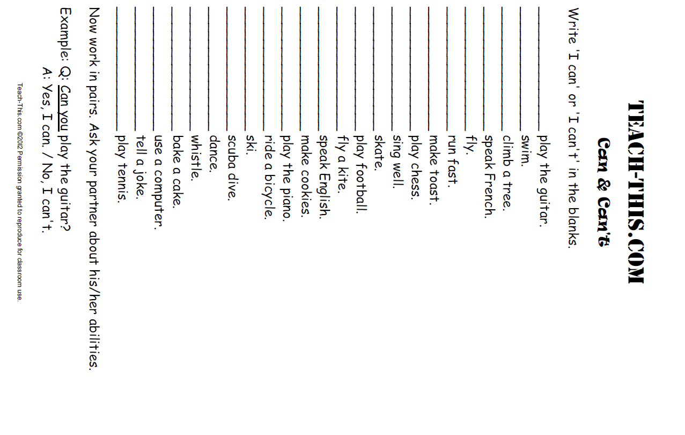

Lesson 2  Day 3 | Background Building | Estimated Time: One 60-minute period (depending on student familiarity with its concepts, this lesson may need to be extended to two 60-minute periods)

Brief overview of lesson: Students continue learning key content/topic vocabulary/topic language patterns as they are introduced to the concept of human rights. They discuss the essential question “Why should access to clean water be a human right?” as well as wants, needs, and “should-haves” of all people. Students learn about some common problems in the world, including lack of access to clean water, and analyze world maps to identify geographic and economic patterns for where these issues occur. They also learn how to describe the existence of these world problems using There is and There are. This knowledge will be used to discuss key points about a substantive topic and explain causes and effects in their final assessment. As you plan, consider the variability of learners in your class and make adaptations as necessary.

What students should know and be able to do to engage in this lesson:
- Basic social and instructional language.
- Social studies vocabulary and basic language patterns.

LESSON FOUNDATION
Unit-Level Focus Language Goals to Be Addressed in This Lesson |  | Unit-Level Salient Content Connections to Be Addressed in This Lesson
G.1 Discuss by stating opinions/claims about a substantive topic.  G.2 Explain causes and effects to create evidence-based claims. |  | CCSS.ELA-LITERACY.SL.7.4—Present claims and findings, emphasizing salient points in a focused, coherent manner with pertinent descriptions, facts/evidence, details, and examples; use appropriate eye contact, adequate volume, and clear pronunciation.
Language Objective |  | Essential Questions Addressed in This Lesson
Students will be able to explain the existence of common global issues using There is/There are and academic vocabulary (e.g., pollution, war, malnutrition, poverty). |  | Q.1 How can I use language to make a difference in a problem that is important to me, my community, or other people?  Q.3 Why should access to clean water be a human right?
Assessment
- Formative assessment: Assess students’ ability to complete There is/There are statements with appropriate content vocabulary.
- Observation: The lesson provides numerous opportunities to assess students’ ability to explain common global issues and the formation and use of simple sentences using There is/There are statements.
- Formative assessment: Use the exit ticket (There is/There are cloze) to assess students’ application of their understanding of how to form simple sentences using There is/There are.
- Self-assessment: Student self-assessment of learning in relation to the language objective.
- Optional: The extension/homework assignment (list five ways your family uses water) provides the opportunity to assess students’ ability to connect the topic of study to their everyday lives.
Thinking Space: What Academic Language Will Be Practiced in This Lesson?
Discourse Dimension | Sentence Dimension |  | Word Dimension
Social/instructional language; one-sentence definitions; responding to do/is/wh- (i.e., who/what/where/when/why) questions | Simple sentences with There is/There are |  | Bacteria, pollution, malnutrition, poverty, homelessness, violence, wars, terrorism, contaminated water, disease, pollution
Instructional Tips/Strategies/Suggestions for Teacher
- Continuously consider how the word/phrase and sentence dimensions are used to craft meanings and messages at the discourse dimension.
- If necessary, offer more practice with simple present tense verbs. This lesson focuses on the formation and use of simple sentences with There is/There are.
- Post and explain the lesson objective so students can see and understand it.
- Use the exit ticket to formatively assess student progress. When needed, make changes for the following day/lesson based on what you learn from the exit ticket, as well as from other pieces of evidence of how students are producing and processing language.

STUDENT CONSIDERATIONS
Sociocultural Implications
- Discrimination may exist among some groups. It may be based on socioeconomic status, race, religion, tribal group, or other aspects. The educator should remain aware of these factors when introducing diverse cultural groups and skillfully address them.
- Some students may not be aware of the unequal distribution of natural resources world-wide, including the fact that a number of nations lack access to essential natural resources such as clean water.
- Some students may have come from countries that lack natural resources such as clean water, and the topic may trigger strong emotional responses. Again, students need to be skillfully supported.
- Some students may be more comfortable expressing themselves orally, rather than in writing. Give thoughtful consideration to both components.
- Some students may not be familiar with expressing cultural sensitivity, cultural norms of turn-taking, and the etiquette of classroom conversations, and may need direct instruction to develop these skills.
Anticipated Student Pre-Conceptions/Misconceptions
Difficulties with singular and plural nouns might make subject/verb agreement challenging for some students.
THE LESSON IN ACTION
Lesson Opening
- Post and share the language objective with students: “Students will be able to explain the existence of common global issues using There is/There are and academic vocabulary (e.g., pollution, war, malnutrition, poverty).” To promote student ownership and self-monitoring of learning, have students record the objective in their notebooks. At the end of the lesson, students can reflect on their learning in relation to the objective.

- Collaboratively craft a definition of human right with students. Give students a few minutes to brainstorm the meaning of the term on their own or with a partner. For students who have trouble conceptualizing this abstract idea, offer a few examples such as images of shelter or freedom and prompts to consider whether these should be considered human rights, and why and how this reflects the meaning of the term human right.
Provide options for recruiting interest and perception, such as use of native language dictionaries, images for definitions, visual dictionaries such as Visuwords, and use of a blendspace for the term human rights.
- Brainstorm examples of human rights. For example, say: “What are some human rights?” Allow students time to think-pair-share this prompt.
During the Lesson
- Show the Day 2 PowerPoint (PDF) about human rights, which addresses Q.3, Why should access to clean water be a human right? Ask students yes/no questions using pictures as prompts to determine the rights all humans should have. For a comprehensive, student-friendly list, see the Youth for Human Rights website.
Provide options for physical action, such as use of computers for note-taking.
Provide options for perception, such as printing out the PowerPoint for students, posting the pictures around the room, or having students view the PowerPoint and/or website on a computer. Students could also use a text-to-speech reader if reviewing the PowerPoint on a computer.
- Have students expand their Vocabulary Quilts from Lesson 1 by adding new key terms: bacteria, pollution, malnutrition, and poverty.
Provide options for recruiting interest and perception, such as use of native language dictionaries, images for definitions, visual dictionaries such as Visuwords, and use of a blendspace for key terms.
Provide for options for physical action, such as drawing, using a computer to complete a task, using Microsoft Paint to create images, and/or choosing images online.
- Guide students through a gallery walk showcasing some global problems. Post photos showing problems such as malnutrition, poverty, homelessness, violence, wars, terrorism, contaminated water, disease, and pollution on chart paper around the classroom. Label each photo with both There is ____ and There are _____ statements to model grammatical forms introduced in the lesson.

- Give students Post-Its with words describing the images on the gallery walk (e.g., hunger, malnutrition, poverty, homelessness, violence, contaminated water, disease, and pollution). Ask them to match the word to the correct picture on the chart paper.
Provide options for perception and physical action, such as having students view the images on a computer and type in the word for each blank from a word bank.
- Provide a mini-lesson on how to express in English that these problems exist in the world.
  - Explain how students can use There is ____ for singular nouns or There are _____ for plural nouns. Give examples, highlighting the use of the -s suffix for plural nouns (e.g., There is violence. There is hunger. There are wars.). Depending on contextual need and the students' readiness to learn about exceptions to the plural rule, explain cases where the plural does not need the -s suffix (non-count nouns, such as pollution: There is pollution.)
  - Remove Post-It notes from the gallery walk charts. Divide students into pairs and give each pair one Post-It. Ask them to discuss which poster their word belongs to so they can complete the statement using the correct form of either There is ___ or There are ______.
  - After students are finished placing the Post-Its, address any errors made and ask students to record the corrected sentences in their notebooks.
- Show a physical map of the world such as the one at Maps of World. Ask students to identify where global problems from the gallery walk currently occur. For example, say: “Where in the world have you heard of the issues from the gallery walk happening?” and ask students for names of countries, geographic areas, or climates.
Provide options for perception, such as having students view the map on a computer, printing the map out for students to view, or using Google Earth.
- Introduce the idea that not all countries have the same access to the same natural resources. Display images of access and lack of access to natural resources such as clean water. Ask students if they think that it is okay that the access to resources is unequal around the world. Through the discussion, make the connection that this inequality is not okay given the fact that humans need these essential resources for survival.

- Refocus the class on images showing contaminated water. Ask for votes on a key question: “Is access to clean water a human right?” Consider displaying a glass of clean water and a glass of dirty water while students respond.
Provide options for physical action, such as writing the response on whiteboards, giving a thumbs up/thumbs down, or using an anonymous voting program such as Plickers.
- Introduce the unit focus topic of access to clean water as a human right.
Lesson Closing
- Ask students to complete an exit ticket with a There is/There are cloze. Students will also complete original sentences using There is/There are.
Provide options for physical action and expression and communication, such as dictation, using a computer to complete a task, and/or matching the correct words to complete the cloze.
- Extension/homework: “Water and Me” handout.

Lesson 2 Resources
- Notebooks
- Computer/projector
- Post-Its
- Student-friendly list of human rights (see Youth for Human Rights‘ simplified version of the Universal Declaration of Human Rights)
- Physical world map (e.g., the one at Maps of World)
- Vocabulary Quilt (sample definitions available below)
- “Exit Ticket: Cloze” handout (available below)
- “Extension/Homework: Water and Me” handout (available below)
- Day 2 PowerPoint (PDF)
Vocabulary Quilt
Use a format such as the Vocabulary Quilt from Scholastic. Provide students with student-friendly definitions. Sample definitions for key terms provided below.

Vocabulary
bacteria (noun): A group of microscopic, one-celled organisms, some of which are involved in infectious diseases, fermentation, and decay. (More student-friendly alternative: A group of very small living things, some of which cause disease.)
pollution (noun): The act of polluting or the state of being polluted; the harmful or poisonous substances introduced into an environment. (More student-friendly alternative: The act of making a place dirty and not safe to use. Also, substances that pollute.)
malnutrition (noun): Lack of adequate nutrition resulting from insufficient food, unbalanced diet, or defective assimilation. (More student-friendly alternative: An unhealthy state that results from having too little food or too little healthy food.)
poverty (noun): The state of having little or no money, goods, or means of support.
For other student-friendly definitions, refer to the Merriam-Webster learner’s dictionary.

Exit Ticket: Cloze
Name: ________________________________________________________ Date: ___________________

Write a sentence starter! Start each sentence with There is or There are.
Examples:
- ______ contaminated water.  There is contaminated water. | - _______ contaminated rivers.  There are contaminated rivers.
- _____________ problems in the world.  - _____________ poverty.  - _____________ hunger.  - _____________ wars.  - _____________ terrorism. | - _____________ pollution.  - _____________ malnutrition.  - _____________ violence.  - _____________ wars.  - _____________ diseases.

Write three original sentences using There is or There are.

- ________________________________________________________________________________________________________________________________________
- ________________________________________________________________________________________________________________________________________
- ________________________________________________________________________________________________________________________________________

Lesson 2 Extension/Homework: Water and Me
Name: _____________________________________

List five ways your family uses water.

1. ___________________________________________________________________  2. ___________________________________________________________________  3. ___________________________________________________________________ | 4. ___________________________________________________________________  5. ___________________________________________________________________

People all over the world use water in many different ways. What is your favorite use for water? Draw a picture of yourself enjoying water.

Source: Adapted from water.org

Lesson 3  Days 4 and 5 | Background Building and Fact Gathering | Estimated Time: Two 60-minute periods

Brief overview of lesson: Students extend their language used to discuss access to clean water while exploring basic sentence structure in English (subject/verb/object) and learning about facts and related signal words. Students analyze videos about lack of access to clean water to continue expanding their knowledge of content/topic language and identify facts about clean water access. This knowledge will be used to create evidence-based claims about this substantive topic. As you plan, consider the variability of learners in your class and make adaptations as necessary.

What students should know and be able to do to engage in this lesson:
- Basic sentence structure.
- Some content vocabulary from previous lessons.
- Awareness of global issues, including access to clean water.

LESSON FOUNDATION
Unit-Level Focus Language Goals to Be Addressed in This Lesson |  | Unit-Level Salient Content Connections to Be Addressed in This Lesson
G-2 Explain by discussing causes and effects to create evidence-based claims about a substantive topic. |  | CCSS.ELA-LITERACY.SL.7.4—Present claims and findings, emphasizing salient points in a focused, coherent manner with pertinent descriptions, facts/evidence, details, and examples; use appropriate eye contact, adequate volume, and clear pronunciation.
Language Objective |  | Essential Questions Addressed in This Lesson
Students will be able to state facts/evidence about the need for clean water using verbs in the present tense and content vocabulary (e.g., crisis, germs, contaminated). |  | Q.3 Why should access to clean water be a human right?
Assessment
- Formative assessment: Use a positive and negative word sort (lesson opening and closing) to assess students’ ability to analyze information to determine the connotation of the information.
- Formative assessment: Use the “Global Awareness Fact Sheet” handout to assess students’ ability to listen closely for information and to identify factual information.
- Formative assessment: The differentiated assignment (version 1, version 2, version 3) illustrates students’ ability to analyze factual information to determine the most important information and to state facts/evidence about the need for clean water using verbs in the present tense and content vocabulary.
- Observation: Student discussion of fact/evidence about the need for clean water. For example, during the lesson closing, look for student use of factual information during teacher questioning.
- Self-assessment: Student monitoring of learning in relation to the language objective.
Thinking Space: What Academic Language Will Be Practiced in This Lesson?
Discourse Dimension | Sentence Dimension |  | Word Dimension
Social/instructional language; listening to video introducing simple present tense with supporting graphics; listening for specific information in a video introducing clean water issue with text and images; reading single sentence statements about clean water issue; explaining a reason using simple sentences and a sentence starter | Simple sentences with subject + verb + object structure; simple present tense |  | Positive, negative, fact “signal words” (according to, in the text, etc.), topic vocabulary (e.g., access, human right, dirty/clean water)
Instructional Tips/Strategies/Suggestions for Teacher
- Continuously consider how the word/phrase and sentence dimensions are used to craft meanings and messages at the discourse dimension.
- Words may not have the same connotation for everyone. Students may interpret them differently based on family and/or education background.
- There are two versions of the global awareness fact sheet. One version has signal words underlined for students; the other does not. This provides options for differentiating the lesson for students.
- Post and explain the lesson objective so students can see and understand it.
- Use the exit ticket to formatively assess student progress. When needed, make changes for the following day/lesson based on what you learn from the exit ticket.

STUDENT CONSIDERATIONS
Sociocultural Implications
- Discrimination may exist among some groups. It may be based on socioeconomic status, race, religion, tribal group, or other aspects. The educator should remain aware of these factors when introducing diverse cultural groups and skillfully address them.
- Some students may not be aware of the unequal distribution of natural resources world-wide, including the fact that a number of nations lack access to essential natural resources such as clean water.
- Some students may have come from countries that lack natural resources such as clean water, and the topic may trigger strong emotional responses. Again, students need to be skillfully supported.
- Some students may be more comfortable expressing themselves orally, rather than in writing. Give thoughtful consideration to both components.
- Some students may not be familiar with expressing cultural sensitivity, cultural norms of turn-taking, and the etiquette of classroom conversations, and may need direct instruction to develop these skills.
Anticipated Student Pre-Conceptions/Misconceptions
Students may not be aware that words can have both literal and emotional meaning.

THE LESSON IN ACTION
Day 4 Lesson Opening
- Post and share the language objective with students: “Students will be able to state facts/evidence about the need for clean water using verbs in the present tense and content vocabulary (e.g., crisis, germs, contaminated).” To promote student ownership and self-monitoring of learning, have students record the objective in their notebooks. At the end of the lesson, students can reflect on their learning in relation to the objective.

- Tell students they will continue to develop the language needed to discuss access to clean water and introduce the opening activity. For example, say: “We will be talking about the positive effects of having access to clean water and the negative effects of not having access to clean water. We will begin by working with the terms ‘positive’ and ‘negative.’”
  - Divide the board in half. Label one half “positive” and post a picture of a smiley face. Label the other half “negative” and post a picture of an unhappy face.
  - Give each student a labeled image of related common things such as those in the Lesson 3 Resources (e.g., sun/clouds, pizza/garbage, smile/frown, sick/healthy, mosquito/butterfly). Ask students to sort images as positive or negative, and reinforce the correct identification of images as students work.
Provide options for physical action, such as allowing students to sort the images at their desk or on a computer, coming to the board and placing images on the board, working in pairs or independently.
During the Lesson
- Introduce basic sentence structure in English: subject/verb/object. Explain each component and how this lesson will focus on the verbs—the action component of the sentence. For example, say to students “We will use complete sentences to discuss access to clean water. In English, sentences have a subject, a verb, and an object. The subject is…” Consider posting the definition of each component with a visual for students as you explain.

- Introduce the simple present tense by defining it as the way to describe something that happens in the present time. Connect to the previous lesson by mentioning how There is/There are statements have the verb to be in the present tense. Consider creating and displaying an anchor chart with different verbs for student reference. Highlight the present tense of other common verbs that will appear in future lessons, such as drink, walk, or live. (Add verbs as needed.)
  - Practice conjugating basic verbs in the present tense, highlighting the addition of the -s suffix for the third person singular. Begin by modeling the conjugation of a verb (such as drink: I drink, you drink, he/she/it drinks, etc.) and then work with students to conjugate other common verbs. Model the conjugation of a verb first.
  - To reinforce these concepts, show a video about the present simple tense with a focus on third person singular. Pause the video, as necessary, to explain and give further examples.
Provide options for perception, such as printing out the video transcript for students, enabling closed captioning on the video, and adjusting the speed of the video. Consider showing the video multiple times if necessary.
  - Students will practice using the present tense. Have the class help you conjugate a verb as a class. Then have students practice conjugating with a partner or independently. Suggested verbs that pertain to access to clean water: drink, walk, live.
  - Have students practice forming complete sentences with the present tense. Begin by asking students to choose the correct form of the verb based with sentences such as I _______________ (live/lives) in Massachusetts; He _____________ (live/lives) in Massachusetts; We _______________ (drink/drinks) water; You ______________________ (drink/drinks) water; They _______________ (walk/walks) for water; I ___________________ (walk/walks) for water.
Provide options for physical action and expression and communication, such as having students come to the board to circle the correct answer, pointing to the correct answer, completing on a computer, or matching the correct verb.
Then students could work on choosing their verbs from a word bank and conjugating them appropriately for fill-in-the-blank sentences. Ask students who have a strong understanding of the present tense to construct original sentences in the present tense.
Lesson Closing
Have students complete follow-up activities to practice using the simple present tense, such as those from ESL Lounge (Level 1) and ESL Flow (Level 2).
THE LESSON IN ACTION
Day 5 Lesson Opening
Review the rules of conjugating verbs in the present tense (adding the -s suffix to the third person singular) by completing sentences with the correct form of the verb using a word bank and/or having students create original sentences with present tense verbs from pictures of common actions.
During the Lesson
- Introduce the lesson by telling students that they will be gathering facts about access to clean water. Define fact: a true statement that can be proven, for which there is evidence, and which can often be observed. (Note that fact and opinion will be studied in subsequent lessons.)
  - Give students some examples of facts such as Today is __________. My name is _________. The name of our school is _________.
  - Write a list of points to consider when determining if something is factual. For example, it is observable, it can be verified (e.g., by checking records to confirm the information).

- Have students practice identifying facts from the “Water Changes Everything” video. Explain to students how they will watch the video twice: once to listen for key vocabulary and the second time to identify key facts.
  - Introduce the “Global Awareness Fact Sheet” handout (adapted from water.org) by reading the topic vocabulary and facts presented on the handout before students listen for it in the video.
  - Watch the video up to the 2:05 mark and have students circle key vocabulary (first viewing) and facts (second viewing) from the video in the handout.
Provide options for perception, such as printing out the video transcript for students, enabling closed captioning on the video, showing the video multiple times and adjusting the speed of the video. Give students the option to watch the video on their own, even outside class.
- After viewing the video, ask students to choose a fact from the global awareness fact sheet, illustrate it, and then state in their own words reasons why people need access to clean water. Scaffold this activity by providing a sentence starter such as “People need clean water so ______” or asking students to write complete sentences on their own.
Provide options for physical action, such as drawing, using a computer to complete a task, or use of speech-to-text software.
Optional activity: As an extension for engagement and to make the content authentic to students’ experience, connect the lesson to water in your school or classroom. For example, ask students to locate and identify the number of drinking fountains in the school, the number of faucets in the school, or the presence of a bottled water machine.
Lesson Closing
- Ask students to sort vocabulary and facts about access to clean water from the video into positive (+) and negative (-) terms in the “Clean Water Access Word Sort” handout. While students are working, circulate and ask students why they selected to sort the information the way that they did.
Provide options for physical action, such as the use of computers, speech-to-text software, or an online note source such as Zoho Notebook.
- Tell students to record or draw the fact about access to clean water that is most important to them and include a statement about why they chose it. Give students one of the differentiated “Choosing Facts” handouts (option A, option B, and option C). Provide sentence frames such as “I think the most important fact about access to clean water is…” if necessary.

Lesson 3 Resources
- Blackboard/whiteboard and chalk/markers
- Notebooks
- Computer/projector
- Video: “Present Simple”
- Video: “Water Changes Everything”
- Follow-up activities on the simple present tense, such as those from ESL Lounge (Level 1) and ESL Flow (Level 2)
- Positive and negative images (examples available below)
- Global awareness fact sheet (version 1 and version 2 available below)
- “Choosing Facts” handout (version 1, version 2, and version 3 available below)
- “Clean Water Access Word Sort” handout (available below)

Positive and Negative Images
 | Photo by James West
sunny | cloudy
 | 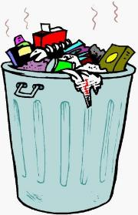
food | trash
smiling | frowning
ill | healthy
mosquito | butterfly

Global Awareness Fact Sheet (Version 1)
Name: ____________________________________________________ Date: _______________________

Part 1: Vocabulary
Watch the “Water Changes Everything” video and circle the words you hear.
Clean  water  food  crisis  poverty  germs | Run  dirty  Africa  Asia  writing  question | Faucet  violence  bucket  women  children  dangerous | careful  contaminated  bacteria  death  rodent  illness | insects  thirsty  education  Europe  Latin America

Part 2: Facts
Watch the “Water Changes Everything” video and circle the facts you hear.
- All living creatures, including humans, need water to survive.
- There is a lot of water in the world, but only a small amount is available to humans and other creatures that depend on fresh water.
- More than 97 percent of the water on Earth is salt water.
- Many people living in other countries die because the water they drink makes them sick.
- 2.6 billion people in the world do not have enough basic sanitation resources.
- Conserving water helps to preserve the planet’s natural resources.
- Millions of women and children spend several hours a day collecting water.
- Less than 1% of the world’s fresh water is readily accessible for direct human use.
- A person can live weeks without food, but only about three days without water.
- All people need access to safe drinking water and improved sanitation conditions.
- Many people in the world suffer from health problems caused by drinking dirty water.

Source: water.org Global Awareness Fact Sheet
Global Awareness Fact Sheet (Version 2)
Name: ____________________________________________________ Date: _______________________
Part 1: Vocabulary
Watch the “Water Changes Everything” video and circle the words you hear.
Clean  water  food  crisis  poverty  germs | Run  dirty  Africa  Asia  writing  question | faucet  violence  bucket  women  children  dangerous | Careful  contaminated  bacteria  death  rodent  illness | insects  thirsty  education  Europe  Latin America
- Humans need water to survive.
- There is a lot of water in the world.
- Humans can use only a small amount of water on Earth.
- 97 percent of the water on Earth is salt water.
- People can die because of dirty water.
- 2.6 billion people in the world do not have basic sanitation resources.
- People can conserve water to save natural resources.
- Millions of women and children spend hours a day collecting water.
- Less than 1% of the world’s fresh water is ready for human use.
- The earth has a limited amount of water.
- The water cycle keeps the same water going around the planet.
- A person can live weeks without food.
- A person can live only three days without water.
- All people need access to safe drinking water.
- People have health problems caused by drinking dirty water.
Source: water.org Global Awareness Fact Sheet
Choosing Facts (Version 1)
Name: ______________________________________________________________ Date: _____________

Choose a fact from the “Global Awareness Fact Sheet” and illustrate it.
My fact: _________________________________________________________________________________
___________________________________________________________________________________________
Illustration of my fact:

Choosing Facts (Version 2)
Name: ______________________________________________________ Date: ___________________

Choose one fact to illustrate from the fact sheet and write why people need clean water in your own words.
My fact: ______________________________________________________________________________
________________________________________________________________________________________

Reasons why people need clean water: __________________________________________
_______________________________________________________________________________________
_______________________________________________________________________________________

Illustration of my fact:

Choosing Facts (Version 3)
Name: _____________________________________________________________ Date: ______________

Using your “Global Awareness Fact Sheet,” state five reasons why people need clean water in your own words.
Reason 1: _______________________________________________________________________________________________________________________________
Reason 2: _______________________________________________________________________________________________________________________________
Reason 3: _______________________________________________________________________________________________________________________________
Reason 4: _______________________________________________________________________________________________________________________________
Reason 5: _______________________________________________________________________________________________________________________________

Now imagine you are writing a paragraph about the five reasons why people need clean water. What can you write as a topic sentence? What about a conclusion sentence? You can use the back of the paper.
___________________________________________________________________________________________________________________________________________
___________________________________________________________________________________________________________________________________________
___________________________________________________________________________________________________________________________________________
___________________________________________________________________________________________________________________________________________

Clean Water Access Word Sort
Name: _______________________________________________________ Date: ________

Sort the following words into the positive or negative category.
clean water crisis poverty thirsty
women children germs dirty Africa
Asia Latin America dangerous hurt contaminated
bacteria death illness education faucet

Positive (+) | Negative (-)

Lesson 4  Days 6 and 7 | Background Building and Fact Gathering | Estimated Time: Two 60-minute periods

Brief overview of lesson: Students extend their thinking and language use about clean water access by simulating the experience of having to walk to gather water, engaging in a follow-up group discussion about the experience, and watching a PSA to gather more facts. Students are also introduced to sequencing signal words as they discuss the simulation experience. They will use this knowledge to discuss key points about clean water access and explain causes and effects related to this issue in the final assessment. As you plan, consider the variability of learners in your class and make adaptations as necessary.

What students should know and be able to do to engage in this lesson:
- Ability to make a statement supported by evidence about the need for clean water using verbs in the present tense and content vocabulary (e.g., crisis, germs, contaminated).

LESSON FOUNDATION
Unit-Level Focus Language Goals to Be Addressed in This Lesson |  | Unit-Level Salient Content Connections to Be Addressed in This Lesson
G.2 Explain causes and effects to create evidence-based claims. |  | CCSS.ELA-LITERACY.SL.7.4—Present claims and findings, emphasizing salient points in a focused, coherent manner with pertinent descriptions, facts/evidence, details, and examples; use appropriate eye contact, adequate volume, and clear pronunciation.
Language Objective |  | Essential Questions Addressed in This Lesson
Students will be able to state facts/evidence about the need for clean water using verbs in the present tense and content vocabulary (e.g., crisis, germs, contaminated).  Additional objective related to the optional activity: Students will be able to formulate questions about the need for clean water using the verbs can, be, and do and content vocabulary (e.g., crisis, germs, contaminated). |  | Q.2 How can I use my knowledge of the English language to convey a powerful message?  Q.3 Why should access to clean water be a human right?
Assessment
- Formative assessment: Video fact sheet.
- Observation: Participation in post-simulation discussion illustrates students’ ability to apply learned language.
- Formative assessment: The student reflection provides insight into students’ ability to connect and explain the simulation in relation to the topic of study.
- Formative Assessment: Use the sequencing activity to assess students’ ability to apply learned language.
- Formative Assessment: The follow-up activities during the lesson closing illustrate student oral discourse about why people need access to clean water.
- Self-assessment: Student monitoring of learning in relation to the language objective.
Thinking Space: What Academic Language Will Be Practiced in This Lesson?
Discourse Dimension | Sentence Dimension |  | Word Dimension
Social/instructional language; listening for specific information in a video introducing clean water issue with text and images; responding to questions about a simulation; reading single sentence statements about clean water issue; explaining a reason using simple sentences and sentence starter | Simple sentences with present tense verbs and sequencing signal words; forming questions with do, is, and can (when the optional activity is included) |  | Sequencing signal words (e.g., first, next, then, last, finally), topic vocabulary (e.g., access, human right, dirty/clean water)
Instructional Tips/Strategies/Suggestions for Teacher
- Continuously consider how the word/phrase and sentence dimensions are used to craft meanings and messages at the discourse dimension.
- Review appropriate behavior when carrying water before beginning the simulation.
- Post and explain the lesson objective so students can see and understand it.
- Before the lesson, prepare a tub of dirty water, presented and labeled as a lake or other dirty water source, and a half-mile route mapped out around the school. Students will use gallon water jugs to carry the water during the simulation.
- Enlarge the sequencing words and images for the simulation before printing.
- There are two versions of the global awareness fact sheet. One version has signal words underlined for students; the other does not. This provides options for differentiating the lesson for students.

STUDENT CONSIDERATIONS
Sociocultural Implications
- Discrimination may exist among some groups. It may be based on socioeconomic status, race, religion, tribal group, or other aspects. The educator should remain aware of these factors when introducing diverse cultural groups and skillfully address them.
- Some students may not be aware of the unequal distribution of natural resources world-wide, including the fact that a number of nations lack access to essential natural resources such as clean water.
- Some students may have come from countries that lack natural resources such as clean water, and the topic may trigger strong emotional responses. This lesson includes a simulation based on the video “Water Changes Everything.” Students may have walked to get water themselves, so extreme sensitivity is needed.
- Some students may be more comfortable expressing themselves orally, rather than in writing. Give thoughtful consideration to both components.
- Some students may not be familiar with expressing cultural sensitivity, cultural norms of turn-taking, and the etiquette of classroom conversations, and may need direct instruction to develop these skills.
Anticipated Student Pre-Conceptions/Misconceptions
Students may not have a good understanding of distance and may believe that carrying water for half a mile is easy.

THE LESSON IN ACTION
Day 6 Lesson Opening
- Post and share the language objective with students: “Students will be able to state facts/evidence about the need for clean water using verbs in the present tense and content vocabulary (e.g., crisis, germs, contaminated).” To promote student ownership and self-monitoring of learning, have students record the objective in their notebooks. At the end of the lesson, students can reflect on their learning in relation to the objective.

- Show the “Water Changes Everything“ video again, up to the 2:05 mark.
Provide options for perception, such as printing out the video transcript for students, enabling closed captioning on the video, and adjusting the speed of the video. Additional options for engagement and perception include creating a blendspace of women carrying water over all types of terrain and children drinking contaminated water, printing out these images, or having students view the images on a computer.
During the Lesson
- Preparing for the simulation: Introduce the water journey simulation. (Introduce this activity with a considerable amount of sensitivity and support as some students in class may have come from a region where this is common practice.)
  - Explain to students how they will be given a gallon (or larger) jug filled with dirty water (water with dirt, rocks, and grass) similar to the one on display in the classroom and labeled “lake.”

- During the simulation: Tell students to carry the container for a half mile in a pre-measured “journey” around the school from the classroom and back, and that once they get back to the classroom they will be poured and offered a drink from their container. Explain how this journey simulates what many women and girls must do in parts of the world showcased in the “Water Changes Everything” video.
Provide options for engagement and perception for students who may not be able to participate in carrying the water, such as watching a video recording of the journey around the school or a similar video of the journey to get water.
- Make sure to review norms for walking around the school during school hours.
- After the simulation, debrief the activity with the whole class, asking questions such as the following:
- Would you like a drink of water after your half-mile “journey,” or walk? Why or why not? (Students can point, gesture, or similarly express their answers.)
- What was your journey like? Describe it in words, in images, or with your body.
- Did you want to drink the water from your jug at the end of the journey? Why or why not?
- Yes or no: The women and girls in the video drink the dirty water.
- What do we do in our city if we want water? Do we have options?
- Is what we do different from what the people in the video do? Are they equal?
Provide options for perception, such as having the questions printed on handouts, to be reflected on independently or discussed in small groups (as well as being displayed and discussed in a large group). Allow students to record or draw their responses.
Lesson Closing
Connect the simulation to the unit topic. Ask students to reflect on what the journey was like and why they think it is relevant to understanding the human right to access to clean water.
Provide options for physical action and expression and communication, such as writing a response, using a computer to type the answer, drawing, acting out, or using speech-to-text software.
THE LESSON IN ACTION
Day 7 Lesson Opening
- Introduce the first activity by telling students they will learn about language to help them talk about the water-carrying journey from the previous day. For example, say: “Today we will discuss our journey around the school. We will begin by learning some language to help us talk about it.”
- Introduce sequencing words (first, next, then, after that, finally) by briefly explaining how they can be used to describe the steps in a process or the order in which something happen.
- Orally discuss with the whole class the steps taken to complete the water-carrying journey from the previous day. Use sentence starters such as “First we ___________”; “Next we ___________”; “Then we ___________”; “After that we ___________”; and “Finally we ___________.” Note that sequencing words will be practiced with and reinforced in subsequent lessons. Their use in this lesson is to help students discuss their journey around the school).
- Hand out cards with each step and an illustration to students and ask them to put the events from the simulation in order. Sample images are provided in the lesson resources. Alternatively, ask students to create a storyboard of their journey in their notebooks or a digital document (e.g., a Microsoft Word file).
Provide options for physical action, such as using a computer or note-taking software such as Zoho Notebook to organize the steps of the simulation.
During the Lesson
- Introduce the next activity by explaining how students will continue to learn more facts about access to clean water. For example, say: “We will continue to gather more facts about access to clean water. We will continue to watch the ‘Water Changes Everything’ video.”
  - Instruct students to circle key vocabulary and facts they hear from the video on the “Global Awareness Fact Sheet” handout.
  - Show the “Water Changes Everything” video starting from the 2:05 mark. Repeat the video with subtitles as necessary.
Provide options for perception, such as printing out the video transcript so that students can highlight the words, enabling closed captioning on the video, and adjusting the speed of the video.
Provide options for physical action, such as student use of computers and focus questions to guide their attention during the video.
  - After the video, give students time to quietly reflect on what they heard in the video. Consider asking students to turn and talk to share their reflections with a partner.

- Choose a follow-up activity from the following:
  - Ask students to choose three new facts to illustrate, then state in their own words reasons why people need clean water. Scaffold this activity by providing a sentence starter such as “People need clean water so ___________” or asking students to write complete sentences on their own.
Provide options for perception, such as using a computer to review the fact sheet and/or text-to-speech reader.
Provide options for physical action, such as using a computer to draw.
  - Provide a mini-lesson on question formation with key verbs like can, be, and do. (This mini-lesson may need to be taught over two days: questions with do/does on the first day, questions with can and is/are on the second day.)
    - Introduce the topic of the mini-lesson by explaining how we can use questions to gather information, but also create rhetorical questions to persuade others. Provide examples of both types of questions.
    - Model how to write yes/no questions using can, be, and do and the information in the global awareness fact sheet. For example, explain how questions about an action or a verb need the verb do/does at the beginning of the sentence and a question mark at the end and model creating some questions with do/does. Then explain how questions with the verb to be (is/are) or can just need those words at the beginning of the sentence and a question mark at the end.
    - Ask students to help you write a few more examples of questions using facts from the handout, then ask them to try writing their own questions.
Provide options for perception, such as using a computer or a text-to-speech reader to review the fact sheet.
Provide options for physical action, such as using a computer with speech-to-text software to formulate questions, working with a partner, or working independently.
Lesson Closing
Depending on the follow-up activity chosen above, ask students to:
- Orally share one reason why people need clean water. Scaffold this activity by providing a sentence starter such as “People need clean water so ___________” or asking students to write complete sentences on their own.
Provide options for physical action, such as text-to-speech readers.
- Orally share one question with can, do/does, is/are they created based on the global awareness fact sheet.
Provide options for physical action, such as text-to-speech readers.

Lesson 4 Resources
- Computer with Internet access
- Projector
- Video: “Water Changes Everything”
- Sequence signal words (examples available below)
- Water journey simulation images (samples available below)
- Global awareness fact sheet (version 1 and version 2 available below)

Sequence Signal Words
first

then

next

after that

finally
Sample Water Journey Simulation Images

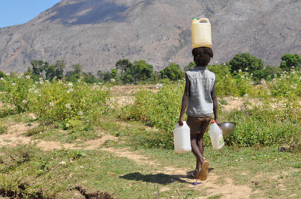  We walked to the water. |  | 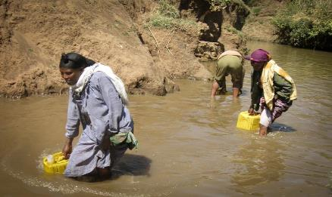  We collected the water.
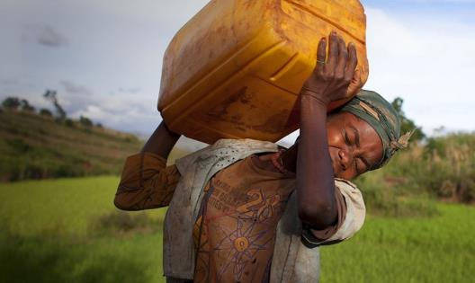  We carried the water. | We looked at the water. |  | 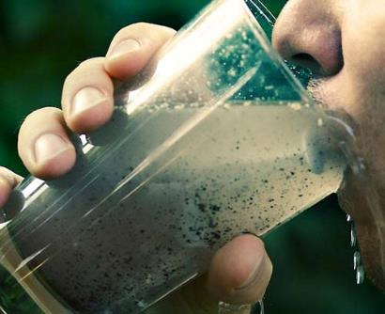  We did not drink the water.

Global Awareness Fact Sheet (Version 1)
Name: __________________________________________________________ Date: __________

Part 1: Vocabulary
Circle each word you hear in the “Water Changes Everything” video.
Solution  nothing  filtration system  opportunity  old  freedom | disease  well  school  family  changes  closer | less  girls  forty  money  increase  save | attendance  solve  access  good  dollars

Part 2: Facts
Circle each fact you hear in the “Water Changes Everything” video.

- All living creatures, including humans, need water to survive.
- There is a lot of water in the world, but only a small amount is available to humans and other creatures that depend on fresh water.
- More than 97 percent of the water on Earth is salt water.
- Many people living in other countries die because the water they drink makes them sick.
- 2.6 billion people in the world do not have enough basic sanitation resources.
- Conserving water helps to preserve the planet’s natural resources.
- Millions of women and children spend several hours a day collecting water.
- Less than 1% of the world’s fresh water is readily accessible for direct human use.
- A person can live weeks without food, but only about three days without water.
- All people need access to safe drinking water and improved sanitation conditions.
- Many people in the world suffer from health problems caused by drinking dirty water.

Source: water.org Global Awareness Fact Sheet

Global Awareness Fact Sheet (Version 2)
Circle each word you hear in the “Water Changes Everything” video.
Solution  nothing  filtration system  opportunity  old  freedom | Disease  well  school  family  changes  closer | less  girls  forty  money  increase  save | attendance  solve  access  good  dollars

- Humans need water to survive.
- There is a lot of water in the world.
- Humans can use only a small amount of water on Earth.
- 97 percent of the water on Earth is salt water.
- People can die because of dirty water.
- 2.6 billion people in the world do not have basic sanitation resources.
- People can conserve water to save natural resources.
- Millions of women and children spend hours a day collecting water.
- Less than 1% of the world’s fresh water is ready for human use.
- The earth has a limited amount of water.
- The water cycle keeps the same water going around the planet.
- A person can live weeks without food.
- A person can live only three days without water.
- All people need access to safe drinking water.
- People have health problems caused by drinking dirty water.

Source: water.org Global Awareness Fact Sheet
Lesson 5  Day 8 | Introduce Cause and Effect Structure | Estimated Time: One 60-minute period

Brief overview of lesson: Students continue gathering facts to identify causes and effects related to lack of access to clean water from a video. They are also introduced to new language and ways to structure thinking around the concepts of cause and effect, related signal words, and ways to structure sentences to explain them. Students practice what they have learned through cloze activities and responding to the prompt “Why is access to clean water a human right?” This knowledge will be used to explain and discuss causes and effects in order to create evidence-based claims about clean water issues in the final assessment. As you plan, consider the variability of learners in your class and make adaptations as necessary.

What students should know and be able to do to engage in this lesson:
- Vocabulary and background information about the clean water issue.
- Knowledge of basic sentence structure.

LESSON FOUNDATION
Unit-Level Focus Language Goals to Be Addressed in This Lesson |  | Unit-Level Salient Content Connections to Be Addressed in This Lesson
G.2 Explain causes and effects to create evidence-based claims. |  | CCSS.ELA-LITERACY.RI.7.10—By the end of the year, read and comprehend literary nonfiction in the grades 6–8 text complexity band proficiently, with scaffolding as needed at the high end of the range.
Language Objective |  | Essential Questions Addressed in This Lesson
Students will be able to create evidence-based claims about the need for clean water access using cause and effect signal words (because, since, as a result). |  | Q.3 Why should access to clean water be a human right?
Assessment
- Formative assessment: Two student-created foldables: one on common cause and effect relationships and one on causes and effects pertaining to access to clean water.
- Formative assessment: Matching of cause and effect visuals.
- Formative assessment: Written cause and effect statements with signal words illustrate students’ ability to form complex sentences with because, since, as a result.
- Formative assessment: Use the optional writing assignment to assess students’ ability to apply learned language in extended written discourse. If using this assignment, look for student use of sentence structure, variety, and use of content vocabulary.
- Observation: Students’ ability to use language to discuss causes and effects related to clean water access using sentence frames orally and in writing.
- Self-assessment: Student monitoring of learning in relation to the language objective.
Thinking Space: What Academic Language Will Be Practiced in This Lesson?
Discourse Dimension | Sentence Dimension |  | Word Dimension
Listening for specific information in a video with text and images; discussing causes and effects related to clean water issue using sentence frames orally and in writing | Complex sentences with because, since, as a result |  | Cause, effect, cause and effect “signal words”: because, since, as a result
Instructional Tips/Strategies/Suggestions for Teacher
- Continuously consider how the word/phrase and sentence dimensions are used to craft meanings and messages at the discourse dimension.
- Review how to create foldables before asking students to make them. Depending upon their familiarity with foldables, students may need more time to complete them.
- The video “The Importance of Water” uses vocabulary and terms that students may not know even if they can identify the vocabulary on the handout. Consider pre-teaching the vocabulary and/or additional language to signal cause and effect relationships.

STUDENT CONSIDERATIONS
Sociocultural Implications
- Discrimination may exist among some groups. It may be based on socioeconomic status, race, religion, tribal group, or other aspects. The educator should remain aware of these factors when introducing diverse cultural groups and skillfully address them.
- Some students may not be aware of the unequal distribution of natural resources world-wide, including the fact that a number of nations lack access to essential natural resources such as clean water.
- Some students may have come from countries that lack natural resources such as clean water, and the topic may trigger strong emotional responses. Again, students need to be skillfully supported.
- Some students may be more comfortable expressing themselves orally, rather than in writing. Give thoughtful consideration to both components.
- Some students may not be familiar with expressing cultural sensitivity, cultural norms of turn-taking, and the etiquette of classroom conversations, and may need direct instruction to develop these skills.
Anticipated Student Pre-Conceptions/Misconceptions
- Students may believe that sentence order/structure is rigid.
- Students may believe they should never start a sentence with because.

THE LESSON IN ACTION
Lesson Opening
- Post and share the language objective with students: “Students will be able to create evidence-based claims about the need for clean water access using cause and effect signal words (because, since, as a result).” To promote student ownership and self-monitoring of learning, have students record the objective in their notebooks. At the end of the lesson, students can reflect on their learning in relation to the objective.

- Introduce the lesson by telling students that they will continue gathering information about the access to clean water issue and learn about related causes and effects. For example, say: “Today we will discuss the causes (or reasons why) people do not have access to clean water, and the effects (or results) of not having access to clean water. We will also learn language that helps us to explain causes and effects of issues like access to clean water.” Share sentences that explain a cause-effect relationship and include related signal words targeted in the lesson (because, since, as a result). Start with some familiar situations for students. For example: “Because of the rain, the road is flooded”; “Since my coffee spilled, the floor is wet”; “It is cold. As a result, we have the heat on.” Consider creating an anchor chart, have students create personal reference sheets, or use a computer to take notes. To further engage student interest, consider having students brainstorm their own examples based on personal experiences with related causes and effects.

- Continue to activate prior knowledge about common causes and effects. Ask students to match common causes and effects using the “Matching” handout. Common causes and effects used in the matching assignment are: “Because it rains, the flowers grow”; “Because the baby is hungry, the baby cries”; “Since he studies, he gets an A”; “It snows. As a result, there is no school.”
Provide options for physical action, such as working individually, working with a small group, or making the first foldable of common causes and effects as a whole class. Ask students to paste the foldables they make into their notebooks, then write sentences in the foldables.
Provide options for physical action, such as using a computer to match and create the foldables, pointing to the causes and effects, and writing the causes and effects.
During the Lesson
- Tell students they will watch a new video, “The Importance of Water,” to learn about access to clean water; they should listen for the effects of not having access of clean water. Reinforce for students that the effects of not having access to clean water, as presented in the video, are all facts.
  - Tell students to circle words they hear on the “Global Awareness Fact Sheet” handout from the previous lesson with problems that come from lack of access to clean water.
Provide options for perception, such as printing out the video transcript for students, enabling closed captioning on the video, and adjusting the speed of the video. Students can also view the video before or after school.
Provide options for physical action, such as student use of computers to take notes or an electronic notebook such as Zoho Notebook.
  - After the video, discuss the causes and effects of a lack of access to clean water identified in the video. This can be done with a turn-and-talk as well as quiet, individual time to think.
Provide options for physical action, such as student use of computers.
- Extend the concept of causes and effects to vocabulary background building activities from prior days. Tell students that you will use the same cause and effect language to discuss access to clean water. Begin by reviewing some of the factual information students identified in previous lessons. For example, say “Because the water is dirty, people get sick.” Ask students to create a foldable for the effects of a lack of clean water. Explain how they should match visual causes and effects, then paste them into their notebooks, and then complete sentences with cause and effect vocabulary using sentence frames. The goal of this activity is for students to understand causes and effects, so constructing the foldable should not be the focus for feedback. The examples used in the second foldable are: “Because the water is dirty, people get sick.” “Since children walk to get water, they don’t go to school.” “Because of the water crisis, people die.” “The water is dirty. As a result, people die.”
Provide options for physical action, such as use of computer to match and create the foldables, pointing to the causes and effects, and writing the causes and effects. Consider providing a graphic organizer with arrows from causes to effects that may help students visualize them.
Lesson Closing
- Exit ticket: Ask students to create one original cause and effect statement using the visuals and words listed as a support. Provide sentence frames as needed.
Provide options for physical action, such as writing, drawing, using a computer to type, or using a speech-to-text reader.
- Optional activity: Provide students with a writing prompt, such as “Why do you think that access to clean water is a human right?”
Provide options for physical action, such as writing, drawing, typing, using speech-to-text software, or dictating their response.

Lesson 5 Resources
- Blackboard/whiteboard and chalk/markers
- Notebooks
- Video: “The Importance of Water”
- Foldables PowerPoint (PDF)
- Cause and effect sentence frames (examples available below)
- “Vocabulary Matching” handout (available below)
- Graphic organizer (sample available below)

Cause and Effect Sentence Frames
Because _____________________________, __________________________________________.

Since ___________________________, _______________________________________________.

_________________________________. As a result, __________________________________.

Vocabulary Matching
 |  | school
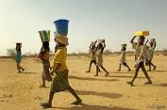 |  | dirty
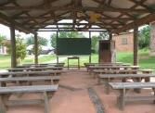 |  | illness
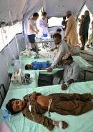 |  | walk
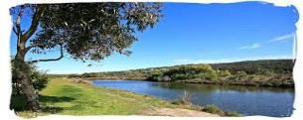 |  | water

Sample Graphic Organizer
Cause
Effect

Lesson 6  Days 9–11 | Exploring the Topic through Active Reading | Estimated Time: Three 60-minute periods

Brief overview of lesson: Students review content/topic language learned so far and continue expanding their knowledge of the topic by reading abridged topic-related texts, identifying key vocabulary, and gathering causes and effects related to the issue using a graphic organizer. They also have an opportunity to discuss these facts as a whole class. This knowledge will be used to explain and discuss causes and effects in order to create evidence-based claims about clean water issues in the final assessment. As you plan, consider the variability of learners in your class and make adaptations as necessary.

What students should know and be able to do to engage in this lesson:
- Cause and effect sentence structure.
- Topic vocabulary.

LESSON FOUNDATION
Unit-Level Focus Language Goals to Be Addressed in This Lesson |  | Unit-Level Salient Content Connections to Be Addressed in This Lesson
G.2 Explain causes and effects to create evidence-based claims. |  | CCSS.ELA-LITERACY.RI.7.10—By the end of the year, read and comprehend literary nonfiction in the grades 6–8 text complexity band proficiently, with scaffolding as needed at the high end of the range.
Language Objective |  | Essential Questions Addressed in This Lesson
Students will be able to explain causes and effects related to access/lack of access to clean water using cause and effect signal words (because, since, as a result). |  | Q.1 How can I use language to make a difference in a problem that is important to me, my community, or other people?  Q.2 How can I use my knowledge of the English language to convey a powerful message?
Assessment
- Formative assessment: Use student-annotated/marked-up texts (circled vocabulary words) and comprehension questions to assess student textual analysis and comprehension of the texts.
- Formative assessment: Use completed cause and effect organizers (one for each text) to assess student use of language to analyze text and identify causes and effects.
- Self-assessment: Metacognitive and meta-linguistic strategies used during reading.
- Self-assessment: Student monitoring of learning in relation to the language objective.
- Observation: Student oral discussion of causes and effects in the lesson closing.
Thinking Space: What Academic Language Will Be Practiced in This Lesson?
Discourse Dimension | Sentence Dimension |  | Word Dimension
Social/instructional language; reading texts with multiple, related simple sentences about the clean water issue; answering comprehension questions by selecting words from a word bank; completing graphic organizers with previously learned words/phrases | Complex sentences with because, since, as a result |  | Cause, effect, topic vocabulary (e.g., responsibility, access, human right, potable, PlayPump); cause and effect “signal words”: because, since, as a result
Instructional Tips/Strategies/Suggestions for Teacher
- Continuously consider how the word/phrase and sentence dimensions are used to craft meanings and messages at the discourse dimension.
- Create a word wall of cause and effect signal words.
- Use think-aloud strategies to identify cause and effect.
- Post and explain the lesson objective so students can see and understand it.
- Pre-teach or review metacognitive strategies for reading. For example, model strategies via a think-aloud. Consider giving examples for making connections during reading, making inferences, using context clues, and using text features to analyze the text. Model for students how to annotate the text. Explicit instruction on metacognitive and metalinguistic strategies promotes student self-monitoring of learning.

STUDENT CONSIDERATIONS
Sociocultural Implications
- Discrimination may exist among some groups. It may be based on socioeconomic status, race, religion, tribal group, or other aspects. The educator should remain aware of these factors when introducing diverse cultural groups and skillfully address them.
- Some students may not be aware of the unequal distribution of natural resources world-wide, including the fact that a number of nations lack access to essential natural resources such as clean water.
- Some students may have come from countries that lack natural resources such as clean water, and the topic may trigger strong emotional responses. Again, students need to be skillfully supported.
- Some students may be more comfortable expressing themselves orally, rather than in writing. Give thoughtful consideration to both components.
- Some students may not be familiar with expressing cultural sensitivity, cultural norms of turn-taking, and the etiquette of classroom conversations, and may need direct instruction to develop these skills.
Anticipated Student Pre-Conceptions/Misconceptions
- Students may be confused about what is a cause and what is an effect, especially with a chain of events.
- Students may think there are no signal words or that words cannot give hints about the relationship between events.
THE LESSON IN ACTION
Day 9 Lesson Opening
- Post and share the language objective with students: “Students will be able to explain causes and effects related to access/lack of access to clean water using cause and effect signal words (because, since, as a result).” To promote student ownership and self-monitoring of learning, have students record the objective in their notebooks. At the end of the lesson, students can reflect on their learning in relation to the objective.

- Review vocabulary from Lessons 1–5 each day of this lesson using activities/games such as Heads Up!, Trashketball, Fly Swatter, and/or a quiz show (in which the teacher or a student, acting as a game show host, alternate giving clues from a Frayer Model graphic organizer and students guess the vocabulary word).
During the Lesson
Introduce the lesson by explaining how students will read an abridged text about causes and effects related to access to clean water and complete a cause and effect graphic organizer.
- Give students handouts with an excerpt from Just Add Water by Robin Hill and Charles O. Hall.
Provide options for perception, such as using a computer to adjust the display, a text-to-speech reader, mentor/mentee pairings, and/or highlighted text.
Provide options for engagement, such as whole-class or individual use of the “Water for South Sudan” website, images and/or videos of wells being drilled, or a map illustrating where South Sudan is.
- Ask students to actively read by underlining keyword vocabulary from previous lessons or using Post-Its to highlight keyword vocabulary. Pre-teach and model additional metacognitive and metalinguistic strategies to promote student comprehension, self-monitoring, and analysis.
- After reading, have students answer fill-in-the-blank comprehension questions supported by a word bank and trace causes and effects from the article in a graphic organizer.
Provide options for physical action, such as using a computer; pointing, dictating, and/or drawing responses; using speech-to text software; and/or matching images illustrating the reading.
Provide options for engagement, such as asking students to make personal connections to the text they read.
Lesson Closing
Have students orally share out one cause/effect pair from the day’s reading.
Provide options for physical action, such as using a computer, pointing or writing responses, using text-to-speech software, and/or matching images related to the text.
THE LESSON IN ACTION
Day 10 Lesson Opening
Review vocabulary from Lessons 1–5 each day of this lesson using activities/games such as Heads Up!, Trashketball, Fly Swatter, and/or a quiz show (in which the teacher or a student, acting as game show host, alternate giving clues from a Frayer Model graphic organizer and students guess the vocabulary word).
During the Lesson
Introduce the lesson by explaining how students will read one abridged text about causes and effects related to access to clean water and complete a cause and effect graphic organizer.
- Give students handouts with the abridged excerpt from “Water Woes” (original from readworks.org).
Provide options for perception, such as use of computer to adjust the display, text-to-speech reader, mentor/mentee pairings, and/or highlighted text.
Provide options for engagement, such as images of dams, images and videos of pumping stations, and/or a map to show where Iztapalapu is.
- Ask students to actively read by underlining keyword vocabulary from previous lessons or using Post-Its to highlight keyword vocabulary. Pre-teach and model additional metacognitive and metalinguistic strategies to promote student comprehension, self-monitoring, and analysis.

- After reading, have students answer comprehension questions supported by the class word bank and trace causes and effects from the article in a graphic organizer.
Provide options for physical action, such as using a computer; pointing, dictating, and/or drawing responses; using speech-to text software; and/or matching images illustrating the reading.
Provide options for engagement, such as asking students to make personal connections to the text they read.
Lesson Closing
Have students orally share out one cause/effect pair from the day’s reading.
Provide options for physical action, such as the use of computer; pointing or writing responses; using text-to-speech software; and/or matching images related to the text.
THE LESSON IN ACTION
Day 11 Lesson Opening
Review vocabulary from Lessons 1–5 each day of this lesson using activities/games such as Heads Up!, Trashketball, Fly Swatter, and/or a quiz show (in which the teacher or a student, acting as a game show host, alternate giving clues from a Frayer Model graphic organizer and students guess the vocabulary word).
During the Lesson
Introduce the lesson by explaining how students will read an abridged text about causes and effects related to access to clean water and complete a cause and effect graphic organizer.

- Give students handouts with “Playing for Clean Water” from readworks.org.
Provide options for perception, such as using a computer to adjust the display, text-to-speech reader, mentor/mentee pairings, and/or highlighted text.
Provide options for engagement, such as images of PlayPumps.
- Ask students to actively read by underlining keyword vocabulary from previous lessons or using Post-Its to highlight keyword vocabulary. Pre-teach and model additional metacognitive and metalinguistic strategies to promote student comprehension, self-monitoring, and analysis.

- After reading, have students answer comprehension questions and trace causes and effects from the article in a graphic organizer.
Provide options for physical action, such as using a computer; pointing, dictating, and/or drawing responses; using speech-to text software; and/or matching images illustrating the reading.
Provide options for engagement, such as asking students to make personal connections to the text they read.
Lesson Closing
Have students orally share out one cause/effect pair from the day’s reading.
Provide options for physical action, such as using a computer; pointing or writing responses; using text-to-speech software; and/or matching images related to the text.

Lesson 6 Resources
- Highlighters
- Post-Its
- Word bank as needed
- Activities/games:
  - Heads Up!
  - Trashketball
  - Fly Swatter
- Frayer Model graphic organizer
- Graphic organizer (sample available below)
- Just Add Water excerpt (available below)
- Questions on the Just Add Water excerpt (available below)
- “Water Woes” excerpt (available below)
- Questions on the “Water Woes” excerpt (available below)
- “Playing for Clean Water” handout (available below)
Sample Graphic Organizer
Cause
Effect

Just Add Water Excerpt (Abridged)
Look at pages 19, 20, and 21 of Just Add Water to see the pictures that go along with the reading.
I wanted to see the water that made my father sick. I went to my village in South Sudan. The village was empty. Many of the buildings, schools, markets, and shops disappeared. I saw young boys walking with cattle and young girls walking with buckets of water on their heads.
I followed the girls to the place where my father drank his water. Goats and cattle were standing at this pond drinking. Children filled the buckets with the brown water. They wanted to collect water for their families.
I felt scared for the children and the families. I did not want them to get sick like my father. I felt helpless to make a change.
Suddenly, I had an idea. I went to my father in the hospital. I told him I had to return to the United States. I made a promise to return with a great gift.
I learned there is water below the ground. This groundwater is safe and clean to drink. I had a plan to get his water, but I needed money. With the help of others, I raised money. I returned to my village with workers, pipes, and a large drilling rig. In my village and the villages nearby, we were ready to make wells. My father was there waiting for me.
“Salva, you have brought water for Sudan,” he shouted with a smile.

Just Add Water: Questions
Name: _______________________________________________________Date: ___________________

After reading the excerpt from Just Add Water, please answer the following questions.
1. What caused Salva’s father to be sick?
__________________________________________________________________________________________________________________________________________________________
__________________________________________________________________________________________________________________________________________________________
2. Describe Salva’s village. What do you think caused the village to be empty?
__________________________________________________________________________________________________________________________________________________________
__________________________________________________________________________________________________________________________________________________________
3. Why did Salva go to the United States?
__________________________________________________________________________________________________________________________________________________________
__________________________________________________________________________________________________________________________________________________________
4. What was the gift Salva brought to Southern Sudan? How can this gift affect the water crisis?
__________________________________________________________________________________________________________________________________________________________
__________________________________________________________________________________________________________________________________________________________
__________________________________________________________________________________________________________________________________________________________
“Water Woes” Excerpt (Abridged)
Running Low
World leaders meet to discuss the planet’s water problems
It is difficult for Mexico City resident Carmen Martinez to get water. She lives in Iztapalapa, one of the poorest slums of the Mexican capital. A slum is a crowded, dirty area with poor living conditions within a large city.
Once a week, she wakes up early and walks to a pumping station to beg for water. She stands in line with 150 other people. When it is her turn, she gets on a tanker truck full of a brown, smelly liquid.
The truck then goes up the hill and pours the water into a dumpster and six barrels. Martinez and her family use the water to bathe, clean, and wash. Although the water is clean, it is not potable, or drinkable. Martinez must buy bottled water at a store. She imagines turning on a faucet.
Representatives from 148 countries recently met in Mexico City for the World Water meeting. More than 1 billion people around the world do not have access to safe drinking water, according to the United Nations. In the meeting, the participants discussed ideas about how to get clean water to everyone in the world.
Precious resource
More than two-thirds of Earth’s surface is covered in water, but there is only a limited amount of drinking water. Salt water makes up about 97% of the world’s water. Another two percent of water is frozen at the North and South Poles.
Half a percent of water is underground, and cannot be reached. Only half a percent of water is fresh for all the people and animals on Earth. Fresh water has no salt in it. Earth’s fresh water supply is renewable only by precipitation, such as rain, sleet, or snow.
Most Americans have access to clean water, but many people around the world do not. There is contaminated, or dirty water, in some countries in Central and South America, Asia, and Africa. Chemicals from factories, fertilizers from farms, and sewage contaminate the water supply. In addition, many poor counties do not collect and conserve, or save, water.
Searching for solutions
At the World Water meeting in Mexico City, participants discussed ways of collecting the world’s money and resources to save water. They think more dams (a barrier that prevents the flow of water in order to collect a large supply) will help collect rainwater.
The participants think governments need to provide people with water. Around the world, people agree that access to clean water is a basic human right.
Governments know they need to act now to save water. “Water is endangered and so are we.”

“Water Woes” Questions
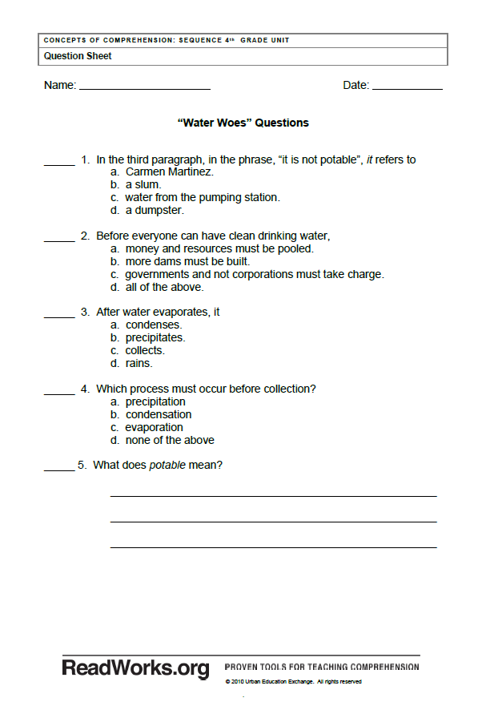
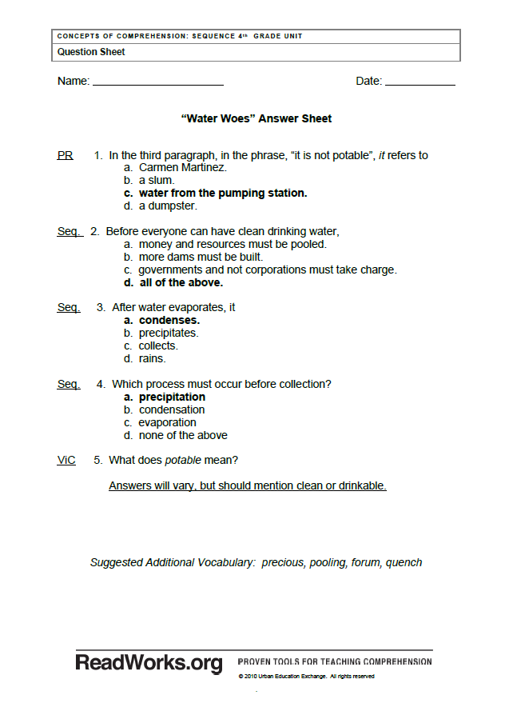
Playing for Clean Water
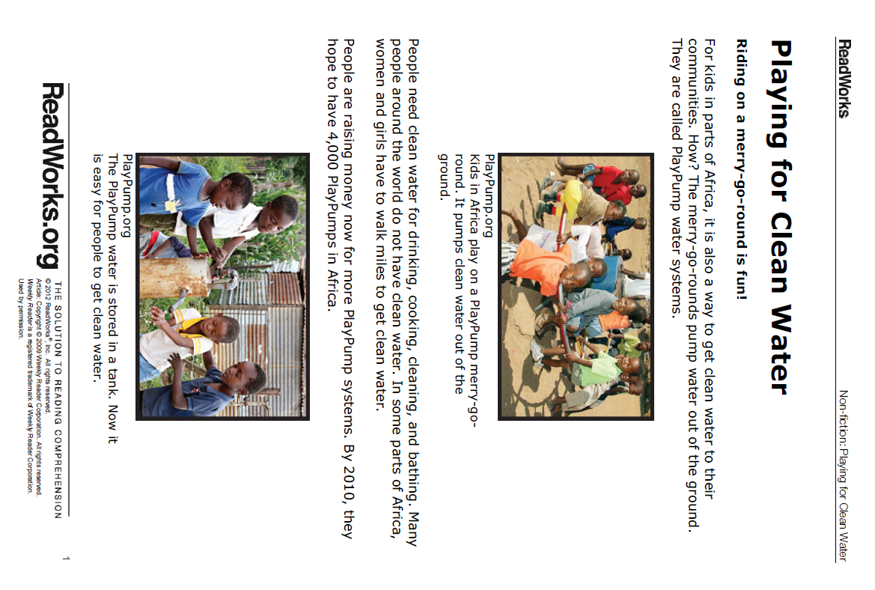
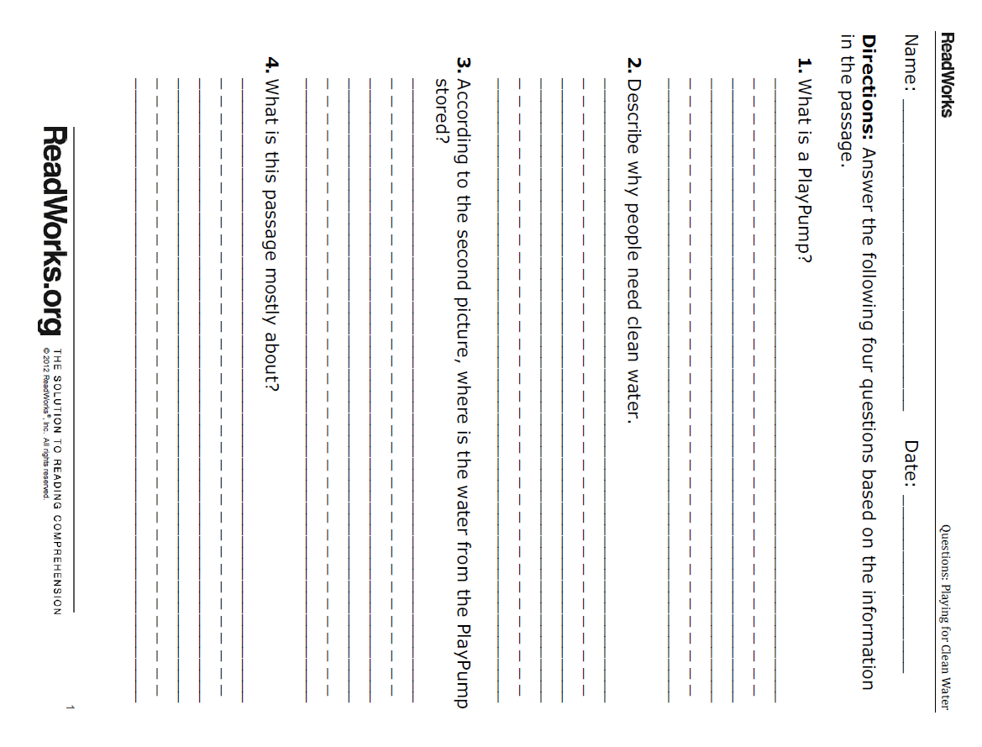
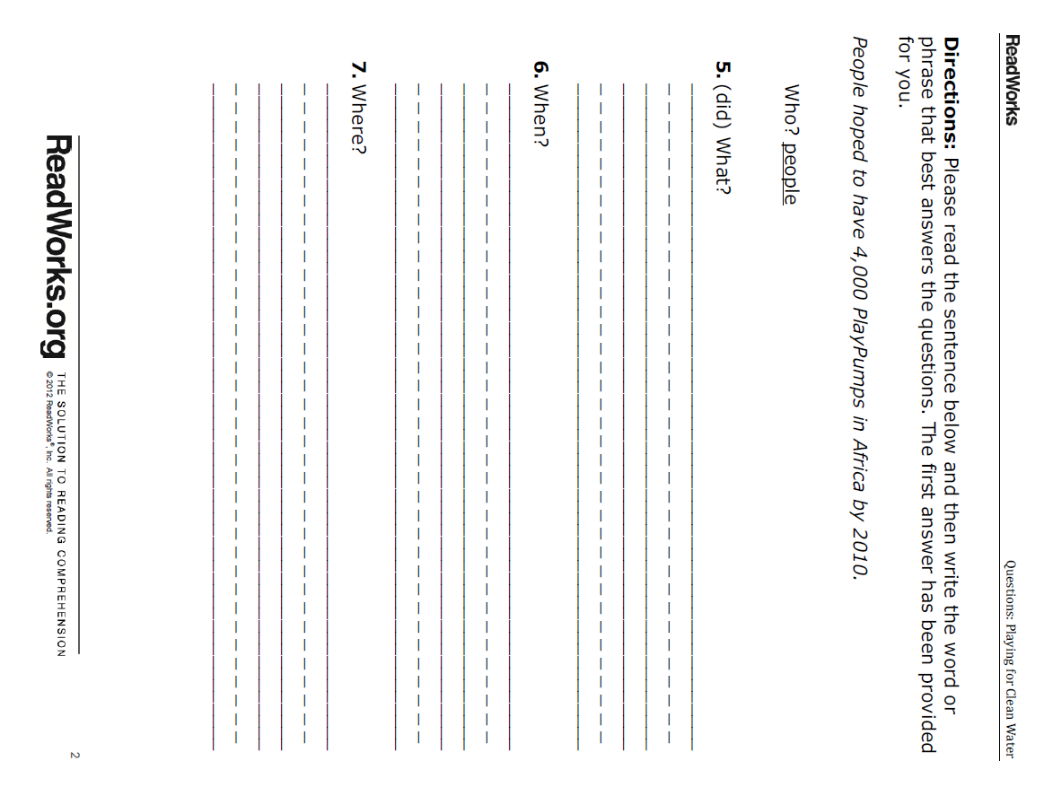
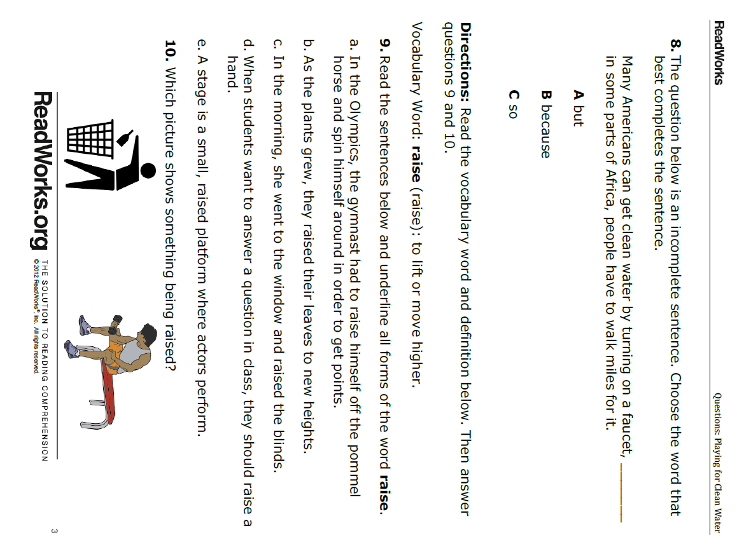
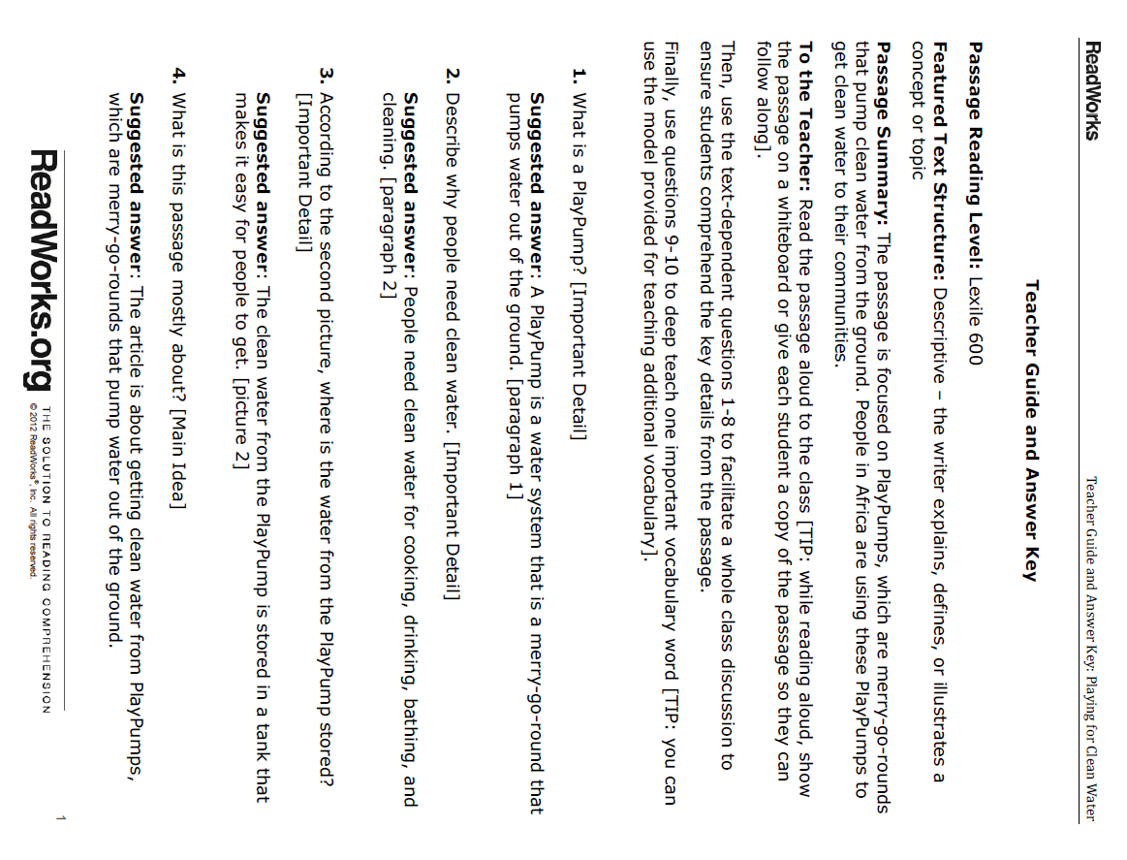
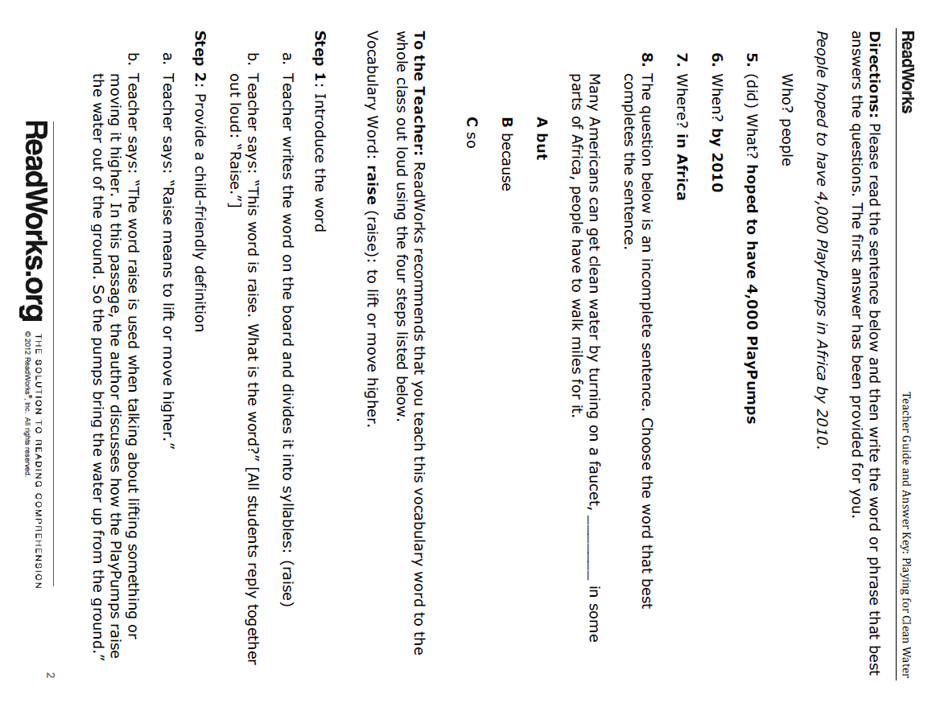
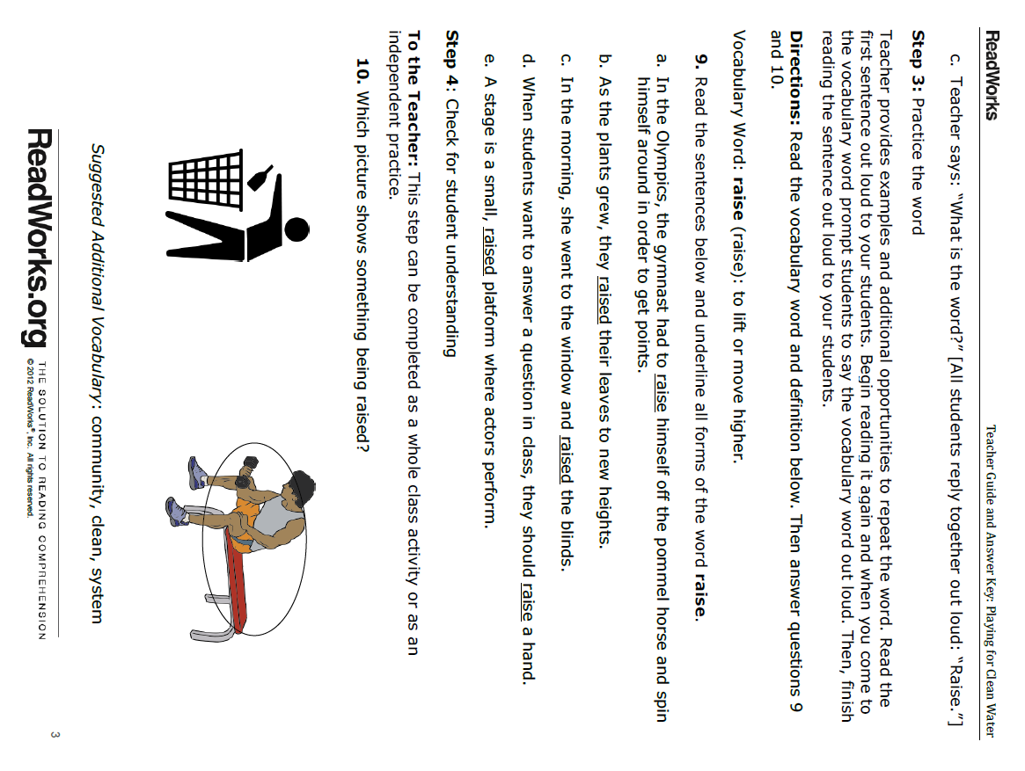

Lesson 7  Days 12 and 13 | Fact/Evidence and Opinions/Claims (Language Checkpoint) | Estimated Time: Two 60-minute periods

Brief overview of lesson: This lesson serves as the language checkpoint for the unit. Students expand their knowledge of using language to state facts and learn about terms such as evidence, opinions, claims, and related signal words. They also practice identifying, formulating and writing original facts and opinions, as well as content-related facts and opinions. This knowledge will be used to discuss key points about clean water access and state opinions/claims about the issue. As you plan, consider the variability of learners in your class and make adaptations as necessary.

What students should know and be able to do to engage in this lesson:
- How to make statements with evidence.
- Familiarity with topic vocabulary.

LESSON FOUNDATION
Unit-Level Focus Language goals to Be Addressed in This Lesson |  | Unit-Level Salient Content Connections to Be Addressed in This Lesson
G.1 Discuss by stating opinions/claims about a substantive topic. |  | CCSS.ELA-LITERACY.SL.7.1.B—Follow rules for collegial discussions, track progress toward specific goals and deadlines, and define individual roles as needed.
Language Objective |  | Essential Questions Addressed in This Lesson
Students will be able to create fact and opinion statements about the clean water issue using related signal words (e.g., According to, In the text, I think, In my opinion). |  | Q.2 How can I use my knowledge of the English language to convey a powerful message?
Assessment
- Formative assessment: Use the exit ticket to assess student construction of fact and opinion statements.
- Formative assessment. Use the language checkpoint to measure student written and oral language development in relation to the Focus Language Goals. Assess student classification of fact and opinion statements about access to clean water using the appropriate version of the “Water Access Statements: Fact or Opinion?” handout, student-written construction of fact and opinion statements about access to clean water, and student oral discussion of facts and opinions pertaining to access to clean water. Look for students’ ability to construct fact and opinion statements, use of simple sentences with have/has, is/are, and topic vocabulary used appropriately in context.
- Observation: Use the divide and slide activity to assess students’ use of language to construct fact and opinion statements, use of simple sentences with have/has, is/are, and topic vocabulary used appropriately in context.
- Self-assessment: Student monitoring of learning in relation to the language objective.
Thinking Space: What Academic Language Will Be Practiced in This Lesson?
Discourse Dimension | Sentence Dimension |  | Word Dimension
Social/instructional language; reading simple statements on PowerPoint presentation; responding to simple yes/no and wh- questions; stating and reading facts and opinions with corresponding signal words | Simple sentences with have/has, is/are, and fact and opinion “signal words” (believe, think, feel) |  | Fact and opinion “signal words”: believe, think, opinion, according to, in the text; fact, opinion, claim, evidence, other topic vocabulary (e.g., access, human right, dirty/clean water)
Instructional Tips/Strategies/Suggestions for Teacher
- Continuously consider how the word/phrase and sentence dimensions are used to craft meanings and messages at the discourse dimension.
- Use think-aloud questions.
- Create a word wall of fact/evidence and opinion/claim signal words.
- Post sentence starters.
- Post and explain the lesson objective so students can see and understand it.
- Use the exit ticket to formatively assess student progress. When needed, make changes for the following day/lesson based on what you learn from the exit ticket.
- The language checkpoint is used to measure student progress in relation to the Focus Language Goals. Use the language checkpoint to inform instruction.

STUDENT CONSIDERATIONS
Sociocultural Implications
- Discrimination may exist among some groups. It may be based on socioeconomic status, race, religion, tribal group, or other aspects. The educator should remain aware of these factors when introducing diverse cultural groups and skillfully address them.
- Some students may not be aware of the unequal distribution of natural resources world-wide, including the fact that a number of nations lack access to essential natural resources such as clean water.
- Some students may have come from countries that lack natural resources such as clean water, and the topic may trigger strong emotional responses. Again, students need to be skillfully supported.
- Some students may be more comfortable expressing themselves orally, rather than in writing. Give thoughtful consideration to both components.
- Some students may not be familiar with expressing cultural sensitivity, cultural norms of turn-taking, and the etiquette of classroom conversations, and may need direct instruction to develop these skills.
Anticipated Student Pre-Conceptions/Misconceptions
- Students may think it is not necessary to provide support/evidence when stating facts or opinions.
- Students may think opinions alone and facts alone are enough to support an issue.
- Students may think that they already can tell the difference between fact and opinion statements.
- Students may think that agreeing with an opinion makes it a fact.

THE LESSON IN ACTION
Day 12 Lesson Opening
- Post and share the language objective with students: “Students will be able to create fact and opinion statements about the clean water issue using related signal words (e.g., According to, In the text, I think, In my opinion).” To promote student ownership and self-monitoring of learning, have students record the objective in their notebooks. At the end of the lesson, students can reflect on their learning in relation to the objective.

- Ask for a student volunteer to tell the class what they will be learning about in the lesson and have him/her read the language objective off the board: “Students will use signal words of fact/evidence and opinions/claims to discuss key points about access to clean water.” Introduce the lesson by explaining how students will learn about facts and opinions to discuss the topic of clean water access. For example, say: “Today we are going to talk about facts and opinions in order to discuss clean water access. We have already talked about facts. Can someone tell me what a fact is?” Prompt students to make a fact statement or to point to the fact anchor chart from Lesson 3.

- Review what a fact is and examples that the class has added to the anchor chart. Tell students that today they will be revisiting facts and learning the difference between facts and opinions.
  - Contrast facts and opinions by holding up a common object all students can see and making fact and opinion statements about it. For example, while holding a broken phone, say: “Look at my phone. What color is my phone?” Elicit responses from students, then record it on the board (e.g., The phone is white). Then ask: “What do you think of my phone? Do you think my phone is the best in the school?” Elicit responses such as “The phone is terrible!”; feign offense and reply: “I think my phone is the best!” Write these two opinion statements on the board: “You think the phone is terrible” and “I think the phone is the best.” By now there should be three statements on the board. Ask a different student to read each statement: “The phone is white.” “You think the phone is terrible.” “I think the phone is the best.”
  - Explain how some of these statements are facts and some of these are opinions. Tell students to turn and talk to a partner, read each statement aloud first, and then discuss together as a class which is a fact and which is an opinion. Give students one minute to share, and walk around to the different groups. Encourage students as you walk by. For example, say: “You did a very good job distinguishing between a fact and an opinion.”
  - Prompt students to analyze statements identified as opinions and identify common words/phrases. For example, say: “What words do we use when we want to express an opinion?” Students should identify I think as a phrase used to signal opinions. Revisit the anchor chart with facts, and add a column for opinions. Tell students they will be exploring other opinion signal words and add them, along with examples of opinions, to the anchor chart.
During the Lesson
Show the Lesson 7 “Fact and Opinion” PowerPoint. (PDF) It begins with facts to reinforce student understanding of the concept. It is meant to be shown in sections, with stops to allow students to practice the language presented.
Provide options for physical action, such as using computers for note-taking while watching the presentation.
Provide options for perception, such as printing out the PowerPoint slides for students, posting the slides around the room, or having students view the PowerPoint on a computer. Students could also use a text-to-speech reader if viewing the PowerPoint on a computer.
- Start with the fact portion of the PowerPoint (slides 3–9). This section includes turn-and-talk and writing/whiteboard activities.

- Follow with the opinion portion (slides 10–15). This section includes turn-and-talk and writing/whiteboard activities.

- After these sections, review all the signal words introduced (using slides 16–19). Using the PowerPoint, have students repeat signal words with the teacher as a whole group. Then divide the board into two columns: Fact and Opinion. Hand out fact and opinion signal words on Post-Its to the students, and ask them to come up to the board and place them in the correct column.
Provide options for physical action, such as using a computer to sort signal words.
Finally, add the reviewed fact and opinion signal words to the anchor chart.

- Give each student two index cards, one labeled fact and the other opinion. When showing slides 21 and 22, ask students to identify whether the statement is a fact or an opinion by holding up the correct card.
Provide options for physical action, such as viewing the PowerPoint on a computer and clicking fact or opinion using Plickers.
Lesson Closing
Exit ticket: Ask students to create fact and opinion statements using signal words and this fact and opinion handouts. There are three versions of the fact statements handout (1, 2, and 3) and two versions (1 or 2) of the opinion statement handout. Select the appropriate handout for students or allow students to self-select.
Provide options for physical action, such as using a computer, drawing, or using a text-to-speech reader.
THE LESSON IN ACTION
Day 13 Lesson Opening
Review the lesson objective with students, then continue showing Lesson 7 “Fact and Opinion” PowerPoint (PDF) focusing on slides 23–27 (about access to clean water).
During the Lesson
- Pair students with a partner and instruct them to classify statements as facts or opinions about access to clean water. There are three versions of this assignment with varying levels of scaffolding. Select the appropriate version (1, 2, or 3) or allow students to choose. Model how to use the following think-aloud protocol before asking students to use it for each statement; post the questions or print them out in a handout so students can refer to them during their partner work.
- To figure out if it’s an opinion/claim, ask: “Is there a signal word of opinions/claims? What is the signal word of opinions/claims?” Refer to the signal words of opinion/claim chart.
- To figure out if it’s a fact/evidence: ask: “Can you find this information in a reference book?” Refer to the fact anchor chart.
Provide options for perception and physical action, such as using a computer to complete a task, text-to-speech readers, speech-to-text software, and/or grouping students in mentor/mentee pairings.
- Have students record their own fact or opinion statements about access to clean water. Differentiate this activity by asking students to either reproduce one fact and one opinion in their notebooks and create an original fact and an original opinion about access to clean water using signal words or create one opinion about clean water access supported by two facts. Be sure to model this for students before asking students to work independently.
Provide options for physical action, such as using a computer, Post-Its, or other writing tools to complete.
Lesson Closing
Set up a divide and slide line, where students line up facing one another. One side shares their recorded fact and the other side shares their recorded opinion. When they finish, one line slides down one person and shares again with a new partner.
Provide options for physical action, such as having a fact written instead of delivering it orally.

Lesson 7 Resources
- Notebooks
- Lesson 7 PowerPoint
- “Facts about Yourself” handout (version 1, version 2, and version 3 available below)
- “Opinion Statements” handout (version 1 and version 2 available below)
- “Water Access Statements: Fact or Opinion?” handout (version 1, version 2, and version 3 available below)

Facts about Yourself (Version 1)
Name: _____________________________________________ Date: ________________

List two facts about yourself.
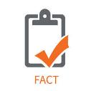 | My name is __________________________.
 | I am _____ years old.

Facts about Yourself (Version 2)
Name: _____________________________________________ Date: ________________

Write three facts about yourself.
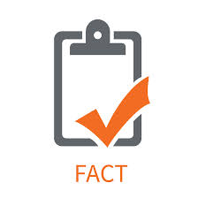
Example: I am a student.

- I am ________________________________________.
- My name is ________________________________.
- I live in ____________________________________.

Facts about Yourself (Version 3)
Name: ________________________________________________ Date: _________________

Write two facts about yourself.

1. ____________________________________________________________________________
2. ____________________________________________________________________________

Try to write one fact about where you are from.

________________________________________________________________________________

Opinion Statements (Version 1)
Name: __________________________________________ Date: __________________________

Write three opinions using the words and images.

I think soccer fun  - ________________________________________________________________ | I think school fun  - ____________________________________________________________________
*
I think English difficult

- ________________________________________________________________

*Copyright: <a href='http://www.123rf.com/profile_mammothis'>mammothis / 123RF Stock Photo</a>
Opinion Statements (Version 2)
Name: ________________________________________________ Date: __________________________

Write three opinions using the images.

- ________________________________________________________________ | - ____________________________________________________________________
*

- ________________________________________________________________

*Copyright: <a href='http://www.123rf.com/profile_mammothis'>mammothis / 123RF Stock Photo</a>

Water Access Statements: Fact or Opinion? (Version 1)
Name: ___________________________________________________ Date: _______________________

Put a check under “Fact” or “Opinion” for each statement. Look for signal words to help you.

Fact | Statement | Opinion
 | - I think water is delicious.
- According to the United Nations, 1 billion people do not have access to clean water.
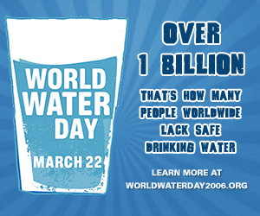
- I believe people should conserve water.
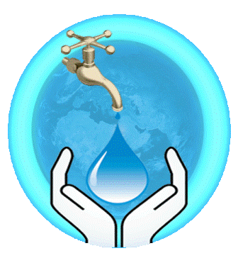
- In the text, there is a description of contaminated water.
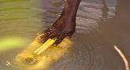
- My opinion is that PlayPumps are fun.
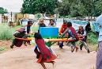
- As stated in the article, salt water covers 97% of Earth.
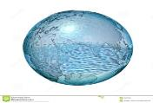
- Through the water cycle, water moves all around the world.
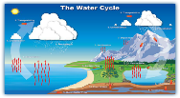
- A PlayPump is one way to get clean water to a community.
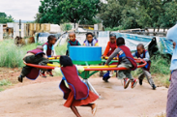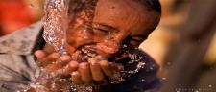

Water Access Statements: Fact or Opinion? (Version 2)
Name: ___________________________________________________ Date: _______________________
Check the right column (fact or opinion) for each statement. Look for signal words to help you.

Fact | Statement | Opinion
 | - I think water is delicious.
 | - People need water to survive.
 | - According to the United Nations, 1 billion people do not have access to clean water.
 | - I believe people should conserve water.
 | - In the text, there is a description of contaminated water.
 | - My opinion is PlayPumps are fun.
 | - As stated in the article, salt water covers 97% of the Earth.
 | - Through the water cycle, water moves all around the world.
 | - A PlayPump is one way to get clean water to a community.

Water Access Statements: Fact or Opinion? (Version 3)
Name: ____________________________________________________________ Date: ______________

Check off whether each statement is a fact or an opinion. Look for signal words to help you.

Fact | Statement | Opinion
 | - I think it is unfair that people have no water.
 | - All living creatures need water to survive.
 | - According to the United Nations, more than 1 billion people around the world do not have access to safe drinking water.
 | - I believe people should conserve water.
 | - In the text there is description of contaminated and dirty water.
 | - My opinion is that there is enough water in the world for everyone.
 | - As stated in the article, salt water is 97% of the water on Earth.
 | - Through the water cycle, water moves all around the world.
 | - A PlayPump is one way to get clean water to a community.

Lesson 8  Day 14 | Writing a Call to Action Using Modal Verbs | Estimated Time: One 60-minute period

Brief overview of lesson: In this lesson, students discuss and write about ways people can stand up for causes they believe in through a gallery walk, and are introduced to modal verbs as a language feature that is useful for formulating a call to action to improve global access to clean water. Students will also discuss what they can do to support greater access to clean water, beginning to form their own perspective and possibilities for engagement with this issue. This knowledge will be used to discuss key points and state opinions/claims about the issue in the final assessment. As you plan, consider the variability of learners in your class and make adaptations as necessary.

What students should know and be able to do to engage in this lesson:
- The difference between language used to create statements of fact and statements of opinion.
- Topic vocabulary.
- The concept of modal verbs structure of sentences with the modal verb can.

LESSON FOUNDATION
Unit-Level Focus Language Goals to Be Addressed in This Lesson |  | Unit-Level Salient Content Connections to Be Addressed in This Lesson
G.1 Discuss by stating opinions/claims about a substantive topic |  | CCSS.ELA-LITERACY.W.7.1—Write arguments to support claims with clear reasons and relevant evidence.
Language Objective |  | Essential Questions Addressed in This Lesson
Students will be able to use their knowledge of ways people can stand for causes to make fact and opinion statements about the need for access to clean water using modal verbs (can, should, must, have to). |  | Q.1 How can I use language to make a difference in a problem that is important to me, my community, or other people?  Q.2 How can I use my knowledge of the English language to convey a powerful message?  Q.3 Why should access to clean water be a human right?
Assessment
- Formative assessment: Use an oral statement using modal auxiliary verbs to assess students’ use and application of modal auxiliary verbs.
- Formative assessment: Use the Clean Water Access- Modal Verbs exit ticket to assess student use and application of modal auxiliary verbs to craft a call to action.
- Self-assessment: Student monitoring of learning in relation to the language objective.
Thinking Space: What Academic Language Will Be Practiced in This Lesson?
Discourse Dimension | Sentence Dimension |  | Word Dimension
Social/instructional language; stating and listening to simple sentence facts and opinions with corresponding signal words; matching images with simple sentences | Simple sentences with can, must, should, and have to |  | Can, must, should, have to, stand up for (a cause), believe in, topic vocabulary (e.g., access, human right, dirty/clean water)
Instructional Tips/Strategies/Suggestions for Teacher
- Continuously consider how the word/phrase and sentence dimensions are used to craft meanings and messages at the discourse dimension.
- Create a word wall.
- Make a continuum to illustrate the meaning of different modals and percentage of obligation they represent.
- Post and explain the lesson objective so students can see and understand it.
- Use the “Clean Water Access—Modal Auxiliary Verbs”-exit ticket to formatively assess student progress. When needed, make changes for the following day/lesson based on what you learn from the exit ticket.
- Use discussion questions during the gallery walk to personalize the learning for students and to prompt student discussion.

STUDENT CONSIDERATIONS
Sociocultural Implications
- Discrimination may exist among some groups. It may be based on socioeconomic status, race, religion, tribal group, or other aspects. The educator should remain aware of these factors when introducing diverse cultural groups and skillfully address them.
- Some students may not be aware of the unequal distribution of natural resources world-wide, including the fact that a number of nations lack access to essential natural resources such as clean water.
- Some students may have come from countries that lack natural resources such as clean water, and the topic may trigger strong emotional responses. Again, students need to be skillfully supported.
- Some students may be more comfortable expressing themselves orally, rather than in writing. Give thoughtful consideration to both components.
- Some students may not be familiar with expressing cultural sensitivity, cultural norms of turn-taking, and the etiquette of classroom conversations, and may need direct instruction to develop these skills.
- Students may be unfamiliar with causes and standing up for what one believes. Consider providing a quick explanation of what a cause is and what it means to stand up for what one believes.
Anticipated Student Pre-Conceptions/Misconceptions
- Using modals with the infinitive from of a verb instead of conjugating the verb.
- Inability to distinguish among the levels of obligation related to each modal verb.
- Cause has several meanings. Consider reviewing them.

THE LESSON IN ACTION
Lesson Opening
- Post and share the language objective with students: “Students will be able to use their knowledge of ways people can stand for causes to make fact and opinion statements about the need for access to clean water using modal verbs (can, should, must, have to).” To promote student ownership and self-monitoring of learning, have students record the objective in their notebooks. At the end of the lesson, students can reflect on their learning in relation to the objective.

- Begin the lesson with a gallery walk featuring pictures of ways people stand up for causes they believe in (e.g., protesting, fundraising/donating, volunteering, raising awareness, educating others, writing letters of support). When introducing the gallery walk, consider providing a quick explanation of what a cause is, what it means to stand up for what one believes in, and how the gallery walk will showcase ideas for how to stand up for causes. Review/model the gallery walk protocol for students before beginning the activity, explaining how students are to walk around the room and pay attention to the images while thinking about the following discussion questions:
  - Have you ever _____________?
  - How have you _____________?
  - How can you ______________?
  - How do people stand up for something?
  - Has someone ever made a difference in your life? How?
Provide options for perception, such as using a computer to view the images and printouts of the images.
Provide options for physical action, such as using computers, pointing, writing, commenting with Post-Its, drawing, or letting students collaborate or discuss with a peer as they move through the gallery walk.
During the Lesson
- Remind students of the modal can. Consider revisiting the work from Lesson 1. Then tell students they will be learning about more words like can in this lesson: can, must, should, and have to.

- Introduce the modal auxiliary verbs with the “Modal Auxiliary Verbs” video. (Note: This video provides a general introduction into modals and introduces modals other than those targeted in the lesson.)
Provide options for perception, such as printing out the video transcript for students, enabling closed captioning on the video, and adjusting the speed of the video. Also, consider offering a video viewing station in the classroom where students could watch independently. Students could use translation captions or pause and ask questions whenever they need more clarity.
- Debrief the video and provide your own explanation of what modals are. Tell students that modals are special words used to express ability (can) and obligation (must, have to, should). Explain how modals express different degrees of obligation: must and have to express 100 percent obligation, whereas should expresses 50 percent obligation.
Provide options for engagement and perception, such as making a continuum to illustrate these different degrees of obligation or an anchor chart for reference.
- Go back to the gallery walk. Ask students to brainstorm ways people can support a cause using modal verbs and sentence frames. Consider modeling examples via a think-aloud. Allow for some time for quiet individual reflection before beginning to write.
Provide options for physical action, such as using computers to type, speech-to-text software, drawing, and/or dictation.
- After students have practiced recording ways peoples can support a cause, ask students to answer the question: “What can we do to support clean water access for everyone?” Allow for some time for quiet reflection then have students write answers in their notebooks.
Provide options for physical action, such as Zoho Notebook, drawing, speech-to-text software, using computers to type, and/or giving students time to discuss with a partner or small group prior to writing.
Lesson Closing
Exit ticket: Ask students to reproduce facts/evidence and opinions/claims using modal verbs and index cards matched to a gallery walk photo (see the sample Model Performance Indicator for speaking). Consider modeling a few examples for students before having students work independently. Below are a couple:
- For a fact statement about clean water access: “Millions of people lack clean water.”
- For an opinion statement using a modal: “Access to clean water should be a human right.”

Afterwards, ask students to record their statements in their notebooks, and consider having students share their statements orally with a partner.
Provide options for physical action, such as Zoho Notebook, drawing, speech-to-text software, text-to-speech readers, and using computers to type.

Lesson 8 Resources
- Notebooks
- Computer with Internet access
- Projector
- Sentence frames on index cards
- Video: “Modal Auxiliary Verbs”
- Images for gallery walk (samples available below)
- “Clean Water Access—Modal Auxiliary Verbs” handout (available below)

Sample Images for Gallery Walk
Protest peacefully | Donate money
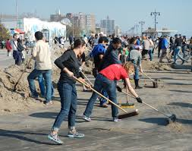  Volunteer | 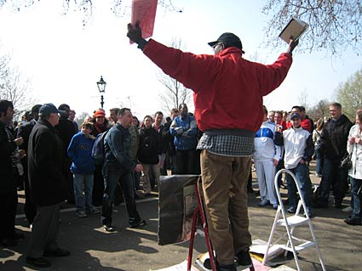  Raise awareness
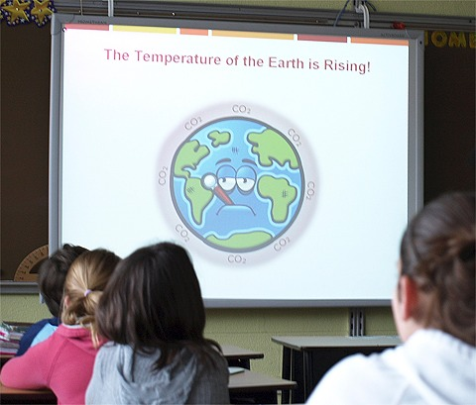  Educate others | 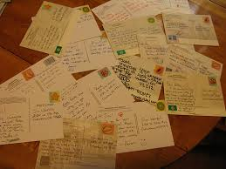  Write letters of support

Clean Water Access—Modal Auxiliary Verbs
Can—Ability to do something. Example: I can swim.
Must—100 percent obligation to do something. Example: I must go home after school.
Have to—100 percent obligation to do something Example: I have to do my homework tonight.
Should—50 percent obligation to do something Example: I should study for the test.

Use the pictures and activities from the gallery walk to complete each statement:
- People should ____________________________________________________________.
- You must _________________________________________________________________.
- We have to ______________________________________________________________.
- Everyone should ___________________________________________________________.

Lesson 9  Days 15 and 16 | Interpreting Maps, Charts, and Graphs | Estimated Time: Two 60-minute periods

Brief overview of lesson: To further develop their knowledge about clean water issues, students learn about different ways of graphically displaying information (maps, charts, graphs). Students analyze these visuals to interpret information and evaluate their effectiveness in communicating a message. They also record important facts derived from maps, charts, and graphs and choose visuals for their upcoming PSAs. This knowledge will be used to create evidence-based claims about clean water issues and effectively communicate this information in the final assessment. As you plan, consider the variability of learners in your class and make adaptations as necessary.

What students should know and be able to do to engage in this lesson:
- Write statements and questions.
- Cause and effect language.
- Topic vocabulary.

LESSON FOUNDATION
Unit-Level Focus Language Goals to Be Addressed in This Lesson |  | Unit-Level Salient Content Connections to Be Addressed in This Lesson
G.2 Explain causes and effects to create evidence-based claims. |  | CCSS.ELA-LITERACY.SL.7.5—Include multimedia components and visual displays in presentations to clarify claims and findings and emphasize salient points.
Language Objective |  | Essential Questions Addressed in This Lesson
Students will be able to use their knowledge of how to interpret graphs, maps, charts, and other visuals to create evidence-based claims about the clean water issue. |  | Q.2 How can I use my knowledge of the English language to convey a message?
Assessment
- Observation: Oral sharing during think-pair-share. The class discussions throughout the lesson provide a formative assessment of students’ use of language to articulate their analysis of graphs, charts, and other visuals to create evidence-based claims about clean water access. Look for student use of extended discourse, application of learned language, and use of according to and this shows.
- Formative assessment: The lesson closing illustrates students’ ability to state and support their opinion on the efficacy of the graphic selected. Through this assessment, look for student use of extended discourse.
- Formative assessment: Use students’ analysis of the “Access to Clean Water” graphs/charts to assess their ability to use language.
- Formative assessment: Student selection of appropriate graphic for a clean water PSA.
- Self-assessment: Students’ use of metacognitive and metalinguistic strategies to read and analyze the graphics. Students’ reflection on the efficacy of the graphic representations of data.
- Self-assessment: Students’ monitoring of learning in relation to the language objective.
Thinking Space: What Academic Language Will Be Practiced in This Lesson?
Discourse Dimension | Sentence Dimension |  | Word Dimension
Social/instructional language; responding to a survey with simple questions and answer choices about a familiar topic; reading texts with simple sentences and visuals (e.g., graphs, charts) about the clean water issue; stating facts with sentence starters; answering simple reading comprehension questions; discussing information presented in graphs, charts, and visuals using sentence frames | Simple sentence statements using according to, this shows… and comparative language |  | Chart, graph, pie chart, line graph, bar graph, visual, comparative language (e.g., more/less, bigger/smaller), topic vocabulary (e.g., access, human right, dirty/clean water)
Instructional Tips/Strategies/Suggestions for Teacher
- Continuously consider how the word/phrase and sentence dimensions are used to craft meanings and messages at the discourse dimension.
- Use a variety of graphs and charts to highlight how data can be displayed in different ways.
- When analyzing graphs and charts in the beginning of the lesson, use topics interesting to the students to promote engagement.
- Post and explain the lesson objective so students can see and understand it.
- Use the exit ticket on choosing a graphic to formatively assess student progress. When needed, make changes for the following day/lesson based on what you learn from the exit ticket.
- The survey conducted during the lesson opening could be provided to students a few days before this lesson so as to provide additional time to prepare the corresponding graphs/charts.
- Pre-teach and model any metacognitive and metalinguistic strategies that will aid student analysis of the graphics.

STUDENT CONSIDERATIONS
Sociocultural Implications
- PSAs or defending the rights of others may be a new concept for some ELs.
- Discrimination may exist among some groups. It may be based on socioeconomic status, race, religion, tribal group, or other aspects. The educator should remain aware of these factors when introducing diverse cultural groups and skillfully address them.
- Some students may not be aware of the unequal distribution of natural resources world-wide, including the fact that a number of nations lack access to essential natural resources such as clean water.
- Some students may have come from countries that lack natural resources such as clean water, and the topic may trigger strong emotional responses. Again, students need to be skillfully supported.
- Some students may be more comfortable expressing themselves orally, rather than in writing. Give thoughtful consideration to both components.
- Some students may not be familiar with expressing cultural sensitivity, cultural norms of turn-taking, and the etiquette of classroom conversations, and may need direct instruction to develop these skills.
Anticipated Student Pre-Conceptions/Misconceptions
Students may think charts, maps and graphs are not as important as text, do not teach anything, and do not require interpretation or special instruction in order to be understood.

THE LESSON IN ACTION
Day 15 Lesson Opening
- Post and share the language objective with students: “Students will be able to use their knowledge of how to interpret graphs, maps, charts, and other visuals to create evidence-based claims about the clean water issue.” To promote student ownership and self-monitoring of learning, have students record the objective in their notebooks. At the end of the lesson, students can reflect on their learning in relation to the objective.
- Distribute a survey about common interesting topics such as favorite food, activity, or candy. Consider using anonymous polling such as Plickers. Use the survey results to create graphs and charts such as a pictograph. Use of Microsoft Excel or other software to create the graphs and charts is recommended.
During the Lesson
- Introduce the focus of today’s lesson. Discuss with students how charts, graphs, and maps are effective ways to communicate a message. Consider projecting a chart or graph and allowing students to quietly reflect on what they see and what they notice about it. Then prompt thinking by asking students to think about what they can learn from the chart or graph and leading a class discussion. Make sure to talk about how there are different ways to display information. Inform students that they will be analyzing and interpreting charts and graphs to collect more information about the access to clean water issue and to designing an effective PSA at the end of the unit.

- Depending upon student familiarity with charts and graphs as a method for conveying information, consider modeling how to analyze a graphic.
  - You can start with a familiar example such as the “Which Fast Food Chain Has the Best Burger and Fries?” bar graph. Project the bar graph for students, and consider providing hard copies for them to analyze. Post a question to guide the graph analysis, such as “Based on the graph, what fast food chain has the best burgers?” Allow for quiet time to analyze the graph individually first, then work with a small group to discuss thoughts before sharing as a class. Provide a sentence frame such as “According to the bar graph, more people like _______ burgers” for sharing. Repeat this process for French fries as well, using the same bar graph.
  - Extend student practice with an additional graph, such as “U.S. Teens Love Instagram.” In this case, a guiding question might be “Based on the graph, what social media site do most teenagers prefer?”; students could repeat their analysis with other social media sites.

- Tabulate the results of the classroom survey and create five graph types based on the survey results (e.g., bar graph, line graph, pie chart). Print these graphs and post them on the walls or create digital files with the graphs and share them with students and have them view the graphs on a computer. Be sure to label the types of graphs for students.

- Analyze one of the graphs created based on the class survey as a whole class. For example, create a graph with numbers along the left side (y-axis) and types of food/activities/candy along the bottom (x-axis). (Sample provided below.) Place an icon or image representing the topic. First, allow students some time to analyze the graph. Have them discuss the graph in a small group and then invite the whole class to the discussion. This allows students time to build and share their own ideas before turning to the larger group, where not all students are as comfortable sharing their ideas. Provide sentence starters such as “Most students like ___________”; “Students like ___________ the least”; “Nobody likes ___________”; “According to the pictograph ___________.”
Provide options for perception, such as using computers and/or printouts of the graphs for student reference.
It may also be helpful to provide options for physical action and expression and communication, such as using a computer to type responses.
Lesson Closing
- Give students some time to analyze each graph. Ask them to discuss with a partner or small group the different ways that we can communicate the same information.

- Then tell them to state their opinions on which graphic is the most effective. This will help students begin to think about the different ways in which we can present information and how the method of presenting information can impact how effective the message is.

- Finally, ask students to record the type of graphs in their notebooks and what is effective/ineffective about each type of graph.
THE LESSON IN ACTION
Day 16 Lesson Opening
- Begin the lesson by projecting a graph about the clean water access issue. A suggested graph is “Deaths Due to Unsafe Water.” Consider allowing students to use computers and/or printouts of the graph to refer to while they analyze it.
- Give students some time to analyze and reflect on the graph. Have students discuss the graph in a small group, then invite the whole class to the discussion. This allows students time to build and share their own ideas before turning to the larger group where not all students are as comfortable sharing their ideas.

- Provide sentence frames to share insights about the graph, such as “According to the graph, ___________ [country] had the most deaths due to contaminated drinking water”; “According to the graph, ___________ [country] had more deaths due to contaminated drinking water than ___________ [country]”; “According to the graph, ___________ [country] had the fewest deaths due to contaminated water.” Throughout the discussion, students may point out how countries with the highest number of deaths did not have access to clean water.

- As a reflection, ask students to think about how they might represent this information through another graphic representation to communicate its message.
During the Lesson
1. Have students read abridged texts/graphs about access to clean water.
Provide options for perception, such as reading the text/analyze the graphs independently, using a text-to-speech reader, or working with a partner.
Ask students to answer questions and make statements of fact using the “Access to Clean Water” graphs. Provide sentence starters as support such as “According to…” or “This represents…” Then have students record these statements in their notebooks.
Provide options for physical action, such as use of speech-to-text software, using computers to complete a task, and/or work with a partner.
- As a class, discuss the charts/graphs analyzed. Provide sentence frames to share insights about the graph, such as “According to the graph, ___________”; “This illustrates ___________”; “The graph shows ___________.” Ask students to orally answer questions and make statements of fact using the access to clean water graphs.
Lesson Closing
- Exit ticket: Ask students to pick one map, chart, or graph they can use in a PSA to increase awareness of clean water access issues. Consider reminding students about what a PSA is and how the “Water Changes Everything” video they have watched is a PSA. Students can add the map, chart, or graph to their student notebook. As an extension, students could explain orally or in writing why they chose that particular graphic.

- Ask students to consider the following question: “What is effective about including charts/graphs in our PSAs?” Students can share with a partner.
- Optional activity: Have students create their own surveys and graphs. For example, students could create a survey about access to clean water to see what their peers in the school know about it. They could graph the results of the survey. Then, after sharing their PSAs at the end of the unit, students could re-administer the same survey to students and graph the results and compare them to previous results. If students create this survey, be sure to offer checklists and examples for them to use so that the overall process becomes clear and engaging. Focus on offering feedback throughout the process, not just at the end.

Lesson 9 Resources
- Computer (with software that can create graphs and charts, such as Excel)
- Projector
- Internet access
- Notebooks
- WGBH’s Effective Practices for Description of Science Content within Digital Talking Books
- Anonymous polling tool as Plickers
- Sample graphs (available below)
- “Access to Clean Water: Graph/Chart Analysis” handout (available below)
Sample Graphs
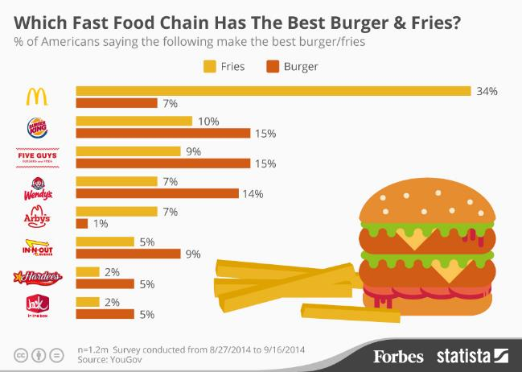  Source: Statista | 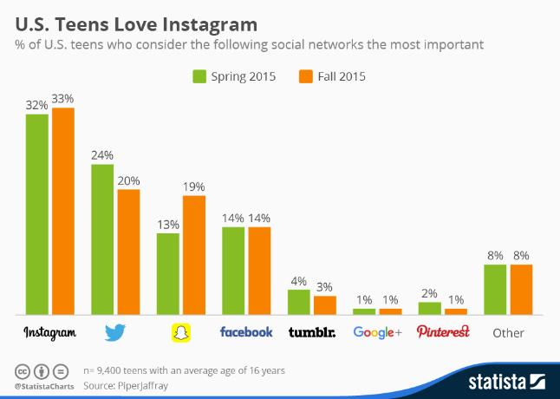  Source: Statista

Sample based on class survey:

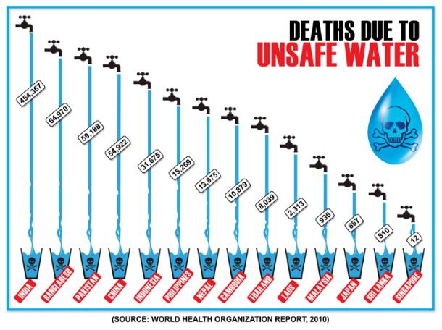
Source: Climate Change in Asia
Access to Clean Water: Graph/Chart Analysis
Name: ___________________________________________________ Date: __________________

Look at the visuals and answer the questions.

1. | Statistics from Facts and Water and Sanitation | - What percent of people have access to clean water? ______________  - What percent of people do not have access to clean water? ____________
2. | 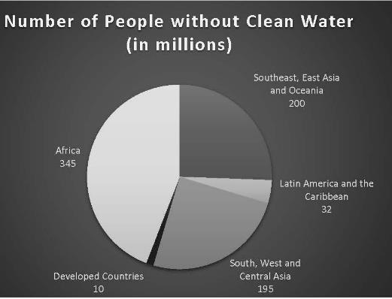 | - What type of visual is this? _________________________________________________  - What is the title of the visual? _________________________________________________  - Where are the most people without clean water? _________________________________________________  - Where are the fewest people without clean water? _________________________________________________
3. | 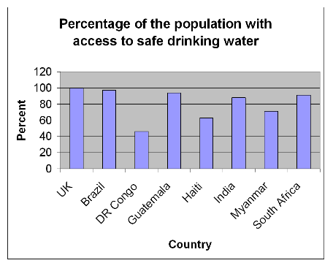 | - What type of visual is this? _________________________________________________  - What is the title of the visual? _________________________________________________  - What county has the lowest access to clean water? _________________________________________________  - What country has the highest access to clean water? _________________________________________________
4. | 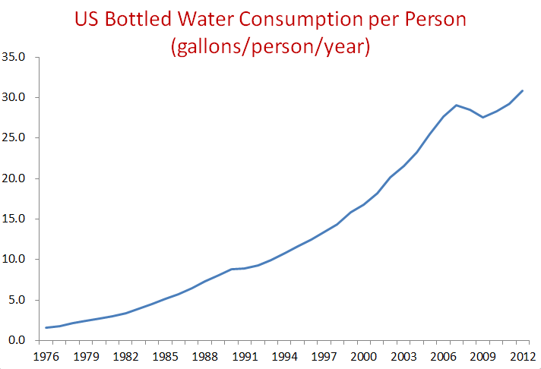 | - What type of visual is this? ________________________________________________  - What is the title of the visual? ________________________________________________  - Is bottled water consumption growing or shrinking? ________________________________________________  - When was the lowest consumption of bottled water per person? _______________________________________

Lesson 10  Day 17 | The Power of Words | Estimated Time: One 60-minute period

Brief overview of lesson: Students analyze images and PSAs to learn more about the power of words and actions and the causes and effects related to the clean water issue. Students also have an opportunity to create a visual to strategically communicate the need for access to clean water. This knowledge will be used to discuss key points and explain causes and effects related to clean water access in the final assessment. This lesson is the introduction to the CEPA. As you plan, consider the variability of learners in your class and make adaptations as necessary.

What students should know and be able to do to engage in this lesson:
- Write statements and questions.
- Cause and effect language.
- Topic vocabulary.

LESSON FOUNDATION
Unit-Level Focus Language Goals to Be Addressed in This Lesson |  | Unit-Level Salient Content Connections to Be Addressed in This Lesson
G.1 Discuss by stating opinions/claims about a substantive topic |  | CCSS.ELA-LITERACY.SL.7.5—Include multimedia components and visual displays in presentations to clarify claims and findings and emphasize salient points.
Language Objective |  | Essential Questions Addressed in This Lesson
Students will be able to explain and discuss clean water issues using topic-related language (including topic-related vocabulary such as access, human right, powerful, opportunity) and selected visuals (pictures, maps, charts, and/or graphs). |  | Q.1 How can I use language to make a difference in a problem that is important to me, my community, or other people?  Q.2 How can I use my knowledge of the English language to convey a message?
Assessment
- Observation: During the oral sharing part of the think-pair-share exercise, notate student use of topic-related language (including topic-related vocabulary).
- Formative assessment: Use students’ completion of the cause/effect cloze and written reflection to look for their listening for cause and effect information and their statements of opinion supported by evidence.
- Formative assessment: Use the sketched visual for a clean water PSA, with the statement “This shows power because ________________________,” to assess students’ use of learned language to discuss how and why the image portrays power.
- Self-assessment: Students’ use of metacognitive strategies during the video viewing and analysis.
- Self-assessment: Students’ monitoring of learning in relation to the language objective.
Thinking Space: What Academic Language Will Be Practiced in This Lesson?
Discourse Dimension | Sentence Dimension |  | Word Dimension
Social/instructional language; discussing opinions about images, videos, and teacher-given prompts; listening for cause and effect information in videos | Simple sentences with because (e.g., This shows power because…) |  | PSA, power, powerful, topic vocabulary (e.g., access, human right, dirty/clean water)
Instructional Tips/Strategies/Suggestions for Teacher
- Continuously consider how the word/phrase and sentence dimensions are used to craft meanings and messages at the discourse dimension.
- Teacher enthusiasm is key, as this is the introduction to the CEPA.
- Remind students of some of the key instructional moments of the unit so far to stimulate engagement.
- Post and explain the lesson objective so students can see and understand it.
- Use the exit ticket to formatively assess student progress. When needed, make changes for the following day/lesson based on what you learn from the exit ticket.
- Pre-teach and model metacognitive and metalinguistic strategies to aid student review and analysis of the video. Consider printing the transcript for students and analyzing the linguistic features of the video.

STUDENT CONSIDERATIONS
Sociocultural Implications
- PSAs or defending the rights of others may be a new concept for some ELs.
- Discrimination may exist among some groups. It may be based on socioeconomic status, race, religion, tribal group, or other aspects. The educator should remain aware of these factors when introducing diverse cultural groups and skillfully address them.
- Some students may not be aware of the unequal distribution of natural resources world-wide, including the fact that a number of nations lack access to essential natural resources such as clean water.
- Some students may have come from countries that lack natural resources such as clean water, and the topic may trigger strong emotional responses. Again, students need to be skillfully supported.
- Some students may be more comfortable expressing themselves orally, rather than in writing. Give thoughtful consideration to both components.
- Some students may not be familiar with expressing cultural sensitivity, cultural norms of turn-taking, and the etiquette of classroom conversations, and may need direct instruction to develop these skills.
- Students may not be familiar with the advertising form of a PSA. Consider showing examples of PSAs raising awareness about relevant issues such as drugs, smoking, or pollution.
- Some students may think only actions are powerful, not words.
- Some students may think having power only comes from coercion or force, not influencing others’ thinking. What it means to have power may be different across cultures (some cultures value subtler ways of exerting power/influence while others may promote coercive or forceful ways of creating change).
Anticipated Student Pre-Conceptions/Misconceptions
- Students may think that visuals are only used for aesthetics, not because they carry a message just like words.
- Students may think that words alone are strong enough to carry a message.

THE LESSON IN ACTION
Lesson Opening
- Post and share the language objective with students: “Students will be able to explain and discuss clean water issues using topic-related language (including topic-related vocabulary such as access, human right, powerful, opportunity) and selected visuals (pictures, maps, charts, and/or graphs).” To promote student ownership and self-monitoring of learning, have students record the objective in their notebooks. At the end of the lesson, students can reflect on their learning in relation to the objective.

- Introduce the concept of power. Consider discussing what it means to have power, clarifying any misunderstandings and making sure students’ concept of power aligns with the intended meaning of the word in this lesson.
  - Post labeled images representing power such as words, weightlifter, President Obama, fighter jet, ox, hurricane, iceberg, bear, elephant, electricity, etc. Consider providing printouts of the images or allowing students to view the images on a computer.
  - Prompt student thinking by asking a question such as “Which pictures show power?” Allow students to quietly reflect on the images or allow them to create their own image showing the idea of power. Have students discuss the images in a small group and then discuss it together as a whole class. This allows students time to build and share their own ideas before turning to the larger group where not all students are as comfortable sharing their ideas. During the conversation, help students consider how all of the images illustrate the idea of power, including the image of words. Also, help students notice differences between physical strength and power through intellect or position.
  - Optional activity: Ask students to choose the image they feel is the most powerful with a Post-It, using anonymous voting software such as Plickers, or by making comments with tools such as Padlet. Consider offering sentence starters or model examples of how to explain their opinion to highlight the thinking process—for example, “This image is the most powerful because ___________”; “___________ is a powerful image because ___________”; “___________ portrays power because ___________.”
During the Lesson
- Introduce the PSA as a medium to promote public awareness of issues. Explain how PSAs make a difference in the world by communicating a message using words and pictures.
- Review the “Power of Words” video. Consider offering a video station in the classroom where students can watch it independently. For example, they may use translation captions or pause and ask questions whenever they need more clarity.
- After the video, give students some time to do a think-pair-share. Ask guiding questions such as “How can words make a difference in your life?” “How can they make a difference in another person’s life?” “How does access to clean water change a person’s life?” “How does no water affect a person’s life?” “How can your words help others learn about clean water issues?” Allow students to answer them orally or in writing, and consider posting the questions on the board or a handout for students to refer to during the think-pair-share.
- Introduce the idea that actions have power. Show students some solutions that have been developed to help people have access to clean water. These are examples of people making a difference in the world of clean water access with their actions. Suggestions: videos about the Lifestraw, the Lifesaver bottle, and building wells in South Sudan.
    - Before each video, remind students about the focus of their viewing. Ask them to complete the “Causes and Effects” handout and take notes about causes and effects of lack of access to clean water as discussed in the videos.
    - Consider offering a video station in the classroom where students could watch this video independently.
    - Optional activity: Give students time to explore websites such as Lifestraw.com and WaterforSouthSudan.org to learn more about potential solutions to the problem of clean water access. Give students time to quietly reflect on these solutions, then share their reactions orally or in writing.
Lesson Closing
Exit ticket: Ask students to use their notebooks, sketching one visual they can use in a PSA to raise awareness of the need to help people around the world have access to clean water. Students could illustrate a solution or a visual to stimulate others to get involved in solving lack of access to clean water. Allow students to use computers to create images (using software such as Microsoft Paint). Tell students to support their images with an oral statement of opinion or a written sentence using the following frame: “I think this visual is strong because ___________.”

Lesson 10 Resources
- Computer with Internet access
- Projector
- Notebooks
- Post-Its, anonymous voting software such as Plickers, or tools such as Padlet
- Videos:
  - “The Power of Words”
  - “The Lifestraw: Where Did It Come From?”
  - “Michael Pritchard: How to Make Filthy Water Drinkable” (video on the Lifesaver bottle)
  - “Drilling for Water in South Sudan”
- Websites:
  - Lifestraw.com
  - WaterforSouthSudan.org
- “Think-Pair-Share: The Power of Words” handout (available below)
- “Causes and Effects” handout (available below)

Think-Pair-Share: The Power of Words
- How can words make a difference in your life?
- How can words make a difference in another person’s life?
- How does access to clean water change a person’s life?
- How does no access to clean water affect another person’s life?
- How can your words help others learn about clean water issues?

Causes and Effects
Name: ____________________________________________________________ Date: _______________

After you watch each video, complete each call to action using cause/effect language (because, since, or as a result).

For example:

Lifestraw:
- People should raise money to buy lifestraws _____________________ they make the water clean.
Lifesaver bottle:
- __________________ the water is full of bacteria, the lifesaver bottle can prevent diseases.
Water for South Sudan:
- ____________________ of wells, the water is clean.

Which solution do you support the most? Why?

________________________________________________________________________________________________________________
________________________________________________________________________________________________________________

Lesson 11  Days 18 and 19 | PSA Background Building and Organizing | Estimated Time: Two 60-minute periods

Brief overview of lesson: Students explore PSAs as a form of communication by watching and analyzing the components of several effective PSA exemplars. Students are introduced to storyboards and also expand earlier learning about sequencing language. They apply this knowledge to develop steps for creating PSAs. They will also organize the PSA’s elements (for the final assessment), discussing key points about access to clean water and explaining related causes and effects. As you plan, consider the variability of learners in your class and make adaptations as necessary.

What students should know and be able to do to engage in this lesson:
- Forming statements of fact/evidence and opinion/claims using can and other modal auxiliary verbs.
- Forming cause and effect statements using key signal words.
- Topic vocabulary.

LESSON FOUNDATION
Unit-Level Focus Language Goals to Be Addressed in This Lesson |  | Unit-Level Salient Content Connections to Be Addressed in This Lesson
G.1 Discuss by stating opinions/claims about a substantive topic.  G.2 Explain causes and effects to create evidence-based claims. |  | CCSS.ELA-LITERACY.SL.7.1.B—Follow rules for collegial discussions, track progress toward specific goals and deadlines, and define individual roles as needed.
Language Objective |  | Essential Questions Addressed in This Lesson
Students will be able to explain the process for creating a PSA about the clean water issue using sequence words (e.g., first, next, then, last, finally). |  | Q.2 How can I use my knowledge of the English language to convey a powerful message?
Assessment
- Formative assessment: Participation in creating a storyboard using sequence words
- Formative assessment: The “Elements of a PSA” checklist illustrates students’ ability to identify and explain the components of a PSA.
- Formative assessment: Use the ordering activity for “Steps to Create a PSA” to assess students’ ability to explain the process for creating a PSA about clean water access using sequence words.
- Formative assessment: Use the exit ticket to assess students’ ability to use language to analyze and explain the components of a PSA.
- Self-assessment: Students’ use of metacognitive and metalinguistic strategies during close reading of PSA script. Students’ use of the “Steps to Create a PSA” sequence to monitor progress in creation of their PSAs.
- Self-assessment: Student monitoring of learning in relation to the language objective.
Thinking Space: What Academic Language Will Be Practiced in This Lesson?
Discourse Dimension | Sentence Dimension |  | Word Dimension
Social/instructional language; listening for information in videos to identify elements of PSAs; stating opinions about PSAs; reading and ordering simple statements describing steps in a process with sequence signal words | Language of facts/evidence and opinions/claims using can and modal auxiliary verbs |  | sequencing signal words (e.g., first, next, then, last, finally), opinion signal words (believe, think, opinion), topic vocabulary (e.g., access, human right, dirty/clean water)
Instructional Tips/Strategies/Suggestions for Teacher
- Continuously consider how the word/phrase and sentence dimensions are used to craft meanings and messages at the discourse dimension.
- Students may not have experience with technology, so additional time may be needed to complete the lesson.
- Post and explain the lesson objective so students can see and understand it.
- Pre-teach and model metacognitive and metalinguistic strategies to aid student reading and analysis of PSAs.
- Consider recording yourself creating a PSA for student viewing as opposed to modeling the steps during the class.

STUDENT CONSIDERATIONS
Sociocultural Implications
- Students may not be familiar with the advertising form of a PSA. Consider showing examples of PSAs raising awareness about relevant issues such as drugs, smoking, or pollution.
- PSAs or defending the rights of others may be a new concept for some ELs.
- Discrimination may exist among some groups. It may be based on socioeconomic status, race, religion, tribal group, or other aspects. The educator should remain aware of these factors when introducing diverse cultural groups and skillfully address them.
- Some students may not be aware of the unequal distribution of natural resources world-wide, including the fact that a number of nations lack access to essential natural resources such as clean water.
- Some students may have come from countries that lack natural resources such as clean water, and the topic may trigger strong emotional responses. Again, students need to be skillfully supported.
- Some students may be more comfortable expressing themselves orally, rather than in writing. Give thoughtful consideration to both components.
- Some students may not be familiar with expressing cultural sensitivity, cultural norms of turn-taking, and the etiquette of classroom conversations, and may need direct instruction to develop these skills.
Anticipated Student Pre-Conceptions/Misconceptions
- Students may think that all advertisements on TV are the same—they are trying to sell a product.
- Students may believe technology is for fun, not for education; that it can’t be used to change the world.
- Students may think they do not need a plan or practice time to make a video; that it just happens spontaneously.
- Students may think that all appeals to persuade are the same kind. Some students may be unaware that there are different types of persuasive appeals used for different purposes.

THE LESSON IN ACTION
Day 18 Lesson Opening
1. Post and share the language objective with students: “Students will be able to explain the process for creating a PSA about the clean water issue using sequence words (e.g., first, next, then, last, finally).” To promote student ownership and self-monitoring of learning, have students record the objective in their notebooks. At the end of the lesson, students can reflect on their learning in relation to the objective.

2. Introduce the elements of a successful PSA, such as strong visuals, hook, call to action, facts/evidence, opinions/claims, modal verbs, appeals to heart and head. Consider reviewing what an appeal is and the different types of appeals as needed. Distribute the “Elements of a PSA” handout to students and explain how they will use it to analyze sample PSA videos.
  - Review each one of the elements in the checklist with students, modeling an analysis of a PSA for students using the checklist.
  - After identifying each element, pause and provide students time to reflect on it. For example, identify the strong visuals used in a sample PSA and then ask students why they think the visuals were strong. Visit Time magazine for a collection of famous PSAs.
  - Work with students to jointly analyze another PSA using the checklist.
During the Lesson
- With students, analyze the script of a PSA as a genre. While analyzing, use a think-aloud to model thinking and to point out how linguistic features appear in a real-life example. Remind students that, as they begin to craft their PSAs, they will need to consider how to use their learned language to craft a script.
- Show examples of other clean water access PSAs (some student-produced) to familiarize students further with this form of communication. Continue to remind students of the purpose of viewing these videos (to learn about the elements of a successful PSA) and to use the checklist to analyze them. Consider modeling how to analyze one of these PSAs or having students work in pairs and/or small groups before asking students to do it on their own. Sample clean water PSAs to analyze: “Clean Water Africa,” “The Story of charity: water,” “Water Shortage in Africa,” “Save Water Save Life,” “Clean Water PSA,” and “PSA for Clean Drinking Water.”
- Consider offering a video station in the classroom where students could watch this video independently. Encourage students to use translation captions or to pause and ask questions whenever they may need more clarity.
- Consider giving students time to reflect on how each of the PSAs made them feel.
- Consider having students analyze the script of the PSA in addition to analyzing the video.
- Optional activity: You could create an anchor chart for each element of the PSA—with students—highlighting what students should include in their own PSAs. You could ask students to share what examples they think clearly illustrate each element. Students may choose to bring their own examples from magazines or television.
Lesson Closing
Exit ticket: Ask students to individually analyze one PSA using the elements checklist. Consider having students analyze the script of the PSA as well. Alternatively, ask students to describe each of the elements of a PSA, orally, in writing, or by drawing.
THE LESSON IN ACTION
Day 19 Lesson Opening
Begin by reviewing the elements of a PSA introduced the previous day. Describe each element in the “Elements of a PSA” checklist and ask students to give you an example of each element from the PSAs you reviewed as a class. Remind students that they will be making their own PSAs to raise awareness about the lack of access to clean water issue. Highlight how this process should also happen in order, the way they do things to get ready for school every day. As you review the process for creating a PSA, make sure it is posted and available in multiple formats, such as on the board, on a handout, or copied into students’ notebooks.
During the Lesson
- Review sequence words (first, then, next, finally, etc.) using visuals, labels of each word, and a storyboard. Complete a storyboard using a document camera to illustrate describing steps in a process using transition words for sequencing. Start with a common topic such as how to get to school in the morning. Consider allowing students to view the storyboard at their desks using a handout or on a computer. Sample steps to include in the storyboard include:
- First you wake up to your alarm.
- Then you get out of bed.
- Next you take a shower.
- Then you eat breakfast.
- After that, you pack your bag for school.
- Then you wait for the bus.
- Next you ride the bus to school.
- Finally, you are at school.

- Relate sequencing words to the process of creating a PSA. Model the creation of a PSA first, then have students work independently or with a partner with cut-out sentences from the “Steps to Create a PSA” to sequence the steps based on the teacher modeling. Sample sequencing statements include:
  - First, make a list of facts/evidence and opinions/claims to include in your video (from prior lessons or newly created).
  - Then, create or find visuals to support facts/evidence and opinions/claims.
  - Next, make final statements and questions using can and other modals (should, could, have to).
  - Then, make cause/effect statements about clean water to use in the video.
  - After that, complete a skeleton storyboard using the facts/evidence and opinions/claims and visuals collected.
  - Then, film the video.
  - Next, edit the video.
  - Finally, show the video publicly on Clean Water Day.
- Debrief with students after students have ordered the sequence of events. Clarify any misunderstandings.
Lesson Closing
- Have students copy the sequence or paste a handout with the sequence into their notebooks. This will become their checklist to track progress while creating their PSAs and a tool for reviewing their work with peers. Consider having students spend some time reviewing the checklist in relations to the elements of a PSA. This can reinforce each element of the PSA.
- Optional activity: As an extension, if students are working in groups, have them create a group project folder with the steps for creating a PSA.

Lesson 11 Resources
- Document camera
- Projector and screen
- Notebooks and project folders
- Web page: Time magazine’s “Top 10 Public Service Announcements”
- Sample clean water PSA videos:
  - “Clean Water Africa”
  - “The Story of charity: water”
  - “Water Shortage in Africa”
  - “Save Water Save Life”
  - “Clean Water PSA”
  - “PSA for Clean Drinking Water”
- “Elements of a PSA” handout (available below)
- “Steps to Create a PSA” handout (available below, along with sample group checklist)

Elements of a PSA
Name: __________________________________________________________________________ Date: ______________________________

As you watch examples of PSAs, put an X next to each element you observe.

- Strong visuals ______
- Dramatic hook _____
- Striking facts/evidence ______
- Opinions _______
- Modal verbs (can, have to, need, should) ______
- Cause and effect (because, so, therefore, since) ______
- Call to action ______
- Appeals to heart and head ______

Steps to Create a PSA
(Teacher note: Cut the sequence words and steps apart before distributing to students)

First, | Make a list of facts/evidence and opinions/claims to include in your video.
Then, | Create/find visuals to support facts/evidence and opinions/claims.
Next, | Make final statements and questions using “can” and strong modal auxiliary verbs.
Then, | Make cause/effect statements about clean water to use in the video.
After that, | Complete a storyboard using above facts/evidence and opinions/claims and images.
Then, | Film the video.
Next, | Edit the video on the computer.
Finally, | Show the video publicly on Clean Water Day.

Completed Steps for Creating a PSA
After successfully matching the sequence words and steps, students can create their own group checklist to look like this:

First, | - Make a list of facts/evidence and opinions/claims to include in your video. | - Group member:
Then, | - Create/find visuals to support facts/evidence and opinions/claims. | - Group member:
Next, | - Make final statements and questions using “can” and strong modal auxiliary verbs. | - Group member:
Then, | - Make cause/effect statements about clean water to use in the video. | - Group member:
After that, | - Complete a storyboard using above facts/evidence and opinions/claims and images. | - Group member:
Then, | - Film the video. | - Group member:
Next, | - Edit the video on the computer. | - Group member:
Finally, | - Show the video publically on Clean Water Day. | - Group member:

Lesson 12  Day 20 | Organizing the PSA | Estimated Time: One 60-minute period (note: the focus of this lesson is to begin to plan for and organize the PSA, not complete the PSA)

Brief overview of lesson: Students brainstorm ideas for their PSAs and begin creating their storyboards. They incorporate earlier learning about the topic and make linguistic choices in using the three dimensions of academic language (word/phrase, sentence, and discourse) to construct and communicate meaning, including sequencing signal words, signal words for facts/evidence and opinions/claims, the present tense, cause/effect statements, and content/topic knowledge about the clean water issue. This lesson allows students to demonstrate how they are currently using the linguistic tools at their disposal to express their knowledge about the topic as they engage in discussion, statement of opinions/claims, explanation of causes and effects, and development of evidence-based claims. As you plan, consider the variability of learners in your class and make adaptations as necessary.

What students should know and be able to do to engage in this lesson:
- Write statements of fact/evidence, opinion/claim and cause/effect.
- Basic knowledge of how to use video software on a phone or video camera.

LESSON FOUNDATION
Unit-Level Focus Language Goals to Be Addressed in This Lesson |  | Unit-Level Salient Content Connections to Be Addressed in This Lesson
G.1 Discuss by stating opinions/claims about a substantive topic.  G.2 Explain causes and effects to create evidence-based claims. |  | CCSS.ELA-LITERACY.W.7.1—Write arguments to support claims with clear reasons and relevant evidence.
Language Objective |  | Essential Questions Addressed in This Lesson
Students will be able to synthesize relevant information for creating PSAs to promote awareness about the clean water issue using verbs in the present tense; modal verbs; and cause, effect, fact, and opinion signal words. |  | Q.1 How can I use language to make a difference in a problem that is important to me, my community, or other people?  Q.2 How can I use my knowledge of the English language to convey a powerful message?
Assessment
- Formative assessment: The PSA checklist items completed in the specified order, and the storyboard, illustrate students’ ability to use language to synthesis relevant information about clean water access. Assess student use of present tense, modal verbs, and cause, effect, fact, and opinion signal words.
- Formative assessment: Use the exit ticket to assess students’ use of modals to craft a call to action.
- Self-assessment: Students’ continued use of the “Steps to Create a PSA” sequence to monitor progress in creation of their PSAs.
- Self-assessment: Students’ monitoring of learning in relation to the language objective.
Thinking Space: What Academic Language Will Be Practiced in This Lesson?
Discourse Dimension | Sentence Dimension |  | Word Dimension
Social/instructional language; stating facts and opinions about the clean water issue | Present tense statements with can, should, must, have to; complex sentences with since and because |  | Topic vocabulary (e.g., access, human right, dirty/clean water), cause, effect, fact, opinion, evidence, claim, storyboard, script
Instructional Tips/Strategies/Suggestions for Teacher
- Continuously consider how the word/phrase and sentence dimensions are used to craft meanings and messages at the discourse dimension.
- Create a word wall with sequence words.
- Model how to complete a storyboard.
- Provide a think-aloud for how to organize the PSA elements.
- Consider providing some options for action and expression in addition to the storyboard. For example, students could create a narrated PowerPoint or a documentary. Be sure to clearly articulate and review the expectations for each option with students.
- You may wish to extend this lesson over more than one day and have students focus on collecting and organizing their information for one element each day.

STUDENT CONSIDERATIONS
Sociocultural Implications
- PSAs or defending the rights of others may be a new concept for some ELs.
- Discrimination may exist among some groups. It may be based on socioeconomic status, race, religion, tribal group, or other aspects. The educator should remain aware of these factors when introducing diverse cultural groups and skillfully address them.
- Some students may not be aware of the unequal distribution of natural resources world-wide, including the fact that a number of nations lack access to essential natural resources such as clean water.
- Some students may have come from countries that lack natural resources such as clean water, and the topic may trigger strong emotional responses. Again, students need to be skillfully supported.
- Some students may be more comfortable expressing themselves orally, rather than in writing. Give thoughtful consideration to both components.
- Some students may not be familiar with expressing cultural sensitivity, cultural norms of turn-taking, and the etiquette of classroom conversations, and may need direct instruction to develop these skills.
Anticipated Student Pre-Conceptions/Misconceptions
- Students may think they don’t need to plan to make a video.
- Students may think they don’t need to sequence steps to track progress toward a goal.

THE LESSON IN ACTION
Lesson Opening
Post and share the language objective with students: “Students will be able to synthesize relevant information for creating PSAs to promote awareness about the clean water issue using verbs in the present tense; modal verbs; and cause, effect, fact, and opinion signal words.” To promote student ownership and self-monitoring of learning, have students record the objective in their notebooks. At the end of the lesson, students can reflect on their learning in relation to the objective.

Review the “Elements of a PSA” checklist from Lesson 11. If you created an anchor chart for these elements, review examples of each one.
During the Lesson
Explain to students how they will begin working on developing their PSAs by brainstorming ideas and starting to draft their storyboards. Using the modeled example from the previous lesson, review each component of the storyboard so that students are familiar with each row and the necessary components. Be sure that each component is clearly labeled. Keep this storyboard posted and visible for students to refer to as they are working.
  - Review the steps for creating a PSA from the previous lesson.

  - Tell students to collect information from previous lessons (notes, handouts, etc.) and organize their information for the PSAs. Consider asking students to brainstorm information to include in their PSAs using Post-Its. Model it to the whole class first (how to find information, write it on a Post-It, and then organize several Post-Its in order). Consider allowing students to work as a small group during this part of the task. As students work, circulate around the room highlighting key elements of a successful PSA.

  - Have students begin drafting their storyboard on the “Clean Water Access PSA Storyboard” handout. Give students the “PSA Guidelines” handout for reference as they consider what to include in each component. This handout will be used in subsequent lessons as students begin to fully develop their PSAs.
Lesson Closing
Exit ticket: Ask students write or dictate a call to action. Prompt them with a question such as “What do you want people to do after watching your PSA?” Provide some examples of what a call to action might look like in response to the prompt (e.g., “You must help”; “You can help people get clean water”; “Because you help, girls can go to school”; “You should care about clean water”).

Lesson 12 Resources
- Project folder
- Notebooks
- Post-Its
- “PSA Guidelines” handout (available below)
- PSA storyboard graphic organizer (example available below)

PSA Guidelines
Name: ________________________________________________________ Date: __________________

Use the following sentence starters and guidelines to help you with your PSA. Write all your ideas in your notebook.

- Review your information about the lack of access to clean water from previous lessons and use the following sentence starters to provide facts/evidence and opinions/claims to use in your PSA.

Facts/Evidence  - In the world, there are… (insert a statistic or other facts)  - Many people have to… (insert a statistic or other facts)  - Contaminated water… (insert a statistic or other facts) | Opinions/Claims  - When people have access to clean water, … (insert your opinion or thoughts based on evidence)  - Children (should, must, can)…  - Access to clean water (should, must, can)…

- Sample statements with modal verbs:
- Contaminated water can…
- Access to clean water can…
- All children should…
- People have to…
- Everyone needs to…

- Generate ideas for visuals to support facts/evidence and opinions/claims.

- Sample statements to show cause and effect:
- Because people don’t have access to clean water…
- Since the water is contaminated, …

- Complete a skeleton storyboard with visuals accompanying each statement from above.

- Write a call to action:
- People need to…

Clean Water Access PSA Storyboard Graphic Organizer
Visual | Visual | Visual
Action | Action | Action
Dialogue | Dialogue | Dialogue
Notes | Notes | Notes
Visual | Visual | Visual
Action | Action | Action
Dialogue | Dialogue | Dialogue
Notes | Notes | Notes

Lesson 13  Day 21 | Incorporating Visuals and Multimedia | Estimated Time: One 60-minute period

Brief overview of lesson: Students explore how particular visuals can be used to strategically communicate a message by revisiting a PowerPoint from Lesson 1. They also gather or select strong graphics and visuals for their PSAs and write related statements in their storyboards. This lesson allows students to demonstrate how they are currently using the linguistic tools at their disposal as they engage in discussion, state opinions/claims, explain causes and effects, and develop evidence-based claims to express knowledge about the topic. As you plan, consider the variability of learners in your class and make adaptations as necessary.

What students should know and be able to do to engage in this lesson:
- Question (optional) and statement formation.
- Using modal verbs to create statements.
- Formulating cause/effect statements.
- Topic vocabulary.
- Knowledge that visuals can carry messages as well as text.
- Basic knowledge of how to use computers.

LESSON FOUNDATION
Unit-Level Focus Language goals to Be Addressed in This Lesson |  | Unit-Level Salient Content Connections to Be Addressed in This Lesson
G.1 Discuss by stating opinions/claims about a substantive topic.  G.2 Explain causes and effects to create evidence-based claims. |  | CCSS.ELA-LITERACY.SL.7.5—Include multimedia components and visual displays in presentations to clarify claims and findings and emphasize salient points.
Language Objective |  | Essential Questions Addressed in This Lesson
Students will be able to justify their choice of visuals to support fact and opinion statements about the clean water issue using because. |  | Q.1 How can I use language to make a difference in a problem that is important to me, my community, or other people?  Q.2 How can I use my knowledge of the English language to convey a powerful message?  Q.3 Why should access to clean water be a human right?
Assessment
- Formative assessment: Strong visuals to match statements and/or questions along with a map, chart, or graph chosen in Lesson 9.
- Formative assessment: Use the exit ticket to assess students’ use of complex sentences to justify their choice of visuals.
- Self-assessment: Students’ use of the “Steps to Create a PSA” sequence to monitor progress in creation of their PSAs.
- Self-assessment: Student monitoring of learning in relation to the language objective.
Thinking Space: What Academic Language Will Be Practiced in This Lesson?
Discourse Dimension | Sentence Dimension |  | Word Dimension
Social/instructional language; stating reasons to a partner; interpreting information from visuals (e.g., graphs, images, charts, tables) about the clean water issue | Complex sentences with because |  | topic vocabulary (e.g., access, human right, dirty/clean water), because, chart, graph, pie chart, line graph, bar graph, visual
Instructional Tips/Strategies/Suggestions for Teacher
- Continuously consider how the word/phrase and sentence dimensions are used to craft meanings and messages at the discourse dimension.
- Use a variety of maps, charts, graphs, and other visuals.
- Provide examples related to high interest and engaging topics for this age and language proficiency level.
- Post and explain the lesson objective so students can see and understand it.
- Use the exit ticket to formatively assess student progress. When needed, make changes for the following day/lesson based on what you learn from the exit ticket.

STUDENT CONSIDERATIONS
Sociocultural Implications
- PSAs or defending the rights of others may be a new concept for some ELs.
- Discrimination may exist among some groups. It may be based on socioeconomic status, race, religion, tribal group, or other aspects. The educator should remain aware of these factors when introducing diverse cultural groups and skillfully address them.
- Some students may not be aware of the unequal distribution of natural resources world-wide, including the fact that a number of nations lack access to essential natural resources such as clean water.
- Some students may have come from countries that lack natural resources such as clean water, and the topic may trigger strong emotional responses. Again, students need to be skillfully supported.
- Some students may be more comfortable expressing themselves orally, rather than in writing. Give thoughtful consideration to both components.
- Some students may not be familiar with expressing cultural sensitivity, cultural norms of turn-taking, and the etiquette of classroom conversations, and may need direct instruction to develop these skills.
Anticipated Student Pre-Conceptions/Misconceptions
- Students may ignore visuals, thinking they are just decorations and not realizing that they sometimes contain as much information as text.
- Students may struggle to synthesize the information from multiple sources (e.g., graphs, text) to make statements.
THE LESSON IN ACTION
Lesson Opening
- Post and share the language objective with students: “Students will be able to justify their choice of visuals to support fact and opinion statements about the clean water issue using because.” To promote student ownership and self-monitoring of learning, have students record the objective in their notebooks. At the end of the lesson, students can reflect on their learning in relation to the objective.

- Revisit the Lesson 1 PowerPoint (PDF) to show students examples of strong visuals and related statements with can. Consider providing students with printouts of the PowerPoint or allowing students to view the PowerPoint on a computer.
During the Lesson
Take students to the computer lab to search for five images and/or strong visuals to match statements for their PSAs generated from previous lessons. Consider modeling how to search for, copy, paste, and print images from the internet.
  - Remind students that visuals in a video can help them make a point or support their opinion/claim. Reinforce for students that a combination of visuals and text/statements is most powerful.
  - Model for students how to use Google Images to search for strong visuals using keywords from the vocabulary list, their draft storyboard, videos, texts, and statements.
  - Help students print images according to computer lab rules.
Alternatively, if a computer lab is not available, give students a series of images/visuals to choose from. Students could also create their own images (by drawing or painting) to support their statements.
Lesson Closing
Exit ticket: Ask students to add five visuals to their storyboards to match current statements and explain why they chose them. Provide a sentence frame such as “This visual shows…” Ask students to tell a partner why they chose their visuals. Consider providing a sentence frame such as “I chose this visual because…”

Lesson 13 Resources
- Computers with Internet access
- Printers
- Notebooks

Lesson 14  Days 22–26 | Creating the PSA (CEPA) | Estimated Time: Five 60-minute periods

Brief overview of lesson: This lesson spans several days and allows students to complete their PSAs about the challenges and benefits of access to clean water around the world, demonstrating their learning of key concepts and skills developed in the unit. Students begin by analyzing each other’s storyboards and providing feedback using a checklist, then incorporate feedback to finalize their storyboard and visuals. On the second day of the lesson, students create a script for their PSAs based on their storyboard. The third day they prepare visuals to be filmed, practice scripts and film PSAs, then edit videos on day 4. Once PSAs are finished, students exhibit their storyboards and/or PSAs to other students in the school. Students will self-assess using a rubric. As you plan, consider the variability of learners in your class and make adaptations as necessary.

What students should know and be able to do to engage in this lesson:
- Question and statement formation
- Formulating statements with modal verbs
- Formulating cause and effect statements
- Topic vocabulary

LESSON FOUNDATION
Unit-Level Focus Language Goals to Be Addressed in This Lesson |  | Unit-Level Salient Content Connections to Be Addressed in This Lesson
G.1 Discuss by stating opinions/claims about a substantive topic.  G.2 Explain causes and effects to create evidence-based claims. |  | CCSS.ELA-LITERACY.SL.7.4—Present claims and findings, emphasizing salient points in a focused, coherent manner with pertinent descriptions, facts/evidence, details, and examples; use appropriate eye contact, adequate volume, and clear pronunciation.
Language Objective |  | Essential Questions Addressed in This Lesson
Students will be able to explain relevant information about clean water access by creating PSAs to promote awareness using verbs in the present tense; modal verbs; and cause, effect, fact, and opinion signal words.  Students will be able to develop and apply their knowledge of effective oral presentations as they explain and discuss facts and opinions about the clean water issue using appropriate verbal and nonverbal presentation cues (e.g., eye contact, volume, pronunciation). |  | Q.1 How can I use language to make a difference in a problem that is important to me, my community, or other people?  Q.2 How can I use my knowledge of the English language to convey a powerful message?  Q.3 Why should access to clean water be a human right?
Assessment
- Formative assessment: Student development of PSA. While they draft, practice, and finalize their PSAs, assess students’ use of verbs in the present tense, modal verbs, and cause, effect, fact, and opinion signal words.
- Summative assessment: Completed PSA, script, and storyboard.
- Self-assessment: Student use of the “Steps to Create a PSA” sequence to monitor progress in creation of their PSAs. Student self-assessment using the PSA rubric.
Thinking Space: What Academic Language will be practiced in this lesson?
Discourse Dimension | Sentence Dimension |  | Word Dimension
Social/instructional language; stating facts and opinions about the clean water issue; listening to student-created presentations; presenting clean water PSAs (CEPA) | Question and statement formation, cause/effect statements |  | Topic vocabulary (e.g., access, human right, dirty/clean water), cause, effect, cause and effect “signal words” (e.g., because, since, as a result), fact, opinion, claim, evidence, fact and opinion “signal words” (according to, in the text, believe, think, opinion), PSA, call to action, script, rubric, storyboard
Instructional Tips/Strategies/Suggestions for Teacher
- Continuously consider how the word/phrase and sentence dimensions are used to craft meanings and messages at the discourse dimension.
- Be vigilant with students to make sure they are using technology appropriately.
- Ensure that students have enough practice time.
- Model good speaking from another student video or other good presentations.
- Ensure that the PSA rubric is available during the process so students can continually discuss and monitor their own progress toward the goals.
- The presentation focuses on student processing and production of learned language. As students prepare for their presentations, it helps to review how effective presentation skills can help them. Although the core presentation skills focused on in this lesson are eye contact, volume, and pronunciation, others can be selected. Consider analyzing a video of a student giving a presentation, watching for these components or modeling them for students. Discuss strategies to use if these are a challenge for students. For example, if eye contact is a challenge, what strategies can they try? Consider letting students video record their presentations on their own as opposed to in class, and still analyze/grade them for appropriate eye contact, volume, and pronunciation.

STUDENT CONSIDERATIONS
Sociocultural Implications
- PSAs or defending the rights of others may be a new concept for some ELs.
- Discrimination may exist among some groups. It may be based on socioeconomic status, race, religion, tribal group, or other aspects. The educator should remain aware of these factors when introducing diverse cultural groups and skillfully address them.
- Some students may not be aware of the unequal distribution of natural resources world-wide, including the fact that a number of nations lack access to essential natural resources such as clean water.
- Some students may have come from countries that lack natural resources such as clean water, and the topic may trigger strong emotional responses. Again, students need to be skillfully supported.
- Some students may be more comfortable expressing themselves orally, rather than in writing. Give thoughtful consideration to both components.
- Some students may not be familiar with expressing cultural sensitivity, cultural norms of turn-taking, and the etiquette of classroom conversations, and may need direct instruction to develop these skills.
Anticipated Student Pre-Conceptions/Misconceptions
- Students may think they can create PSAs on their own.
- Students may think a PSA doesn’t need different elements such as visuals or a call to action.
- Students may think it’s OK for only one person to speak on the PSA.
- Students may think it is not necessary to speak clearly to convey a powerful message.

THE LESSON IN ACTION
Lesson Opening
- Post and share the language objective with students: “Students will be able to explain relevant information about clean water access by creating PSAs to promote awareness using verbs in the present tense; modal verbs; and cause, effect, fact, and opinion signal words. Students will be able to develop and apply their knowledge of effective oral presentations as they explain and discuss facts and opinions about the clean water issue using appropriate verbal and nonverbal presentation cues (e.g., eye contact, volume, pronunciation).” To promote student ownership and self-monitoring of learning, have students record the objective in their notebooks. At the end of the lesson, students can reflect on their learning in relation to the objective.
- Give students an opportunity to review their work so far. Organize a gallery walk where students display each other’s storyboards and discuss whether they include all required elements. Consider having students use the “Elements of a PSA” handout from Lesson 11 to check for each element.
During the Lesson
Throughout Lesson 14 students will complete their PSAs. Below is a sample schedule for the five days spanning the lesson:

- Day 1: Allow students time to finalize storyboard items and all visuals. Consider changing the format for the student-created PSAs. For example, students may wish to create a narrated PowerPoint or a documentary. Make sure the core elements they need to include (e.g., modals, cause and effect language, visuals, call to action) are clearly outlined so students can include them regardless of the format they choose. Students can refer to their PSA guidelines from Lesson 12. While students are working, circulate and offer feedback that is directly tied to their use of targeted academic language to convey meaning.

- Day 2: Guide students through the creation of a script from the storyboard, and give them time to practice saying it. Consider revisiting previously analyzed PSA scripts, noting key linguistic features. Be sure to have the previously analyzed script available for student reference. Consider having students write the script on index cards and practice off the cards. Another option would be to print their script using large font. Some students may want to include visuals in their script, such as an image of an eye when they want to look up for eye contact with the audience. Circulate and offer students specific feedback about their progress in relation to the PSA checklist.

- Day 3: Ask students to create any visuals that need to be filmed for the PSA (this may mean enlarging or coloring images with markers, etc.). Emphasize to students that they should be sure the enlarging and coloring is consistent with and highlights the message they want to convey. Circulate and ask questions to prompt student reflection about why they chose the visuals.

- Day 4: Have students practice their scripts using the rubric. Some may prefer to do this independently; others may prefer to do so in groups. Consider modeling an effective and ineffective presentation for students. Alternatively, consider showing a video of a student delivering an effective presentation. Ask students to think about what made the presentation effective.

- Day 5: This day is focused on students acting out their script together, and taking turns filming and appearing in their PSAs. Provide students with ongoing feedback regarding their use of key presentation skills. Once the PSAs are completed, edit the videos with help from students.
Lesson Closing
- Organize ways for students to share their videos with part or the whole school to promote Clean Water Day. Advertise for the event using announcements, flyers, and posters. Display student storyboards as well to promote awareness of clean water issues.

- Provide students time to self-assess their work using the PSA rubric.

Lesson 14 Resources
- Computer with Internet access
- Poster board, markers, scissors
- Video camera or smartphone
- Editing software
- Differentiation of the CEPA using WIDA Performance Indicators (available below)
- PSA rubric (available below)
Differentiation of the CEPA using WIDA Performance Indicators
Teachers may adjust performance indicators as necessary based on student needs.

Model Performance Indicators
WIDA Standard: The Language of English Language Arts
WIDA PI Receptive Domain: Receptive/Reading (Related to G.2)
Level 1—Entering  Match causes and effects after reading using index cards with both pictures and words. | Level 2—Emerging  Identify the causes and effects after reading using a graphic organizer with a word bank and visuals. | Level 3—Developing  X | Level 4—Expanding  X | Level 5—Reaching  X
WIDA Standard: The Language of English Language Arts
WIDA PI Productive Domain: Productive/Speaking (Related to G.1)
Level 1—Entering  Express facts/evidence and opinions/claims in partners using index cards printed with a variety of sentence chunks. | Level 2—Emerging  Communicate facts/evidence and opinions/claims using sentence starters and a word bank. | Level 3—Developing  X | Level 4—Expanding  X | Level 5—Reaching  X
WIDA Standard: The Language of English Language Arts
WIDA PI Productive Domain: Productive/Writing (Related to G.2)
Level 1—Entering  Generate simple present tense cause and effect statements including common auxiliary verbs using educator-provided sentence chunks. | Level 2—Emerging  Make cause and effect statements and ask questions with strong modal auxiliary verbs using sentence frames and a word bank. | Level 3—Developing  X | Level 4—Expanding  X | Level 5—Reaching  X
WIDA Standard: The Language of English Language Arts
WIDA PI Productive Domain: Receptive/Listening (Related to G.1)
Level 1—Entering  Point to the picture that represents a fact or opinion given in present tense and using basic auxiliary verbs. | Level 2—Emerging  Complete an orally read cloze activity with facts/opinions and strong modal auxiliary verbs using a word bank. | Level 3—Developing  X | Level 4—Expanding  X | Level 5—Reaching  X

Access to Clean Water PSA Rubric
Criteria: Focus Language, Knowledge, and Skills | 4 | 3 | 2 | 1–0
Ideas and organization:
- Video has a beginning, middle, and end
- Video has a call to action
- Video has strong images and words
- Video features each team member speaking (optional)
- Information is accurate and true
- Information is organized
Processing and production of language:
- Uses strong language to discuss and explain access to clean water (discourse dimension)
- Uses topic vocabulary in context with appropriate application
- Uses cause/effect language to effectively convey meaning
- Uses language to express facts/evidence to support claims
- Uses language of opinion/claims (including signal words and modals)
- Makes effective linguistic choices at the discourse, sentence, and word dimensions to convey complex messages

Criteria: Additional Skills
Neatness:
- Script and storyboard are complete, neatly written, and organized
Presentation:
- Good eye contact
- Clear, energetic presentation
- Proper pronunciation and pacing
- Supporting visuals add to the video
Teamwork (optional for groups working in a team):
- Every group member participated well
- Team members were respectful and polite with each other and with the teacher
- Group members had clearly defined roles
Comments: Score:

