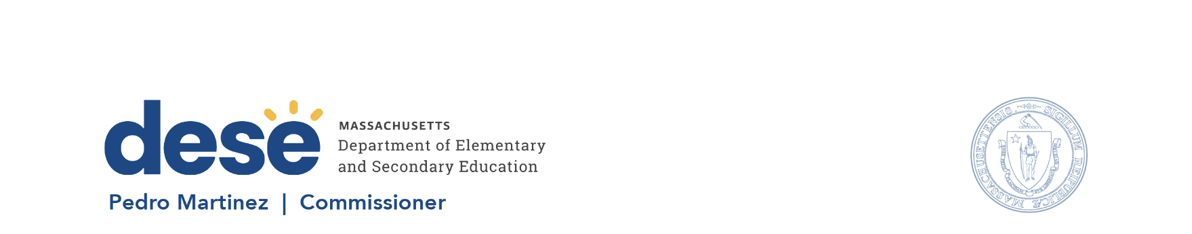

135 Santilli Hwy, Everett MA 02149 Voice: (781) 338-3000 TTY: 1-800-439-2370 www.doe.mass.edu

August 19, 2026

Subject: 2026–27 Multilingual Education Leaders Network Convenings

Dear Superintendent or School Leader:
The Office of Instruction and Multilingual Education invites you to support the participation of your district’s multilingual education leaders in the 2026–27 Multilingual Leaders Network Convenings.
The Network brings together leaders in English learner education, dual language education, world language education, and the State Seal of Biliteracy for professional learning, collaboration, and connection with colleagues and Department staff.
The two full-day, in-person convenings will be held at the Devens Common Center:
Fall Convening: Monday, October 26, 2026, 8:00 a.m.–3:00 p.m.
Spring Convening: Tuesday, April 6, 2027, 8:00 a.m.–3:00 p.m.
We encourage districts to support appropriate staff members in attending both convenings, including providing release time and necessary travel support.
Schools and districts may also choose to award Professional Development Points (PDPs) for staff engagement in these convenings.
Thank you for supporting multilingual education leadership in your district.
Sincerely,
Allison Balter, Associate Commissioner
Office of Instruction and Multilingual Education
Massachusetts Department of Elementary and Secondary Education

