ROOT CAUSE ANALYSIS, CORRECTIVE ACTION PLANS AND PROGRESS REPORTS

Introduction

The Root Cause Analysis form was created to help districts take an in-depth look at their ELE program and identify the primary barriers to the success of ELs so that districts can create a plan that will attack those root causes and reduce or remove impediments to student learning. The process follows the order below:
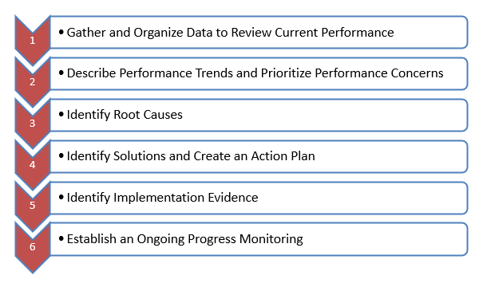

Districts should consider the following facts before they start their analysis:
There is no ONE “root cause” to an educational problem. There are many contributing causes. The team should identify the factors most influential on ELs’learning in their particular setting.
Student outcomes are symptoms, not causes. When ELs are described as a low performing group the district needs to adopt the five whys approach and question why ELs are a low performing group in the district. What is the root cause of this low performance?
Confusing a learning outcome with its cause leads to blaming the victim. For example: Newcomers come with no English and they don’t understand the content introduced in the class. What does the district do to overcome this barrier and to give full access to the curricula taught in the district as state and federal laws require?
Correctly linked causes and effects can be crafted into a reasonable “If. . . then . .” statement: If lessons are sheltered to address student learning needs, more ELs will meet their learning targets. (or in the negative, If lessons are not sheltered to address ELs’ learning needs, they may not achieve expected learning goals.)

Step 1: Gather and Organize Data to Review Current Performance

Districts considered various district-specific data and information, including demographic and student learning data to determine the needs of their EL population and to decide about ELE programming in order to best meet the needs of these students.
Demographic Data Study:
a. What is the number and percentage of ELs by school and district-wide? Have the number of ELs increased over the past three years? Has the district been able to keep up with staffing needs if the numbers of ELs have increased?
b. What is the number and percentage of ELs by grade or grade clusters? Are ELs concentrated at certain grades or grade clusters?
c. What is the breakdown of ELs by English proficiency levels and how are these levels spread out by grades or grade clusters?
d. What are the five year trends in EL enrollment (number, language, grade, etc)?
e. How many students with limited interrupted formal education (SLIFE) are enrolled in the district? Are they concentrated in particular grades/grade clusters/schools?
f. How many ELs with disabilities are enrolled in the district? Are they concentrated at particular grades/grade clusters/schools? How does the percentage of ELs identified as requiring special education services compare to the rate for non-ELs?
k. What is the breakdown of languages spoken by ELs in the district?

Student Learning Data Study and Key Performance Indicators (KPIs):
Core Indicators (Core data to determine Tiers)

  - ELs’ growth in acquiring English (EL Student Learning Target Number 1): Student Growth Percentiles for ACCESS (SGPAs) are calculated for each EL who took ACCESS for ELLs® for two successive years and were compared with the growth-to-proficiency target for students at that proficiency level who had attended a Massachusetts school for one through five (or more) years.
  - The number of ELs in the district who attained English proficiency (EL Student Learning Target Number 2): District attainment targets are based on the statewide percentage of students who attained a score of Level 5 on ACCESS, based on the number of years in a Massachusetts school. Districts must have also met a 95% participation rate on ACCESS for ELLs® in order to meet this target number.
  - Academic achievement of ELs and former ELs as compared to their never-EL peers or Cumulative PPI (EL Student Learning Target Number 3): The PPI incorporates MCAS/PARCC scores in English Language Arts (ELA), Mathematics, and Science and Technology/Engineering (STE); growth in ELA and Math; graduation rates; and dropout rates, calculated over the past four years. Cumulative PPI is weighted to give greater emphasis to the results of more recent years.
Additional Indicators
- Are all ELs exited based on the exit criteria determined by DESE?
- Graduation rate for ELs (What percentage of ELs does not graduate in four/five years and does it mimic the rate for non-ELs?)
- Proportion of identification of ELs for Special Education services (What percentage of ELs is identified as requiring Special Education services and does it mimic the rate for non-ELs? Is there over-identification of ELs with disabilities)
- Long-term ELs or ELs who have remained as ELs for more than five years (What is the number and percentage of ELs not attaining English proficiency within 5 years and is it above or below the state average?)
Please gather and organize data to review the current performance of your ELs. You may want to revisit some of the data listed above. Specify areas where the district failed to meet the target numbers determined by the state. You may need to have an analysis of data at a more detailed level than that presented in the district’s overall performance reports in order to see patterns over time:

- for cohorts of students (3rd grade in one year, 4th grade in the next year, 5th grade in the third year);
- within a grade level (per content area);
- within a disaggregated group of students; and/or
- within a content strand

Step 2: Describe Performance Trends and Prioritize Performance Concerns
The identification of trends involves analyzing at least three years of data for each performance indicator area. Once the team has identified performance trends, it must prioritize those trends that are identified as “challenges.” Prioritizing Performance Concerns may be the most critical step in the entire planning process as it sets the tone for each of the subsequent steps. Once the performance indicator is determined the team can look at the data and see more specifically the concern areas such as a certain grade level, a certain content area and come up with a trend statement.
Example:
Performance Indicator | Content Area | Measurement | EL Grade level | ELP
Academic Growth | Science | MCAS data | 5&8 | 1, 2, 3

Trend Statement: The achievement of 5th and 8th grade ELs at the WIDA proficiency levels 1, 2 and 3 in Science decreased 5% in 2015 and 3% in 2016.
Step 3: Identify Root Causes
A root cause is an initiating cause of either a condition or a causal chain that leads to an outcome or effect of interest. Commonly, root cause is used to describe the depth in the causal chain where an intervention could reasonably be implemented to improve performance or prevent an undesirable outcome. The process helps districts to correctly identify the true problems rather than addressing symptoms. Often, the most immediate or obvious cause is mistakenly identified as the root cause when, instead, it is simply a contributory cause. This means that we really have to dig deep to find most roots. They usually are not the most immediate and obvious causes. Often, they are three, four, or five layers down into the system.
This form offers two tools for Root Cause Analysis: 5Whys Root Cause Analysis Worksheet and Fishbone Diagram. Please use one of them for your submission.

5 Whys for Root Cause Analysis

By repeatedly asking the question “Why” you can peel away the layers of symptoms which can lead to the root cause of a problem.

Directions:
- Write down the specific problem. Writing the issue helps you formalize the problem and describe it completely. It also helps a team focus on the same problem.
- Ask why the problem happens and write the answer down below the problem.
- If the answer you just provided doesn’t identify the root cause of the problem that you wrote down in Step 1, ask why again and write that answer down.
- Loop back to step 3 until the team is in agreement that the problem’s root cause is identified. Again, this may take fewer or more times than five Whys.
Fishbone Diagram for Root Cause Analysis

The fishbone diagram is a simple tool that allows quick and effective root causes to be understood, in the pursuit of corrective actions. It is used to brainstorm issues and causes of particular problems. In a fishbone diagram, the various causes are grouped into categories and the causes cascade from the main categories, flowing towards the effect, forming what resembles a fishbone appearance. Team members brainstorms all the possibilities that could cause the problem and then drill down the factors that are causing the issue.

Directions
  - Focus on closely related performance concerns.
  - If an external review has been done in the district, then consider the findings of the review. If not, consider the categories of factors that typically cause performance concerns.
  - Agree on the problem statement. It is written at the mouth of the fish. Be as clear and specific as possible about the problem.
  - Agree on major categories of causes of the problem (written as branches from the main arrow).
  - Brainstorm possible explanations (causes) for the performance concerns using the fishbone chart. Ask: “Why does this happen?” As each idea is given, the facilitator writes it as a branch from the appropriate category. Causes can be written in several places if they relate to several categories.
  - Again ask “why does this happen?” about each cause. Write sub–causes branching off the causes. Continue to ask “Why?” and generate deeper levels of causes. Layers of branches indicate causal relationships.
  - Categorize like causes together.
  - Narrow the explanations to those that are actionable, which includes removing items outside of the district’s control.
  - Deepen the thinking to ensure the causes are ―root causes by using the ―Why … Because chart or the enhanced questions below.
  - Verify root causes with multiple data sources to ensure improvement strategies and action steps align with the root cause of performance concerns. They should be the deepest and most basic reason, within the district’s control, evidence based, and focused on the adult actions of the leaders and teachers.

Step 4: Identify Solutions and Create an Action Plan

CORRECTIVE ACTION

The State annually determines the targets for each of the Key Performance Indicators (KPI). Targets for school year are set in the month of February of the previous school year. Districts must conduct a “Root Cause Analysis” and develop a corrective action plan when the district does not meet the targets determined by the Department for any of the KIPs.

District Name Superintendent Name

District Address City Zip Code Telephone Number E-mail address

ELE Director Telephone Number E-mail address

District has not meet the KPIs below in the SY 20__-20__ :
- 1- ELs’ growth in acquiring English (EL Student Learning Target Number 1): Student Growth Percentiles for ACCESS (SGPAs) are calculated for each EL who took ACCESS for ELLs® for two successive years and were compared with the growth-to-proficiency target for students at that proficiency level who had attended a Massachusetts school for one through five (or more) years.
- 2- The number of ELs in the district who attained English proficiency (EL Student Learning Target Number 2): District attainment targets are based on the statewide percentage of students who attained a score of Level 5 on ACCESS, based on the number of years in a Massachusetts school. Districts must have also met a 95% participation rate on ACCESS for ELLs® in order to meet this target number.
- 3- Academic achievement of ELs and former ELs as compared to their never-EL peers or Cumulative PPI (EL Student Learning Target Number 3): The PPI incorporates MCAS/PARCC scores in English Language Arts (ELA), Mathematics, and Science and Technology/Engineering (STE); growth in ELA and Math; graduation rates; and dropout rates, calculated over the past four years. Cumulative PPI is weighted to give greater emphasis to the results of more recent years.
- 4- Are all ELs exited based on the exit criteria determined by DESE?
- 5- Graduation rate for ELs (What percentage of ELs does not graduate in four/five years and does it mimic the rate for non-ELs?)
- 6- Proportion of identification of ELs for Special Education services (What percentage of ELs is identified as requiring Special Education services and does it mimic the rate for non-ELs? Is there over-identification of ELs with disabilities)
- 7- Long-term ELs or ELs who have remained as ELs for more than five years (What is the number and percentage of ELs not attaining English proficiency within 5 years and is it above or below the state average?)

Establish a Team
List the names and contact information for the individuals who will serve on the Corrective Action Team. Additional rows may be added to the chart as needed. Team members should include individuals who have expertise in student achievement data, English language acquisition, and cultural or cultural adjustment issues. Examples of possible team members include District Superintendent, ELE Director/Coordinator, teachers, testing coordinator, family or parent liaison, counselor, Special Education representative, and budget or fiscal personnel. The Corrective Action team will provide the expertise needed in order to address the needs of the district to ensure that the district is making progress in meeting KPIs the following school year.

Corrective Action Team
Role | Name | E-mail address | Phone number

Describe the root cause analysis findings for the KPIs that require improvement and next, write a goal for meeting each of those KPIs.

Describe the action steps to be taken in order to address the areas that need improvement.

*Please copy and paste the table below for each KPI that the district needs a corrective action for.
Targeted KPI
Root Cause Analysis Findings
Goal
Action: | Describe what action steps will be implemented in order to ensure successful accomplishment of the goals
Responsible Staff
Timeline: | When will the action steps be started and what is the expected completion date?
Indicators of Success: | Did the actions address problem causes, instead of just symptoms?  Are the actions fully implemented?

Step 5: Identify Implementation Evidence
The key to verification is evidence. You are seeking objective, factual evidence that your problem causes have been reduced or removed. This evidence usually takes the form of data or records. The exact amount of evidence depends on the magnitude of the problem. Broader and more severe problems lead to more profound solutions, which in turn require more evidence to verify effectiveness. The scale of verification must match the scale of the actions taken.
Step 6: Progress Monitoring
Gather the team together periodically to review the data used to set the goals and any new data that has been gathered as it relates to completing the goals. List the action steps that will be monitored, and who will be responsible for checking that the action steps are being implemented as intended. List the processes and tools used to complete the action steps to ensure goals are being met on time and with the attention needed to ensure success of the plan. Also, please indicate the frequency with which monitoring of the action steps will take place. Determine whether any changes need to be made in order to ensure the success of the plan. Rows may be added as needed.
Action Steps to be Monitored
Responsible Staff and Their Position/Role
Process/Tools Used
Timeline/Frequency
Changes needed

APPENDIX

5 WHYs Worksheet
Define the Problem: (Insert one of the top prioritized student needs)

Why is it happening? (Identify each as a concern, influence or control.)

1. | Why is  that?

2. | Why is  that?

3. | Why is  that?

4. | Why is  that?
5. | Why is  that?

Caution: If your last answer is
something you cannot control
go back up to previous answer.

5 WHYs Worksheet- SAMPLE
Define the Problem: 95% of ELs in the district’s middle school did not show growth in acquiring English.

Why is it happening? (Identify each as a concern, influence or control.)

1. Students are not motivated to learn. (concern) | Why is  that?

2. Instruction is not differentiated. (influence) | Why is  that?

3. Teachers don’t know strategies to make the content comprehensible for ELs. (influence) | Why is  that?

4. Most of the core academic teachers in the middle school are not SEI endorsed. (control) | Why is  that?
5. District and school administration does not have procedures to support core academic content teachers of ELs in earning an SEI Teacher Endorsement. (control) | Why is  that?

Caution: If your last answer is
something you cannot control
go back up to previous answer.

FISHBONE DIAGRAM
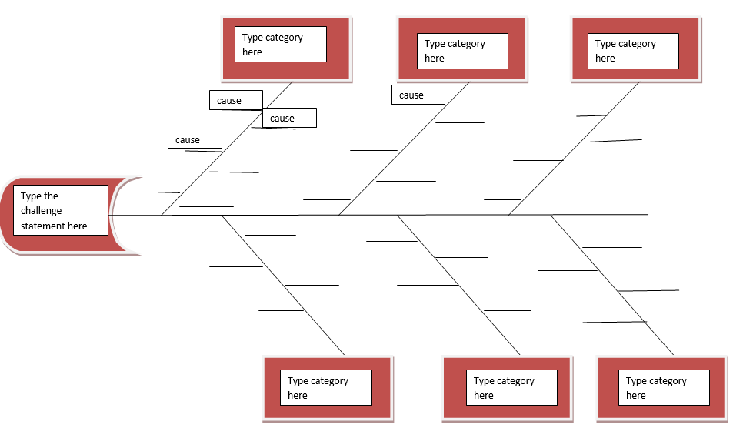

FISHBONE DIAGRAM (SAMPLE)
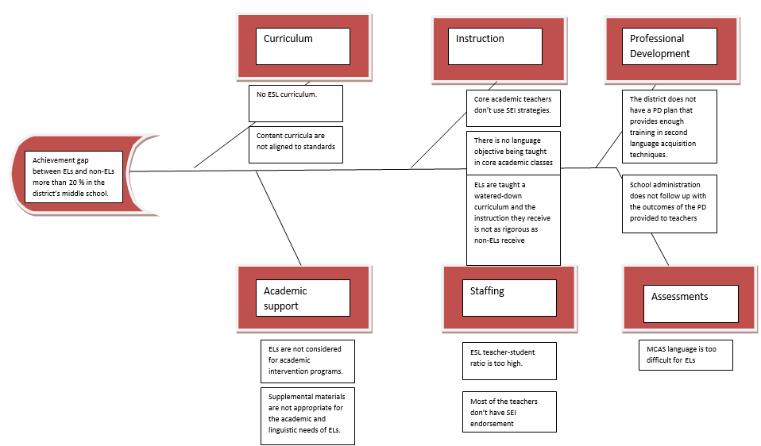

Root causes:
√ No ESL curriculum: A well designed ESL curriculum is essential to help students acquire English at a rapid pace. Students who do not have a language barrier would be more successful in academics.
X Content curricula are not aligned to standards: Even if this is a problem it would affect non-ELs achievement scores as well. This cannot be a cause for the achievement gap between ELs and non-ELs.
X ELs are taught a watered-down curriculum and the instruction they receive is not as rigorous as non-ELs receive: Although this can be a reason for the achievement gap the question” why” can lead us to a more specific root cause.
Why? Because….
√ Core academic teachers don’t use SEI strategies: This is a root cause since ELs will not be able to master content standards if teachers do not make the content comprehensible for them by using SEI strategies.
X There is no language objective being taught in core academic classes: A teacher who uses SEI strategies will most likely include language objectives in his/her lesson plan. Therefore, this cannot be a direct root cause for the problem.
X The district does not have a PD plan that provides enough training in second language acquisition techniques: Although it is important to have a continuous PD plan for teachers, this cannot be a root cause when all core academic teachers of ELs are already SEI endorsed licensed teachers.
X School administration does not follow up with the outcomes of the PD provided to teachers: Although it is important to follow up with the outcomes of the PD provided to teachers, this cannot be a root cause when all core academic teachers of ELs are already SEI endorsed, licensed teachers.
X ELs are not considered for academic intervention programs: Interventions would not make a big difference if the content is not made comprehensible for ELs. Therefore, this cannot be a root cause for the problem.
X Supplemental materials are not appropriate for the academic and linguistic needs of ELs: Although it is important to provide materials that are appropriate for the academic and linguistic needs of ELs it can have less effect on student learning when ELs have access to appropriate content instruction.
√ ESL teacher-student ratio is too high: It is important to keep a reasonable ESL teacher-student ratio to ensure that ELs have access to sufficient language development and can acquire English at a rapid pace, which in return provide students with access to core curricula.
√ Most of the teachers don’t have SEI endorsement: This is major root cause. Teachers who haven’t received training to shelter the content for the ELs in the classroom cannot meet the linguistic and academic needs of ELs.
X MCAS language is too difficult for ELs: It is not a cause we have control over.

