THE COMMONWEALTH OF MASSACHUSETTS
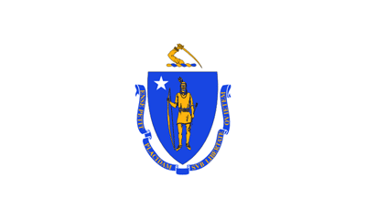
A Proclamation
Whereas Parents are their children’s earliest and most continuous teachers, and play a critical role in their children’s school success from birth through career and college readiness; and

Whereas Parents partner with school staff to support their children to achieve high academic standards; and

Whereas Families benefit from engaging in shared learning activities at home and in the community; and

Whereas Communities, libraries, and schools provide family engagement opportunities that support children’s language and literacy development; and

Whereas The Massachusetts Family Literacy Consortium brings state agencies and family serving organizations together to support community efforts that promote early literacy and reading proficiency by the end of third grade to give children a foundation for success in school; and

Whereas The Commonwealth of Massachusetts has a tradition of commitment to universal literacy and family literacy,

Now, Therefore, I, Charles D. Baker, Governor of the Commonwealth of Massachusetts, do hereby proclaim November 2015, to be,

Family Literacy Month

And urge all the citizens of the Commonwealth to take
cognizance of this event and participate fittingly in its observance.

Given at the Executive Chamber in Boston, this First Day of November, in the year two thousand and fifteen, and of the Independence of the United States of America, the two hundred and thirty-ninth.

By His Excellency

Charles D. Baker Karyn E. Polito
Governor of the Commonwealth Lt. Governor of the Commonwealth

William Francis Galvin
Secretary of the Commonwealth

God Save the Commonwealth of Massachusetts

