# State Level Equitable Services Needs Assessment – FY25 Summary of Results

## Administration

* The opportunity to participate in the State Level Equitable Services Needs Assessment - FY25 was sent to ~700 private school contacts across the Commonwealth from [eseaequitableservices@mass.gov.](mailto:eseaequitableservices@mass.gov)
* The Assessment was open for 19 days from Monday, April 28, 2025 through Friday, May 16, 2025.
* The initial invitation was sent the field on Monday, April 28, 2025 with reminder emails sent on Thursday, May 8, 2025 and Thursday, May 15, 2025.
* DESE received 121 complete responses and 201 partial responses.
* The information provided below was compiled from the pool of complete responses.

## Demographics of Responding Private Schools

* The majority of schools serve students in grades PK-8.
* Average number of students enrolled is 267.
* Average number of educators is 53.

## Identifying Student Needs

Respondents ranked differentiated instruction as the highest priority student need this year, followed by improving academic performance and mental health/social emotional supports. Compared to the initial administration of the needs assessment in Fall 2023, mental health and social-emotional supports dropped from the top priority to third, while differentiated instruction rose to the highest-ranked need.

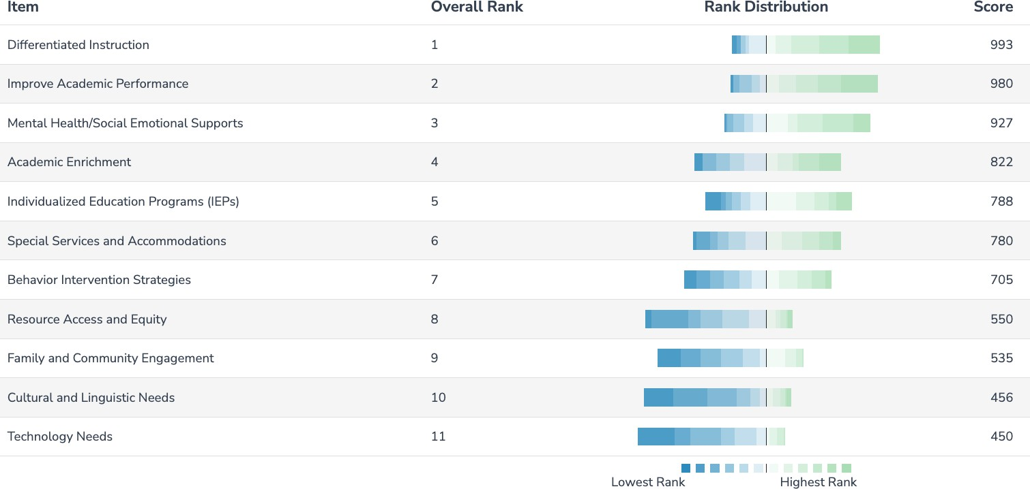

*Results for Q8: Based on your analysis of the data indicated above, what are the highest priority areas for your school to address student needs?*

Respondents again identified Mathematics and English Language Arts (Reading/Writing) as the subject areas where students demonstrate the most significant need for improvement. Of note, there was no clear trend in the nine write-in responses this year, though executive functioning and social-emotional learning (SEL) were mentioned as additional areas of need.

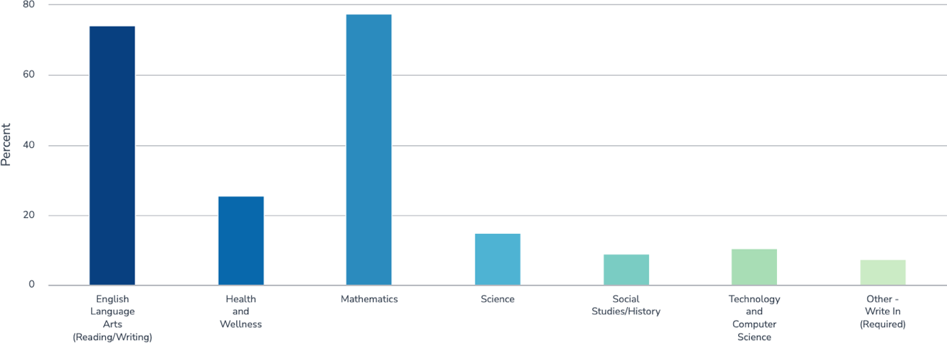

*Results for Q9: Based on your analysis of the data indicated above, in which subject areas do students demonstrate the most significant need for improvement? (Select all that apply).*

## Identifying Professional Development Needs for Educators

Respondents again ranked differentiated instruction and classroom management as the two highest priority educator professional development needs, followed by instructional pedagogy and mental health/social emotional learning.

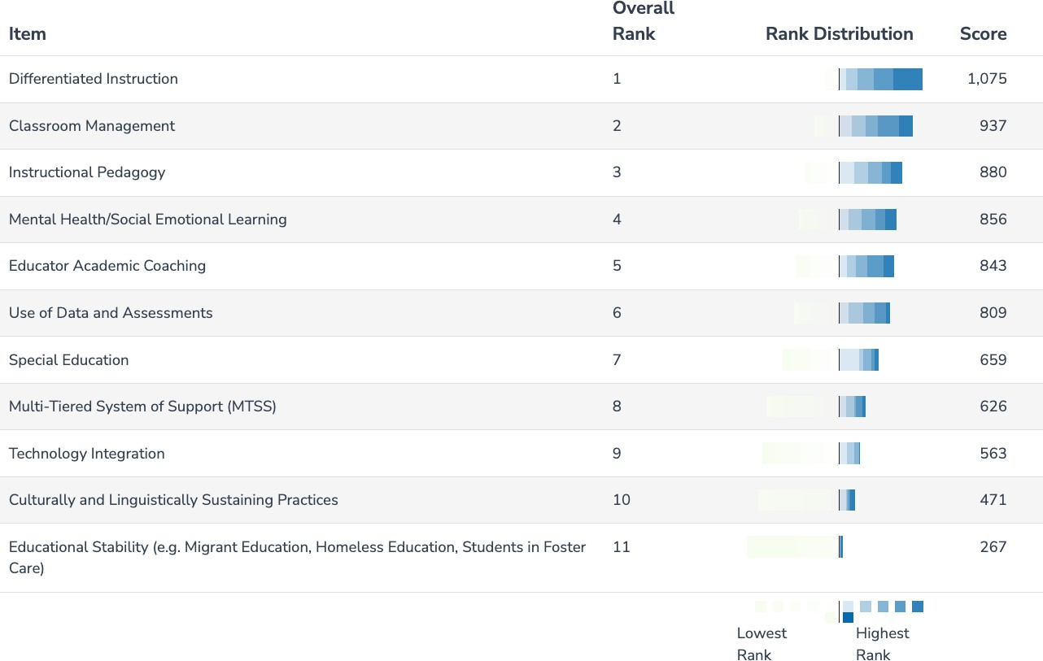

*Results for Q12: All professional development needs should be focused on the impact it will have on students' academic success. Considering your responses related to student needs as well as the analysis of educator data, what are your priorities for educator PD in the 2025-26 school year?*