**Reallocating Unused ESSA Grant Equitable Participation Funding**

This guide outlines what to do if a private school that is participating in your district’s ESSA Title I, Title IIA, Title IIIA, and/or Title IVA equitable services, either chooses to terminate participation or closes before all generated funds have been expended by the district or cooperation needed to implement planned services has lapsed or has not been forthcoming.

[**When can funds allocated for participating private school participation be reallocated for other purposes?**](http://www.doe.mass.edu/federalgrants/titlei-a/guidance/)

\

Under one of the following two conditions, a district may repurpose all or a portion of the funds identified for a program at a private school.

1. A private school official has declined, in writing, further equitable services due to lack of continued interest or because the planned program has been implemented to the extent requested even though equitable services funds reserved for that school remain.
2. The district has notified a private school official, in writing, that it is discontinuing the program due to the school’s continued lack of cooperation. To support this determination, the district must maintain documentation of all the following conditions:
   1. The district has offered proper ongoing consultation which includes a discussion of the private school’s expected responsibilities,
   2. The district has planned and/or was ready, willing, and able to provide suitable services,
   3. The school has failed to fulfill its responsibilities to allow services to be provided,
   4. The district has previously notified the school of its unfulfilled responsibilities and has provided reasonable opportunities for the school to make corrections by a specified date, and
   5. The private school has not provided a timely and adequate response.

[**When can funds allocated for participating private school participation be reallocated for other purposes?**](http://www.doe.mass.edu/federalgrants/titlei-a/guidance/)

**For Title I:**

Throughout the life of the grant funding, the funds will remain reserved for equitable services for use at any other participating private schools, proportioned according to the counts of fund-generating students that were established during consultation. If there are no other private schools participating, the funds will be used for eligible district schools.

**For Titles IIA, IIIA, and IVA:**

Throughout the life of the grant funding, the remaining funds should be shared with other participating private schools and the district’s public schools, according to proportionate share calculations. If there are no other private schools participating, the funds will be used for allowable expenses by the district for its students.

**What must be done to document the reversion of equitable services funds on the ESSA consolidated application in GEM$?**

If the above criteria have been met, please follow the steps below to reallocate or revert ESSA equitable services funds:

1. Log into GEM$ and navigate to Search -> Application Supplements.

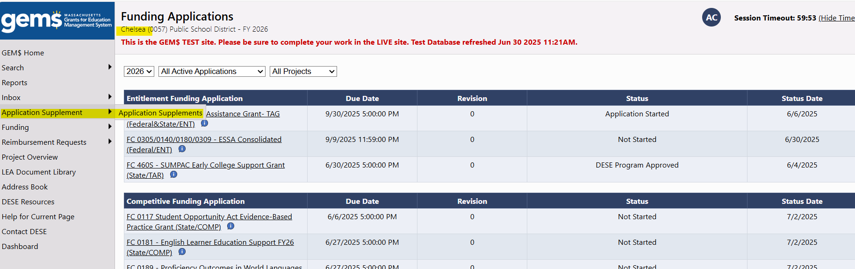

1. On the Application Supplements page, ensure the correct fiscal year is selected from dropdown (2025 for FY24 and FY25 ESSA grants) and then select and click on “ESSA Equitable Services – Reallocation and Reversion Request.”

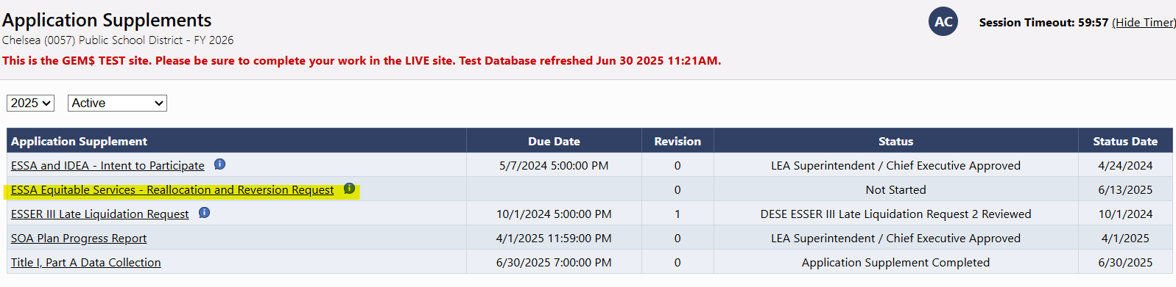

1. On the Sections Page of the application supplement, change the Status to “Application Supplement Started.” Then click on the “Required Information” page.

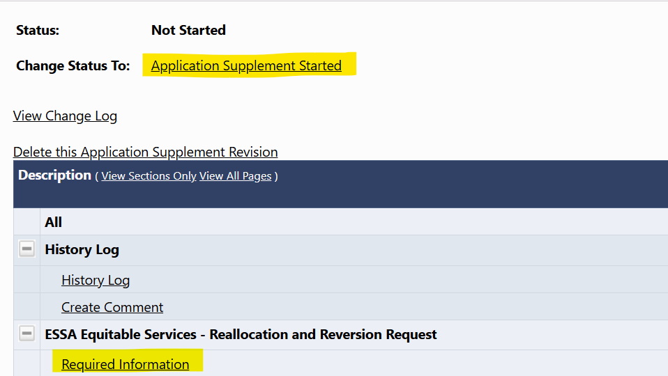

1. On the Required Information page, scroll down to the ESSA grant (Title I example below) where you are reallocating/reverting funds. Type in the ESSA fiscal year that is being reallocated/reverted, the name of the private school, their original equitable services reservation, and how much is being reallocated (**This should be the total amount of unused funds that will be reallocated to other participating private schools first, then to participating schools in the district**).
   1. The number in the “Amount to be Reallocated” column should be the same or lower than the original reservation.

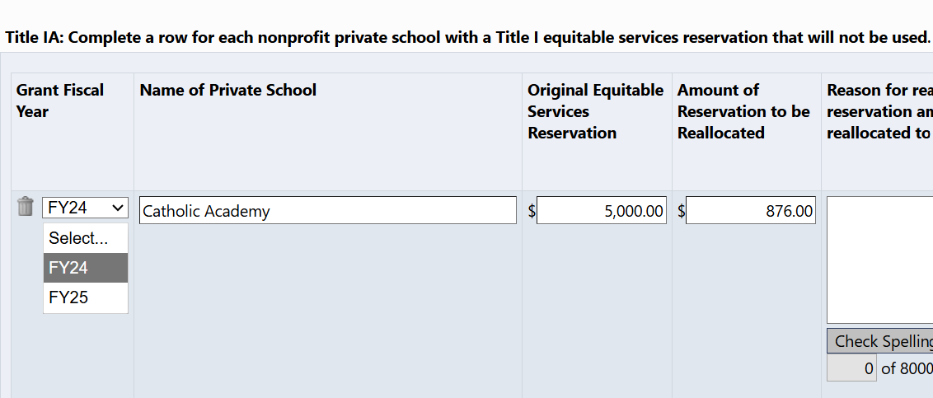

1. Scroll to the right and provide a clear and thorough explanation of why the funds were not able to be expended, and how they will be used by the recipients of the reallocated funds.
2. If you have not yet secured written confirmation from the private school that the funds will not be used, please use the box to the right to explain why. **Please note that you do not need to upload the written confirmation but should keep it on file in case DESE requests it in the future.**

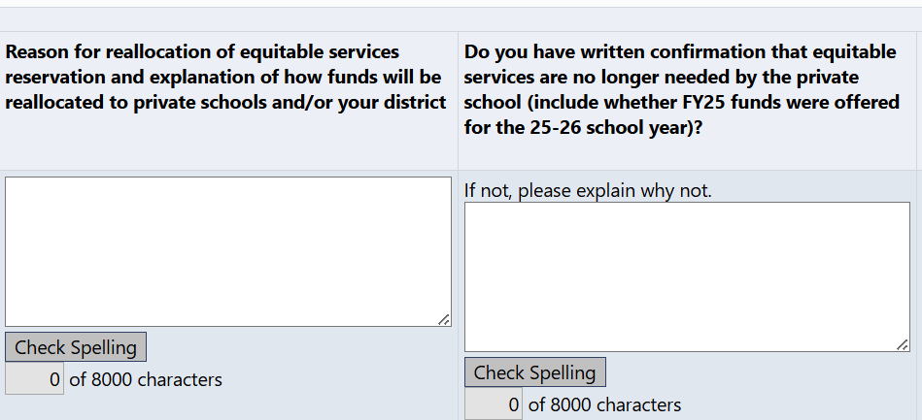

1. Use the final box at the far right of the page to list the amount of the unused reservation that is being reverted to the district. This should be either a smaller number or the same number as what was in the “Amount of Reservation to be Reallocated” column.

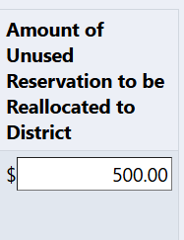

1. Use the “Add Row” link to add additional private schools whose reservations are being reallocated under this grant.

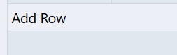

1. Once you have added all private schools who are not using their full allocation under this ESSA grant, check the Attestation box (***the Application Supplement cannot be approved if this box is not checked***).

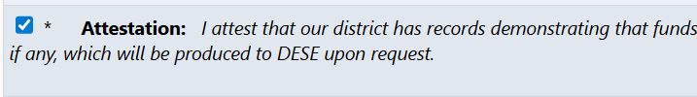

1. Scroll down and repeat these steps for any other ESSA grants where equitable services will be reallocated. Once you have entered all information, click “Save and Go To” -> Section Page.
2. Change the status to “Application Supplement Completed.” The LEA’s Fiscal Representative will then need to approve. Once they change the status to “LEA Fiscal Representative Approved,” it will be submitted to DESE for review.
   1. To ensure awareness, please also email your [Federal Grants Liaison](https://www.doe.mass.edu/federalgrants/liaisons.xlsx) to let them know the Fiscal Representative has submitted this application supplement in GEM$.

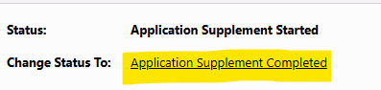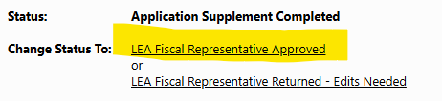

1. If your Federal Grants Liaison approves the reallocation, DESE will manually enter the amount being reverted to the district into your ESSA application in Section 5.D(ii) on the equitable services page for each impacted grant. Your liaison will let you know when the reversion has been fully processed.

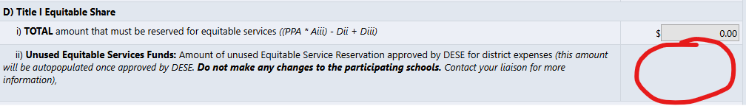

1. Upon approval and adjustment of required amounts in the grant application, revise the district’s ESSA consolidated application by doing the following:
   1. For each grant impacted, check the ESSA attestation box under 5.D(ii) of the private school participation page *(skip this step if this information was previously provided on the application supplement)*.
   2. Provide any explanation for how the funds are being reallocated in the narrative box *(skip this step if this information was previously provided on the application supplement)*.
   3. Do not make any changes to the original participating private schools or their enrollments – the adjustment will be recorded in Section 5.D as shown above.
   4. Modify applicable grant budgets to indicate changes in use of reallocated funds.
      1. Adjust amounts to participating private schools, as needed.
      2. Adjust private school service tags for budgeted items, as needed.
   5. If unused Title I equitable share funds are being used for Title I schools in the district, modify school allocations on School Ranking page, as needed.
2. Submit your ESSA grant revision for review and approval. From there, you will follow the normal grant revision process in GEM$.
3. If you need to request another reversion or reallocation for FY24 or FY25 equitable services funds, please start a revision to your application supplement (by changing the status to “Application Supplement Revision Started”) and resubmit to DESE.

Updated June 2025

*The contents of this document do not have the force and effect of law and are not meant to bind the public in any way; they are intended only to provide clarity to the public regarding existing requirements under the law or agency policies.*