Navigating Perkins (0400/0401) in GEM$
This addendum is a guide as districts/LEAs develop and reconcile their Perkins 0400/0401 budgets in GEM$. The grant writer and LEA fiscal representative should review each budget item to ensure the object and function codes are correct. Districts should also review the Chart of Accounts Guidance listed in the GEM$ DESE Resources.
Please note:
- The function code in the GEM$ budgets automatically defaults to COMM (community services)
- 01M is the object code for all positions that are required to take MTRS (Massachusetts Teacher Retirement System – Non-Applicable for 0401 applicants).
- 01NM is the object code for positions that are not part of MTRS.
- 04C is the object code for contract items <$25,000.
- Any contract over $25,000 should be object code 04MC, except in cases where the contractor is filling a role that is usually carried out in-house, like for an independent contractor/contracted employee who serves as a nurse or speech pathologist and uses payroll, HR – these contracts belong in 04C
While these represent the functions and objects for most expenses identified here, but there may be some departures for special circumstances. Please check with your business office if you believe an expense should be coded differently than indicated here.
Object and Functions Code Suggestions
Allowable Perkins cost | Object Code | Function Code
CTE Student Group Transportation | 04C Contracted Services  or  06-Other Expenses | SERV-Pupil Services
Counseling and Guidance specific to CTE programs | 01M –Professional Salaries (MTRS)  or  O1NM Professional Salaries (Non –MTRS)  or  04C Contracted Services | GUID - Guidance, Counseling, and Testing
CTE Curriculum Development | 04C Contracted Services | LDRS - Instructional Leadership
Occupational certifications and licenses (student testing fees and certifications, i.e., OSHA, Adobe) | 06-Other Expenses | GUID - Guidance, Counseling, and Testing
Post Secondary Linkage Dual Enrollment Educators/Staff | 03-Other Salaries | TSER-Other Teaching Services
Post Secondary Linkage Dual Enrollment Courses/Tuition | 04C Contracted Services  or  06-Other Expenses | TSER –Other Teaching Services
Professional Development Membership Fees/Dues/Travel costs | 06-Other Expenses | PDEV-Professional Development
Stipends for CTE Educator and CTE Administrators: supporting CTE Extracurricular activities (I.e., Career Tech Student Organizations (CTSOs), Student clubs, Committees, Orientation events) | 01M –Professional Salaries (MTRS)  or  O1NM Professional Salaries (Non –MTRS)  or  03 – Other Salaries  or  06-Other Expenses | TCHER - Teachers
Stipends for CTE Educators and CTE Administrators: Providing or attending Professional Development | 01M –Professional Salaries (MTRS)  or  O1NM Professional Salaries (Non –MTRS)  or  03 – Other Salaries  or  06-Other Expenses | PDEV-Professional Development
Tutoring Services specific and supplemental CTE program improvement and support | 03 – Other Salaries | PARA- Paraprofessionals

Reconciling Capital Expense Forms
Equipment and Capital Expense should be submitted with original application or revised applications
- Capital expenditures are:
  - Tangible or intangible (software) asset that has useful life greater than one year (or upgrade to existing asset) and meets or exceeds the capitalization level of the organization (usually $5,000)
- Capital Expenditures form required for:
  - Equipment or capital expenditure of $30,000 or more
  - Form available in Capital Expense section of the application or available here at: (https://www.doe.mass.edu/federalgrants/resources/)

Submit completed, signed Capital expense form and accompanying required documentation with application submission or revision submission.
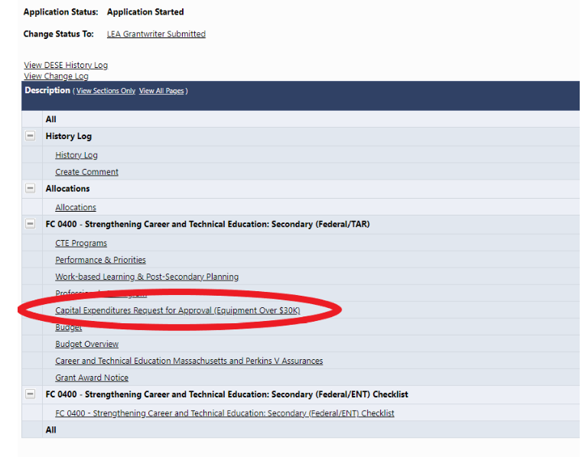
When completing reimbursement requests or the grant closeout period. The capital expense should be reconciled by attaching a final purchase order or invoice in the related documents section of the Reimbursement Request.
