ESSA Family Engagement Quick Reference Guide:
Fulfilling ESSA Requirements while developing capacity building activities
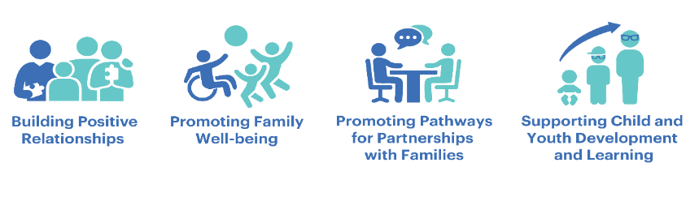
What is Family Engagement?
The primary goal of family engagement is to facilitate shared responsibility that contributes to the healthy development, learning, and growth of children. Family Engagement builds authentic relationships between students, families, educators, and the community. These relationships over time develop into meaningful partnerships rooted in the strengths and assets of all.
- Effective family engagement is culturally responsive, collaborative, equitable, and respectful of diverse languages, norms, beliefs, and values.
- Effective engagement strives to eliminate barriers to participation.
- These engagement practices take place in schools, in the community, and wherever students live and learn. Refer to Prenatal through Young Adulthood Family Engagement Framework for additional guidance.
Family Engagement Requirements related to Title I, Part A

District Family Engagement Policy - Each district that receives Title I funds must develop a written family engagement policy. Families must be involved in the development of this policy and agree to the contents of the policy.

School Family Engagement Policy - Each school that receives Title I funds must develop a written family engagement policy. Rather than having separate family engagement policies at the school and district level, a district may adopt an inclusive policy that incorporates all the required district-level and school-level components under ESSA.

School-Parent Compact - As a component of the family engagement policy, each school served under Title I shall develop jointly with families a school-parent compact for all children served under Title I. The school-parent compact may be part of the policy inclusive of both district and school-level required components.

Parent’s Right-to-Know - At the beginning of each school year, districts shall notify the parents of students attending a Title I school that parents may request, and the district will provide in a timely manner, information regarding the professional qualifications of their child’s classroom teachers.
.

 | Annual Stakeholder Consultation | Annual Activities | Notes
Title II, Part A |  |  | Must seek advice from stakeholders on how best to improve Title II activities to meet the grant’s purposes  Through consultation with listed stakeholders, must coordinate activities with other related strategies, programs, and activities being conducted in the community
Title III, Part A |  |  | Must use funds to implement family and community engagement activities that enhance or support language instruction for ELs
Title IV, Part A |  |  | Must engage in continued consultation with listed stakeholders to improve Title IV activities to meet the grant’s purposes
Family and stakeholder engagement requirements of ESSA Titles II, III, and IV. The stakeholder engagement processes described below may be part of a combined stakeholder engagement process that meets all the required components of Titles. Refer to District and School Family Engagement & Required Policies (DESE Guidance) for expanded guidance.

Cross-Cutting Family Engagement Requirements of ESSA (Title II, Title III, & Title IV)
Strategies to Stregthening Capacity for Family Engagement
- Conduct a needs assessment with families, asking about their preferred ways of communication and how/where they go to access information. Using results of the needs assessment, create multiple channels of two-way communication for families and practitioners to share information, express concerns/ needs, and provide feedback (e.g., blogs, social media, and face to face opportunities in various community locations).
- With families, identify logistical supports for families to attend family and community engagement opportunities (e.g., transportation, food, space, childcare, translation).
- Engage families to identify barriers to accessing community organizations and services and to innovate creative ways to overcome them (e.g. hire diverse speakers of primary languages spoken in the community; navigate with families as they seek to meet basic needs; ensure that family engagement staff reflect cultural diversity)
- Refer to Family, School and Community Partnership Fundamentals Self-Assessment Version 2.0 for additional guidance

Needs Assessments
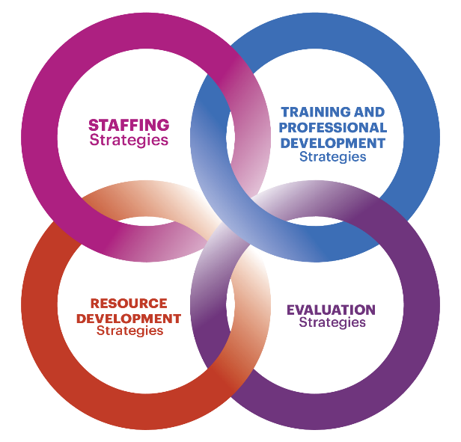

- Community partners provide culturally and linguistically responsive services and helpful resources. Partners are available to work with families and other practitioners on such goals as family members’ health, mental health, educational advancement, economic mobility, and other aspects of family well-being identified by the family
- Create and/or build upon opportunities to engage the community (e.g., business, libraries, town administration) to provide different civic, career, vocational, education and higher education, paid internships, and volunteer opportunities for families.
- Collaborate with community organizations, including libraries, to address a variety of other areas of well-being

Community Partnerships
- Design and implement opportunities to regularly listen to the voices of families (e.g., listening tours, coffee hours, and online social media) to engage families in proactive problem solving around community engagement.
- Provide opportunities for groups and events with a specific focus identified by families.
- Support interactive family education and learning opportunities in an intentional and ongoing way.
- Compensate family members in ways that are meaningful to them (e.g., resources, or services) for their role in designing and implementing opportunities for families to connect with one another and to share information.
- Fund a peer-to-peer program that provides a continuum of opportunities/roles for families to engage as coaches, ambassadors, etc.
Create Interactive Opportunities for Family Engagement
Complete List of Resources

- District and School Family Engagement & Required Policies (DESE Guidance)
- Prenatal through Young Adulthood Family Engagement Framework
- Family, School and Community Partnership Fundamentals Self-Assessment Version 2.0
- Department of Elementary & Secondary Education Family Portal

